SUPPLEMENTARY MATERIALS

Development Trajectories of Autistic Traits in Infants with a Family History of Autism and/or ADHD: Predictors and Mid-Childhood Outcomes
Appendix S1
Sample Recruitment and Characterization
Four hundred and six infant siblings (213 boys, 193 girls) were recruited in a prospective family history study. Family history infants at either 5 or 10 months of age were enrolled if they had a first-degree relative with a community clinical diagnosis of autism, a first-degree relative with a community clinical diagnosis of ADHD or elevated ADHD traits, or both.
Participants were recruited for a longitudinal study running from 2013 to 2024 from a volunteer database, community flyers, internet adverts and clinical networks. Parental report of an existing community clinical diagnosis of autism and / or ADHD in an older sibling (proband) was the most common route (see Table S1 below). Some parents reported that they themselves had a community clinical diagnosis of either condition or they or their older child had suspected ADHD following which screening with a short version of one the Conners suite of measures was employed to determine eligibility (see below). Information about diagnostic status was ascertained through a number of methods. Before families enrolled in the study, a telephone screening was conducted to determine the presence of autism and ADHD in family members. During their infant’s visit to the lab, the parent/caregiver also completed a medical and psychiatric history interview. We asked for medical updates at each subsequent study visit including new autism and ADHD diagnoses in family members.
Up to 30% of children with autism meet criteria for ADHD when directly assessed (Simonoff et al., 2008). In clinical practice, the prevalence of dual diagnosis is in practice lower (Russell et al., 2014). Given the nature of the co-occurrence between autism and ADHD and our longitudinal study, sometimes family members would have a suspected diagnosis of ADHD at study entry that would be confirmed later in the study; on other occasions, a family would enrol on the basis of an autism diagnosis in an older sibling but by the end of the study, they would report that the same sibling was now undergoing assessment for suspected additional ADHD. At initial contact with participants, parents were asked if there were any diagnoses of ADHD in the immediate family or if they had any concerns about ADHD. If parents reported concerns about suspected ADHD at study entry, they were screened using a shortened version of the Conners to determine eligibility for the study. For siblings aged less than 6 years a shortened version of the Conners Early Childhood (Conners, 2009) and for siblings 6 years or older a shortened version of the Conners 3 (Conners, 2008) were used. Thresholds for inclusion were the presence of 6 ADHD traits on either the hyperactivity/impulsivity or inattention scale, and a positive score on the impairment scale. For parents a shortened version of the Conners Adults ADHD Rating Scale (CAARS; (Conners et al., 1999)) was used. Thresholds for inclusion were the presence of 5 ADHD traits on either the hyperactivity/impulsivity or inattention scale as per DSM-5 guidelines. In terms of the use impairment scores, we used a reduced version of the Conners EC and Conners 3 for individuals under 18 and the CAARS for individuals aged 18+ years. The Conners EC and Conners 3 included questions regarding impairment, as such we also included these questions in our screening forms. In comparison, the CAARS (adult questionnaire) did not include questions regarding impairment. In order to maintain consistency of measure, we did not adapt the CAARS to add impairment questions. As shown below in Table S1, this was the case only for a small minority of participants in the Family History ADHD group and for many children initially suspected ADHD was subsequently confirmed as a diagnosis by parental report on review at the mid-childhood follow-up. This resulted in most diagnoses and hence allocation to Family History group being based on a parent report of a confirmed community clinical diagnosis of an older sibling or parent.
Parent-reported family medical histories were examined for significant conditions in the proband or extended family members (e.g., Fragile X syndrome, tuberous sclerosis) with no such conditions reported. 384 infants were born full-term (37-42 weeks), 14 infants were preterm (32-36 weeks) and term/gestation data was missing for 8 infants. Infants were (M (SD) = 7.08 (2.21)) months old (range 3 to 15 months) at their first infant research assessment with all but 6 children’s first research visit being at or before 12 months.

Table S1

Categorisation of Family History Group

 | FH-Autism  N = 207 | FH-ADHD  N = 30 | FH-Autism + ADHD  N = 67 | No FH  N = 102
Parent reported diagnosis in older sibling | 196ª | 12^{b} | 50
Parent reported diagnosis in parent | 1 | 17 | 2
Parent reported diagnosis in both older sibling and parent | 10 | 1 | 15
Screened parent (for ADHD traits) |  | 0 | 3^{c}
Screened older sibling (for ADHD traits) |  | 0 | 2^{d}

FH-Autism = Autism Family History, FH-Autism + ADHD = Autism + ADHD Family History, FH-ADHD = ADHD Family History, No FH = No Family History of Autism or ADHD

a = 5 half-siblings; b = 2 half-siblings; c = Sibling diagnosed with autism, parent also screened positive for ADHD traits; d = Older sibling with autism, sibling also screened positive for ADHD traits.

Table S2
Retention to Mid-Childhood by Demographic Characteristics
 | Retained (N = 263) |  | Not Retained (N = 143) |  | X² (p-value)
 | N (%) |  | N (%)
Phase
1 | 81 (78%) |  | 23 (22%) |  | X² (2, N = 406) = 15.06, p = .001
2 | 95 (66%) |  | 48 (34%)
3 | 87 (55%) |  | 72 (45%)
Child Sex
Male | 133 (62%) |  | 80 (38%) |  | X² (1, N = 406) = 1.07, p = .300
Female | 130 (67%) |  | 63 (33%)
Child ethnicity
Asian/African/Black/  African-Caribbean/Mixed | 43 (52%) |  | 39 (48%) |  | X² (1, N = 390) = 8.72, p = .003
White/European/Irish | 215 (70%) |  | 93 (30%)
Mother's highest education
Up to 16/GCSE | 17 (71%) |  | 7 (29%) |  | X² (3, N = 383) = 2.60, p = .457
Up to 18/School/College | 65 (60%) |  | 43 (40%)
Degree level | 90 (68%) |  | 42 (32%)
Postgraduate/Professional | 82 (69%) |  | 37 (31%)
Total Annual Household Income
Up to £20,000 | 18 (64%) |  | 10 (36%) |  | X² (4, N = 342) = 2.83, p = .588
£20,000 to £40,000 | 58 (65%) |  | 31 (35%)
£40,000 to £60,000 | 64 (72%) |  | 25 (28%)
£60,000 to £80,000 | 34 (77%) |  | 10 (23%)
Above £80,000 | 66 (72%) |  | 26 (28%)
Age First Visit (months) M (SD) | 6.86 (2.09) |  | 7.49 (2.38) |  | t-test: t (400) = 2.73, p = .007

Table S3

Retention to Mid-Childhood by 10-Month Infant Characteristics

 | Retained |  |  | Not Retained
 | Mean | SD | N | Mean | SD | N | t-test (p)
Mullen ELC | 98.81 | (16.39) | 260 | 95.82 | (17.99) | 130 | t (388) = 1.65 (.100)
Vineland ABC | 95.08 | (14.11) | 243 | 94.92 | (11.62) | 113 | t (354) = 0.10 (.918)
AOSI Total Score | 8.20 | (4.71) | 176 | 8.54 | (5.08) | 71 | t (245) = 0.488 (.626)
IBQ Surgency | 4.76 | (0.66) | 248 | 4.80 | (0.57) | 117 | t (363) = 0.548 (.584)
IBQ Negative Affect | 3.54 | (0.84) | 247 | 3.58 | (0.85) | 115 | t (360) = 0.438 (.662)
IBQ Effortful Control | 4.75 | (0.62) | 248 | 4.82 | (0.65) | 116 | t (362) = 0.968 (.334)

Mullen ELC = Mullen Early Learning Composite; Vineland ABC = Vineland Adaptive Behavior Composite; AOSI = Autism Observation Schedule for Infants; IBQ = Infant Behavior Questionnaire

Table S4

Participant Numbers and Mean Scores at Each Timepoint on Measures Used to Derive Autistic Trait Trajectories

Timepoint N Mean (SD) Missing N % Missing
(from N = 384)

Vineland Socialization Domain (standard score)
5 months | 154 | 100.35 (15.12) | 230 | 59.9%
10 months | 363 | 98.54 (13.38) | 21 | 5.5%
14 months | 355 | 96.79 (11.33) | 29 | 7.6%
24 months | 352 | 100.54 (11.32) | 32 | 8.3%
36 months | 341 | 97.58 (12.71) | 43 | 11.2%
Mid-childhood | 222 | 99.24 (16.30) | 162 | 42.2%
Q-CHAT and SRS-2 (raw score)
14 months (Q-CHAT) | 259 | 29.35 (10.59) | 125 | 32.6%
24 months (Q-CHAT) | 338 | 23.97 (11.25) | 46 | 12.0%
36 months (SRS-2) | 327 | 36.17 (29.79) | 57 | 14.8%
Mid-childhood (SRS-2) | 244 | 42.64 (37.88) | 140 | 36.5%
AOSI and ADOS-2 (raw score)
10 months (AOSI) | 247 | 8.30 (4.81) | 137 | 35.7%
14 months (AOSI) | 359 | 6.66 (5.00) | 25 | 6.5%
24 months (ADOS-2) | 307 | 5.96 (5.02) | 77 | 20.1%
36 months (ADOS-2) | 355 | 5.33 (4.55) | 29 | 7.6%
Mid-childhood (ADOS-2) | 223 | 4.66 (4.55) | 161 | 41.9%

Q-CHAT: Quantitative Checklist for Autism in Toddlers; SRS-2: Social Responsiveness Scale-2; AOSI: Autism Observation Scale for Infants; ADOS-2: Autism Diagnostic Observation Schedule-2.

Table S5

Cross-time correlations on the trait measures

Vineland Socialization Social 5m Social 10m Social 14m Social 24m Social 36m

Social 10m 0.420***
N = 134

Social 14m 0.391*** 0.509***
N = 128 N = 327

Social 24m 0.159 0.345*** 0.383***
N = 135 N = 330 N = 321

Social 36m 0.143 0.254*** 0.362*** 0.654***
N = 124 N = 318 N = 313 N = 325

Social 104m 0.164 0.263*** 0.267*** 0.429*** 0.543***
N = 78 N = 212 N = 206 N = 211 N = 212

Q-CHAT/SRS-2 Q-CHAT 14m Q-CHAT 24m SRS-2 36m

Q-CHAT 24m 0.627***
N = 223

SRS-2 36m 0.456*** 0.759***
N = 213 N = 301

SRS-2 104m 0.357*** 0.534*** 0.690***
N = 157 N = 216 N = 214

AOSI/ADOS-2 AOSI 10m AOSI 14m ADOS-2 24m ADOS-2 36m

AOSI 14m 0.274***
N = 241

ADOS-2 24m 0.284*** 0.355***
N = 184 N = 285

ADOS-2 36m 0.218*** 0.123* 0.519***
N = 237 N = 331 N = 293

ADOS-2 104m 0.254*** 0.289*** 0.361*** 0.376***
N = 168 N = 212 N = 182 N = 219

* p < .05, ** p > .01, *** p < .001
Q-CHAT: Quantitative Checklist for Autism in Toddlers; SRS-2: Social Responsiveness Scale-2; AOSI: Autism Observation Scale for Infants; ADOS-2: Autism Diagnostic Observation Schedule-2.

Table S6

Comparison of Linear vs. Quadratic Fit for 2-to-5 Class Solutions

Groups | BIC Linear | BIC Quadratic | ΔBIC (Q−L) | AIC Linear | AIC Quadratic | ΔAIC (Q−L)
2 | −10358.08 | −10358.75 | −0.67 | −10326.47 | −10315.29 | +11.18
3 | −10246.88 | −10254.59 | −7.71 | −10201.45 | −10191.38 | +10.07
4 | −10207.26 | −10198.36 | +8.90 | −10148.00 | −10115.39 | +32.61
5 | −10152.54 | −10131.16 | +21.38 | −10079.46 | −10028.44 | +51.01
Note: Positive ΔBIC/ΔAIC = quadratic fits better; higher (less negative) values indicate better fit.

Table S7

Summary of the Joint Trajectory Class Models

Entropy BIC N participants APPA OCC
1 2 3 4 5 1 2 3 4 5 1 2 3 4 5
Classes

2 .92 -10358.75 69 315 - - - .95 .98 - - - 96.84 16.91 - - -
3 .91 -10254.59 24 89 271 - - .98 .93 .97 - - 919.31 45.16 17.62 - -
4 .81 -10198.36 24 94 60 206 - .97 .86 .91 .91 - 648.06 19.72 57.68 9.64 -
5 .85 -10131.16 18 23 87 53 203 .96 .97 .84 .89 .92 579.50 588.89 19.53 52.16 10.99

N = 384 participants included in the model
Note: The 6 and 7 class models did not resolve
BIC: Bayesian Information Criterion, APPA: Average Posterior Probability of Assignment), OCC: Odds of Correct Classification
Bold solution was the best-fitting model

Table S8

Estimated Parameters for 5-Class Quadratic Joint Trajectory Model

Class Parameter Estimate SE p-value

Vineland Social domain

1 Intercept 120.39 3.03 <.001
Linear -1.88 0.20 <.001
Quadratic 0.015 0.002 <.001

2 Intercept 83.64 2.69 <.001
Linear -0.23 0.15 0.136
Quadratic 0.00 0.001 0.763

3 Intercept 87.97 1.73 <.001
Linear 0.36 0.10 <.001
Quadratic -0.00 0.001 .006

4 Intercept 105.72 2.00 <.001
Linear -0.36 0.12 .002
Quadratic 0.00 0.001 .275

5 Intercept 102.02 1.04 <.001
Linear 0.08 0.06 0.139
Quadratic -0.00 0.00 0.590

Sigma 10.11 0.19 <.001

Q-CHAT + SRS-2

1 Intercept -0.28 0.44 .523
Linear 0.07 0.02 .002
Quadratic -0.00 0.00 .001

2 Intercept 1.23 0.34 <.001
Linear 0.05 0.02 .003
Quadratic -0.00 0.00 .003

3 Intercept 1.22 0.23 <.001
Linear -0.06 0.01 <.001
Quadratic 0.00 0.00 <.001

4 Intercept -0.22 0.27 .406
Linear 0.04 0.01 .004
Quadratic -0.00 0.00 .034

5 Intercept -0.85 0.13 <.001
Linear 0.01 0.01 .023
Quadratic -0.00 0.00 .039

Sigma 0.62 0.02 <.001

AOSI + ADOS-2

1 Intercept -0.09 0.37 0.804
Linear 0.11 0.02 <.001
Quadratic -0.00 0.00 <.001

2 Intercept 1.04 0.35 .003
Linear -0.04 0.02 .036
Quadratic 0.00 0.00 .010

3 Intercept 0.68 0.23 .003
Linear -0.03 0.01 .005
Quadratic 0.00 0.00 .008

4 Intercept -0.09 0.22 .670
Linear -0.00 0.01 .912
Quadratic 0.00 0.00 .606

5 Intercept -0.38 0.19 .001
Linear 0.01 0.01 .145
Quadratic -0.00 0.00 .108

Sigma 0.88 0.02 <.001

SE: Standard Error
Figure 1

Scores on the Vineland Socialization Standard Score and Q-CHAT/SRS and AOSI/ADOS Raw Scores for the Trajectory Classes

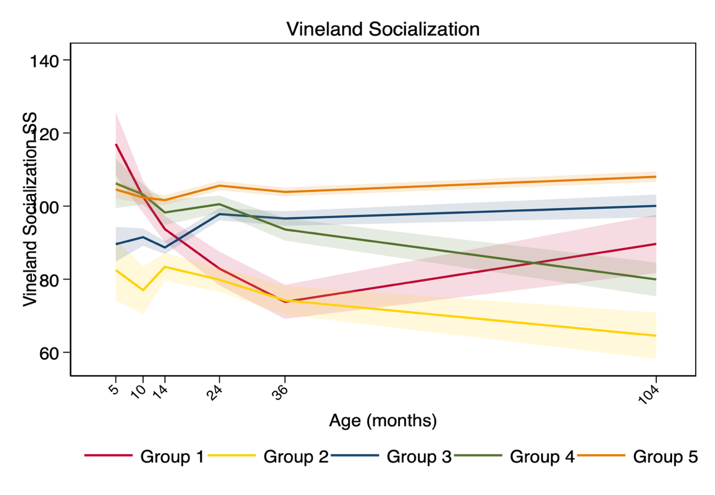

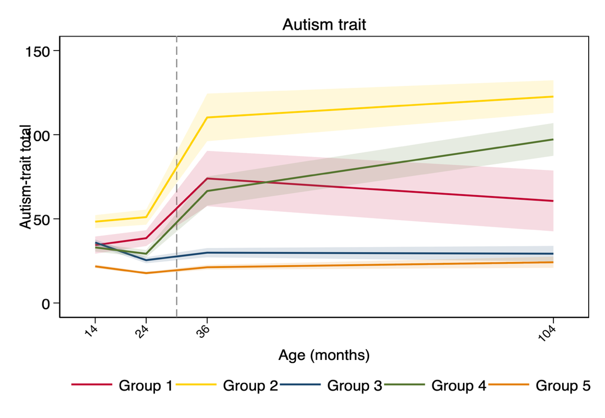
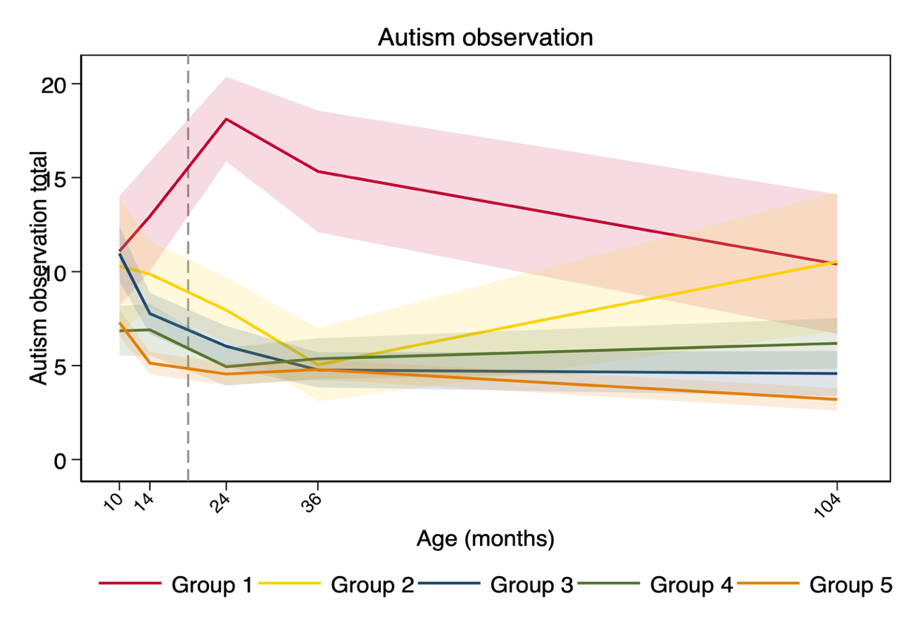

Note: Dashed lines indicate where instrument (raw) scores change. Shaded area = 95% confidence intervals

Table S9

Joint Trajectory Class by Family History Grouping

 | Family History Group
 | FH-Autism |  | FH-ADHD |  | FH  ASD+ADHD |  | No FH
 | N  (Row %)  [Column %] |  | N  (Row %)  [Column %] |  | N  (Row %)  [Column %] |  | N  (Row %)  (Column %]
Joint Trajectory Class

Infant Low to High Autism Traits [with Amelioration) | 14  (78%)  [7%] |  | 0  (0%)  [0%] |  | 4  (22%)  [6%] |  | 0  (0%)  [0%]
High Early Persistent Autism Traits | 17  (74%)  [9%] |  | 1  (4%)  [4%] |  | 5  (22%)  [8%] |  | 0  (0%)  [0%]
Typical (Slow Starters) | 50  (57%)  [25%] |  | 7  (8%)  [30%] |  | 10  (11%)  [15%] |  | 20  (23%)  [21%]
Later Emerging Autism Traits | 26  (49%)  [13%] |  | 6  (11%)  [26%] |  | 17  (32%)  [26%] |  | 4  (8%)  [4%]
Typical Class | 92  (45%)  [46%] |  | 9  (4%)  [39%] |  | 29  (14%)  [45%] |  | 73  (36%)  [75%]

FH-Autism = Autism Family History, FH-Autism + ADHD = Autism + ADHD Family History, FH-ADHD = ADHD Family History, No FH = No Family History of Autism or ADHD

Table S10

Multivariate predictors of Trajectory Class Membership

Predictor Class 2 Class 3 Class 4
RRR (95% CI) RRR (95% CI) RRR (95% CI)

Sex / Gender 3.13 (1.19, 8.19)* 2.16 (1.28, 3.65)** 1.55 (0.81, 2.96)
Child Ethnicity 3.65 (0.77 – 17.36) 0.72 (0.38 – 1.38) 0.87 (0.40 – 1.93)
Maternal Education 0.66 (0.39 – 1.12) 0.71 (0.52 – 0.96)* 0.79 (0.54 – 1.15)
Household Income 0.50 (0.31 – 0.80)** 0.95 (0.76 – 1.20) 0.72 (0.53 – 0.96)*
FH-Autism 10.89 (1.39 – 85.50)* 1.34 (0.76 – 2.35) 2.24 (1.02 – 4.92)*
FH-ADHD 1.17 (0.40 – 3.42) 0.99 (0.51 – 1.90) 3.07 (1.56 – 6.06)**

Note: Class 1 excluded due to perfect separation with FH-Autism
Note: Reference Class: Class 5
RRR = Relative Risk Ratio, CI = Confidence Intervals
* p < .05, ** p < .01

Appendix S2
Parent-Reported Regression from 3-year ADI-R
Regression was examined using standard ADI-R items (questions 11–28) for participants completing ADI-Rs at the 3-year assessment (N = 314). This analysis was exploratory and focused on Classes 1, 2 and 4, which showed increasing autistic traits during infancy, particularly Class 1 which started with low traits in early infancy. Regression was reported for 18 children (10–20% of Classes 1, 2 and 4), most commonly language loss (ADI-R item 11) but also loss of other skills including self-help and play; most children (12/18) with reported regression were diagnosed with autism. Regression rates did not differ significantly between Classes 1, 2, and 4. Only two children in Classes 3 and 5 showed loss of skills. Regression was reported in 4 children (22%) in Class 1, 6 children (26%) in Class 2, no children in Class 3, 6 children (11%) in Class 4 and 2 children (1%) in Class 5. Across all 5 classes regression was associated with class (χ² (4, N = 384) = 51.69, p < .001) being more common than expected in Class 1 (z = 3.61, p < .001), Class 2 (z = 5.01, p < .001) and Class 4 (z = 2.46, p < .05) and less common than expected in Class 3 (z = -2.35, p < .05) and Class 5 (z = -3.64, p < .001).

Appendix S3
Statistical Analysis of Mid-Childhood Outcomes for Trajectory Classes
Mean (SD) scores and Tukey-Kramer post-hocs (p < .05) are shown in the main paper (Table 5). Mid-childhood outcomes differed significantly across the five trajectory classes on all measures: WASI FSIQ (F(4, 220) = 6.31, p < .001); Vineland ABC (F(4, 217) = 63.67, p < .001); ADI-R Social domain (current) (F(4, 159) = 50.36, p < .001); ADI-R Communication domain (current) (F(4, 157) = 63.72, p < .001); ADI-R RRB domain (current) (F(4, 157) = 50.85, p < .001); ADOS-2 Total CSS (F(4, 218) = 15.73, p < .001); SRS-2 Total T-score (F(4, 237) = 130.84, p < .001); ADHD Inattention (F(4, 240) = 29.17, p < .001); ADHD Hyperactivity/Impulsivity (F(4, 240) = 33.17, p < .001); SDQ Total Difficulties Score (F(4, 168) = 46.56, p < .001); SDQ Impact Score (F(4, 168) = 41.07, p < .001).

References

Conners. (2009). Conners Early Childhood Manual. Multi-Health Systems Inc.
Conners, C. (2008). Conners 3rd Edition manual. Toronto, Ontario, Canada: Multi-Health Systems.
Conners, C., Erdhardt, D., & Sparrow, E. (1999). Conners Adults ADHD Ratings Scales (CAARS). Multi-Health Systems Inc.
Russell, G., Rodgers, L. R., Ukoumunne, O. C., & Ford, T. (2014). Prevalence of parent-reported ASD and ADHD in the UK: Findings from the Millennium Cohort Study. Journal of Autism and Developmental Disorders, 44(1), 31–40. https://doi.org/10.1007/s10803-013-1849-0
Simonoff, E., Pickles, A., Charman, T., Chandler, S., Loucas, T., & Baird, G. (2008). Psychiatric disorders in children with autism spectrum disorders: Prevalence, comorbidity, and associated factors in a population-derived sample. Journal of the American Academy of Child and Adolescent Psychiatry, 47(8), 921–929. https://doi.org/10.1097/CHI.0b013e318179964f

