Parenting in Overdrive: A Meta-Analysis of Helicopter Parenting Across Multiple Indices of Emerging Adult Functioning

Shelly S. McCoy¹, Laura M. Dimler, and Luiza Rodrigues¹
Supplemental Information: Online Resource

Author Note

Shelly McCoy¹ https://orcid.org/0000-0002-7157-2298
Laura Dimler² https://orcid.org/0000-0001-7789-8398
¹La Sierra University, Psychology Department, Riverside, California
²Point Loma Nazarene University, Psychology Department, San Diego, California

Statements and Declarations

We have no conflicts of interest to disclose.

We would like to thank Dr. Travis Miller for his quantitative support.

Correspondence concerning this article should be addressed to Shelly McCoy, Email: smccoy@lasierra.edu

Figure 1

Funnel plot of studies investigating the relationship between helicopter parenting and emerging adult internalizing behaviors

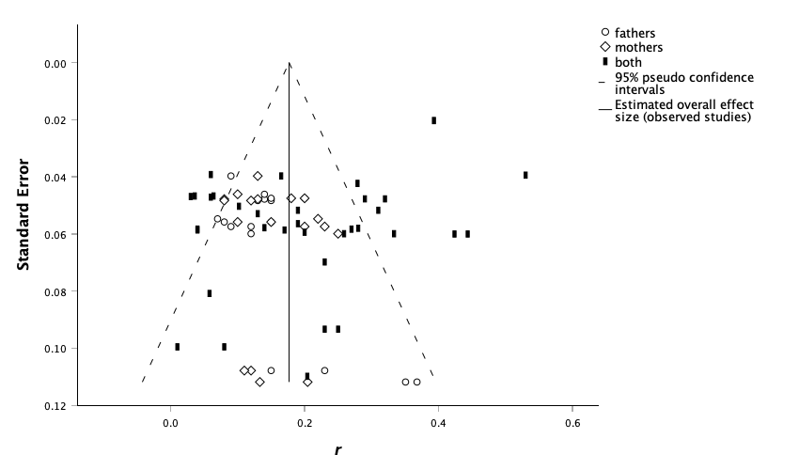
Note: both = the study did not separate mothers’ data from fathers’ data.

Figure 2

Funnel plot of studies investigating the relationship between helicopter parenting and emerging adult academic adjustment

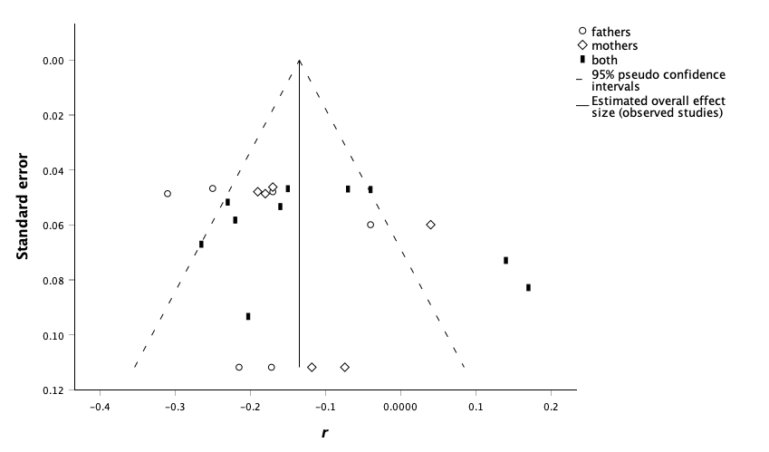

Note: both = the study did not separate mothers’ data from fathers’ data.

Figure 3

Funnel plot of studies investigating the relationship between helicopter parenting and emerging adult self-efficacy

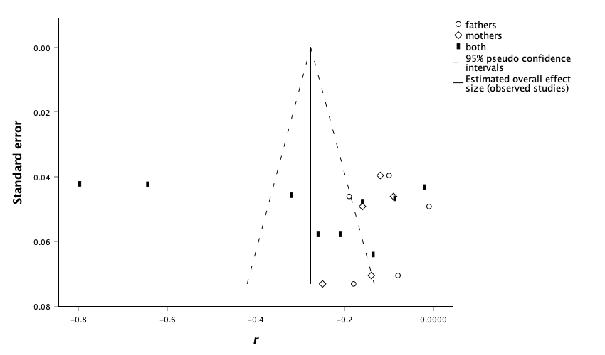

Note: both = the study did not separate mothers’ data from fathers’ data.

Figure 4

Funnel plot of studies investigating the relationship between helicopter parenting and emerging adult regulatory abilities

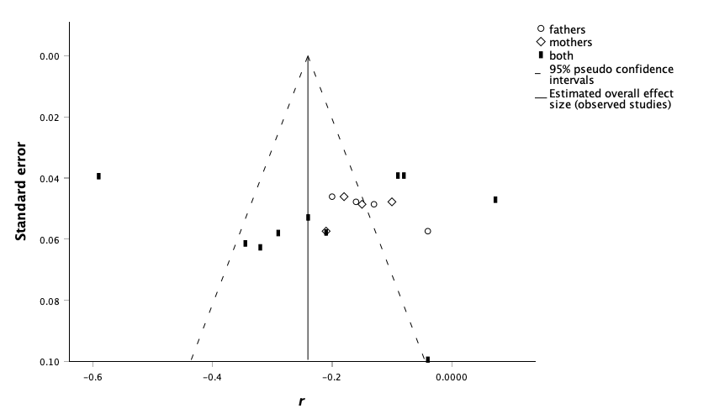

Note: both = the study did not separate mothers’ data from fathers’ data.

