Supplementary info

Supplementary Table 1. Characteristics of ~ 2mm ø twines used for experimentation.
Material | Form | Decitex (g·10 km) | Supplier
Cotton | Braided | n.m. | Homebase, UK
Jute | Twisted | n.m. | Homebase, UK
Kuralon (PVA) | Braided or twisted | 1330 | Tecnored, ES
PA | Braided or twisted | 470 | Tecnored, ES
PES₁ | Braided or twisted | 1100 | Sioen Industries NV, BE
PES₂ | Braided or twisted | 1670 | Tecnored, ES
PP | Braided or twisted | 1670 | Tecnored, ES
Sisal | Twisted | n.m. | Homebase, UK
PA – polyamide, PES₁/PES₂ – polyester from two suppliers, PP – polypropylene, PVA – polyvinylalcohol, n.m. – not measured.

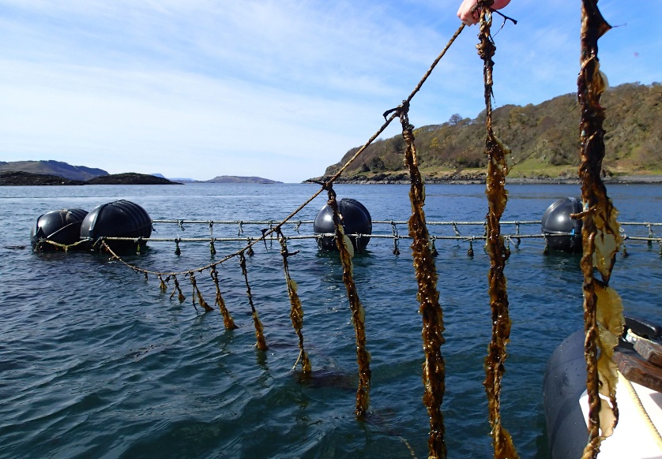
Supplementary Figure 1 - Ladder system to deploy 1 m ropes sections at Kerrera experimental seaweed farm, Scotland (56.3820º N, 5.5370º E). Each rope was spaced 1 m apart and carried twine grown in experiment 1 and 2. The ropes were grown horizontally at 1.5 m depth, not vertically as indicated by picture.

 | 4 wk |  | 6 wk
 | Braided | Twisted | Braided | Twisted
PA | 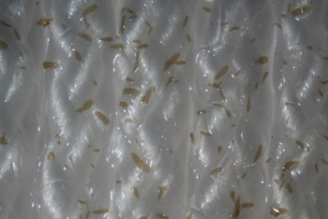 | 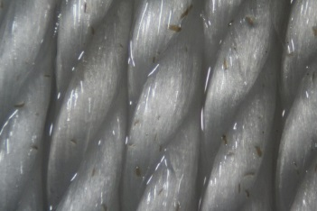 | 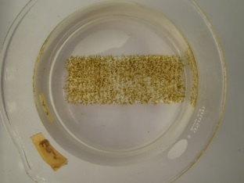 | 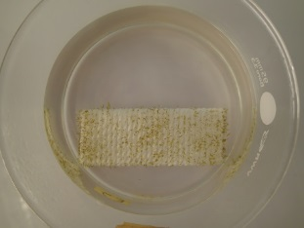
PES₁ | 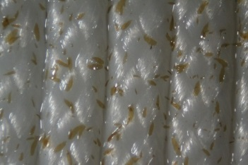 | 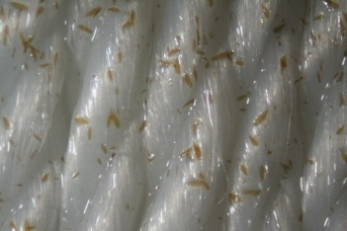 | 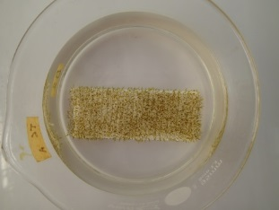 | 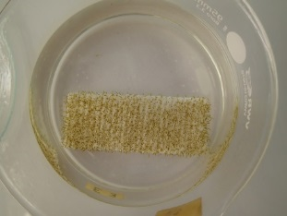
PES₂ | 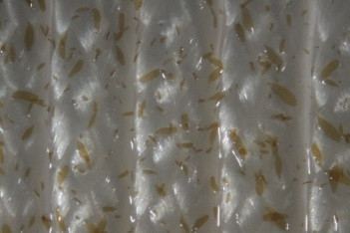 | 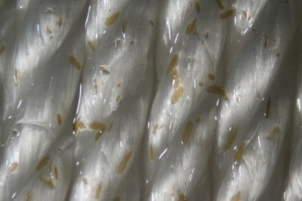 | 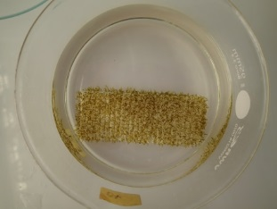 | 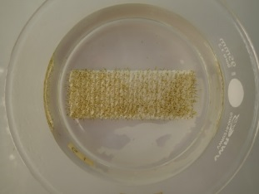
PP | 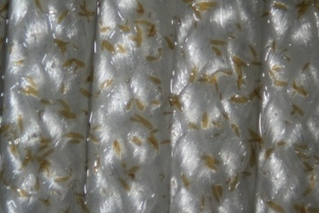 | 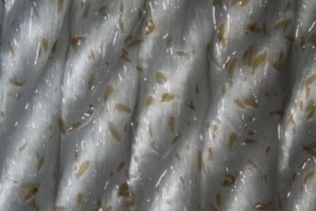 | 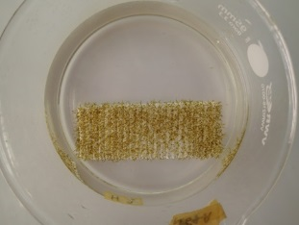 | 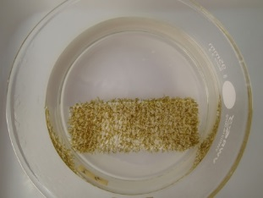
PVA | 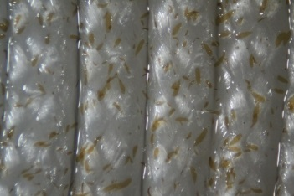 | 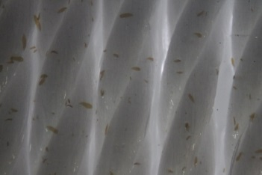 | 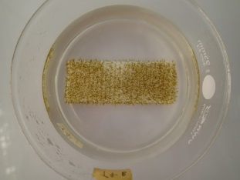 | 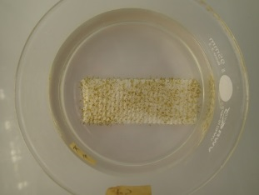
Cotton | 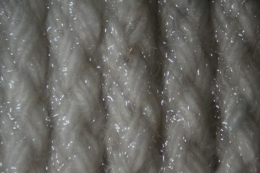
Jute |  | 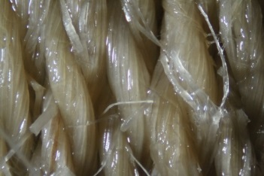
Sisal | 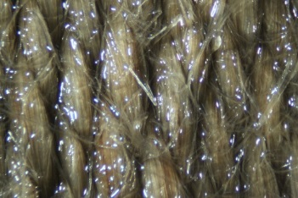
Supplementary Figure 2. Saccharina latissima sporophyte development on different ~ 2 mm ø twine, 4 and 5 wk after seeding with meiospores in E1. Shown is the median result of five replicates. PA – polyamide, PES_{1/2} – polyester from two suppliers, PP – polypropylene, PVA – polyvinylalcohol.

 | 4 wk |  | 6 wk
 | Untreated | Corona | Braided | Twisted
PA | 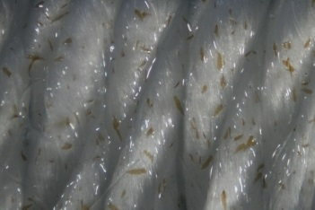 | 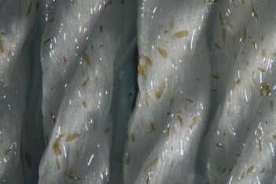 | 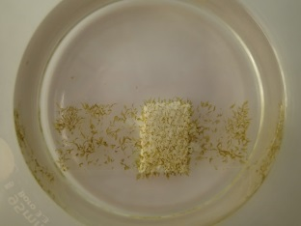 | 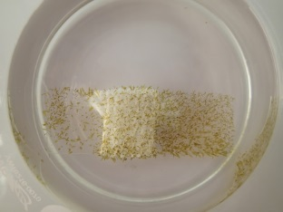
PES₁ | 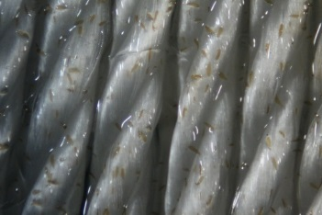 | 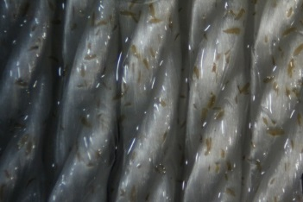 | 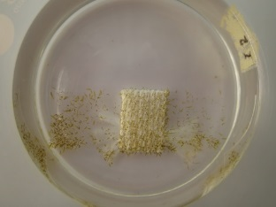 | 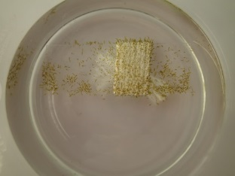
PP | 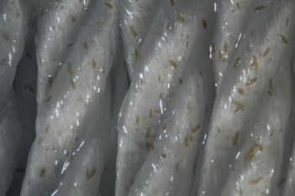 | 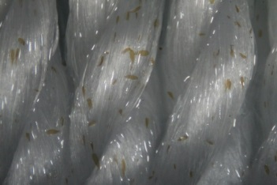 | 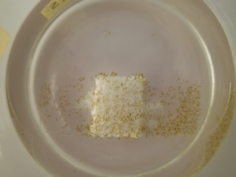 | 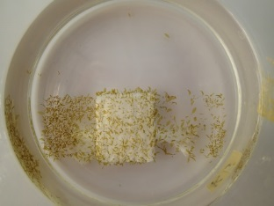
PVA | 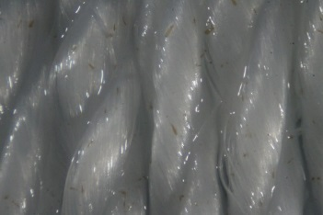 | 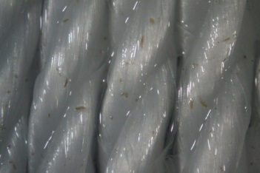 | 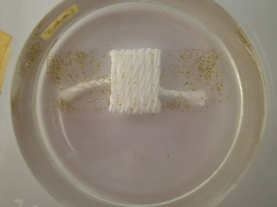 | 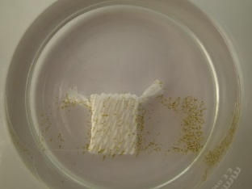
Supplementary Figure 3. Saccharina latissima sporophyte development on different ~ 2 mm ø twine, 4 and 6 wk after seeding with meiospores in E1. Shown is the median result of five replicates. PA – polyamide, PES_{1/2} – polyester from two suppliers, PP – polypropylene, PVA – polyvinylalcohol.

Supplementary Table 2. Physiognomy of Saccharina latissima 3 mo following seeding as sporophytes onto different polymer twines, used for detachment trials. Shown is mean ± standard deviation.
Polymer | Frond length (mm) | Frond width (mm) | Stipe length (mm) | Hapterae length (mm) | Samples taken
PA Br | 154 ± 50 | 36 ± 7 | 5.9 ± 3.4 | 23 ± 4 | 3
PES Br | 118 ± 54 | 34 ± 8 | 4.0 ± 0.1 | 25 ± 1 | 2
PES Tw | 146 ± 52 | 39 ± 13 | 11.1 ± 7.6 | 17 ± 11 | 6
PP Br | 169 ± 52 | 48 ± 10 | 6.4 ± 1.9 | 19 ± 9 | 6
PP Tw | 233 ± 166 | 48 ± 17 | 8.8 ± 6.5 | 32 ± 12 | 6
PVA Br | 238 ± 57 | 61 ± 13 | 9.6 ± 3.4 | 29 ± 10 | 6
PVA Tw | 150 ± 113 | 44 ± 18 | 7.6 ± 3.4 | 23 ± 7 | 6
Cotton | 212 ± 20 | 59 ± 9 | 10.6 ± 4.3 | 23 ± 6 | 6
Jute | 111 ± 8 | 35 ± 4 | 5.4 ± 0.6 | 12 ± 4 | 6
Sisal | 95 ± 35 | 39 ± 6 | 5.5 ± 0.4 | 25 ± 6 | 2
PA – polyamide, PES – polyester, PP – polypropylene, PVA – polyvinylalcohol, Br – braided, Tw – twisted.

