Supplementary
Tab. S1 Collected Schizymenia spp. samples in Wellington harbour at Whairepo Lagoon and characterized genetically (using cytochrome oxidase subunit 1 as genetic marker, D’Archino and Zuccarello 2014) to determine the species (S. apoda or S. dubyi). Different locations at the Lagoon: P1 = pool 1, P2 = pool 2, B = boulder in front of the pools)
Schizymenia apoda | Schizymenia dubyi
P1J | P1B
P1K | P1F
P2C | P1I
P2I | P2B
P2K | P2D
B3 | P2F
B4 | P2H
 | P2J
7 | 8

Tab. S2 Measured abiotic factors with units and the respective stations with geographical position. CliFlo, 2020
Abiotic factor | Station name | Latitude  [dec.deg] | Longitude  [dec.deg] | Unit
Daily global radiation | Wellington,  Greta Point Cws | -41.302 | 174.805 | MJ m⁻²
Mean daily maximum UVI | Wellington,  Irl 2 | -41.236 | 174.918 | Watts m⁻²  x40
Daily total sunshine | Wellington,  Kelburn | -41.286 | 174.767 | h
Total rainfall | Wellington,  Greta Point Cws | -41.302 | 174.805 | mm
Mean total ozone | Wellington,  Kelburn | -41.286 | 174.767 | Dobson  units (DU)

Tab. S3 Collection dates of Bostrychia arbuscula, Champia novae-zelandiae and Schizymenia spp. which were included in the analyses of the seasonally changing stress metabolites. The x indicates the months were colletions were not made
Bostrychia arbuscula | Champia novae-zelandiae | Schizymenia spp.
27/07/2018 | 27/07/2018 | x
27/08/2018 | 27/08/2018 | 10/08/2018
28/09/2018 | 28/09/2018 | 14/09/2018
x | x | 20/10/2018
14/11/2018 | 14/11/2018 | x
20/12/2018 | 20/12/2018 | 15/12/2018
23/01/2019 | 23/01/2019 | x
12/03/2019 | 12/03/2019 | 13/03/2019
10/04/2019 | 10/04/2019 | 09/04/2019
22/05/2019 | 22/05/2019 | 08/05/2019
17/06/2019 | 17/06/2019 | 03/06/2019
15/07/2019 | 15/07/2019 | 18/07/2019
05/08/2019 | 05/08/2019 | 29/08/2019

Tab. S4 Detailed statistical analysis of the monthly total mycosporine-like amino acid (MAA) concentration of Bostrychia arbuscula over the course of the season (July 2018 to August 2019). Results of Levene’s test (p > 0.05), ANOVA (significant: p < 0.05) and the post-hoc Turkey’s test (only significant differences, p < 0.05).
 |  | ANOVA
Dependent variable | Levene’s test | F | p | Significant differences  (post-hoc Turkey’s test)
Total MAA concentration | 0.075 | 4.178 | 0.002 | Jan 19 to Jul 18 (p = 0.006)  Jan 19 to Aug 18 (p = 0.002)  Jan 19 to Nov 18 (p = 0.004)  Jan 19 to May 19 (p = 0.009)  Jan 19 to Jul 19 (p = 0.003)  Jan 19 to Aug 19 (p = 0.009)

Tab. S5 Detailed statistical analysis of the monthly total mycosporine-like amino acid (MAA) concentration of Champia novae-zelandiae over the course of the season (July 2018 to August 2019). Results of Levene’s test (p > 0.05), ANOVA (significant: p < 0.05) and the post-hoc Turkey’s test (only significant differences, p < 0.05).
 |  | ANOVA
Dependent variable | Levene’s test | F | p | Significant differences  (post-hoc Turkey’s test)
Total MAA concentration | 0.160 | 5.250 | 0.001 | Jul 18 to Nov 18 (p = 0.007)  Jul 18 to Dec 18 (p = 0.046)  Jul 18 to Jan 19 (p = 0.026)  Sep 18 to Nov 18 (p = 0.004)  Sep 18 to Dec 18 (p = 0.028)  Sep 18 to Jan 19 (p = 0.016)  May 19 to Nov 18 (p = 0.003)  May 19 to Dec 18 (p = 0.028)  May 19 to Jan 19 (p = 0.010)

Tab. S6 Detailed statistical analysis of the monthly shinorine concentration of Schizymenia spp. over the course of the season (July 2018 to August 2019). Results of Levene’s test (p > 0.05), Welch-ANOVA (significant: p < 0.05) and the Games Howell post-hoc test (only significant differences, p < 0.05).
 |  | Welch-ANOVA
Dependent variable | Levene’s test | F | p | Significant differences  (Games Howell post-hoc test)
Shinorine concentration | 0.005 | 22.214 | 0.001 | Aug 18 to Dec 18 (p = 0.022)  Aug 18 to Jun 19 (p = 0.046)  Sep 18 to Dec 18 (p = 0.012)  Sep 18 to Oct 18 (p = 0.018)  Sep 18 to May 19 (p = 0.011)  Sep 18 to Jun 19 (p = 0.022)  Sep 18 to Aug 19 (p = 0.009)  Dec 18 to Mar 19 (p = 0.034)  Dec 18 to Apr 19 (p = 0.033)  Dec 18 to May 19 (p = 0.038)  Dec 18 to Aug 19 (p = 0.004)  Jun 19 to Mar 19 (p = 0.046)  Jun 19 to Apr 19 (p = 0.048)  Jun 19 to May 19 (p = 0.034)  Jun 19 to July 19 (p = 0.044)  Jun 19 to Aug 19 (p = 0.009)

Tab. S7 Detailed statistical analysis of the monthly digenaside and sorbitol concentrations of Bostrychia arbuscula over the course of the season (July 2018 to August 2019). Results of Levene’s test (p > 0.05), ANOVA (significant: p < 0.05) and the post-hoc Turkey’s test (only significant differences, p < 0.05).
 |  | ANOVA
Dependent variable | Levene’s test | F | p | Significant differences  (post-hoc Turkey’s test)
Digeneaside concentration | 0.155 | 4.032 | 0.002 | Dec 18 to Jul 18 (p = 0.016)  Dec 18 to Apr 19 (p = 0.034)  Dec 18 to May 19 (p = 0.010)  Dec 18 to Jun 19 (p = 0.028)  Dec 18 to Jul 19 (p = 0.024)
Sorbitol concentration | 0.153 | 25.366 | 0.001 | Jul 18 to Aug 18 (p = 0.031)  Jul 18 to Sep 18 (p = 0.001)  Jul 18 to Nov 18 (p = 0.001)  Jul 18 to Dec 18 (p = 0.001)  Jul 18 to Jan 19 (p = 0.001)  Jul 18 to Mar 19 (p = 0.001)  Jul 18 to Apr 19 (p = 0.001)  Aug 18 to Dec 18 (p = 0.001)  Aug 18 to Jan 19 (p = 0.001)  Sep 18 to Dec 18 (p = 0.008)  Sep 18 to May 19 (p = 0.001)  Sep 18 to Jun 19 (p = 0.001)  Sep 18 to Jul 19 (p = 0.001)  Sep 18 to Aug 19 (p = 0.001)  Nov 18 to Dec 18 (p = 0.001)  Nov 18 to May 19 (p = 0.011)  Nov 18 to Jun 19 (p = 0.004)  Nov 18 to Jul 19 (p = 0.004)  Nov 18 to Aug 19 (p = 0.005)  Dec 18 to Mar 19 (p = 0.001)  Dec 18 to Apr 19 (p = 0.001)  Dec 18 to May 19 (p = 0.001)  Dec 18 to Jun 19 (p = 0.001)  Dec 18 to Jul 19 (p = 0.001)  Dec 18 to Aug 19 (p = 0.001)  Jan 19 to May 19 (p = 0.001)  Jan 19 to Jun 19 (p = 0.001)  Jan 19 to Jul 19 (p = 0.001)  Jan 19 to Aug 19 (p = 0.001)  Mar 19 to May 19 (p = 0.007)  Mar 19 to Jun 19 (p = 0.003)  Mar 19 to Jul 19 (p = 0.003)  Mar 19 to Aug 19 (p = 0.004)  Apr 19 to May 19 (p = 0.013)  Apr 19 to Jun 19 (p = 0.005)  Apr 19 to Jul 19 (p = 0.005)  Apr 19 to Aug 19 (p = 0.006)

Tab. S8 Detailed statistical analysis of the monthly floridoside concentration of Champia novae-zelandiae over the course of the season (July 2018 to August 2019). Results of Levene’s test (p > 0.05), Welch-ANOVA (significant: p < 0.05) and the Games Howell post-hoc test (only significant differences, p < 0.05).
 |  | Welch ANOVA
Dependent variable | Levene’s test | F | p | Significant differences  (Games Howell post-hoc test)
Floridoside concentration | 0.001 | 15.159 | 0.001 | Jul 18 to Sep 18 (p = 0.007)  Jul 18 to Nov 18 (p = 0.012)  Sept 18 to Apr 19 (p = 0.048)  Sept 18 to Jun 19 (p = 0.030)  Sept 18 to Jul 19 (p = 0.044)  Nov 18 to Apr 19 (p = 0.024)  Nov 18 to Jun 19 (p = 0.015)  Nov 18 to Jul 19 (p = 0.030)

Tab. S9 Detailed statistical analysis of the monthly floridoside concentration of Schizymenia spp. over the course of the season (July 2018 to August 2019). Results of Levene’s test (p > 0.05), Welch-ANOVA (significant: p < 0.05) and the Games Howell post-hoc test (only significant differences, p < 0.05).
 |  | Welch ANOVA
Dependent variable | Levene’s test | F | p | Significant differences  (Games Howell post-hoc test)
Floridoside concentration | 0.028 | 49.105 | 0.001 | Aug 18 to Oct 18 (p = 0.035)  Aug 18 to Dec 18 (p = 0.001)  Aug 18 to Jul 19 (p = 0.021)  Aug 18 to Aug 19 (p = 0.031)  Sep 18 to Oct 18 (p = 0.001)  Sep 18 to Aug 19 (p = 0.002)  Oct 18 to Dec 18 (p = 0.003)  Oct 18 to Mar 19 (p = 0.001)  Oct 18 to Apr 19 (p = 0.001)  Oct 18 to May 19 (p = 0.026)  Oct 18 to June 19 (p = 0.44)  Oct 18 to Jul 19 (p = 0.001)  Dec 18 to May 19 (p = 0.006)  Dec 18 to Aug 19 (p = 0.015)  Mar 19 to Aug 19 (p = 0.001)  Apr 19 to Aug 19 (p = 0.001)  May 19 to Jul 19 (p = 0.041)  May 19 to Aug 19 (p = 0.001)  Jun 19 to Aug 19 (p = 0.001)  Jul 19 to Aug 19 (p = 0.007)

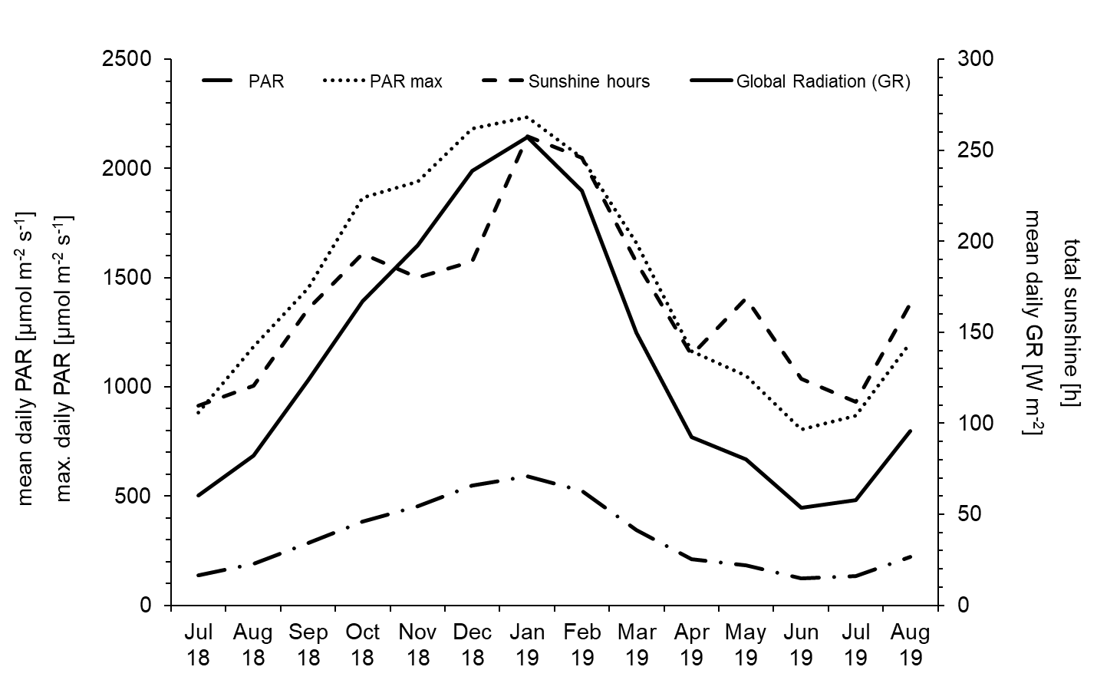
Fig. S1 Solar radiation data from July 2018 to August 2019 (x-axis) in Wellington, New Zealand. On the left y-axis the mean daily PAR [μE m⁻² s⁻¹] along with the maximum daily PAR [μE m⁻² s⁻¹] are shown. On the right y-axis the monthly total sunshine hours and the mean daily global radiation (GR in W m⁻²) are plotted. Data were downloaded from CliFlo (2020)
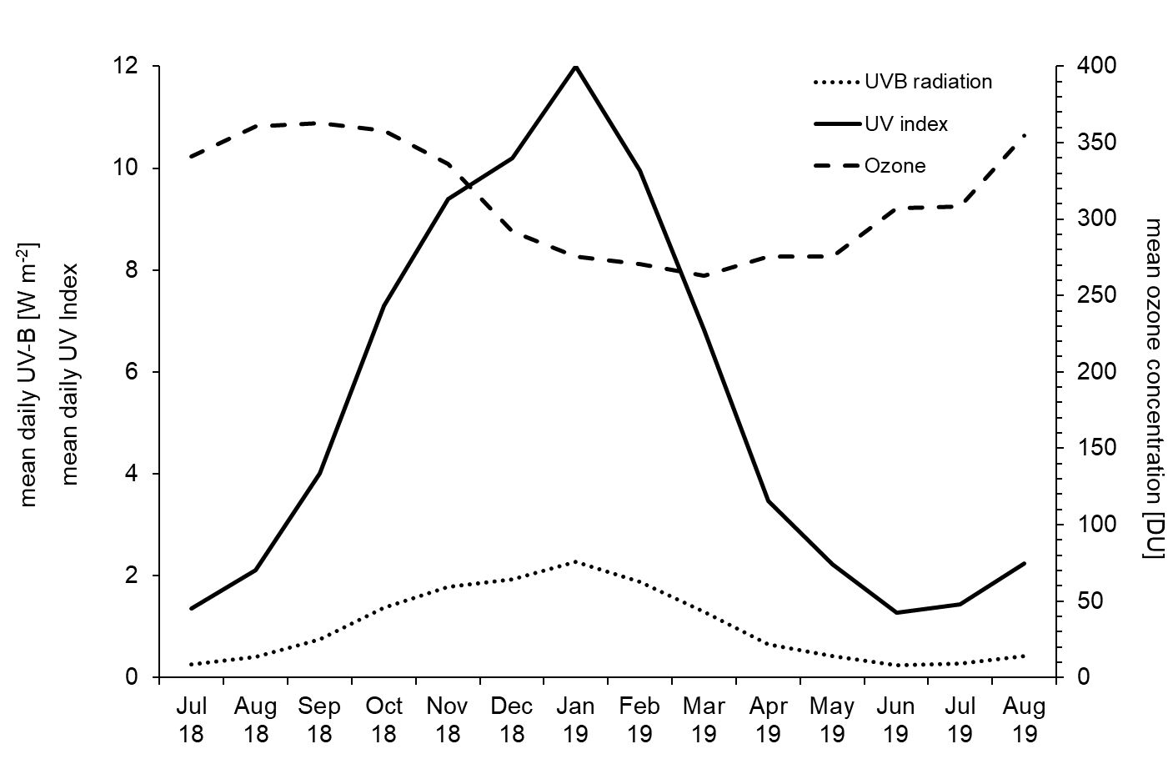
Fig. S2 Ultraviolet and ozone data from July 2018 to August 2019 (x-axis) in Wellington, New Zealand. On the left y-axis mean daily UVB radiation [W m⁻²] and mean daily UV Index are shown. On the right y-axis mean ozone concentration (DU) is plotted. Data were downloaded from CliFlo (2020)
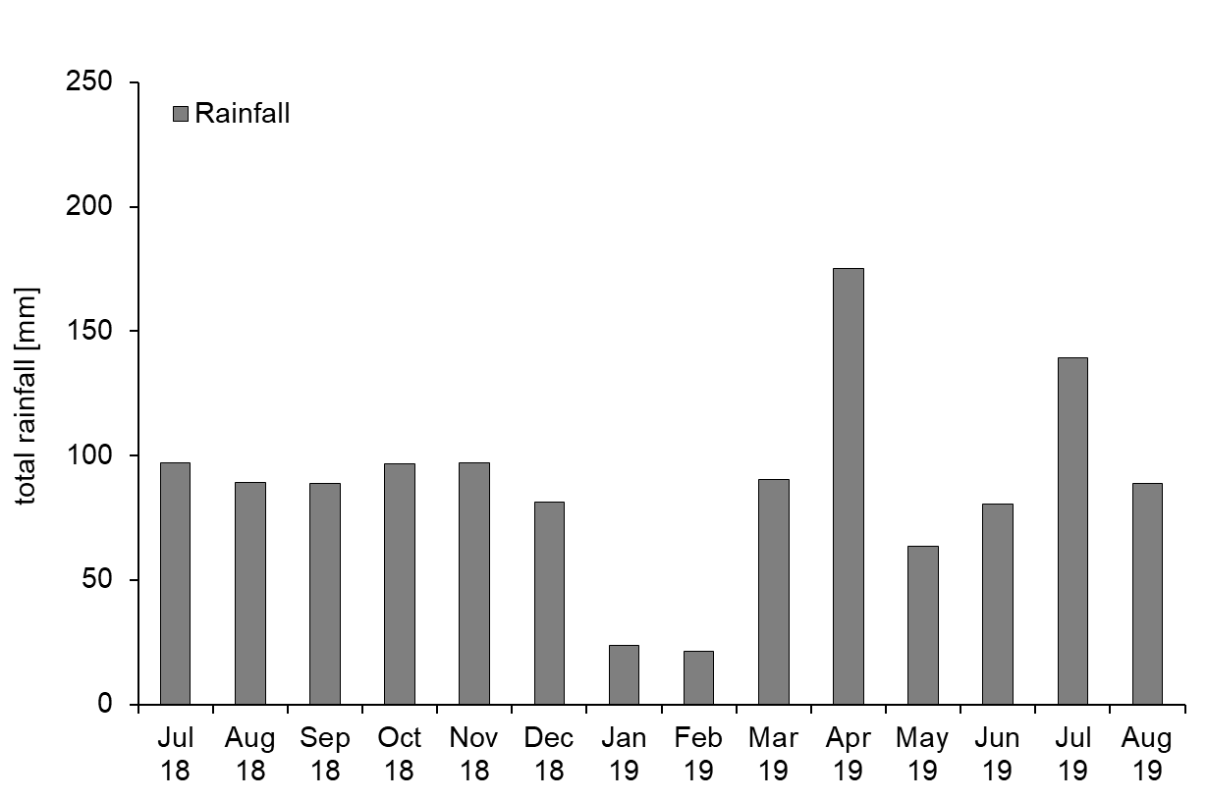
Fig. S3 Total Rainfall [mm] is plotted on the y-axis from July 2018 to August 2019 (x-axis) in Wellington, New Zealand. Data were downloaded from CliFlo (2020)

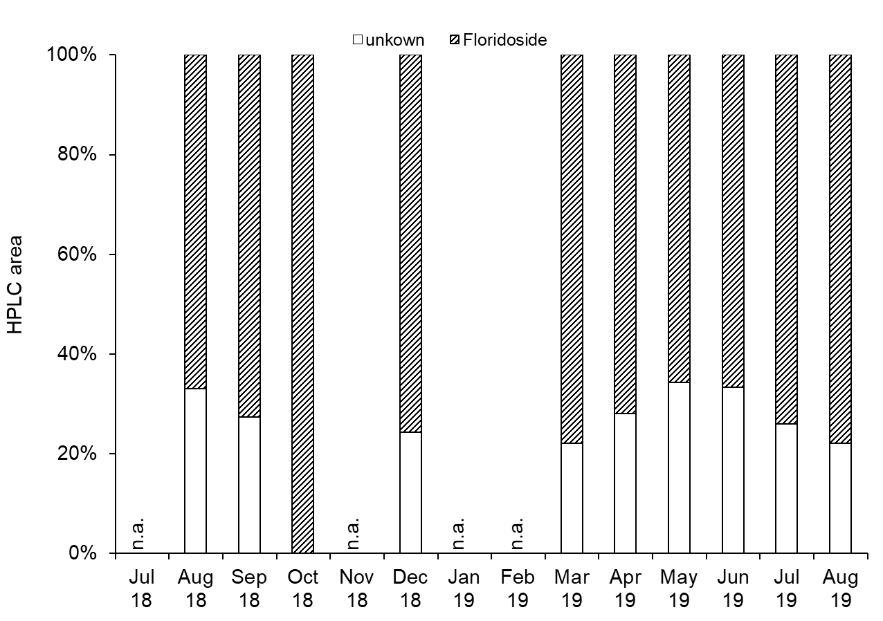
Fig. S4 Percentages of floridoside and the unknown compound of the total produced compounds of Schizymenia spp., collected monthly at Moa Point, Wellington, New Zealand. The x-axis shows the months of the collected samples from July 2018 to August 2019; n.a. = no samples collected. The y-axis shows the integrated area in %, measured with the High Performance Liquid Chromatograph (HPLC)

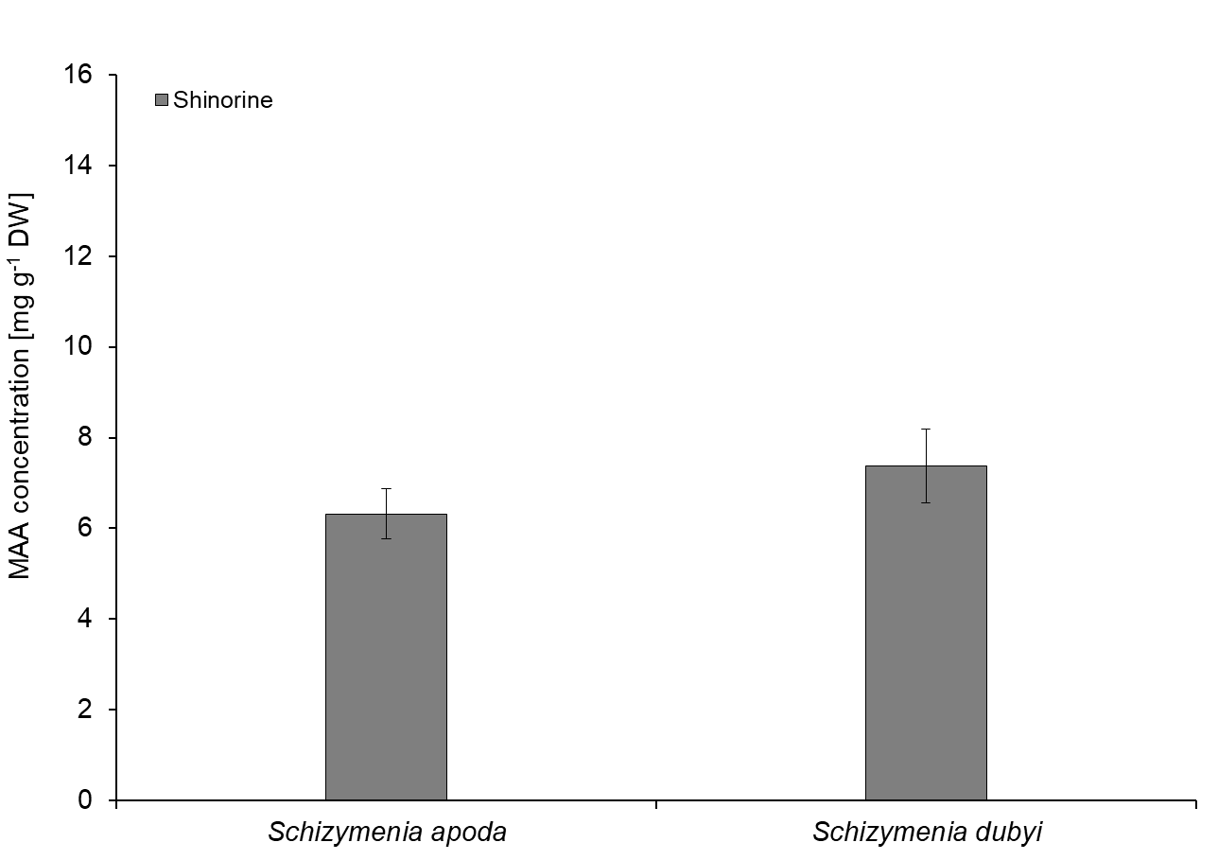
Fig. S5 Shinorine concentrations of Schizymenia apoda and Schizymenia dubyi, collected in the Whairepo Lagoon, Wellington harbour, New Zealand. Values are means (n = 3) ± SD. The y-axis show the shinorine concentrations in mg per g dry weight [mg g⁻¹ DW]

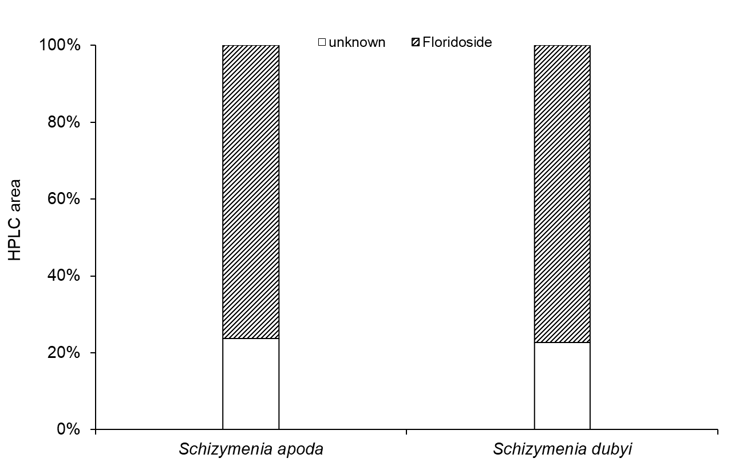
Fig. S6Percentages of floridoside and the unknown compound of the total HPLC area (integrated peaks) of Schizymenia apoda and Schizymenia dubyi, collected in the Whairepo Lagoon, Wellington harbour, New Zealand. The y-axis show the integrated area in %, measured with the High Performance Liquid Chromatograph (HPLC)

