Supplementary information
Synthetic algal-bacteria consortia for space-efficient microalgal growth in a simple hydrogel system
Noah Martin¹*, Tatum Bernat¹*, Julie Dinasquet¹, Andrea Stoftko¹, April Damon¹, Dimitri D. Deheyn¹, Farooq Azam¹, Jennifer E. Smith¹, Matthew P. Davey^{2,3} Alison G. Smith², Silvia Vignolini⁴, & Daniel Wangpraseurt^{1,4,5#}

¹Marine Biology Research Division, Scripps Institution of Oceanography, University of California San Diego, La Jolla, California 92093-0205, USA
²Department of Plant Sciences, University of Cambridge, Cambridge CB2 3EA, UK
³Scottish Association for Marine Science, Oban, PA37 1QA, UK
⁴Department of Chemistry, University of Cambridge, Cambridge CB2 1TN, UK
⁵Department of Nanoengineering, University of California San Diego, La Jolla, California 92093-0205, USA

*shared first author
#correspondance: dwangpraseurt@eng.ucsd.edu (D. Wangpraseurt)

Supplementary Table 1
Bacterial isolates tested from our culture collection. Closest relative assignment based on 16S rRNA gene sequencing. All bacteria were isolated off Scripps Pier.
Bacterial strain | Closest relative
SIO_BE5 | AlphaProteobacteria; Rhodobacterales; Rhodobacteraceae; Phaeobacter sp.
SIO_La7 | AlphaProteobacteria; Hyphomonodales; Hyphomonodaceae; Henriciella sp
SIO_La6 | AlphaProteobacteria; Sphingomonadales; Erythrobacteraceae; Erythrobacter sp.
SIO_La5 | AlphaProteobacteria; Rhodobacterales; Rhodobacteraceae; Phaeobacter sp.
SIO_La4 | AlphaProteobacteria; Rhodobacterales; Rhodobacteraceae; Phaeobacter sp.
SIO_La1 | AlphaProteobacteria; Sphingomonadales; Erythrobacteraceae; Erythrobacter sp.
B6P1 | Gammaproteobacteria; Alteromonadales; Alteromonadaceae; Alteromonas macleodii
AltSIO | Gammaproteobacteria; Alteromonadales; Alteromonadaceae; Alteromonas macleodii
P1RIIB2 | Bacteroidetes; Flavobacteriales; Flavobacteriaceae; Cellulophaga sp.
BBFL7 | Bacteroidetes; Flavobacteriales; Flavobacteriaceae; Flavobacterium sp.
DMS2 | Gammaproteobacteria; Oceanospirillales; Oceanospirillaceae; Marinomonas sp.
A1.2 | Bacteroidetes; Flavobacteriales; Flavobacteriaceae; Polaribacter sp.
MMK1 | Alphaproteobacteria; Rhizobiales; Methylobacteriaceae; Methylobacterium sp.
TW7 | Gammaproteobacteria; Alteromonadales; Pseudoalteromonadaceae; Pseudoalteromonas sp.

Supplementary Table 2
Statistical analyses performed on the effect of monoculture vs. co-culture on Marinichlorella kaistiae KAS603 hydrogels (unpaired t-tests, α=0.05, *= significant difference).
Parameter | t | df | Sig. (2-tailed) | Mean difference
cells day 1 | 1.101 | 6 | 0.313 | 405000
cells day 2 | 2.836 | 7 | 0.025* | -3689091
cells day 3 | 5.176 | 7 | 0.001* | -16659091
O₂ flux, dark | 22.151 | 3 | 0.0002* | 0.0371
O₂ flux, light | 6.117 | 3 | 0.008* | -0.054
F_{v}/F_{m} day 2 | 2.578 | 4 | 0.061 | -0.063
F_{v}/F_{m} day 3 | 3.216 | 4 | 0.032* | -0.142
F_{v}/F_{m} day 7 | 5.289 | 4 | 0.0006* | -0.068

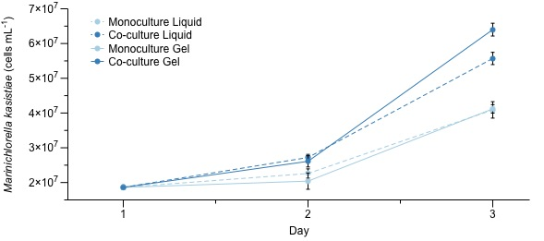
Supplementary Fig. 1 Comparison of cell growth of Marinichlorella kaistiae KAS603 in co-culture with Erythrobacter strain SIO_LA6 (dark blue) and in mono-culture (light blue) when cultivated in liquid medium vs hydrogel. Data are means ± SE (n = 2-3 hydrogels/liquid culture flasks)
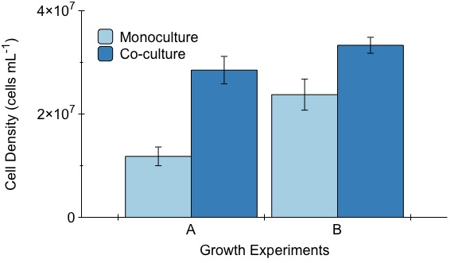

Supplementary Fig. 2 Effect of algal-bacterial hydrogel co-culture on microalgal cell density growth after 72 hours. Microalgal starting cell density was 5.42 x 10⁶ (± 4.2 x 10⁵) cells/mL for growth experiment A and 2.21 x 10⁷ (± 4.9 x 10⁵) cells/mL for growth experiment B. Data are means ± SE (n = 2 hydrogels for monoculture B, n = 5 for all other groups).

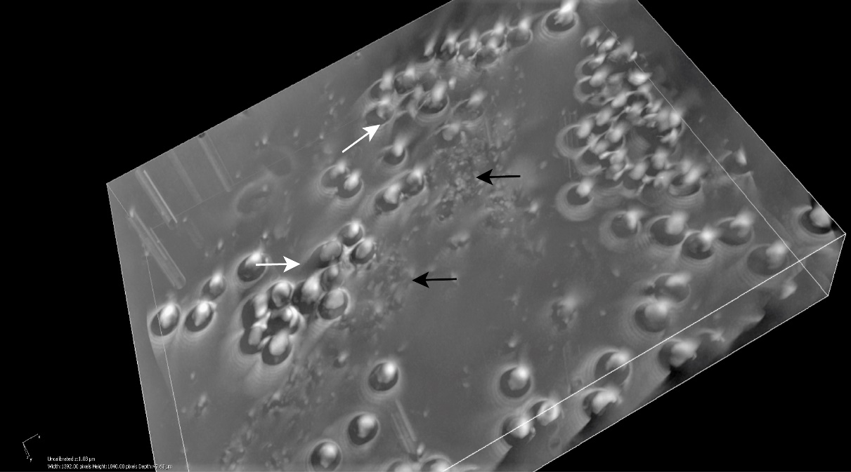

Supplementary Fig. 3 3D composite image of co-culture in hydrogel. White arrows show the M. kaistiae aggregates above the bacterial SIO_La6 aggregates (black arrows). (Brightfield magnification 200x)

