Bioactives from Microalgae:
A review on process intensification using hydrodynamic cavitation

Rochak Mittal and Vivek Ranade*
Multiphase Reactors and Intensification Group
Bernal Institute, University of Limerick, Ireland
*Email: Vivek.Ranade@ul.ie
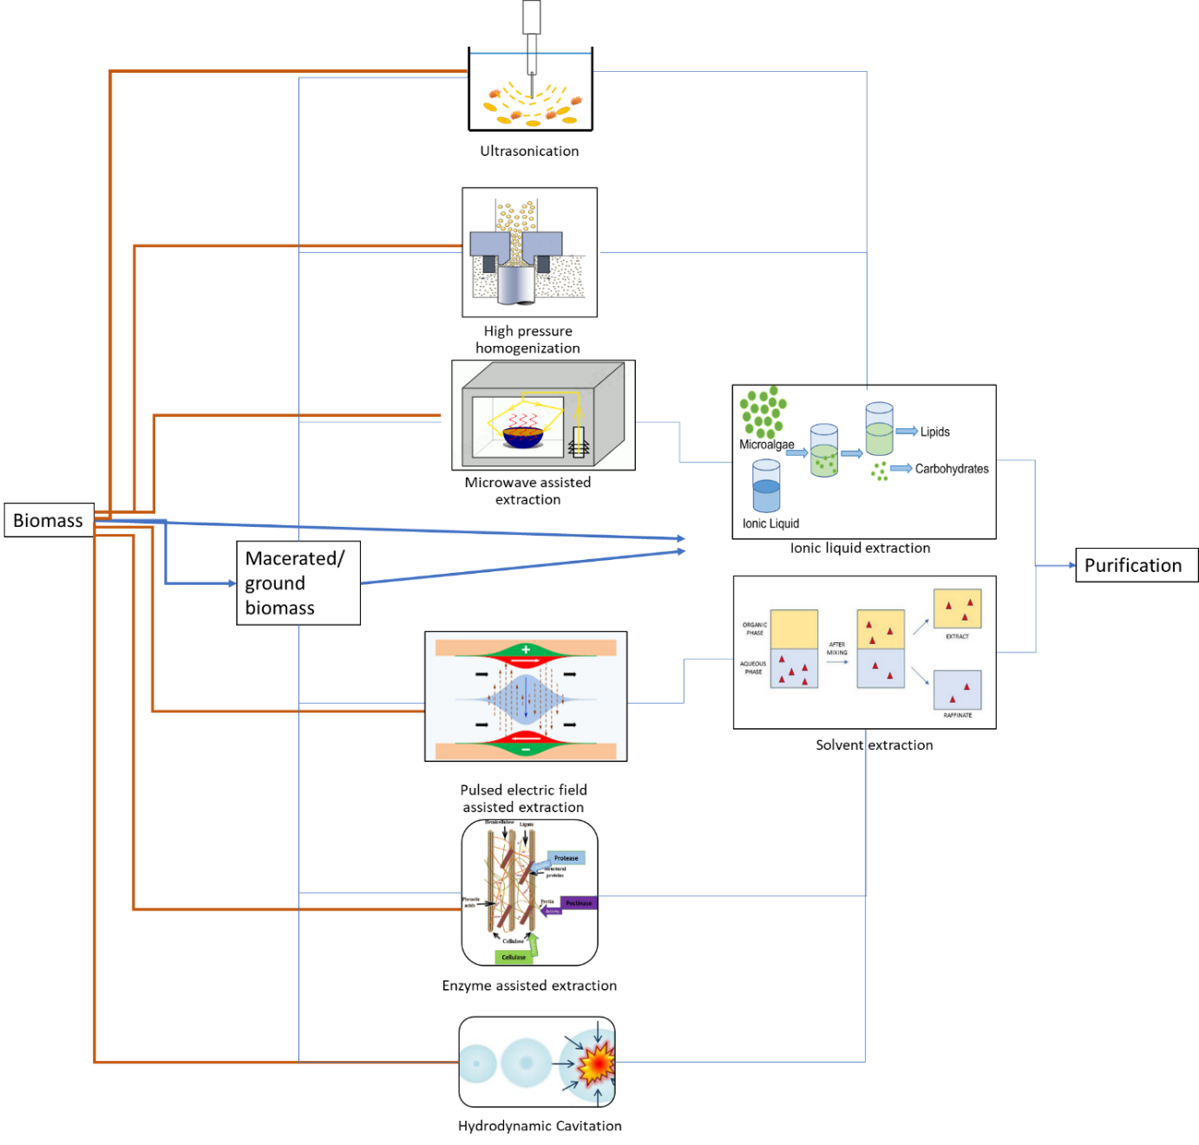
Fig. S1 Key steps and pre-treatment methods and extraction
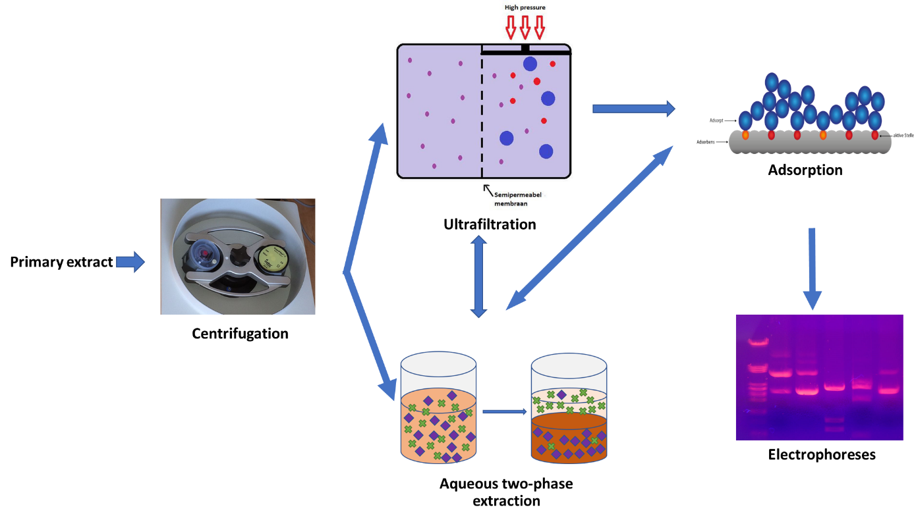
Fig. S2 Schematic representation of key steps and methods for purification

