Pilot-scale cultivation of the red alga Porphyridium purpureum over a two-year period in a greenhouse
Journal of Applied Phycology
- Floris Schoeters^{1*}, Jornt Spit¹, Erwin Swinnen¹, Audrey De Cuyper¹, Rut Vleugels¹, Isabelle Noyens¹, Sabine Van Miert¹
¹Radius, Thomas More University of Applied Sciences, Geel, Belgium.
* Correspondence:
Floris Schoeters
floris.schoeters@thomasmore.be

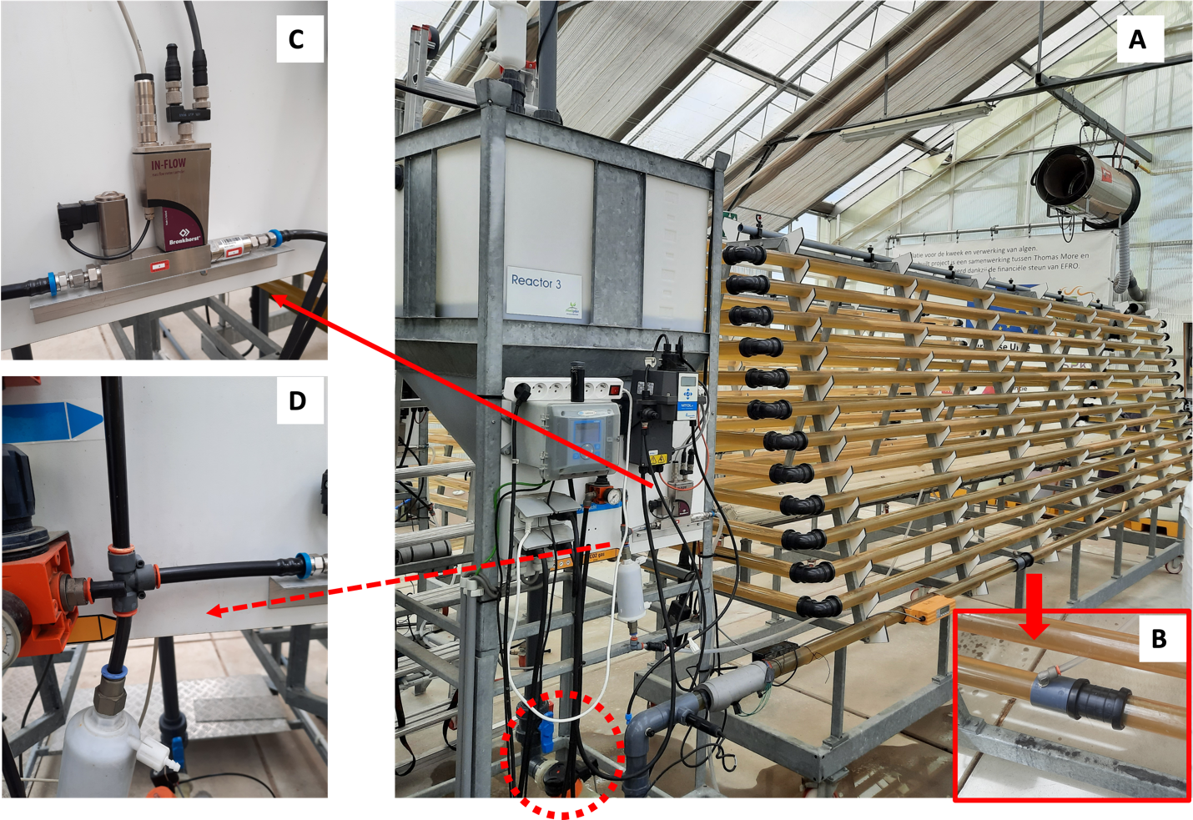
Supplemental Figure 1 A general overview of the reactor used with the degasser at the left (were ‘Reactor 3’ can be read) (A). Ambient air was injected continuously in the lowest tube for mixing (B). CO₂ was injected, in the airflow, on demand using an in-flow mass flow meter/controller (Bronkhorst, The Netherlands) (C). The CO₂ and ambient air were filtered (0.1 μm) before injected. Harvesting or sampling was performed by manually opening a valve at the bottom of the degasser (left bottom red dashed circle, part A).

