Supplementary Material

Supplementary Fig 1. Gating strategy used to sort top ~1% fluorescing cells of unsorted Phaeodactylum tricornutum cultures with FACS (rectangle – A) compared to alternative method (manually curved – B).

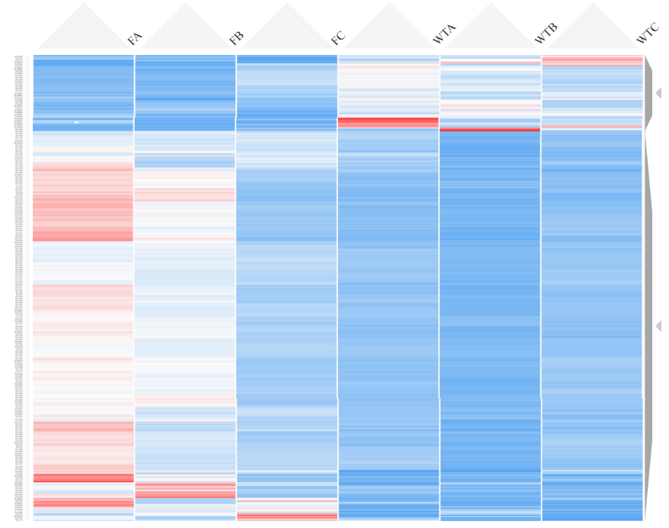
Supplementary Fig 2. Heatmap showing relative gene expression between WT and F cultures of P. tricornutum expressed as z-scores. Genes are grouped by GO aspect term with minimum gene pool of 4. Made using Clustergrammer https://maayanlab.cloud/clustergrammer/.

Supplementary Fig 3. Cell volume measured using the geometric mean of FSC-A (Forward Scatter Area) and SSC-A (Side Scatter-A) over the experimental period. Values are FACS replicates divided by WT mean with floating bars from minimum to maximum, n = 5.

Supplementary table 1. Enrichment analysis results depicting fold enrichment and FDR for GO aspect Biological Processes, sorted by fold enrichment.
GO aspect | Pathway | Fold Enrichment | FDR
BP | Protoporphyrinogen IX metabolic process | 19.64 | <0.001
BP | Protoporphyrinogen IX biosynthetic process | 19.64 | <0.001
BP | Porphyrin-containing compound biosynthetic process | 17.28 | <0.001
BP | Porphyrin-containing compound metabolic process | 14.90 | <0.001
BP | Pigment biosynthetic process | 14.73 | <0.001
BP | Tetrapyrrole biosynthetic process | 13.94 | <0.001
BP | Heme biosynthetic process | 13.86 | <0.001
BP | Pigment metabolic process | 13.09 | <0.001
BP | Photosynthesis, light harvesting | 12.16 | <0.001
BP | Tetrapyrrole metabolic process | 12.00 | <0.001
BP | Heme metabolic process | 11.22 | <0.001
BP | Protein-chromophore linkage | 11.10 | <0.001
BP | Photosynthesis, light reaction | 10.78 | <0.001
BP | Photosynthesis | 10.27 | <0.001
BP | Ribosome biogenesis | 6.71 | <0.001
BP | RRNA processing | 5.82 | 0.001
BP | RRNA metabolic process | 5.71 | 0.001
BP | Ribonucleoprotein complex biogenesis | 5.56 | <0.001
BP | Generation of precursor metabolites and energy | 4.04 | <0.001
BP | Cellular component biogenesis | 3.43 | <0.001
BP | NcRNA processing | 3.06 | 0.012
BP | Purine-containing compound metabolic process | 3.02 | 0.048
BP | Cellular component organization or biogenesis | 2.63 | 0.001
BP | NcRNA metabolic process | 2.58 | 0.018
BP | Nucleobase-containing small molecule metabolic process | 2.38 | 0.047
BP | Aromatic compound biosynthetic process | 2.13 | 0.003
BP | Heterocycle biosynthetic process | 2.07 | 0.005
BP | Organic cyclic compound biosynthetic process | 1.99 | 0.008
BP | Organonitrogen compound biosynthetic process | 1.87 | 0.018
BP | Heterocycle metabolic process | 1.82 | <0.001
BP | Cellular aromatic compound metabolic process | 1.80 | <0.001
BP | Organic cyclic compound metabolic process | 1.79 | <0.001
BP | Small molecule metabolic process | 1.79 | 0.032
BP | Organonitrogen compound metabolic process | 1.62 | 0.001
BP | Organic substance biosynthetic process | 1.60 | 0.014
BP | Cellular nitrogen compound metabolic process | 1.55 | 0.007
BP | Biosynthetic process | 1.55 | 0.024
BP | Cellular biosynthetic process | 1.54 | 0.038

Supplementary table 2. Enrichment analysis results depicting fold enrichment and FDR for GO aspect Cellular Component, sorted by fold enrichment.
GO aspect | Pathway | Fold Enrichment | FDR
CC | Light-harvesting complex | 12.46 | <0.001
CC | Photosystem | 10.25 | <0.001
CC | Photosystem II | 10.25 | <0.001
CC | Photosynthetic membrane | 9.43 | <0.001
CC | Thylakoid | 8.73 | <0.001
CC | Nucleolus | 6.67 | <0.001
CC | Plastid | 5.82 | <0.001
CC | Chloroplast | 5.50 | <0.001
CC | Nuclear lumen | 3.80 | 0.003
CC | Membrane protein complex | 3.16 | 0.003
CC | Membrane-enclosed lumen | 3.02 | 0.011
CC | Organelle lumen | 3.02 | 0.011
CC | Intracellular organelle lumen | 3.02 | 0.011
CC | Intracellular membrane-bounded organelle | 1.72 | 0.002
CC | Membrane-bounded organelle | 1.72 | 0.002
CC | Nucleus | 1.62 | 0.044
CC | Intracellular organelle | 1.58 | 0.005
CC | Organelle | 1.57 | 0.005
CC | Intracellular anatomical structure | 1.49 | 0.005

Supplementary table 3. Enrichment analysis results depicting fold enrichment and FDR for GO aspect Molecular Function, sorted by fold enrichment.
GO aspect | Pathway | Fold Enrichment | FDR
MF | Chlorophyll binding | 12.46 | <0.001
MF | Pentosyltransferase activity | 10.91 | 0.001
MF | Tetrapyrrole binding | 5.50 | <0.001
MF | Magnesium ion binding | 4.79 | 0.034
MF | Helicase activity | 4.04 | 0.017
MF | ATP-dependent activity | 2.57 | 0.013
MF | Purine ribonucleoside triphosphate binding | 2.12 | <0.001
MF | Purine ribonucleotide binding | 2.11 | <0.001
MF | Purine nucleotide binding | 2.07 | <0.001
MF | Carbohydrate derivative binding | 2.06 | <0.001
MF | ATP binding | 2.05 | <0.001
MF | Ribonucleotide binding | 2.04 | <0.001
MF | Adenyl ribonucleotide binding | 2.03 | <0.001
MF | Adenyl nucleotide binding | 1.99 | <0.001
MF | Anion binding | 1.92 | <0.001
MF | Nucleotide binding | 1.89 | <0.001
MF | Nucleoside phosphate binding | 1.89 | <0.001
MF | Small molecule binding | 1.81 | <0.001
MF | Hydrolase activity | 1.80 | 0.001
MF | Ion binding | 1.40 | 0.030

