Chemical food safety of seaweed: Species, spatial and thallus dependent variation of potentially toxic elements (PTEs) and techniques for their removal

Madeleine Jönsson^{1,*} and Eva Nordberg Karlsson^{1,*}
1 Biotechnology, Department of Chemistry, Lund University, Lund, Sweden
* Correspondence: madeleine.jonsson@biotek.lu.se and eva.nordberg_karlsson@biotek.lu.se

Supplementary Data

Table S1. Calculated amounts (g DW) considered safe to consume daily for adults (70 kg), based on maximum tolerable weekly intake (TWI) levels established by the European Food Safety Authority (EFSA): cadmium (2.5 µg kg⁻¹ body weight (b.w.) (EFSA, 2011)), mercury (4 µg kg⁻¹ b.w. for inorganic mercury (EFSA, 2012b)), and tolerable daily intake (TDI) levels for iodine (600 µg day⁻¹ for adults, which would correspond a TWI of 60 µg kg⁻¹ b.w. for an average adult of 70 kg (EFSA, 2006; 2012a)). TWI levels for arsenic (25 µg kg⁻¹ b.w. (EFSA, 2009)) and lead (25 µg kg⁻¹ b.w. (EFSA, 2010)) are considered no longer appropriate.
 | Cd | Hg | Pb | I | iAs
Samples of four species harvested in Ireland
S. latissima ¹ | 30 | 2 120 | 3 330 | 0.2 | 26
A. esculenta | 24 | 3 760 | 3 580 | 2.0 | 60
P. palmata | 142 | 3 220 | 216 | 4.1 | 594
U. lactuca | 187 | 5 030 | 364 | 13.7 | 1 220
Samples of S. latissima from three harvest sites
Sweden ² | 45 | 2 130 | 930 | 0.2 | 1 170
Norway | 22 | 2 770 | 3 140 | 0.2 | 1 310
Ireland ¹ | 30 | 2 120 | 3 330 | 0.2 | 26
Samples of different thallus parts from Swedish S. latissima
Whole thallus ² | 45 | 2 130 | 930 | 0.2 | 1 170
Blade top | 176 | 1 870 | 524 | 0.3 | 526
Blade base | 32 | 2 180 | 4 250 | 0.3 | 3 700
Stipe/holdfast | 37 | 1 330 | 1 330 | 0.2 | 1 950
Samples of processed Swedish S. latissima
Untreated ² | 45 | 2 130 | 930 | 0.2 | 1 170
HPP | 22 | 1 150 | 1 830 | 0.9 | 3 130
Soaking H₂O | 29 | 1 510 | 280 | 0.2 | 8 380
Soaking Acid | 23 | 1 110 | 660 | 0.1 | 9 510
UAE | 33 | 1 360 | 863 | 0.2 | 12 000
HAE | 46 | 1 650 | 910 | 0.8 | 15 500
Blanching | 27 | 1 410 | 983 | 0.3 | 8 260
¹ Same samples. ² Same samples. HPP: High-pressure processing. UAE: Ultrasound-assisted extraction. HAE: Heat-assisted extraction.

Table S2. Limit of detection (LOD) and/or limit of quantification (LOQ) for elements. Values are given as mg kg⁻¹ DW.
LOD for elements
Ag | Co | Cr | Cu | Fe | Mn | Mo | Na | Ni | Zn
0.0002 | 0.0007 | 0.0048 | 0.0108 | 0.0721 | 0.0049 | 0.0015 | 1.8025 | 0.0038 | 0.0546
LOD for PTEs |  |  |  |  |  | LOQ for arsenic species
I | tAs | Cd | Hg | Pb |  | iAs | MMA | DMA
0.0136 | 0.0033 | 0.0004 | 0.0009 | 0.0004 |  | 0.007 | 0.007 | 40

Table S3. Correlation matrix from the comparison of compounds in different species (S. latissima, A. esculenta, P. palmata and U. lactuca) from Ireland. The Pearson correlation was based on the mean values (n=4) for each of the compounds.
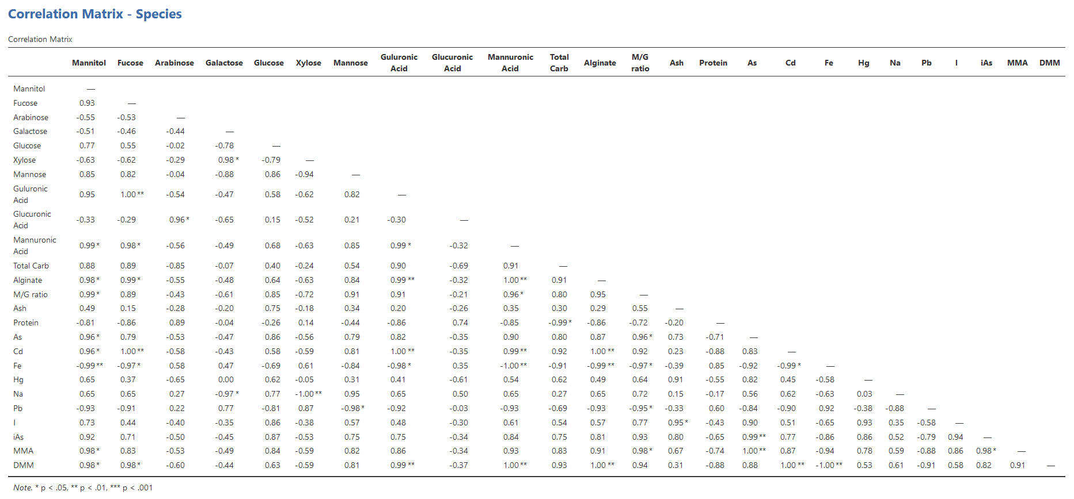

Table S4. Correlation matrix from the comparison of different compounds in S. latissima harvested in three different locations, Sweden, Norway, and Ireland. The Pearson correlation was based on the mean values (n=3) for each of the compounds.
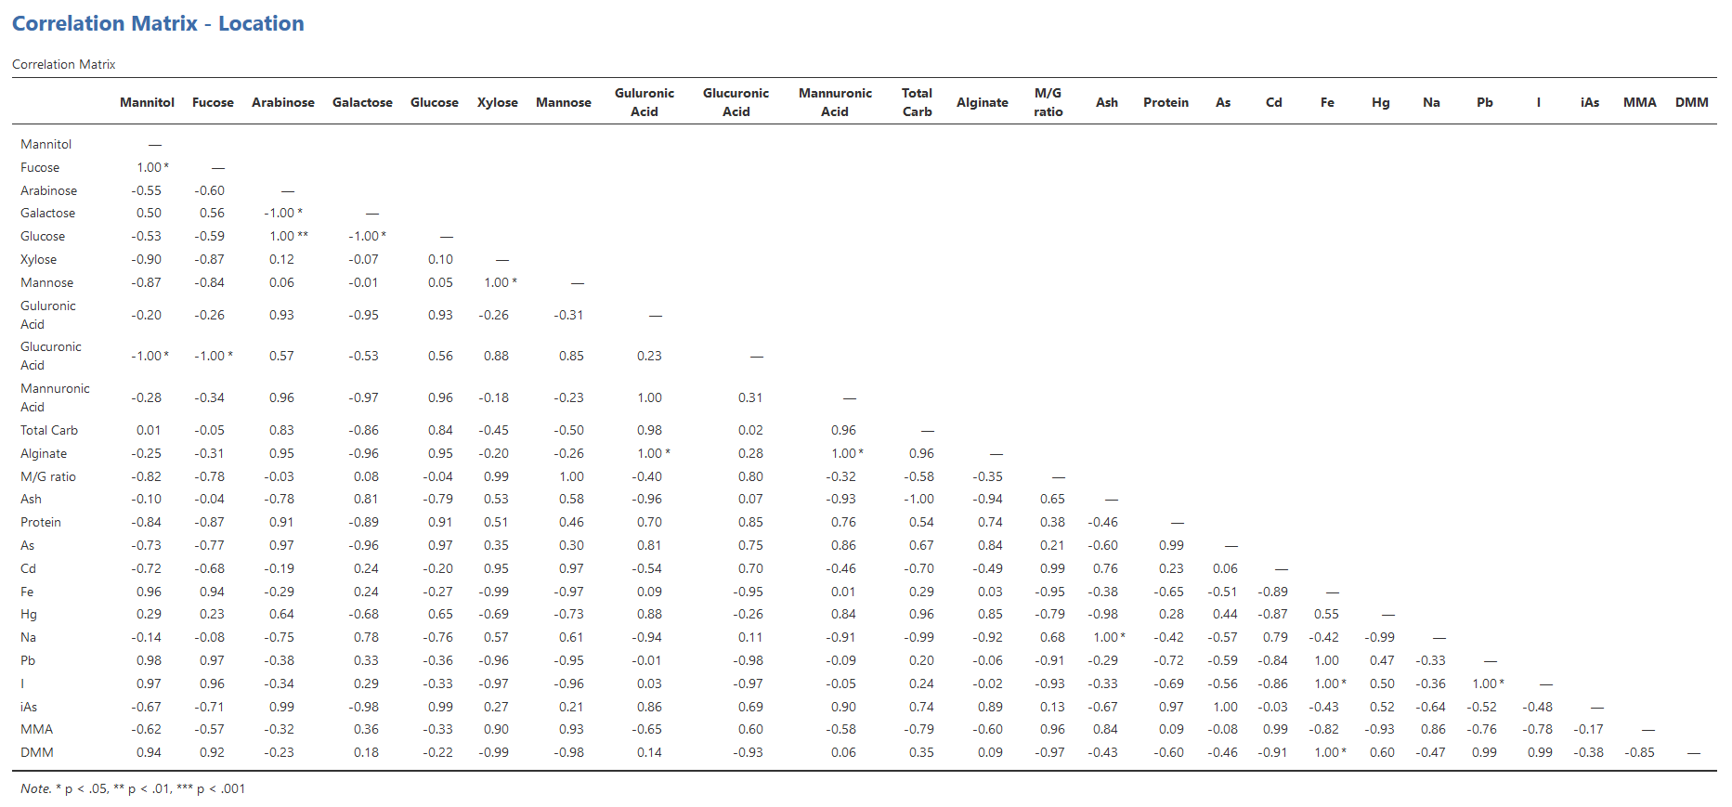

Table S5. Correlation matrix from the comparison of different compounds in three various parts (blade top, blade base, and stipe/holdfast) and whole thallus of the brown seaweed S. latissima harvested in Sweden. The Pearson correlation was based on the mean values (n=4) for each of the compounds.
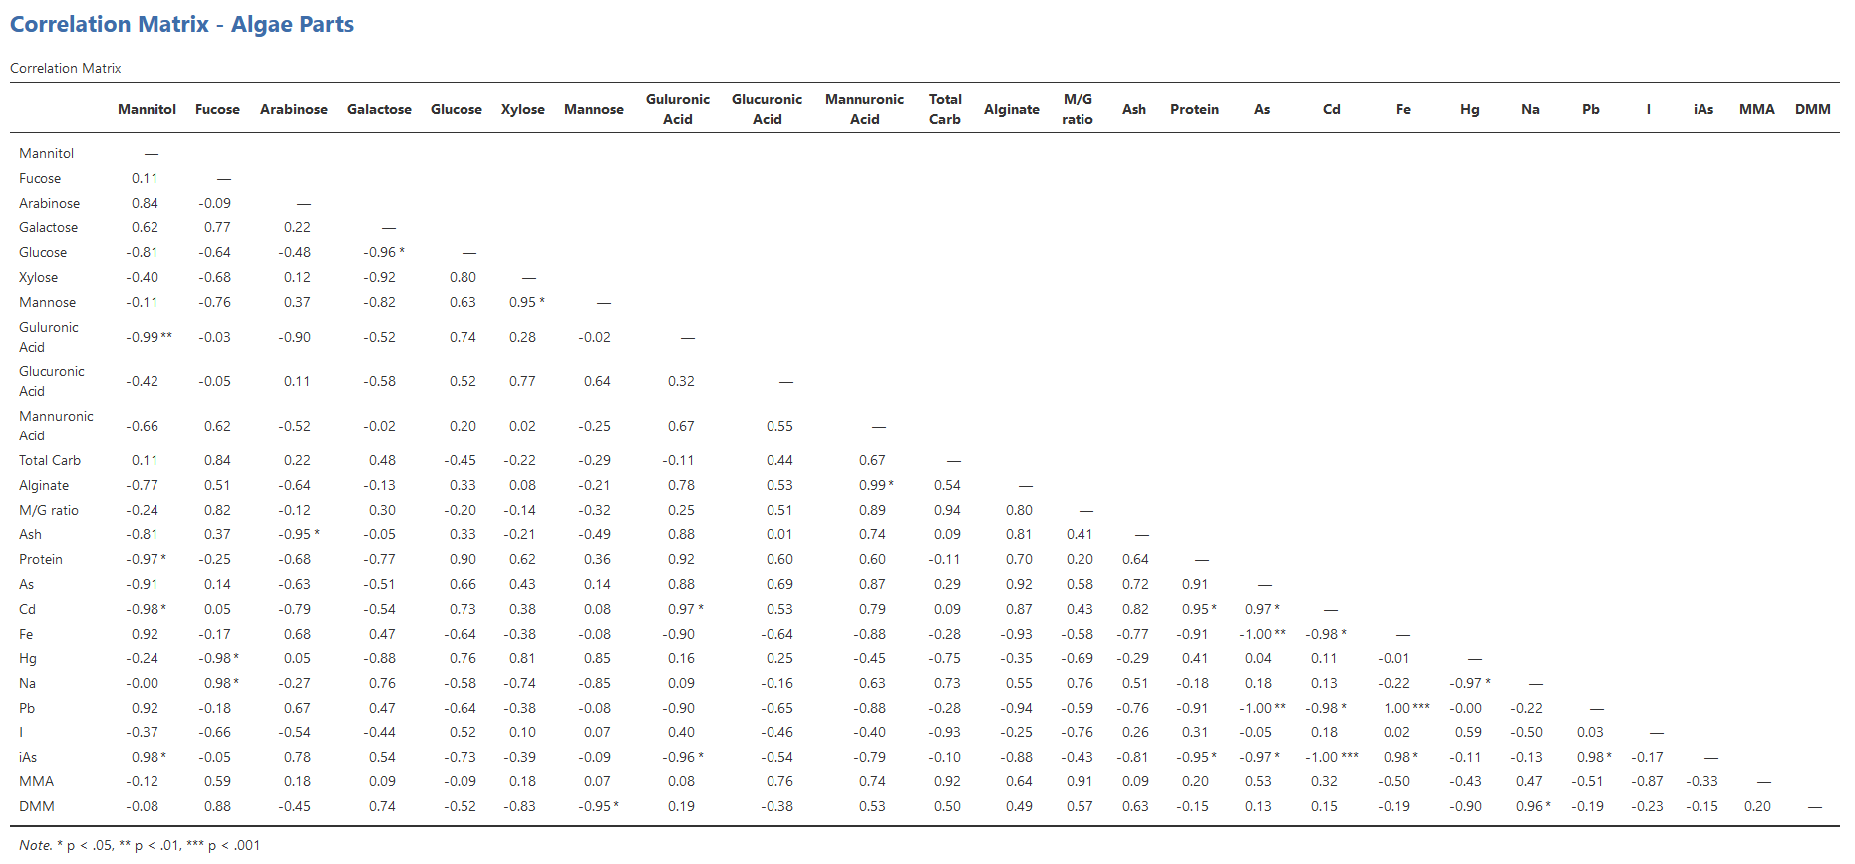

Table S6. Correlation matrix from the comparison of various compounds in Swedish S. latissima before and after being subjected to six different processing methods for reduction of PTEs. The Pearson correlation was based on the mean values (n=7) for each of the compounds.


