Supplementary Information
Aggregation/disaggregation of microalgal-bacterial flocs in high-rate oxidation ponds is a response to biotic/abiotic-induced changes in microbial community structure

Taobat A. Keshinro^{1,2} · Olajide M. Keshinro^{1,3} · Yinka Titilawo^{1,4} · A. Keith Cowan^{1, *}
¹Institute for Environmental Biotechnology (EBRU), Rhodes University, Makhanda 6140, South Africa
²Department of Microbiology, Lagos State University, Ojo, Lagos, Nigeria
³Department of Botany, Lagos State University, Ojo, Lagos, Nigeria
⁴Department of Microbiology, Alex Ekwueme Federal University, Ndufu Alike Ikwo, Ebonyi State, Nigeria

*Corresponding author: a.cowan@ru.ac.za

Table S1. Taxonomic classification of dominant bacterial and eukaryotic OTUs from the HRAOP microbial population.

Bacteria |  | Eukaryotes
OTU ID | Taxonomy | OTU ID | Taxonomy
B_OTU001 | Thiothrix sp. | OTU001 | Desmodesmus sp.
B_OTU002 | Silanimonas sp. | OTU002 | Desmodesmus sp.
B_OTU003 | Mariniradius sp. | OTU003 | Pseudopediastrum sp.
B_OTU004 | SM1A02 sp. | OTU004 | Brachionus sp.
B_OTU005 | Porphyrobacter sp. | OTU005 | Sanchytrium sp.
B_OTU006 | Porphyrobacter sp. | OTU006 | Micractinium sp.
B_OTU007 | Algoriphagus sp. | OTU007 | Paraphysoderma sp.
B_OTU008 | Ideonella sp. | OTU008 | Chlorella sp.
B_OTU009 | SM1A02 sp. | OTU009 | Desmodesmus sp.
B_OTU010 | Gemmatimonas sp. | OTU010 | Micractinium sp.
B_OTU011 | Dokdonella sp. | OTU011 | Scenedesmus sp.
B_OTU012 | uncultured Chitinophagaceae | OTU012 | Cephalodella sp.
B_OTU013 | Malikia sp. | OTU013 | Stenocypris sp.
B_OTU014 | uncultured Cyanobacterium | OTU014 | Desmodesmus sp.
B_OTU015 | Rheinheimera sp. | OTU015 | Moina sp.
B_OTU016 | Roseomonas sp. | OTU016 | uncultured Choanoflagellate
B_OTU017 | uncultured Cyanobacterium | OTU017 | Desmodesmus sp.
B_OTU018 | Blastopirellula sp. | OTU018 | uncultured Chytridiomycota
B_OTU019 | Pseudohongiella sp. | OTU019 | Hariotina sp.
B_OTU020 | Tropicimonas sp. | OTU020 | Desmodesmus sp.
B_OTU022 | Pirellula sp. | OTU021 | Telotrochidium sp.
B_OTU031 | Hydrogenophaga sp. | OTU022 | Amphileptus sp.
B_OTU034 | uncultured Cyanobacterium | OTU023 | Rhizophydium sp.
B_OTU039 | uncultured Rhodocyclaceae | OTU024 | Nitzschia sp.
B_OTU040 | Polynucleobacter sp. | OTU025 | Telotrochidium sp.
B_OTU042 | Flavobacterium sp. | OTU026 | uncultured Chytridiomycota
B_OTU043 | Methylophilus sp. | OTU027 | Chlorella sp.
B_OTU044 | Pirellula sp. | OTU028 | Desmodesmus sp.
B_OTU046 | Flavobacterium sp. | OTU031 | Pseudopediastrum sp.
B_OTU047 | Phenylobacterium sp. | OTU032 | Paraphysoderma sp.
B_OTU051 | Rhodobaca sp. | OTU033 | Brachionus sp.
B_OTU052 | Sediminibacterium sp. | OTU034 | Chlorella sp.
B_OTU064 | Thauera sp. | OTU035 | Micractinium sp.
B_OTU066 | Gemmobacter sp. | OTU038 | Scenedesmus sp.
B_OTU068 | uncultured Ignavibacteria | OTU039 | Desmodesmus sp.
B_OTU080 | Kerstersia sp. | OTU044 | uncultured Eukaryote
B_OTU083 | Thiothrix sp. | OTU052 | Brachionus sp.
B_OTU086 | Thiothrix sp. | OTU054 | Meyerozyma sp.
B_OTU087 | uncultured Rhizobiales | OTU088 | Peridinium sp.
B_OTU0103 | uncultured Cyanobacterium
B_OTU0108 | uncultured Bacteroides
B_OTU0120 | uncultured Cyanobacterium
B_OTU0135 | Candidatus Halomonas phosphatis
B_OTU0136 | Algoriphagus sp.

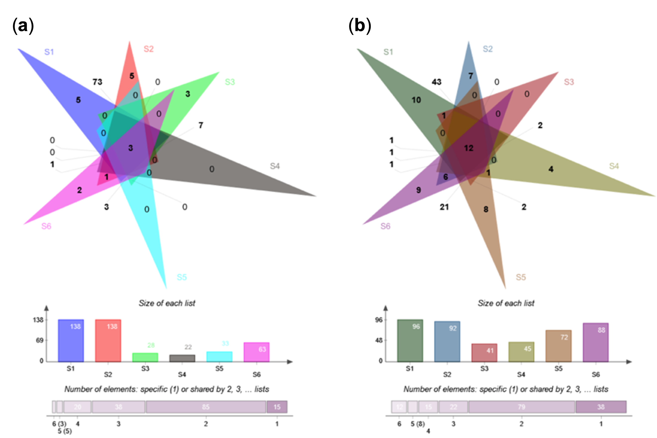Fig. S1 Venn diagram showing shared and unique bacterial (a) and eukaryotic (c) OTUs in samples of HRAOP mixed liquor harvested at the specified intervals. S1 and S2 = summer (February-March 2019); S3 and S4 = winter (June-July 2019); and S5 and S6 = spring (November-December 2019).

