Supplementary materials for:
Botryococcus braunii reduces algal grazing losses to Daphnia and Poterioochromonas through both chemical and physical interference
Patrick Thomas^{1*}, Finn Arn², Micha Freiermuth², Anita Narwani¹
¹Department of Aquatic Ecology, Swiss Federal Institute of Aquatic Science and Technology (Eawag), Dübendorf, Switzerland
²Department of Biology, ETH Zurich, Zurich, Switzerland
*Corresponding author: Patrick Thomas (patrick.thomas@eawag.ch). Swiss Federal Institute of Aquatic Science and Technology (EAWAG), 133 Überlandstasse, 8600 Dübendorf, Switzerland.

Contents:
Table S1: Detailed ANOVA results for effects of grazers on biomass and growth rate
Fig. S1: Daphnia survival over time

Table S1. 2-way ANOVA results testing effects of B. braunii treatment on biomass (max. chl-a fluorescence) and growth rates under different grazer treatments. Significance codes: ***p<0.001, **p<0.01, *p<0.05.
(A) Effects of Botryococcus treatment on chl-a biomass change with Daphnia as grazer
 | Df | Sum of squares | Mean squares | F statistic | p value | significance
bot_medium | 1 | 1180 | 1180 | 3.434 | 0.0787 | .
bot_colonies | 1 | 8678 | 8678 | 25.259 | 6.48E-05 | ***
bot_medium:bot_colonies | 1 | 2272 | 2272 | 6.614 | 0.0182 | *
Residuals | 20 | 6871 | 344
(B) Effects of Botryococcus treatment on growth rate change with Daphnia as grazer
 | Df | Sum of squares | Mean squares | F statistic | p value | significance
bot_medium | 1 | 0.4662 | 0.4662 | 14.35 | 0.001153 | **
bot_colonies | 1 | 1.2888 | 1.2888 | 39.68 | 3.78E-06 | ***
bot_medium:bot_colonies | 1 | 0.5816 | 0.5816 | 17.91 | 0.000409 | ***
Residuals | 20 | 0.6496 | 0.0325
(C) Effects of Botryococcus treatment on chl-a biomass change with Poterioochromonas as grazer
 | Df | Sum of squares | Mean squares | F statistic | p value | significance
bot_medium | 1 | 8986 | 8986 | 270.53 | 1.08E-12 | ***
bot_colonies | 1 | 22 | 22 | 0.67 | 0.423
bot_medium:bot_colonies | 1 | 3385 | 3385 | 101.9 | 4.52E-09 | ***
Residuals | 19 | 631 | 33
(D) Effects of Botryococcus treatment on growth rate change with Poterioochromonas as grazer
 | Df | Sum of squares | Mean squares | F statistic | p value | significance
bot_medium | 1 | 0.06428 | 0.06428 | 62.63 | 1.97E-07 | ***
bot_colonies | 1 | 0.22312 | 0.22312 | 217.39 | 7.45E-12 | ***
bot_medium:bot_colonies | 1 | 0.05086 | 0.05086 | 49.55 | 1.06E-06 | ***
Residuals | 19 | 0.0195 | 0.00103
(E) Effects of Botryococcus treatment on chl-a biomass with grazers absent
 | Df | Sum of squares | Mean squares | F statistic | p value | significance
bot_medium | 1 | 0.0860 | 0.0860 | 10.204 | 0.00455 | **
bot_colonies | 1 | 0.0468 | 0.0468 | 5.560 | 0.02867 | *
bot_medium:bot_colonies | 1 | 0.00001 | 0.00001 | 0.001 | 0.97748
Residuals | 20 | 0.16834 | 0.00842
(F) Effects of Botryococcus treatment on growth rate change with grazers absent
 | Df | Sum of squares | Mean squares | F statistic | p value | significance
bot_medium | 1 | 0.0002 | 0.0002 | 0.529 | 0.475547
bot_colonies | 1 | 1.6855 | 1.6855 | 4244.987 | <2E-16 | ***
bot_medium:bot_colonies | 1 | 0.0082 | 0.0082 | 20.694 | 0.000195 | ***
Residuals | 20 | 0.0079 | 0.0004

Table S2.

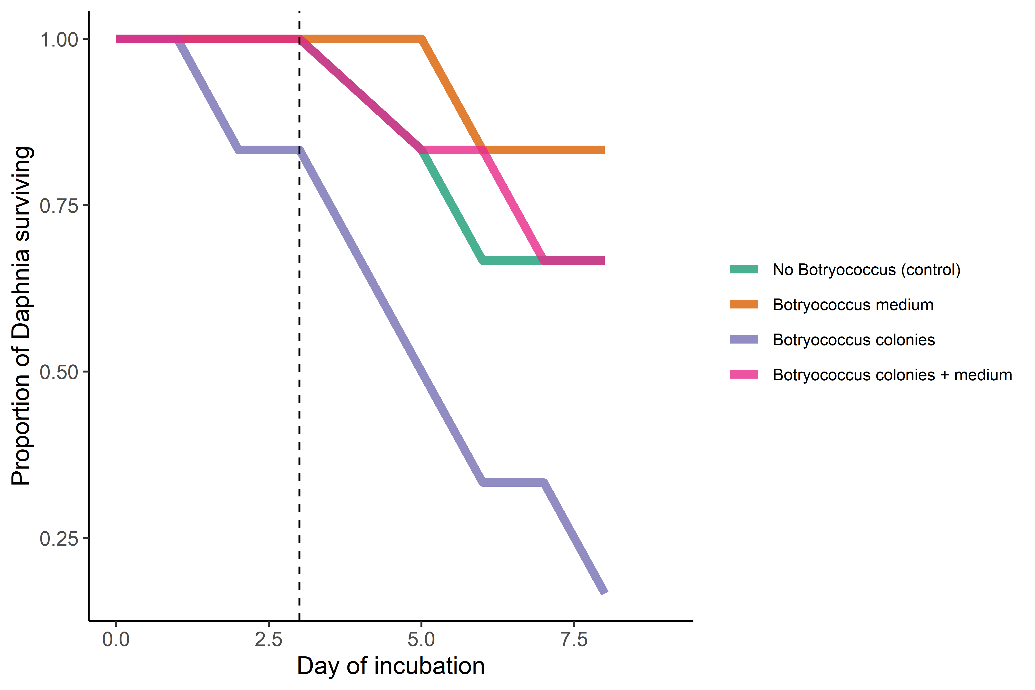
Fig. S1. Proportion of Daphnia magna individuals alive in the first week of the experiment. Survival was high (23 of 24 total individuals) in the first 3 days, indicating an effective grazing treatment. After day 3 (indicated by vertical dashed line), survival decreased, most notably in the Botryococcus colonies and medium treatment, likely due to stressful growth conditions. Therefore, Daphnia grazing assays only include the first 3 days where grazers effectively exerted control on algal biomass.

