Journal of Applied Phycology

Supplementary figures for
"Global interfertility and heterosis in sugar kelp populations:
a next step in sugar kelp breeding”

Job Cohen^{1,2}*, Robert Twijnstra¹, Jessica Schiller³, Gabriel Montecinos Arismendi³, Brigit Reus³, Karline Soetaert¹, Klaas Timmermans¹

¹ Department of Estuarine and Delta Systems, NIOZ Royal Netherlands Institute for Sea Research, 4401NT Yerseke, The Netherlands
² Centre for Isotope Research (CIO) – Oceans, Energy and Sustainability Research Institute Groningen, Faculty of Science and Engineering, University of Groningen, PO Box 11103, 9700CC Groningen, The Netherlands
³ Hortimare, 1704CC Heerhugowaard, The Netherlands

*Corresponding author: Job Cohen (job.cohen@nioz.nl)

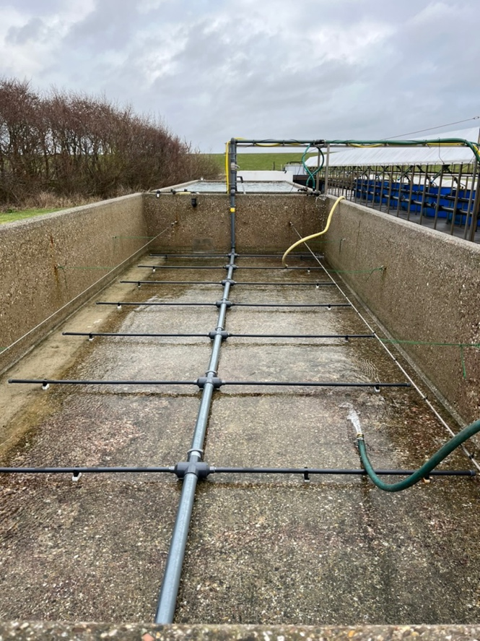
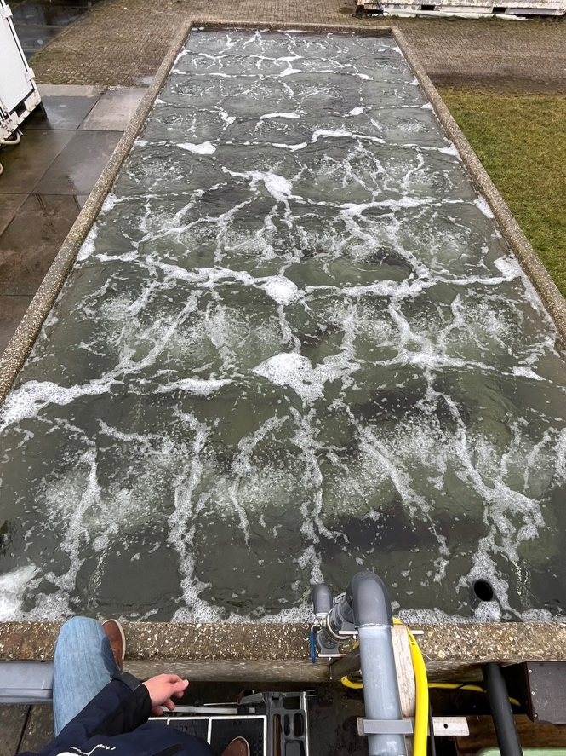
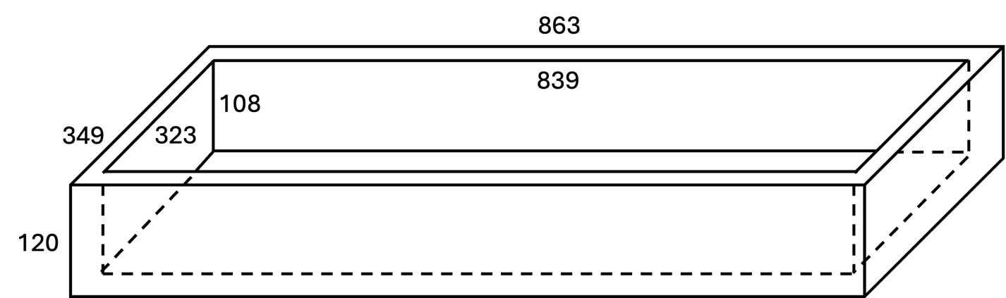
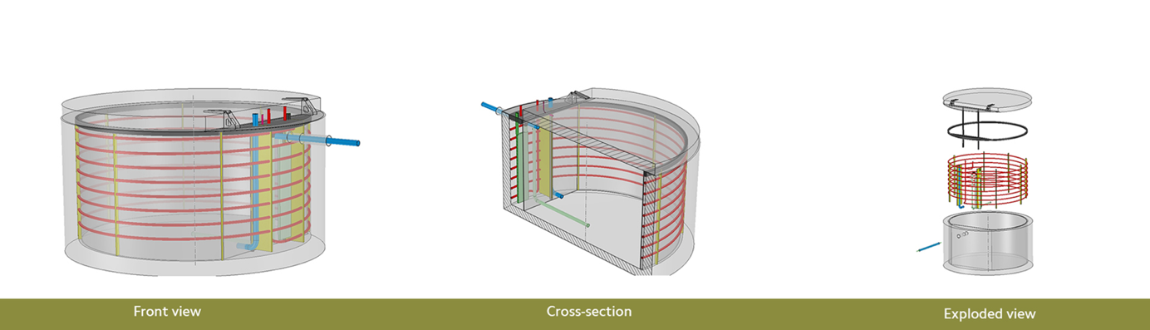
Fig. S1 Experimental tank setup of the large tank: a) Schematic overview including dimension (in cm), b) cable and bottom aeration placement, c) operating tank experiment with turned-on aeration, and d) specifics of the 1500L circular tanks
d
a
c
b
b

Temperature (℃)

Fig. S2 Tank water temperature during the experiment

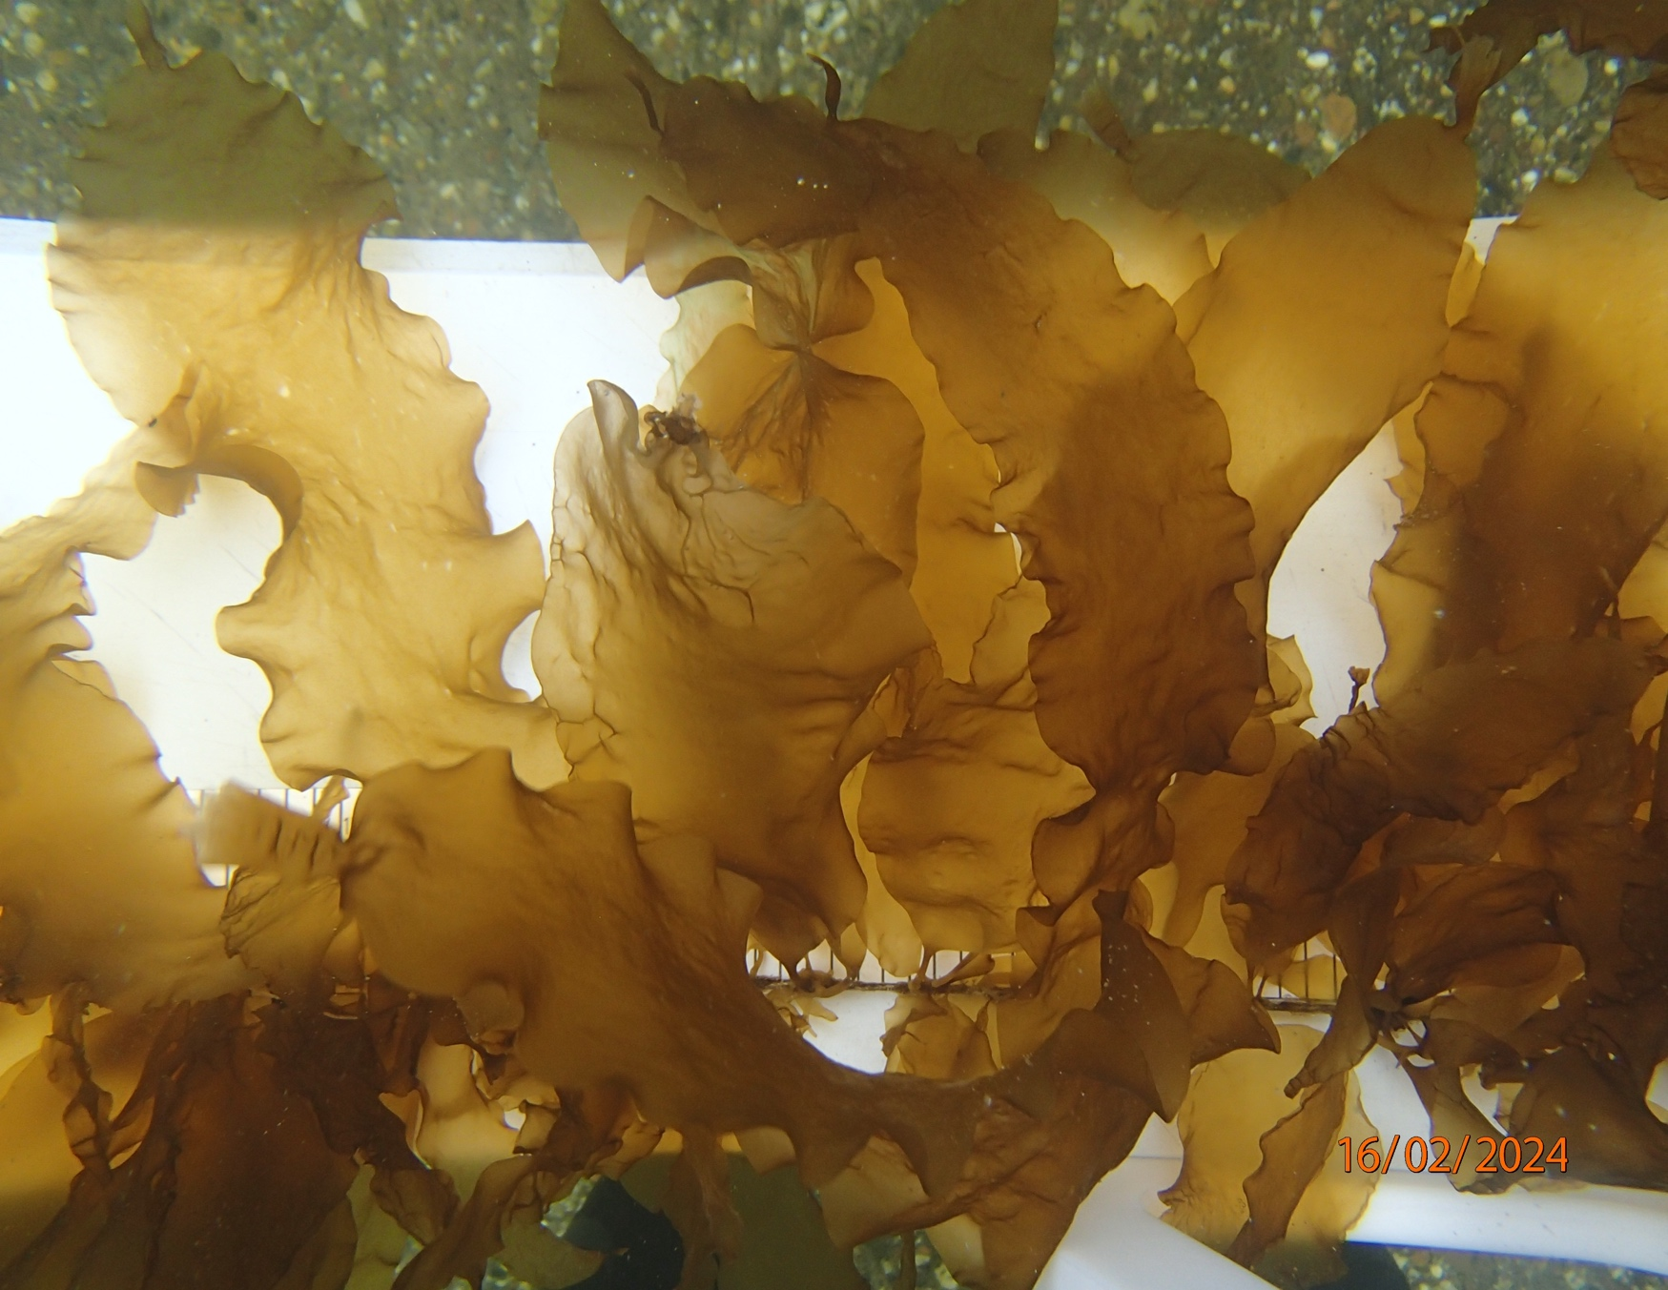
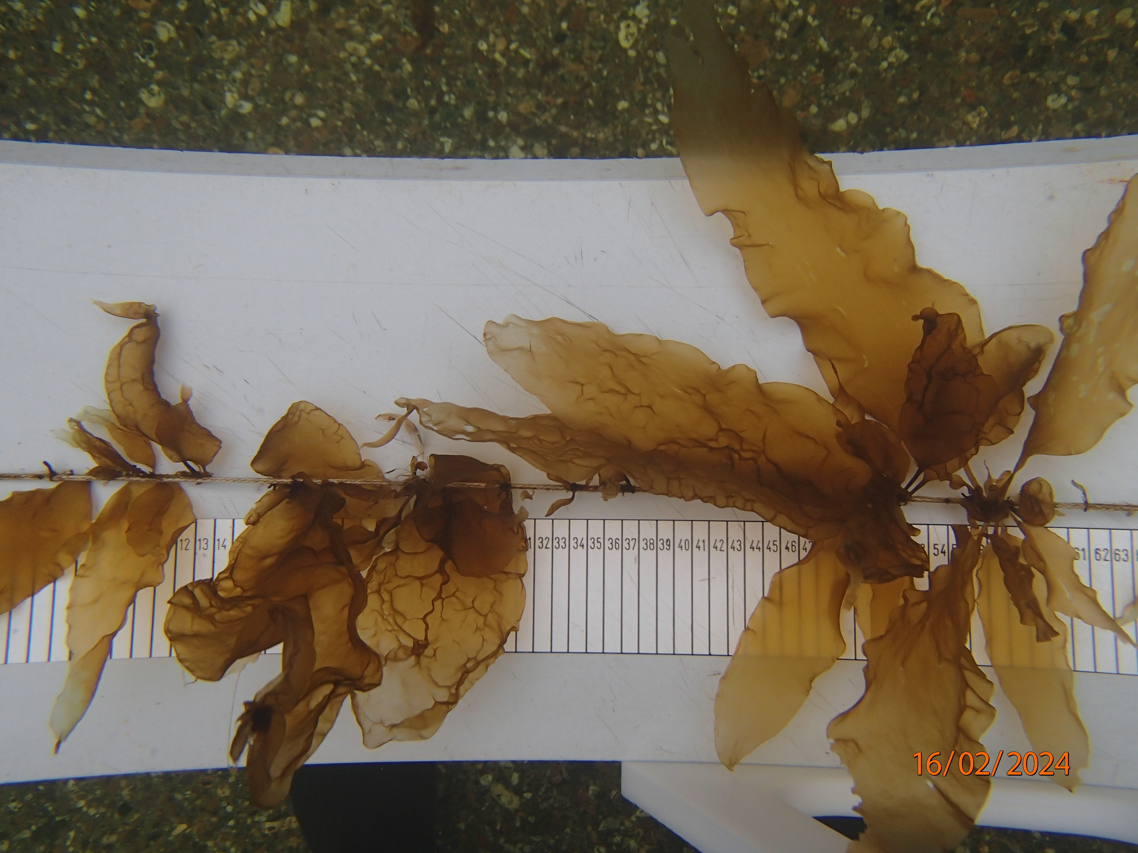
a
b

Fig. S3 Examples of hybrids containing CA males that show good growth but bleaching tips one month prior to harvest: a) CA(f)xCA(m) and b) GR(f)xCA(m)
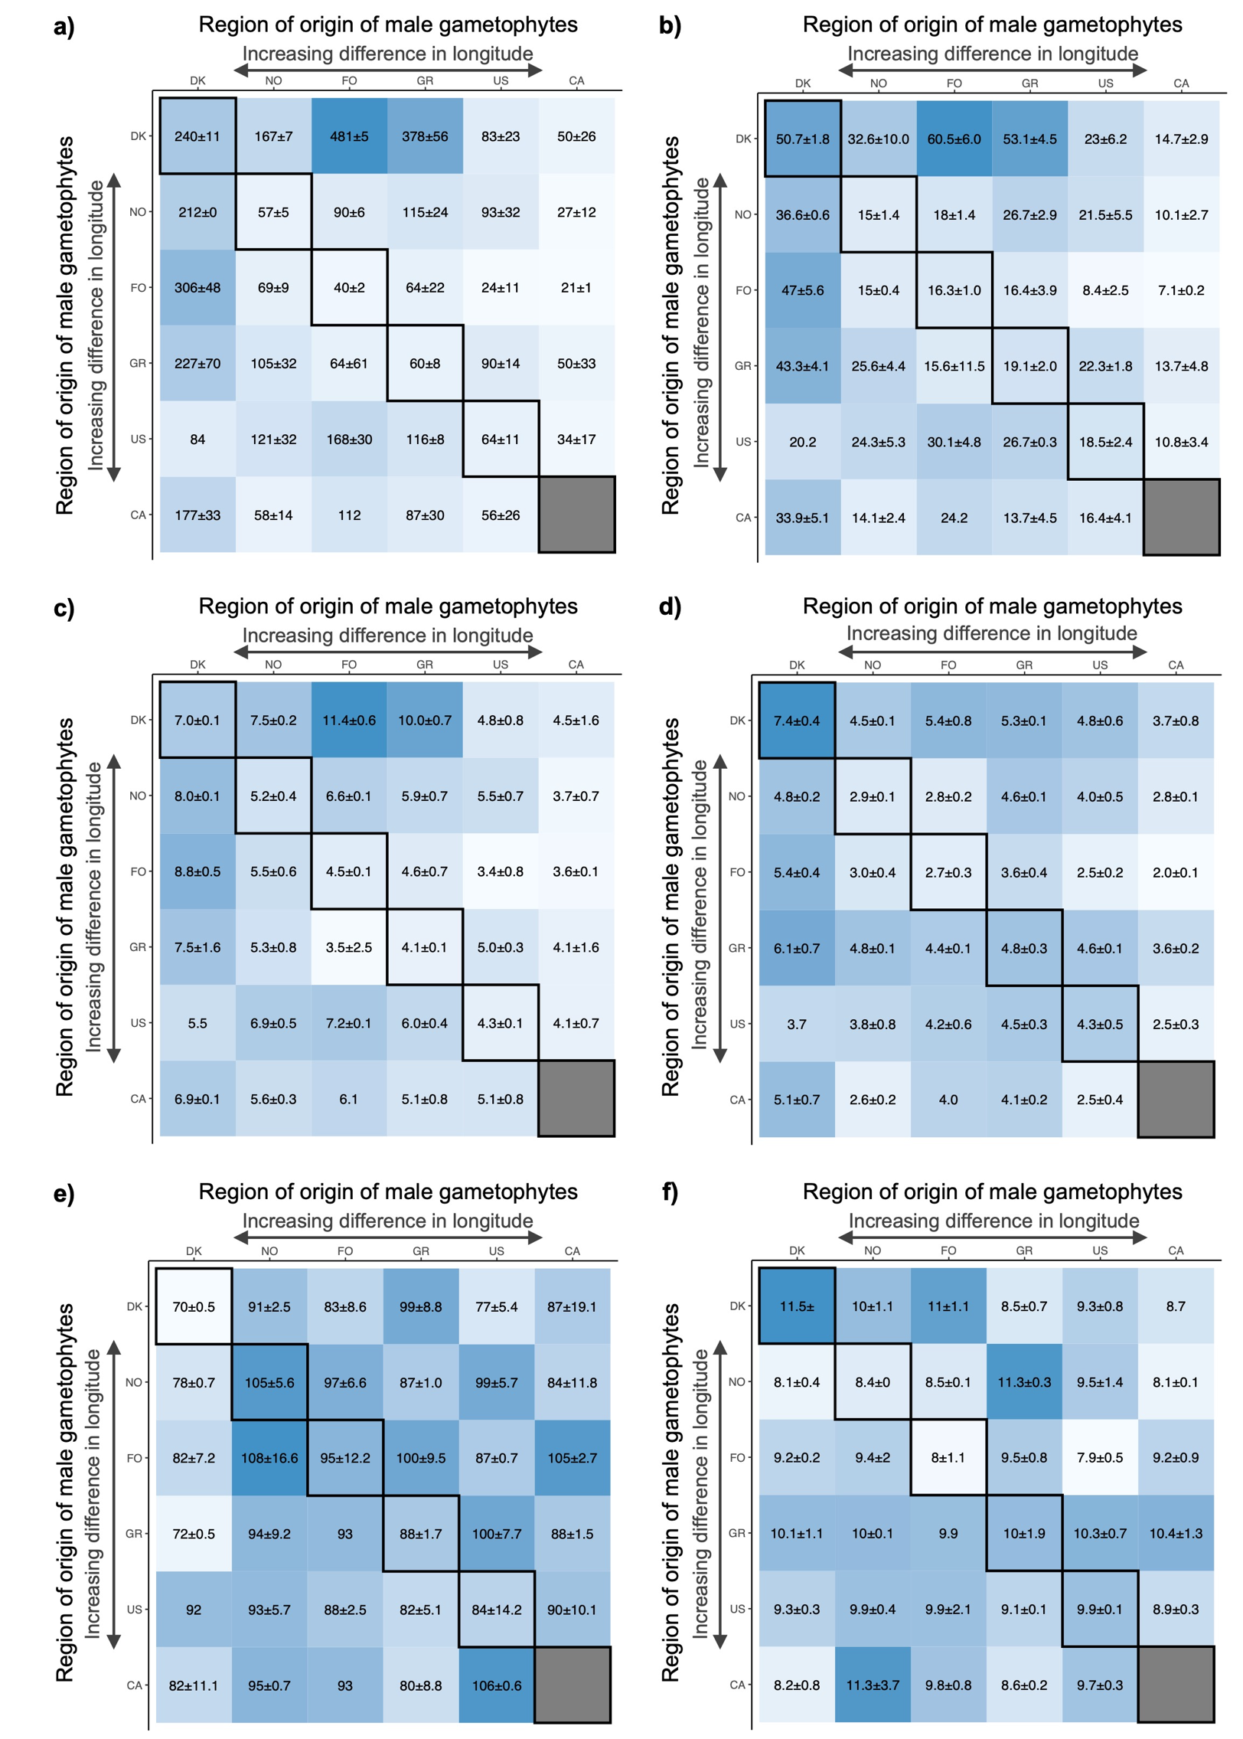

Fig. S4 Intra- and interregional hybrid plot data heatmaps showing a) blade surface area (cm²) ± SE, b) blade length (cm) ± SE, c) blade maximum width (cm), d) blade length to width ratio, e) blade base angle (º) and f) dry weight percentage (%). Intraregional hybrids are found diagonally and are outlined in black. The color gradient reflects the magnitude of values

