Supplementary Material.

Table S1. Number of male and female gametophytes collected from each sporophyte sampled per population for gametophyte heat stress experiment.

Population | Sporophyte ID | No. female gametophytes used | No. male gametophytes used
BL | 11 | 1 | 0
BL | 12 | 0 | 2
BL | 13 | 0 | 1
BL | 17 | 0 | 1
BL | 18 | 1 | 0
CB | 2 | 0 | 2
CB | 3 | 0 | 1
CB | 4 | 1 | 2
CB | 5 | 1 | 0
CB | 7 | 2 | 1
CB | 10 | 0 | 1
CC | 1 | 0 | 1
CC | 3 | 1 | 0
CC | 5 | 2 | 0
CC | 6 | 1 | 1
CC | 9 | 1 | 1
CC | 12 | 1 | 0
FW | 14 | 2 | 0
FW | 21 | 0 | 1
JS | 5 | 1 | 1
JS | 6 | 0 | 3
JS | 9 | 2 | 1
JS | 11 | 0 | 1
JS | 16 | 2 | 0
JS | 19 | 1 | 1
LD | 2 | 0 | 1
LD | 3 | 1 | 0
LD | 9 | 0 | 1
LD | 13 | 2 | 0
LL | 9 | 1 | 1
NC | 1 | 1 | 1
NC | 8 | 1 | 0
NC | 10 | 1 | 1
NL | 2 | 2 | 1
NL | 3 | 1 | 1
NL | 6 | 1 | 0
NL | 7 | 1 | 0
NL | 9 | 0 | 1
NL | 10 | 1 | 0
OD | 6 | 0 | 3
OI | 4 | 0 | 1
OI | 5 | 0 | 1
OI | 6 | 1 | 1
OI | 7 | 0 | 1
OI | 11 | 1 | 1
OI | 15 | 0 | 1
OI | 16 | 0 | 1
OI | 17 | 2 | 0
PI | 1 | 2 | 2
SF | 13 | 1 | 1
SF | 17 | 1 | 0
TI | 3 | 0 | 1
TI | 4 | 2 | 2

Table S2. Number of male and female gametophytes collected from each sporophyte sampled per population for the juvenile sporophyte heat stress experiment.

Population | Sporophyte ID | No. female gametophytes used | No. male gametophytes used
CB | 10 | 0 | 1
CC | 3 | 0 | 1
CC | 5 | 1 | 0
CC | 6 | 1 | 0
JS | 16 | 1 | 0
JS | 19 | 0 | 1
JS | 5 | 1 | 0
JS | 6 | 0 | 2
JS | 9 | 1 | 0
NC | 10 | 1 | 0
OI | 15 | 0 | 1
OI | 16 | 0 | 1
SF | 13 | 1 | 0

Table S3. Gametophyte mixes used to test fertility of the 93 heat-stressed gametophytes. A homogenous mix of all male gametophytes were added to female gametophytes to be tested, and a homogenous mix of all female gametophytes were added to male gametophytes to be tested. Gametophyte IDs are written as SL18 (Saccharina latissima, 2018) followed by the two-letter site code (see main text, Table 1), the wild sporophyte identification number, and the gametophyte identification number with FG=female gametophyte and MG=male gametophyte.

Gametophyte ID | Gametophyte sex
CC-S12-FG2 | Female
CC-S5-FG3 | Female
CC-S9-FG1 | Female
OI-S6-FG2 | Female
SF-S17-FG2 | Female
LL-S9-MG4 | Male
CB-S3-MG1 | Male
CB-S10-MG1 | Male

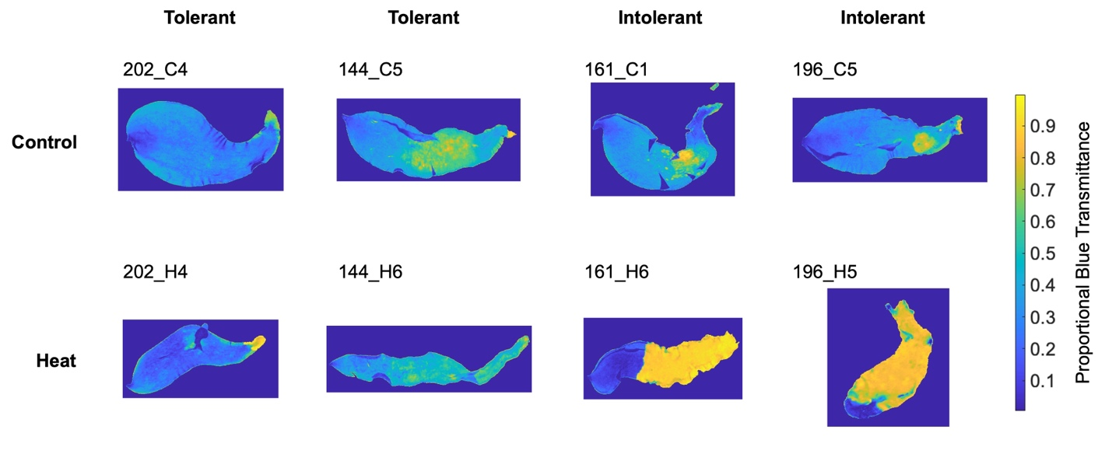

Figure S1. Images of juvenile Saccharina latissima blades showing the proportional blue light transmittance for each pixel in the image. More degraded tissue absorbs less blue light and consequently has higher proportional blue transmittance values. Original digital photos of the same blades can be found in the main text, Figure 1.

