Effect of temperature on growth and nitrate and phosphate uptake kinetics of juvenile Saccharina latissima sporophytes (Phaeophyceae)
Xiaowei Ding^{1,2}, Karline Soetaert¹, Klaas Timmermans¹
¹ Department of Estuarine and Delta Systems, NIOZ Royal Netherlands Institute for Sea Research, PO Box 140, 4401 NT Yerseke, the Netherlands
² Centre for Isotope Research (CIO) - Oceans, Energy and Sustainability Research Institute 8 Groningen, Faculty of Science and Engineering, University of Groningen, PO Box 72, 9700 AB Groningen, the Netherlands

*Corresponding author:
xiaowei.ding@nioz.nl. (X. Ding)

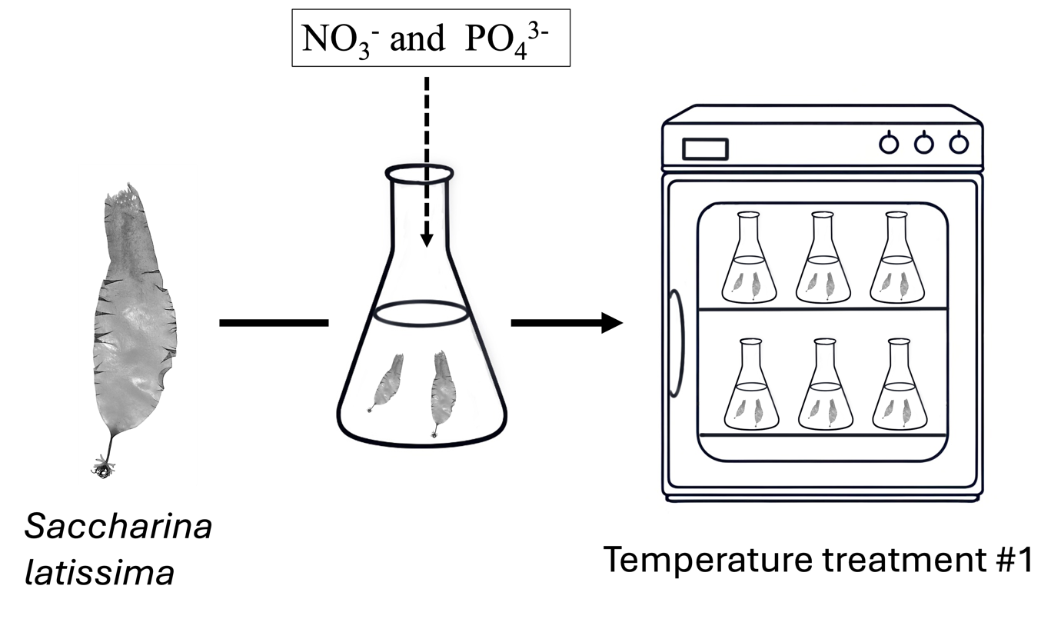
Supplementary Fig 1. The scheme of the set up of this expriment.

Supplementary Table 1 Tukey HSD test result of growth rate of S. latissima under variable temperature treatments
Variable | Temperature treatment | Temperature treatment | mean difference | std. Error | sig. | 95% confidence interval
 |  |  |  |  |  | lower bound | upper bound
Growth rate | 7.6 | 12.6 | -0.067 | 0.012 | 0.310 | -0.163 | 0.029
Growth rate | 7.6 | 15.7*** | -0.236 | 0.012 | <0.001 | -0.334 | -0.139
Growth rate | 7.6 | 20.9*** | -0.280 | 0.012 | <0.001 | -0.376 | -0.185
Growth rate | 7.6 | 24.5*** | -0.360 | 0.012 | <0.001 | -0.463 | -0.256
Growth rate | 12.6 | 7.6 | -0.067 | 0.012 | 0.310 | -0.163 | 0.029
Growth rate | 12.6 | 15.7*** | -0.169 | 0.012 | <0.001 | -0.281 | -0.057
Growth rate | 12.6 | 20.9*** | -0.214 | 0.012 | <0.001 | -0.324 | -0.103
Growth rate | 12.6 | 24.5*** | -0.293 | 0.012 | <0.001 | -0.410 | -0.176
Growth rate | 15.7 | 7.6*** | -0.236 | 0.012 | <0.001 | -0.334 | -0.139
Growth rate | 15.7 | 12.6*** | -0.169 | 0.012 | <0.001 | -0.281 | -0.057
Growth rate | 15.7 | 20.9 | -0.044 | 0.012 | 0.812 | -0.156 | 0.068
Growth rate | 15.7 | 24.5 | -0.124 | 0.012 | 0.036 | -0.242 | -0.005
Growth rate | 20.9 | 7.6*** | -0.280 | 0.012 | <0.001 | -0.376 | -0.185
Growth rate | 20.9 | 12.6*** | -0.214 | 0.012 | <0.001 | -0.324 | -0.103
Growth rate | 20.9 | 15.7 | -0.044 | 0.012 | 0.812 | -0.156 | 0.068
Growth rate | 20.9 | 24.5 | -0.079 | 0.012 | 0.343 | -0.196 | 0.038
Growth rate | 24.5 | 7.6*** | -0.360 | 0.012 | <0.001 | -0.463 | -0.256
Growth rate | 24.5 | 12.6*** | -0.293 | 0.012 | <0.001 | -0.410 | -0.176
Growth rate | 24.5 | 15.7 | -0.124 | 0.012 | 0.036 | -0.242 | -0.005
Growth rate | 24.5 | 20.9 | -0.079 | 0.012 | 0.343 | -0.196 | 0.038
Significance level : ***0.001,**0.01,**0.05

Supplementary Table 2 Tukey HSD test result of NO₃⁻ uptake rate of S. latissima under variable temperature treatments
Variable | Temperature treatment | Temperature treatment | mean difference | std. Error | sig. | 95% confidence interval
 |  |  |  |  |  | lower bound | upper bound
NO₃⁻ uptake rate | 7.6 | 12.6 | -0.218 | 0.029 | 0.065 | -0.444 | 0.008
NO₃⁻ uptake rate | 7.6 | 15.7*** | -0.706 | 0.029 | <0.001 | -0.937 | -0.476
NO₃⁻ uptake rate | 7.6 | 20.9*** | -0.616 | 0.029 | <0.001 | -0.843 | -0.390
NO₃⁻ uptake rate | 7.6 | 24.5*** | -0.654 | 0.029 | <0.001 | -0.905 | -0.403
NO₃⁻ uptake rate | 12.6 | 7.6 | -0.218 | 0.029 | 0.065 | -0.444 | 0.008
NO₃⁻ uptake rate | 12.6 | 15.7*** | -0.489 | 0.029 | <0.001 | -0.753 | -0.224
NO₃⁻ uptake rate | 12.6 | 20.9*** | -0.399 | 0.029 | <0.001 | -0.659 | -0.138
NO₃⁻ uptake rate | 12.6 | 24.5*** | -0.436 | 0.029 | <0.001 | -0.719 | -0.154
NO₃⁻ uptake rate | 15.7 | 7.6*** | -0.706 | 0.029 | <0.001 | -0.937 | -0.476
NO₃⁻ uptake rate | 15.7 | 12.6*** | -0.489 | 0.029 | <0.001 | -0.753 | -0.224
NO₃⁻ uptake rate | 15.7 | 20.9 | 0.09 | 0.029 | 0.884 | -0.174 | 0.354
NO₃⁻ uptake rate | 15.7 | 24.5 | 0.052 | 0.029 | 0.987 | -0.234 | 0.338
NO₃⁻ uptake rate | 20.9 | 7.6*** | -0.616 | 0.029 | <0.001 | -0.843 | -0.390
NO₃⁻ uptake rate | 20.9 | 12.6*** | -0.399 | 0.029 | <0.001 | -0.659 | -0.138
NO₃⁻ uptake rate | 20.9 | 15.7 | 0.090 | 0.029 | 0.884 | -0.174 | 0.354
NO₃⁻ uptake rate | 20.9 | 24.5 | -0.038 | 0.029 | 0.996 | -0.320 | 0.245
NO₃⁻ uptake rate | 24.5 | 7.6*** | -0.654 | 0.029 | <0.001 | -0.905 | -0.403
NO₃⁻ uptake rate | 24.5 | 12.6*** | -0.436 | 0.029 | <0.001 | -0.719 | -0.154
NO₃⁻ uptake rate | 24.5 | 15.7 | 0.052 | 0.029 | 0.987 | -0.234 | 0.338
NO₃⁻ uptake rate | 24.5 | 20.9 | -0.038 | 0.029 | 0.996 | -0.320 | 0.245
Significance level : ***0.001,**0.01,**0.05

Supplementary Table 3 Tukey HSD test result of PO₄³⁻ uptake rate of S. latissima under variable temperature treatments
Variable | Temperature treatment | Temperature treatment | mean difference | std. Error | sig. | 95% confidence interval
 |  |  |  |  |  | lower bound | upper bound
PO₄³⁻ uptake rate | 7.6 | 12.6 | -0.009 | 0.004 | 0.930 | -0.038 | 0.021
PO₄³⁻ uptake rate | 7.6 | 15.7 | -0.015 | 0.004 | 0.632 | -0.046 | 0.015
PO₄³⁻ uptake rate | 7.6 | 20.9 | -0.011 | 0.004 | 0.831 | -0.041 | 0.018
PO₄³⁻ uptake rate | 7.6 | 24.5 | -0.023 | 0.004 | 0.302 | -0.055 | 0.009
PO₄³⁻ uptake rate | 12.6 | 7.6 | -0.009 | 0.004 | 0.930 | -0.038 | 0.021
PO₄³⁻ uptake rate | 12.6 | 15.7 | -0.007 | 0.004 | 0.984 | -0.041 | 0.028
PO₄³⁻ uptake rate | 12.6 | 20.9 | -0.003 | 0.004 | 0.999 | -0.037 | 0.031
PO₄³⁻ uptake rate | 12.6 | 24.5 | -0.014 | 0.004 | 0.829 | -0.050 | 0.022
PO₄³⁻ uptake rate | 15.7 | 7.6 | -0.015 | 0.004 | 0.632 | -0.046 | 0.015
PO₄³⁻ uptake rate | 15.7 | 12.6 | -0.007 | 0.004 | 0.984 | -0.041 | 0.028
PO₄³⁻ uptake rate | 15.7 | 20.9 | 0.004 | 0.004 | 0.998 | -0.031 | 0.039
PO₄³⁻ uptake rate | 15.7 | 24.5 | -0.007 | 0.004 | 0.983 | -0.044 | 0.029
PO₄³⁻ uptake rate | 20.9 | 7.6 | -0.011 | 0.004 | 0.831 | -0.041 | 0.018
PO₄³⁻ uptake rate | 20.9 | 12.6 | -0.003 | 0.004 | 0.999 | -0.037 | 0.031
PO₄³⁻ uptake rate | 20.9 | 15.7 | 0.004 | 0.004 | 0.998 | -0.031 | 0.039
PO₄³⁻ uptake rate | 20.9 | 24.5 | -0.011 | 0.004 | 0.915 | -0.047 | 0.025
PO₄³⁻ uptake rate | 24.5 | 7.6 | -0.023 | 0.004 | 0.302 | -0.055 | 0.009
PO₄³⁻ uptake rate | 24.5 | 12.6 | -0.014 | 0.004 | 0.829 | -0.050 | 0.022
PO₄³⁻ uptake rate | 24.5 | 15.7 | -0.007 | 0.004 | 0.983 | -0.044 | 0.029
PO₄³⁻ uptake rate | 24.5 | 20.9 | -0.011 | 0.004 | 0.915 | -0.047 | 0.025
Significance level : ***0.001,**0.01,**0.05

