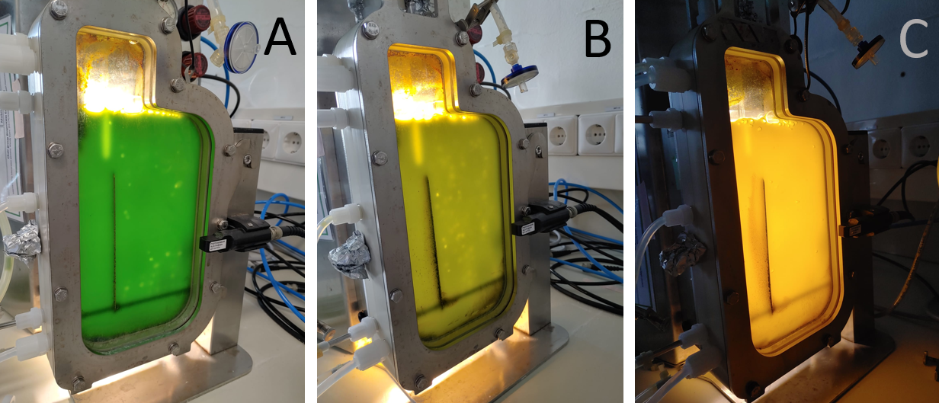
Figure S1: Colour changes in Nannochloropsis oceanica across different cultivation phases, A) Reactor at the end of the repletion phase, B) Reactor at the end of the nitrogen starvation phase at low biomass-specific photon supply rates 9 μmol_{photon} g_{dw}⁻¹ s⁻¹, and C) Reactor at the end of the nitrogen starvation phase at high biomass-specific photon supply rates 18 μmol_{photon} g_{dw}⁻¹ s⁻¹

Figure 2S. The cell concentration (cells/ml) for Nannochloropsis oceanica and Microchloropsis gaditana under (A) nitrogen repletion (N+) and (B) nitrogen starvation (N-) conditions at different initial biomass-specific photon supply rates (9 and 18 μmol_{photon} g_{dw}⁻¹ s⁻¹)

Figure 3S. The cell diameter cell (µm) for Nannochloropsis oceanica and Microchloropsis gaditana under (A) nitrogen repletion (N+) and (B) nitrogen starvation (N-) conditions at different initial biomass-specific photon supply rates (9 and 18 μmol_{photon} g_{dw}⁻¹ s⁻¹)

Figure 4S. Chlorophyll content (mg g_{dw}⁻¹) of Nannochloropsis oceanica and Microchloropsis gaditana cultivated in nitrogen repletion (N+) (A) or nitrogen starvation (N-) (B) conditions at different initial biomass-specific photon supply rates (9 and 18 μmol_{photon} g_{dw}⁻¹ s⁻¹). t is the time in days, t₀ (start of nitrogen repletion phase), t_{(ENRP)} (end of nitrogen repletion phase)
Note: Bars with different small letters indicate significant differences (p < 0.05) within the same strain under different cultivation conditions. Bars with different capital letters indicate significant differences (p < 0.05) between the two strains under the same cultivation condition. Statistical comparisons were performed using a two-sided test of equality for column means, with adjustments for all pairwise comparisons within a category using the Bonferroni correction. Error bars represent the standard error of the mean (SEM), calculated from two biological replicates (n = 2).

Figure 5S: Individual fatty acids mg_{fatty acid}/mg_{dw}, for Nannochloropsis oceanica and Microchloropsis gaditana at different phases of cultivation: Beginning of nitrogen repletion phase, End of nitrogen repletion phase and End of nitrogen starvation phase at different initial biomass-specific photon supply rates (9 and 18 μmol_{photon} g_{dw}⁻¹ s⁻¹). t is the time in days, t₀ (start of nitrogen repletion phase), t_{(ENRP)} (end of nitrogen repletion phase), and t_{(ENSP)} (end of nitrogen starvation phase).
Error bars represent the standard error of the mean (SEM), calculated from two biological replicates (n = 2).

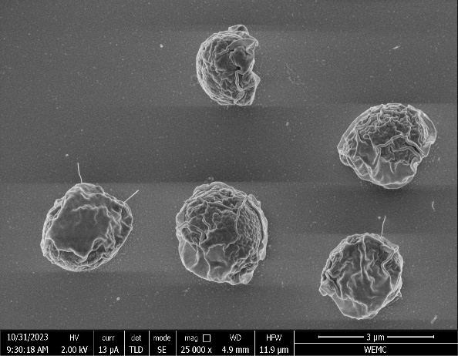
A
B
C
D
Figure 6S. SEM images of Nannochloropsis oceanica cells. A: Cells at the start of the nitrogen repletion phase at 200 μmol_{photon} m⁻² s⁻¹. B: Cells at the end of the nitrogen repletion phase (8 days of cultivation) at 1200 μmol_{photon} m⁻² s⁻¹. C: Cells at the end of the nitrogen starvation phase (5 days of cultivation) at 1200 μmol_{photon} m⁻² s⁻¹ at low photo supply rate (9 μmol_{photon} g_{dw}⁻¹ s⁻¹). D: Cells at the end of the nitrogen starvation phase (5 days of cultivation) at 1200 μmol_{photon} m⁻² s⁻¹ at high photo supply rate (18 μmol_{photon} g_{dw}⁻¹ s⁻¹).Scale bars: 3 µm

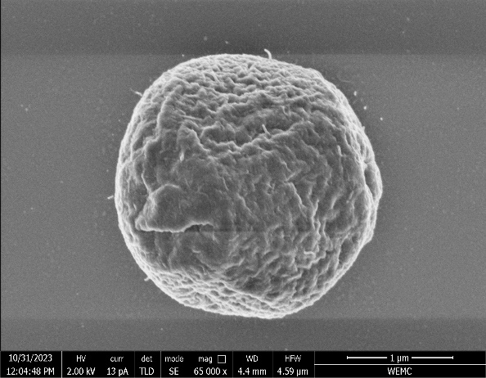
A
B
C
D
Figure 7S. SEM images of Microchloropsis gaditana cells. A: Cells at the start of the nitrogen repletion phase at 200 μmol_{photon} m⁻² s⁻¹. B: Cells at the end of the nitrogen repletion phase (11 days of cultivation) at 1200 μmol_{photon} m⁻² s⁻¹. C: Cells at the end of the nitrogen starvation phase (5 days of cultivation) at 1200 μmol_{photon} m⁻² s⁻¹ at low photo supply rate (9 μmol_{photon} g_{dw}⁻¹ s⁻¹). D: Cells at the end of the nitrogen starvation phase (5 days of cultivation) at 1200 μmol_{photon} m⁻² s⁻¹ at high photo supply rate (18 μmol_{photon} g_{dw}⁻¹ s⁻¹). Scale bars: A: 1 µm and B, C and D: 3 µm

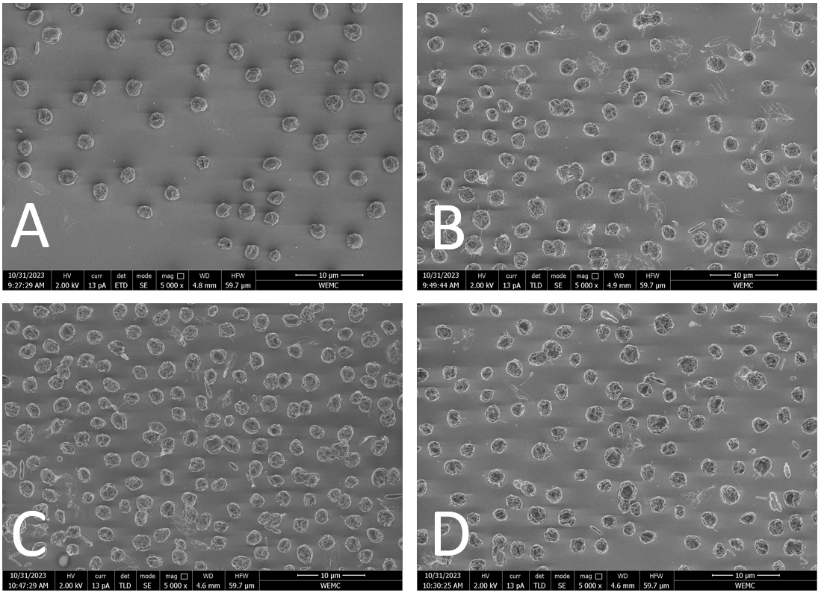
Figure 8S: SEM images of Nannochloropsis oceanica cells. A – Cells at the start of the repletion phase. B – Cells at the end of the nitrogen repletion phase (8 days of cultivation). C – Cells at the end of the nitrogen starvation phase (5 days of cultivation) at the low biomass-specific photon supply rates (9 μmol_{photon} g_{dw}⁻¹ s⁻¹). D – Cells at the end of the nitrogen starvation phase (5 days of cultivation) of the high biomass-specific photon supply rates (18 μmol_{photon} g_{dw}⁻¹ s⁻¹). Scale bar: 10 µm

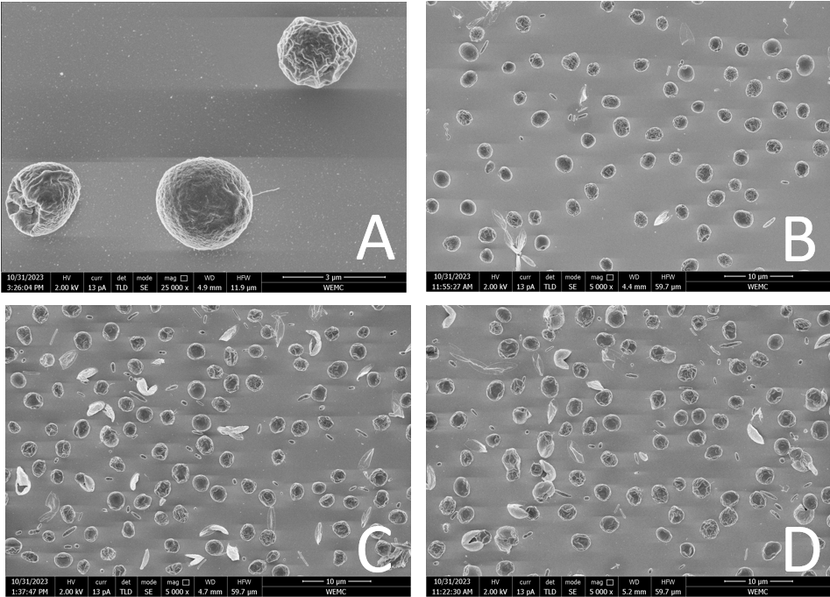
Figure 9S: SEM images of Microchloropsis gaditana cells. A – Cells at the start of the nitrogen repletion phase. B – Cells at the end of the nitrogen repletion phase (11days of cultivation). C – Cells at the end of the nitrogen starvation phase (5 days of cultivation) at the low biomass-specific photon supply rates (9 μmol_{photon} g_{dw}⁻¹ s⁻¹). D – Cells at the end of the nitrogen starvation phase (5 days of cultivation) of the high biomass-specific photon supply rates (18 μmol_{photon} g_{dw}⁻¹ s⁻¹). Scale bars: For A: 3 µm and for B, C and D: 10 µm

Table 1S. Complete experimental timeline and morphological analysis points
Day | Light intensity  μmol_{photons} m⁻² s⁻¹ | N. oceanica |  | M. gaditana
Day | Light intensity  μmol_{photons} m⁻² s⁻¹ | Stage | Sampling | Stage | Sampling
0 | 200 | Start of N-repletion | TEM/SEM | Start of N-repletion | TEM/SEM
1 | 600 | Light acclimation | - | Light acclimation | -
2 | 1200 | Light acclimation | - | Light acclimation | -
8 | 1200 | End of N-repletion and  start of N-starvation | TEM/SEM | - | -
11 | 1200 | - | - | End of N-repletion and start of N-starvation | TEM/SEM
13 | 1200 | End of N-starvation | TEM/SEM | - | -
16 | 1200 | - | - | End of N-starvation | TEM/SEM

Table 2s. Growth rate µ (d⁻¹) of Nannochloropsis oceanica and Microchloropsis gaditana under nitrogen (N) repletion and N-starvation conditions at different biomass-specific photon supply rates from the onset of nitrogen starvation (9 and 18 μmol_{photon} g_{dw}⁻¹ s⁻¹)
Phases  Samples | N-repletion phase | N-starvation phase  (9μmol_{photon} g_{dw}⁻¹ s⁻¹) | N-starvation phase  (18μmol_{photon} g_{dw}⁻¹ s⁻¹)
N. oceanica | 0.28 | 0.10 | 0.095
M. gaditana | 0.23 | 0.05 | 0.087
Note: Values in the same row and subtable not sharing the same small subscript and Values in the same column and subtable not sharing the capital subscript are significantly different at p< .05 in the two-sided equality test for column means. Cells with no subscript are not included in the test.

Table 3s. Chlorophyll content (mg g_{dw}⁻¹) of Nannochloropsis oceanica and Microchloropsis gaditana under nitrogen (N) repletion and N-starvation conditions at different biomass-specific photon supply rates from the onset of N-starvation (9 and 18 μmol_{photon} g_{dw}⁻¹ s⁻¹)
Phases  Samples | Start of the N-repletion phase | End of the N-repletion phase | N-starvation phase (9μmol_{photon} g_{dw}⁻¹ s⁻¹) | N-starvation phase (18μmol_{photon} g_{dw}⁻¹ s⁻¹)
N. oceanica | 1.35_{a,c,A}±0.14 | 4.80_{b,A}±0.42 | 2.08_{a,A}±0.03 | 0.71_{c,A}±0.13
M. gaditana | 1.29_{a,A}±0.17 | 4.84_{b,A}±0.09 | 3.86_{b,B}±0.34 | 1.09_{a,A}±0.34
Note: Values in the same row and subtable not sharing the same small subscript and Values in the same column and subtable not sharing the capital subscript are significantly different at p< .05 in the two-sided test of equality for column means. Cells with no subscript are not included in the test.

Table 4S. Total fatty acid content (g_{TFA} g_{dw}⁻¹) of Nannochloropsis oceanica and Microchloropsis gaditana under nitrogen (N) repletion and N-starvation conditions at different biomass-specific photon supply rates from the onset of N-starvation (9 and 18 μmol_{photon} g_{dw}⁻¹ s⁻¹)
Phases  Samples | Start of the N-repletion phase | End of the N-repletion phase | N-starvation phase (9μmol_{photon} g_{dw}⁻¹ s⁻¹) | N-starvation phase (18μmol_{photon} g_{dw}⁻¹ s⁻¹)
N. oceanica | 0.09_{a,A}± 0.00 | 0.20_{b,A} ±0.02 | 0.35_{c,A} ±0.01 | 0.42_{c,A} ±0.03
M. gaditana | 0.08_{a,A} ±0.02 | 0.12_{a,b,A} ±0.02 | 0.18_{a,b,B} ±0.03 | 0.30_{b,A} ±0.06
Note: Values in the same row and subtable not sharing the same small subscript and Values in the same column and subtable not sharing the capital subscript are significantly different at p< .05 in the two-sided test of equality for column means. Cells with no subscript are not included in the test.

Table 5S. TAG content (g_{TAG} g_{dw}⁻¹) of Nannochloropsis oceanica and Microchloropsis gaditana under nitrogen (N) repletion and N-starvation conditions at different biomass-specific photon supply rates from the onset of N-starvation (9 and 18 μmol_{photon} g_{dw}⁻¹ s⁻¹)
Phase  Sample | Start of the N-repletion phase | End of the N-repletion phase | N-starvation phase (9μmol_{photon} g_{dw}⁻¹ s⁻¹) | N-starvation phase (18μmol_{photon} g_{dw}⁻¹ s⁻¹)
N. oceanica | 0.01_{a,A} ±0.00 | 0.09_{a,A}±0.02 | 0.29_{b,A}±0.01 | 0.37_{b,A}±0.03
M. gaditana | 0.01_{a,A}±0.00 | 0.03_{a,B}±0.00 | 0.11_{a,b,B}±0.04 | 0.24_{b,B}±0.07
Note: Values in the same row and subtable not sharing the same small subscript and Values in the same column and subtable not sharing the capital subscript are significantly different at p< .05 in the two-sided test of equality for column means. Cells with no subscript are not included in the test.

Table 6S. EPA content (g_{EPA} g_{dw}⁻¹) of Nannochloropsis oceanica and Microchloropsis gaditana under nitrogen (N) repletion and N-starvation conditions at different biomass-specific photon supply rates from the onset of N-starvation (9 and 18 μmol_{photon} g_{dw}⁻¹ s⁻¹)
Phase  Sample | Start of the N-repletion phase | End of the N-repletion phase | N-starvation phase (9μmol_{photon} g_{dw}⁻¹ s⁻¹) | N-starvation phase (18μmol_{photon} g_{dw}⁻¹ s⁻¹)
N. oceanica | 0.033_{a,A} ± 0.001 | 0.040_{b,A} ±0.002 | 0.031_{a,A} ±0.002 | 0.029_{a,A} ±0.0
M. gaditana | 0.029_{a,A} ±0.002 | 0.038_{a,A} ±0.004 | 0.035_{a,A} ±0.003 | 0.030_{a,A} ±0.001
Note: Values in the same row and subtable not sharing the same small subscript and Values in the same column and subtable not sharing the capital subscript are significantly different at p< .05 in the two-sided test of equality for column means. Cells with no subscript are not included in the test.

