Supplimentary Materials
Table S1: Ion chromatography elution protocol
Time (min) | A (water)  (%) | B (250mM NaOH)  (%) | C (1M NaAcO)  (%)
0 | 94 | 6 | 0
10 | 52 | 8 | 40
12 | 22 | 8 | 70
18 | 20 | 80 | 0
20 | 94 | 6 | 0

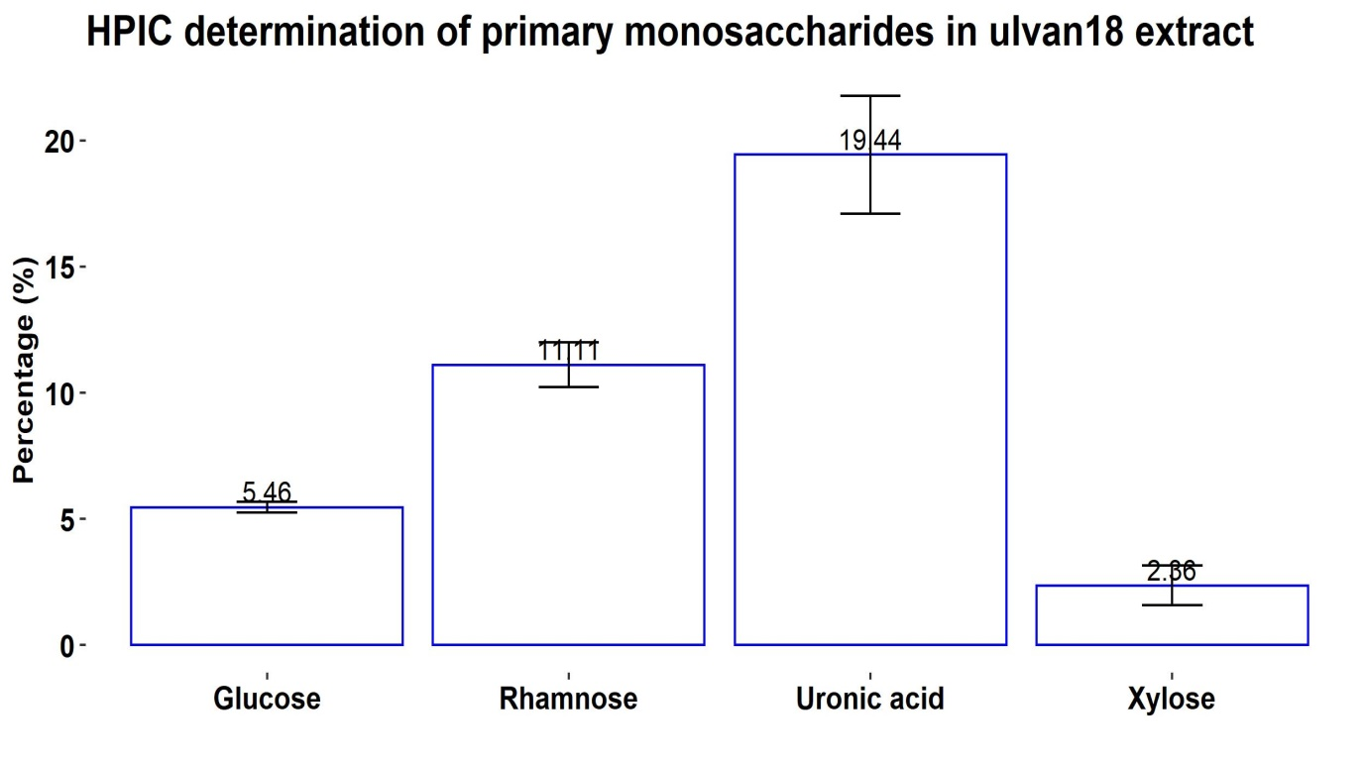
Figure S1: Monosaccharides (%) in the ulvan18 extract, obtained by acid hydrolysis and quantified using Dionex ion chromatography; n = 4, bars show ± SE.

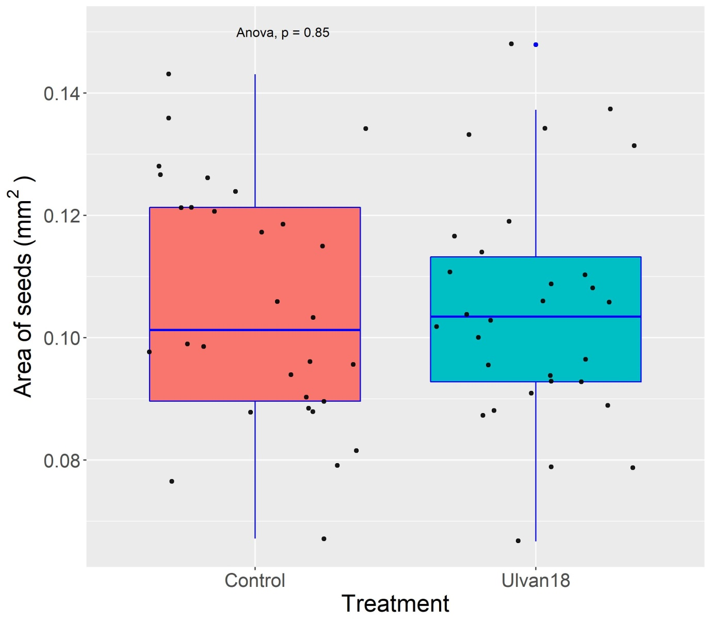
Figure S2: Average seed area for the control and treated A. thaliana plants. The results show the equivalent area for the seeds in both treatments (n=30,p = 0.85).

Figure S3: Calibration curve (built from the six groups of weighed seeds) of A. thaliana seed weight as a function of the number of seeds. The corresponding equation used to calculate the number of seeds is number of seeds = (weight of seeds + 0.1631)/0.0154

