Mitochondrial phylogenomics of eucheumatoids (Solieriaceae, Rhodophyta) from the Indo-Pacific
Supplementary Data
Figure S1. Maps of mitochondrial genomes sequenced in this study A. Kappaphycus alvarezii (MRW19); B. K. alvarezii (UMS7); C. Kappaphycus sp. (SLR7); D. K. striatus (OMD62).
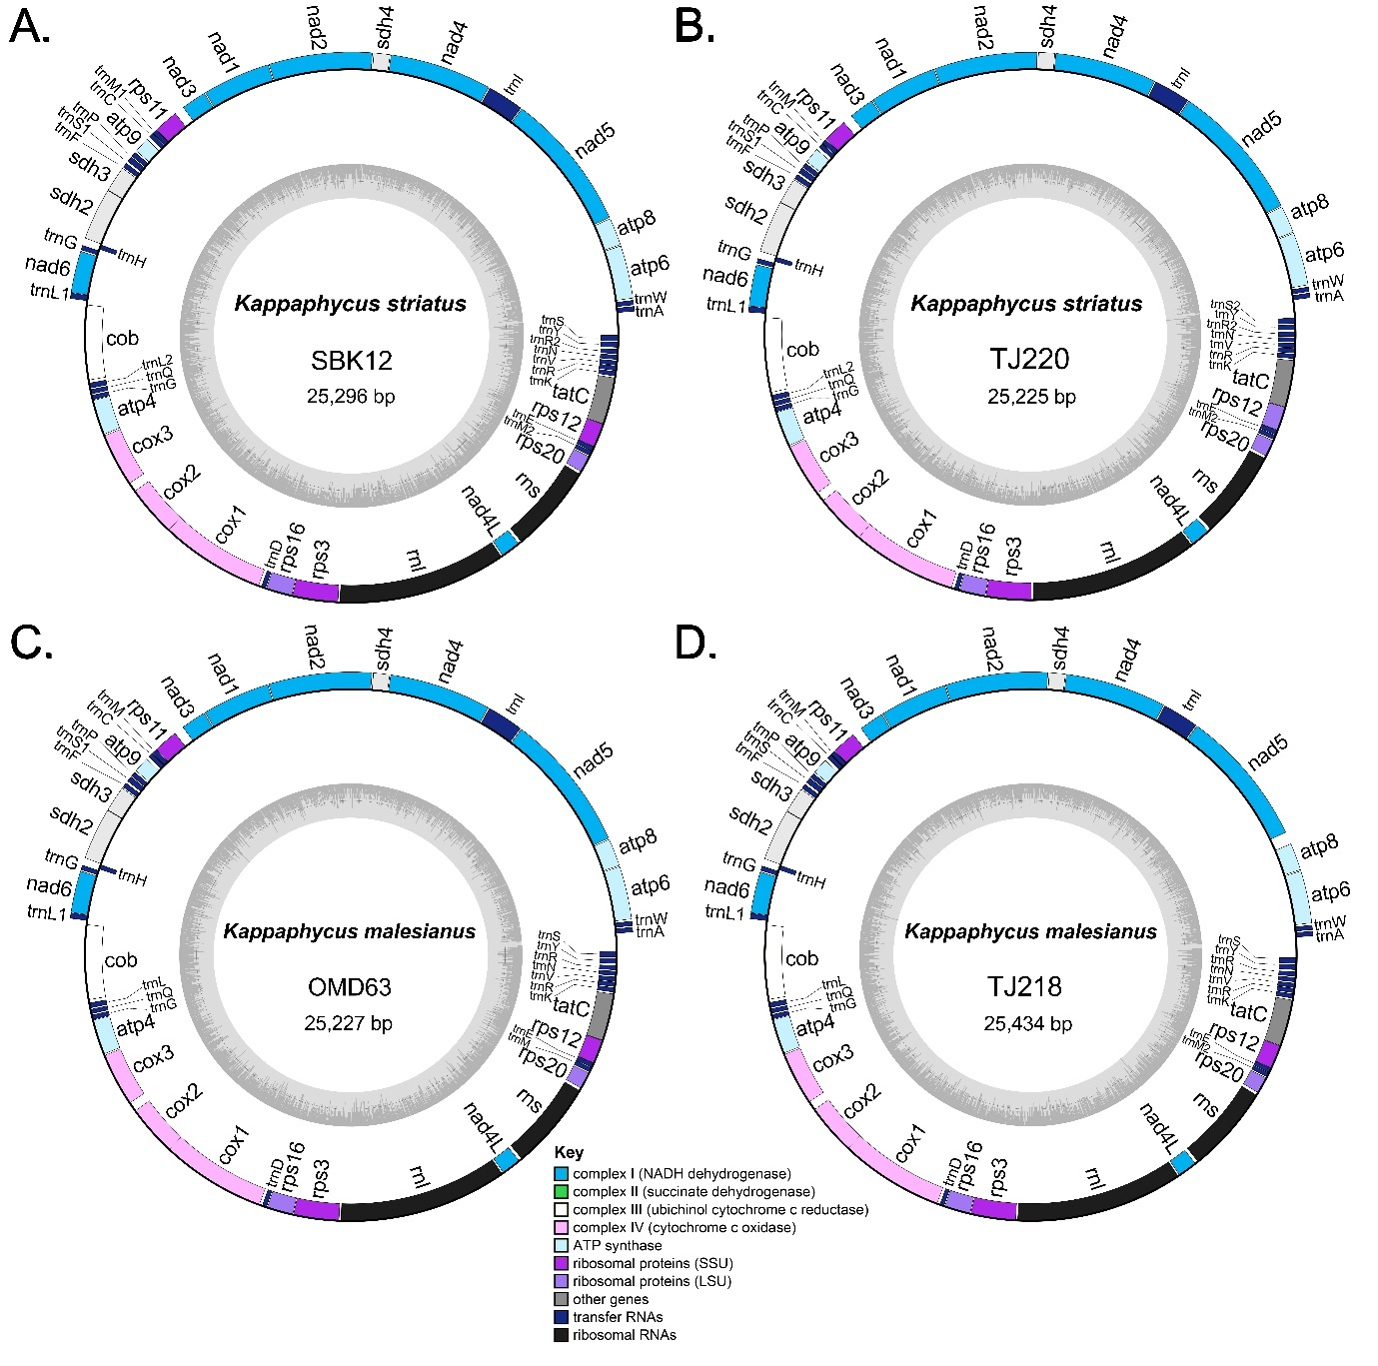

Figure S2. Maps of mitochondrial genomes sequenced in this study A. Kappaphycus striatus (SBK12); B. K. striatus (TJ220); C. K. malesianus (OMD63); D. K. malesianus (TJ218).

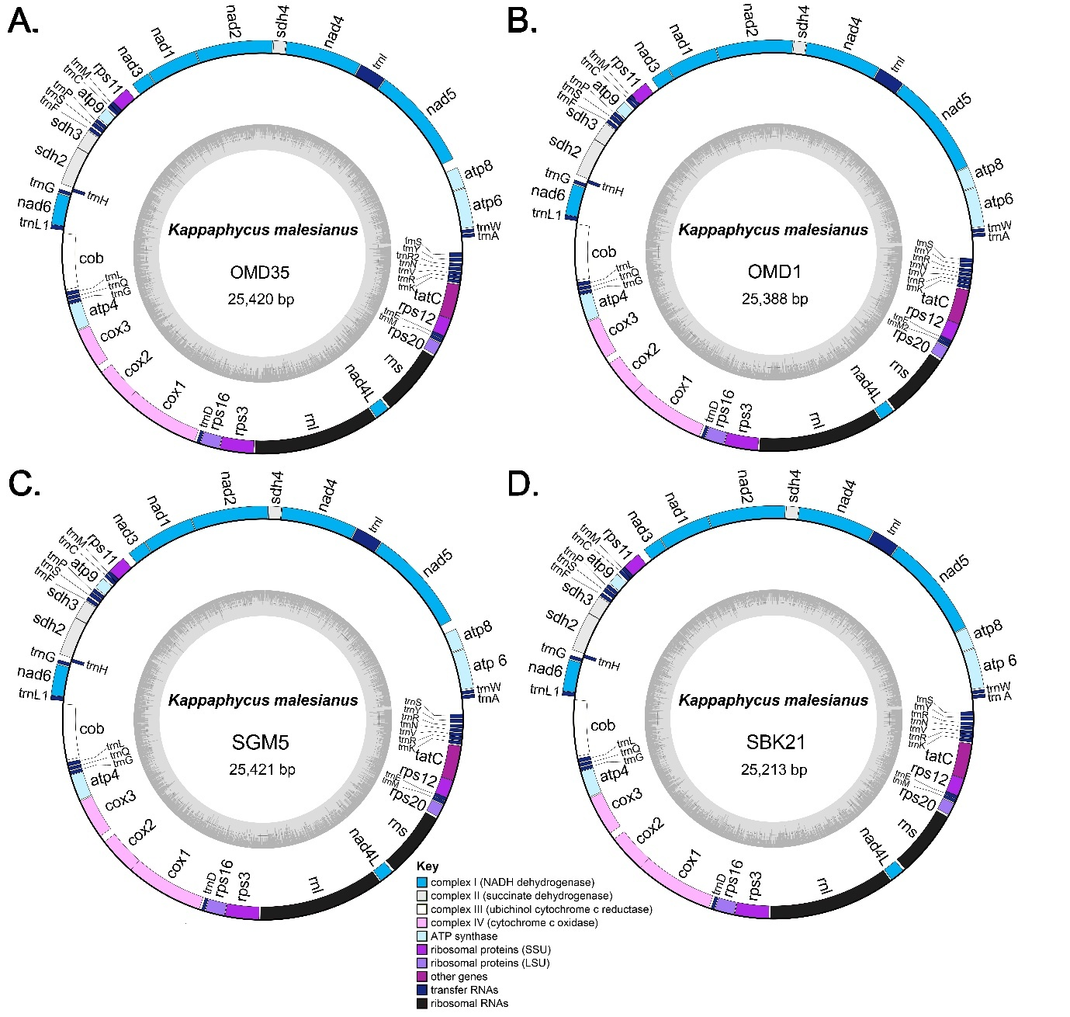

Figure S3. Maps of mitochondrial genomes sequenced in this study A. Kappaphycus malesianus (OMD35); B. K. malesianus (OMD1); C. K. malesianus (SGM5); D. K. malesianus (SBK21).
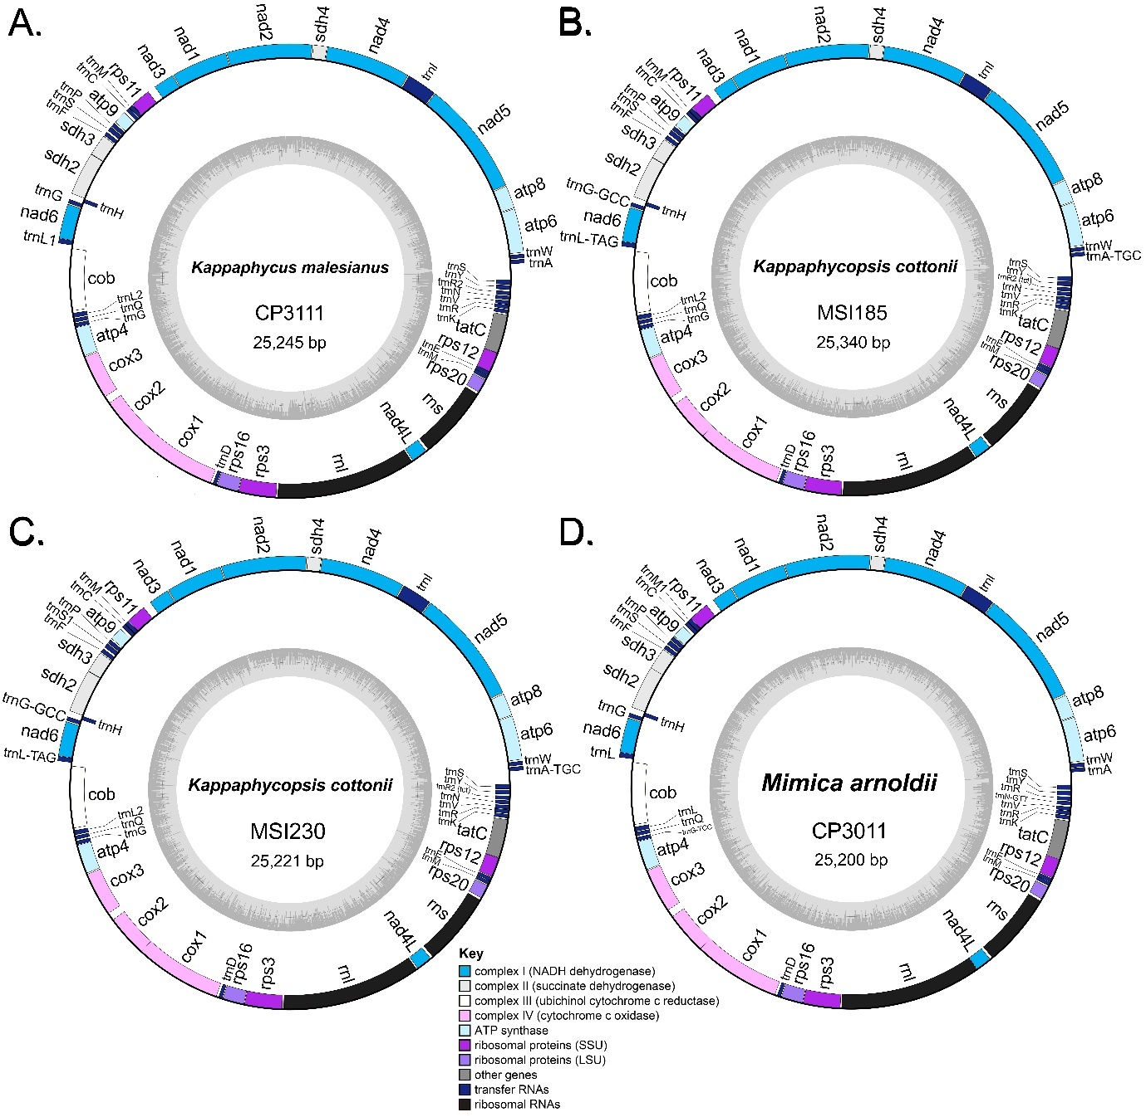

Figure S4. Maps of mitochondrial genomes sequenced in this study A. Kappaphycus malesianus (CP3111); B. Kappaphycopsis cottonii (MSI185); C. Kp. cottonii (MSI230); D. Mimica arnoldii (CP3011).
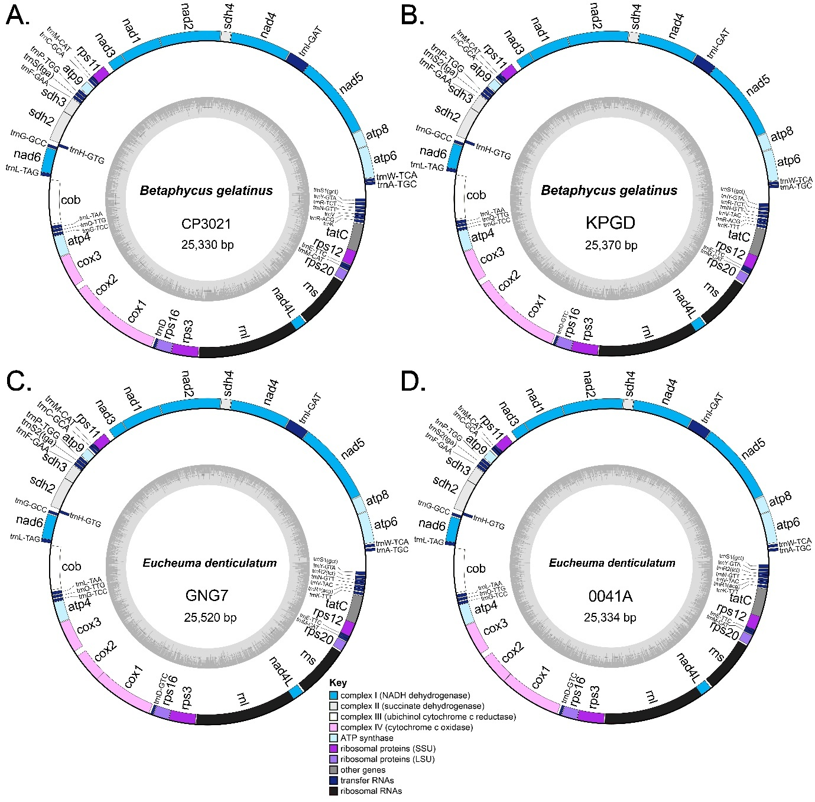

Figure S5. Maps of mitochondrial genomes sequenced in this study A. Betaphycus gelatinus (CP3021); B. B. gelatinus (KPGD); C. Eucheuma denticulatum (GNG7); D. E. denticulatum (0044A).
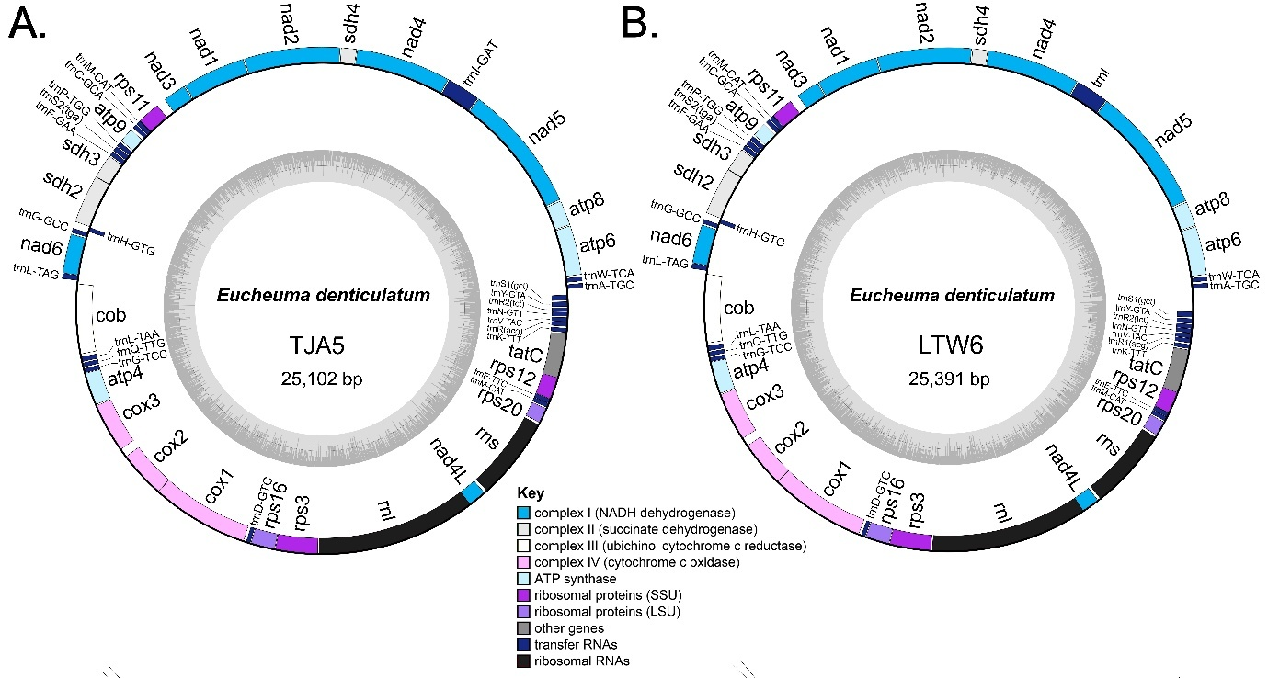

Figure S6. Maps of mitochondrial genomes sequenced in this study A. Eucheuma denticulatum (TJA5); B. E. denticulatum (LTW6).

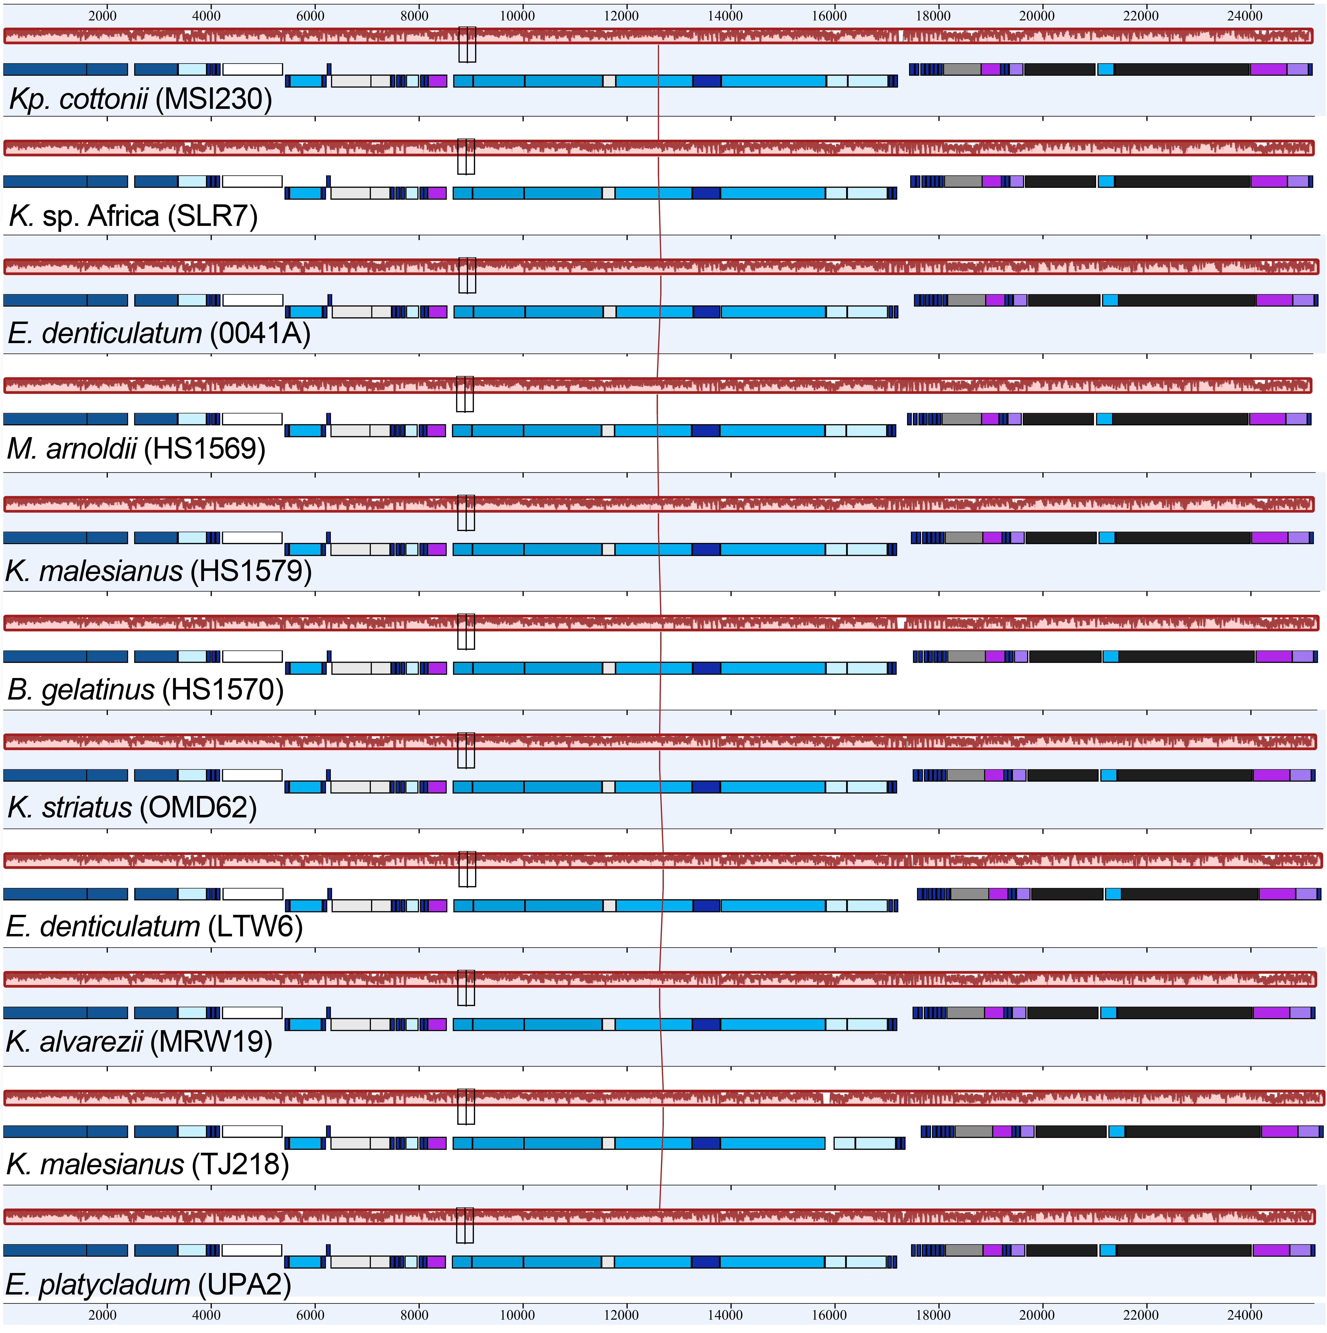
Figure S7. Whole mitogenome MAUVE alignment illustrating synteny between selected taxa from nine different eucheumatoid species.

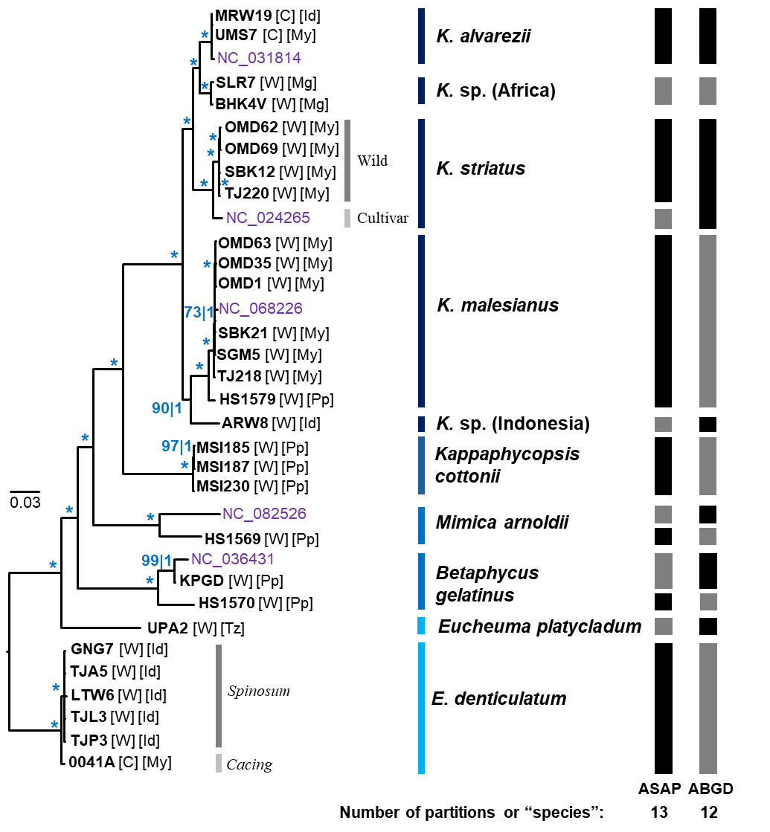
Figure S8. Simplified Bayesian tree of eucheumatoids used in this study based on all mitochondrial genes except atp6, atp8, and nad5. Numbers at nodes indicate ultrafast ML (UFML) bootstrap support and Bayesian posterior probabilities. Asterisks indicate ML = 100%; PP = 1.00. Letters in parentheses indicate cultivar (C) or wild specimen (W). Letters in square brackets indicate locality of origin: ID, Indonesia; Mg, Madagascar; My, Malaysia; Pp, Philippines; Tz, Tanzania. Black and grey boxes correspond to species groups inferred by delimitation analyses Assemble Species by Automatic Partitioning (ASAP) and Automatic Barcode Gap Discovery (ABGD). Scalebar represents number of substitutions per site.

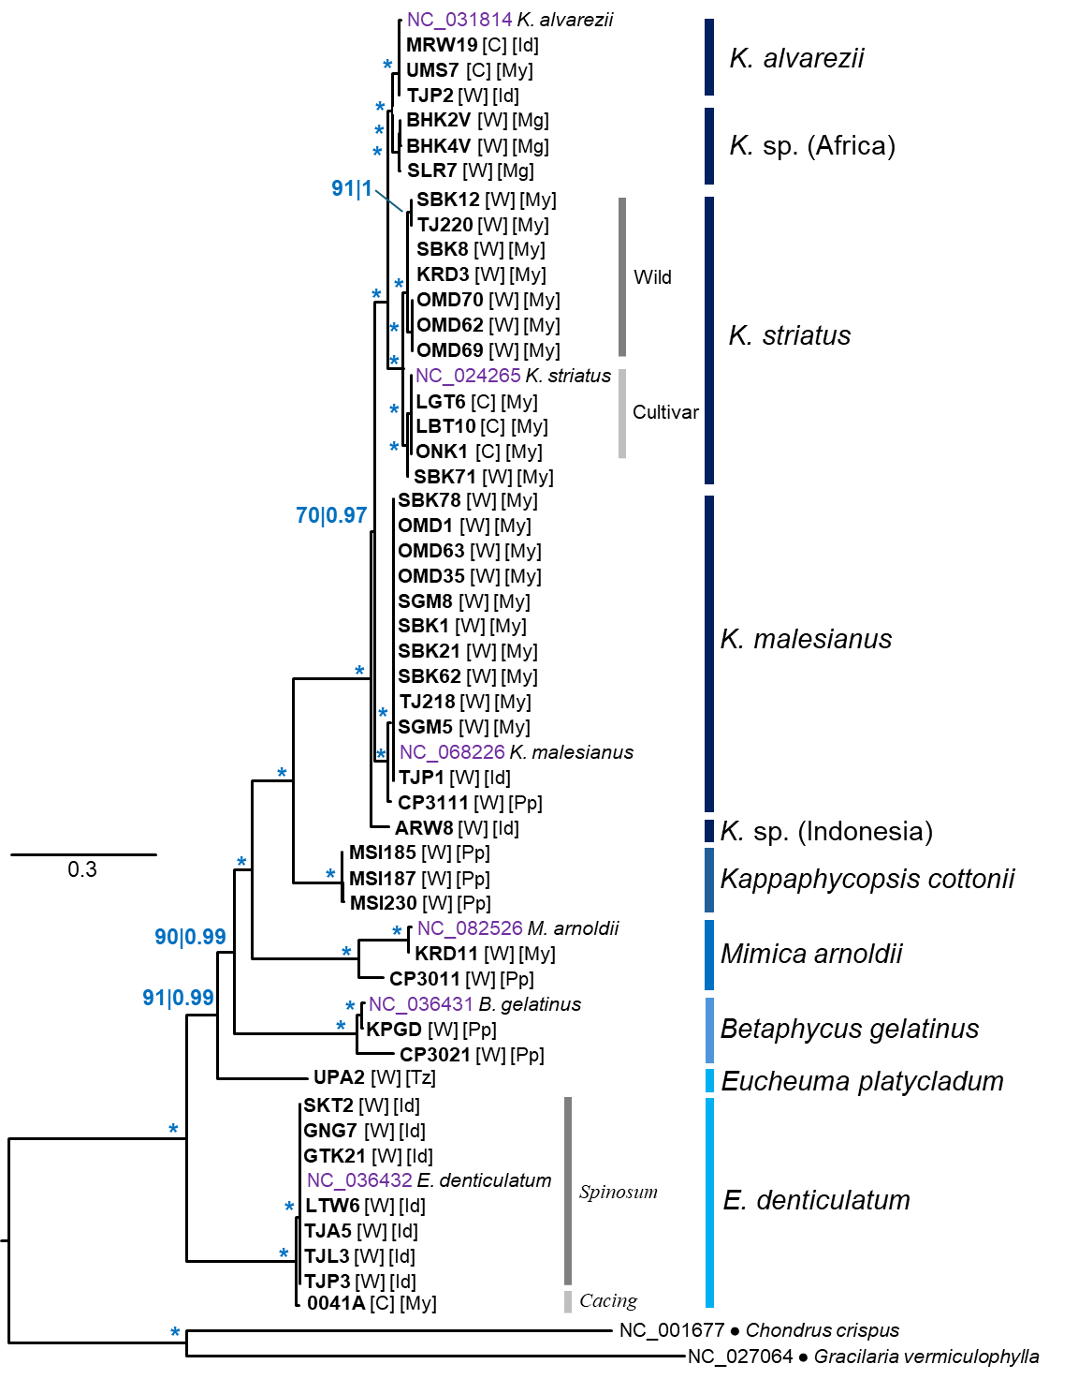
Figure S9. Bayesian tree of eucheumatoids reconstructed from the concatenated data of 24 mitochondrial protein-coding sequences (CDS). Numbers at nodes indicate ultrafast UFML bootstrap support and Bayesian posterior probabilities. Asterisks indicate ML=100%; PP=1.00. Letters in parentheses indicate cultivar (C) or wild specimen (W). Letters in parentheses indicate cultivar (C) or wild specimen (W). Letters in square brackets indicate locality of origin: ID, Indonesia; Mg, Madagascar; My, Malaysia; Pp, Philippines; Tz, Tanzania. Scale bar represents number of substitutions per site.
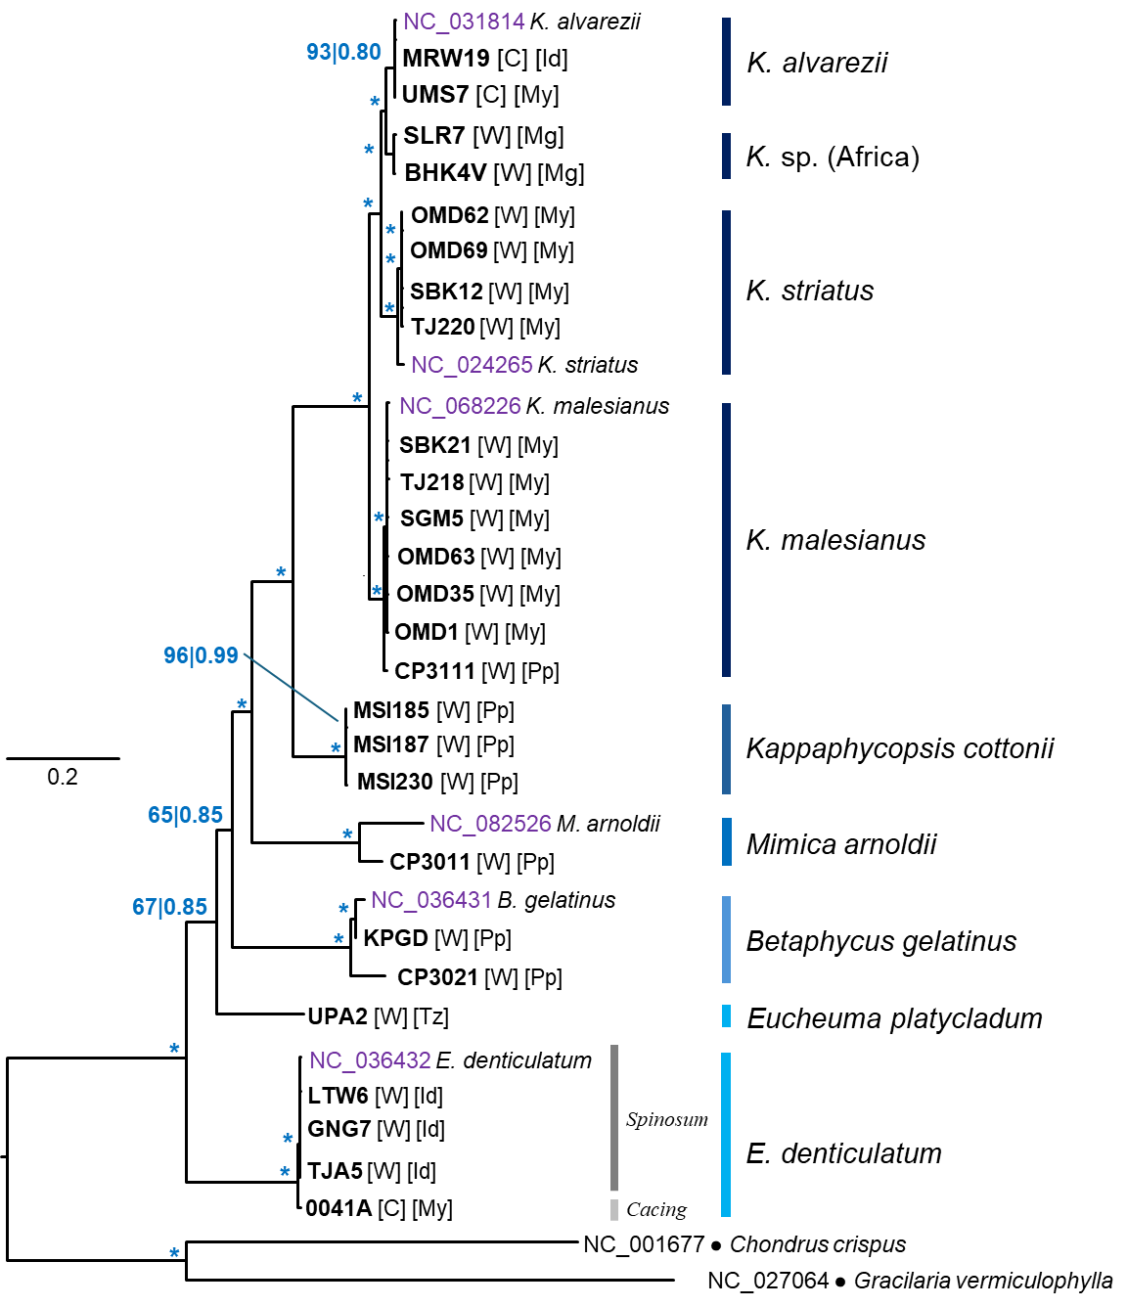
Figure S10. Bayesian tree of eucheumatoids reconstructed from concatenated mitochondrial protein-coding sequence data (CDS) derived from 26 specimens with fully sequenced mitochondrial genomes. Numbers at nodes indicate ultrafast UFML bootstrap support and Bayesian posterior probabilities. Asterisks indicate ML=100%; PP=1.00. Letters in parentheses indicate cultivar (C) or wild specimen (W). Letters in parentheses indicate cultivar (C) or wild specimen (W). Letters in square brackets indicate locality of origin: ID, Indonesia; Mg, Madagascar; My, Malaysia; Pp, Philippines; Tz, Tanzania. Scale bar represents number of substitutions per site.
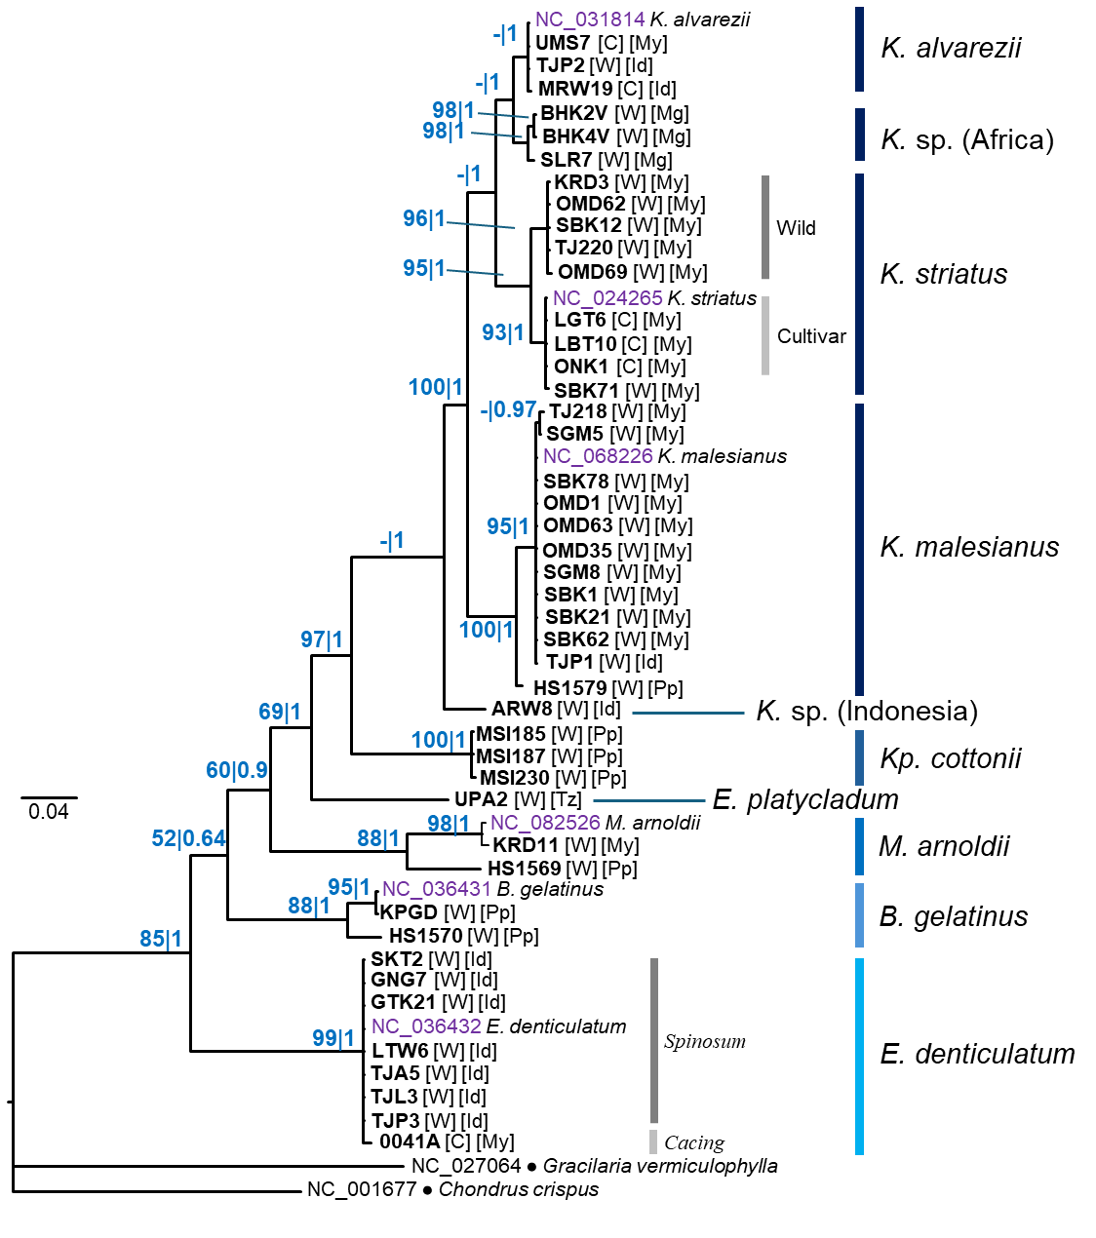
Figure S11. Bayesian tree of eucheumatoids reconstructed from the nad6 DNA marker. Numbers at nodes indicate ultrafast UFML bootstrap support and Bayesian posterior probabilities. Letters in parentheses indicate cultivar (C) or wild specimen (W). Letters in parentheses indicate cultivar (C) or wild specimen (W). Letters in square brackets indicate locality of origin: ID, Indonesia; Mg, Madagascar; My, Malaysia; Pp, Philippines; Tz, Tanzania. Scale bar represents number of substitutions per site.

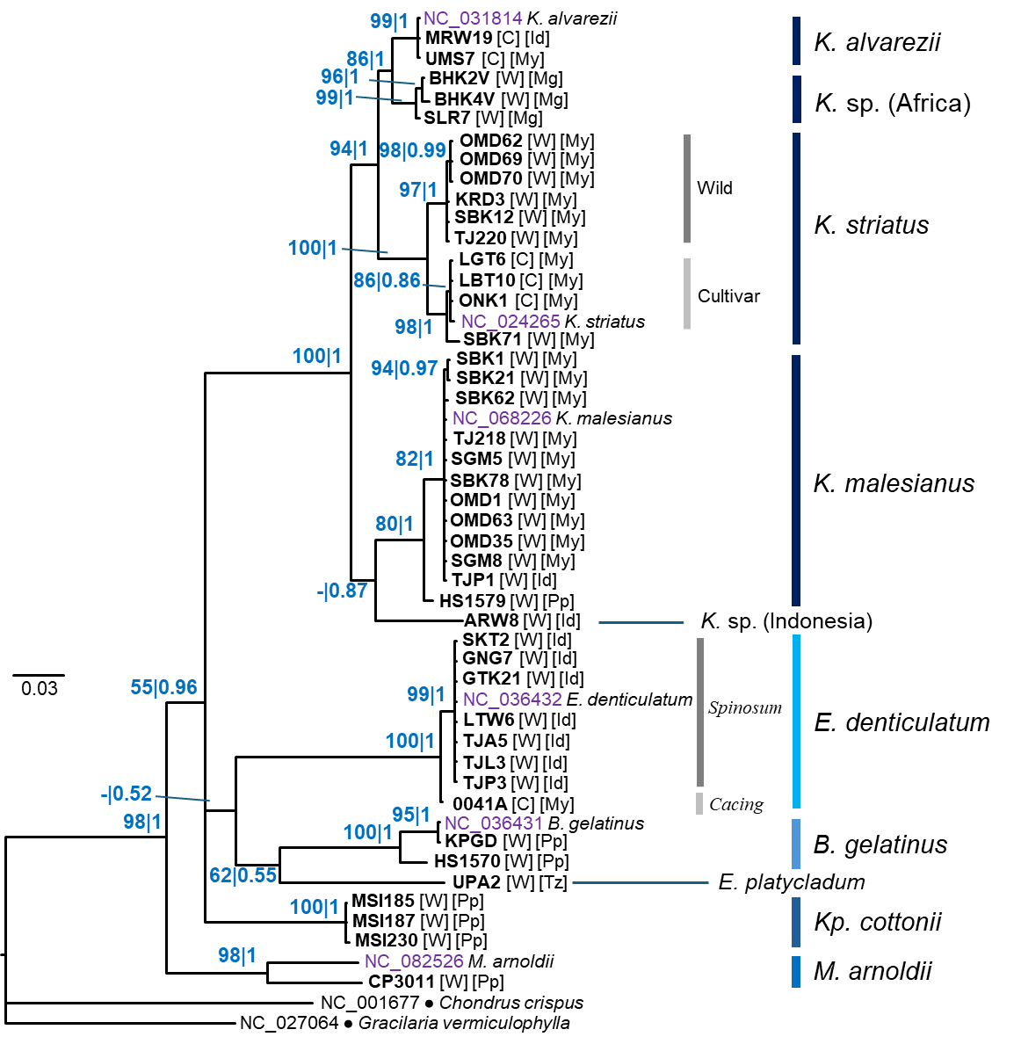
Figure S12. Bayesian tree of eucheumatoids reconstructed from the sdh2 DNA marker. Numbers at nodes indicate ultrafast UFML bootstrap support and Bayesian posterior probabilities. Letters in parentheses indicate cultivar (C) or wild specimen (W). Letters in parentheses indicate cultivar (C) or wild specimen (W). Letters in square brackets indicate locality of origin: ID, Indonesia; Mg, Madagascar; My, Malaysia; Pp, Philippines; Tz, Tanzania. Scale bar represents number of substitutions per site.

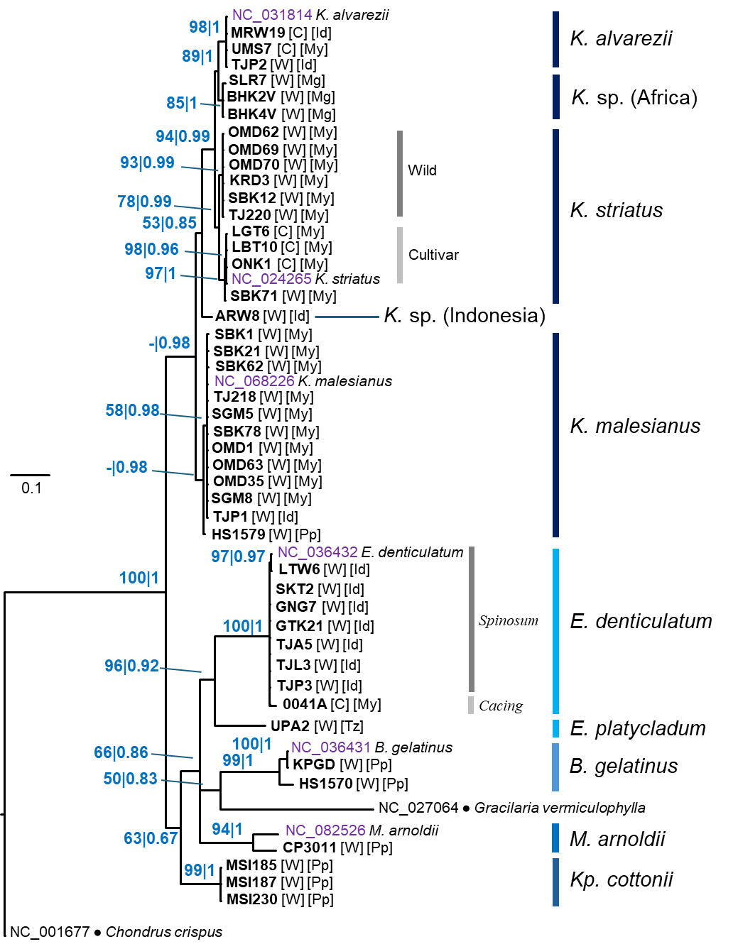
Figure S13. Bayesian tree of eucheumatoids reconstructed from the sdh3 DNA marker. Numbers at nodes indicate ultrafast UFML bootstrap support and Bayesian posterior probabilities. Letters in parentheses indicate cultivar (C) or wild specimen (W). Letters in parentheses indicate cultivar (C) or wild specimen (W). Letters in square brackets indicate locality of origin: ID, Indonesia; Mg, Madagascar; My, Malaysia; Pp, Philippines; Tz, Tanzania. Scale bar represents number of substitutions per site.
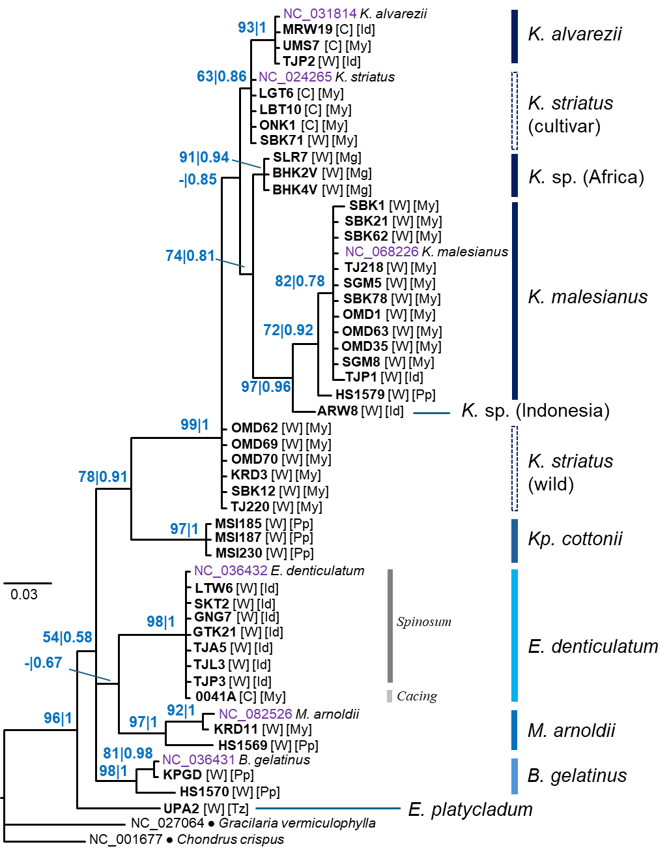
Figure S14. Bayesian tree of eucheumatoids reconstructed from the atp9 DNA marker. Numbers at nodes indicate ultrafast UFML bootstrap support and Bayesian posterior probabilities. Letters in parentheses indicate cultivar (C) or wild specimen (W). Letters in parentheses indicate cultivar (C) or wild specimen (W). Letters in square brackets indicate locality of origin: ID, Indonesia; Mg, Madagascar; My, Malaysia; Pp, Philippines; Tz, Tanzania. Scale bar represents number of substitutions per site.

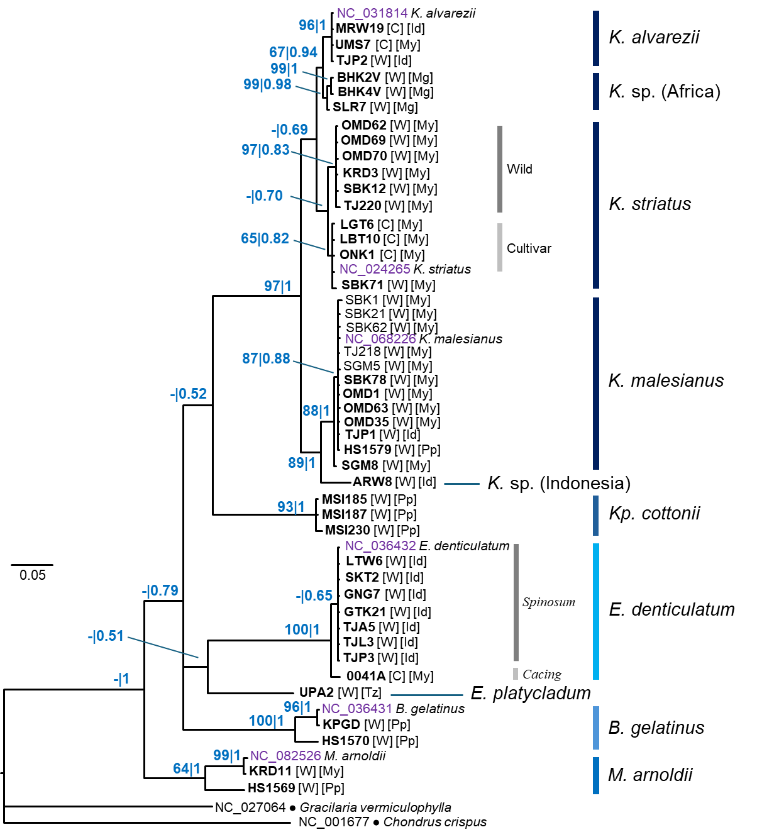
Figure S15. Bayesian tree of eucheumatoids reconstructed from the rps11 DNA marker. Numbers at nodes indicate ultrafast UFML bootstrap support and Bayesian posterior probabilities. Letters in parentheses indicate cultivar (C) or wild specimen (W). Letters in parentheses indicate cultivar (C) or wild specimen (W). Letters in square brackets indicate locality of origin: ID, Indonesia; Mg, Madagascar; My, Malaysia; Pp, Philippines; Tz, Tanzania. Scale bar represents number of substitutions per site.

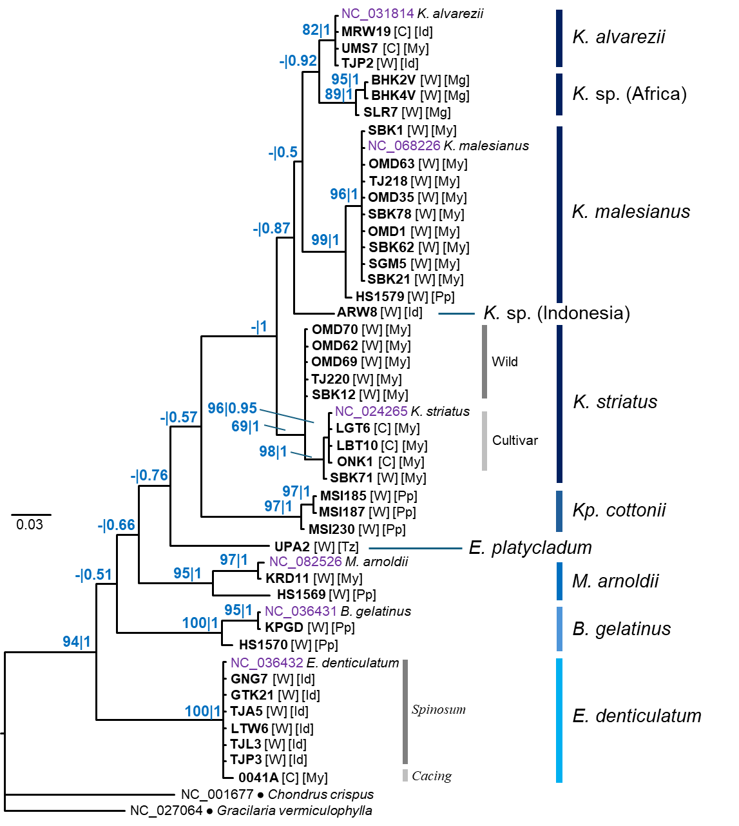
Figure S16. Bayesian tree of eucheumatoids reconstructed from the nad3 DNA marker. Numbers at nodes indicate ultrafast UFML bootstrap support and Bayesian posterior probabilities. Letters in parentheses indicate cultivar (C) or wild specimen (W). Letters in parentheses indicate cultivar (C) or wild specimen (W). Letters in square brackets indicate locality of origin: ID, Indonesia; Mg, Madagascar; My, Malaysia; Pp, Philippines; Tz, Tanzania. Scale bar represents number of substitutions per site.

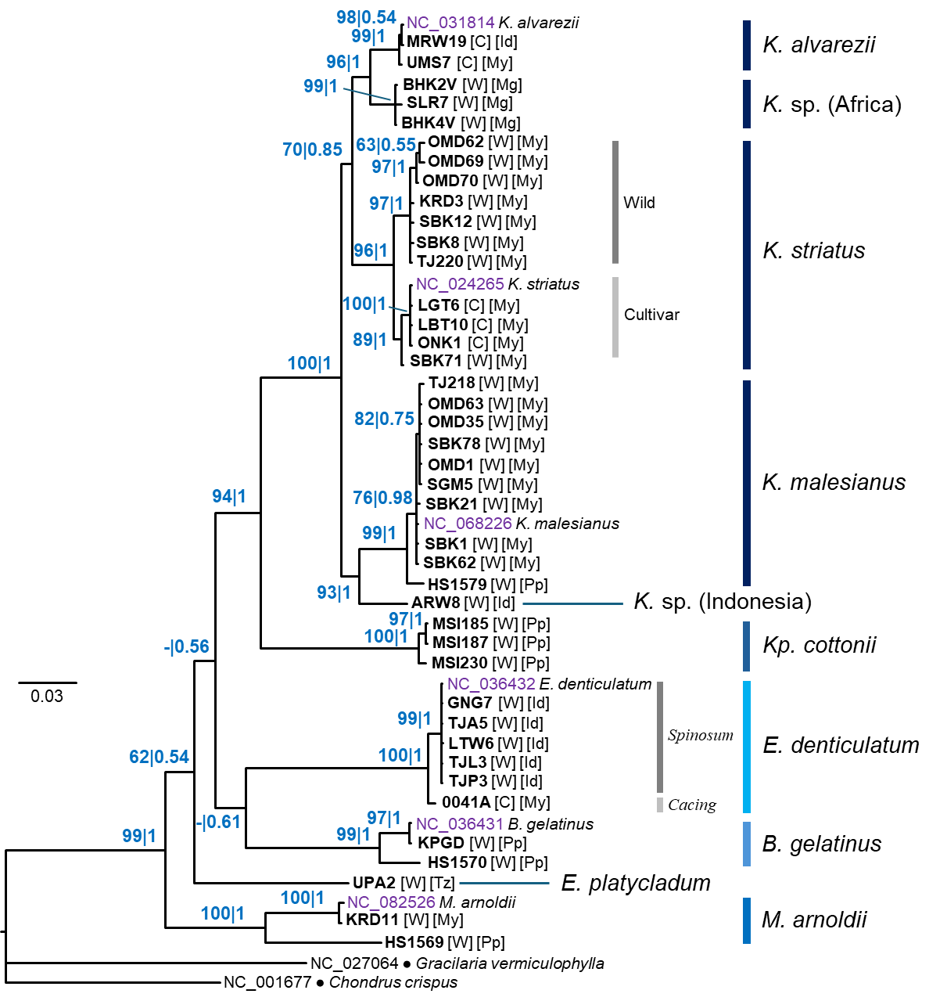
Figure S17. Bayesian tree of eucheumatoids reconstructed from the nad1 DNA marker. Numbers at nodes indicate ultrafast UFML bootstrap support and Bayesian posterior probabilities. Letters in parentheses indicate cultivar (C) or wild specimen (W). Letters in parentheses indicate cultivar (C) or wild specimen (W). Letters in square brackets indicate locality of origin: ID, Indonesia; Mg, Madagascar; My, Malaysia; Pp, Philippines; Tz, Tanzania. Scale bar represents number of substitutions per site.

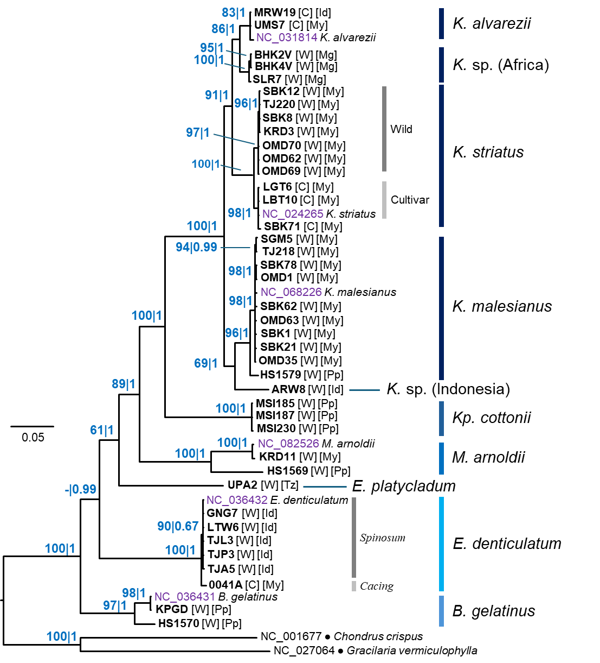
Figure S18. Bayesian tree of eucheumatoids reconstructed from the nad2 DNA marker. Numbers at nodes indicate ultrafast UFML bootstrap support and Bayesian posterior probabilities. Letters in parentheses indicate cultivar (C) or wild specimen (W). Letters in parentheses indicate cultivar (C) or wild specimen (W). Letters in square brackets indicate locality of origin: ID, Indonesia; Mg, Madagascar; My, Malaysia; Pp, Philippines; Tz, Tanzania. Scale bar represents number of substitutions per site.

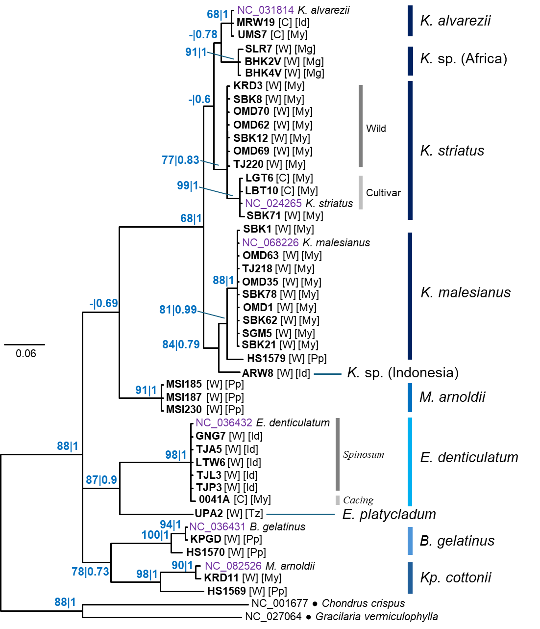
Figure S19. Bayesian tree of eucheumatoids reconstructed from the sdh4 DNA marker. Numbers at nodes indicate ultrafast UFML bootstrap support and Bayesian posterior probabilities. Letters in parentheses indicate cultivar (C) or wild specimen (W). Letters in parentheses indicate cultivar (C) or wild specimen (W). Letters in square brackets indicate locality of origin: ID, Indonesia; Mg, Madagascar; My, Malaysia; Pp, Philippines; Tz, Tanzania. Scale bar represents number of substitutions per site.
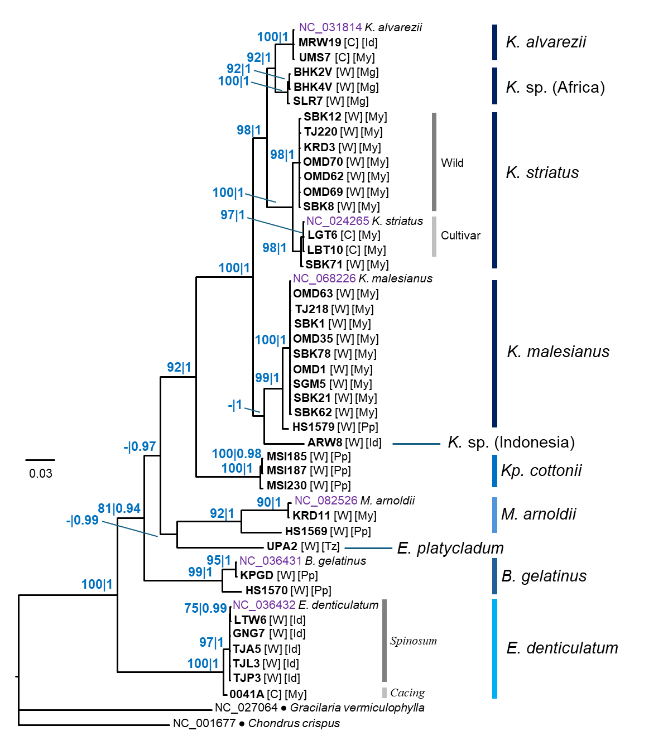
Figure S20. Bayesian tree of eucheumatoids reconstructed from the nad4 DNA marker. Numbers at nodes indicate ultrafast UFML bootstrap support and Bayesian posterior probabilities. Letters in parentheses indicate cultivar (C) or wild specimen (W). Letters in parentheses indicate cultivar (C) or wild specimen (W). Letters in square brackets indicate locality of origin: ID, Indonesia; Mg, Madagascar; My, Malaysia; Pp, Philippines; Tz, Tanzania. Scale bar represents number of substitutions per site.

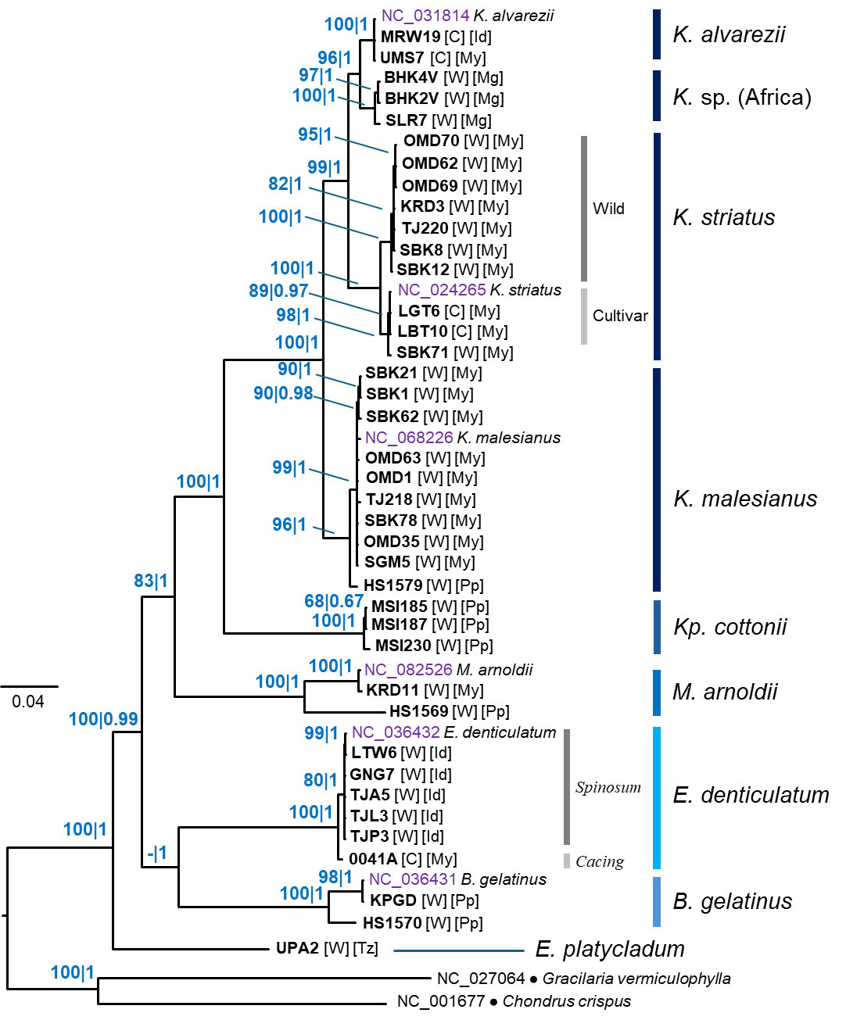
Figure S21. Bayesian tree of eucheumatoids reconstructed from the nad5 DNA marker. Numbers at nodes indicate ultrafast UFML bootstrap support and Bayesian posterior probabilities. Letters in parentheses indicate cultivar (C) or wild specimen (W). Letters in parentheses indicate cultivar (C) or wild specimen (W). Letters in square brackets indicate locality of origin: ID, Indonesia; Mg, Madagascar; My, Malaysia; Pp, Philippines; Tz, Tanzania. Scale bar represents number of substitutions per site.

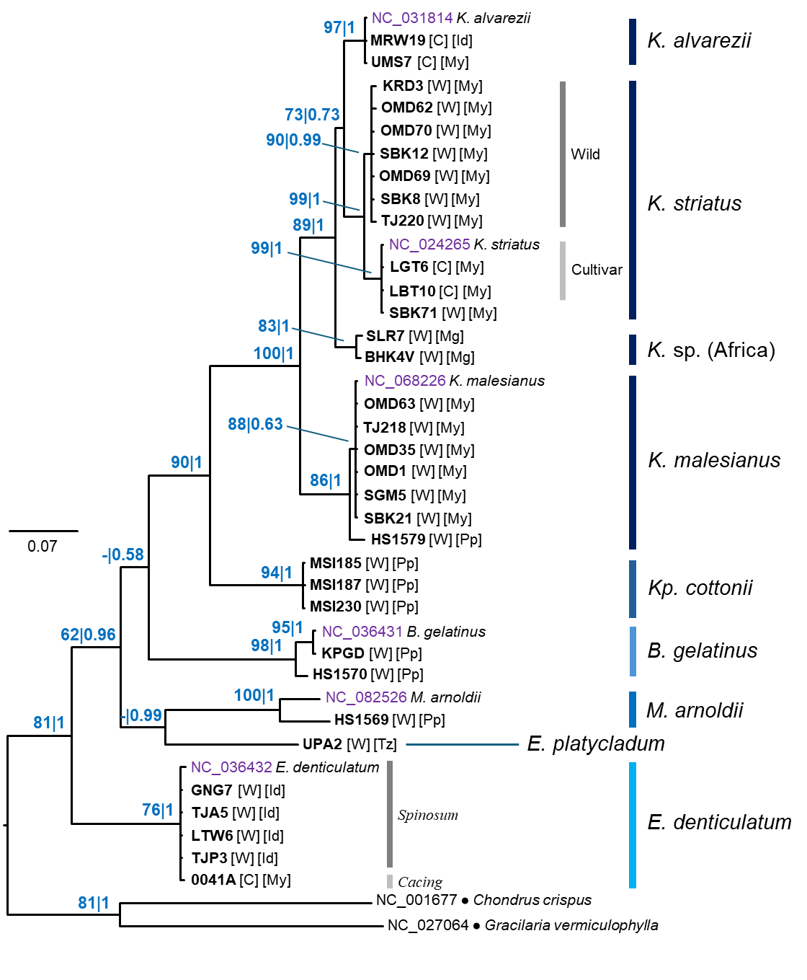
Figure S22. Bayesian tree of eucheumatoids reconstructed from the atp8 DNA marker. Numbers at nodes indicate ultrafast UFML bootstrap support and Bayesian posterior probabilities. Letters in parentheses indicate cultivar (C) or wild specimen (W). Letters in parentheses indicate cultivar (C) or wild specimen (W). Letters in square brackets indicate locality of origin: ID, Indonesia; Mg, Madagascar; My, Malaysia; Pp, Philippines; Tz, Tanzania. Scale bar represents number of substitutions per site.

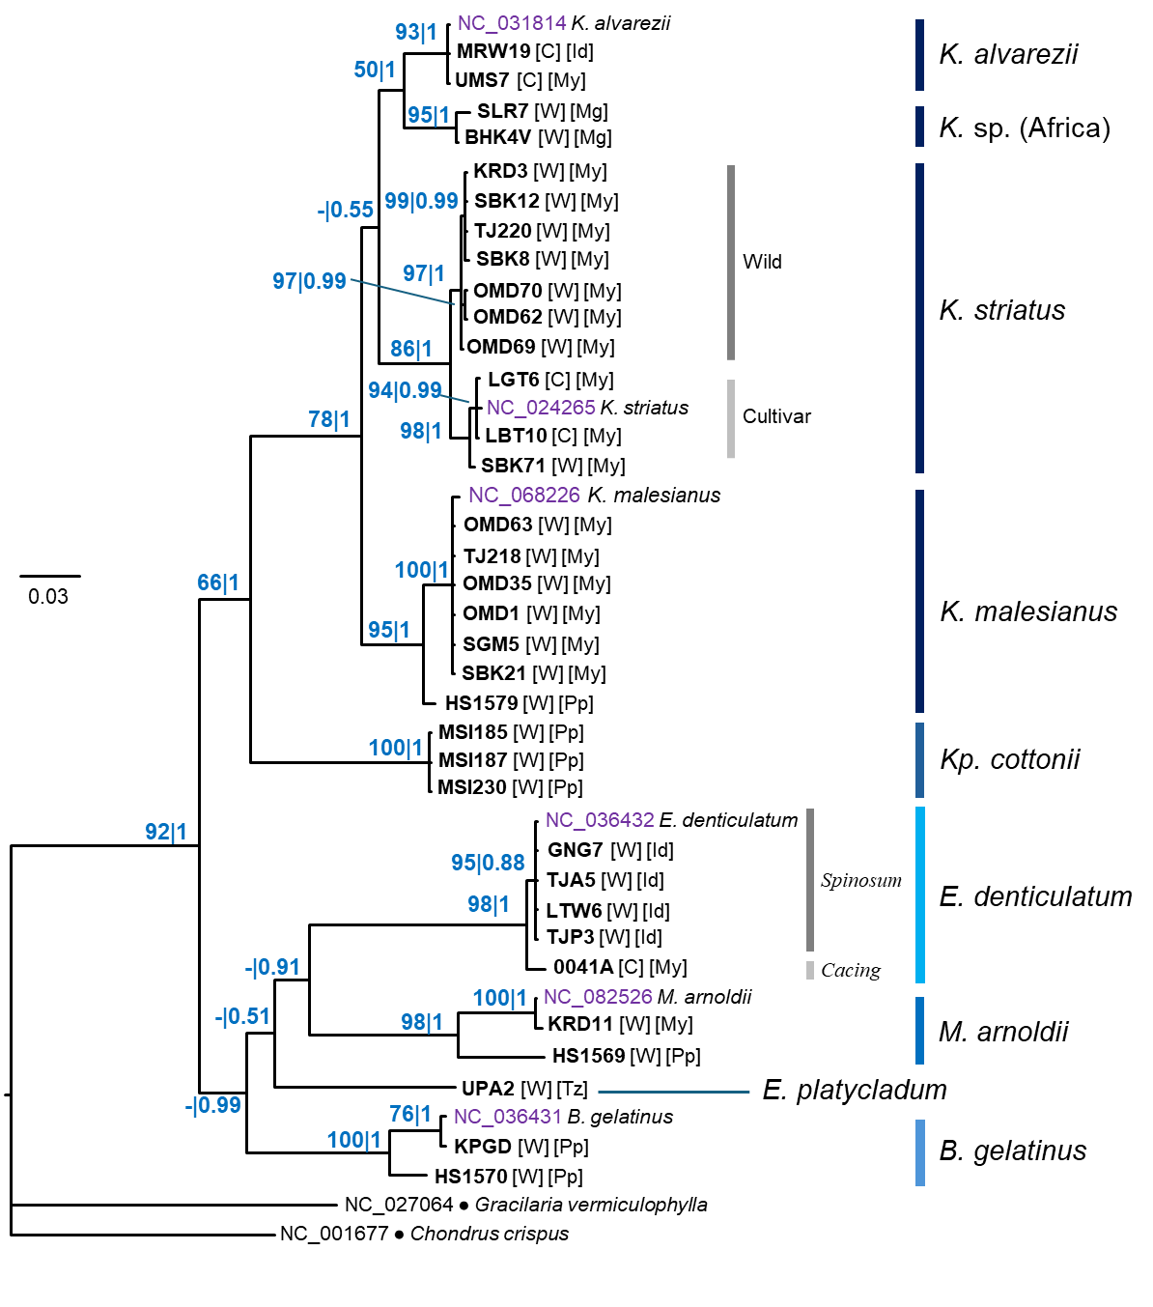
Figure S23. Bayesian tree of eucheumatoids reconstructed from the atp6 DNA marker. Numbers at nodes indicate ultrafast UFML bootstrap support and Bayesian posterior probabilities. Letters in parentheses indicate cultivar (C) or wild specimen (W). Letters in parentheses indicate cultivar (C) or wild specimen (W). Letters in square brackets indicate locality of origin: ID, Indonesia; Mg, Madagascar; My, Malaysia; Pp, Philippines; Tz, Tanzania. Scale bar represents number of substitutions per site.

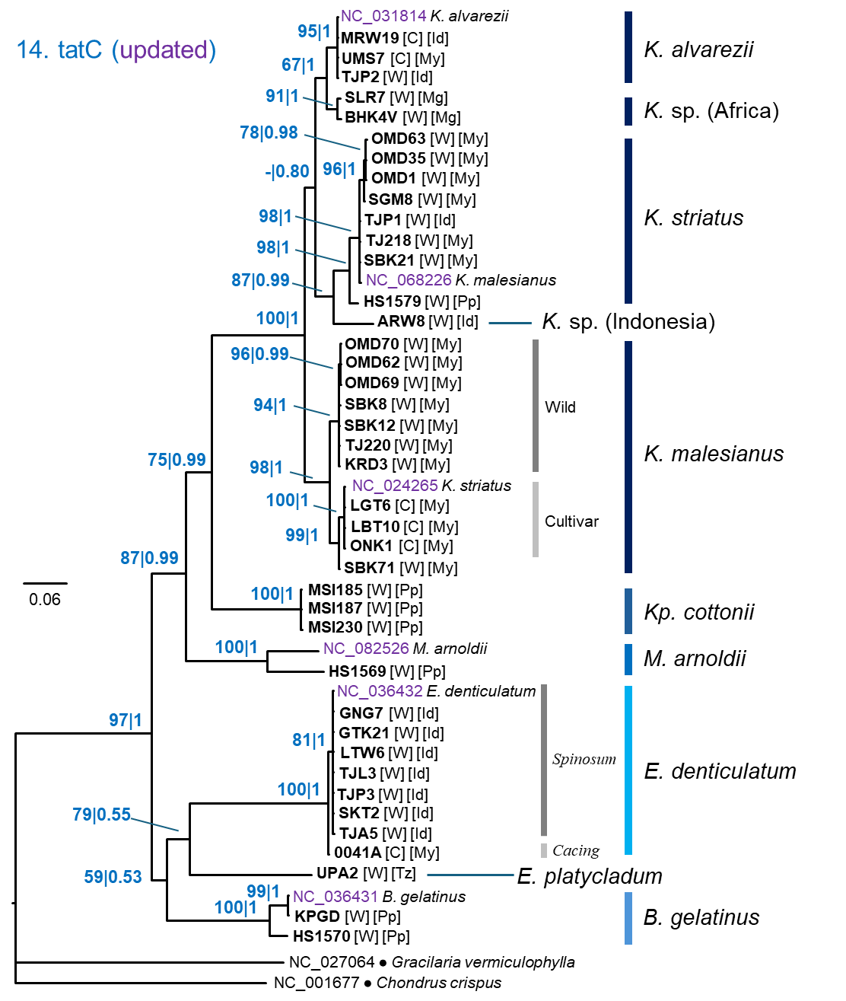
Figure S24. Bayesian tree of eucheumatoids reconstructed from the tatC DNA marker. Numbers at nodes indicate ultrafast UFML bootstrap support and Bayesian posterior probabilities. Letters in parentheses indicate cultivar (C) or wild specimen (W). Letters in parentheses indicate cultivar (C) or wild specimen (W). Letters in square brackets indicate locality of origin: ID, Indonesia; Mg, Madagascar; My, Malaysia; Pp, Philippines; Tz, Tanzania. Scale bar represents number of substitutions per site.

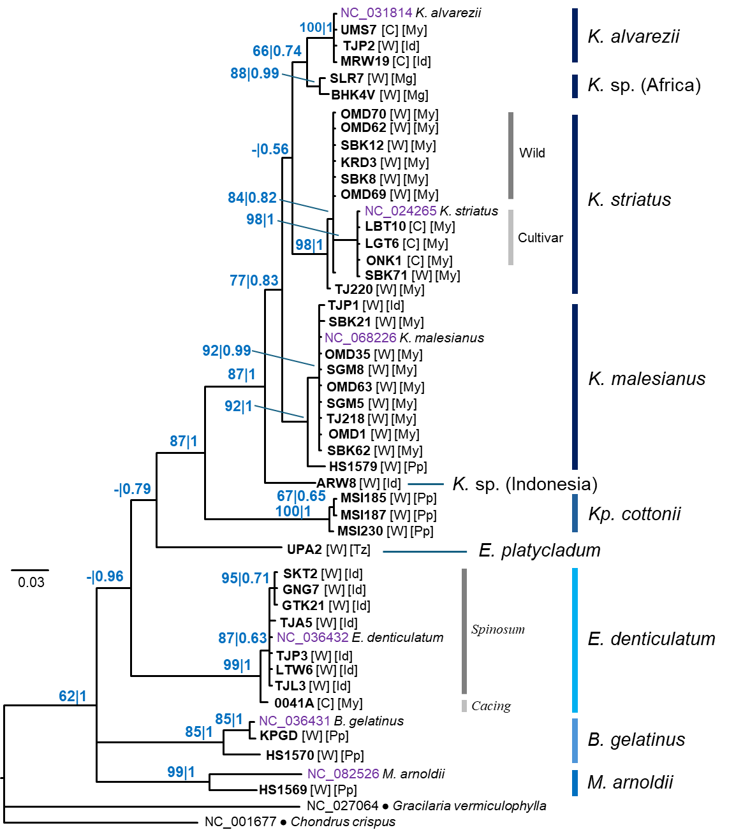
Figure S25. Bayesian tree of eucheumatoids reconstructed from the rps12 DNA marker. Numbers at nodes indicate ultrafast UFML bootstrap support and Bayesian posterior probabilities. Letters in parentheses indicate cultivar (C) or wild specimen (W). Letters in parentheses indicate cultivar (C) or wild specimen (W). Letters in square brackets indicate locality of origin: ID, Indonesia; Mg, Madagascar; My, Malaysia; Pp, Philippines; Tz, Tanzania. Scale bar represents number of substitutions per site.

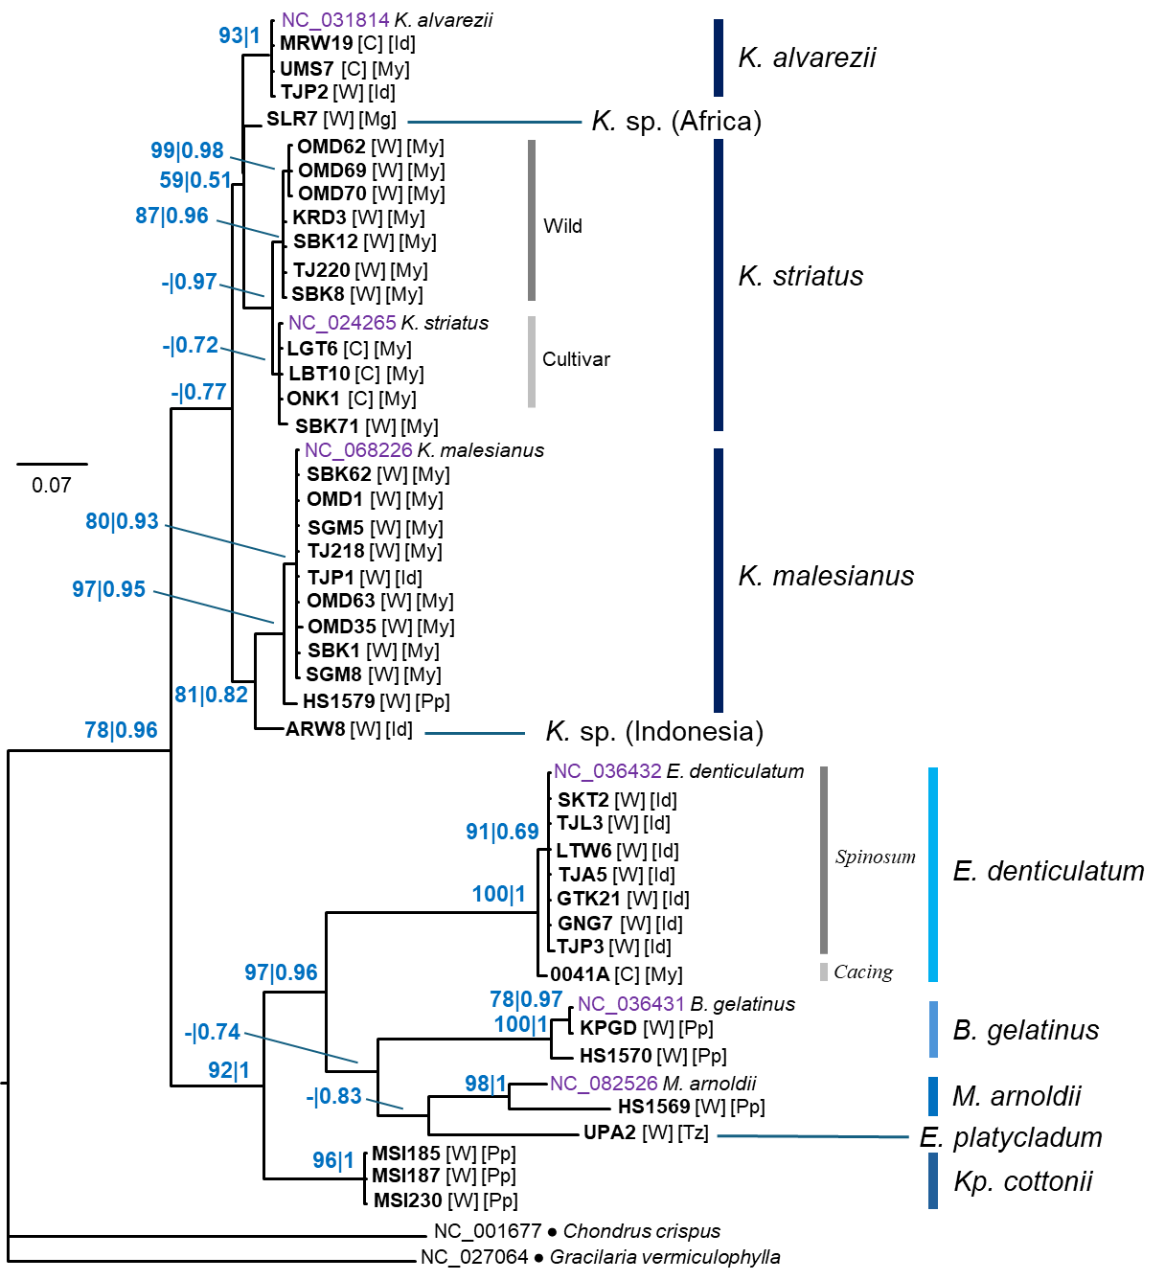
Figure S26. Bayesian tree of eucheumatoids reconstructed from the rpl20 DNA marker. Numbers at nodes indicate ultrafast UFML bootstrap support and Bayesian posterior probabilities. Letters in parentheses indicate cultivar (C) or wild specimen (W). Letters in parentheses indicate cultivar (C) or wild specimen (W). Letters in square brackets indicate locality of origin: ID, Indonesia; Mg, Madagascar; My, Malaysia; Pp, Philippines; Tz, Tanzania. Scale bar represents number of substitutions per site.

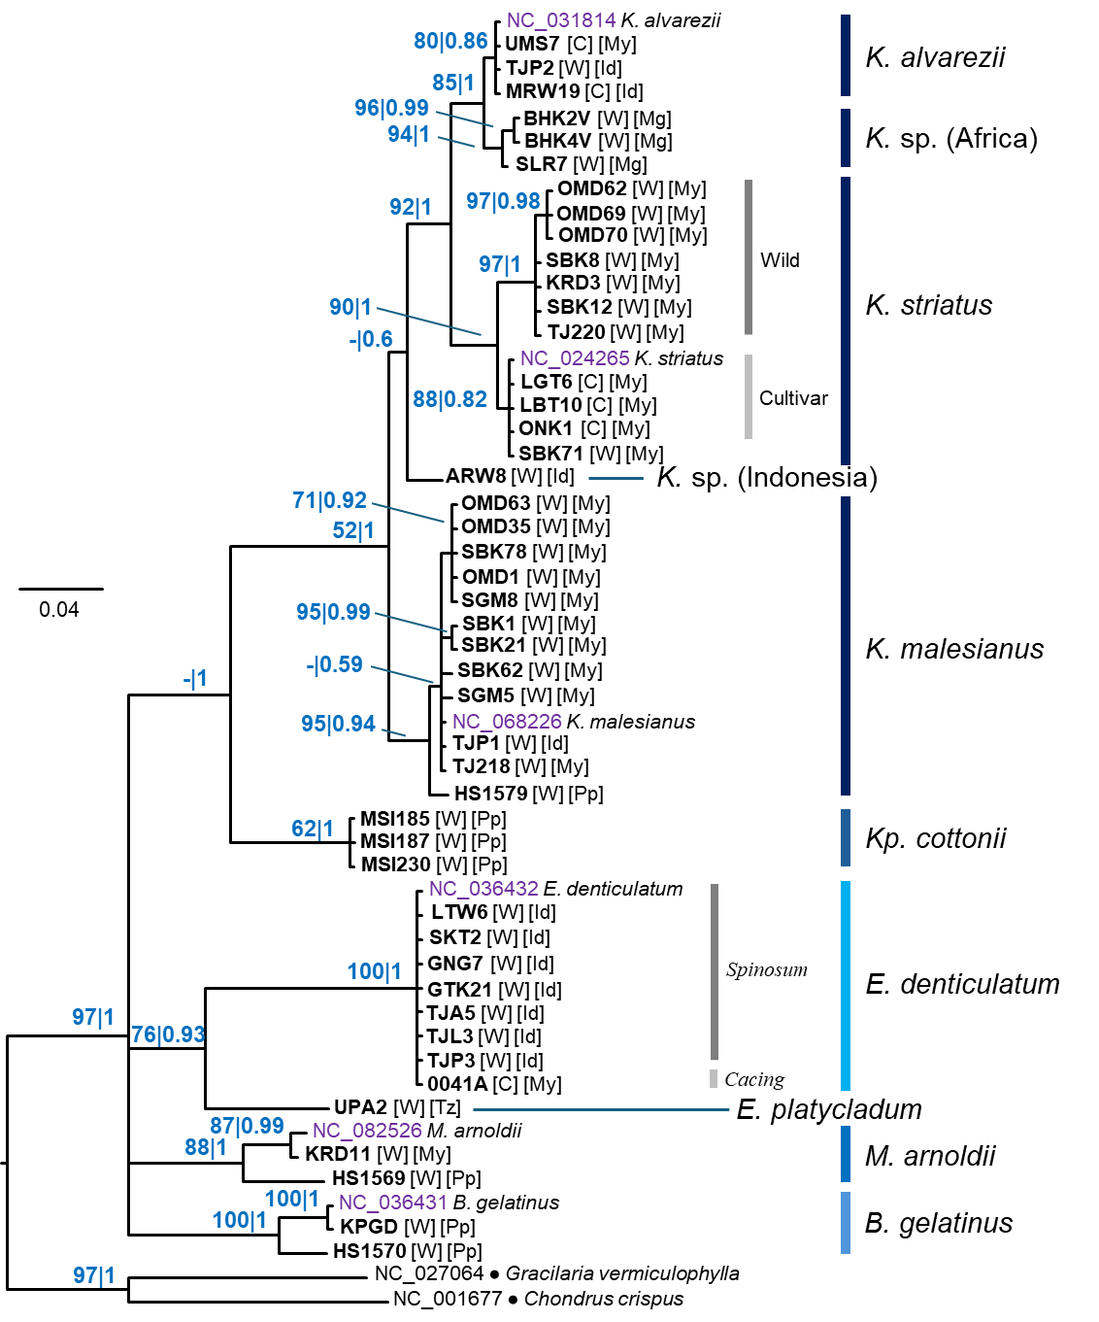
Figure S27. Bayesian tree of eucheumatoids reconstructed from the nad4L DNA marker. Numbers at nodes indicate ultrafast UFML bootstrap support and Bayesian posterior probabilities. Letters in parentheses indicate cultivar (C) or wild specimen (W). Letters in parentheses indicate cultivar (C) or wild specimen (W). Letters in square brackets indicate locality of origin: ID, Indonesia; Mg, Madagascar; My, Malaysia; Pp, Philippines; Tz, Tanzania. Scale bar represents number of substitutions per site.

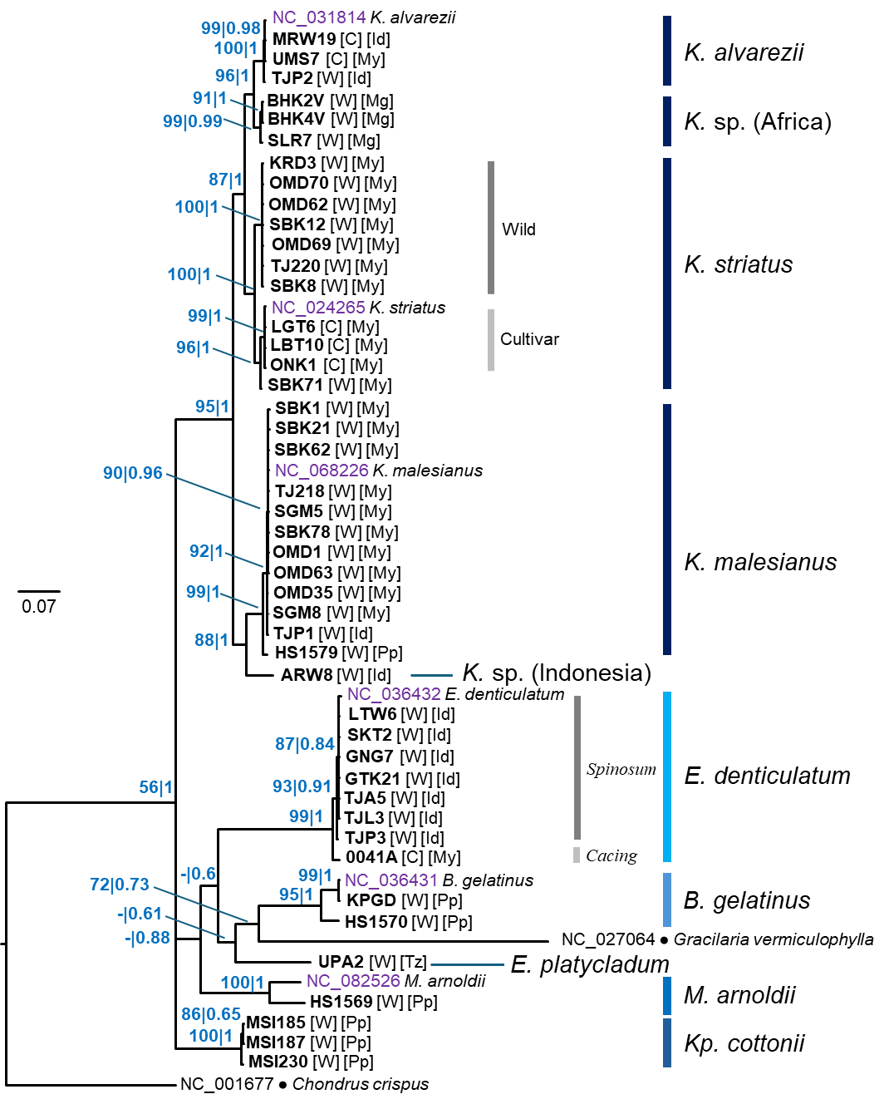
Figure S28. Bayesian tree of eucheumatoids reconstructed from the rps3 DNA marker. Numbers at nodes indicate ultrafast UFML bootstrap support and Bayesian posterior probabilities. Letters in parentheses indicate cultivar (C) or wild specimen (W). Letters in parentheses indicate cultivar (C) or wild specimen (W). Letters in square brackets indicate locality of origin: ID, Indonesia; Mg, Madagascar; My, Malaysia; Pp, Philippines; Tz, Tanzania. Scale bar represents number of substitutions per site.
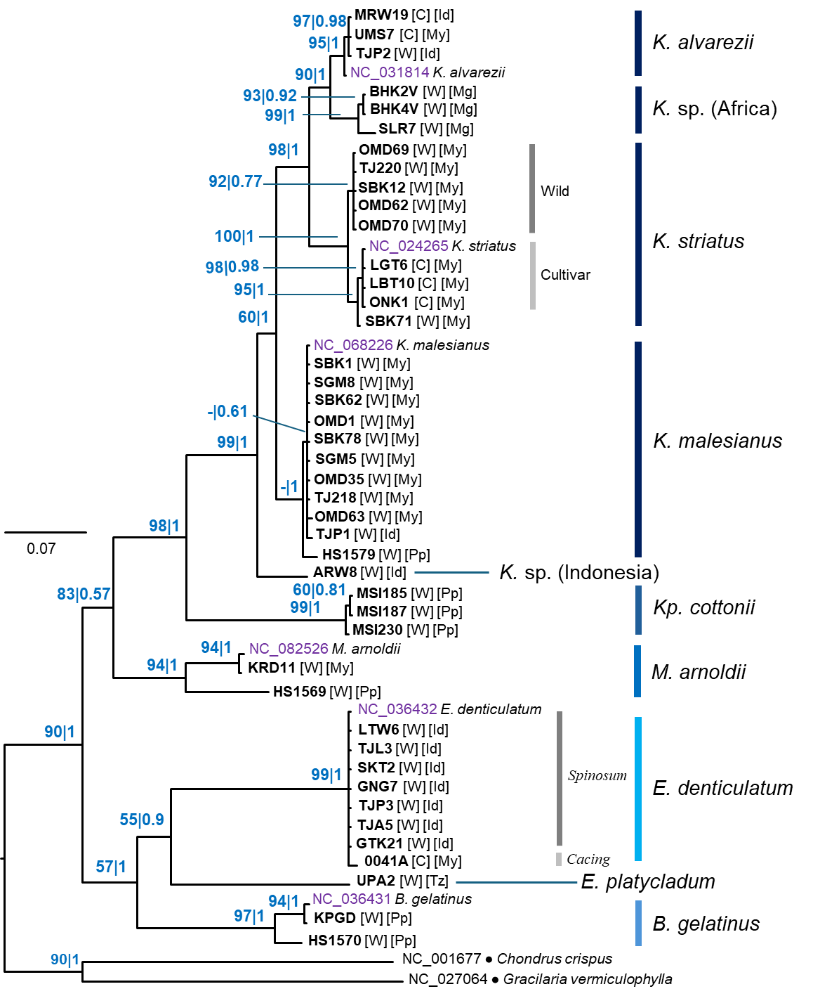
Figure S29. Bayesian tree of eucheumatoids reconstructed from the rpl16 DNA marker. Numbers at nodes indicate ultrafast UFML bootstrap support and Bayesian posterior probabilities. Letters in parentheses indicate cultivar (C) or wild specimen (W). Letters in parentheses indicate cultivar (C) or wild specimen (W). Letters in square brackets indicate locality of origin: ID, Indonesia; Mg, Madagascar; My, Malaysia; Pp, Philippines; Tz, Tanzania. Scale bar represents number of substitutions per site.

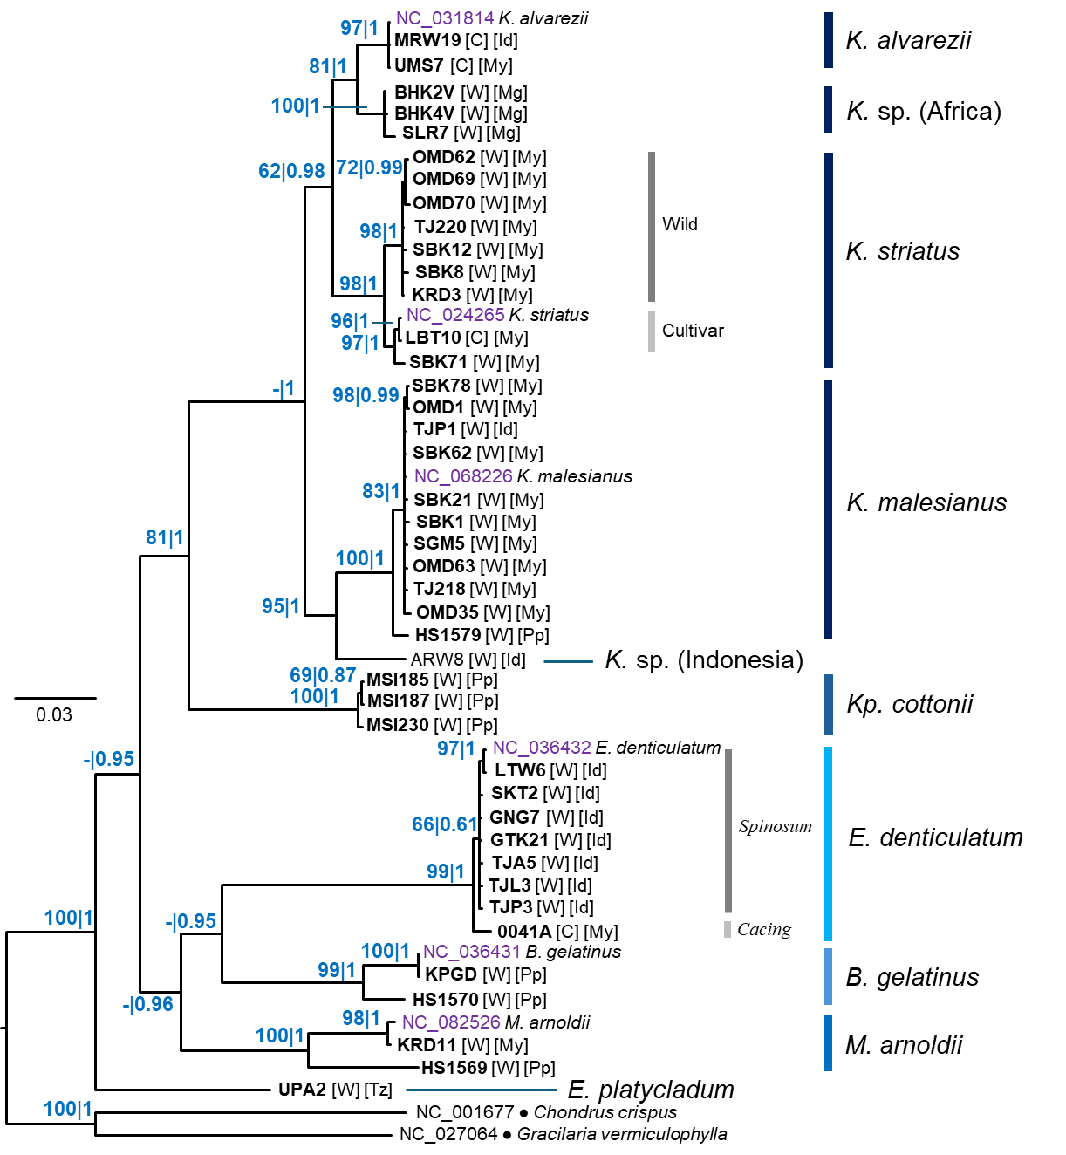
Figure S30. Bayesian tree of eucheumatoids reconstructed from the cox1 DNA marker. Numbers at nodes indicate ultrafast UFML bootstrap support and Bayesian posterior probabilities. Letters in parentheses indicate cultivar (C) or wild specimen (W). Letters in parentheses indicate cultivar (C) or wild specimen (W). Letters in square brackets indicate locality of origin: ID, Indonesia; Mg, Madagascar; My, Malaysia; Pp, Philippines; Tz, Tanzania. Scale bar represents number of substitutions per site.

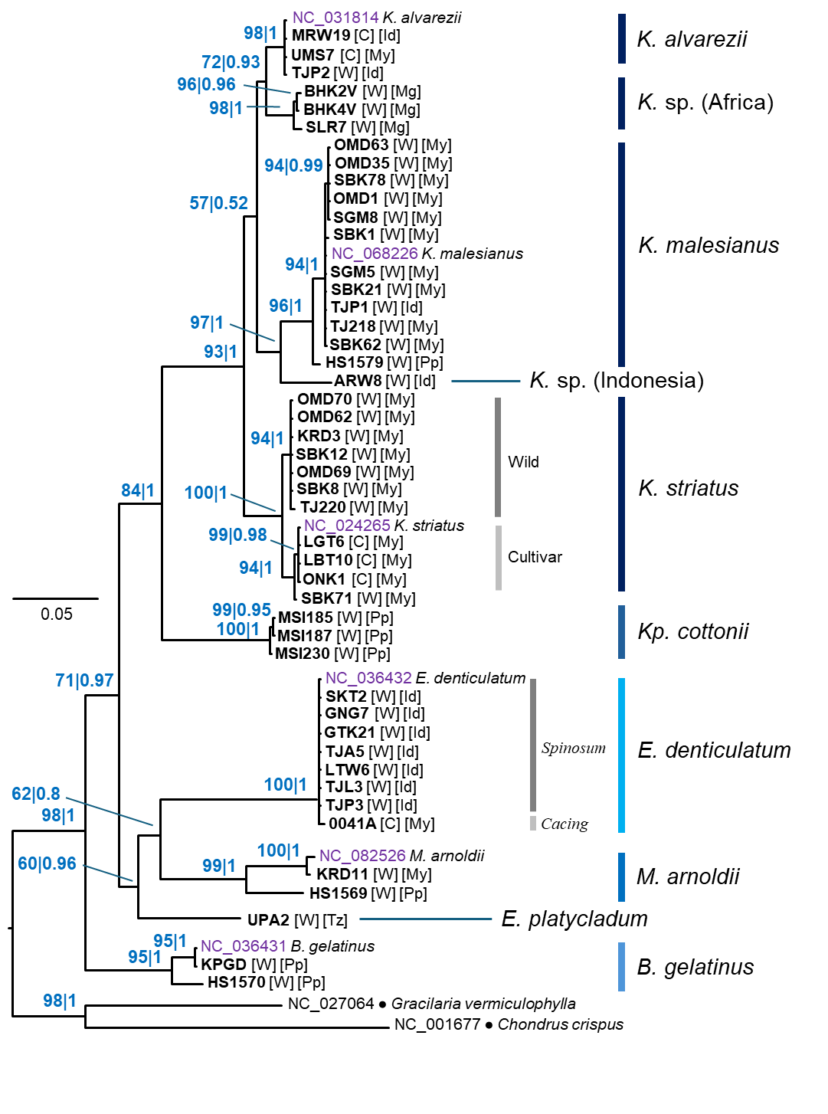
Figure S31. Bayesian tree of eucheumatoids reconstructed from the cox2 DNA marker. Numbers at nodes indicate ultrafast UFML bootstrap support and Bayesian posterior probabilities. Letters in parentheses indicate cultivar (C) or wild specimen (W). Letters in parentheses indicate cultivar (C) or wild specimen (W). Letters in square brackets indicate locality of origin: ID, Indonesia; Mg, Madagascar; My, Malaysia; Pp, Philippines; Tz, Tanzania. Scale bar represents number of substitutions per site.
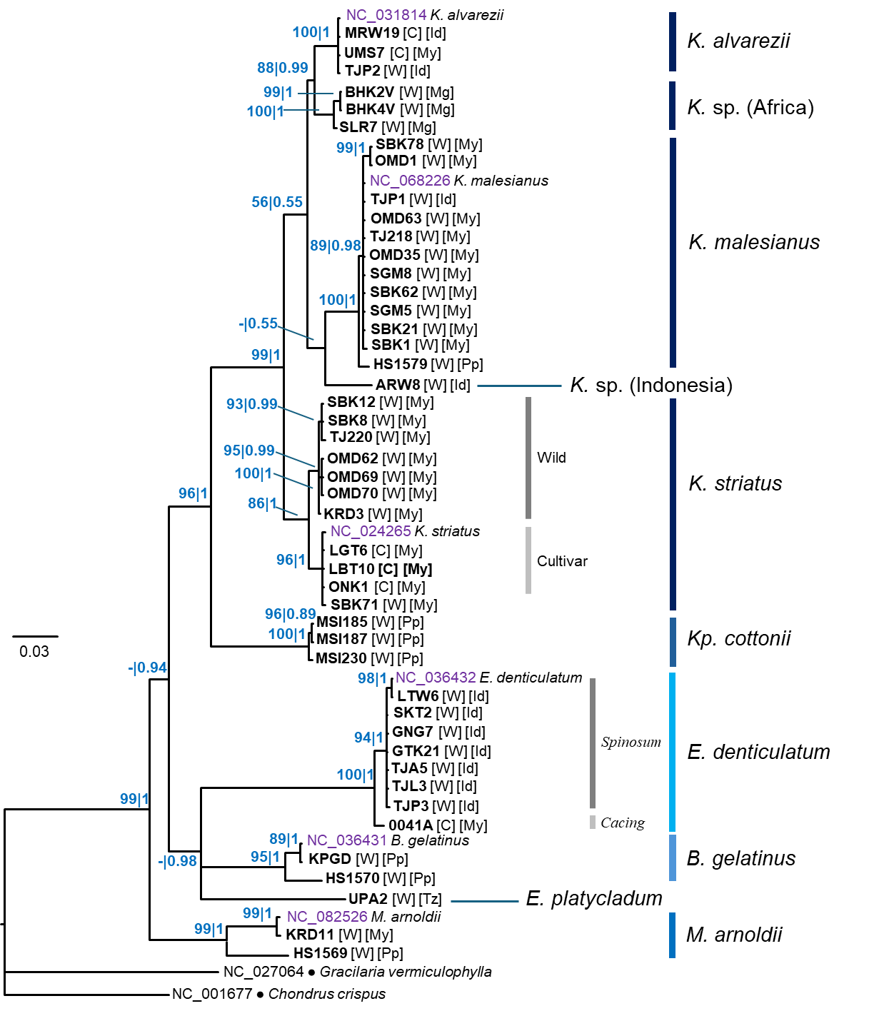
Figure S32. Bayesian tree of eucheumatoids reconstructed from the cox3 DNA marker. Numbers at nodes indicate ultrafast UFML bootstrap support and Bayesian posterior probabilities. Letters in parentheses indicate cultivar (C) or wild specimen (W). Letters in parentheses indicate cultivar (C) or wild specimen (W). Letters in square brackets indicate locality of origin: ID, Indonesia; Mg, Madagascar; My, Malaysia; Pp, Philippines; Tz, Tanzania. Scale bar represents number of substitutions per site.

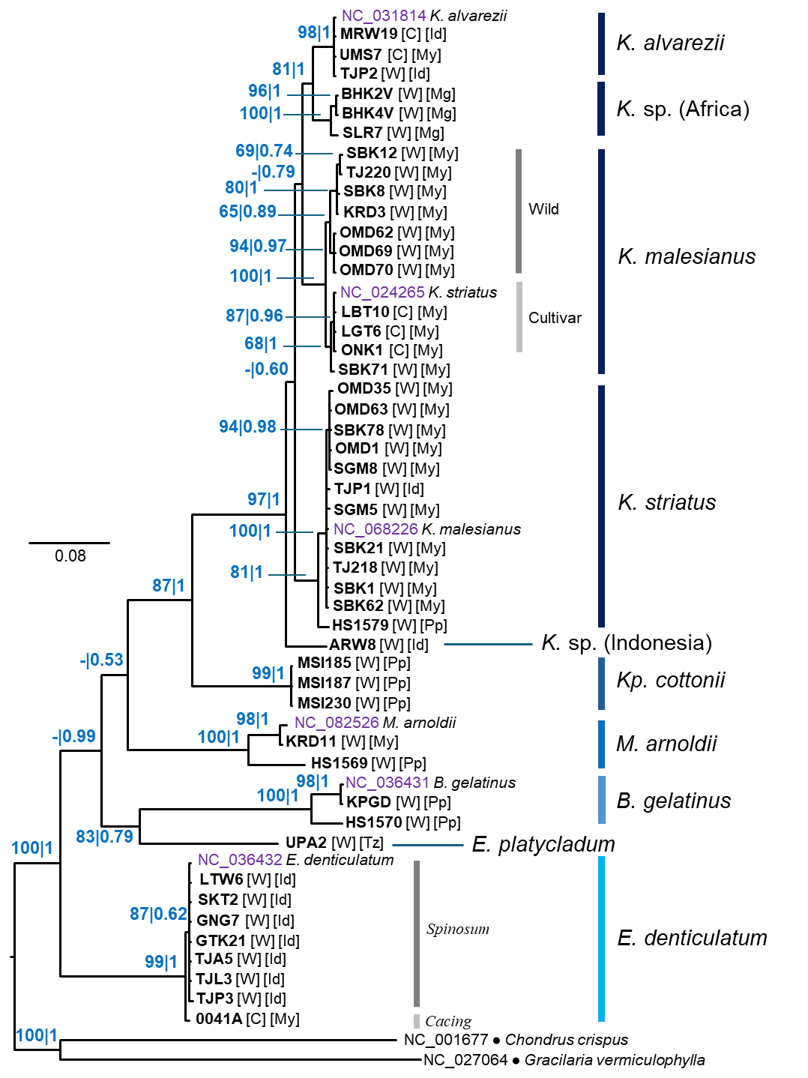
Figure S33. Bayesian tree of eucheumatoids reconstructed from the atp4 DNA marker. Numbers at nodes indicate ultrafast UFML bootstrap support and Bayesian posterior probabilities. Letters in parentheses indicate cultivar (C) or wild specimen (W). Letters in parentheses indicate cultivar (C) or wild specimen (W). Letters in square brackets indicate locality of origin: ID, Indonesia; Mg, Madagascar; My, Malaysia; Pp, Philippines; Tz, Tanzania. Scale bar represents number of substitutions per site.
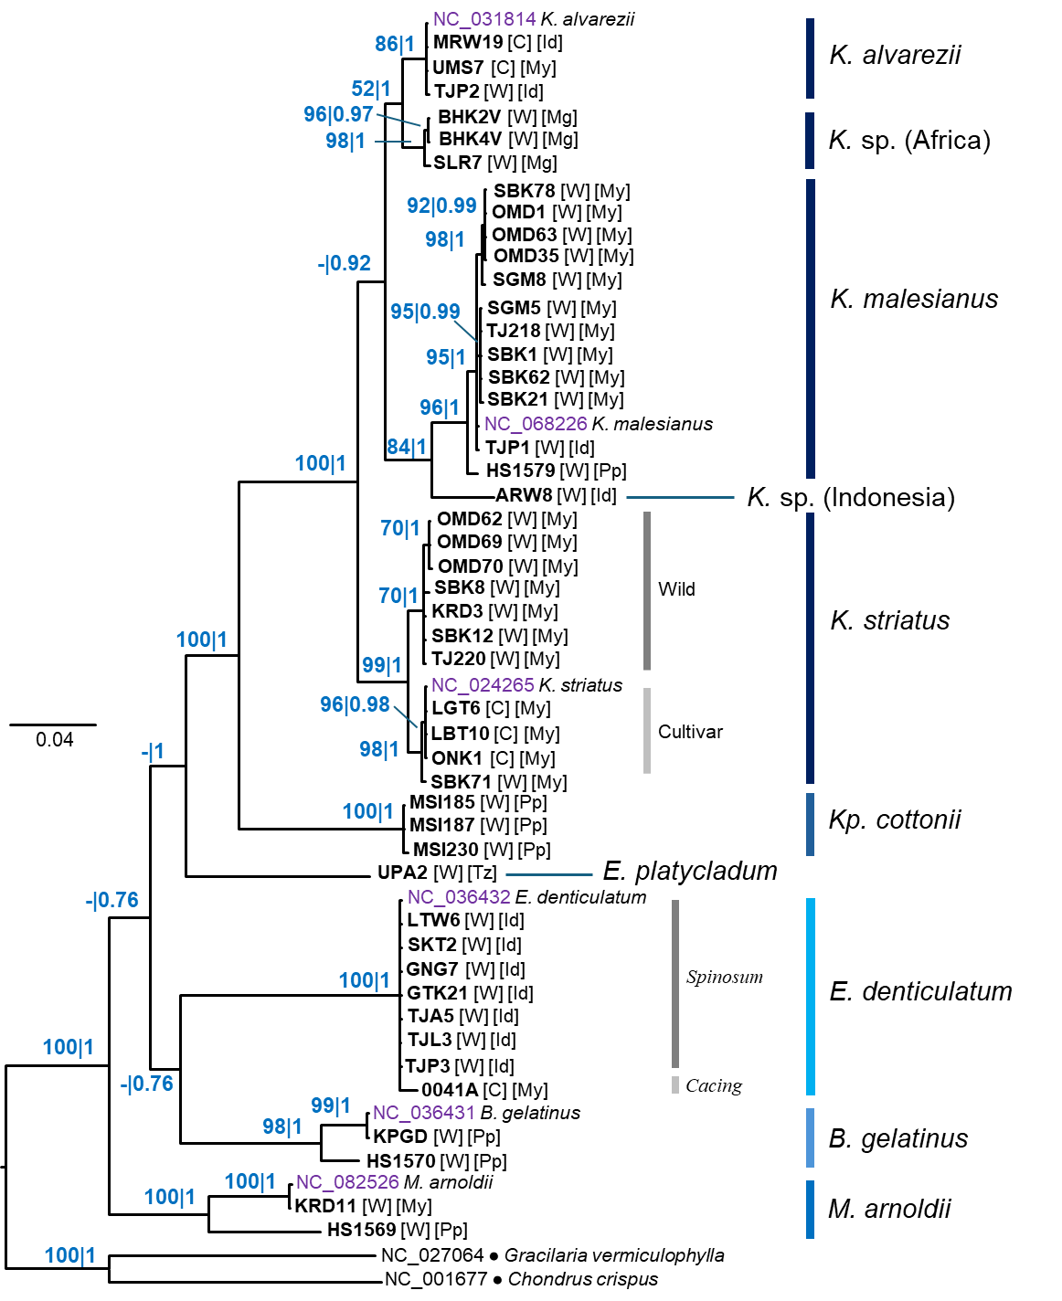
Figure S34. Bayesian tree of eucheumatoids reconstructed from the cob DNA marker. Numbers at nodes indicate ultrafast UFML bootstrap support and Bayesian posterior probabilities. Letters in parentheses indicate cultivar (C) or wild specimen (W). Letters in parentheses indicate cultivar (C) or wild specimen (W). Letters in square brackets indicate locality of origin: ID, Indonesia; Mg, Madagascar; My, Malaysia; Pp, Philippines; Tz, Tanzania. Scale bar represents number of substitutions per site.
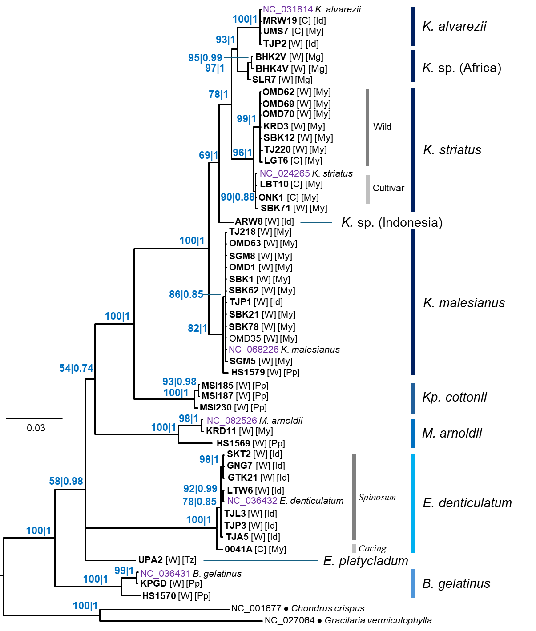
Figure S35. Bayesian tree of eucheumatoids reconstructed from the rns rRNA marker. Numbers at nodes indicate ultrafast UFML bootstrap support and Bayesian posterior probabilities. Letters in parentheses indicate cultivar (C) or wild specimen (W). Letters in parentheses indicate cultivar (C) or wild specimen (W). Letters in square brackets indicate locality of origin: ID, Indonesia; Mg, Madagascar; My, Malaysia; Pp, Philippines; Tz, Tanzania. Scale bar represents number of substitutions per site.

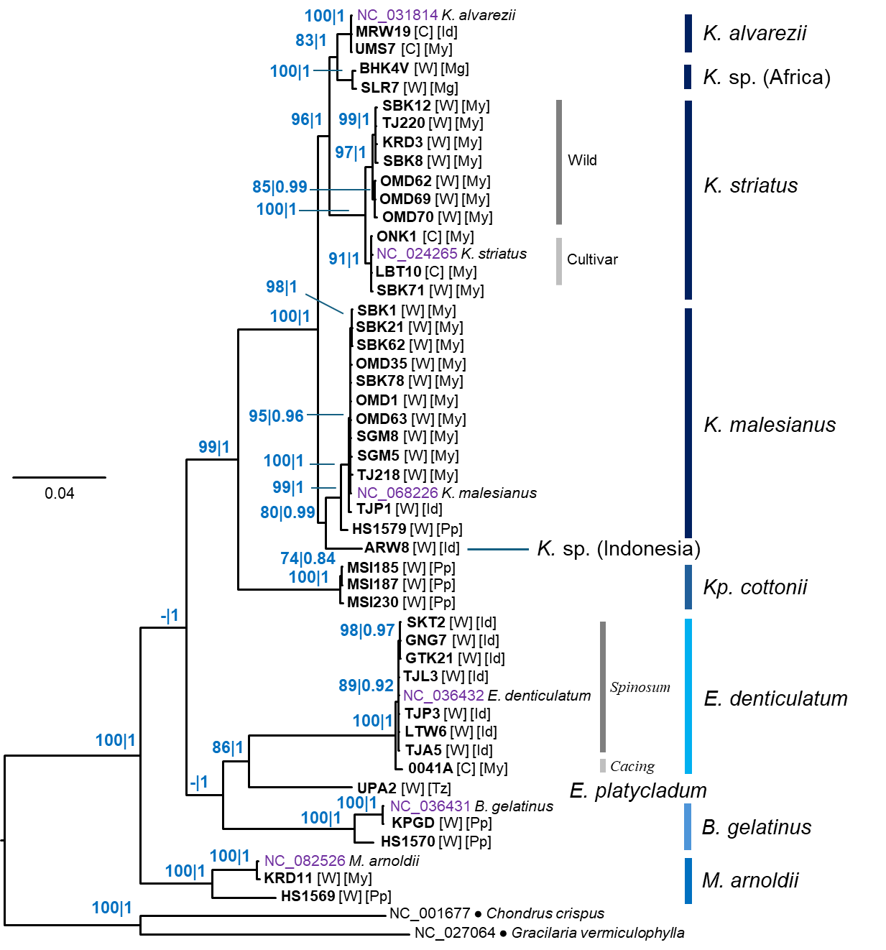
Figure S36. Bayesian tree of eucheumatoids reconstructed from the rnl rRNA marker. Numbers at nodes indicate ultrafast UFML bootstrap support and Bayesian posterior probabilities. Letters in parentheses indicate cultivar (C) or wild specimen (W). Letters in parentheses indicate cultivar (C) or wild specimen (W). Letters in square brackets indicate locality of origin: ID, Indonesia; Mg, Madagascar; My, Malaysia; Pp, Philippines; Tz, Tanzania. Scale bar represents number of substitutions per site.

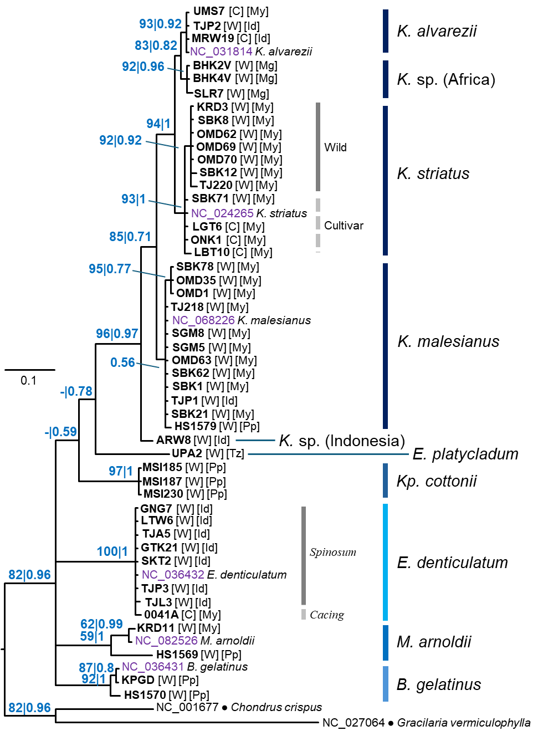
Figure S37. Bayesian tree of eucheumatoids reconstructed from the cox2–3 spacer. Numbers at nodes indicate ultrafast UFML bootstrap support and Bayesian posterior probabilities. Letters in parentheses indicate cultivar (C) or wild specimen (W). Letters in parentheses indicate cultivar (C) or wild specimen (W). Letters in square brackets indicate locality of origin: ID, Indonesia; Mg, Madagascar; My, Malaysia; Pp, Philippines; Tz, Tanzania. Scale bar represents number of substitutions per site.
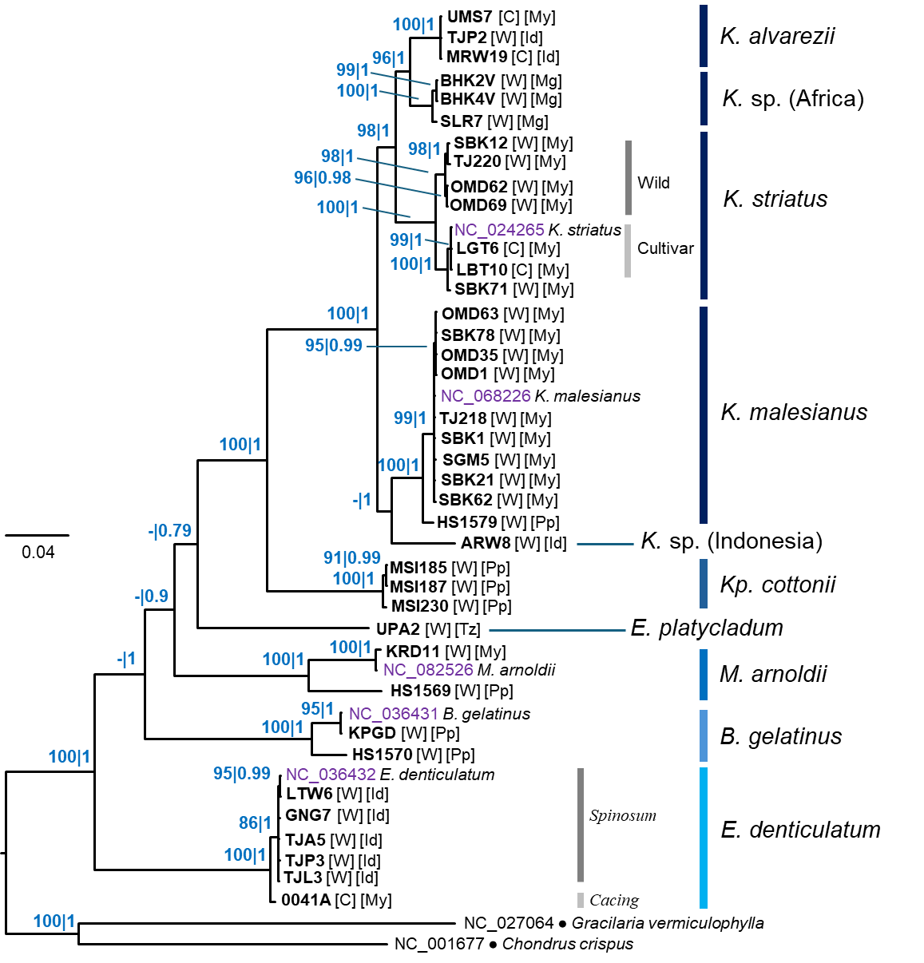
Figure S38. Bayesian tree of eucheumatoids reconstructed from the nad4+atp4 markers. Numbers at nodes indicate ultrafast UFML bootstrap support and Bayesian posterior probabilities. Letters in parentheses indicate cultivar (C) or wild specimen (W). Letters in parentheses indicate cultivar (C) or wild specimen (W). Letters in square brackets indicate locality of origin: ID, Indonesia; Mg, Madagascar; My, Malaysia; Pp, Philippines; Tz, Tanzania. Scale bar represents number of substitutions per site.

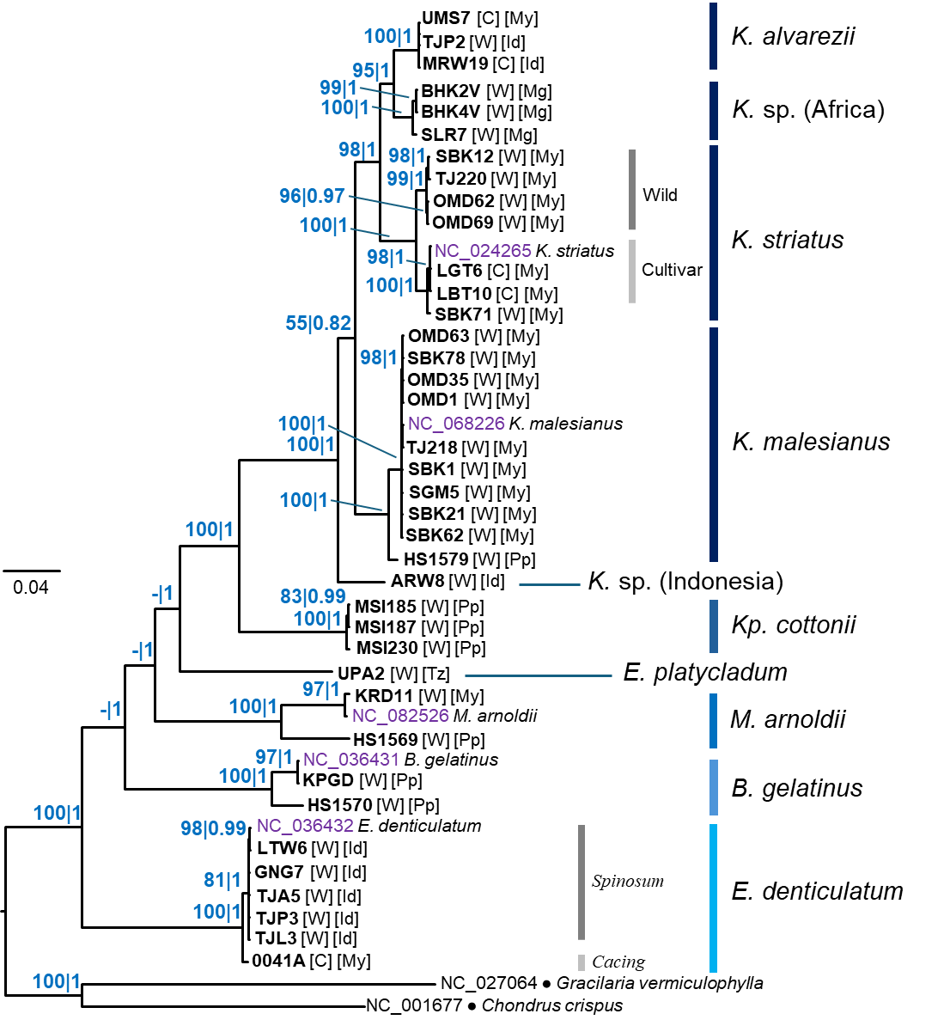
Figure S39. Bayesian tree of eucheumatoids reconstructed from the combined nad4+atp4+nad6 markers. Numbers at nodes indicate ultrafast UFML bootstrap support and Bayesian posterior probabilities. Letters in parentheses indicate cultivar (C) or wild specimen (W). Letters in parentheses indicate cultivar (C) or wild specimen (W). Letters in square brackets indicate locality of origin: ID, Indonesia; Mg, Madagascar; My, Malaysia; Pp, Philippines; Tz, Tanzania. Scale bar represents number of substitutions per site.

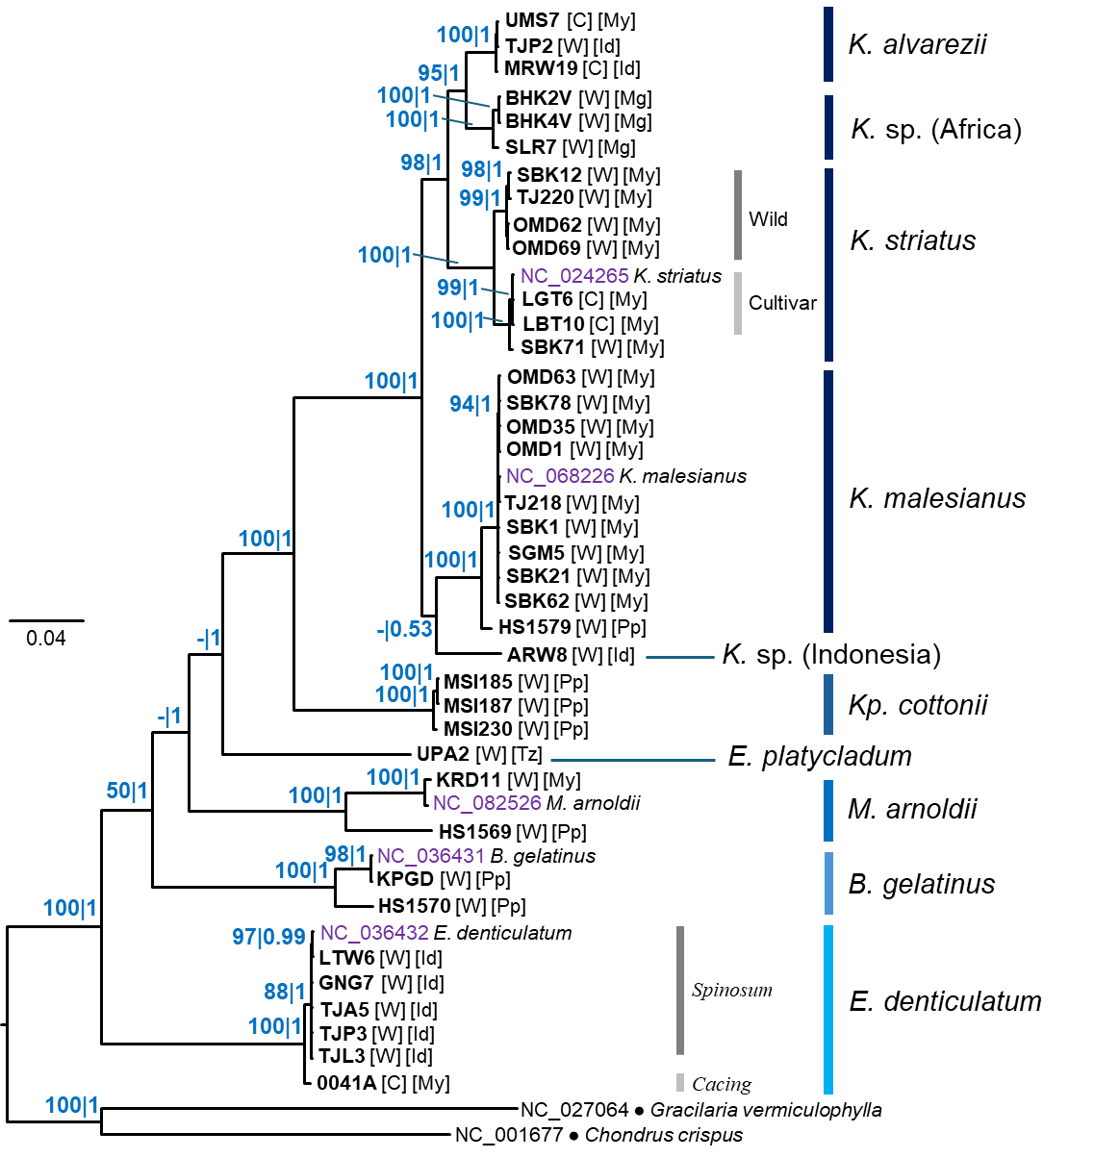
Figure S40. Bayesian tree of eucheumatoids reconstructed from the combined nad4+atp4+nad6+ nad3 markers. Numbers at nodes indicate ultrafast UFML bootstrap support and Bayesian posterior probabilities. Letters in parentheses indicate cultivar (C) or wild specimen (W). Letters in parentheses indicate cultivar (C) or wild specimen (W). Letters in square brackets indicate locality of origin: ID, Indonesia; Mg, Madagascar; My, Malaysia; Pp, Philippines; Tz, Tanzania. Scale bar represents number of substitutions per site.

