Supplementary Material

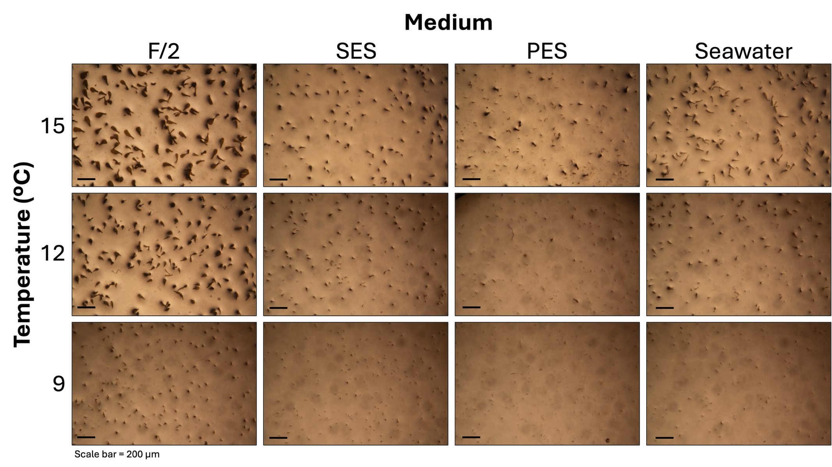
Figure S1. Juvenile Durvillaea potatorum for each treatment combination of Experiment 3, testing the effect of temperature and nutrient medium on the density and early growth of juvenile D. potatorum 30 days post fertilisation. Nutrient media: F/2 = Guillard’s half-strength F-medium; SES = Simple Enriched Seawater (N and P only); PES = Provasoli’s Enriched Seawater.

