Supplementary Materials

Table 1. Summary of volume (V) of eggs and sperm added to the wells to test the effect of adding different amounts of sperm at t₀ (initial time) and t₁₀ (after 10 minutes) on fertilisation while keeping the final sperm concentration constant at 10⁷ sperm mL⁻¹ for Experiment 3. The same procedure was applied in a second experiment where the sperm concentration was reduced by half (10³.⁵ sperm mL⁻¹). The % columns represent the percentage of the volume of male gametes added at each time.
Eggs  Total volume (mL) | Sperm
Eggs  Total volume (mL) | t₀ |  | t₁₀
Eggs  Total volume (mL) | V (mL) | % | V (mL) | %
5 | 5 | 100 | 0 | 0
5 | 4.5 | 90 | 0.5 | 10
5 | 4 | 80 | 1 | 20
5 | 3.5 | 70 | 1.5 | 30
5 | 3 | 60 | 2 | 40
5 | 2.5 | 50 | 2.5 | 50
5 | 2 | 40 | 3 | 60
5 | 1.5 | 30 | 3.5 | 70
5 | 1 | 20 | 4 | 80
5 | 0.5 | 10 | 4.5 | 90
5 | 0 | 0 | 5 | 100

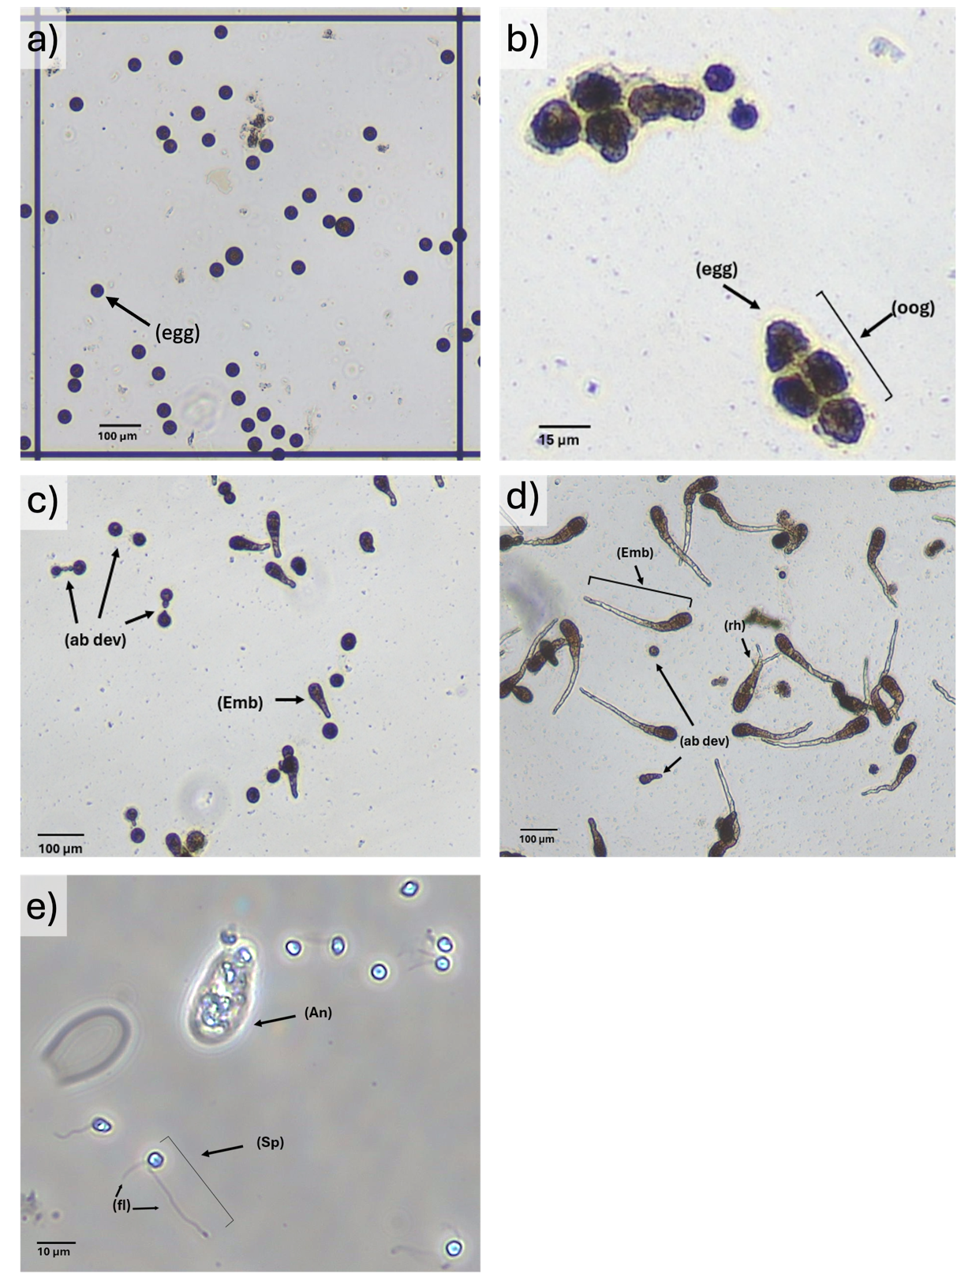

Figure 1. Gamete and early embryonic morphology in Durvillaea potatorum. (a) Released eggs (egg) exhibited a spherical morphology once expelled into the medium. (b) Eggs were not always released individually; in some cases they remained enclosed within the oogonium (oog), which typically contained four compacted eggs forming a tetrad that was expelled together. (c–d) Embryonic development at 48 hours (c) and 7 days (d) post-fertilisation. Normal embryos (Emb) displayed the characteristic asymmetrical morphology and rhizoid elongation (rh) indicative of successful fertilisation. Abnormally developing embryos (ab dev), including those with symmetrical morphology or signs consistent with polyspermy and developmental arrest, were also observed at both time points. (e) Male gametes showing sperm (Sp) with their typical oval to reniform shape and two flagella (fl). Some sperm were released freely, while others remained enclosed within intact antheridia (An), which were observed in the medium either empty or still containing compacted sperm. Release from antheridia occurred gradually; in some cases sperm remained immobile and did not exit, while others remained motile inside without being released. This variability in release behaviour made it difficult to determine precise timing relative to sperm that exited readily.

