Over the hills and far away: modelling mobility and connectivity across the Iranian Plateau in late prehistory (c. 10,000-2000 BC) using multi-factor probabilistic corridors
C.A. Petrie, F.K. Jürcke, T.C. Wilkinson, and H.A. Orengo

Supplementary Information
The supplementary information (SI) contains the following:
SI 1. Overview of factors and proxies used in “Multi-factor, Probabilistic Route Modelling” (MPRM)
SI 2. Google Earth Engine (GEE) code for the creation of cost surfaces in the “Multi-factor, Probabilistic Route Modelling” (MPRM) [also available at the following GitHub repository: https://github.com/fjuercke/2025_MPRM_Petrie_etal_JAR]
SI 3. Technical specifications of the corridor networks and each corridor generated to create the corridor networks
SI 4. Results of individual corridor models between each start and end point node combination
Bibliography

SI 1. Overview of factors and proxies used in “Multi-factor, Probabilistic Route Modelling” (MPRM)
The factors used in the model are presented below in order of their integration.
FACTOR A - topographic slope (`cost_slope`): Terrain data was derived from ALOS 30 m/px (Tadono et al. 2016), the highest quality freely available global DSM. The elevation data was transformed to mathematical slope. The slope costs for humans were derived using the sixth-degree polynomial developed by Herzog (2013) using experimental data from Minetti et al. (2002). This raster forms the basis of the cost surface to which all other factors are multipliers or dividers (except for the sea and reservoir masks, which are summed).
FACTOR B - elevation and snow cover (`cost_altitude`,`cost_snow`): The effects of high altitude were included through a custom function and selective inclusion of snow coverage. Human physiology is increasingly affected by reducing oxygen levels and the barrier to movement created by permanent or semi-permanent snow at higher altitudes. This is particularly acute beyond 2000-4000 metres and communities which inhabit such high altitudes permanently (for example across the Himalayas and the Tibetan plateau) often develop genetic or cultural adaptations to facilitate life in these environments (e.g. Azad et al. 2017). Since such adaptations are themselves difficult to model, and since they emerge only after long periods of occupation, we have assumed that altitude and snow coverage represent long-term significant but difficult-to-quantify costs against high altitude mobility. One factor layer was therefore created to measure the cost of traversing high mountain areas using the function f = 0.00345*e^0.000845h (where h is the DSM value for each cell with a minimum threshold of 2000 m.a.s.l.). This function derives a curve intersecting the two values for which data is available on how altitude affects walking performance (Minetti et al. 2006). We also created a layer based on snow coverage derived from the MODIS MOD10A1 V6.1 daily NDSI_Snow_Cover band (0–100%) 500m product (Hall et al. 2016) as an empirical basis to nuance this factor. Data was derived from a snow mapping algorithm that employs a Normalized Difference Snow Index (NDSI). For each season of travel (defined by day-of-year ranges), we computed a long-term seasonal mean by averaging all daily images across the archive (with no explicit year filter), after spatially restricting the images employed to the study area. Pixels with no valid observations are set to 0. The result is then restricted to elevations ≥ 2000 m a.s.l. Finally, we mapped the mean snow fraction linearly to a multiplicative penalty in (1, 4) using Multiplier for snow = 1+3*(S/100), where S is the mean percentage of snow cover. Thus, snow has no effect where absent (multiplier = 1) and increases costs up to fourfold in areas persistently covered by snow during the selected season (see Pandolf et al 1977; Herzog 2014).
Water is probably one of the most complex factors to consider when modelling movement. While often acting as arteries (e.g. Steinkeller 2021), rivers and lakes frequently have to be excluded from least-cost analyses as the water and adjacent areas may not actually be passable for various reasons, including intensity of water flow and limitations of space (Howey 2007; Herzog 2014). Travelling and transport on water in prehistory and with regard to non-motorized travel is generally considered preferable to overland travel (Rahn 2005; Howey 2007; Bevan 2011), but difficult to implement in a land-based least-cost model. As the base cost function remains one of walking across a sloping surface, and unless it is very shallow no one can travel across water on foot, such implementations face a myriad of challenges. Perennial and seasonal surface water bodies such as lakes and rivers were therefore excluded from the analysis.
FACTOR C - surface water barriers (`mask_sea`, `cost_surface_water`,`mask_reservoirs`): The Global Water Mask combines the SRTM Water Body Data and MODIS 250m data in a 250 m/px global map of surface water (Carroll et al. 2017). Water pixels were given a cost value of 255 to discourage transit over major standing water. However, this data set does not include temporary or smaller perennial water bodies such as rivers that can hinder movement. For this we used the JRC Monthly Water Recurrence dataset (Pekel et al. 2016): cost values were rescaled to range between 1 and 4 depending on the quantity of water documented in each 30 m pixel for the specific month. The datasets also reflect standing water bodies created by modern dam construction. Often situated at crucial mountain passes but resulting from a very recent phenomenon, dam reservoirs introduce high-cost areas which do not represent mobility potential in the past. Reservoirs were therefore excluded by creating a binary raster mask based on the Global Reservoir and Dam Database v1.3 (GRanD) (Lehner et al 2011). The binary mask (0 = reservoirs, 1 = everywhere else) was multiplied with the final cost raster to set the reservoir areas to 0 and then reclassified to give them the value of 3.28 to account for the movement potential of the underlying topography. This value (before normalisation) corresponds to the minimum cost value (raster cells with no slope and no other costs). As we could not calculate the topography of the areas currently under the reservoirs' waters, we assumed a minimum cost value. As most reservoirs are enclosing mountain valleys, which constitute natural transit routes, this value was considered more adequate than the barrier the reservoirs would have constituted otherwise.
In addition to land-locked surface water, the Global Water Mask was also used as a mask (summative factor) to exclude the sea from considerations of land travel. While less important for the consideration of trans-Iranian plateau movements, a potential future expansion of our approach would allow the incorporation of sea-travel, when suitable ways of comparing the relative cost of transport on land and sea are developed (cf. McLean and Rubio-Campillo 2022, for an inspiring approach to this problem).
Successful pre-mechanized travel relied on the presence and accessibility of potable water sources, especially in semi-arid and arid environments. Desert areas obviously create exponential costs in terms of the practicality of collecting, storing or transporting water for mobile humans and animals. This absence of water is a very complex cost to factor as how the lack of water affects movement is dependent upon numerous environmental (and indeed technological) factors, including temperature, wind, sunlight/shade, vegetation and water-retaining geological or biological reservoirs. Not all of these factors are easily quantifiable or tractable to relevant resolutions, especially with currently available global satellite or other geodata. Deserts have not been included in this model as a cost. They have been extracted as an EVI derivative for arid areas but the only function of these values is to define a lower threshold for the calculation of areas where water might be present, so arid pixels simply lose the water-based cost reduction rather than receiving an exponential penalty. This model used a proxy to account for the availability of potable water as a cost reducer.
FACTOR D - potable water accessibility (`cost_reducer_water_accessibility`): Previous multi-factor cost models (e.g. Wilkinson 2014) used rainfall as a well-documented proxy for regional water presence, but rainfall provides only a very crude indicator for true water accessibility, since after falling, rain water flows, collects and evaporates very heterogeneously across regions with putatively similar rainfall levels. While rivers and streams are obvious sources of water, humans also make use of ground-water in various ways, and the range of practices are less well understood from a global perspective. We ultimately identified surface vegetation as the best relevant proxy for overall water availability, as healthy plant growth indicates localized water availability (surface or near-ground). While modern irrigation may occasionally provide misleading indications at a micro-level this is less pronounced on the Iranian Plateau, and at a regional-level, vegetation health represents a favourable combination of precipitation, surface conditions and underground water sources as a proxy for vegetation growth and is therefore a far superior proxy to rainfall. Different vegetation indices are available for land cover and vegetation monitoring (Xue and Su 2017). The Enhanced Vegetation Index (EVI) is particularly suitable for crop classification (Evrendilek and Gulbeyaz 2008; Zhang et al. 2016) and identification of paleo-rivers (Orengo and Petrie 2017) in arid and semi-arid regions. The multi-year monthly Landsat 5-derived EVI was thus used as a base for this layer, but remapped with the EVI values clamped between two thresholds: a desert floor threshold of 0.05, below which no cost reduction is applied, and a water threshold of 0.10, above which the maximum reduction is reached. Within this interval, costs are linearly reduced, such that the final divider ranges from 1 (neutral) to 2 (halving costs). This approach ensures that only vegetation reliably associated with water availability exerts an attractive effect, while hyper-arid pixels do not introduce spurious bias (Wardlow and Egbert 2010). Here, water presence acts as an attractor (cost reducer) for both initial travel, long-term settlement and subsequent travel sustainability, hence the values are included as inverse-multipliers in the overall cost formula.
FACTOR | DATA | RESOLUTION (/PX) | PARAMETER VALUES | SCALED VALUE RANGE | OPERATION & EXPECTED EFFECT
A: SLOPE | ALOS DEM (Tadono et al. 2016) | 30 m | Slope in mathematical degrees  Cost function: sixth degree polynomial (Herzog 2013; Minetti et al. 2002) | n/a | Create base for cost surface creation
B: ALTITUDE | ALOS DEM; Function developed based on information from physiological studies (see Herzog 2014) |  | f = 0.00345*e^0.000845h  (where h is the dsm value for each cell) | n/a | Multiplication  Raise costs above 2000m
B: SNOW | MODIS MOD10A1 V6.1 Snow Cover Daily Global 500m (Hall et al. 2016) | 500 m | 1-100  >2000 m asl only | Maximum value of 4 | Multiplication  Raise costs for all areas covered in snow
C: SEA WATER BARRIER | Global Water Mask derived from SRTM Water Body Data and MODIS 250m data (2000-2002)*  (Carroll et al. 2017) | 250 m | Sea value remapped to value of 255 |  | Addition; mask all navigable water bodies (sea) by assigning highest cost
C: SURFACE WATER BARRIER | JRC Monthly Water Recurrence, v1.3 (between 1984-1999, 2000-2019) (Pekel et al. 2016) | 30 m | 0-100 recurrence value expressed as % per month | 1-4 | Multiplication  Raise costs of areas with constant water presence as difficult to traverse
C: RESERVOIR MASK | Global Reservoir and Dam Database v1.3 (GRanD) (Lehner et al. 2011) | Vector, rasterized 30m | Binary mask  0 = reservoirs  1 = everywhere else | Absolute value of 3.28 | 1) Multiplication to reset reservoir areas to 0  2) Addition to assign all reservoir areas value 3.28
D: POTABLE WATER ACCESSIBILITY | Enhanced Vegetation Index of Landsat 5 TM Collection 1 Tier 1 composites (Huete et al. 2002)* | 30 m | -1.0 to 1.0  default minimum threshold: 0.1 | 1-2 | Division  Lower the costs of vegetated areas above minimum threshold

Table S1.i: Cost factors included in the MPRM with dataset used, resolution of the dataset, parameter values, scaled value range and mathematical operation to combine the factors with the base layer. The datasets specified in the table reflect those used in the creation of the corridors presented in this paper. * = datasets have been updated in the Google Earth Engine Dataset Catalogue and were updated in the code provided with this paper to enable reproducibility. See below.

Potable water accessibility threshold specifications
The Enhanced Vegetation Index (EVI) was chosen as a proxy to incorporate potable water accessibility into the cost surface (see main paper, Factor D). Choosing the right threshold value to mark the transition between desert and vegetation conditions in the EVI is not straightforward. Very few absolute EVI classification values are reported. In their examination of MODIS indices, Huete et al. (2002) noted a desert peak at 0.1 for the Atacama desert. EVI values for three types of grasslands in Turkey are reported around 0.19 +/- 0.06, 0.22 +/- 0.08 and 0.27 +/- 0.09 (Evrendilek and Gulbeyaz 2008), but EVI values of major crop types in Kansas, US, can be noted around a baseline of 0.1 (Wardlow and Egbert 2010). In south-east Iran, the threshold at EVI value 0.1 seems to reflect more ephemeral plants and phreatophytes, important non-agricultural indicators of ground- and near-surface water (Jürcke 2024). This lower EVI value was also found to better predict known travellers’ routes, such as those by Stein (Jürcke 2024).
To account at least partially for the potential impact of modern irrigation to occasionally provide misleading indications at a micro-level, the EVI is based on the oldest available Landsat images from Landsat 5 TM. While these images do not predate the introduction of modern irrigation techniques, most parts of south-east Iran have seen major expansions only from the 1990s onwards.

Datasets and updates in Google Earth Engine
A number of datasets have been updated in the Google Earth Engine Dataset Catalogue since the corridors presented here were produced. The code has been updated to reflect the most recent datasets available. Updates to the datasets are not expected to alter the results of the corridors.
The DSM dataset ALOS World 3D has been updated from version 2.2 to version 4.1. The code has been updated to include the required reprojection for version 4.1.
The MODIS Snow Cover dataset has been updated from version 6.0 to 6.1.
Google Earth Engine recently migrated its available Landsat dataset from Collection 1 to Collection 2. The corridors presented in this paper were created using the EVI composite of Landsat 5 TM images available in Collection 1. The code has since been updated to reflect the new dataset of Collection 2 filtered for images from Landsat 5.

SI 2. Google Earth Engine (GEE) code for the creation of cost surfaces in the “Multi-factor, Probabilistic Route Modelling” (MPRM)

/*
JavaScript code to be implemented in Google Earth Engine(c) developed by H.A. Orengo, T.C. Wilkinson and F.K. Jürcke
to accompany the paper:
C.A. Petrie; F.K. Jürcke; T.C. Wilkinson; and H.A. Orengo 'Over the hills and far away: modelling mobility
and connectivity across the Iranian Plateau in late prehistory' submitted to Journal of Archaeological Research

------------- ooo -------------
TO EXECUTE THE ALGORITHM PASTE THIS CODE INTO GOOGLE EARTH ENGINE CODE EDITOR AND PRESS 'Run'
------------- ooo -------------

Title: Multi-factor, Probabilistic Route Modelling (MPRM)
Type: GEE Javascript code
Authors: Hector A. Orengo, Toby C. Wilkinson, Friederike K. Jürcke
Date: 2024-06-27
Description: The Multi-factor, Probabilistic Route Modelling (MPRM) algorithm generates a cost surface for use in
least-cost analysis. The following cost factors are implemented:
- FACTOR A: topographic slope ('cost_slope')
- FACTOR B: altitude ('cost_altitude')
- FACTOR B: cost_snow ('cost_snow')
- FACTOR C: sea water barrier ('mask_sea')
- FACTOR C: surface water barrier ('cost_surface water')
- FACTOR C: reservoir mask ('mask_reservoirs')
- FACTOR D: potable water accessibility ('cost_reducer_water_accessibility')

------------- ooo -------------
!!! NOTES, READ CAREFULLY !!!
1. Specific instructions of how the algorithm works have been included within the code, please,
read these carefully and consult the paper's text to understand how to best apply it.
2. To run the code you need to upload the reservoir dataset provided alongside the code into your GEE assets.
Then you need to update line 188 with the path to the reservoir dataset you have uploaded.
Detailed instructions how to download and ingest the reservoir dataset can be found in the reservoir_instructions.md
3. To apply the analysis to your own areas of interest (AOIs):
1. Define a central point in your study area (as X,Y WGS84 decimal degrees) and a scale
for visualisation purposes in line 62.
2. Eliminate the polygon variable in lines 66-73 and define your own polygon. This can be done by either
replacing the coordinates of the polygon variable with coordinates of a different polygon
(as X,Y WGS84 decimal degrees) or drawing your own polygon (as a geometry) delimiting the AOI
using the tool provided in the top left of Google Earth Engine’s map window. This will create a
polygon named ‘geometry’ by default. The analysis will be performed in the newly defined area.
4. Visualisation parameters for each layer can be adjusted in the Layers dialogue in the map
area of Google Earth Engine.
5. The images resulting from this script can be transferred to your Assets or Google Drive running
the analysis from the 'Tasks' tab on the top right of the screen and selecting the Drive option.
------------- ooo -------------

For more information on how this code works and how to apply it, refer to the text of the article.

///FACTORS INCLUDED:
SLOPE
SEA MASK
SNOW
ALTITUDE
SURFACE WATER as barrier
RESERVOIR MASK
WATER PRESENCE as attractor (dsrtThrs: 0.05; waterThrs: 0.1)
*/

//////// AREA OF INTEREST /////////
// Define a central point in your study area (as X,Y WGS84 decimal degrees) and a scale,
// just for visualisation purposes

Map.setCenter(61.5339, 26.6598, 5);

// Define your AOI as a polygon with a set of WGS84 coordinates

var geometry = ee.Geometry.Polygon([[
[ 41.835136120996907, 24.535424533447777 ],
[ 74.214706535851121, 24.535424533447777 ],
[ 74.214706535851121, 40.300730175980803 ],
[ 41.835136120996907, 40.300730175980803 ],
[ 41.835136120996907, 24.535424533447777 ]]],
'EPSG:4326',
false);

//////// TEMPORAL PARAMETERS ////////

// Seasonal parameters.
var spring = ee.Filter.dayOfYear(79,172);
var summer = ee.Filter.dayOfYear(172,266);
var autumn = ee.Filter.dayOfYear(266,355);
var winter = ee.Filter.dayOfYear(355,79);

// User input: Specify a period form the list of variables above.
// Which season of travel will the cost surface be created for?
var select_period = prompt('Select season of travel: spring, summer, autumn, winter', 'spring');//

if (select_period == 'spring') {var period = spring; var monthNum = '03'; var monthName = 'spring'}
if (select_period == 'summer') {var period = summer; var monthNum = '06'; var monthName = 'summer'}
if (select_period == 'autumn') {var period = autumn; var monthNum = '09'; var monthName = 'autumn'}
if (select_period == 'winter') {var period = winter; var monthNum = '00'; var monthName = 'winter'}
// The ee.ImageCollection("JRC/GSW1_3/MonthlyRecurrence") used for the calculation of the surface water barrier
// factor is available for each month, denoted by a two-digit number; the data for this factor is extracted for
// the central month of the three-month period spanning each season and represented by the monthNum variable
// (03 for April; 06 for July; 09 for October; 00 for January).

//////// DIGITAL SURFACE MODEL (DSM) ////////

// Load the DSM. Here the ALOS Global 30m DSM is used.
var ref = ee.ImageCollection('JAXA/ALOS/AW3D30/V4_1').filterBounds(geometry).select('DSM').first();

var dsm = ee.ImageCollection('JAXA/ALOS/AW3D30/V4_1')
.filterBounds(geometry)
.select('DSM')
.mosaic()
.reproject(ref.projection())
.clip(geometry);

//////// **FACTOR A**: TOPOGRAPHIC SLOPE ('cost_slope') ////////
// Create a raster representing slope costs. This raster forms the basis of the cost surface to which all other
// factors are multipliers or dividers (except for the sea mask and reservoirs mask, which are summed).

// Creating a slope map in degrees from the DSM image.
var slope = ee.Terrain.slope(dsm);

// Transform slope to mathematical degrees as a basis for the slope cost calculation in the next step.
var slp_rad = slope.multiply(3.1415926536)
.divide(180);
var slp_dg = slp_rad.tan();

// Calculate slope costs for humans using the sixth degree polynomial developed by Herzog (2013).
var cost_slope = ((slp_dg.pow(6)).multiply(1337.8))
.add((slp_dg.pow(5)).multiply(278.19))
.subtract((slp_dg.pow(4)).multiply(517.39))
.subtract((slp_dg.pow(3)).multiply(78.199))
.add((slp_dg.pow(2)).multiply(93.419))
.add((slp_dg.multiply(19.825)))
.add(1.64);

//////// **FACTOR B:** ALTITUDE ('cost_altitude') ////////
// Create a raster to factor in the effect of altitude for travellers for all areas above 2000 m asl.
// Using a purposefully developed function: f = 0.00345*e^0.000845h (where h is the dsm value for each cell)
var cost_altitude = (ee.Image(0.00345)
.multiply(ee.Image(2.718)
.pow(dsm.multiply(ee.Image(0.000845)))))
.multiply(dsm.gt(2000))
.add(ee.Image(1));

//////// **FACTOR B:** SNOW ('cost_snow') ////////
// Create a raster layer representing areas covered in snow.
// Load and filter the image collection.
var snowBase = ee.ImageCollection('MODIS/061/MOD10A1').select('NDSI_Snow_Cover')
.filter(period)
.filterBounds(geometry)
.reduce(ee.Reducer.mean(), 4)
.unmask(0)
.clip(geometry)
.multiply(dsm.gte(2000));

// Create the cost layer. Convert the original image values to a range between 1-4.
var cost_snow = snowBase.divide(33.33).add(ee.Image(1));

//////// **FACTOR C:** SEA WATER BARRIER ('mask_sea') ////////
// Create a mask raising the costs across seas and standing water bodies to prevent least-cost analysis across water
// bodies.
// Data is provided in band 'water_mask'; original values: 0 = Land 1 = Water.

// Load the image.
var sea = ee.Image('MODIS/MOD44W/MOD44W_005_2000_02_24').select('water_mask').clip(geometry);

// Create the mask layer. The bitmask is remapped to create a mask usable for addition. Increase the image values for
// water to 255.
var mask_sea = sea.remap([0,1],[0,255]);

//////// **FACTOR C:** SURFACE WATER BARRIER ('cost_surface_water') ////////
// Create a raster layer representing areas with surface water. The layer is derived from global monthly recurrence
// surface water product based on Landsat 5-8 data.

// Load the image.
var watRecur = ee.Image('JRC/GSW1_3/MonthlyRecurrence/monthly_recurrence_'+ monthNum).select("monthly_recurrence")
.unmask(0)
.clip(geometry);

// Create the cost layer. Convert the original image values to a range between 1-4.
var cost_surface_water = watRecur.divide(33.33).add(ee.Image(1));

//////// **FACTOR C:** RESERVOIR MASK ('mask_reservoirs') ////////
// Create a binary raster to mask reservoir areas based on the GRanD database provided by Global Dam Watch (Lehner
// et al 2011).

// Load the reservoir dataset provided as a polygon vector layer.
var reservoir_polygons = ee.FeatureCollection('projects/ee-fkjuercke/assets/GDW_reservoirs_v1_0'); // !!!ADJUST PATH TO WHERE THE RESERVOIR DATASET IS STORED!!!

// Create a binary raster with value 0 for all areas covered in reservoirs and 1 for all other cells. Upon multiplication to the 'cost_slope' raster all reservoir
// areas will be set to 0.
// 1. Create a base image (the background, outside polygons = 0).
// - Use the first band of the DSM to get the extent and projection.
var emptyImage = dsm.select(0).multiply(0); // Creates an image of all 0s over the DSM area

// Paint the polygons onto the empty image (inside polygons = 1) to create a binary raster mask for the reservoirs.
var mask_reservoirs = emptyImage.paint({
featureCollection: reservoir_polygons,
color: 1, // The value to paint (1; for inside the polygons)
}).rename('binary') // Rename the band to 'binary'
.clip(geometry)
.remap([0,1],[1,0]);

// Remap binary reservoir map to give the cells previously covered by reservoirs a cost value of 3.28. To be added
// in final cost raster creation.
var reservoirs_new_value = mask_reservoirs.remap([0,1],[3.28,0]);

//////// **FACTOR D:** POTABLE WATER ACCESSIBILITY ('cost_reducer_water_accessibility') ////////
// Create a cost reducer raster to factor in attraction to areas with presence of potable water.

// Load and filter the image collection: multi-temporal Enhanced Vegetation Index (EVI) based on Landsat data.
var evi = ee.ImageCollection('LANDSAT/COMPOSITES/C02/T1_L2_8DAY_EVI')
.filterDate('1984-01-01', '1991-12-31')
.filter(period)
.filterBounds(geometry)
.reduce(ee.Reducer.mean())
.unmask(0)
.clip(geometry);

// The desert threshold 'dsrtThrs' is the EVI value designated below which desert conditions prevail.
var dsrtThrs = 0.05;

// The water threshold 'waterThrs' is the EVI value at and above which healthy vegetation representing water
// availability prevails.
var waterThrs = 0.1;

// Create the cost raster at a value range between 1-2.
var water1 = evi.gte(dsrtThrs); // Select values above the desert threshold.
var water2 = evi.lte(waterThrs); // Select values below the water threshold.
var water3 = (evi.lte(dsrtThrs)).multiply(dsrtThrs); // Values lower than 0.05 equal 0.05.
var water4 = (evi.gte(waterThrs)).multiply(waterThrs); // Values greater than 0.1 equal 0.1.
var water5 = ((water1.multiply(water2)).multiply(evi)).add(water3).add(water4);
var cost_reducer_water_accessibility = ((water5.subtract(dsrtThrs)).divide(waterThrs-dsrtThrs)).add(1);

//////// COMBINE FACTORS TO COMPLETE MULTI-FACTOR COST RASTER CREATION ////////
// Create cost raster of raw costs multiplying costs of snow, altitude and surface water barrier and dividing potable
// water accessibility factors. Multiply the reservoir mask and give the masked cells a new cost value.
// Add the sea mask to increase the cost of all surface water areas that are not navigable using a hiking function.

var costs_raw = (cost_slope
.select('slope').rename('cost'))
.multiply(cost_snow)
.multiply(cost_altitude)
.multiply(cost_surface_water)
.divide(cost_reducer_water_accessibility)
.multiply(mask_reservoirs)
.add(reservoirs_new_value)
.add(mask_sea);

//////// SCALING AND NORMALISATION ////////
// Scaling and normalisation are necessary to reduce the very high computational costs a floating raster will have
// in the calculation of the cost accumulation raster. From the current floating point raster an unsigned 8 bit
// raster is developed.
// The process includes two steps:
// 1. Assigning a maximum cost value that will substitute all values larger than it. This reduces the impact of
// extremely high outlier values in the floating raster and retains more detailed variability at lower values
// that are the most significant in terms of movement.
// 2. Scaling cost values to between 0-255.

// Assign a maximum cost value. User input required.
var specify_maximum_cost = prompt('Value for the maximum cost', 40);
var maximum_cost = Math.round(specify_maximum_cost);
print('Maximum cost', maximum_cost);

// Substitute all values higher than the maximum cost value.
var costs_max_assigned = (costs_raw.gt(maximum_cost).multiply(maximum_cost))
.add(costs_raw.lte(maximum_cost).multiply(costs_raw));

// Scale values to between 0-255
var cost_surface = (costs_max_assigned.divide(maximum_cost)).multiply(255)
.byte();

//////// VISUALISATION ////////
// Visualise the cost surface in the Code Editor map display.
Map.addLayer(cost_surface,
{palette: '0f00ff, 03ff00, efff00, ffbc00, ff0000, ff0081'
}, 'Cost surface');

//////// EXPORT COST SURFACE ////////
// Export the cost surface to Google Drive.

// Specify the resolution for the output raster.
var dsm_resolution = Math.round((dsm.projection().nominalScale().getInfo())*1000) / 1000;
var specify_output_resolution = prompt('Output raster resolution in m (default equals DSM resolution)', dsm_resolution);

// If output resolution specified is different from the DSM resolution, use the specified resolution for output.
if (specify_output_resolution <= dsm_resolution) {var output_resolution = dsm_resolution;} else {var outrr = specify_output_resolution;}

// Set variables for file string to declare a clear file name for the exported cost surface.
// Get the current date as string.
var eeToday = ee.Date(Date.now());
var today = eeToday.format('YYMMdd');
var date = today.getInfo();

// Turn the EVI water threshold into a string.
var waterThrs_string = waterThrs.toString().replace(".", "");
// Turn the output resolution into a string.
var output_resolution_string = output_resolution.toString().replace(".", "");

// Export the cost surface to Google Drive.
// The description serves both as the description for the task and the file name for the exported file.
// A folder with the specified name will be created if it does not already exist.
// CAREFUL: This string should be no longer than 40 characters as Google Drive truncates file names above 40
// characters upon download of the file.
Export.image.toDrive({
image: cost_surface,
description: 'costsurf' + '_costs' + 'slope' + 'seas' + 'snow' +'surfw' + 'dam' + 'watattr' + waterThrs_string + '_' + monthNum + monthName + '_maxcost' + maximum_cost + '_' + 'res' + output_resolution_string + '_' + date,
folder: 'GEE_exports',
scale: output_resolution,
maxPixels: 9e12,
region: geometry
});

SI 3. Technical specifications of the corridor networks and each corridor generated to create the corridor networks

1. Cost Surface Model. The MPRM was designed to generate seasonal cost surfaces in Google Earth Engine. Upon export from Google Earth Engine, the seasonal cost surfaces (spring, summer, autumn, winter) were reprojected to the projected coordinate system EPSG:3395, clipped to the land area of the Iranian Plateau as illustrated in Fig. 2a and averaged by calculating the mean across all four seasonal cost surfaces using GRASS GIS 7.8 and r.mapcalc (Shapiro,Clements 2021).
2. Cost Distances and Paired-Node Corridors. Corridors were then created using GRASS GIS 7.8 and the modules r.cost (Awaida et al. 2020) and r.mapcalc. r.cost was run with the -k flag using the Knight’s move to produce more accurate and natural results. The cost accumulation raster resulting from r.cost were averaged to produce corridors between two points at a time. The width of each corridor was defined as the least costly 10% of each corridor (Beier et al. 2008). The 10th percentile of each corridor was calculated using the GRASS GIS module r.quantile (Clements 2019) and the corridors reclassified using r.mapcalc (Shapiro and Clements 2021). Lower or higher corridor width was found to reduce interpretability.
The other cost distance module available in GRASS GIS 7.8, r.walk, was not used here because it includes a different cost function (Aitken 1977/Langmuir 1984 based on Naismith’s rule) — in our model, slope costs are already incorporated via the Herzog/Minetti formula in factor A.
Many LCP applications implement anisotropic (direction-dependent) costs. In our study have we deliberately used an isotropic base cost because (i) our goal is to model corridor envelopes at continental scale, not single track-lines, (ii) the direction of travel is unknown and plausibly bidirectional over long periods, (iii) transport modes were mixed (humans, pack animals, caravans), for which published anisotropic walking functions calibrated on individual hikers are not directly transferable, and (iv) at this scale, non-slope factors (snow, altitude, surface/standing water, potable-water accessibility) dominate route feasibility relative to up/down asymmetry on individual slopes. Methodologically, isotropy also ensures reproducibility across our cloud/HPC workflow (GEE cost construction; GRASS r.cost accumulation with a 16-neighbour “knight’s move” for more natural radial expansion), while avoiding path-dependent directionality that current GEE accumulation tools do not support natively. Our slope term follows Herzog’s (2014) polynomial in absolute gradient, which penalises steep terrain regardless of direction; the anisotropic detail of slightly faster gentle downhills is therefore not the primary determinant of cross-plateau corridors in our setting. Prior work has also cautioned that fine-grained LCP specifications can be over-confident for large areas/time scales (e.g., methodological discussions in Herzog 2014). We make this modelling choice explicit below and note that anisotropy would likely refine local alignments within the same broad corridor envelopes rather than overturning them.
3. Corridor Networks. Corridor networks were created using minimum cell statistics. Aggregation into a corridor network was achieved by rescaling each 10%-corridor to between 0-255 to normalise the corridors across the region and then selecting the minimum values across the region from relevant paired corridors to create the corridor network. Note that the process of normalisation means that long absolute routes can be equivalent in cost to shorter absolute routes, so the values in these corridor networks should not be translated into time cost.
The corridor model generated a substantial amount of data, and required significant computing time, provided by the virtual machine of the Computational and Digital Archaeology Laboratory at the Department of Archaeology, University of Cambridge. Each cost surface is c. 7GB in size, while all processed raster, i.e. cost distance raster and corridor raster are c. 38-40 GB each. The 10% and normalised corridors are smaller at c. 4 GB each, so are the corridor networks.
4. All paired corridors and corridor networks were visualised in QGIS 3.34.2-Prizren using the Cividis colour ramp as it is colour-blind safe with 10 quantile classes.

Fig. S3i. The Neolithic corridor network consists of four paired corridors, between four sites: Chogha Bonut, Sheikh-e Abad, Sang-e Chakmak, Mehrgarh.
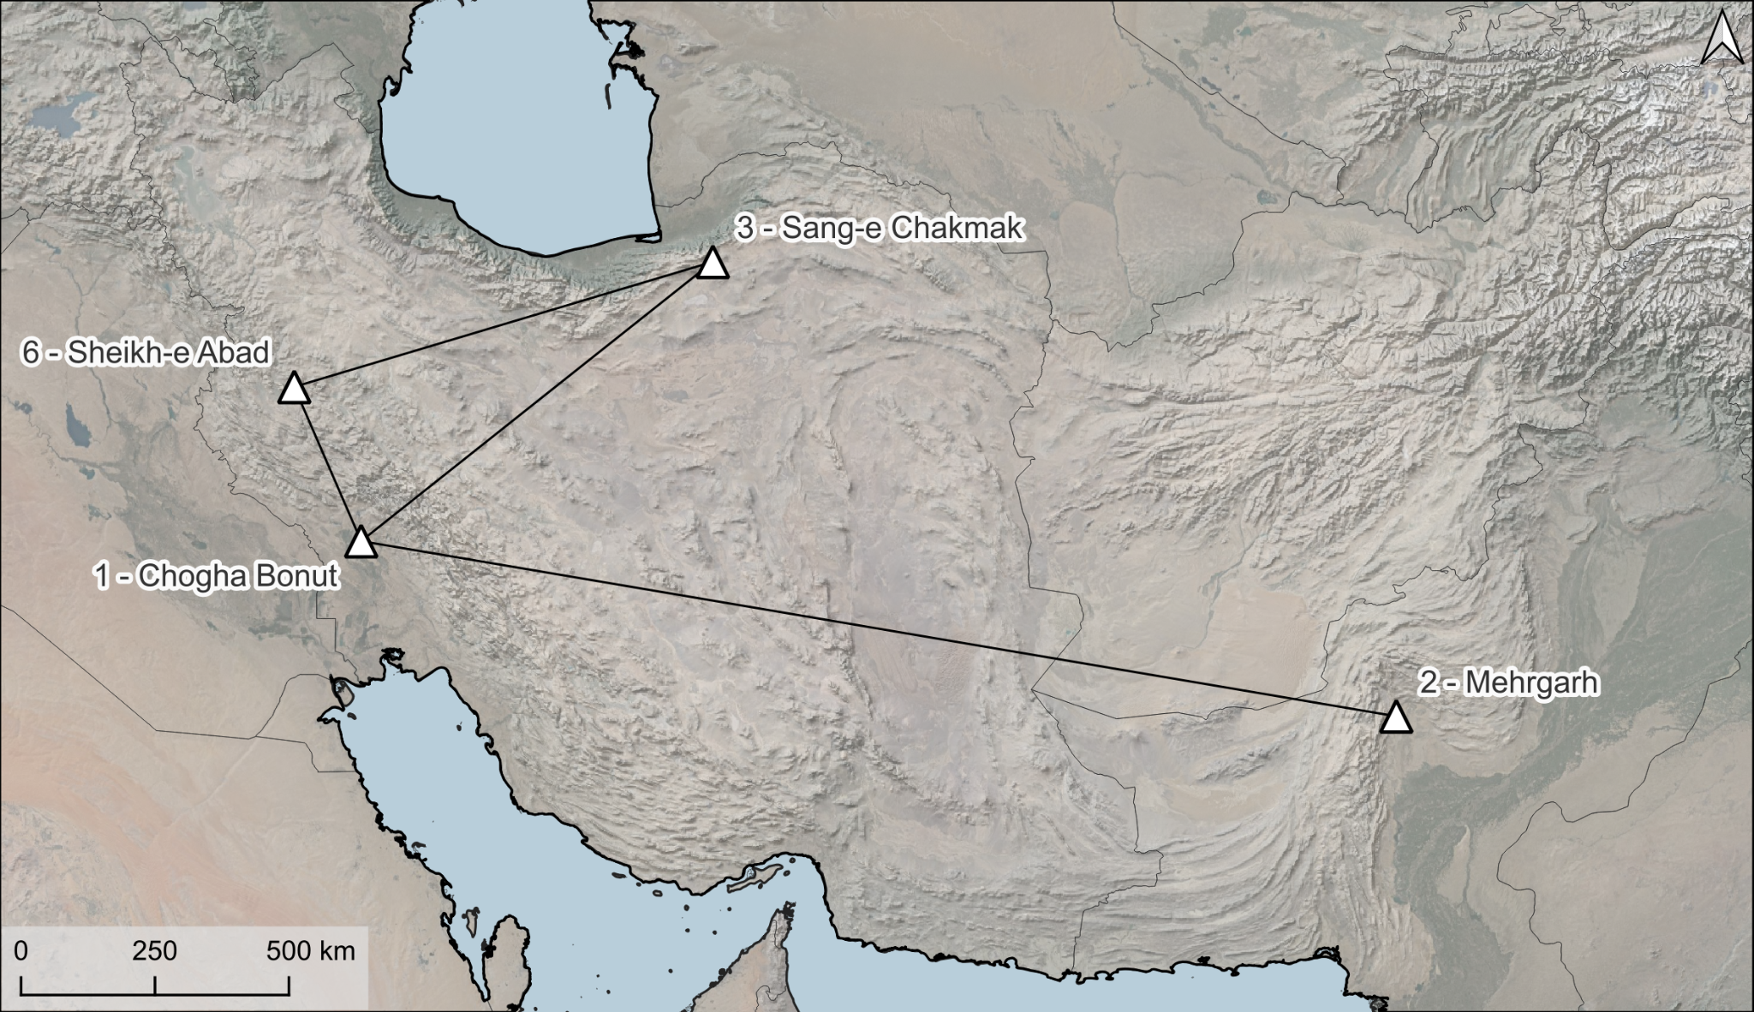
The map represents the cartesian connections between:
Chogha Bonut | Mehrgarh
Chogha Bonut | Sheikh-e Abad
Chogha Bonut | Sang-e Chakmak
Sang-e Chakmak | Sheikh-e Abad

There is no archaeological evidence for connections between Mehrgarh and Sang-e Chakmak and Mehrgarh and Sheikh-e Abad in the Neolithic. These connections have therefore been excluded from the corridor network.

Fig. S3ii. The Chalcolithic corridor network consists of nine paired corridors between five sites: Mehrgarh, Susa, Sar-e Sang, Tepe Gawra, Shahr-e Sukhteh.
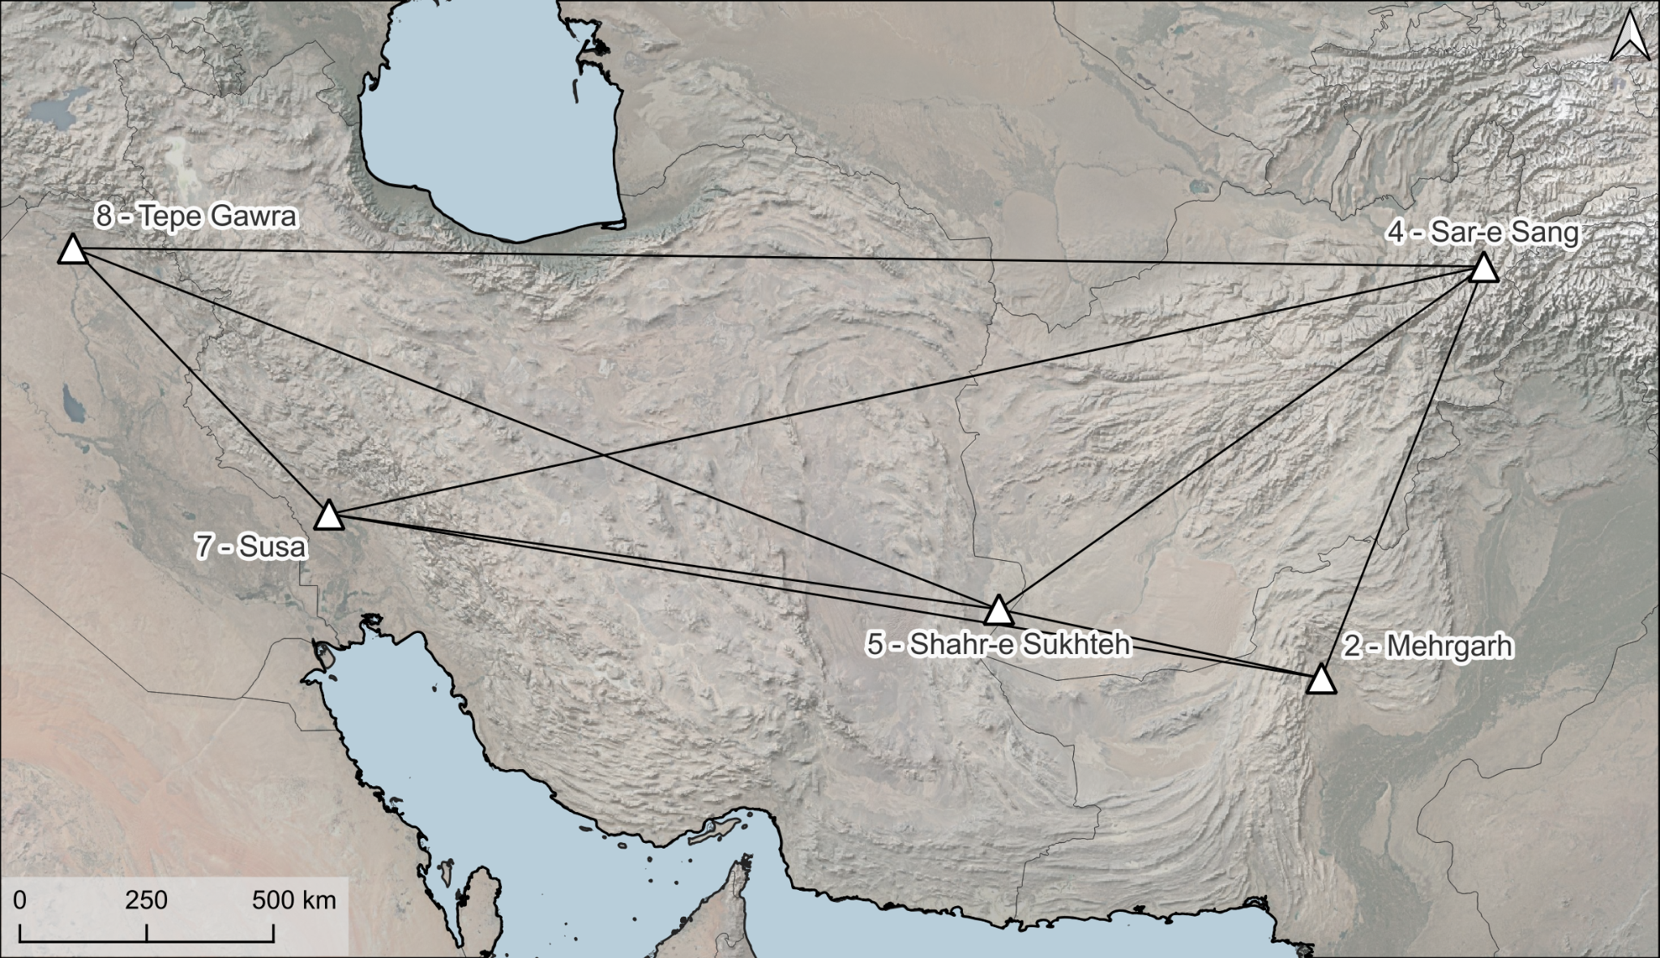
The map represents the cartesian connections between
Mehrgarh | Sar-e Sang
Mehrgarh | Shahr-e Sukhteh
Mehrgarh | Susa
Susa | Sar-e Sang
Susa | Shahr-e Sukhteh
Susa | Tepe Gawra
Shahr-e Sukhteh | Sar-e Sang
Shahr-e Sukhteh | Tepe Gawra
Sar-e Sang | Tepe Gawra

There is no archaeological evidence for a direct connection between Tepe Gawra and Mehrgarh in the Late Chalcolithic. This corridor has therefore been excluded from the corridor network.

Fig. S3iii. The Bronze Age corridor network consists of 24 paired corridors between eight sites: Mehrgarh, Susa, Liyan, Shahr-e Sukhteh, Tepe Gawra, Sar-e Sang, Namazga-depe, Minab.
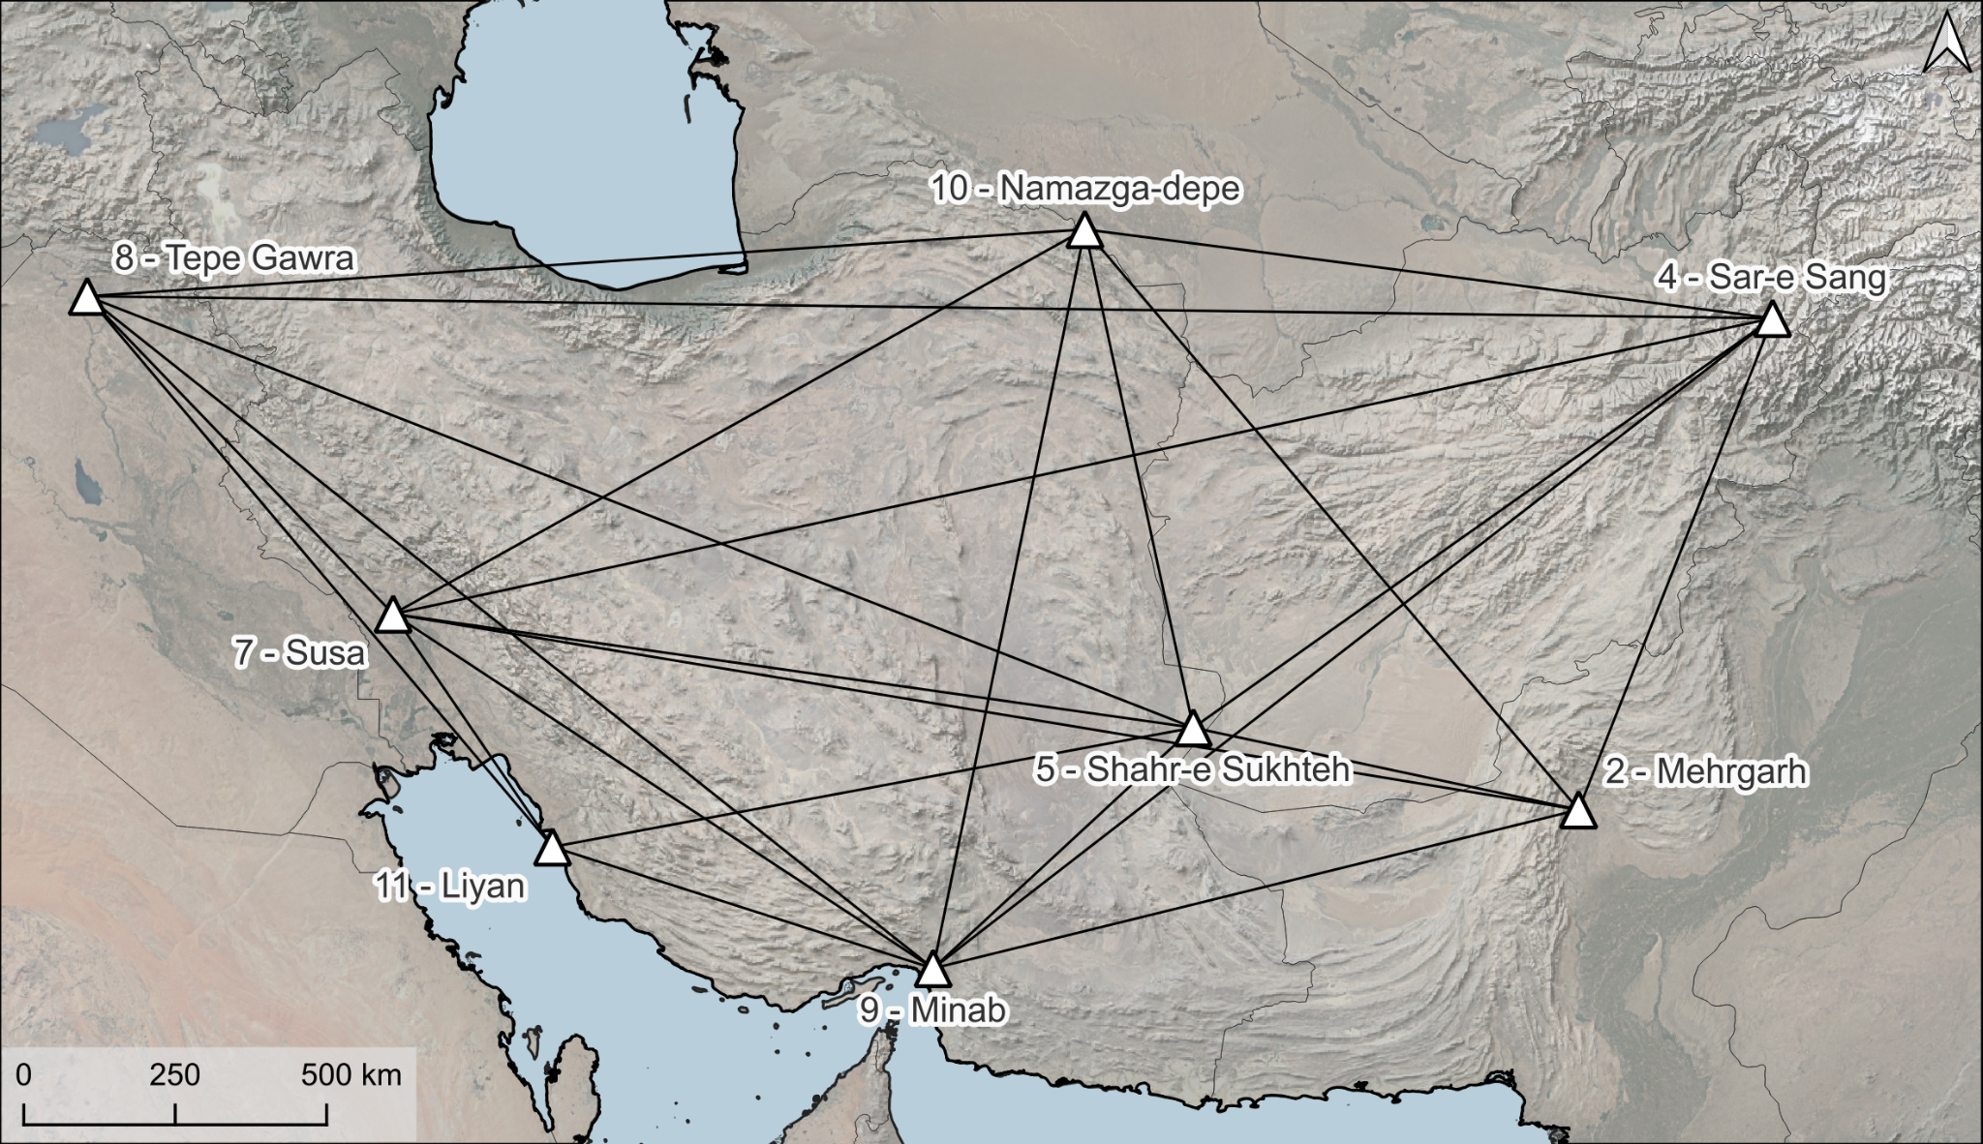
The map represents the cartesian connections between:
Mehrgarh | Sar-e Sang | Shahr-e Sukhteh | Liyan
Mehrgarh | Shahr-e Sukhteh | Shahr-e Sukhteh | Minab
Mehrgarh | Minab | Shahr-e Sukhteh | Namazga-depe
Mehrgarh | Namazga-depe | Shahr-e Sukhteh | Tepe Gawra
Mehrgarh | Susa | Sar-e Sang | Minab
Susa | Sar-e Sang | Sar-e Sang | Namazga-depe
Susa | Shahr-e Sukhteh | Sar-e Sang | Tepe Gawra
Susa | Liyan | Namazga-depe | Minab
Susa | Minab | Namazga-depe | Tepe Gawra
Susa | Namazga-depe | Minab | Liyan
Susa | Tepe Gawra | Minab | Tepe Gawra
Shahr-e Sukhteh | Sar-e Sang | Tepe Gawra | Liyan

There is no archaeological evidence for direct connections between Tepe Gawra - Mehrgarh, Liyan - Namazga-depe, Liyan - Sar-e Sang and Liyan - Mehrgarh. These connections have therefore been excluded from the corridor network.

SI 4. Results of individual corridor models between each start and end point node combination
Fig. S4i. Case study #1 corridors
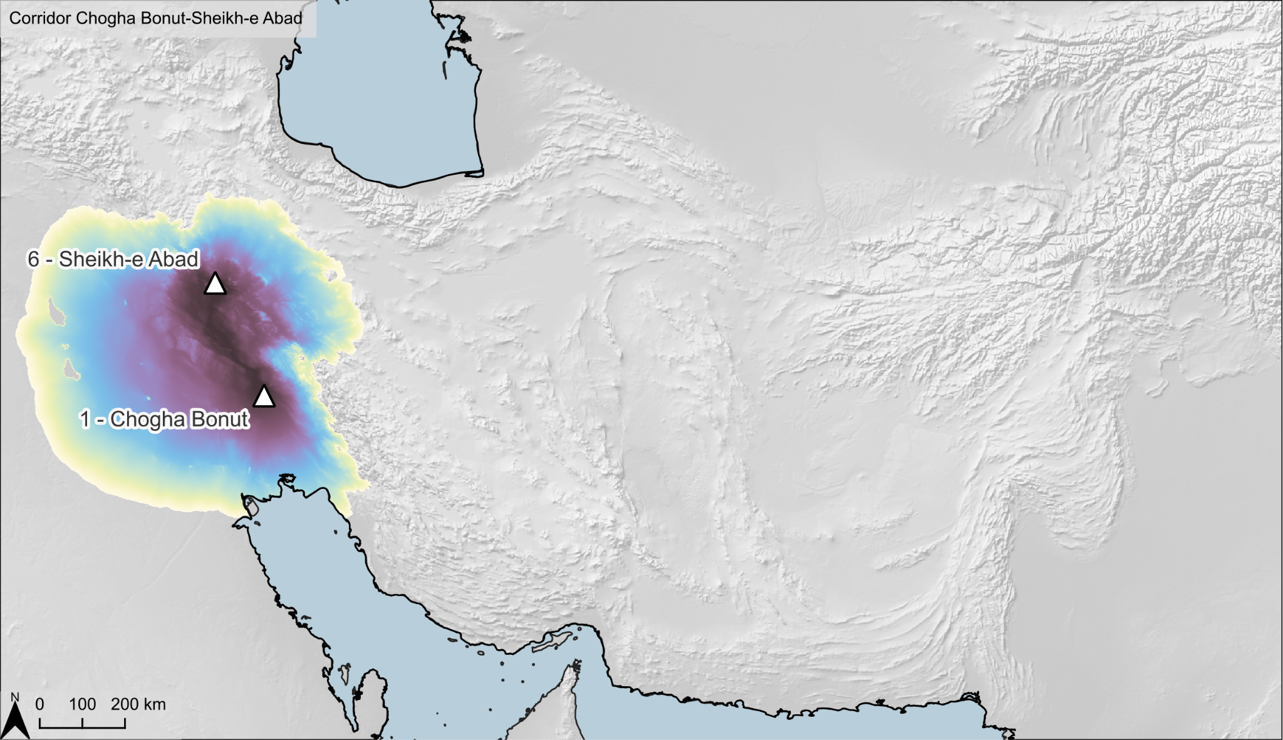  - Chogha-Bonut + Sheikh-e Abad | 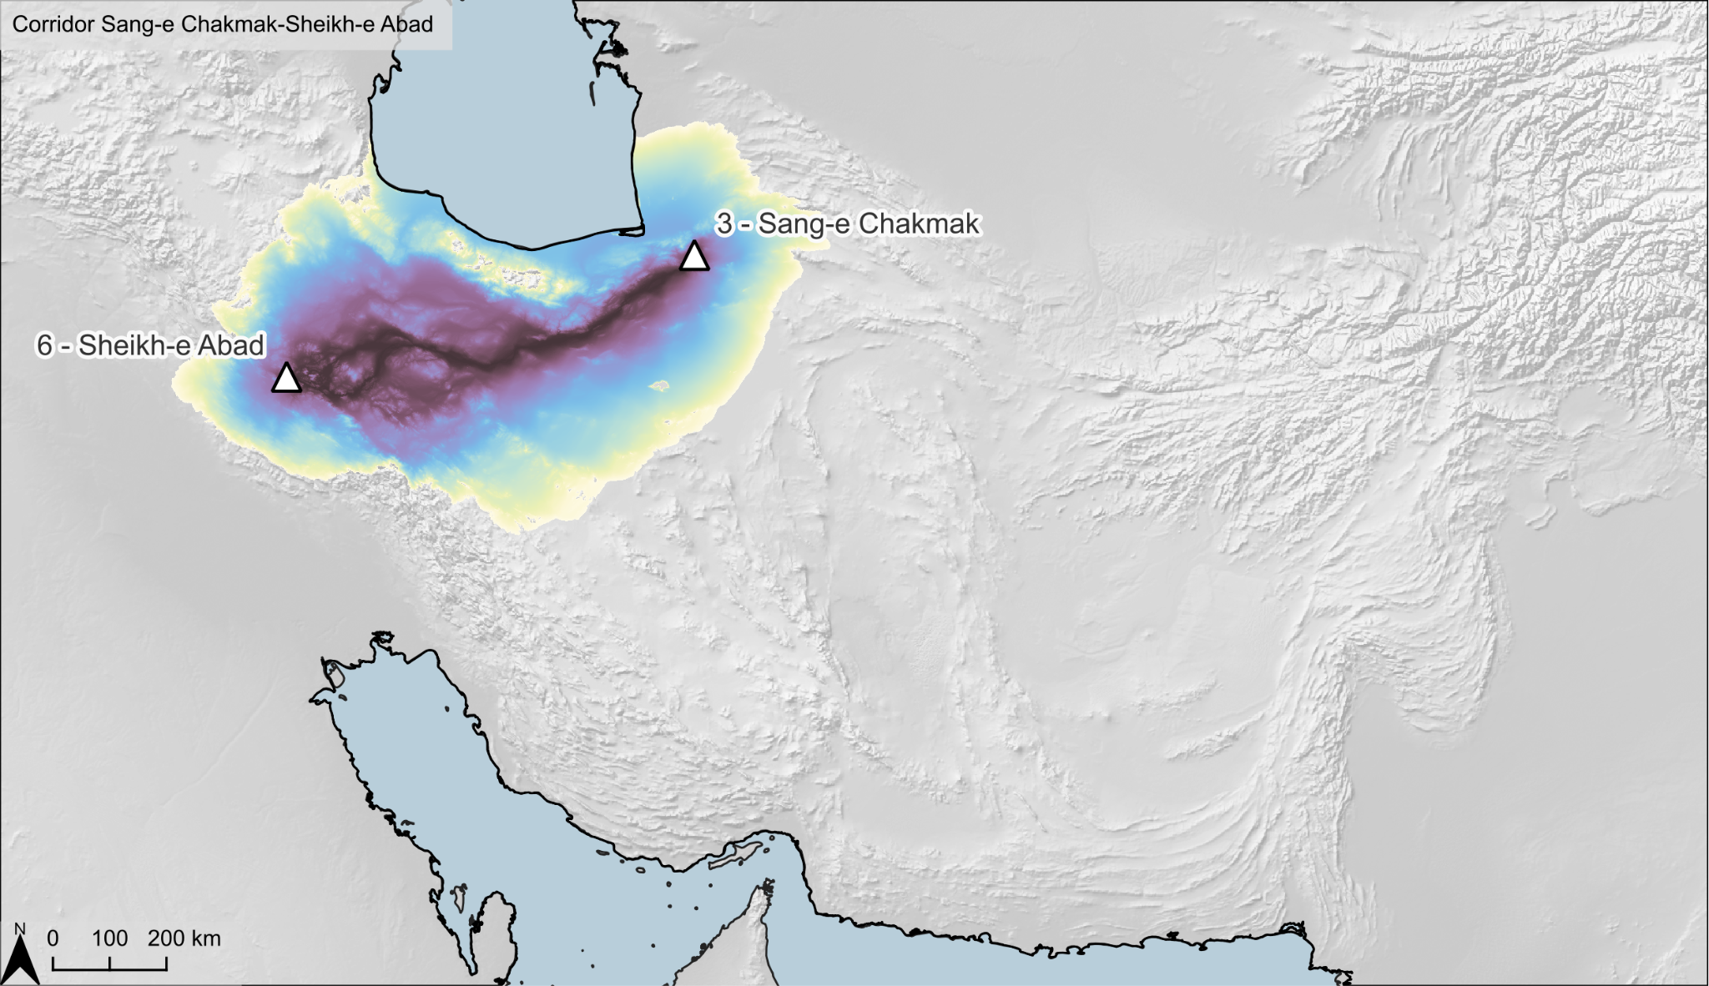  b. Sheikh-e Abad + Sang-e Chakmak
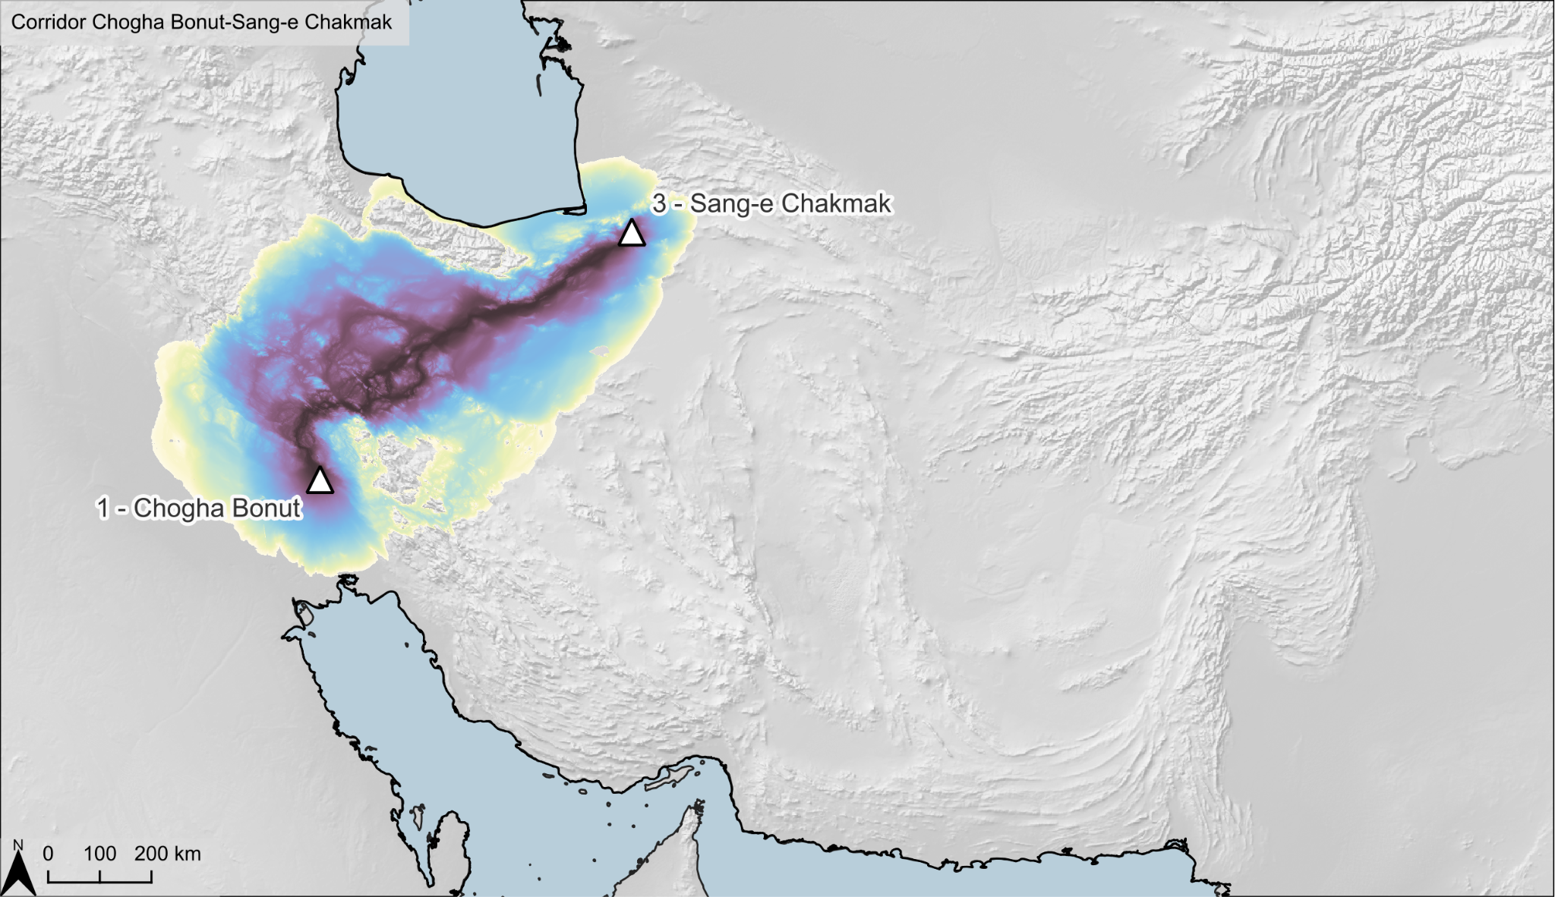  c. Chogha-Bonut + Sang-e Chakmak | 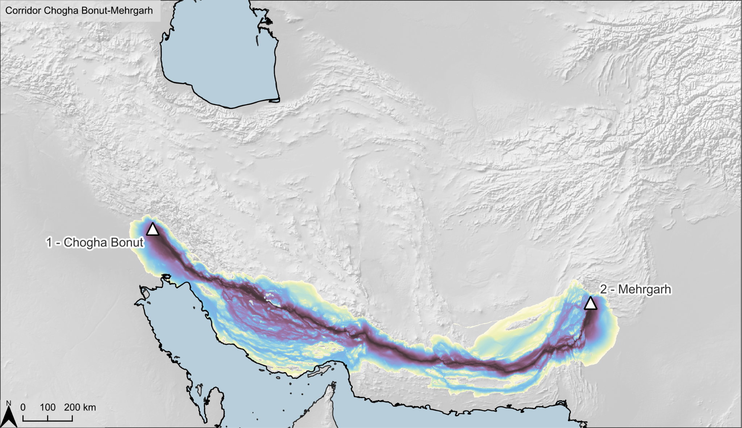  d. Chogha-Bonut + Mehrgarh
Fig. S4ii. Case study #2 corridors
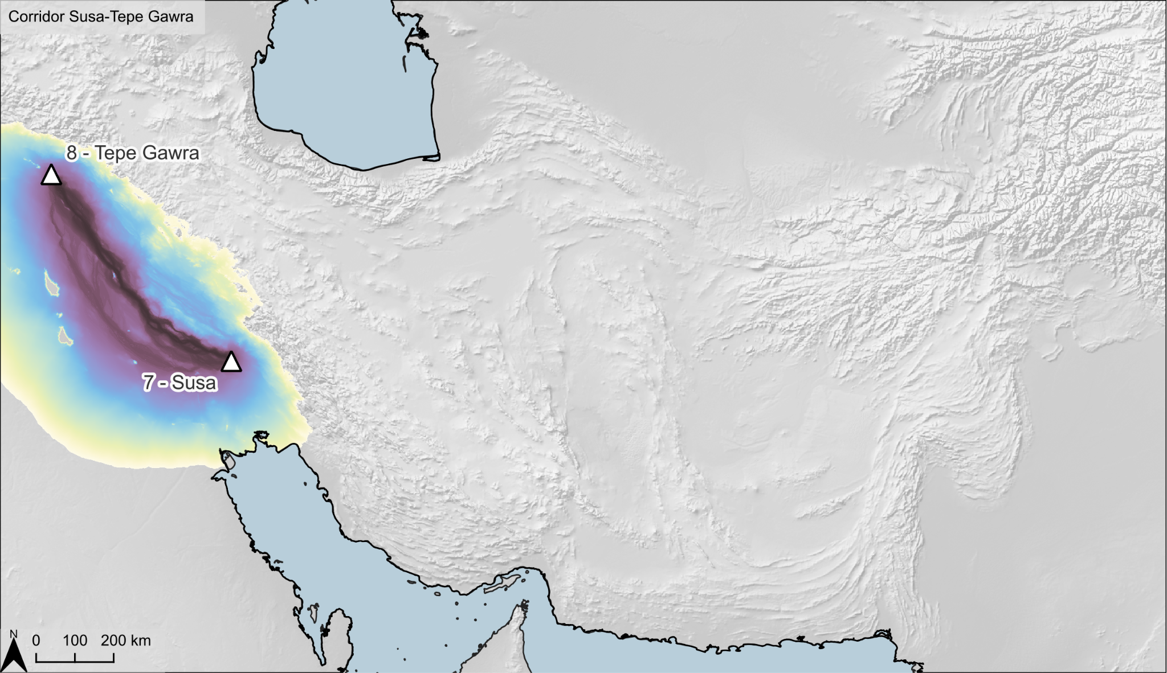  a. Susa + Tepe Gawra | 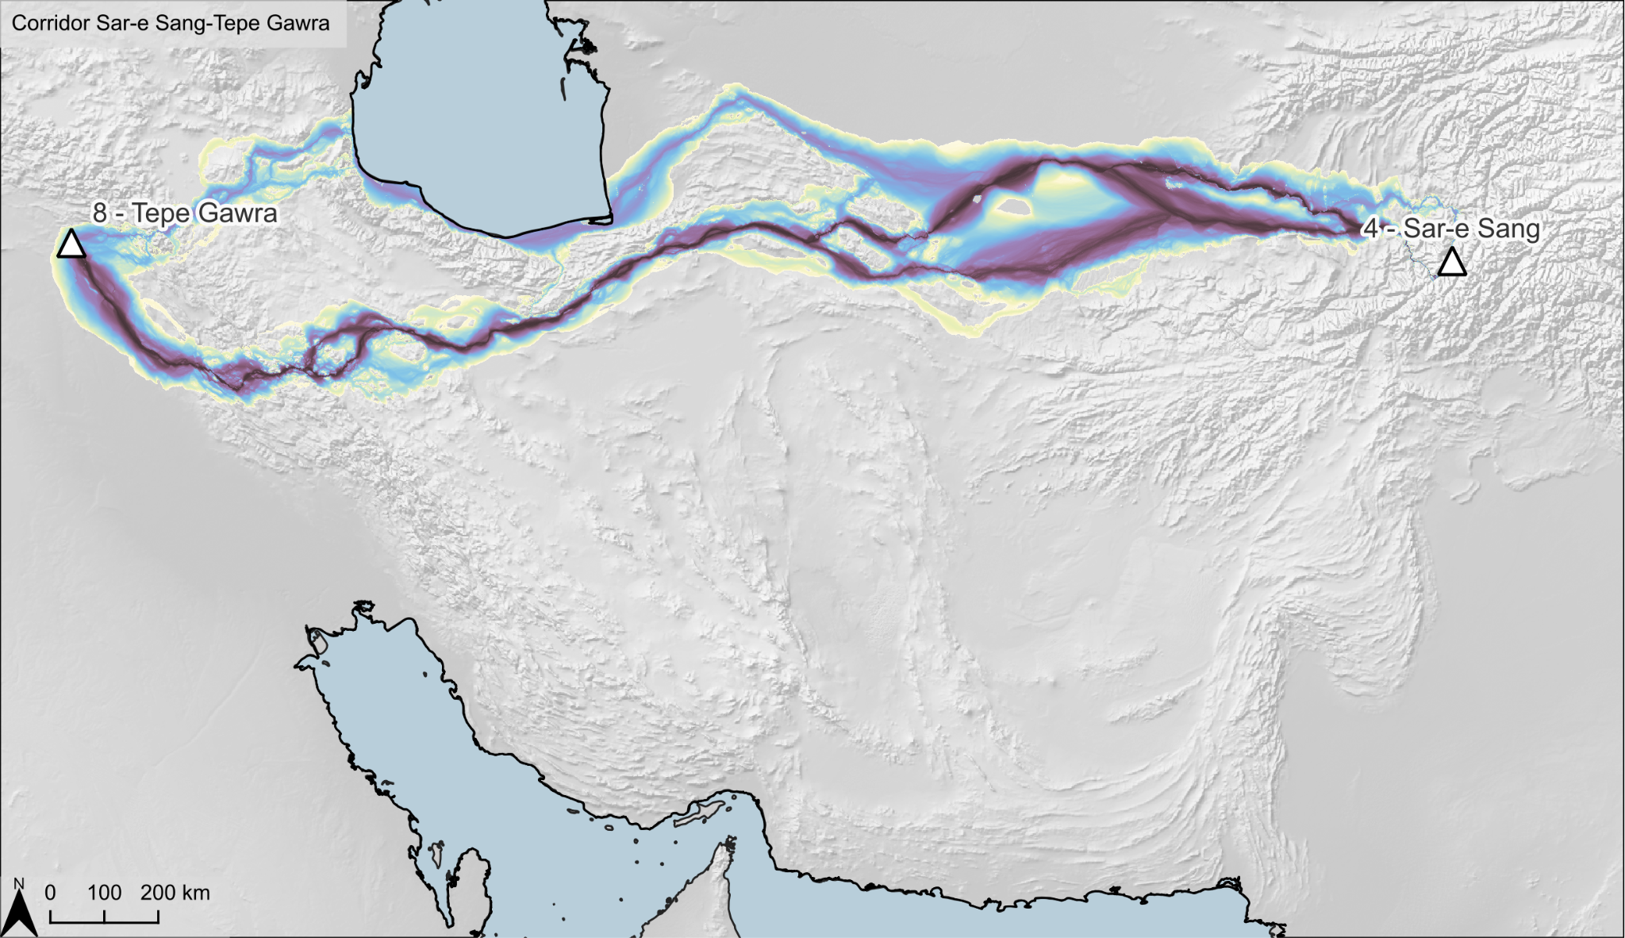  b. Tepe Gawra + Sar-e Sang
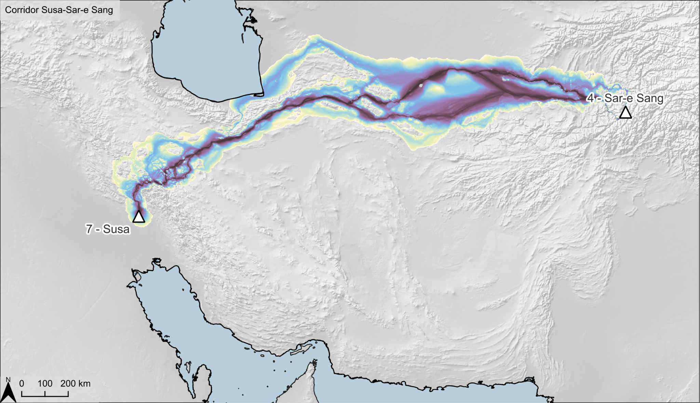  c. Susa + Sar-e Sang | 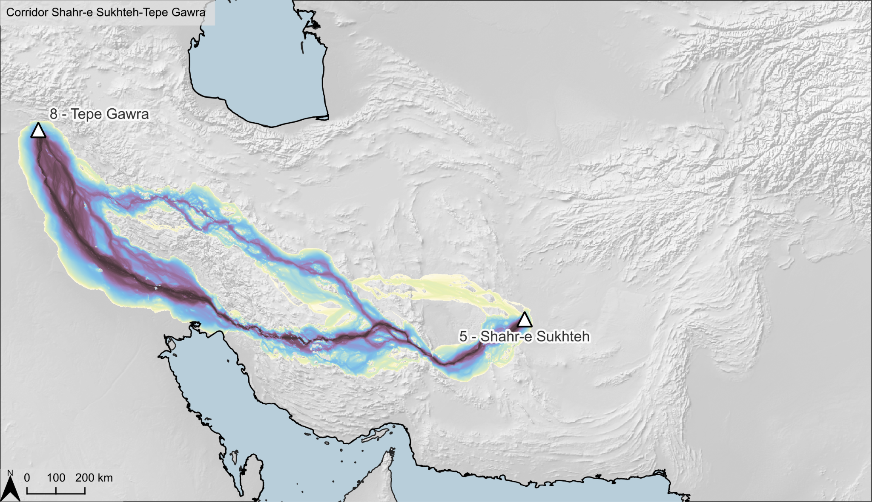  d. Tepe Gawra + Shahr-e Sukhteh
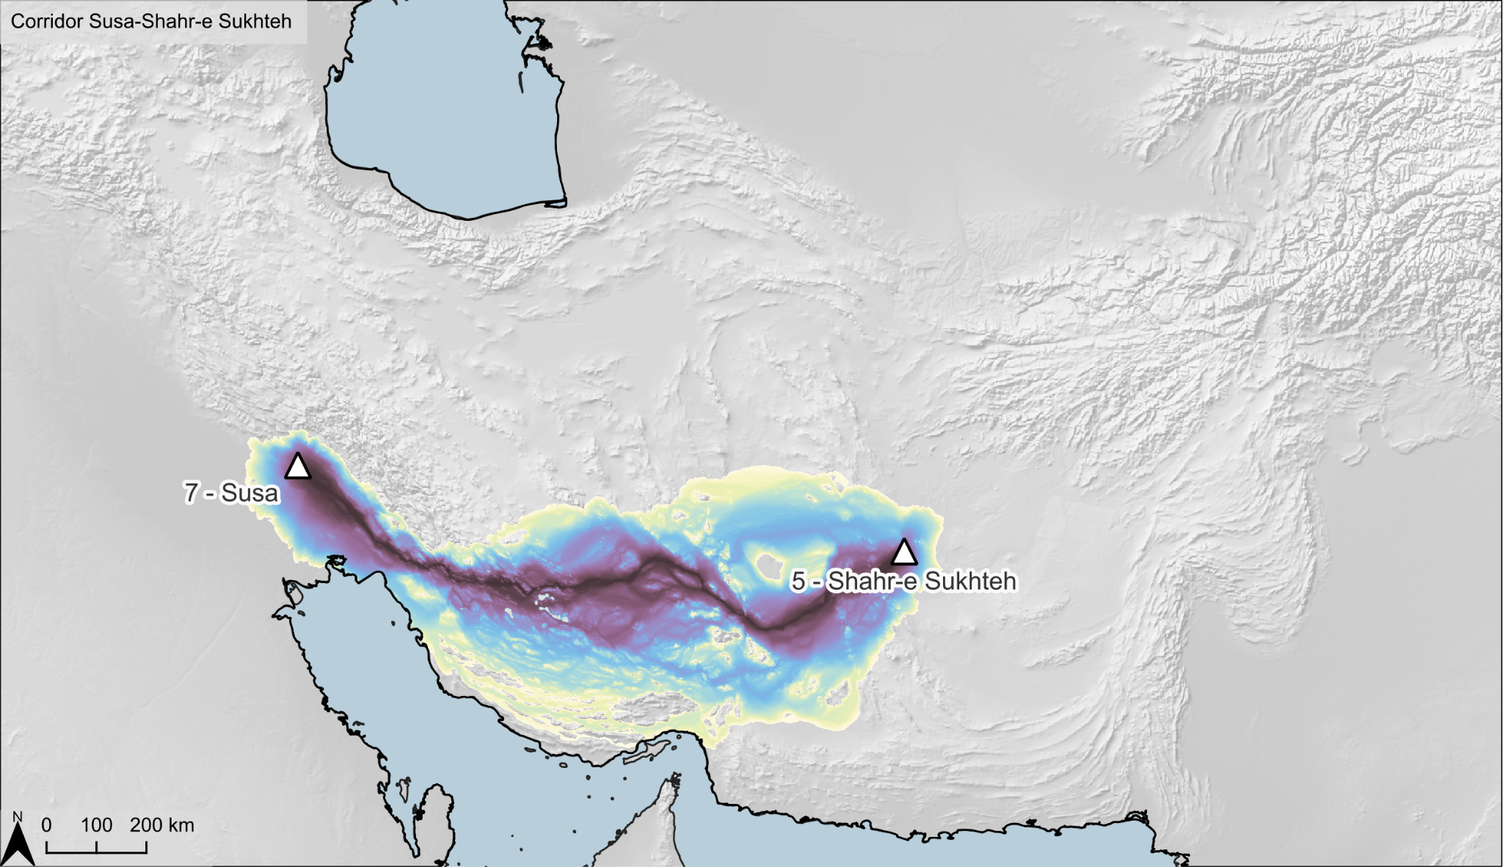  e. Susa + Shahr-e Sukhteh | 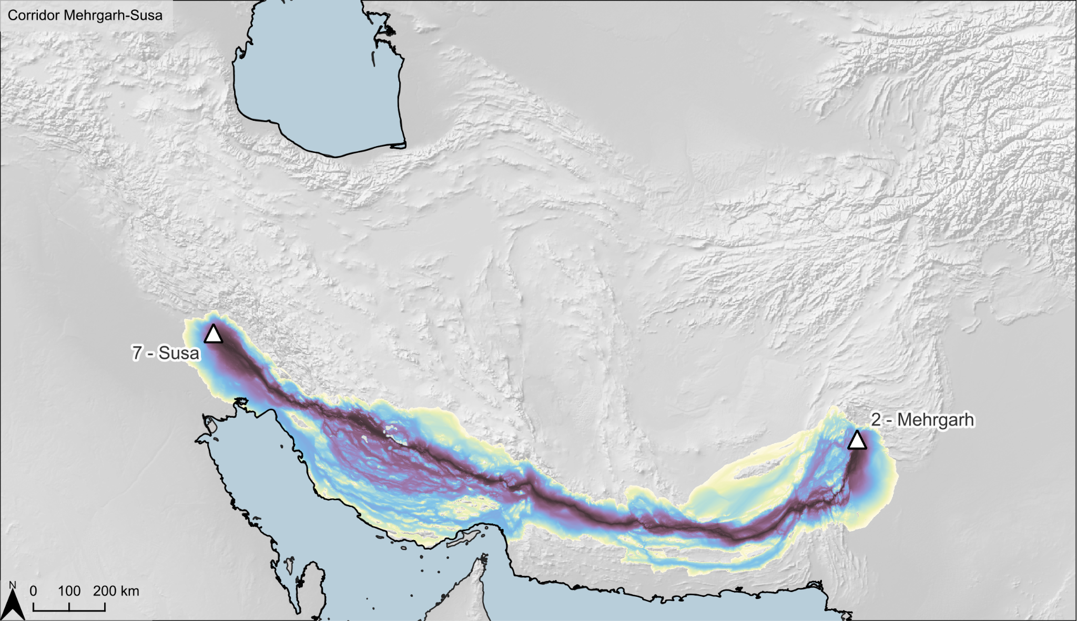  f. Susa + Mehrgarh
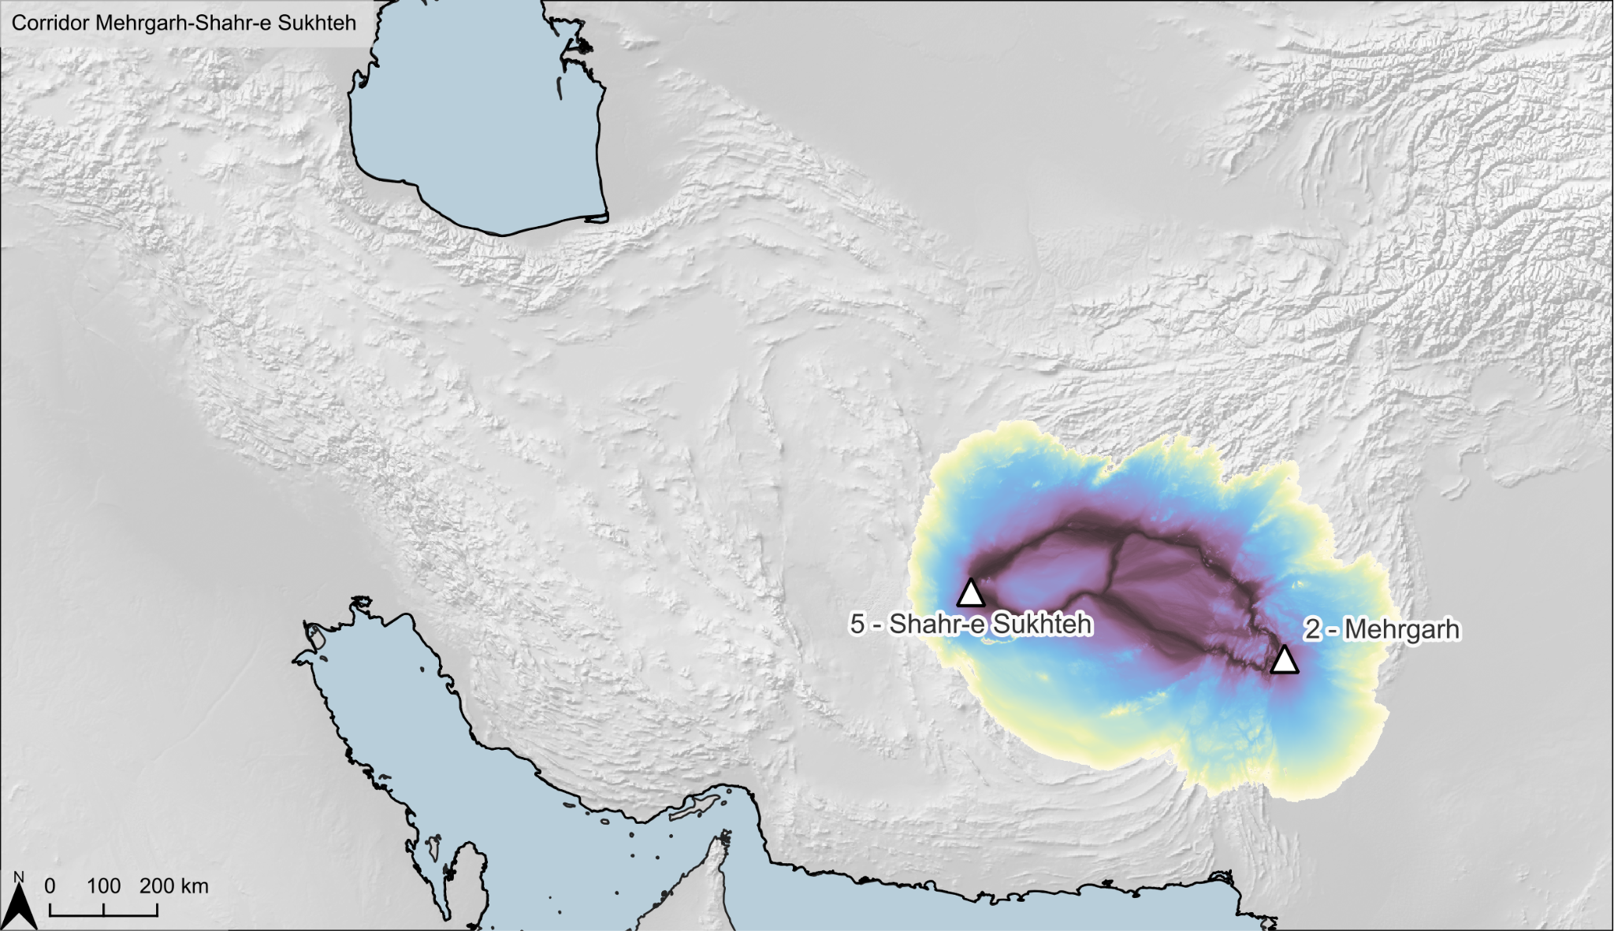  g. Shahr-e Sukhteh + Mehrgarh | 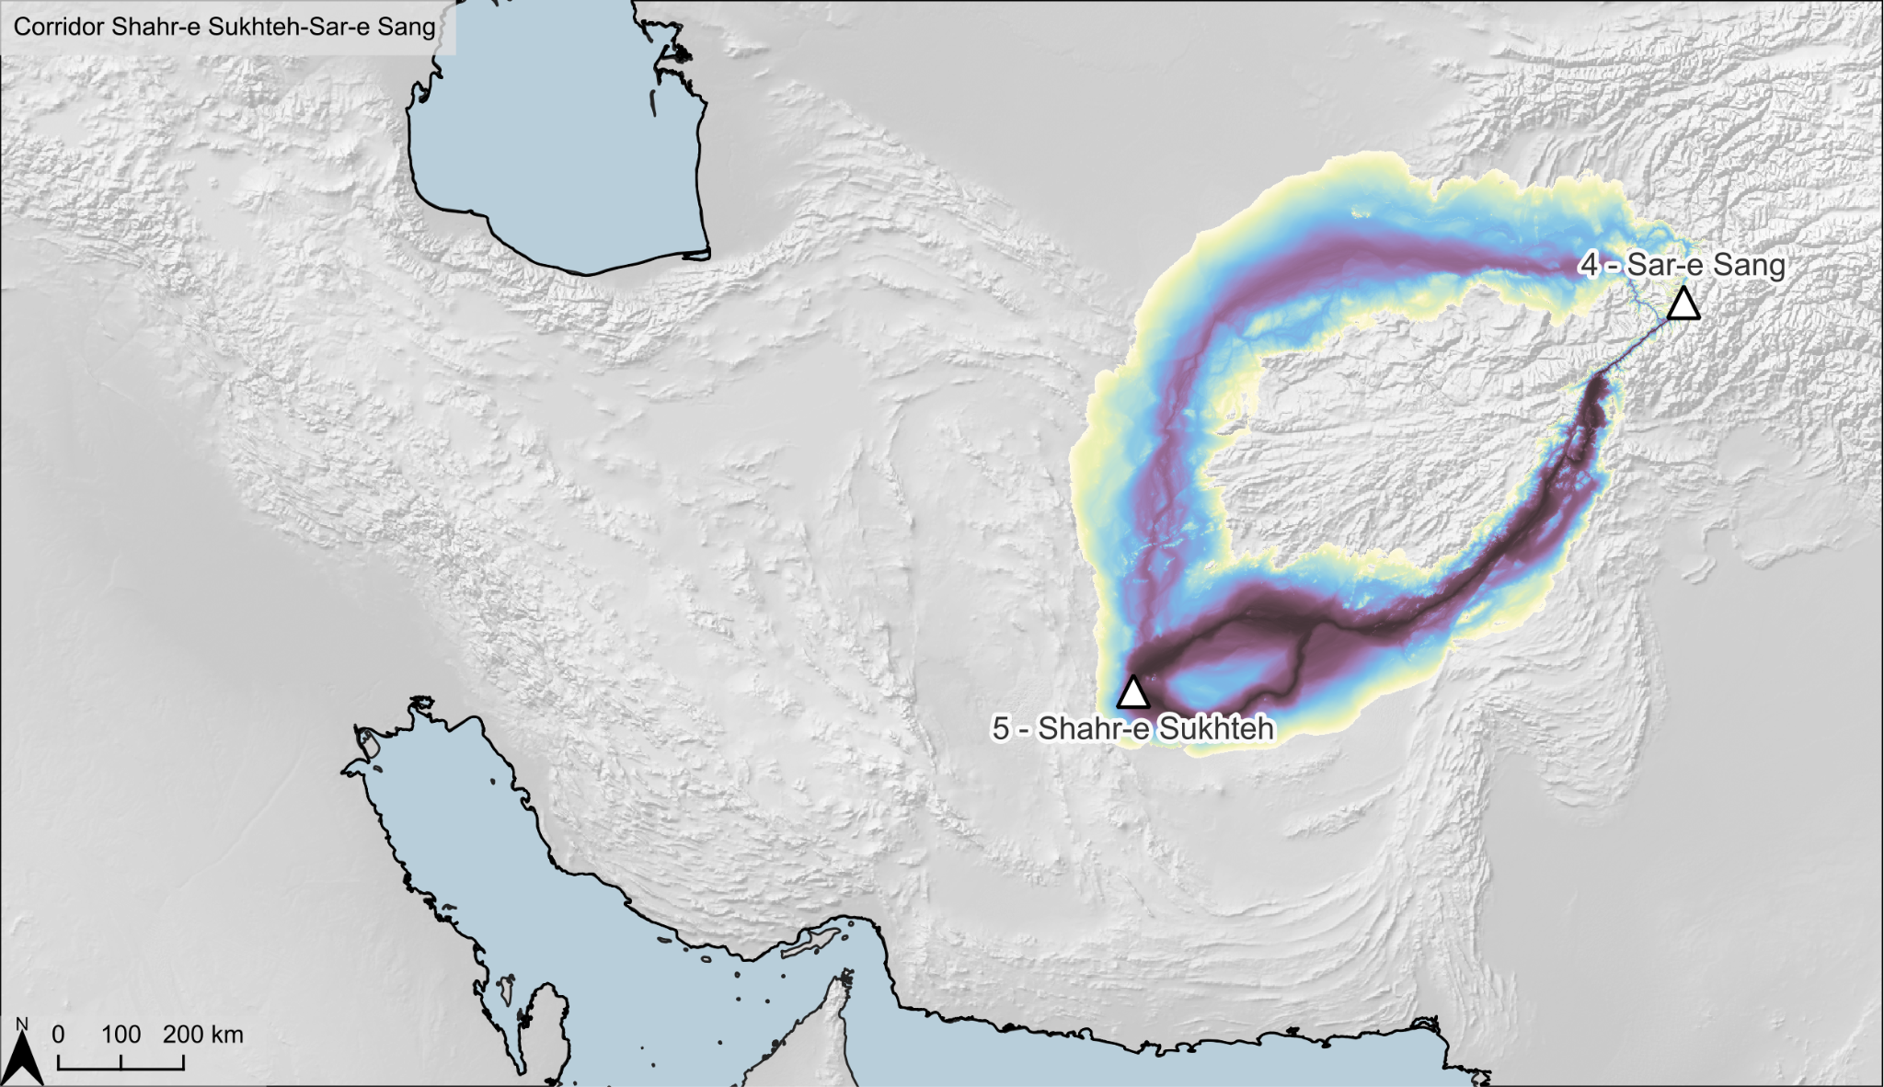  h. Shahr-e Sukhteh + Sar-e Sang
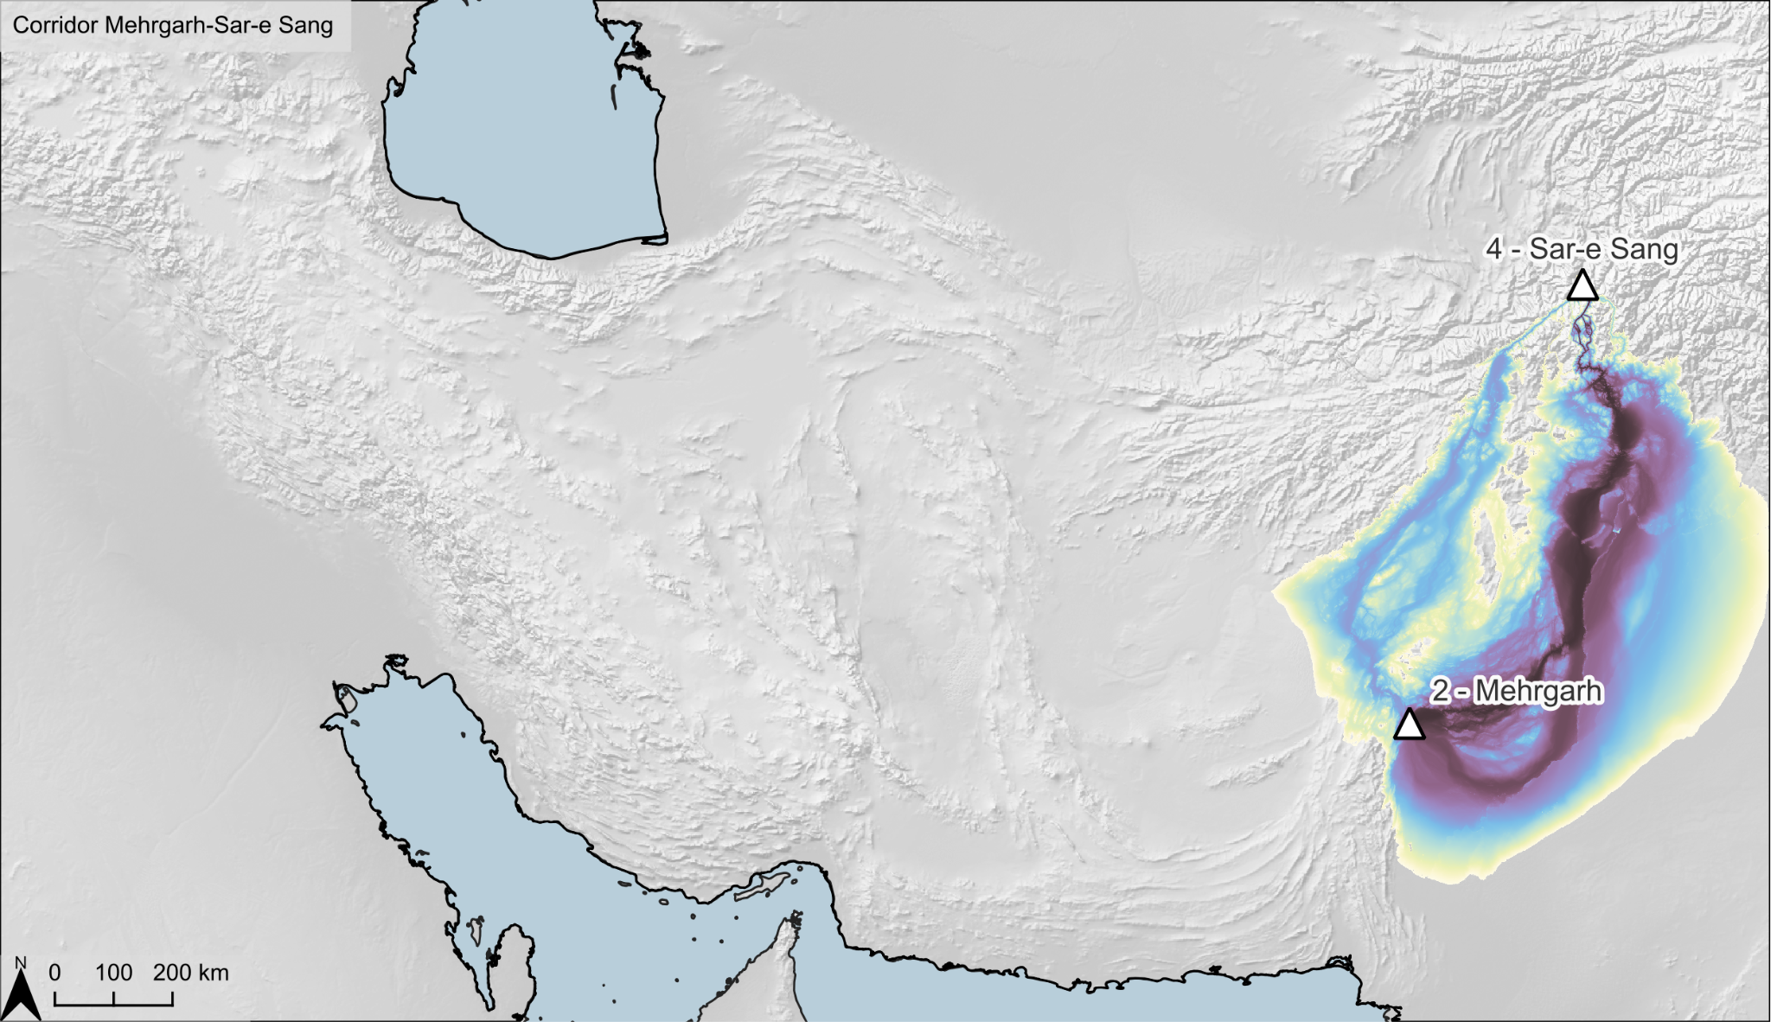
i. Sar-e Sang + Mehrgarh
Fig. S4iii. Case study #3 corridors
a. Susa + Tepe Gawra | 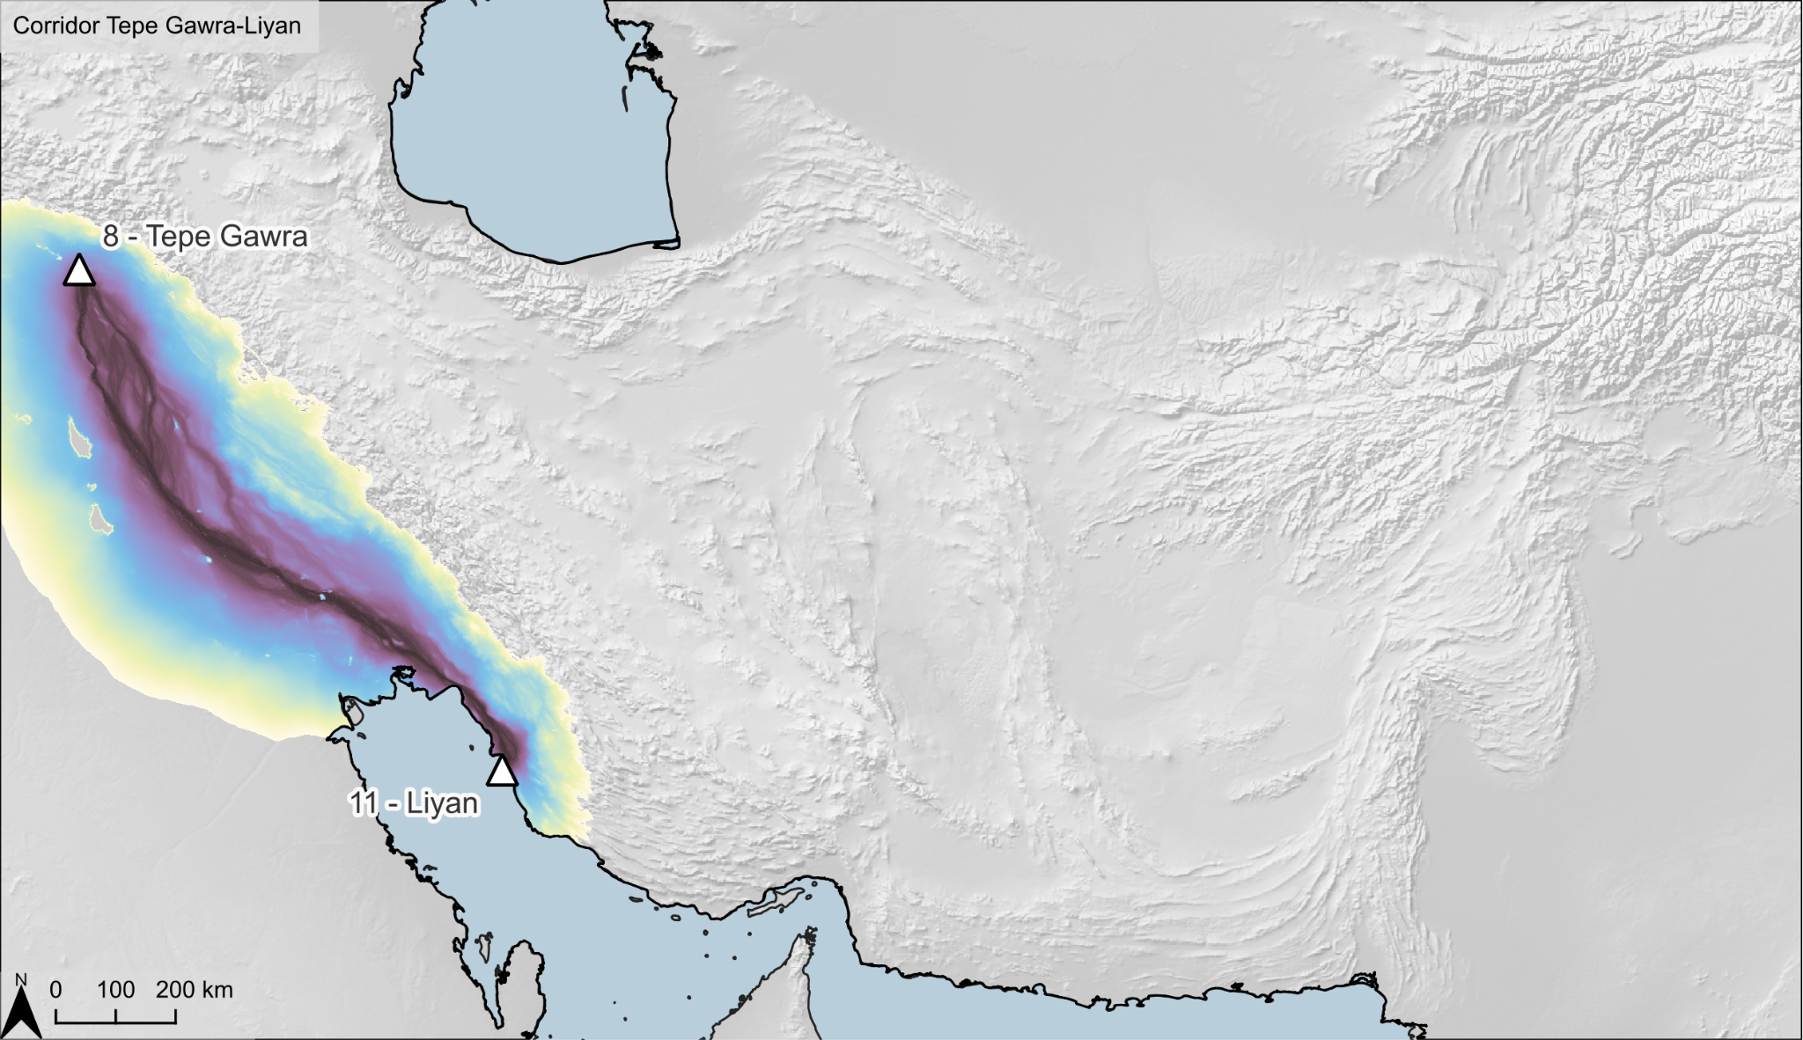  b. Liyan + Tepe Gawra
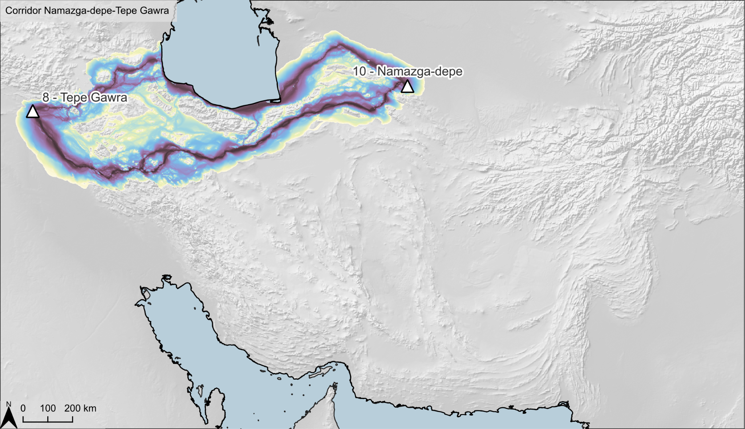  c. Tepe Gawra + Namazga-depe | d. Tepe Gawra + Sar-e Sang
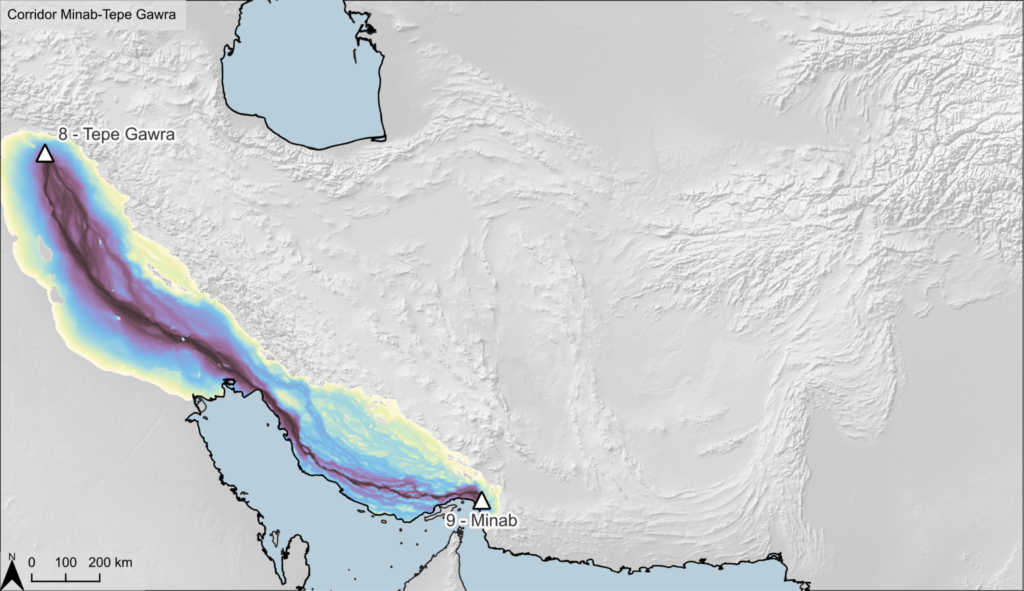  e. Tepe Gawra + Minab | f. Tepe Gawra + Shahr-e Sukhteh
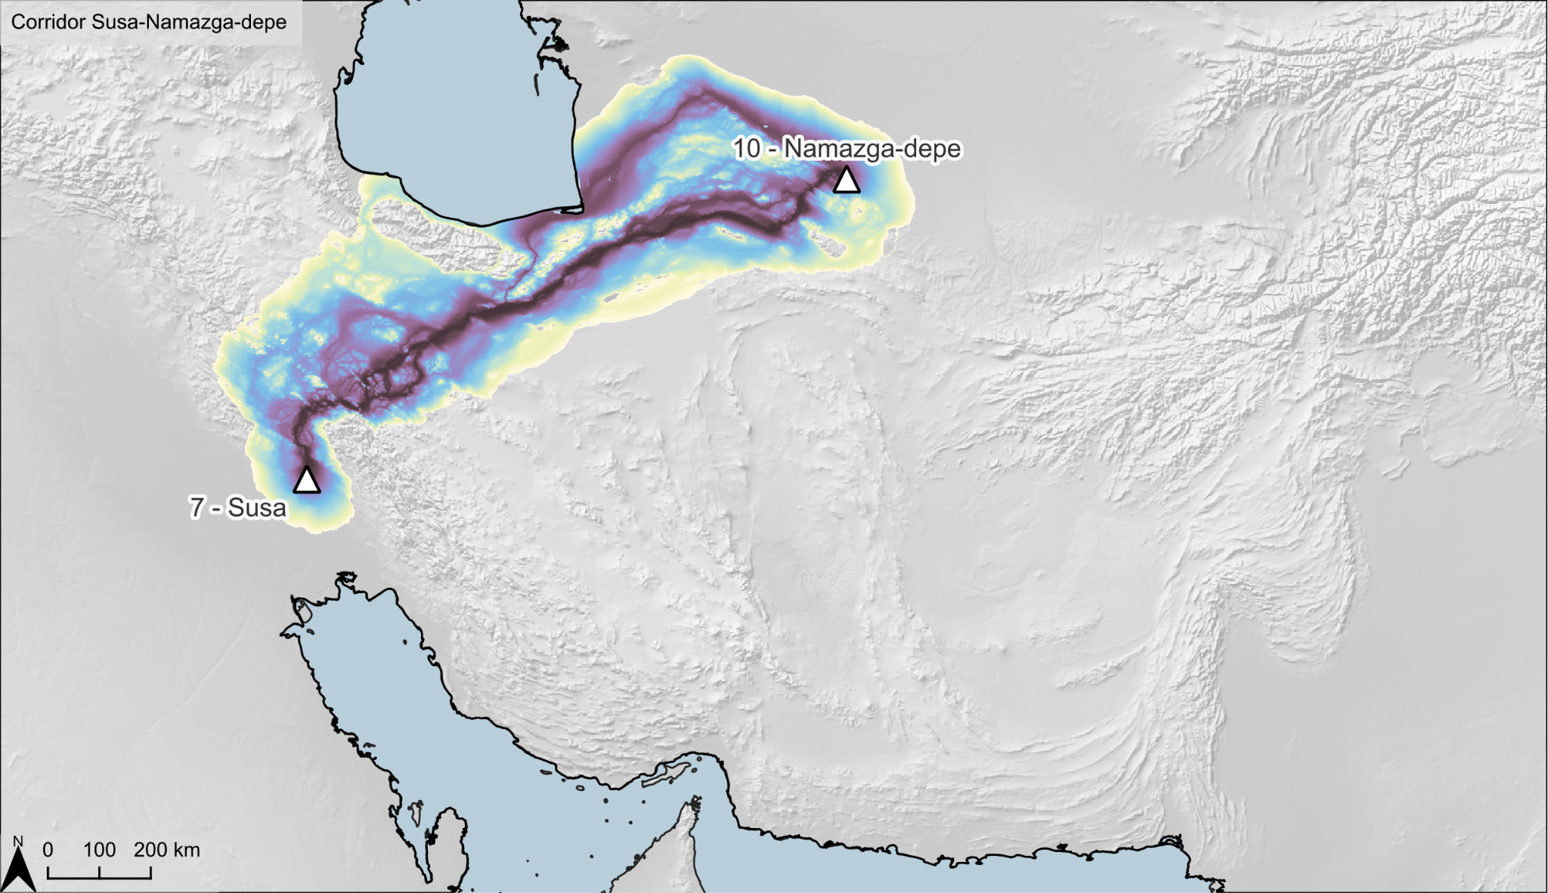  g. Susa + Namazga-depe | h. Susa + Sar-e Sang
i. Susa + Shahr-e Sukhteh | j. Susa + Mehrgarh
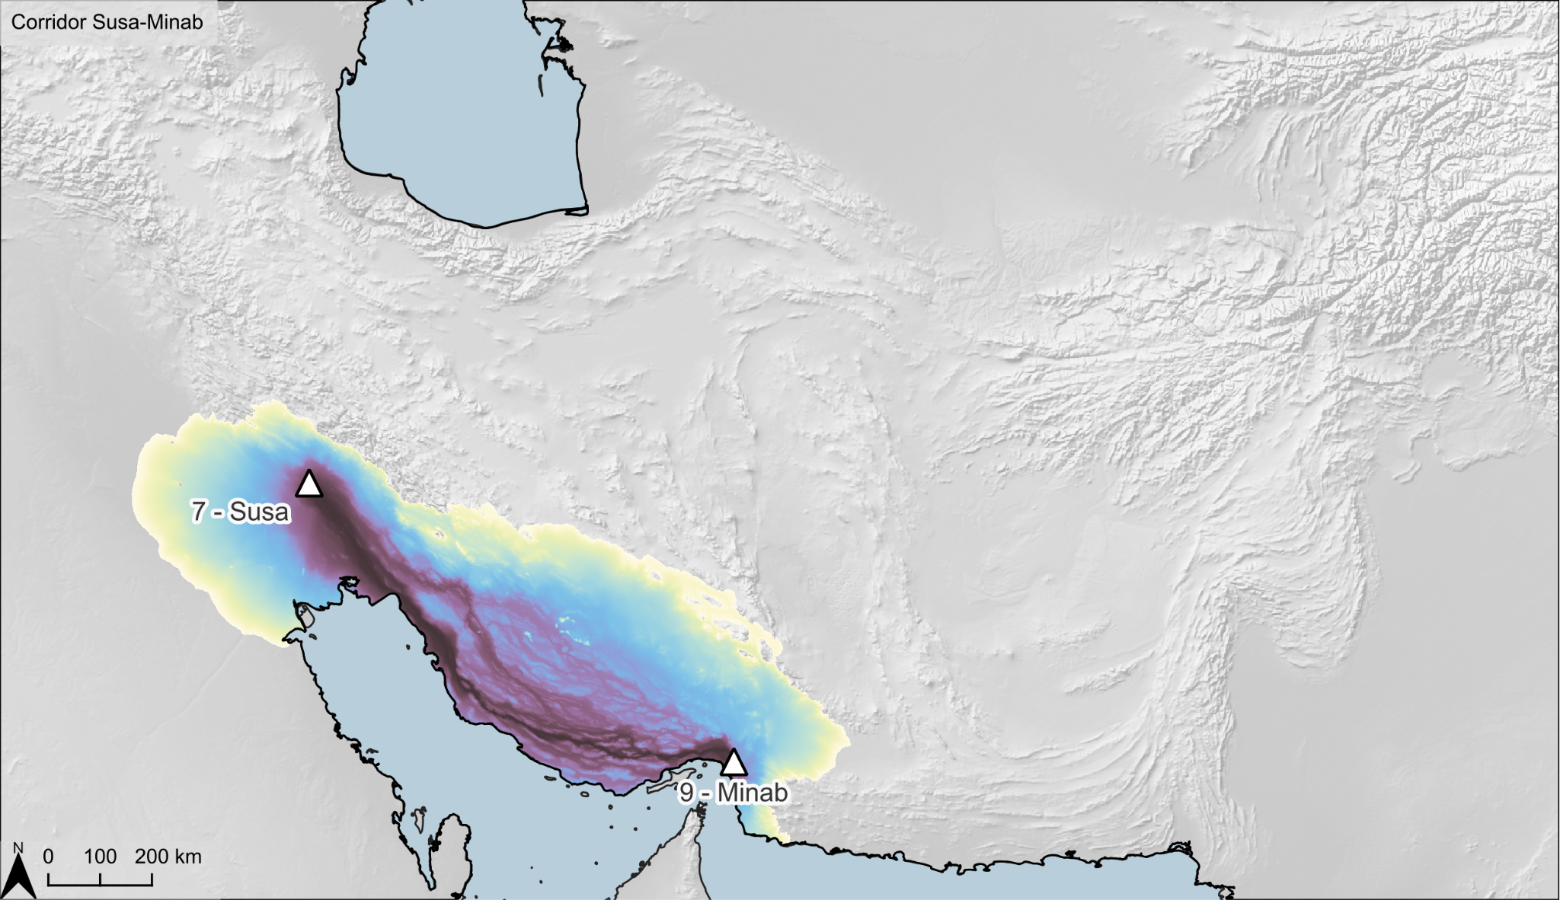  k. Susa + Minab | 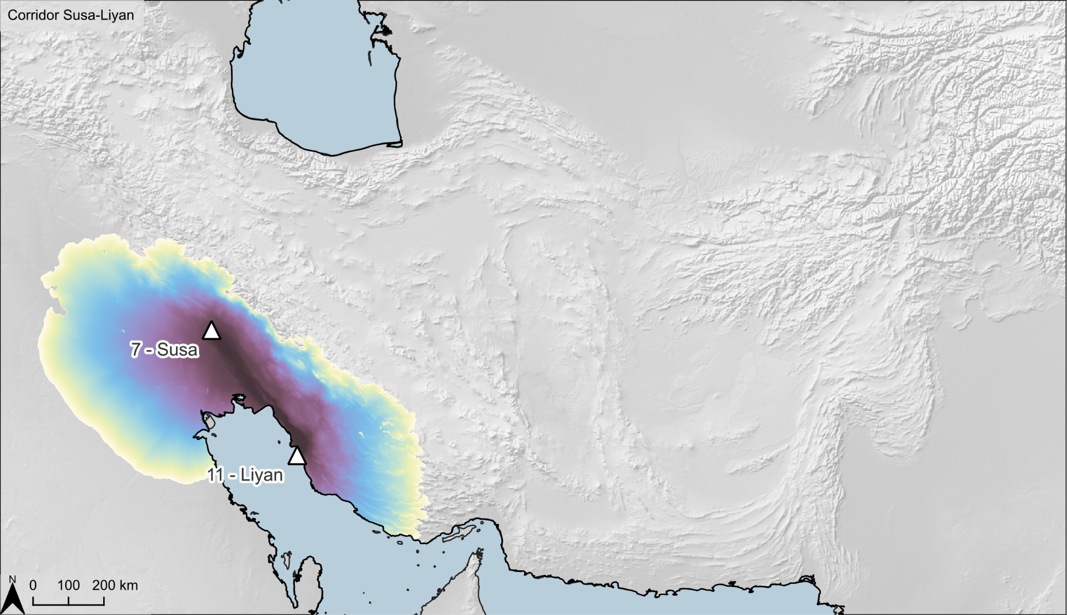  l. Susa + Liyan
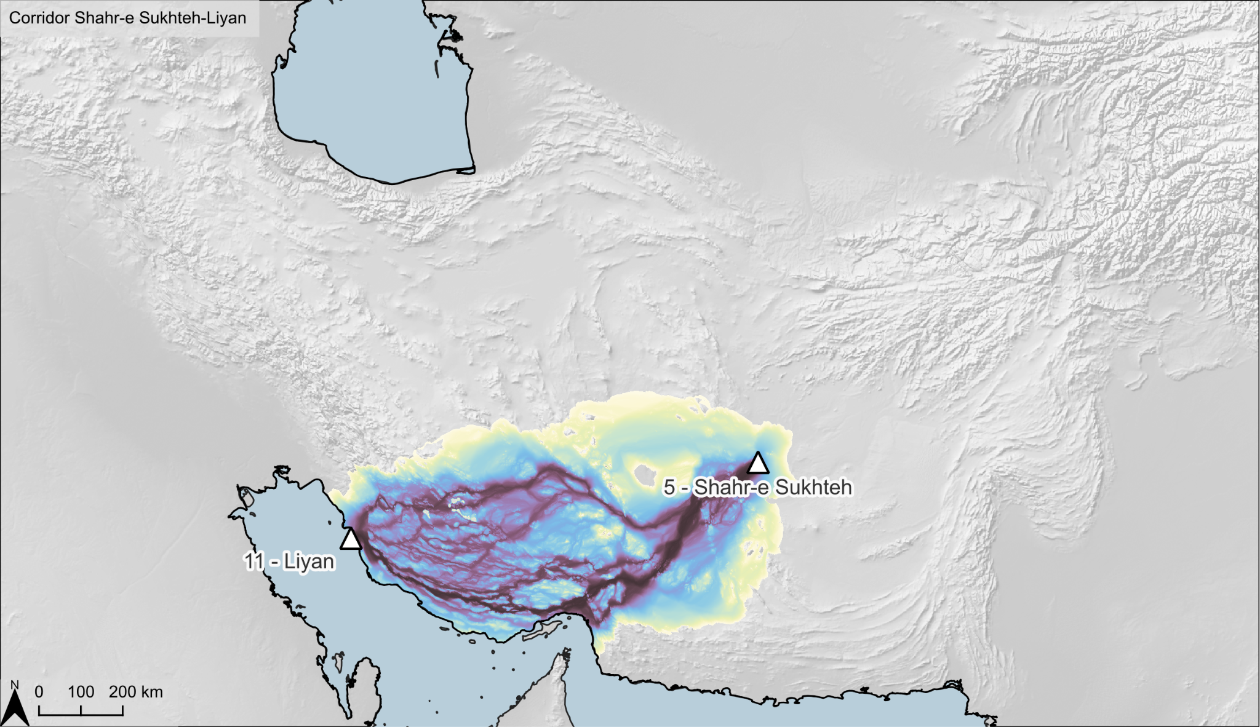  m. Liyan + Shahr-e Sukhteh | 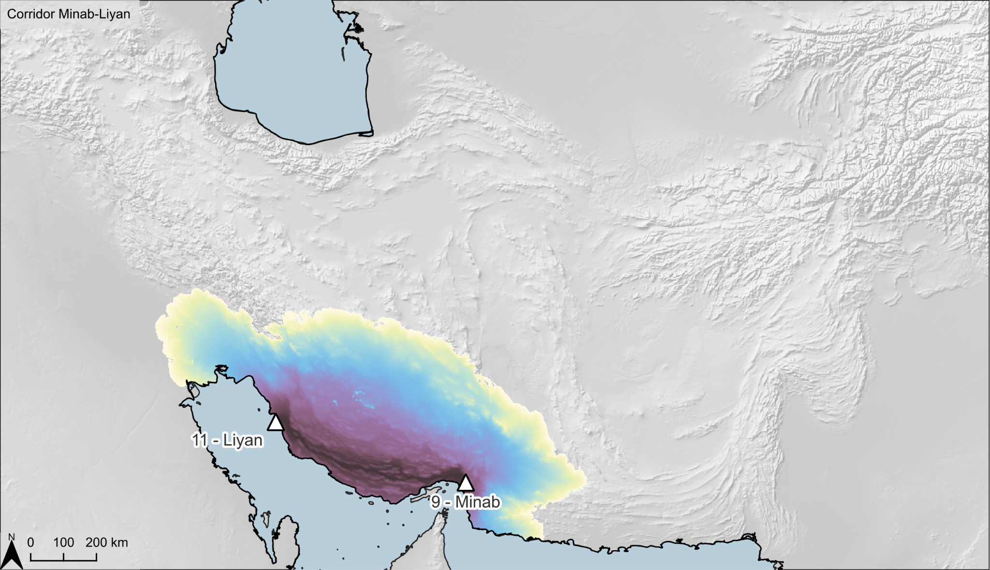  n. Liyan + Minab
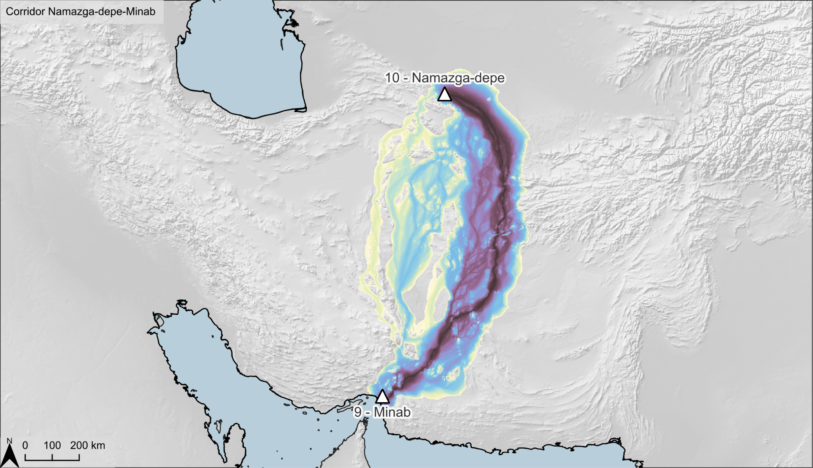  o. Minab + Namazga-depe | 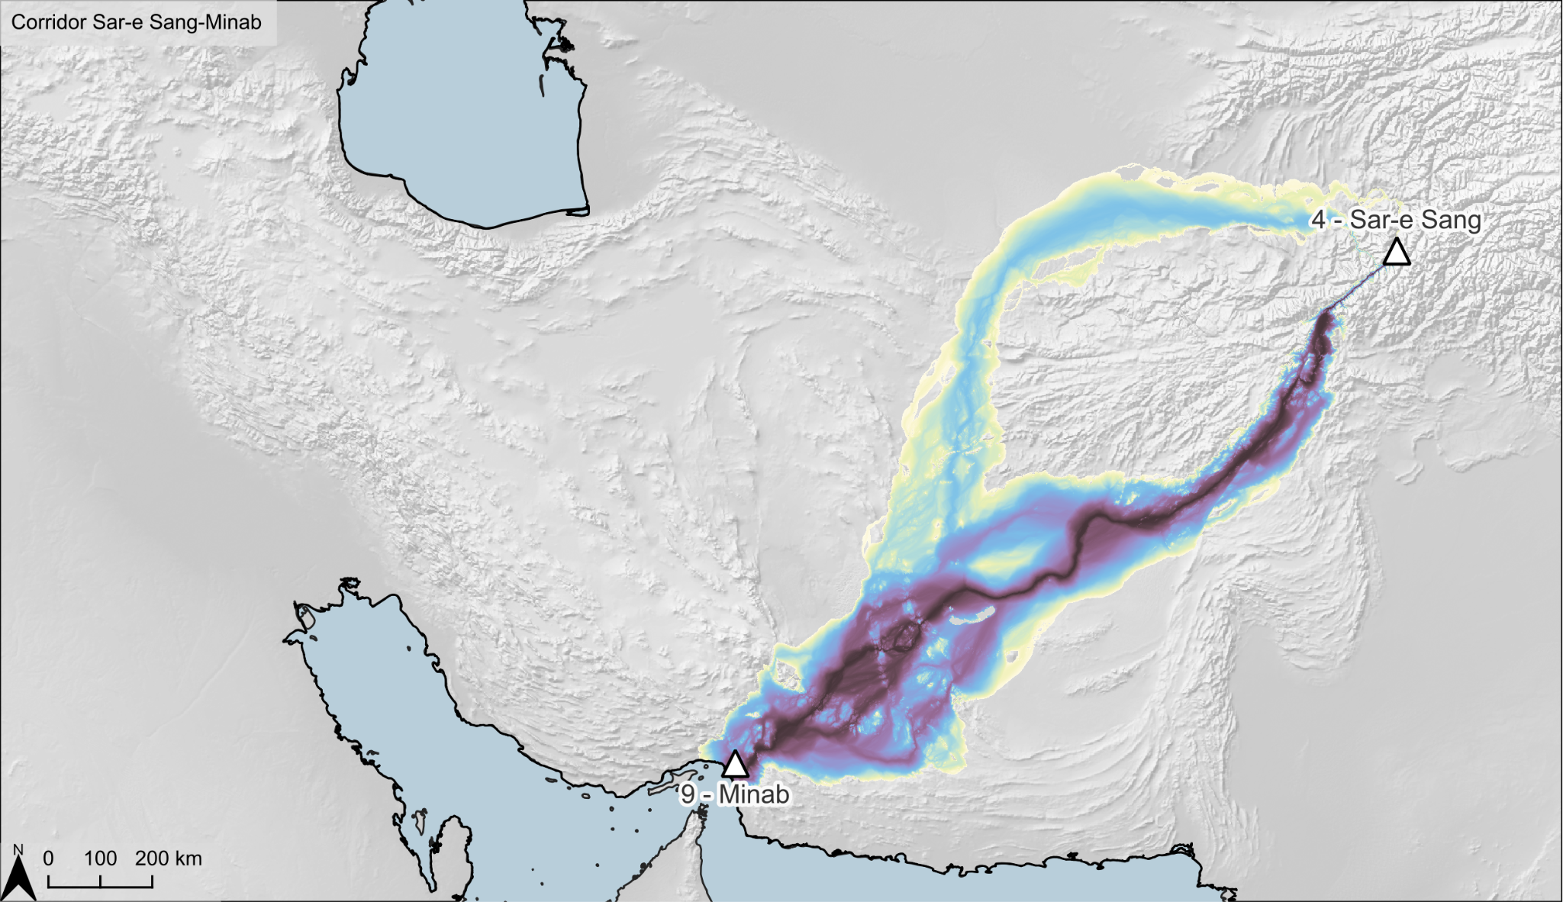  p. Minab + Sar-e Sang
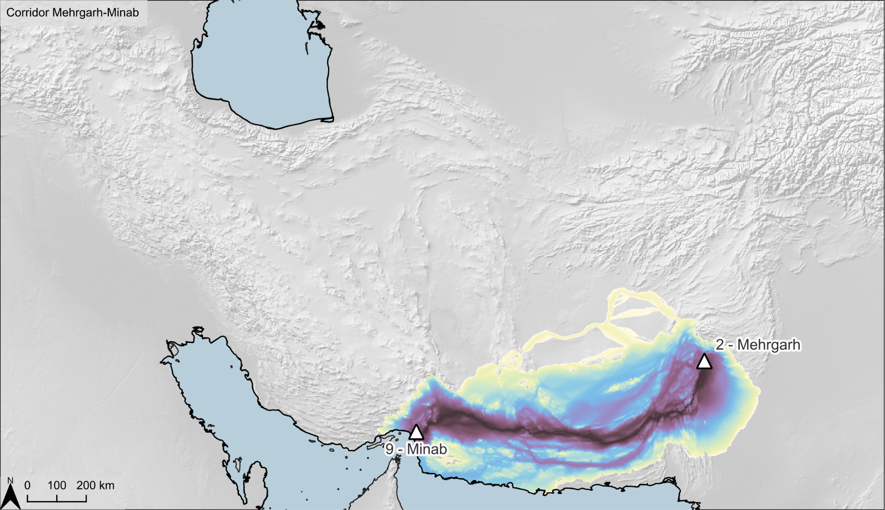  q. Minab + Mehrgarh | 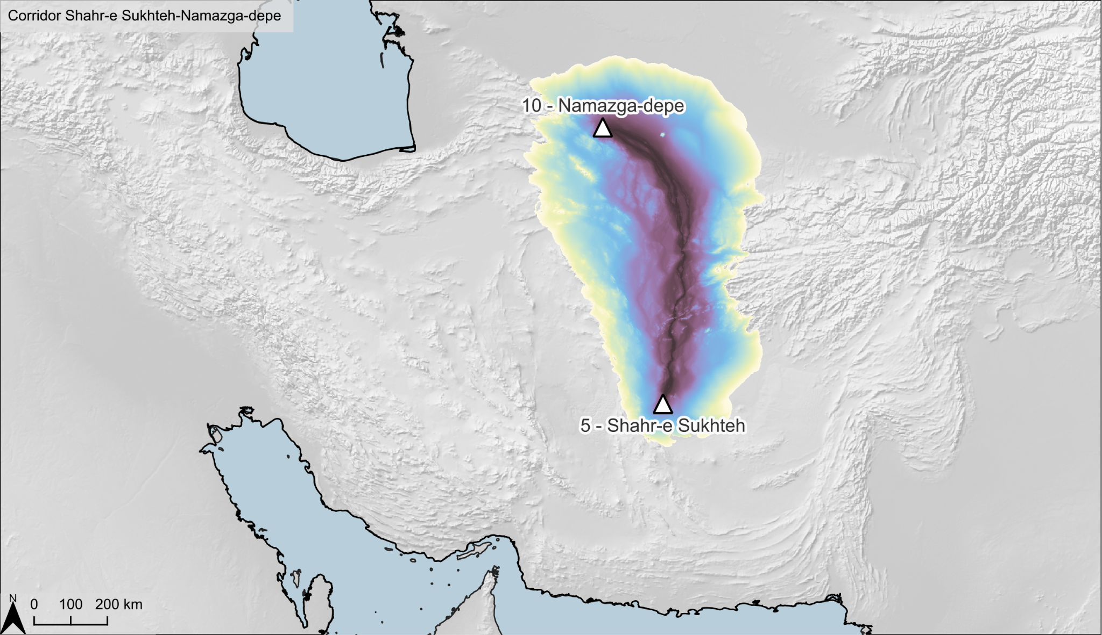  r. Namazga-depe + Shahr-e Sukhteh
s. Shahr-e Sukhteh + Sar-e Sang | t. Shahr-e Sukhteh + Mehrgarh
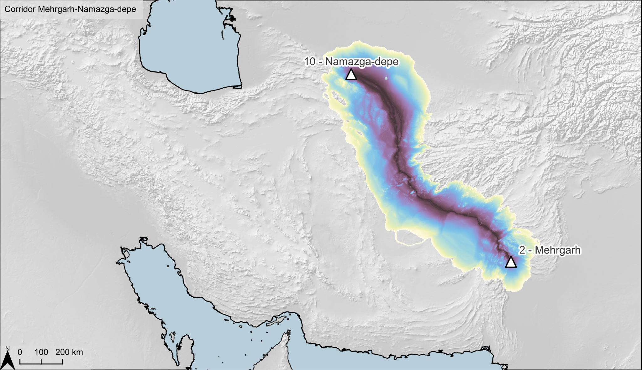  u. Namazga-depe + Mehrgarh | 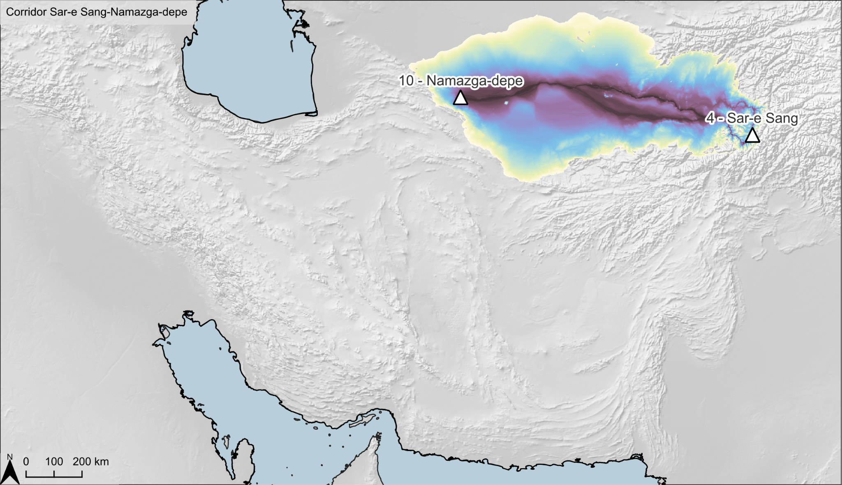  v. Namazga-depe + Sar-e Sang
x. Mehrgarh + Sar-e Sang

Bibliography
Awaida, Antony, James Westervelt, Pierre de Mouveaux, and Markus Metz. 2020. ‘GRASS GIS Module r.cost’.
Azad, P., Stobdan, T., Zhou, D., Hartley, I., Akbari, A., Bafina, V. and Haddad, G.G. 2017. High-altitude adaptation in humans: from genomics to integrative physiology, Journal of Molecular Medicine 95: 1269-1282. [DOI 10.1007/s00109-017-1584-7].
Beier, Paul, Daniel R. Majka, and Wayne D. Spencer. 2008. ‘Forks in the Road: Choices in Procedures for Designing Wildland Linkages’. Conservation Biology 22(4):836–51. doi: 10.1111/j.1523-1739.2008.00942.x.
Bevan, A.H. 2011. Computational Models for Understanding Movement and Territory, in Mayoral Herrera, V. and Celestino Pérez, S. (eds.), Tecnologías de información geográfica y análisis arqueológico del territorio: Actas del V Simposio Internacional de Arqueología de Mérida, Mérida: Consejo Superior de Investigaciones Científicas: 383–394.
Carroll, M., DiMiceli, C., Wooten, M., Hubbard, A., Sohlberg, R., Townshend, J. (2017). MOD44W MODIS/Terra Land Water Mask Derived from MODIS and SRTM L3 Global 250m SIN Grid V006 [Data set]. NASA EOSDIS Land Processes DAAC. Accessed 2022-03-22 from https://doi.org/10.5067/MODIS/MOD44W.006
Clements, Glynn. 2019. ‘GRASS GIS Module r.quantile’.
Evrendilek, Fatih, and Onder Gulbeyaz. 2008. ‘Deriving Vegetation Dynamics of Natural Terrestrial Ecosystems from MODIS NDVI/EVI Data over Turkey’. Sensors 8(9):5270–5302. doi: 10.3390/s8095270.
Hall, D. K., V. V. Salomonson, and G. A. Riggs. 2016. MODIS/Terra Snow Cover Daily L3 Global 500m Grid. Version 6. Boulder, Colorado USA: NASA National Snow and Ice Data Center Distributed Active Archive Center.
Herzog, I. 2013. Theory and Practice of Cost Functions. In F. Contreras, M. Farjas and F.J. Melero (eds.) Proceedings of the 38th Annual Conference on Computer Applications and Quantitative Methods in Archaeology, CAA2010. Archaeopress, Oxford: 375-82.
Herzog, Irmela. 2014. ‘Least-Cost Paths - Some Methodological Issues.’ Internet Archaeology 36. doi: https://doi.org/10.11141/ia.36.5.
Herzog, I., 2020. Spatial analysis based on cost functions., in: Gillings, M., Hacıgüzeller, P., Lock, G. (Eds.), Archaeological Spatial Analysis: A Methodological Guide. Routledge, pp. 333–358. https://doi.org/10.4324/9781351243858
Howey, M.C.L. 2007. Using multi-criteria cost surface analysis to explore past regional landscapes: a case study of ritual activity and social interaction in Michigan, AD 1200–1600, Journal of Archaeological Science 34: 1830-1846 [https://www.sciencedirect.com/science/article/pii/S030544030700009X].
Huete, A., Didan, K., Miura, T., Rodriguez, E.P., Gao, X., Ferreira, L.G., 2002. Overview of the radiometric and biophysical performance of the MODIS vegetation indices. Remote Sensing of Environment, The Moderate Resolution Imaging Spectroradiometer (MODIS): a new generation of Land Surface Monitoring 83, 195–213. https://doi.org/10.1016/S0034-4257(02)00096-2
Jürcke, F. 2024. ‘Across Mountains and Deserts: Patterns of Movement and Interaction in Fourth and Third Millennium BC South-East Iran’. Doctoral Thesis, University of Cambridge, Cambridge.
Lehner, B., Liermann, C.R., Revenga, C., Vörösmarty, C., Fekete, B., Crouzet, P., Döll, P., Endejan, M., Frenken, K., Magome, J., Nilsson, C., Robertson, J.C., Rödel, R., Sindorf, N., Wisser, D., 2011. High-resolution mapping of the world’s reservoirs and dams for sustainable river-flow management. Frontiers in Ecology and the Environment 9, 494–502. https://doi.org/10.1890/100125
Llobera, M., Sluckin, T.J., 2007. Zigzagging: Theoretical insights on climbing strategies. Journal of Theoretical Biology 249, 206–217. https://doi.org/10.1016/j.jtbi.2007.07.020
McLean, A. and Rubio-Campillo, X. 2022. Beyond Least Cost Paths: Circuit theory, maritime mobility and patterns of urbanism in the Roman Adriatic, Journal of Archaeological Science 138: 105534 [https://doi.org/10.1016/j.jas.2021.105534]
Minetti, A.E.; Moia, C.; Roi, G.S.; Susta, D. and Ferretti, G. 2002. Energy cost of walking and running at extreme uphill and downhill slopes. Journal of Applied Physiology, 93: 1039-46.
Minetti, A.E.; Formenti, F. and Ardigò, L.P. 2006. Himalayan porter's specialization: metabolic power, economy, efficiency and skill. Proceedings of the Royal Society on Biological Sciences, 273: 2791-7.
Orengo, H.A. and Petrie, C.A. 2017. Large-Scale, Multi-Temporal Remote Sensing of Palaeo-River Networks: A Case Study from Northwest India and Its Implications for the Indus Civilisation’. Remote Sensing 9.7: 735. [doi: 10.3390/rs9070735].
Pandolf, K.B., Givoni, B., Goldman, R.F., 1977. Predicting energy expenditure with loads while standing or walking very slowly. Journal of Applied Physiology 43, 577–581. [https://doi.org/10.1152/jappl.1977.43.4.577].
Pekel, J.-F., Cottam, A., Gorelick, N., Belward, A.S. 2016. High-resolution mapping of global surface water and its long-term changes. Nature 540, 418-422. [doi:10.1038/nature20584].
Rahn, B. 2005. Cost Surface-Derived Least-Cost Paths: A Case Study from Iron Age Orkney, Internet Archaeology 19. [doi: https://doi.org/10.11141/ia.19.2].
Shapiro, Michael, and Glynn Clements. 2021. ‘GRASS GIS Module r.mapcalc’.
Steinkeller, P. 2021. International Trade in Greater Mesopotamia during Late Pre-Sargonic Times. The Case of Ebla as Illustrated by Her Participation in the Euphratean Timber Trade, in Rahmstorf, L., Barjamovic, G. and Ialongo, N. (eds). Merchants, Measures and Money. Understanding Technologies of Early Trade in a Comparative Perspective Vol. 2, Weight and Value, Göttingen: Wachholtz Verlag Kiel/Hamburg; 173–197.
Tadono, T., Nagai, H., Ishida, H., Oda, F., Naito, S., Minakawa, K. and Iwamoto, H. 2016. Initial Validation of the 30 m-mesh Global Digital Surface Model Generated by ALOS PRISM, The International Archives of the Photogrammetry, Remote Sensing and Spatial Information Sciences, ISPRS, Vol. XLI-B4, pp.157-162, 2016.
Wardlow, Brian D., and Stephen L. Egbert. 2010. ‘A Comparison of MODIS 250-m EVI and NDVI Data for Crop Mapping: A Case Study for Southwest Kansas’. International Journal of Remote Sensing 31(3):805–30. doi: 10.1080/01431160902897858.
Wilkinson, T.C. 2014. Tying the Threads of Eurasia: Trans-regional routes and material flows in Transcaucasia, eastern Anatolia and western central Asia, c.3000-1500 BC, Sidestone Press [https://www.sidestone.com/books/tying-the-threads-of-eurasia].
Xue, J. and Su, B. 2017. ‘Significant Remote Sensing Vegetation Indices: A Review of Developments and Applications’. Journal of Sensors 2017: e1353691. [DOI: https://doi: 10.1155/2017/1353691].
Zhang, C., Lu, D., Chen, X., Zhang, Y., Maisupova, B. and Tao, Y. 2016. The Spatiotemporal Patterns of Vegetation Coverage and Biomass of the Temperate Deserts in Central Asia and Their Relationships with Climate Controls, Remote Sensing of Environment 175: 271–81. [doi: 10.1016/j.rse.2016.01.002].

For a discussion of the different available cost functions see Herzog 2013 (Theory and practice of cost functions), Herzog 2020 and Llobera and Sluckin 2007, among others.
Pandolf et al. 1977 as cited in Herzog Int. Arch. 36.5

