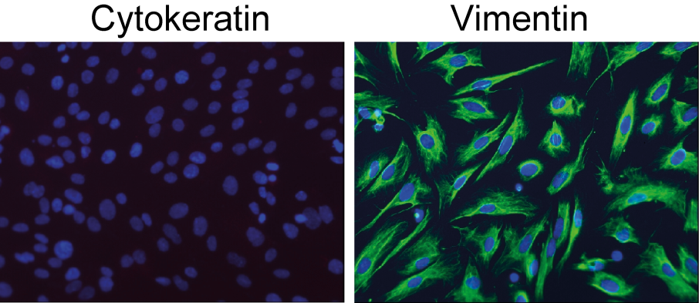

Supplementary Figure 1

Human endometrial stromal cells are negative for cytokeratin (red; left) and positive for vimentin (green; right). Nuclei are stained with DAPI (blue). Only hESCs cultures with a purity of ≥98% were used for subsequent experiments.

