Supplementary Fig1. KIR genotyping
a.
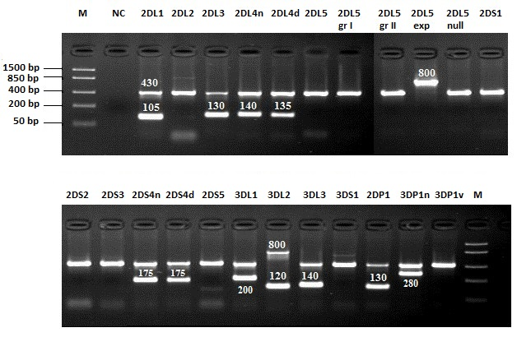
This individual is positive for genes: KIR2DL1, KIR2DL3, KIR2DL4n, KIR2DL4d, KIR2DS4n, KIR2DS4d, KIR3DL1, KIR3DL2, KIR3DL3, KIR2DP1, KIR3DP1n
b.
Reagent | Volume [μl]
Destilled water | 168
Ready PCR | 84
Taq-Polymerase (5 U/μl) | 2,2
DNA (25-100 ng/μl) | 26
Total volume | 280,2
PCR reaction:
Initial denaturation | 96°C | 2 min
Denaturation | 96°C | 15 s. | 10x
Annealing | 65°C | 60 s. | 10x
Denaturation | 96°C | 15 s. | 20x
Annealing | 61°C | 50 s. | 20x
Extension | 72°C | 30 s. | 20x
∞ | 4°C

