Supplementary Figure 1. Schematic of experimental design for LED light exposure. Embryos (10) were cultured in a single drop of medium (20 µl, 4 mm in diameter) centered on a culture dish. Accounting for optical field heterogeneity from the LED source, the size of the drop was controlled to minimize the variation of intensity to < 10%. Each drop was overlaid with paraffin oil to prevent osmolality changes attributed to evaporation. The air gap (~ 10 mm) ensured that the LED uniformly illuminated the drop and thus embryos. Light from each LED passed through a bandpass filter to attenuate light frequencies to ± 10nm. *Schematic not to scale.

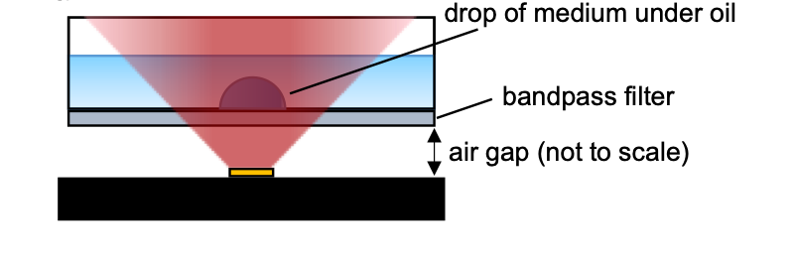

Supplementary Figure 2. No impact on embryo cleavage rates following exposure at the 1-cell stage to (a) blue, (b) green, (c) yellow, and (d) red wavelengths. Data are presented as mean ± SEM, from 3 independent experimental replicates; n = 26-29 embryos per group. Data were analyzed using a Mann-Whitney test.

