Supplementary Figure 1. Family haplotypes were conducted using SNP loci from reference embryos. ref: reference embryos.

Supplementary Figure 2. Illustration of pathogenic chromosome haplotypes in de novo mutation couples. The female partner had a de novo mutation (--^{SEA}), but the parents had normal α globin gene.

Supplementary Figure 3. Illustration of pathogenic chromosome haplotypes in heterozygous family. The genotype of male partner was the αα/--^{SEA}, and since both parents were αα/--^{SEA}.
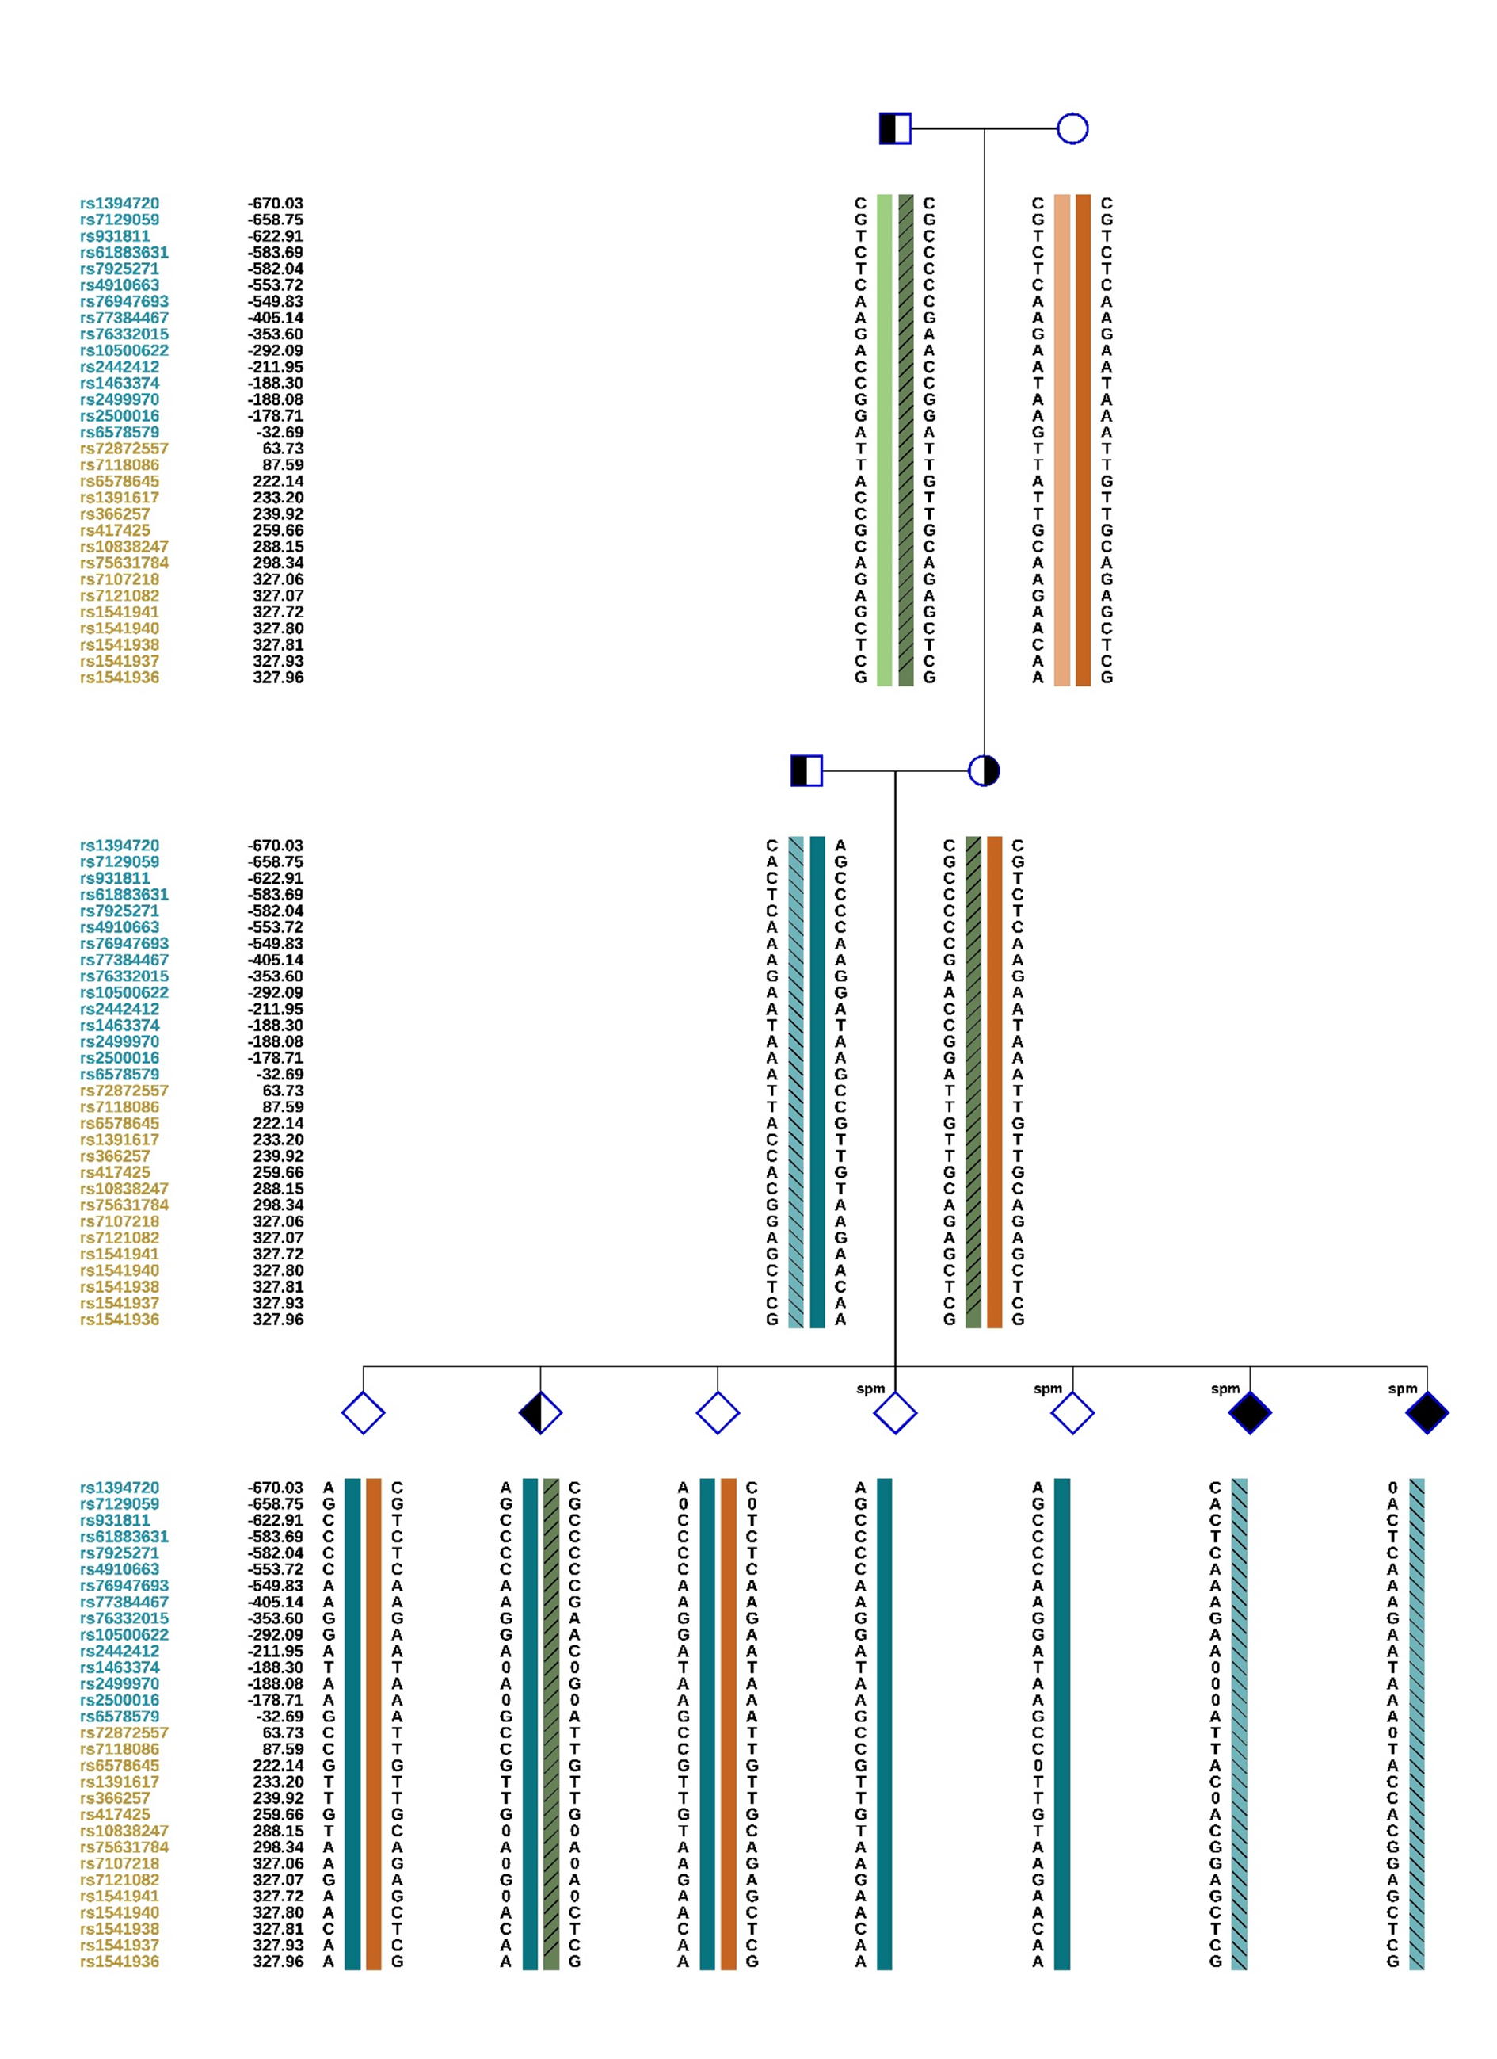
A:
B:

C:

Supplementary Figure 4. Demonstrating pathogenic chromosome haplotypes using the single sperm sequencing, a reference embryo, single sperm sequencing+ a reference embryo. A: single sperm sequencing. B: a reference embryo. C: single sperm sequencing+ a reference embryo.

