Toward Accurate Vaginal Microbiome Profiling: Protocol, Bioinformatics, and Core Microbiota Characterization

Supplementary Table S1. Sequencing depth and quality for each sample ID and primer.
Table 1: Coverage of Reads Binned Per Sample Compared Across Primer 27F-YM_MIX and 341F-NW and Quality Scores after NanoFilt Filtering and After Porechop Demultiplexing and Adapter Trimming.
 | 27F-YM_MIX Primer |  | 341F-NW Primer
Patient ID | Reads Binned | Quality | Reads Binned | Quality
01 | 2,763 | 18 | 3,872 | 15
13 | 1,625 | 18 | 3,575 | 15
18 | 2,519 | 18 | 3,322 | 15
23 | 1,729 | 18 | 2,685 | 15
36 | 1, 086 | 18 | 1,798 | 15
40 | 1,299 | 18 | 1,490 | 15
57 | 1,098 | 18 | 2,059 | 15
61 | 1,526 | 18 | 2,152 | 15
68 | 1,804 | 18 | 2,631 | 15
79 | 588 | 18 | 1,040 | 15
90 | 812 | 18 | 3,188 | 15
99 | 1,963 | 18 | 1,852 | 15
Average | 1,567 (MIN = 578, MAX = 2, 763) | 18 | 2472 (MIN = 1,040, MAX = 3,872) | 15

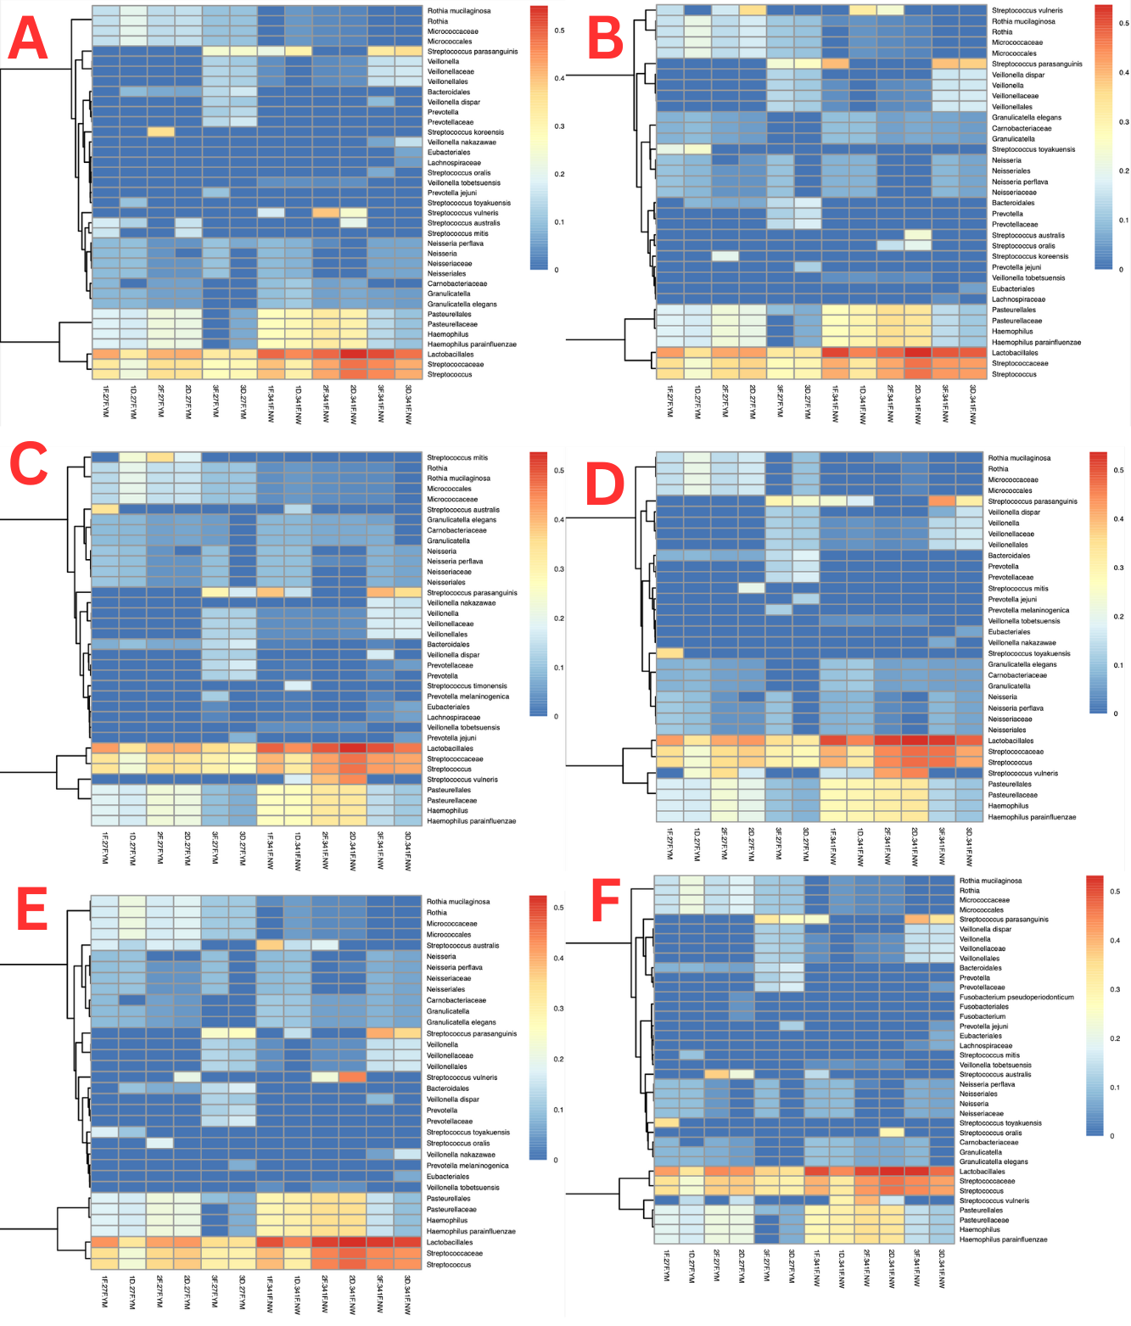
Supplementary Figure S2. Comparison of bacterial abundance for different Base Calling and Porechop Methodologies.
Figure 5.2: Heatmap of Bacterial Abundance and Detection for each DNA Sample (1F, 1D, 2F, 2D, 3F and 3D) for Dorado Simplex Base Calling with Either (A) Porechop Non-specific or (B) Specific Parameters, Dorado Duplex Base Calling with Either (C) Non-specific or (D) Specific Porechop Parameters and GUPPY Base Calling for Either (E)Specific or (F) Non-specific Porechop Adapter and Barcode Trimming and Demultiplexing Parameters. Created in R Studio (rstudio-education.github.io)

