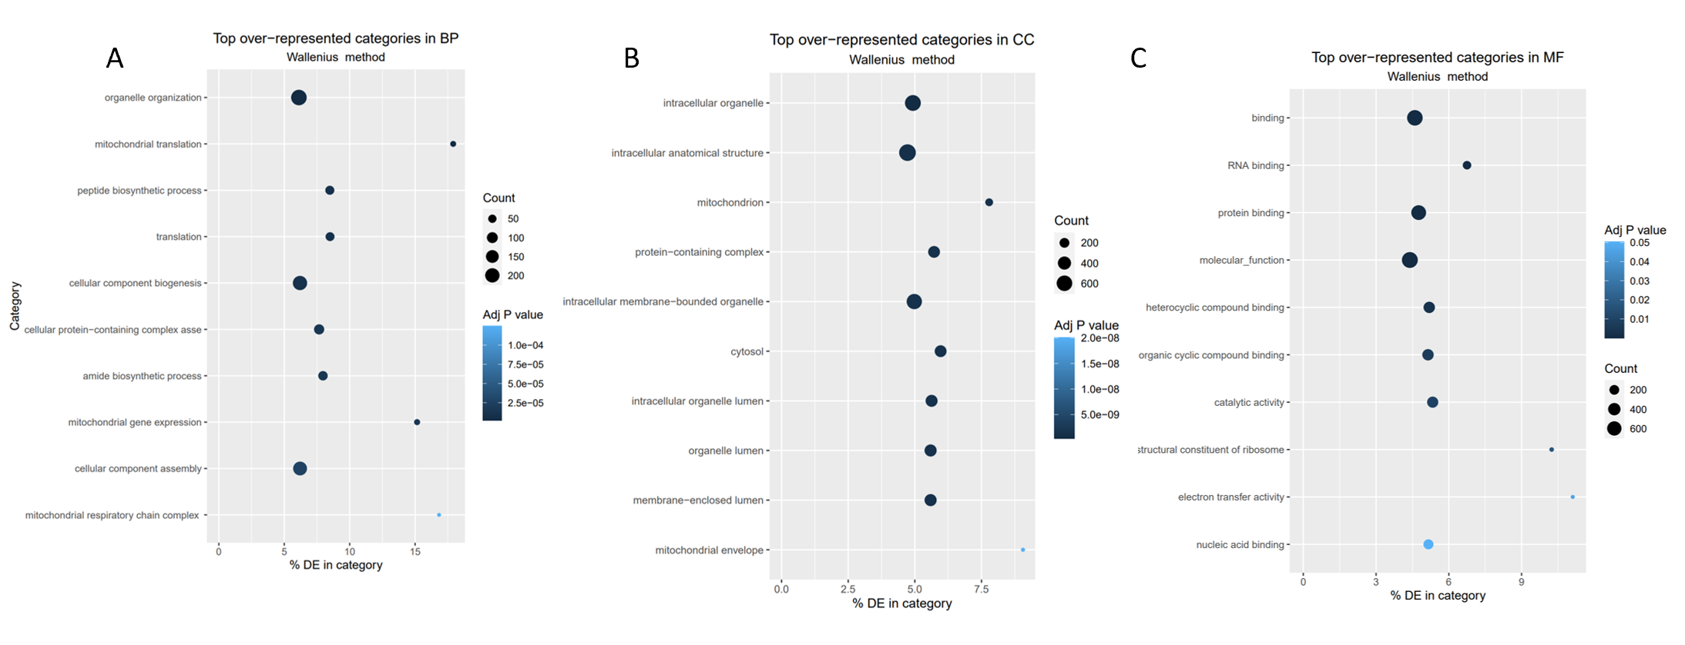
Supplemental Figure 1. Plots represent the top 10 over-represented GO terms considering (A) biological process, (B) cellular component and (C) molecular function. X axis represents differential expression percentage in each category, where zero represents no differential expression.

