Supplementary Figures

Supplementary Figure S1. D2ext: Forest plot comparing extended culture versus immediate transfer for day 2 embryos

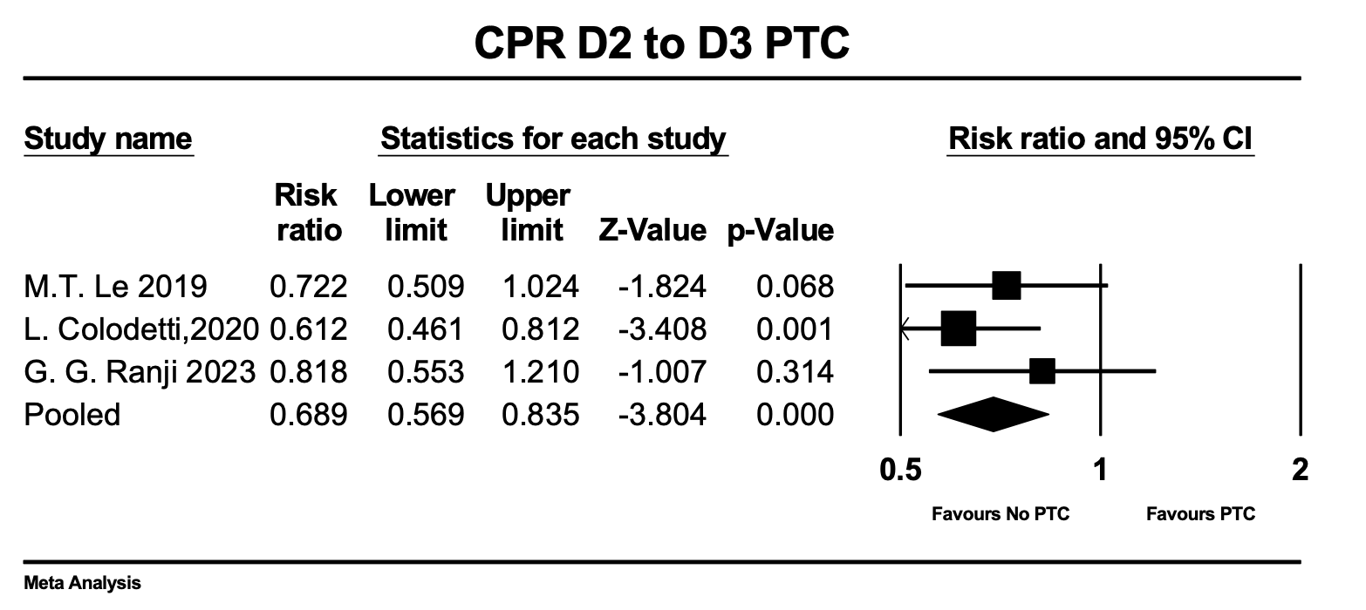
Forest plot showing relative risk (RR) and 95% confidence interval for clinical pregnancy rate in day 2 embryos comparing extended culture to immediate transfer. Three studies included: Le 2019, Colodetti 2020, and Ranji 2023. Square size reflects study weight in meta-analysis. Diamond represents pooled effect estimate.

Supplementary Figure S2. D5/6ext: Forest plots comparing extended culture versus immediate transfer for day 5/6 blastocyst embryos
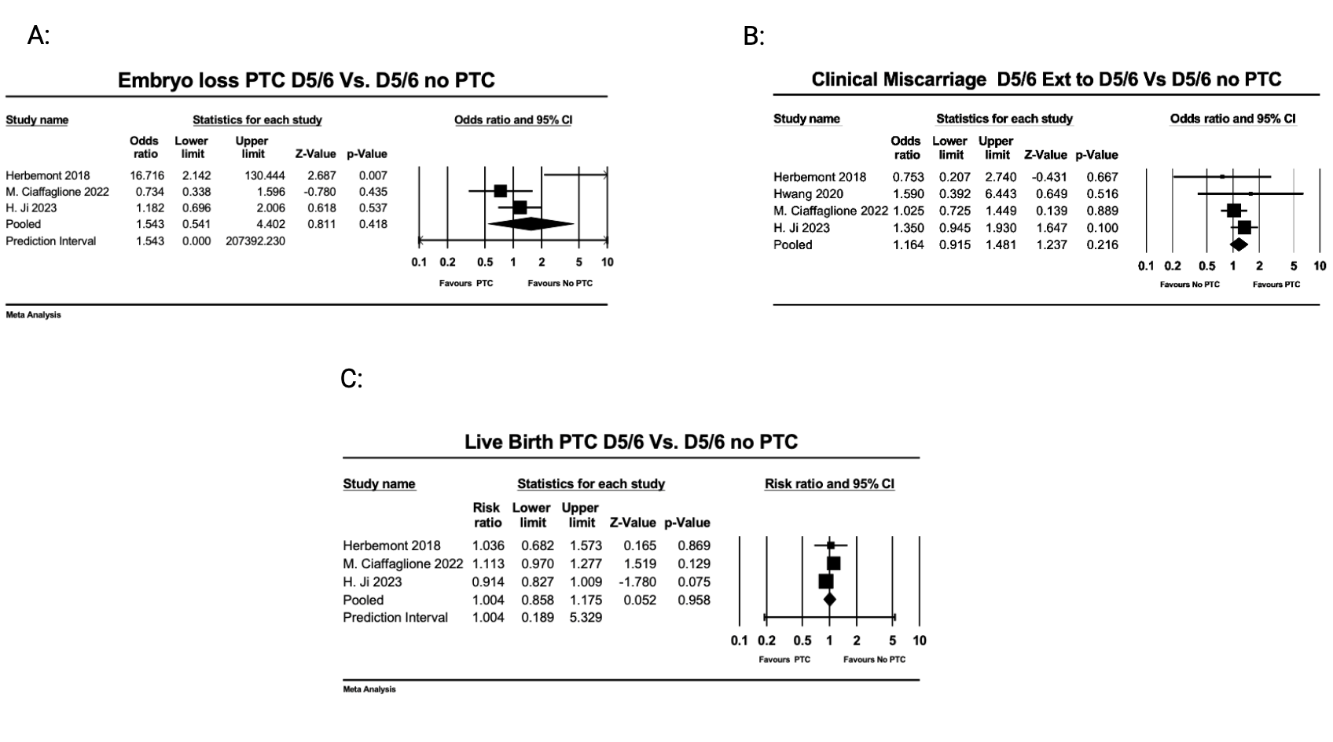
Forest plots showing relative risks (RR) and odds ratios (OR) with 95% confidence intervals for blastocyst-stage embryos comparing extended culture to immediate transfer. Panel A: Embryo loss. Panel B: Clinical miscarriage rate. Panel C: Live birth rate. Studies included: Herbemont 2018, Ciaffaglione 2022, and Ji 2023.

Supplementary Figure S3. Funnel plots for assessment of publication bias.
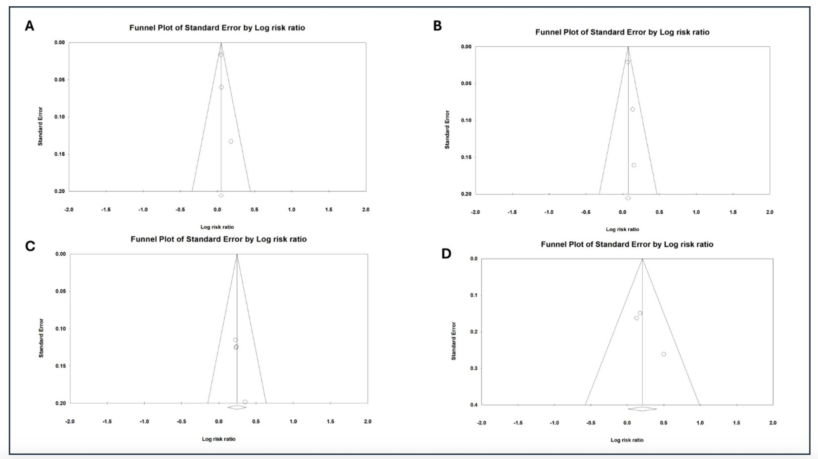
Funnel plots examining publication bias for primary outcomes with sufficient studies. Panel A: Day 3 embryo clinical pregnancy rate. Panel B: Day 3 embryo live birth rate. Panel C: Day 3 to blastocyst clinical pregnancy rate. Panel D: Day 3 to blastocyst live birth rate. X-axis represents effect size (relative risk or odds ratio), Y-axis represents standard error (inverted). Each dot represents one study. Vertical line indicates no effect. Note: Interpretation of funnel plot asymmetry is limited by the small number of studies per comparison (3-4 studies).
Supplementary Table S1. Embryo survival and developmental attrition rates during post-thaw extended culture.
Author | comparison groups | Cum PR PTC | Cum PR no PTC | Post thaw attrition PTC | Ext culture attrition PTC | Post thaw attrition No PTC
L. Colodetti (2020( | D2 TO D3 | Unreported | Unreported | 4.90% | 0% | 9.70%
M.T. Le (2019) | D2 TO D3 | Unreported | Unreported | 3.10% | 0% | 5.50%
G. G. Ranji (2023( | D2 TO D3 | Unreported | Unreported | Unreported | Unreported | Unreported
J.Y.Wang (2023) | D3 vs D3Ext. | Unreported | Unreported | Unreported | Unreported | Unreported
Y. Li (2022) | D3 vs D3Ext. | Unreported | Unreported | Unreported | Unreported | Unreported
L. Guo (2013) | D3 vs D3Ext. | Unreported | Unreported | Unreported | Unreported | Unreported
R. Rahav-Koren (2021) | 3to5 vs 5 | Unreported | Unreported | Unreported | Unreported | Unreported
G. Onalan (2023) | D3T3 vs D3T5 vs D5T5 | Unreported | Unreported | Attrition: D3T3 29.26%, D3T5 12.72%, D5T5 15.81% | Unreported | Unreported
X. Li (2023) | D3T3 vs D3T5 vs D5T5 | Unreported | Unreported | Attrition: D3T3 4.71%, D3T5 5.04%, D5T5 0% | Unreported | Unreported
P. C. Aytac (2022) | 3to5 vs 5 | Unreported | Unreported | 3.20% | 7.10% | 5%
H. Ji (2023) | D5toD5ext | Unreported | Unreported | 13/496 2.6% | Unreported | 12/498 2.4%
H. Ji (2023) | D6toD6ext | Unreported | Unreported | 14/501 2.8% | Unreported | 18/799 2.2%
M. Ciaffaglione (2022( | D5toD5ext | Unreported | Unreported | 8/1029 0.7% | Unreported | 5/885 0.5%
Herbemont (2018) | D5toD5ext | Unreported | Unreported | 0/115 | Unreported | 1/103
Hwang (2020( | D5toD5ext | Unreported | Unreported | Unreported | Unreported | Unreported

