Opening the woods: towards a quantification of Neolithic clearance around the Somerset Levels and Moors
Michelle Farrell, Jane Bunting, Fraser Sturt, Michael Grant, Gerard Aalbersberg, Rob Batchelor, Alex Brown, Denise Druce, Tom Hill, Arthur Hollinrake, Julie Jones, Heather Tinsley, Alex Bayliss, Peter Marshall, Suzi Richer. and Alasdair Whittle

Supplementary Information 3
This study forms part of The Times of Their Lives project, funded by the European Research Council (Advanced Investigator Grant 295412). This analysis was undertaken to provide robust chronologies for previously published pollen analyses of sedimentary sequences from the Somerset Levels and Moors, and to assign individual samples to 200-year time slices for incorporation in the Multiple Scenario Approach modelling. Our original intention was to confine ourselves to sequences that covered the Neolithic period but it became apparent that understanding the vegetational history preceding and following this period was vital to determining the historical ecology of the Neolithic itself. We therefore consider all dating evidence from radiocarbon dated pollen sequences that cover the period from c. 4200–c. 2000 cal BC.

Details of all the scientific dates included in our analysis are provided in Tables S3a–b. The age-depth models shown in Figs S3a–S3ak were derived from Bacon (Blaauw and Christen 2011) using IntCal13 (Reimer et al. 2013). Bacon is Bayesian age-depth modelling software used to reconstruct accumulation histories for deposits by combining radiocarbon dates with prior information – other Bayesian age-depth software includes Bchron (Haslett and Parnell 2008), Bpeat (Blauuw and Christen 2005), and OxCal (Bronk Ramsey 2008; Bronk Ramsey and Lee 2013). Parnell et al. (2011) provide information on the background, workings, and results obtained from OxCal, Bchron, and Bpeat, and Blaauw and Christen (2011) provide a comparison of the output from Bacon, OxCal, and Bchron.

We elected to use Bacon in this study for a number of reasons. Firstly the ability to define a prior for the deposition time of a unit of sediment was appropriate since the sedimentary environment of the majority of the sequences was very similar. Secondly Bacon produces reasonable interpolations in sequences with low numbers of dates, and thirdly it implements a robust approach to identify and dealing with outliers (Christen and Pérez 2009).

The dataset
The 134 radiocarbon age determinations (66 obtained by AMS and 68 by radiometric methods), were obtained from a variety of sample types (Figs S3al and S3am), with the vast majority of these (62.5%) comprising samples of peat and sediment. Plant macrofossils (including both single and bulked items) and wood (including twigs) made up 25% and 10.3% of the dated sample types respectively, with only two samples not being identified prior to submission.

Radiocarbon laboratory methods
Twenty-eight samples were dated by the Scottish Universities’ Research and Reactor Centre (SRR-). The samples were processed according to methods outlined in Mook and Waterbolk (1985) and measured as described by Harkness and Wilson (1973). For these peat samples both the acid-insoluble, alkali-soluble (‘humic acid’) fraction and the alkali- and acid-insoluble (‘humin’) fraction could be selected for dating, depending on the specific characteristics of the particular sample. It is not known which fraction was dated for each of the measurements reported, although the acid-soluble (‘fulvic acid’) fraction was never dated, as by the time the dates in Table S3a were made, this fraction was known to often produce anomalous ages (Dresser 1970).

The 14 samples processed at AERE Harwell (HAR-) were pretreated using the acid-base-acid protocol (Otlet and Slade 1974), combusted to carbon dioxide and synthesised to benzene using a method similar to that initially described by Tamers (1965) and a vanadium-based catalyst (Otlet 1977). The radiocarbon content was measured using liquid scintillation counting as described by Otlet (1979).

Thirty-four samples were dated at the Scottish Universities Environmental Research Centre (SUERC-) by AMS. Two samples of waterlogged plant remains (SUERC-5674–4) were pretreated by the acid-base-acid
protocol (Stenhouse and Baxter 1983) with the acid and alkali insoluble fraction selected for dating. The samples were converted to carbon dioxide in pre-cleaned sealed quartz tubes (Vandeputte et al. 1996), graphitised as described by Slota et al. (1987), and measured by AMS (Xu et al. 2007). The remaining 32 samples were processed and dated using the methods described in Dunbar et al. (2016).

Samples dated at the Scottish Universities Research and Reactor Centre (GU-) were prepared as described by Stenhouse and Baxter (1983), combusted to carbon dioxide, converted to benzene using a chromium-activated catalyst and dated by liquid scintillation spectrometry (Noakes et al. 1965). The seven peat and sediment samples underwent an acid-alkali-alkali-acid pretreatment protocol (Olsson 1979), with the single wood samples undergoing an additional stage of bleaching with a hypochlorite solution before combustion. For peats, different fractions could be selected for dating: the alkali-soluble ‘humic acid’ fraction after either the first or second alkali pretreatment (or both together if the sample was small), the acid- and alkali-insoluble ‘humin’ fraction, or all three of these fractions combined (the ‘acid-washed’ fraction).

One sample from Glastonbury Wells Road produced insufficient carbon dioxide for benzene synthesis following pre-treatment and combustion for conventional dating. A sub-sample of carbon dioxide was sent to the Arizona Accelerator Mass Spectrometer Laboratory (AA-31337) where it was graphitised and dated by accelerator mass spectrometry as described by Slota et al. (1987) and Linick et al. (1986).

The ¹⁴CHRONO Centre, The Queen’s University, Belfast (UBA-) processed and dated nine samples by accelerator mass spectrometry using methods described by Reimer et al. (2015). All samples were graphitised using hydrogen reduction (Vogel et al. 1984) except for UBA-22975–6, which were subject to zinc reduction (Slota et al. 1987).

At the Oxford Radiocarbon Accelerator Unit (OxA-), sixteen samples of waterlogged wood and plant remains were pretreated using an acid-alkali-acid protocol, followed by a bleaching step using sodium hypochlorite (Hedges et al. 1989, and see Brock et al. 2010, table 1 (UW)). The plant macrofossils from Shapwick Heath – Borehole A were treated in this way together with two samples from Queen’s Sedgemoor (OxA-27824–5). For some fragile samples (Queen’s Sedgemoor: OxA-27779, OxA-27919–20, and OxA-27922), the strength of the bleach used in the final stage of pretreatment was reduced (Hedges et al. 1989, and see Brock et al. 2010, table 1 (UV)), or even entirely omitted (Hedges et al. 1989, and see Brock et al. 2010, table 1 (VV)) as was the case with the samples from Shapwick SWA93 and Queen’s Sedgemoor (OxA-27778 and OxA-27921).
Samples were then converted to carbon dioxide (Hedges et al. 1992) and graphitised (Dee and Bronk Ramsey, 2000). Samples with laboratory numbers below OxA-11739 were dated in the General IONEX AMS machine at Oxford using a hybrid ion source (Bronk Ramsey and Hedges, 1997); those with laboratory numbers above this were dated using the replacement HVEE AMS machine (Bronk Ramsey et al. 2004).
The six samples dated at Van de Graaff laboratory, Utrecht University were pretreated using standard procedures (Mook and Streurman, 1983) and measured by AMS (van der Borg et al. 1987).

Four radiocarbon age determinations were obtained from the University of Cambridge Radiocarbon Dating Laboratory on samples measured in 1961. The samples dated were pretreated as outlined in Godwin et al. (1957) and dated by gas proportional counting of carbon dioxide (Godwin and Willis 1960).

Twenty radiocarbon age determinations were obtained from The University of Waikato Radiocarbon Dating Laboratory, New Zealand. Samples were acid washed using 10% hydrochloric acid, rinsed and then washed in 1% sodium hydroxide. Humic acids were obtained from the base-soluble fraction which was acidified, rinsed, and dried, while a further step involving an acid wash in 10% hydrochloric acid, was employed prior to the sample being rinsed and dried and the base-soluble fraction being selected for dating.

The 18 samples dated using Liquid Scintillation spectrometry (LSS) were converted to benzene and dated as described in Hogg et al. (1987). Two samples (Wk-9020–1) of pressed graphite (for methods see www.radiocarbondating.com/operating-procedures/ams.dating) for AMS dating were sent to the Keck Carbon Cycle AMS facility of the University of California, Irvine for analysis (Southon et al. 2000).

Radiocarbon quality assurance
The four laboratories (ORAU, SUERC, ¹⁴CHRONO, and Waikato) from which measurements have been obtained since 2005 maintain continued programmes of quality assurance procedures in addition to participating in international inter-laboratory comparisons (Scott et al. 2007; 2010). These tests indicate no laboratory offsets and demonstrate the validity of the precision quoted.

A number of the radiocarbon measurements in this review were, however, obtained before the first truly detailed assessment of the variability between different stages of the dating process undertaken between 1986 and 1990 (Scott et al. 1990). Before the first international intercomparison radiocarbon dating laboratories had been vigilant to their accuracy and reproducibility of their measurements but in a less formal fashion, with for example the exchange and dating of known-age materials taking place between laboratories since the late 1950s (Willis et al. 1960).

In the late 1970s laboratories then operating in Britain, including AERE Harwell, participated in an inter-comparison study that demonstrated excellent reproducibility in the counting and combustion stages of the dating process of samples of benzene of known activities (Otlet et al. 1980). In the early 1980s the first steps to formalise procedures for quality assurance in radiocarbon dating began with a collaborative study undertaken by 20 international radiocarbon laboratories and designed by the Glasgow University laboratory. The results of this first international intercomparison (International Study Group 1982) suggested that the quoted error estimates were in many cases too low to account for the total error on the measurements and that there was systematic laboratory bias in some facilities.

A larger, three-stage, study undertaken between 1986 and 1990, provided a more detailed assessment of the variability between laboratories in different stages of the dating process (Scott et al. 1990). Generally, quoted errors were seen to adequately describe the precision of a result internally within a laboratory, but to underestimate the total inter-laboratory variation. Again, there was evidence of systematic bias within some laboratories. The radiocarbon determinations from Harwell included in this review were undertaken at this time but the laboratory did not participate in the intercomparison study.

One of the principal methods for assessing the reproducibility of a dating laboratory is to consider the variation in replicate measurements made on the same material. There are eight pairs of replicate measurements available on the humic and humin fractions of bulk samples of peat; one sample with a pair of radiometric measurements and seven with pairs of AMS measurements. Of the replicate groups seven are statistically consistent at 95% confidence, with one statistically significantly different at more than 99% confidence (Table S3c; Fig. S3an). In the latter case the humic acid fraction is younger than the humin fraction and appears to relate to the downward penetration of small amounts of later compounds into the humic acid fraction of the dated material.

The reproducibility of humic and humin measurements predominantly obtained from AMS ‘bulk’ peat samples is in contrast to other studies (e.g. Bayliss et al. 2008, fig. 9) where the majority of humic acid fractions produced a younger age. This is probably due to a number of factors, firstly the environment in which the organic sediments formed (e.g. raised mires), and secondly the fact that samples comprised as much material as possible whereas in the past AMS ‘bulk’ samples typically comprised a few grams of material at most.

Six groups of measurements are available on samples of waterlogged plant macrofossils and wood (short-life twigs), including both single-entity and bulked material measured by AMS. All but one of these groups are statistically consistent at 95% confidence (Table S3d; Fig. S3ao) suggesting that the dated material was reasonably homogenous.

One group of measurements is available from a sample with duplicate measurements on plant macrofossils, together with humic and humin determinations on a peat sample. These four measurements are not statistically consistent at 95% confidence (Table S3e) but are statistically consistent at 99% confidence.

Weighted means of replicate and duplicate radiocarbon results
Weighted means of replicate radiocarbon measurements should be taken before calibration for samples which ceased exchanging carbon with the biosphere at exactly the same time. Most commonly these are replicate samples from the same living organism. Determinations which derive from bulk samples, made up of material from more than one organism are more problematic (Bayliss et al. 2012, xxiii). In a sample of bulk peat, for example, it is extremely unlikely that all the dated components derive from organic material which was laid down in exactly the same year. Even if composed entirely of short-lived wood material, it is likely that the peat formed over several years, or even several decades. In these circumstances, the (probably incorrect) assumption that all the dated material died in the same year has already been made when submitting a bulk sample for radiocarbon dating. For this reason, weighted means of replicate measurements from bulk peat samples (humic and humin fractions) have been taken before calibration, as the assumption of the statistical approach is consistent with that made in the submission of the samples for dating. A similar approach has been taken for duplicate samples of short-lived plant macrofossils from the same sample.

Optically Stimulated Luminescence (OSL) dating
The six OSL ages from Steart Point (Table S3b) were obtained from Geochronology Laboratories, University of Gloucestershire using the methods outlined in Russell (2011; 2012).

Age-depth modelling
Estimation of deposition time (DT)
An estimate of ‘Deposition Time’ (DT = yr cm⁻¹) is required as a priori information to generate age-depth models using the Bayesian software Bacon (Blaauw and Christen 2011).

We produced a summary of DT for the study area using age-depth models for sequences with more than four radiocarbon dates constructed using ‘classical’ age-depth modelling software Clam (Blaauw 2010; R statistical software package) and the IntCal13 calibration curve (Reimer et al. 2013). Smooth spline age-depth models (Figs S3ap–S3aq) were used to calculate the DT at 100-year intervals for each model (Fig. S3ar). As these results are intended to yield insight into the spatial and temporal variability in accumulation rates in the study region and to give estimates of DT that can be used as prior information in Bayesian age-depth modelling with Bacon, DTs are rounded to the nearest 10 yr cm⁻¹. The purpose of the initial modelling was to produce initial estimates of DT for age-depth modelling using Bacon and not to produce chronologies for the pollen data.

The age-depth models constructed using Clam can be grouped into two categories (Fig. S3aq). The first category, characterised by extremely rapid sediment accumulation rates, contains two age-depth models that are very clearly different to the rest (Glastonbury – GA18 and Queens Sedgemoor). Deposition times in this category do not exceed 15 yr cm⁻¹, and the average DT (10 yr cm⁻¹) is much quicker than previous studies (e.g. Goring et al. 2012; Crann et al. 2015) although given the different settings (lacustrine sites in the northeastern US/southeastern Canada and the boreal to tundra ecotone in subarctic Canada) this is not unexpected. The other category, characterised by rapid sediment accumulation rates, shows DT of c. 20 yr cm⁻¹ with amplitudes up to c. 50 yr cm⁻¹ and is equivalent to the default 20 yr cm⁻¹ used by Bacon (Blaauw and Christen 2013) derived from Goring et al. (2012).

The default DT (accumulation rate; acc.mean =) prior used for initial Bacon runs of the individual age-depth models was therefore set at 20 yr/cm. The accumulation rate prior consists of a gamma distribution (Fig. S3a – upper middle), which is much like a normal/Gaussian distribution but is often asymmetric and always positive. A second parameter, acc.shape = (that controls how much influence the accumulation rate will have on the model) was set at the default 1.5 recommended by Blaauw and Christen 2011; 2013) as higher values result in more peaked shapes. In case initial rough age estimates indicate an accumulation rate much different from the default, Bacon suggests an alternative DT based on round values such as 1, 2, 5, 10, 20, 50, .... 500 yr/cm.

Bacon
Age-depth modelling implemented with Bacon is similar to that outlined in Blaauw and Christen (2005), but more numerous and shorter sections are used to generate a more flexible chronology (Blaauw and Christen 2011; 2013). Radiocarbon age distributions are derived from the Student-t distribution, which produces calibrated distributions with longer tails than the Normal model (Christen and Pérez 2009). The longer tails on radiocarbon dates and a prior assumption of unidirectional sediment accumulation, mean in most cases excluding outliers is not necessary when using Bacon.

The memory or coherence in accumulation rates through a sequence is a parameter based on the degree to which the accumulation rate at each interval depends on the previous interval. Thus the memory for modelling accumulation in organic-rich (peat) sediments is higher than for lacustrine sediments because accumulation of peat in peat bogs is less dynamic over time than the accumulation of sediments in a lake. We used the default memory properties given in Blaauw and Christen (2011; mem.strength = 4 and mem.mean = 0.7).

The treatment of outliers in Bacon is analogous to the OxCal General Outlier Model (Bronk Ramsey 2009) in that both draw from a long-tailed Student's t-distribution. The number of parameters employed in the process (Christen and Pérez 2009) by Bacon is significantly different to OxCal, generally resulting in a more flexibility towards potential outliers than the approach implemented in OxCal and also enabling the model to account for possible unknown or underestimated errors associated with the ¹⁴C determinations (Christen and Pérez 2009).

The resulting age-depth models are shown in Figs S3a–S3ak along with plots that describe: (top left panel) the stability of the model (log objective vs. iteration); (top middle panel) the prior (entered by the user) and posterior (resulting) accumulation rate, and; (top right panel) the prior and posterior memory properties.

The chronology of radiocarbon dated pollen diagrams from the Somerset Levels and Moors c. 4200–c. 2000 cal BC
We begin our review by establishing our current understanding of the chronology of radiocarbon dated pollen diagrams, covering the period from c. 4200–c. 2000 cal BC, considering these from east to west across the Somerset Levels and Moors.

Steart Point BH109 and BH112
Assessment of geotechnical data, the drilling of four archaeological boreholes (boreholes WA2011_BH109, WA2011_BH110, WA2011_BH111 and WA2011_BH112; Russell 2011) and subsequent geoarchaeological recording and assessment of subsamples retrieved from the boreholes was undertaken in 2011 by Wessex Archaeology in advance of a Proposed Ecological Habitat Creation scheme on the Steart Peninsula.

Four samples from the 8 m sequence from BH109 underwent pollen assessment and an outline chronology is provided by two radiocarbon dates and one OSL date (Tables S3a–b). The basal OSL date (GL10081; Table S3b) has been excluded from the age-depth modelling (see below) as it is Pleistocene in age.

Four samples from the 11.92 m sequence from BH112 underwent pollen assessment and an outline chronology is provided by two radiocarbon dates (Table S3a). The two OSL dates (GL10082–3; Table S3b) have been excluded from the age-depth modelling (see below) as they both appear to be inaccurate.

Steart Point BH109 – age-depth model
An initial run of the model produced a poor run (Fig. S3a) with the MCMC iterations (left hand panel) showing considerable structure among neighbouring iterations. For the second run therefore the Bacon suggested priors for DT, acc.mean = 10 and acc.shape = 1.5, were accepted.

The Bayesian model from the BH109 (Fig. S3b) sequence shows stable deposition rates over time, most likely because this part of the sequence covers a relatively restricted period of time. The prior and posterior probability distributions for the deposition time are very similar but the memory of around 0.4 is below the assigned value of 0.7. With only two radiocarbon dates and one OSL date it is difficult to accurately infer what changes in accumulation might have taken place.

Steart Point BH112 – age-depth model
An initial run of the model showed relatively poor agreement between the prior and posterior accumulation rates (Fig. S3c – middle). For the second run therefore the Bacon suggested priors for DT, acc.mean = 50 and acc.shape = 1.5, were accepted. The Bayesian model is fairly stable, albeit with a couple of minor perturbations (Fig. S3d). The prior and posterior probability distributions for the accumulation rate in the second run are very similar as is the memory of around 0.75 (assigned 0.7).

Steart Point BH02 and BH05
The drilling of two boreholes for archaeological purposes (boreholes WA2012_BH02 and WA2011_BH05) and subsequent geoarchaeological recording and assessment of subsamples from the boreholes was undertaken by Wessex Archaeology in advance of a Proposed Ecological Habitat Creation scheme on the Steart Peninsula (Russell 2012).

Six sediment subsamples of approximately 4 cm³ were assessed for their pollen content from borehole BH02 (Russell 2012) and an outline chronology for the deposits provided by two radiocarbon dates (Table S3a) and a single OSL measurement (Table S3b). A single pollen sample from BH02 (4.7m OD) with a radiocarbon date from the same level (SUERC-38608) has been assigned to a time slice on the basis of this single age estimate.

Two sediment subsamples of approximately 4 cm³ were assessed for their pollen content from borehole BH05 (Russell 2012) and single radiocarbon and OSL dates obtained (Table S3a–b). The radiocarbon dated pollen sample from 4.2 m OD (SUERC-38610) contained insufficient pollen to be included in the MSA.

Burnham on Sea
The sites from Burnham on Sea, along with the sites from Gravel Banks, Avon, and Oldbury-on-Severn, South Gloucestershire formed part of a PhD thesis undertaken by Denise Druce (2000) identifying past trends in relative sea-level for the Severn Estuary. The pollen, charcoal, plant macrofossil, and foraminifera results for Burnham on Sea are discussed in a separate article (Druce 1998). The site consists of intercalated layers of silts and peat. Two 0.5 m monolith tins were used to sample the sequence; the ‘Upper Profile’ and ‘Lower Profile’.

Four peat samples were submitted for radiocarbon dating (Table S3a) to provide a chronology for the pollen analysis. From the Upper Profile samples were dated from the top and bottom of a contiguous band of peat 0.16 m thick and from the Lower Profile from two thin bands of peat (10 mm and 20 mm thick) situated between bands of silt. The peat samples from the very thin bands of peat, intercalated with silt, were dated with the aim of gaining an understanding of past trends in relative sea-level in the Severn Estuary (Druce 1998).

Burnham on Sea – ‘Upper Profile’ – age-depth model
An initial run of the model showed moderately poor agreement between the prior and posterior accumulation rates (Fig. S3e – middle) and some perturbations in the MCMC iterations (Fig. S3e – left). For the second run therefore the Bacon suggested priors for DT, acc.mean = 50 and acc.shape = 1.5, were accepted. The Bayesian model (Fig. S3f) from the ‘Upper Profile’ shows stable accumulation rates over time, most likely because this core covers such a restricted period of time. The prior and posterior probability distributions for the accumulation rate are very similar as is the memory of around 0.75 (assigned 0.7).

Burnham on Sea – ‘Lower Profile’ – age-depth model
An initial run showed moderately poor agreement between the prior and posterior accumulation rates (Fig. S3g – middle) and one large perturbation in the MCMC iterations (Fig. S3g – left). For the second run therefore the Bacon suggested priors for DT, acc.mean = 50 and acc.shape = 1.5, were accepted. The Bayesian model from the ‘Lower Profile’ shows stable accumulation rates over time (Fig. S3h), most likely because this core covers such a restricted period of time. The prior and posterior probability distributions for the accumulation rate are very similar as is the memory of around 0.7 (assigned 0.7).

Pawlett
Borehole 19 (BH19) was extracted from a field located at the bottom of the northern slope of Pawlett Hill, using a lined core sampler (synthetic sampling tube dimensions: 50 x 46 mm, length 1 m) and an Atlas Cobra TT two-stroke hammer system. The core was situated near to the wetland/dryland boundary, and was thus close to an important ecotone for past human activity as demonstrated during investigations at the Walpole landfill site (located c. 1.5 km east of Pawlett Hill). During the drilling process, a total of 5.5 m of material was collected before the sediment became too wet to be retained within the corer (Sturt et al. 2015).

Five samples were submitted for dating (Table S3a), all extracted from the lower peat horizon identified within the borehole.

Pawlett – age-depth model
The Bayesian model from Pawlett (Fig. S3i) shows stable accumulation rates over time, most likely because this core covers such a restricted period of time. The prior and posterior probability distributions for the accumulation rate are almost identical as is the memory of around 0.70 (assigned 0.7).

Walpole
The new landfill site at Walpole is located to the north of Bridgwater proximal to the River Parrett, and is situated within the interbedded sequence of estuarine silts and freshwater peats that typify the coastal lowlands of the Somerset Levels (Haslett et al. 1998). Archaeological work, undertaken since 2000 (Hollinrake and Hollinrake 2001; 2006) has focussed on the upper c. 5 m of the Holocene sequence, the sediments most at risk from the new development.

Walpole Landfill
The upper c. 4 m of the interbedded sequence is dominated by fine grained estuarine silts and clays, but contains within it three thin peat units. High-resolution palynological analysis of the three peat units was undertaken in order to identify whether evidence for human activity was preserved in the pollen record (Hill and Cairns 2011, 29).

Six radiocarbon dates (Table S3a) were obtained from the top and bottom of the three peat units to provide a chronology for the pollen analysis.

Walpole Landfill – age-depth model
An initial run of the model showed moderately poor agreement between the prior and posterior accumulation rates (Fig. S3j – middle). For the second run therefore the Bacon suggested priors for DT, acc.mean = 5 and acc.shape = 1.5, were accepted. The Bayesian model from Walpole Landfill shows a relatively stable accumulation rate over time (Fig. S3k), but the model had less memory than assigned (this is because memory falls to 0 across a hiatus). The Walpole Landfill sequence also required the addition of a number of hiatus to reflect the changing depositional environments recorded in the sequence (hiatus.depths = 432, 395, 386, and 279 cm) in order to produce a realistic, stable model.

Walpole Trench A
Trench A was located to the west of the Lias island, about 150 m from the point where the bedrock dips down steeply. A peat deposit 100 mm thick was revealed in section about 3 m below the ground surface. Pollen analysis was undertaken on the organic-rich clay below the peat, the peat deposit, and the organic clay overlying it.

A single radiocarbon date was obtained from the base of the peat (Table S3a).

Walpole Trench L
Trench L was located some 600 m north-north-west of the Lias island at Walpole. Three peat horizons, separated by clays, were exposed towards the base of the trench, the upper one buried beneath 2.2 m of overlying clay and silt. The three peats and clays were sampled with a series of 0.5 m steel monolith tins. A fourth peat deposit was found by augering in the base of the trench. Pollen analysis was undertaken on 24 samples (Tinsley 2000).

Five radiocarbon dates were obtained from the four peat deposits in Trench L (Table S3a) from the top and bottom of the basal peat, and from the base of the other three.

Walpole Trench L – age-depth model
Trench L required the addition of a number of hiatus to reflect the changing depositional environments recorded in the sequence (hiatus.depths = 426, 332, 318, 301, 291, and 224 cm) in order to produce a realistic, stable model. The Bayesian model from Walpole Trench L (Fig. S3l) shows a relatively stable accumulation rate over time, but the model had less memory than assigned (this is because memory falls to 0 across a hiatus).

Chedzoy
Chedzoy is situated at the edge of the Burtle ‘island’ and has produced Mesolithic flint and bone. Monolith 6, from Pit 2, was taken from Chedzoy for pollen analysis (Batchelor and Morandi 2015). The monolith spanned 1 m including a layer of well-preserved peat, however, pollen preservation was poor in the minerogenic sediments from the Old Land Surface below 0.8 m and the peat above 0.25 m (Bell et al. 2015).

Four radiocarbon measurements have been obtained on plant macrofossil and ‘bulk’ peat samples (Table S3a).

Chedzoy – age-depth model
The Bayesian model from Chedzoy (Fig. S3m) shows stable accumulation rates over time, most likely because environmental conditions did not change dramatically. The prior and posterior probability distributions for the accumulation rate are almost identical, and the memory of around 0.6 is only slightly below the assigned value of 0.7.

Woolavington Bridge
The Huntspill River is an artificial drainage cut begun in 1939 to supply water to the munitions factory at Puriton, and to improve drainage in the lower Brue valley. Lithostratigraphical investigations of the sediments in this area of the coastal clay belt of Somerset have revealed intercalated peats and clays, a sedimentary pattern resulting from fluctuations in sea-level. The peat beds represent periods when the environment was essentially terrestrial, the clays being alluvial deposits.

Woolavington Bridge lies on the north bank of the Huntspill. In response to a threat of erosion, the excavation of a section of the riverbank was undertaken in February 2002. The excavations revealed a kiln (half eroded away), a briquetage mound, and several pits dug into the surface of the peat, presumably for the settlement of brine. The excavation also offered an opportunity for an associated programme of environmental analysis to be undertaken.

Samples for pollen analysis were collected from two locations, from the site of one of the settling tanks (Tank B), and from beneath the mound of briquetage. The sequence from beneath the briquetage dates to the first millennium cal BC and so is excluded from the analysis.

The settling tank was cut into the peat and three 0.5 m monolith tins and one 0.2 m tin were used to sample a sequence of 1.7 m of sediments, from the ground surface down through the post-Roman alluvium and into the sediments which had accumulated in the tank. In order to sample the lower part of the sediments in the settling tank and the peat beneath (and to establish the depth of the tank), a gouge auger was used. The settling tank sediments were too stiff to allow a wider diameter coring device to penetrate. The gouge cores revealed that the total depth of the peat bed at this site was c. 2.1 m (Tinsley 2003).

Pollen analysis of 16 samples from the Tank B sequence was undertaken and radiocarbon dates from near the base and top of the sequence provided a chronology for interpreting the pollen diagram (Table S3a).

Woolavington Bridge – age-depth model
Woolavington Bridge required the addition of two hiatus to reflect the changing depositional environments recorded in the sequence (hiatus.depths = 75, and 130cm) in order to produce a realistic, stable model. The Bayesian model from Woolavington Bridge (Fig. S3n) shows a relatively stable accumulation rate over time, but the model had less memory than assigned (this is because memory falls to 0 across a hiatus).

Greylake
The Greylake site is situated on the edge of Greylake Island, home to the only known Mesolithic open-air cemetery in Britain (Brunning and Firth 2011). Pollen analysis was undertaken on two bands of peat from borehole BH28 and monoliths from a testpit to the north of BH3 (Batchelor et al. 2015); only monolith 3 is discussed here.

Two overlapping monoliths were extracted, spanning a layer of peat. Two radiocarbon measurements were obtained on waterlogged twigs (Table S3a) from the top of the peat (UBA-25439) and from the lower transition from clay to peat (UBA-25438).

Greylake – age-depth model
An initial run of the model produced a run with the posterior for the accumulation rate suggesting it was slower than the prior (Fig. S3o – middle) and the MCMC iterations having a number of pertubations. For the second run therefore the Bacon suggested priors for DT, acc.mean = 10 and acc.shape = 1.5, were accepted. The Bayesian model from Greylake (Fig. S3p) is fairly stable. The prior and posterior probability distributions for the accumulation rate are almost identical and the memory of around 0.6 is just below the assigned value of 0.7.

Shapwick Heath
Coring was undertaken at Shapwick Heath, with the express purpose of investigating the lower peats present in the area that correspond in date with Mesolithic flint scatters found on the nearby Polden Hills (Tinsley 2007). This lower band of peat is covered by laminated grey clay-silts of the marine transgression of the Lower Wentlooge, followed by an upper band of peat that contains the many trackways of the Somerset Levels, dating from the Neolithic. The upper and lower peat profiles have been examined and discussed separately by Tinsley (2007), each with their own pollen diagram. The lower profile pre-dates the period considered in this study and so only the upper profile is considered here. Two radiocarbon dates from this profile (Table S3a) provide a chronology for the palynological analysis.

Shapwick Heath, Borehole A – Upper Profile – age-depth model

An initial run of the model produced a run with the posterior for the accumulation rate suggesting it was slower than the prior (Fig. S3q – middle) and the MCMC iterations having a number of perturbations. For the second run therefore the Bacon suggested priors for DT, acc.mean = 10 and acc.shape = 1.5, were accepted. The Bayesian model (Fig. S3r) is fairly stable, albeit with a couple of minor perturbations. The prior and posterior probability distributions for the accumulation rate are almost identical but the memory of around 0.45 is below the assigned value of 0.7. With only two radiocarbon dates it is impossible to infer what changes in accumulation might have taken place.

Shapwick: Pit 2
The southern terminal end of the Sweet Track, dated by dendrochronology to 3807/3806 BC (Hillam et al. 1990), is situated in close proximity to Shapwick, meaning that the site has potential to reveal further information about the vegetation contemporary with the track over the wider area. Monolith 127, Trench 2, was taken from Shapwick for pollen analysis. The monolith spanned 0.8 m covering a layer of well-preserved peat and the sandy minerogenic soil below (Bell et al. 2015).

A total of nine radiocarbon measurements have been obtained on peat, twig, and beaver-gnawed wood samples from the monolith (Table S3a). Samples were chosen to reflect changes in the pollen diagram (e.g. changes in key taxa and LPAZ boundaries); and where other key events occur (e.g. the presence of the beaver-gnawed wood).

Shapwick: Pit 2 – age-depth model
An initial run of the model produced a run with the posterior for the accumulation rate suggesting it was slower than the prior (Fig. S3s – middle) and the MCMC iterations having a number of perturbations. For the second run therefore the Bacon suggested priors for DT, acc.mean = 10 and acc.shape = 1.5, were accepted. The Bayesian model from Shapwick: Pit 2 (Fig. S3t) shows stable accumulation rates over time, most likely because environmental conditions did not change dramatically. The prior and posterior probability distributions for the accumulation rate are almost identical, and the memory of around 0.6 is only slightly below the assigned value of 0.7.

Abbot’s Way
A sediment profile of 2.1 m depth was obtained from a monolith that included part of the Abbot’s Way track itself at a depth of 0.8 m. Two pollen diagrams (percentage and influx) are presented for the Abbot’s Way profile (Beckett and Hibbert 1976; 1979).

A total of 14 radiocarbon measurements have been obtained on peat samples (Table S3a). The positioning of the samples was dictated by a wider strategy to establish regional pollen assemblage zones for the Somerset Levels; therefore the measurements occur at points that reflect significant changes in the pollen spectra.

Abbot’s Way – age-depth model
The Bayesian model from the Abbot’s Way (Fig. S3u) shows a largely stable accumulation rate for the Neolithic period, most likely because environmental conditions did not change dramatically. The prior and posterior probability distributions for the accumulation rate are almost identical, but the memory of around 0.45 is well below the assigned value of 0.7. This may reflect a change in sedimentation rate in the upper part of the profile above 0.5 m.

Sweet Track
Pollen analysis has been undertaken at six sites along the length of the Sweet Track, XG and TW (Caseldine 1984); Peat Factory site (F) and Burtle site (B) (Coles et al. 1973), Drove/Factory site (Beckett and Hibbert 1979; Beckett 1979) and the Terminal End site (SWA93) (Wells et al. 1999).

Sweet Track: Terminal End site (SWA93)
The Terminal End site (SWA93; Wells et al. 1999) is located approximately 30 m north of the southern terminal end of the Sweet Track, just to the south of the higher sand island of Shapwick Burtle Bed. A 0.74 m sequence was obtained using monolith tins, with the aim of understanding vegetational changes prior to, during, and after the construction of the track.

A total of seven radiocarbon dates were obtained on peat samples (Table S3a) to provide a chronological framework for interpreting the high-resolution pollen diagram.

Sweet Track: SWA93 – age-depth model
The Bayesian model from the Sweet Track: SWA93 (Fig. S3v) shows a stable accumulation rate, most likely because this core covers such a restricted period of time. The prior and posterior probability distributions for the accumulation rate are similar, as is the memory of around 0.6 (assigned 0.7).

Sweet Track: Factory Site
The Factory site (Beckett and Hibbert 1979; Beckett 1979) was located in the southern half of the trackway, approximately 100 m north of the Shapwick Burtle Bed. A sequence of 1 m of organic sediment was obtained from a monolith that included part of the Sweet Track at a depth of 0.65–0.75 m.

Six radiocarbon dates were obtained on peat samples (Table S3a). The positioning of the samples was dictated by a wider strategy to establish regional pollen assemblage zones for the Somerset Levels; therefore the samples were taken from positions that reflect significant changes in the regional pollen spectra.

Sweet Track: Factory Site – age-depth model
The Bayesian model from the Sweet Track: Factory Site (Fig. S3w) is fairly stable, albeit with a couple of minor perturbations. The prior and posterior probability distributions for the accumulation rate are almost identical, but the memory of around 0.6 is just below the assigned value of 0.7.

Shapwick Heath: Axe Site
In 1957 a Neolithic Group VII (Craig Llwyd-type) axe was found at Shapwick Heath (Godwin 1960) approximately 1 km from the site of the Sweet Track. The axe was found at the base of a humified Sphagnum-Calluna peat, situated just above a layer of birch fen wood. A 0.46 m monolith was taken from the site for the purposes of pollen analysis, with a particular interest in dating the lime decline (Turner 1962).

A total of four radiocarbon measurements have been obtained on peat and wood samples (Table S3a). The positioning of the samples was dictated by obtaining 1) Q-644 - a date for the lime decline; 2) Q-645 - a check on Q-644; and 3) dates for changes in the stratigraphic boundaries, Q-430 and Q-423.

Shapwick Heath: Axe Site – age-depth model
An initial run of the model produced a run with the posterior for the accumulation rate suggesting it was slower than the prior (Fig. S3x – middle). For the second run therefore the Bacon suggested priors for DT, acc.mean = 10 and acc.shape = 1.5, were accepted. The Bayesian model (Fig. S3y) is fairly stable with the prior and posterior probability distributions for the accumulation rate are almost identical, but the memory of around 0.45 is below the assigned value of 0.7. With the uneven distribution of radiocarbon dated samples it is difficult to infer accurately what changes in accumulation might have taken place.

Meare Heath
The Meare Heath Track was built across a very wet raised bog, shortly before the flooding and growth of sedge fen. The structure was made of substantial transverse sleepers laid directly onto the peat; large planks were then laid longitudinally on top of sleepers to form the track (Beckett and Hibbert 1979), and a felling date range of 1530–1503 BC has been obtained by dendrochronology (Brunning 2013, p. 68) for its construction.

The 1.84 m pollen sequence was taken from an exposure of the track – it is only part of a longer 3.66 m monolith sequence. The Meare Heath Track occurs in the pollen monolith at 1 m. The lower portion of the sequence represents the pre-Bronze Age landscape.

A total of seven radiocarbon dates were obtained on peat samples (Table S3a). The positioning of the samples was dictated by a wider strategy to establish regional pollen assemblage zones for the Somerset Levels; therefore the samples occur at points that reflect significant changes in the pollen spectra.

Meare Heath – age-depth model
The Bayesian model (Fig. S3z) is fairly stable, albeit with one minor perturbation. The prior and posterior probability distributions for the accumulation rate are almost identical, but the memory of around 0.5 is below the assigned value of 0.7 and probably due to an apparent change in the accumulation rate at c. 1.0 m.

Sweet Track: TW
A sequence of 1.22 m was obtained from monoliths immediately to the west of the Sweet Track, c. 500 m south of Westhay Island from the Sweet Track TW site (Caseldine 1984). This is the northern-most site along the Sweet Track where pollen analysis has taken place.

Four radiocarbon dates have been obtained on peat samples (Table S3a). The positioning of the samples was dictated by a wider strategy to establish regional pollen assemblage zones for the Somerset Levels and therefore the samples were taken at points that reflect significant changes in the regional pollen spectra.

Sweet Track: TW – age-depth model
The Bayesian model (Fig. S3aa) is fairly stable, albeit with a couple of minor perturbations. The prior and posterior probability distributions for the accumulation rate are almost identical, although the memory of around 0.5 is below the assigned value of 0.7.

Meare Village East
Meare Village East is one of two Iron Age lake villages situated to the east of Westhay island and to the west of Meare island, within the Somerset Levels. Monoliths were taken to produce a sequence (MVE82) that spanned 2.5 m, and samples were analysed for pollen and plant macrofossils (Caseldine 1986). Pollen diagrams were also produced for monoliths from underneath mounds (MV19 and MV20), but these remain undated. The original pollen analysis at Meare East (MVE82) was undertaken by Caseldine (1986). Radiocarbon dates were added to the diagram and a reinterpretation was undertaken in 1988 (Caseldine 1988).

A total of three radiocarbon measurements have been obtained on peat and sediment samples (Table S3a). Two samples were chosen to reflect changes in the local pollen assemblage zones (HAR-7064 and HAR-7065) and a third sample was selected to provide a date for a possible marine incursion in the Glasonbury area (Caseldine 1988).

Meare Village East – age-depth model
The Bayesian model is fairly stable Fig. S3ab), albeit with one perturbation. The prior and posterior probability distributions for the accumulation rate are almost identical, but the memory of around 0.5 is below the assigned value of 0.7. With the low number of radiocarbon dated samples it is difficult to infer accurately what changes in accumulation might have taken place.

Eclipse Track
The Eclipse Track was a 250 m section of trackway, built across raised bog surfaces, just 300 m south of Meare Island and consisted of interlocking hurdles made from hazel. A 2.12 m monolith was taken immediately adjacent to the track way, for the purposes of pollen analysis (Coles et al. 1982).

Seven radiocarbon dates were been obtained on peat samples (Coles and Orme 1985; Table S3a) after the publication of the pollen diagram (Coles et al. 1982). The uppermost sample (HAR-4868) was chosen from the peat directly below the Eclipse Track. The remaining samples were chosen to reflect boundaries in the local and regional pollen assemblage zones.

Eclipse Track – age-depth model
The Bayesian model is fairly stable (Fig. S3ac), with the prior and posterior probability distributions for the accumulation rate being almost identical, but the memory of around 0.5 is below the assigned value of 0.7.

Heath Rhyne
Heath Rhyne lies on the Somerset Levels in the Brue valley, immediately to the south of the low ridge of land on which the modern villages of Westhay and Meare are situated. As part of an archaeological evaluation in advance of peat extraction, 2.5 m of peat was exposed in section, overlying blue/grey clays (Tinsley 2005). The sequence was sampled with a series of monolith tins.

A pollen assessment was undertaken, although more detailed analysis was not commissioned, and statistically consistent (T'=1.7; T'(5%)=3.8; ν=1) replicate radiocarbon measurements obtained on a single Calluna vulgaris twig (Table S3a).

Sharpham Drove
Five evaluation trenches were excavated on rhynes in areas of proposed peat extraction to the west of Sharpham Drove, Sharpham. Peat deposits were uniform across the site and were comparatively thick in extent, with marine clay observed beneath the peat (Hollinrake and Hollinrake 2001). The 4 m of highly organic peat was sampled using 0.5 m monoliths down to the underlying greenish-grey clay. A pollen assessment was undertaken, although more detailed analysis was not commissioned, and radiocarbon dates were obtained from the base and the top of the peat at the transition to the very dry and well humified upper section with visible root disturbance (Table S3a).

Sharpham Drove – age-depth model
An initial run of the model produced a poor run with an unsteady distribution and significant structure among neighbouring iterations (Fig. S3ad – left). For the second run therefore the Bacon suggested priors for DT, acc.mean = 10 and acc.shape = 1.5, were accepted. The Bayesian model (Fig. S3ae) is fairly stable, and the prior and posterior probability distributions for the accumulation rate are almost identical, but the memory of around 0.4 is below the assigned value of 0.7.

Glastonbury: Benedict Street
Work was undertaken at Benedict Street, prior to the construction of the Glastonbury relief road in 1993 (Brunning et al. 1996). Five trenches were excavated, three of which were subject to environmental analyses (Trenches 1, 2, and 5) including pollen, plant macrofossil, and insect analysis, as well as dendrochronology. Full pollen analysis was only undertaken on samples from Trenches 2 and 5 due to poor pollen preservation in Trench 1. Both monoliths consisted of clay and silts overlain by peat, the monolith from Trench 2 was 2.1 m long, and the monolith from Trench 5 was 1.44 m long, with only the top 0.28 m being subject to pollen analysis. Three radiocarbon ages were obtained from Trench 2 and two from Trench 5. Only the dates from Trench 2 cover the Neolithic, and thus those from Trench 5 have not been included in the analysis.

The three radiocarbon measurements from Trench 2 were obtained on peat, wood, and sediment samples (Table S3a). The peat and sediment samples were chosen from near the top and bottom of the sequence, and a third sample, from beaver-chewed wood, was submitted as part of understanding the role of beaver in the wider environment.

Glastonbury: Benedict Street – age-depth model
The Bayesian model is fairly stable (Fig. S3af), and the prior and posterior probability distributions for the accumulation rate are almost identical, but the memory of around 0.45 is below the assigned value of 0.7. With only three radiocarbon dated samples from the 2.1 m sequence is difficult to infer accurately what changes in accumulation might have taken place.

Glastonbury: Wells Road
Excavations and augering by the Avon Archaeological Unit in 1998 on the outskirts of Glastonbury revealed the accumulation of substantial deposits of peat over an area of c. 750 x 150 m. Seven monolith tins were inserted into the west facing section of Trench 1 to sample the 4.5 m of peat overlying basal silts. A pollen assessment was undertaken, although more detailed analysis was not commissioned, and radiocarbon dates were obtained from the top of the peat and at its base immediately above the clay interface (Table S3a).

Glastonbury: Wells Road – age-depth model
Glastonbury: Wells Road required the addition of a hiatus to reflect the changing depositional environment recorded in the sequence, i.e. the detrital mud found at 1.93–2.31 m (hiatus.depths = 1.93, and 2.31m) in order to produce a realistic, stable model (Fig. S3ag). The model shows relatively stable accumulation rates over time, but the model had less memory than assigned. This is because memory falls to 0 across a hiatus.

Glastonbury: GA18
Two cores were taken for palaeoenvironmental analysis and were radiocarbon dated as part of PhD research, the first in the Panborough area (PA1) and the second close to Glastonbury (GA18) (Aalbersberg 2000). Research focussed on understanding vegetational and landscape development, in particular local hydrological conditions, around the River Brue in the Somerset Levels. Deposits in PA1 date from the Iron Age, therefore only those from the GA18 core are included in this analysis.

Six radiocarbon measurements have been obtained on plant macrofossil samples (Table S3a). Sample selection was based on obtaining a chronology for changes in the stratigraphy, such as peat initiation (UtC-7083), a change to alder carr (UtC-7084), top and bottom from a layer of clay (UtC-7086 and -7085, respectively), the beginning of the main phase of fen growth (UtC-7087), and the upper layer of organic deposits (UtC-7088).

Glastonbury: GA18 – age-depth model
An initial run of the model produced a run with the posterior for the accumulation rate suggesting it was slower than the prior (Fig. S3ah – middle) and two major perturbations in the MCMC iterations (Fig. S3ah – left). For the second run therefore the Bacon suggested priors for DT, acc.mean = 5 and acc.shape = 1.5, were accepted. The Bayesian model is fairly stable (Fig. S3ai), albeit with one perturbation. The prior and posterior probability distributions for the accumulation rate are almost identical, but the memory of around 0.4 is below the assigned value of 0.7.

Queen’s Sedgemoor
A 7.74 m core, from Queens Sedgemoor, was extracted using a Russian corer, following an initial survey of the sediments in the area (Hill et al. 2017). Pollen analysis and radiocarbon dating was subsequently undertaken on the core, in addition to diatom, foraminifera, and ostracod analysis.

Twenty three radiocarbon determinations were obtained (Table S3a). Sample locations were taken above and below stratigraphic changes throughout the sequence.

Queen’s Sedgemoor – age-depth model
An initial run of the model produced a poor run with the posterior for the accumulation rate suggesting it was slower than the prior (Fig. S3aj – middle) and very clear structure between MCMC iterations (Fig. S3aj – left). For the second run therefore the Bacon suggested priors for DT, acc.mean = 5 and acc.shape = 1.5, were accepted and the number of iterations increased. The Bayesian model is fairly stable (Fig. S3ak), albeit with some minor perturbations, and the identification of an extreme outlier from the peat sample dated from 5.8 m. The prior and posterior probability distributions for the accumulation rate are almost identical, but the model had less memory than assigned.

References
Aalbersberg, G. (2000). The alluvial fringes of the Somerset Levels. Unpublished PhD thesis: University of Exeter.
Batchelor, C. R., & Brown, A. D. (2015). Shapwick pollen analysis report. Unpublished report: Quaternary Scientific (QUEST).
Batchelor, R., Brown, A. D., & Morandi, L. (2015). Greylake pollen analysis report. Unpublished report, Quaternary Scientific (QUEST).
Batchelor, R., & Morandi, L. (2015). Chedzoy pollem and non-pollen palynomorph analysis report. Unpublished report: Quaternary Scientific (QUEST).
Bayliss, A., Cook, G., Bronk Ramsey, C., van der Plicht, J., & McCormac, G. (2008). Radiocarbon Dates from samples funded by English Heritage under the Aggregates Levy Sustainability Fund 2004–7. Swindon: English Heritage.
Bayliss, A., Hedges, R., Otlet, R., Switsur, R., & Walker, J. (2012). Radiocarbon Dates from samples funded by English Heritage between 1981 and 1988. Swindon: English Heritage.
Beckett, S. C. (1978). The environmental setting of the Meare Heath track. Somerset Levels Papers, 4, 42–46.
Beckett, S. C. (1979). The environmental setting of the Sweet Track Drove site. Somerset Levels Papers, 5, 75–83.
Beckett, S. C., & Hibbert, F. A. (1976). An absolute pollen diagram from the Abbot's Way. Somerset Levels Papers, 2, 24–27.
Beckett, S. C., & Hibbert, F. A. (1979). Vegetational change and the influence of prehistoric man in the Somerset Levels. New Phytologist, 83(2), 577–600.
Bell, M., Brunning, R., Batchelor, C. R., Hill, T., & Wilkinson, K. (2015). The Mesolithic of the wetland/dryland edge in Somerset. Unpublished report: University of Reading.
Bennett, K. D. (1994). Confidence intervals for age estimates and deposition times in late-Quaternary sediment sequences. The Holocene, 4, 337–348.
Blaauw, M. (2010). Methods and code for ‘classical’ age-modelling of radiocarbon sequences. Quaternary Geochronology, 5(5), 512–518.
Blaauw, M., & Christen, J. A. (2005). Radiocarbon peat chronologies and environmental change. Journal of the Royal Statistical Society: Series C (Applied Statistics), 54(4), 805-816.
Blaauw, M., & Christen, J. A. (2011). Flexible paleoclimate age-depth models using autoregressive gamma process. Bayesian Analysis, 6(3), 457–474.
Blaauw, M., & Christen, J. A. (2013). Bacon Manual - v2.2. Available at: http://www.chrono. qub.ac.uk/blaauw/bacon.html. Accessed 08.05.18.
Brock, F., Higham, T., Ditchfield, P., & Bronk Ramsey, C. (2010). Current pretreatment methods for AMS radiocarbon dating at the Oxford Radiocarbon Accelerator Unit (ORAU). Radiocarbon, 52(1), 103–112.
Bronk Ramsey, C. (2008). Deposition models for chronological records. Quaternary Science Reviews, 27, 42–60.
Bronk Ramsey, C. (2009). Dealing with outliers and offsets in radiocarbon dating. Radiocarbon, 51(3), 1023–1045.
Bronk Ramsey, C., & Hedges, R. E. M. (1997). Hybrid ion sources: radiocarbon measurements from microgram to milligram. Nuclear Instruments and Methods in Physics Research B, 123, 539–545.
Bronk Ramsey, C., Higham, T., & Leach, P. (2004). Towards High-Precision AMS: Progress and Limitations. Radiocarbon, 46(1), 17–24.
Bronk Ramsey, C., & Lee, S. (2013). Recent and planned developments of the program OxCal. Radiocarbon, 55, 720–730.
Brunning, R. (2013). Somerset’s peatland archaeology. Managing and investigating a fragile resource. Oxford: Oxbow Books.
Brunning, R., & Firth, H. (2011). An Early Mesolithic Cemetery at Greylake, Somerset, UK. Past (The newsletter of the Prehistoric Society), 69, 6–7.
Brunning, R., Jones, J., West, S., Hillam, J., Groves, C., & Smith, D. (1996). Excavations at Benedict Street, Glastonbury 1993: a study in environmental change from the Neolithic to the Iron Age. Proceedings of the Somerset Archaeological and Natural History Society, 139, 17–45.
Caseldine, A. (1984). Palaeobotanical investigations at the Sweet Track. Somerset Levels Papers, 10, 65–78.
Caseldine, A. E. (1986). The environmental context of the Meare Lake villages. Somerset Levels Papers, 12, 73–96.
Caseldine, A. E. (1988). A reinterpretation of the pollen sequence from Meare. Somerset Levels Papers, 14, 53–56.
Christen, J. A., & Pérez, S. (2009). A new robust statistical model for radiocarbon data. Radiocarbon, 51, 1047–1059.
Coles, J. M., Caseldine, A. E., & Morgan, R. A. (1982). The Eclipse Track 1980. Somerset Levels Papers, 8 26–38.
Coles, J. M., & Orme, B. J. (1985). Radiocarbon dates: fifth list. Somerset Levels Papers, 11, 85.
Coles, J.M., Hibbert, F.A., Orme, B.J., Pettit, M., Rushton, D. & Switsur, V.R. (1973). Prehistoric roads and tracks in Somerset, England: 3. The Sweet Track. Proceedings of the Prehistoric Society, 39: 256–93.
Coles, J. M., Orme, B. J., & Hibbert, F. A. (1975). The Eclipse Track. Somerset Levels Papers, 1, 20–28.
Crann, C. A., Patterson, R. T., Macumber, A. L., Galloway, J. M., Roe, H. M., Blaauw, M., et al. (2015). Sediment accumulation rates in subarctic lakes: Insights into age-depth modeling from 22 dated lake records from the Northwest Territories, Canada. Quaternary Geochronology, 27, 131–144.
Dee, M., & Bronk Ramsey, C. (2000). Refinement of graphite target production at ORAU. Nuclear Instruments and Methods in Physics Research B, 172, 449–453.
Dresser, Q. (1970). A study of sampling and pretreatments of materials for radiocarbon dating. Unpublished PhD thesis: Queen’s University, Belfast,
Druce, D. (1998). Late Mesolithic to early Neolithic environmental change in the central Somerset Levels: recent work at Burnham-on-Sea. Archaeology in the Severn Estuary, 9, 17–30.
Druce, D. (2000). Mesolithic to Romano-British archaeology and environmental change of the Severn Estuary, England. Unpublished PhD thesis: University of Bristol.
Dunbar, E., Cook, G. T., Naysmith, P., Tipney, B. G., & Xu, S. (2016). AMS ¹⁴C dating at the Scottish Universities Environmental Research Centre (SUERC) Radiocarbon Dating Laboratory Radiocarbon, 58(1), 9–23.
Godwin, H. (1960). Prehistoric wooden trackways of the Somerset Levels: their construction, age and relation to climate change. Proceedings of the Prehistoric Society, 26, 1–36.
Godwin, H., Walker, D., & Willis, E. H. (1957.). Radiocarbon dating and post-glacial vegetational history, caleby Moss. Proceedings of the Royal Society London Series B, 147, 352–366.
Godwin, H., & Willis, E. H. (1960). Cambridge University natural radiocarbon measurements II. Radiocarbon, 2, 62–72.
Goring, S., Williams, J. W., Blois, J. L., Jackson, S. T., Paciorek, C. J., Booth, R. K., et al. (2012). Deposition times in the northeastern United States during the Holocene: establishing valid priors for Bayesian age models. Quaternary Science Reviews, 48, 54–60.
Harkness, D. D., & Wilson, H. W. (1973). Scottish Universities Research and Reactor Centre radiocarbon measurements I. Radiocarbon, 15, 554–565.
Haslett, J., & Parnell, A. (2008). A simple monotone process with application to radiocarbon-dated depth chronologies. Journal of the Royal Statistical Society: Series C (Applied Statistics), 57(4), 399–418.
Haslett, S. K., Davies, P., Curr, R. H. F., Davies, C. F. C., Kennington, K., King, C. P., et al. (1998). Evaluating late-Holocene relative sea-level change in the Somerset Levels, southwest Britain. The Holocene, 8(2), 197–207.
Hedges, R. E. M., Humm, M. J., Foreman, J., Van Klinken, G. J., & Bronk, C. R. (1992). Developments in sample combustion to CO2, and in the CO2 ion source system. Radiocarbon, 34, 306–311.
Hedges, R. E. M., Law, I. A., Bronk Ramsey, C., & Housley, R. A. (1989). The Oxford Accelerator Mass Spectrometry facility: technical developments in routine dating. Archaeometry, 31, 99–113.
Hill, T., & Cairns, F. (2011). Palynological investigation of intercalated Holocene coastal deposits at Walpole, Somerset. Quaternary Newsletter, 125.
Hill, T., Whittaker, J. E., Brunning, R., Law, M., Bell, M., Bronk Ramsey, C., et al. (2017). Palaeoenvironmental Investigations of a Mesolithic-Neolithic Sedimentary Sequence from Queen’s Sedgemoor, Somerset. In M. Williams, T. Hill, I. Boomer, & I. P. Wilkinson (Eds.), The archaeological and forensic applications of microfossils: a deeper understanding of human history (pp. 79–102). London: The Geological Society.
Hillam, J., Groves, C., Brown, D. M., Baillie, M. G. L., Coles, J. M., & Coles, B. J. (1990). Dendrochronology of the English Neolithic. Antiquity, 64, 211-220.
Hogg, A. G., Lowe, D. J., & Hendy, C. (1987). Waikato date list 1. Radiocarbon, 29, 263–301.
Hollinrake, C., & Hollinrake, N. (2001). Walpole Landfill Site, Somerset. Archaeology in the Severn Estuary, 12, 119-125.
Hollinrake, C., & Hollinrake, N. (2006). Neolithic structures and auroch bones at Walpole Landfill Site, Somerset: archaeological works in 2005–6 (Interim results from Cells B, C, and D) Archaeology in the Severn Estuary, 17, 143–159.
International Study Group. (1982). An inter-laboratory comparison of radiocarbon measurements in tree-rings. Nature, 198, 619–623.
Linick, T. W., Jull, A. J. T., Toolin, L. J., & Donahue, D. J. (1986). Operation of the NSF-Arizona Accelerator Facility for Radioisotope Analysis and results from selected collaborative research projects. Radiocarbon, 28, 522–533.
Mook, W. G., & Streurman, H. J. (1983). Physical and chemical aspects of radiocarbon dating. In W. G. Mook, & H. T. Waterbolk (Eds.), Proceedings of the First International Symposium ¹⁴C and Archaeology (pp. 31–55): PACT 8.
Mook, W. G., & Waterbolk, H. T. (1985). Radiocarbon dating: a publication of the Sub-committee for Archaeology of the Standing Committee for the Humanities. Strasbourg: European Science Foundation.
Noakes, J. E., Kim, S. M., & Stipp, J. J. (1965). Chemical and counting advances in Liquid Scintillation Age dating. In E. A. Olsson, & R. M. Chatter (Eds.), Proceedings of the Sixth International Conference on Radiocarbon and Tritium Dating (pp. 68–92). Pullman: Washington State University Press.
Olsson, I. U. (1979). The importance of the pretreatment of wood and charcoal samples. In R. Berger, & H. E. Sues (Eds.), Radiocarbon Dating: Proceedings of the 9th International Radiocarbon Conference (pp. 135–146). Los Angeles and San Diego: University of California Press.
Otlet, R. L. (1977). Harwell radiocarbon measurements II. Radiocarbon, 19, 400–423.
Otlet, R. L. (1979). An assessment of laboratory errors in liquid scintillation methods of ¹⁴C dating. In R. Berger, & H. E. Suess (Eds.), Proceedings of the Ninth International Radiocarbon Conference (pp. 256–267). Los Angeles: University of California Press.
Otlet, R. L., & Slade, B. S. (1974). Harwell radiocarbon measurements I. Radiocarbon, 16, 178–191.
Otlet, R. L., Walker, A. J., Hewson, A. D., & Burleigh, R. (1980). ¹⁴C interlaboratory comparison in the UK: experiment design, preparation, and preliminary results. Radiocarbon, 22, 936–946.
Parnell, A. C., Buck, C. E., & Doan, T. K. (2011). A review of statistical chronology models for high-resolution, proxy-based Holocene palaeoenvironmental reconstruction. Quaternary Science Reviews, 30(21–22), 2948–2960.
Reimer, P. J., Bard, E., Bayliss, A., Beck, J. W., Blackwell, P. G., Bronk Ramsey, C., et al. (2013). IntCal13 and Marine13 radiocarbon age calibration curves 0–50,000 years cal BP. Radiocarbon, 55(4), 1869–1887, doi:doi.org/10.2458/azu_js_rc.55.16947.
Reimer, P. J., Hoper, S., McDonald, J., Reimer, R., Svyatko, S., & Thompson, M. (2015). The Queen’s University, Belfast: Laboratory Protocols used for AMS Radiocarbon Dating at the ¹⁴CHRONO Centre (Vol. 5-2015). Portsmouth: English Heritage Research Report.
Russell, J. (2011). The Bristol Port Company Habitat Creation Scheme, Steart Peninsula, Spmerset: Preliminary Geoarchaeological assessment. Unpublsihed report: Wessex Archaeology.
Russell, J. (2012). Steart Point, Somerset: Geoarchaeological and Palaeoenvironmental Assessment. Unpublsihed report: Wessex Archaeology.
Scott, E. M., Aitchinson, T. C., Harkness, D. D., Cook, G. T., & Baxter, M. S. (1990). An overview of all three stages of the international radiocarbon intercomparison. Radiocarbon, 32, 303–319.
Scott, E. M., Cook, G., & Naysmith, P. (2010). The fifth international radiocarbon intercomparison (VIRI): an assessment of laboratory performance in stage 3. Radiocarbon, 53, 859–865.
Scott, E. M., Cook, G. T., Naysmith, P., Bryant, C., & O’Donnell, D. (2007). A report on Phase 1 of the 5th International Radiocarbon Intercomparison (VIRI). Radiocarbon, 49, 409–426.
Slota Jr., P. J., Jull, A. J. T., Linick, T. W., & Toolin, L. J. (1987). Preparation of small samples for ¹⁴C accelerator targets by catalytic reduction of CO. Radiocarbon, 29(2), 303–306.
Southon, J., & Roberts, M. (2000). Ten years of sourcery at CAMS/LLNL — evolution of a Cs ion source. Nuclear Instruments and Methods in Physics Research B, 172, 257–261.
Stenhouse, M. J., & Baxter, M. S. (1983). ¹⁴C reproducibility: evidence from routine dating of archaeological samples. PACT, 8, 147–161.
Sturt, F., Standen, T., Grant, M., & Dix, J. (2015). Determining potential: Onshore/Offshore prehistory. Unpublsihed report: University of Southampton.
Tamers, M. A. (1965). Routine carbon-14 dating using liquid scintillation techniques. In R. M. Chatters, & E. A. Olson (Eds.), Radiocarbon and Tritium Dating: Proceedings of the Sixth International Conference on Radiocarbon and Tritium Dating (pp. 53–67). Washington D.C.: U.S. Atomic Energy Commission.
Tinsley, H. M. (1998). Pollen assessment of spot samples from Trench 1, Wells Road, Glastonbury. Unpublished report.
Tinsley, H. M. (2000). Pollen analysis of sediment samples from Trenches L, A and H1, Walpole Landfill Site, Pawlett, Somerset. Unpublished report: University of Bristol.
Tinsley, H. M. (2001). Pollen assessment of samples from deposits at Sharpham Drove, Somerset. Unpublished report: University of Bristol.
Tinsley, H. M. (2003). Pollen analysis of samples from peat and alluvium associated with a saltern near Woolavington Bridge, Huntspill River. Unpublished report: Somerset County Council.
Tinsley, H. M. (2005). Pollen assessment of samples from Heath Rhyne, Somerset. Unpublished report: University of Bristol.
Tinsley, H. M. (2007). Pollen analysis of peat samples from Borehole A, Shapwick Heath. In C. Gerrard, & M. Aston (Eds.), The Shapwick Project, Somerset: a rural landscape explored (pp. 842–852, Society for Medieval Archaeology Monograph, Vol. 25). Leeds: Maney.
Turner, J. (1962). The Tilia decline: an anthropogenic interpretation. New Phytologist, 61(3), 328–341.
Van Der Borg, K., Alderiesten, C., Houston, C. M., De Jong, A. F. M., & Van Zwol, N. A. ( 1987). Accelerator Mass Spectrometry with ¹⁴C and ¹⁰E in Utrecht. Nuclear Instruments and Methods in Physics Research B, 29, 143–145.
Vandeputte, K., Moens, L., & Dams, R. (1996). Improved sealed-tube combustion of organic samples to CO₂ for stable isotope analysis, radiocarbon dating and percent carbon determinations. Analytical Letters, 29, 2761–2773.
Vogel, J. S., Southon, J. R., Nelson, D. E., & Brown, T. A. (1984). Performance of catalytically condensed carbon for use in accelerator mass-spectrometry. Nuclear Instruments and Methods in Physics Research B, 233, 289–293.
Ward, G. K., & Wilson, S. R. (1978). Procedures for comparing and combining radiocarbon age determinations: a critique. Archaeometry, 20(1), 19–32, doi:10.1111/j.1475-4754.1978.tb00208.x.
Wells, J., Weir, D., & Brunning, R. (1999). Excavation of a possible terminal of the Sweet Track and pollen analysis of associated mid-Holocene peat. Unpublished report: Somerset County Council.
Willis, E. H., Tauber, H., & Münnich, K. O. (1960). Variations in the atmospheric radiocarbon concentration over the past 1300 years. Radiocarbon, 2, 1–4.
Xu, S., Dougans, A., Freeman, S. P. H. T., Maden, C., & Loger, R. (2007). A gas ion source for radiocarbon measurement at SUERC. Nuclear Instruments and Methods in Physics Research B, 259, 76–82.

Table S3a Radiocarbon measurements from selected sites in the Somerset Levels and Moors. [For Wk (The University of Waikato Radiocarbon Dating Laboratory) LSS measurements are denoted by * and AMS measurements by †] The statistical consistency of replicate measurements has been assessed using the method of Ward and Wilson (1978), and weighted means calculated before inclusion in the modelling (see Tables S3c–e). nm: δ¹³C not measured.

Laboratory number | Material | Depth (m) down core | Height (mOD) | Radiocarbon Age (BP) | δ¹³C (‰)
Steart Point - BH109 (Russell 2011)
SUERC-34105 | Plant macrofossil, Phragmites stems |  | 0.67 | 3980±35 | −27.1±0.2
SUERC-34106 | Plant macrofossil, Phragmites stems |  | 1.44 | 5020±35 | −27.5±0.2
Steart Point - BH112 (Russell 2011)
SUERC-34108 | Plant macrofossil, cf. Phragmites stems |  | 1.74 | 4145±35 | −26.8±0.2
SUERC-34107 | Plant macrofossil, Phragmites stems |  | 1.60 | 4715±35 | −26.0±0.2
Steart Point - BH02 (Russell 2012)
SUERC-38608 | Plant macrofossil, Phragmites stem | 4.70 |  | 4020±35 | −27.0±0.2
SUERC-38609 | Sediment (humic acid fraction) | 9.59 |  | 15825±40 | −29.3±0.2
Steart Point BH05 (Russell 2012)
SUERC-38610 | Sediment (humic acid fraction) | 4.20 |  | 4390±30 | −24.5±0.2
Burnham-on-Sea (Druce 1998; 2000)
Wk-5300* | Peat, silty (humin fraction) | 0–0.01 |  | 4790±70 | −30.6
Wk-5299* | Peat, humified with Phragmites remains (humin fraction) | 0.16–0.17 |  | 5370±70 | −27.7
Wk-5297* | Peat, humified (humin fraction) | 2.88–2.89 |  | 5590±70 | −27.7
Wk-5298* | Peat, silty humified (humin fraction) | 3.09–3.1 |  | 6340±70 | −27.6
Pawlett (Sturt et al. 2015)
SUERC-57809 | Peat (humic acid fraction) |  | 0.87–0.86 | 5219±30 | −29.0±0.2
SUERC-57810 | Peat (humin fraction); replicate of SUERC-57809 |  | 0.87–0.86 | 5302±30 | −29.2±0.2
0.87–0.86m OD | T'=3.8; T'(5%)=3.8; ν=1 | - | - | 5261±22 | -
UBA-27975 | Plant macrofossil, waterlogged Phragmites (four fragments, ?originally one), horizontally bedded – 100 mg |  | 0.81 | 5368±47 | −27.9±0.2
SUERC-57814 | Plant macrofossil, waterlogged Phragmites (horizontally bedded one fragment) – 400 mg |  | 0.78 | 5367±30 | −25.1±0.2
UBA-27976 | Plant macrofossil, waterlogged Phragmites, (single fragment) horizontally bedded – 228 mg |  | 0.76 | 5431±45 | −28.1±0.22
Walpole Landfill (Hill and Cairns 2011)
Wk-27341* | Peat (humin fraction) | 2.59 | 1.99 | 3889±42 | −28.3±0.2
Wk-27342* | Peat (humin fraction) | 2.78 | 1.80 | 4224±43 | −27.2±0.2
Walpole Landfill (Hill and Cairns 2011)
Wk-27343* | Peat (humin fraction) | 3.87 | 0.71 | 4830±42 | −28.8±0.2
Wk-27344* | Peat (humin fraction) | 3.94 | 0.64 | 4817±44 | −27.9±0.2
Wk-27345* | Peat (humin fraction) | 4.33 | 0.25 | 4973±42 | −27.7±0.2
Wk-27346* | Peat (humin fraction) | 4.41 | 0.15 | 5345±37 | −26.8±0.2
Walpole Landfill – Trench A (Tinsley 2000)
Wk-9015* | Peat (humin fraction) | 2.82–2.83 |  | 4160±80 | −28.1±0.2
Walpole Landfill – Trench L (Tinsley 2000)
Wk-9017* | Peat (humin fraction) | 2.21–2.22 |  | 3220±70 | −28.6±0.2
Wk-9018* | Peat (humin fraction) | 2.97–2.98 |  | 3710±70 | −28.1±0.2
Wk-9019* | Peat (humin fraction) | 3.27–3.28 |  | 4570±60 | −27.2±0.2
Wk-9020† | Peat (humin fraction) | 4.24–4.26 |  | 5580±100 | −30.2±0.2
Wk-9021† | Peat (humin fraction) | 4.53–4.54 |  | 5750±80 | −27.5±0.2
Chedzoy (Batchelor and Morandi 2015)
UBA-25302 | Plant macrofossil, waterlogged plant macrofossils (10 mg), two Rubus seeds and one Alnus glutinosa catkin (D Young, QUEST) | 0.16–0.18 |  | 4888±43 | nm
UBA-25303 | Plant macrofossil, waterlogged plant macrofossils (10 mg), five Rubus seeds (D Young, QUEST) | 0.56–0.58 |  | 5134±44 | nm
SUERC-53048 | Peat (73 g), (humic acid fraction) | 0.68–0.69 |  | 5291±27 | −27.8±0.2
SUERC-53049 | Peat (73 g), (humin fraction); replicate of SUERC-53048 | 0.68–0.69 |  | 5242±27 | −27.4±0.2
Peat 0.68–0.69m | T'=1.6; T'(5%)=3.8; ν=1 |  |  | 5267±20
Woolavington Bridge (Tinsley 2003)
Wk-11546* | Peat (humin fraction) | 0.02–0.03 |  | 1991±45 | −28.1±0.2
Wk-11547* | Peat (humin fraction) | 2.08–2.09 |  | 5405±44 | −27.0±0.2
Greylake (Batchelor et al. 2015)
UBA-25439 | Plant macrofossil, waterlogged twig, unidentified | 0.01–0.02 |  | 4489±38 | nm
UBA-25438 | Plant macrofossil, waterlogged, Crataegus sp. | 0.35–0.36 |  | 4745±39 | −28.4±0.22
Shapwick Heath – Borehole A (Tinsley 2007)
OxA-11233 | Plant macrofossil, stem fragments, probably from a monocotyledon, not Phragmites, possible sedge | 2.98–3.00 |  | 5745±45 | −25.6
OxA-11234 | Plant macrofossil, stem fragments, probably from a monocotyledon, not Phragmites, possible sedge | 0.36–0.38 |  | 3363±36 | −26.4
Shapwick Pit 2 (Batchelor and Brown 2015)
SUERC-56480 | Wood, unidentified twig | 0.14–0.15 |  | 4293±38 | −26.5±0.2
UBA-27225 | Wood, unidentified twig | 0.14–0.15 |  | 4337±47 | −27.2±0.22
UBA-27226 | Wood, cf. Prunus sapwood, bark removed, beaver-gnawed | 0.36–0.37 |  | 4510±46 | −30.3±0.22
UBA-27227 | Wood, unidentified twig | 0.50–0.51 |  | 4502±50 | −30.7±0.22
SUERC-56478 | Peat (humic acid fraction) | 0.70–0.71 |  | 4701±38 | −28.5±0.2
SUERC-56479 | Peat (humin fraction); replicate of SUERC-56478 | 0.70–0.71 |  | 4706±38 | −28.5±0.2
Peat 0.70–0.71m | T'=0.0; T'(5%)=3.8; ν=1 |  |  | 4704±27
SUERC-53060 | Peat (73 g), (humic acid fraction) | 0.80–0.81 |  | 4921±29 | −28.4±0.2
SUERC-53061 | Peat (73 g), (humin fraction); replicate of SUERC-53060 | 0.80–0.81 |  | 4845±29 | −28.5±0.2
Peat 0.80–0.81m | T'=3.4; T'(5%)=3.8; ν=1 |  |  | 4883±21
SUERC-56481 | Wood, unidentified twig | 0.82–0.83 |  | 4694±38 | −27.8±0.2
Abbot’s Way (Beckett and Hibbert 1976; 1979)
SRR-1011 | Peat, Sphagnum | 0.05–0.07 |  | 1950±40 | −27.1
SRR-1012 | Peat, Sphagnum | 0.17−0.19 |  | 2090±50 | −27
SRR-1013 | Peat, Sphagnum/Eriophorum | 0.25–0.27 |  | 2320±50 | −25.7
SRR-1014 | Peat, fen peat with Cladium rhizomes | 0.37–0.39 |  | 2800±50 | −26.5
SRR-534 | Peat | 0.5–0.51 |  | 3421±45 | nm
SRR-535 | Peat, humified (Sphagnum-Calluna-Eriophorum) | 0.66–0.68 |  | 3600±50 | −27.9
SRR-536 | Peat, humified (Sphagnum-Calluna-Eriophorum) | 0.87–0.89 |  | 3910±50 | −26.2
SRR-537 | Peat, humified (Sphagnum-Calluna-Eriophorum) | 0.99–1.01 |  | 4100±50 | −28.2
SRR-538 | Peat, humified (Sphagnum-Calluna-Eriophorum) | 1.18–1.20 |  | 4230±50 | −28.2
SRR-539 | Peat, humified (Sphagnum-Calluna-Eriophorum) | 1.33–1.35 |  | 4310±60 | −27.4
SRR-540 | Peat, humified (Sphagnum-Calluna-Eriophorum) | 1.50–1.52 |  | 4510±50 | −27.8
SRR-541 | Peat, fenwood | 1.60–1.62 |  | 4660±60 | −26.8
SRR-542 | Peat, fenwood | 1.71–1.73 |  | 4770±50 | −27.9
SRR-543 | Peat, fenwood | 1.83–1.85 |  | 4803±50 | −30.0
Shapwick SWA93 (Wells et al. 1999)
OxA-7096 | Plant macrofossil, Alnus sp., male catkins + female cone | 1.38–1.39 |  | 4595±65 | −28.0
OxA-7060 | Plant macrofossil, Alnus sp., male catkins | 1.62–1.63 |  | 4975±60 | −26.8
OxA-7061 | Plant macrofossil, Alnus sp., fruits and male catkin | 1.69–1.70 |  | 5065±60 | −26.9
OxA-7062 | Plant macrofossil, Alnus sp., fruits, bud scales and male catkin | 1.76–1.77 |  | 5000±60 | −25.4
OxA-7063 | Plant macrofossil, Alnus sp., fruits and bud scales | 1.84–1.85 |  | 5160±130 | −27.3
GU-5390 | Peat, silty amorphous (humic acid fraction) | 2.04–2.06 |  | 5600±50 | −28.9
GU-5391 | Peat, silty amorphous, (humin fraction); replicate of GU-5390 | 2.04–2.06 |  | 5610±70 | −28.9
Weighted mean GU-5390 and GU-5391 | T'=0.0; T'(5%)=3.8; ν=1 |  |  | 5603±41
Sweet Track Factory Site (Beckett 1979; Beckett and Hibbert 1979)
SRR-878 | Peat, Sphagnum/Calluna/Eriophorum | 0.03–0.05 |  | 3600±40 | −27.9
SRR-879 | Peat, Sphagnum/Calluna/Eriophorum | 0.20–0.22 |  | 4050±50 | −26.8
SRR-880 | Peat, fenwood | 0.31–0.33 |  | 4280±50 | −26.7
SRR-881 | Peat, Phragmites fen | 0.55–0.57 |  | 4410±50 | −26.9
SRR-882 | Peat, Phragmites | 0.79–0.81 |  | 4740±50 | −27.4
SRR-883 | Peat, Phragmites | 0.95–0.97 |  | 4850±50 | −27.6
Shapwick – axe site (Turner 1962)
Q-644 | Peat, Sphagnum-Calluna-Eriophorum | 0.72–0.74 |  | 3975±115 | nm
Q-645 | Peat, Sphagnum-Calluna-Eriophorum | 0.74–0.76 |  | 3880±115 | nm
Q-430 | Wood, Betula(?) | 1.20 |  | 4540±130 | nm
Q-423 | Peat, clayey Phragmites peat | 2.87 |  | 5510±120 | nm
Meare Heath (Beckett 1978; Beckett and Hibbert 1979)
SRR-910 | Peat, fresh moss | 0.11–0.13 |  | 1410±50 | −26.6
SRR-911 | Peat, fresh moss | 0.27–0.29 |  | 1750±50 | −27.2
SRR-912 | Peat, humified moss, a little Cladium | 0.49–0.51 |  | 2060±50 | −26.6
SRR-913 | Peat, fresh moss | 0.69–0.71 |  | 2250±50 | −27.9
SRR-914 | Peat, Cladium | 0.85–0.87 |  | 2620±50 | −27.5
SRR-915 | Peat, Calluna/Eriophorum | 1.09–1.11 |  | 3720±50 | −27.8
SRR-916 | Peat, Calluna/Eriophorum | 1.29–1.31 |  | 3800±50 | −28.5
SRR-917 | Peat, Eriophorum | 1.45–1.47 |  | 4000±50 | −26.7
Sweet Track TW (Caseldine 1984)
HAR-5293 | Peat, humified Sphagnum-Eriophorum-Calluna, from top of pollen diagram | 0.50 |  | 3660±80 | −28.5
HAR-5294 | Peat, humified Sphagnum-Eriophorum-Calluna, from regional pollen assemblage zone boundary C/D | 0.82 |  | 4180±70 | −29.1
HAR-5295 | Peat, slightly woody with twigs, leaves, and fruits of Betula, from regional pollen assemblage zone boundary B/C | 1.10 |  | 4510±70 | −28.1
HAR-5296 | Peat, moss with occasional Phragmites rhizomes, from regional pollen assemblage zone boundary A/B | 1.46 |  | 4790±80 | −29.1
Meare Village East (Caseldine 1986; 1988)
HAR-7066 | Sediment, detritus mud with frequent monocots including Phragmites and Scirpus | 0.54–0.55 |  | 2660±70 | −31.8
HAR-7065 | Sediment, detritus mud with abundant compressed Phragmites rhizomes and occasional Betula twigs | 1.14–1.15 |  | 4160±70 | −29.1
HAR-7064 | Peat, with abundant wood, leaves, fruits, and cone-scales of Alnus, Quercus, and Fraxinus | 1.88–1.89 |  | 5270±70 | −30.0
Eclipse Track (Coles et al. 1975)
HAR-4868 | Peat, humified Sphagnum-Eriophorum peat with abundant Calluna vulgaris | 0.25–0.26 |  | 3240±70 | −28.6
HAR-4542 | Peat, Sphagnum/Calluna | 0.42–0.43 |  | 3990±100 | −26.7
HAR-4867 | Peat, humified Sphagnum-Eriophorum peat with abundant Calluna vulgaris | 0.54–0.55 |  | 3840±60 | −29.3
HAR-4543 | Peat, Sphagnum/Calluna/Eriophorum | 0.70–0.71 |  | 4230±80 | −28.1
HAR-4544 | Peat, Calluna/Sphagnum/Eriophorum | 0.94–0.95 |  | 4640±70 | −27.6
HAR-4866 | Peat with rhizomes of Phragmites | 1.26–1.27 |  | 4780±70 | −28.9
HAR-4865 | Peat with rhizomes of Phragmites | 2.11–2.12 |  | 5440±70 | −27.4
Heath Ryne (Tinsley 2005)
SUERC-5674 | Plant macrofossil, Calluna vulgaris twig | 0.61–0.62 |  | 4090±35 | −29.4
SUERC-5676 | Plant macrofossil, Calluna vulgaris twig; replicate of SUERC-5674 | 0.61–0.62 |  | 4020±40 | −29.9
twig | T'=1.7; T'(5%)=3.8; ν=1 |  |  | 4060±27
Sharpham Drove (Tinsley 2001)
Wk-9997* | Peat, very well humified |  | 3.57–3.58 | 3112±54 | −28.3±0.2
Wk-9996* | Peat, fairly well humified |  | 0.13–0.14 | 5867±113 | −28.6±0.2
Glastonbury Benedict Street – Trench 2 (Brunning et al. 1996)
GU-3993 | Peat, woody peat | 0.14–0.15 |  | 2300±60 | −29.5
GU-3997 | Wood, roundwood, beaver chewed | 0.53–0.54 |  | 2940±50 | −28.1
GU-3994 | Sediment, lake mud | 1.79–1.80 |  | 4490±70 | −28.8
Glastonbury Wells Road (Tinsley 1998)
GU-7948 | Peat, humic acid fraction | 0.55–0.56 |  | 1340±60 | −29.0
AA-31537 | Peat, dark brown and twiggy with some larger fragments, humic acid fraction | 4.40–4.41 |  | 5905±65 | −27.2
Glastonbury GA-18 (Aalbersberg 2000)
UtC-7088 | Unknown | 0.75–0.76 |  | 1247±34 | −26.2
UtC-7087 | Unknown | 2.00–2.01 |  | 2173±39 | −31.0
UtC-7086 | Plant macrofossil, Alnus cone (1) | 3.85–3.86 |  | 2974±35 | −29.7
UtC-7085 | Plant macrofossil, various, Alnus seeds and leaf fragments | 4.30–4.31 |  | 3415±44 | −30.2
UtC-7084 | Plant macrofossil, Alnus cone (1) | 7.49–7.50 |  | 5727±43 | −28.4
UtC-7083 | Charcoal, ?grass, possibly Phragmites | 7.97–7.98 |  | 6004±46 | −27.5
Queen’s Sedgemoor (Hill et al. 2017)
SUERC-48415 | Wood, unidentified twigs | 0.81 |  | 2243±34 | −27.6±0.2
SUERC-48416 | Plant macrofossil, waterlogged monocot stems | 0.81 |  | 2157±34 | −26.1±0.2
SUERC-46120 | Plant macrofossil, Calluna vulgaris (woody stems x 5) | 1.81 |  | 3288±29 | −27.8±0.2
OxA-27778 | Plant macrofossil, waterlogged Calluna flowers (29) + leaf cluster | 1.81 |  | 3328±27 | −28.6±0.2
OxA-27919 | Plant macrofossil, charred twigs (3) + twiggy fragments (3) | 3.14 |  | 4357±34 | −27.2±0.2
SUERC-46121 | Plant macrofossil, Calluna stem | 3.30 |  | 4439±29 | −25.5±0.2
SUERC-46122 | Plant macrofossil, small twig (unidentified x2) + Erica flower + Erica tetralix leaves (17 + 12 frags) + Betula twig | 3.30 |  | 4421±29 | −26.1±0.2
OxA-27920 | Plant macrofossil, Cladium mariscus (11 + 8 fragments) + ?monocot stem frags (7) | 3.32 |  | 4492±34 | −21.9±0.2
SUERC-53794 | Peat (humic acid fraction) | 4.10 |  | 4916±35 | −28.9±0.2
SUERC-53795 | Peat (humin fraction); replicate of SUERC-53794 | 4.10 |  | 4952±25 | −27.9±0.2
Peat 4.1m | T’=2.1; T’(5%)= 3.8; v=1 |  |  | 4952±25
OxA-27921 | Plant macrofossil, charred monocot stems (Cladium x34) | 5.21 |  | 5473±36 | −27±0.2
SUERC-53799 | Peat (humic acid fraction) | 5.80 |  | 6122±35 | −30.1±0.2
SUERC-53800 | Peat (humin fraction); replicate of SUERC-53799 | 5.80 |  | 6280±35 | −31.3±0.2
Peat 5.8m | T’=10.2; T’(5%)= 3.8; v=1 |  |  | 6202±25
OxA-27922 | Wood, unidentified fragment | 6.01 |  | 5938±39 | −23.2±0.2
OxA-27779 | Plant macrofossil, Calluna twig | 6.01 |  | 5948±32 | −26.5±0.2
SUERC-53801 | Peat (humic acid fraction) | 6.01 |  | 6051±35 | −29.5±0.2
SUERC-53802 | Peat (humin fraction); replicate of SUERC-53801 | 6.01 |  | 6037±35 | −29.2±0.2
Peat 6.01m | T’=0.1; T’(5%)= 3.8; v=1 |  |  | 6044±25
OxA-27780 | Wood, unidentified twig | 6.09 |  | 5972±32 | −26.5±0.2
SUERC-46123 | Wood, Betula bark fragment | 6.58 |  | 6232±29 | −28.9±0.2
OxA-27824 | Wood, unidentified twig | 6.58 |  | 6202±31 | −26.8±0.2
SUERC-46124 | Wood, Betula bark fragment | 7.15 |  | 6583±30 | −27.9±0.2
OxA-27825 | Wood, unidentified twig | 7.15 |  | 6678±31 | −27.6±0.2
SUERC-46125 | Plant macrofossil, Calluna twig | 7.49 |  | 6587±29 | −28.5±0.2

Table S3b D_{r}, D_{e} and Age data of samples from Steart Point (Russell 2011; 2012). Age estimates expressed relative to year of sampling. Uncertainties in age are quoted at 1σ confidence, based on analytical errors and reflect combined systematic and experimental variability and (in parenthesis) experimental variability alone. Blue indicates samples with accepted age estimates; red, age estimates with caveats
Field Code | Lab Code | Overburden(m) | Grain size (μm) | Moisture content (%) | Ge γ-spectrometry (ex situ) |  |  | α D_{r}  (Gy.ka⁻¹) | β D_{r}  (Gy.ka⁻¹) | γ D_{r}  (Gy.ka⁻¹) | Cosmic D_{r}  (Gy.ka⁻¹) | Total D_{r}  (Gy.ka⁻¹) | Preheat  (°C for 10s) | Low Dose Repeat Ratio | High Dose Repeat Ratio | Post-IR OSL Ratio | D_{e}  (Gy) | Age  (ka)
 |  |  |  |  | K (%) | Th (ppm) | U (ppm)
BH05 | GL11022 | 7.98 | 125–180 | 30±7 | 1.38±0.06 | 7.79±0.50 | 1.57±0.09 | - | 0.91±0.13 | 0.6±0.09 | 0.06±0.01 | 1.57±0.19 | 250 | 0.99±0.03 | 0.99±0.01 | 0.99±0.02 | 1.9±0.1 | 1.2±0.2 (0.2)
BH02 | GL11023 | 10.20 | 5–15 | 23±6 | 2.12±0.09 | 8.73±0.054 | 5.46±0.23 | 0.6±0.07 | 1.97±0.21 | 1.16±0.11 | 0.05±0.01 | 3.78±0.25 | 260 | 0.98±0.16 | 0.90±0.12 | 0.90±0.21 | 687.3±0110.9 | 169±31 (31)
BH109 1.7–1.78m | GL10080 | 1.74 | 5–15 | 25±6 | 2.45±0.11 | 10.57±0.61 | 1.85±0.10 | 0.35±0.05 | 1.76±0.20 | 0.95±0.10 | 0.16±0.02 | 3.22±0.23 | 220 | - | - | - | 8.3±0.3 | 2.6±0.2 (0.2)
BH109 7.35–7.4m | GL10081 | 7.38 | 5–15 | 25±6 | 1.99±0.09 | 9.75±0.61 | 5.46±0.23 | 0.60±0.08 | 1.86±0.21 | 1.14±0.12 | 0.07±0.01 | 3.68±0.25 | 220 | - | - | - | 546±73 | 149±22 (21)
BH112 0.7–0.8m | GL10082 | 0.75 | 5–15 | 28±7 | 2.41±0.10 | 10.33±0.59 | 1.86±0.10 | 0.33±0.05 | 1.65±0.21 | 0.90±0.10 | 0.18±0.02 | 3.07±0.24 | 240 | - | - | - | 5.6±0.2 | 1.8±0.2 (0.1)
BH112 6.2–6.26m | GL10083 | 6.23 | 5–15 | 18±4 | 2.37±0.10 | 10.42±0.61 | 2.07±0.11 | 0.41±0.04 | 1.91±0.18 | 1.05±0.09 | 0.08±0.01 | 3.45±0.20 | 220 | - | - | - | 14.3±0.6 | 4.2±0.3 (0.2)

Table S3c Replicate radiocarbon measurements (humic and humin fractions) on sediment samples included in this review: entries in red are significantly different at 95% confidence (Ward and Wilson 1978): AMS = accelerator mass spectrometry; LSS = liquid scintillation spectrometry

Site | Material | Laboratory number | Radiocarbon Age (BP | Method | Ward and Wilson (1978)
Pawlett | Peat | SUERC-57809 | 5219±30 | AMS | T'=3.8; T'(5%)=3.8; ν=1
Pawlett | Peat | SUERC-57810 | 5302±30 | AMS | T'=3.8; T'(5%)=3.8; ν=1
Chedzoy | Peat | SUERC-53048 | 5291±27 | AMS | T'=1.6; T'(5%)=3.8; ν=1
Chedzoy | Peat | SUERC-53049 | 5242±27 | AMS | T'=1.6; T'(5%)=3.8; ν=1
Shapwick Pit 2 | Peat | SUERC-56478 | 4701±38 | AMS | T'=0.0; T'(5%)=3.8; ν=1
Shapwick Pit 2 | Peat | SUERC-56479 | 4706±38 | AMS | T'=0.0; T'(5%)=3.8; ν=1
Shapwick Pit 2 | Peat | SUERC-53060 | 4921±29 | AMS | T'=0.0; T'(5%)=3.8; ν=1
Shapwick Pit 2 | Peat | SUERC-53061 | 4845±29 | AMS | T'=0.0; T'(5%)=3.8; ν=1
Shapwick SWA93 | Peat, silty amorphous | GU-5390 | 5600±50 | LSS | T'=0.0; T'(5%)=3.8; ν=1
Shapwick SWA93 | Peat, silty amorphous | GU-5391 | 5610±70 | LSS | T'=0.0; T'(5%)=3.8; ν=1
Queen’s Sedgemoor | Peat | SUERC-53794 | 4916±35 | AMS | T’ 2.1= T’(5%)= 3.8; v=1
Queen’s Sedgemoor | Peat | SUERC-53795 | 4952±25 | AMS | T’ 2.1= T’(5%)= 3.8; v=1
Queen’s Sedgemoor | Peat | SUERC-53799 | 6122±35 | AMS | T’ 10.2= T’(5%)= 3.8; v=1
Queen’s Sedgemoor | Peat | SUERC-53800 | 6280±35 | AMS | T’ 10.2= T’(5%)= 3.8; v=1
Queen’s Sedgemoor | Peat | SUERC-53801 | 6051±35 | AMS | T’ 0.1= T’(5%)= 3.8; v=1
Queen’s Sedgemoor | Peat | SUERC-53802 | 6037±35 | AMS | T’ 0.1= T’(5%)= 3.8; v=1

Table S3d Duplicate AMS radiocarbon measurements for samples from the same depth included in this review: entries in red are significantly different at 95% confidence (Ward and Wilson 1978)

Site | Material | Laboratory number | Radiocarbon Age (BP | Ward and Wilson (1978)
Shapwick Pit 2 | Wood, unidentified twig | SUERC-56480 | 4293±38 | T’ 0.5= T’(5%)= 3.8; v=1
Shapwick Pit 2 | Wood, unidentified twig | UBA-27225 | 4337±47 | T’ 0.5= T’(5%)= 3.8; v=1
Queen’s Sedgemoor | Wood, unidentified twigs | SUERC-48415 | 2243±34 | T’ 3.2= T’(5%)= 3.8; v=1
Queen’s Sedgemoor | Plant macrofossil, waterlogged monocot stems | SUERC-48416 | 2157±34 | T’ 3.2= T’(5%)= 3.8; v=1
Queen’s Sedgemoor | Plant macrofossil, Calluna vulgaris (woody stems x 5) | SUERC-46120 | 3288±29 | T’ 1.0= T’(5%)= 3.8; v=1
Queen’s Sedgemoor | Plant macrofossil, waterlogged Calluna flowers (29) + leaf cluster | OxA-27778 | 3328±27 | T’ 1.0= T’(5%)= 3.8; v=1
Queen’s Sedgemoor | Plant macrofossil, Calluna stem | SUERC-46121 | 4439±29 | T’ 0.2= T’(5%)= 3.8; v=1
Queen’s Sedgemoor | Plant macrofossil, small twig (unidentified x2) + Erica flower + Erica tetralix leaves (17 + 12 frags) + Betula twig | SUERC-46122 | 4421±29 | T’ 0.2= T’(5%)= 3.8; v=1
Queen’s Sedgemoor | Wood, Betula bark fragment | SUERC-46123 | 6232±29 | T’ 0.5= T’(5%)= 3.8; v=1
Queen’s Sedgemoor | Wood, unidentified twig | OxA-27824 | 6202±31 | T’ 0.5= T’(5%)= 3.8; v=1
Queen’s Sedgemoor | Wood, Betula bark fragment | SUERC-46124 | 6583±30 | T’ 4.8= T’(5%)= 3.8; v=1
Queen’s Sedgemoor | Wood, unidentified twig | OxA-27825 | 6678±31 | T’ 4.8= T’(5%)= 3.8; v=1

Table S3e AMS radiocarbon measurements for different material from Queen’s Sedgemoor (6.01 m down core) included in this review: red denotes the measurements are significantly different at 95% confidence (Ward and Wilson 1978)

Site | Material | Laboratory number | Radiocarbon Age (BP | Ward and Wilson (1978)
Queen’s Sedgemoor | Wood, unidentified fragment | OxA-27922 | 5938±39 | T’ 8.3= T’(5%)= 7.8; v=3
Queen’s Sedgemoor | Plant macrofossil, Calluna twig | OxA-27779 | 5948±32 | T’ 8.3= T’(5%)= 7.8; v=3
Queen’s Sedgemoor | Peat (humic acid dated) | SUERC-53801 | 6051±35 | T’ 8.3= T’(5%)= 7.8; v=3
Queen’s Sedgemoor | Peat (humin fraction dated) | SUERC-53802 | 6037±35 | T’ 8.3= T’(5%)= 7.8; v=3

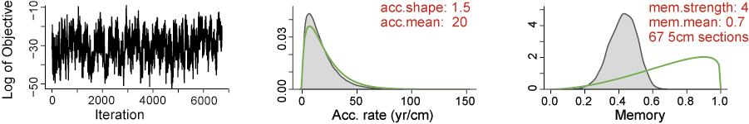

Fig. S3a Steart Point, BH109 sequence based on Bacon (Blauuw and Christen 2011). The three panels depict the MCMC iterations (left panel; a variable distribution with some structure among neighbouring iterations = poor run), the prior (green curve) and posterior (grey histogram) distributions for the accumulation rate (middle panel) and the prior (green curve) and posterior (grey histogram) distributions for memory (right panel)

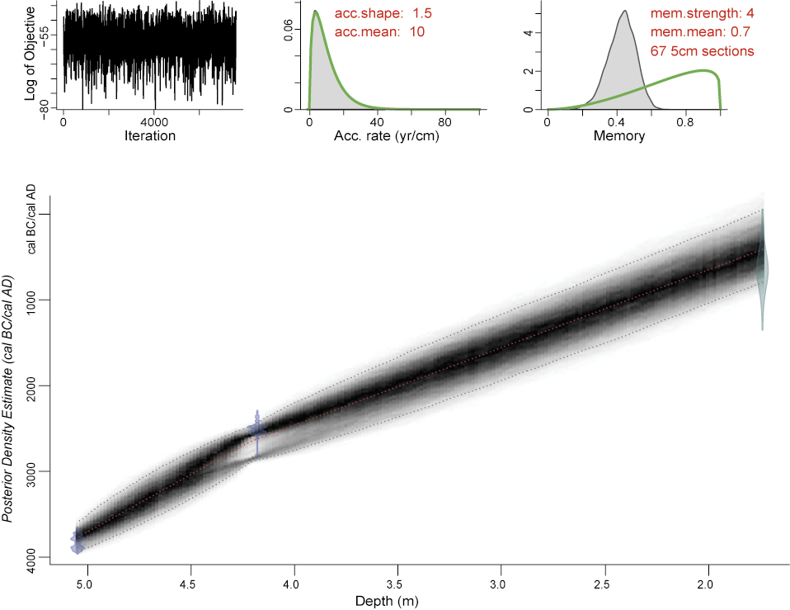

Fig. S3b Steart Point, BH109 sequence based on Bacon (Blauuw and Christen 2011). The three panels depict the MCMC iterations (top – left panel; a stationary distribution with little structure among neighbouring iterations = good run), the prior (green curve) and posterior (grey histogram) distributions for the accumulation rate (top - middle panel) and the prior (green curve) and posterior (grey histogram) distributions for memory (top - right panel). The main bottom panel shows the calibrated radiocarbon dates (transparent blue), OSL date (transparent green) and the age-depth model (darker greys indicate more likely calendar ages; grey stippled lines show 95% Highest Posterior Density Intervals intervals and the red curve shows the single 'best' model) based on the weighted mean age for each depth

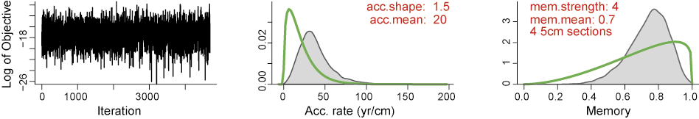

Fig. S3c Steart Point, BH112 sequence based on Bacon (Blauuw and Christen 2011). The three panels depict the MCMC iterations, the prior (green curve) and posterior (grey histogram) distributions for the accumulation rate (middle panel) and the prior (green curve) and posterior (grey histogram) distributions for memory (right panel)

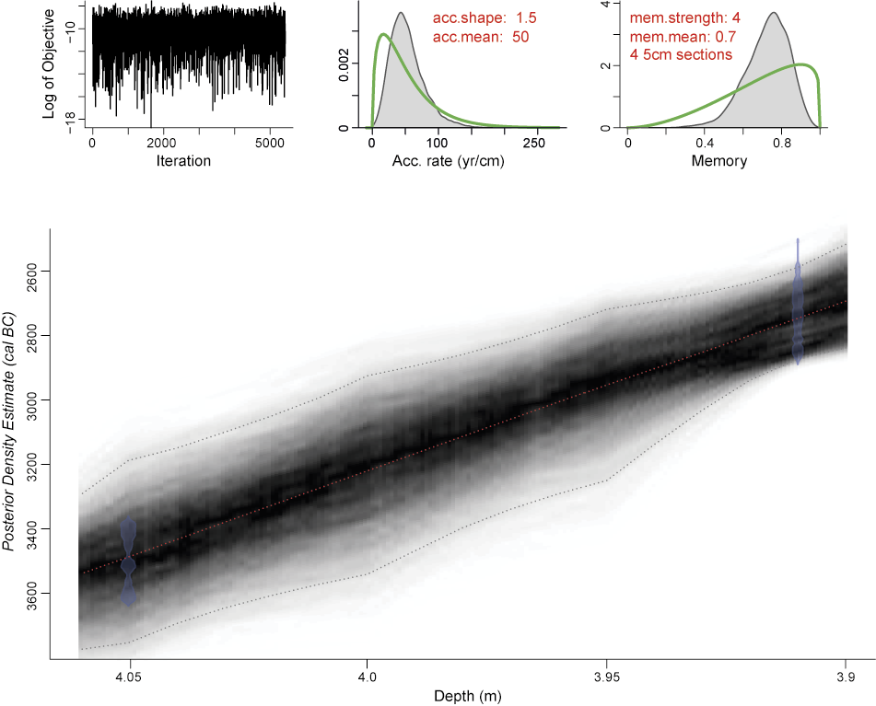

Fig. S3d Age-depth model for the Steart Point, BH112 sequence based on Bacon (Blauuw and Christen 2011). The format is identical to Fig. S3b

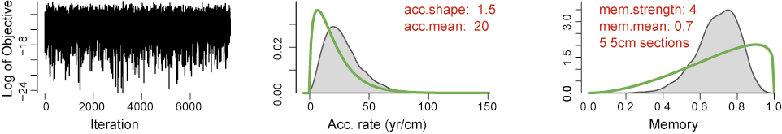

Fig. S3e Burnham-on-Sea, upper profile sequence based on Bacon (Blauuw and Christen 2011). The three panels depict the MCMC iterations, the prior (green curve) and posterior (grey histogram) distributions for the accumulation rate (middle panel) and the prior (green curve) and posterior (grey histogram) distributions for memory (right panel)

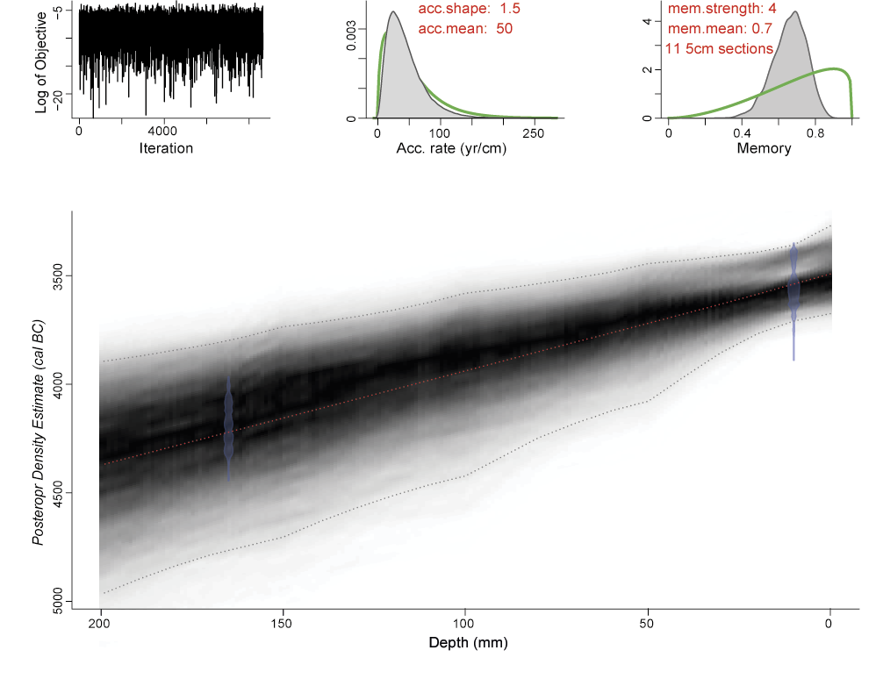
Fig. S3f Age-depth model for the Burnham-on-Sea, upper profile sequence based on Bacon (Blauuw and Christen 2011). The format is identical to Fig. S3b

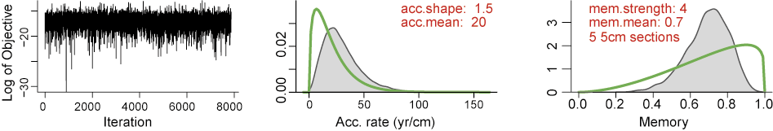

Fig. S3g Burnham-on-Sea, lower profile sequence based on Bacon (Blauuw and Christen 2011). The three panels depict the MCMC iterations, the prior (green curve) and posterior (grey histogram) distributions for the accumulation rate (middle panel) and the prior (green curve) and posterior (grey histogram) distributions for memory (right panel)

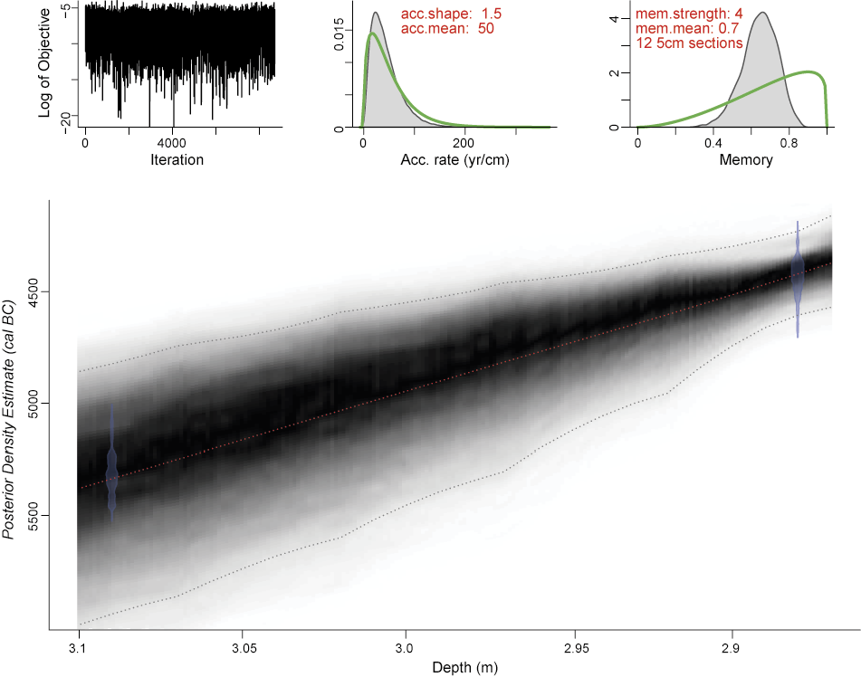

Fig. S3h Age-depth model for the Burnham-on-Sea, lower profile sequence based on Bacon (Blauuw and Christen 2011). The format is identical to Fig. S3b

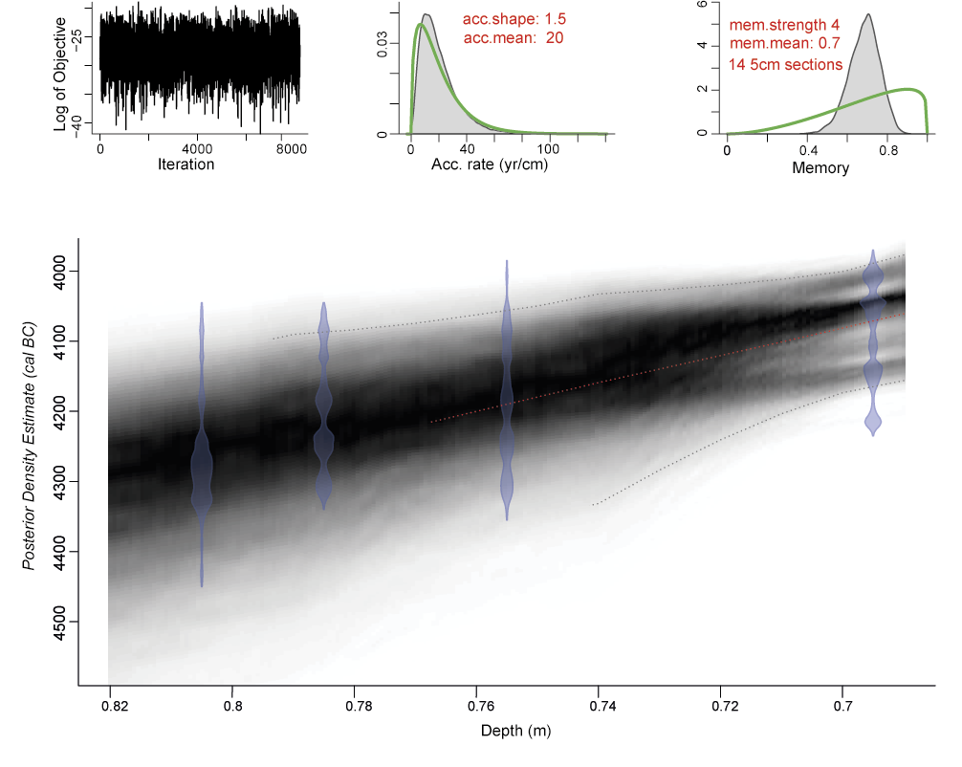

Fig. S3i Age-depth model for the Pawlett sequence based on Bacon (Blauuw and Christen 2011). The format is identical to Fig. S3b

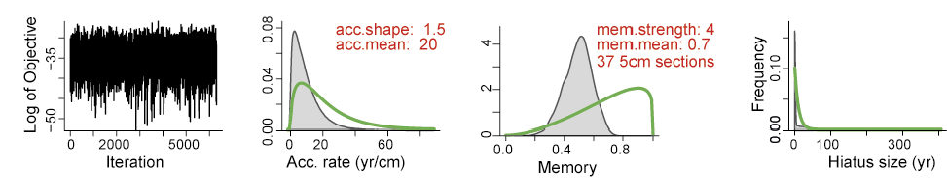

Fig. S3j Walpole Landfill sequence based on Bacon (Blauuw and Christen 2011). The three panels depict the MCMC iterations, the prior (green curve) and posterior (grey histogram) distributions for the accumulation rate (middle panel) and the prior (green curve) and posterior (grey histogram) distributions for memory (right panel)

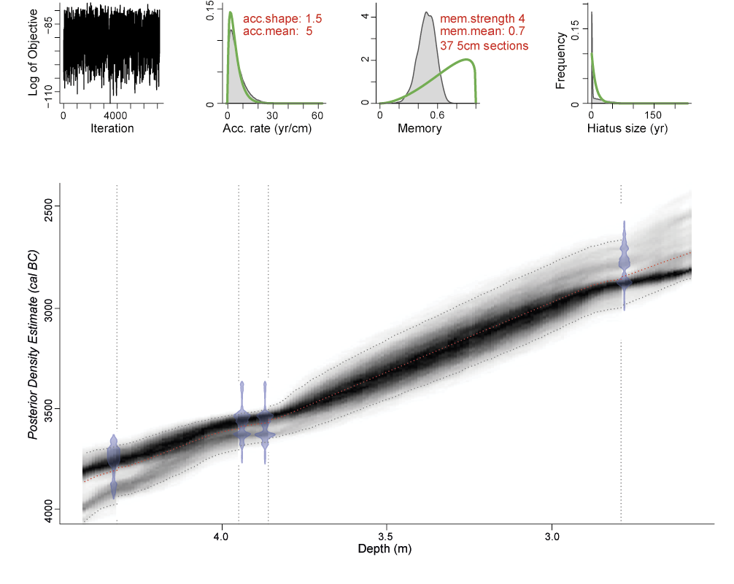
Fig. S3k Age-depth model for the Walpole Landfill sequence based on Bacon (Blauuw and Christen 2011). The format is identical to Fig. S3b, apart from the vertical, dashed lines denoting the position of hiatus

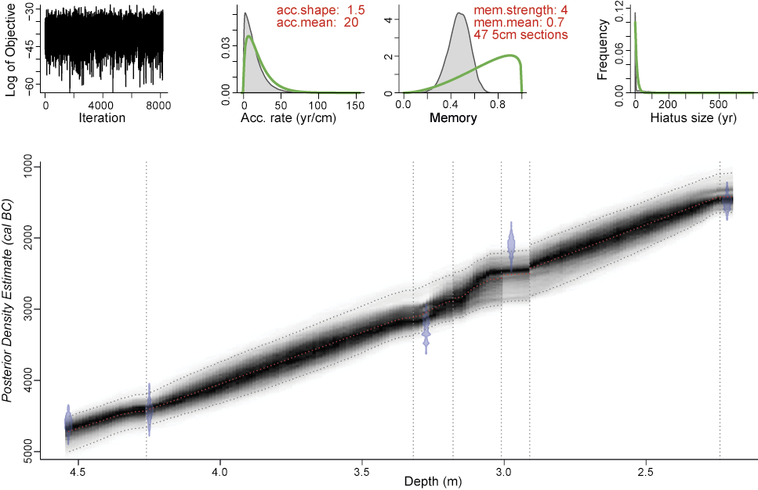

Fig. S3l Age-depth model for the Walpole Trench L sequence based on Bacon (Blauuw and Christen 2011). The format is identical to Fig. S3b, apart from the vertical, dashed lines denoting the position of hiatus

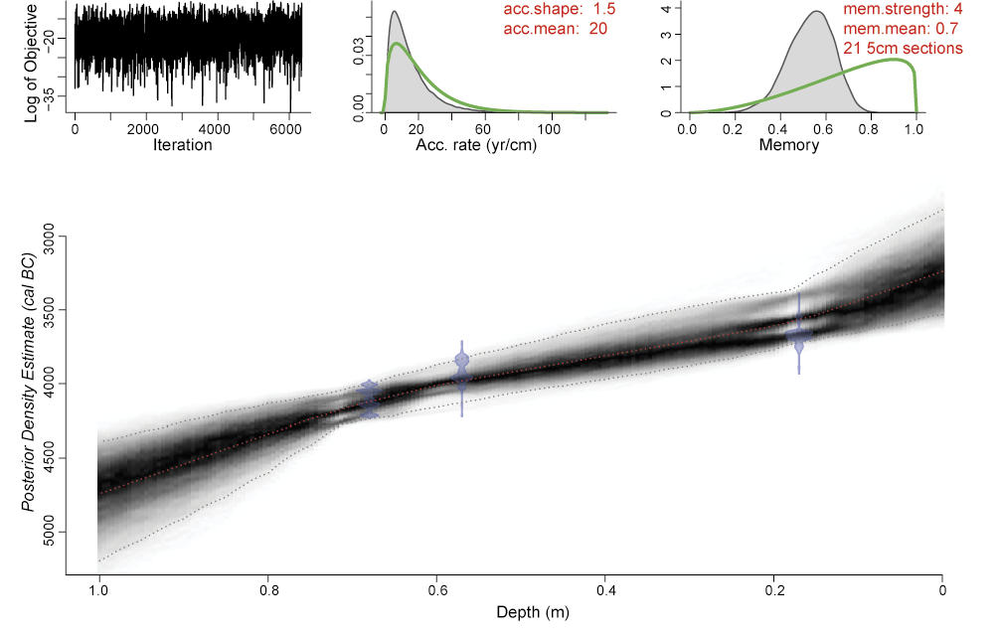

Fig. S3m Age-depth model for the Chedzoy sequence based on Bacon (Blauuw and Christen 2011). The format is identical to Fig. S3b

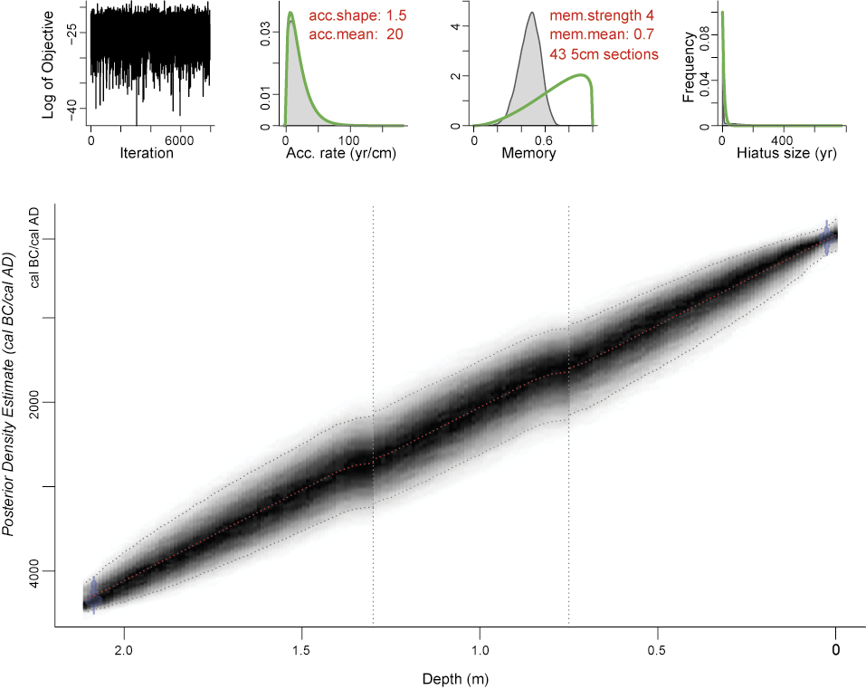

Fig. S3n Age-depth model for the Woolavington Bridge sequence based on Bacon (Blauuw and Christen 2011). The format is identical to Fig. S3b, apart from the vertical, dashed lines denoting the position of hiatus

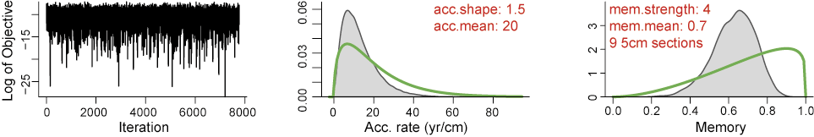

Fig. S3o Greylake sequence based on Bacon (Blauuw and Christen 2011). The three panels depict the MCMC iterations, the prior (green curve) and posterior (grey histogram) distributions for the accumulation rate (middle panel) and the prior (green curve) and posterior (grey histogram) distributions for memory (right panel)

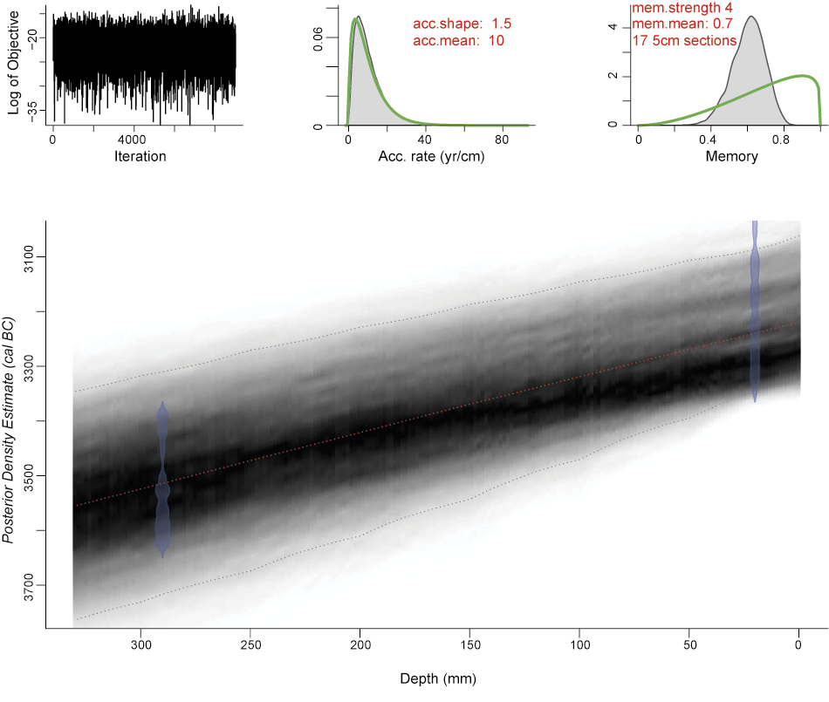

Fig. S3p Age-depth model for the Greylake sequence based on Bacon (Blauuw and Christen 2011). The format is identical to Fig. S3b

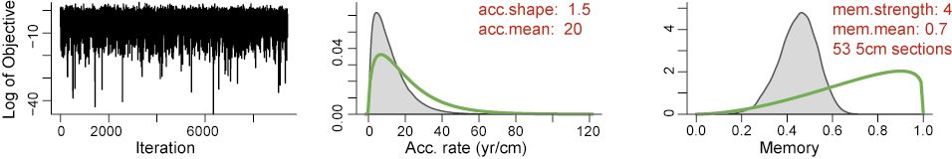

Fig. S3q Shapwick Heath, upper profile sequence based on Bacon (Blauuw and Christen 2011). The three panels depict the MCMC iterations, the prior (green curve) and posterior (grey histogram) distributions for the accumulation rate (middle panel) and the prior (green curve) and posterior (grey histogram) distributions for memory (right panel)

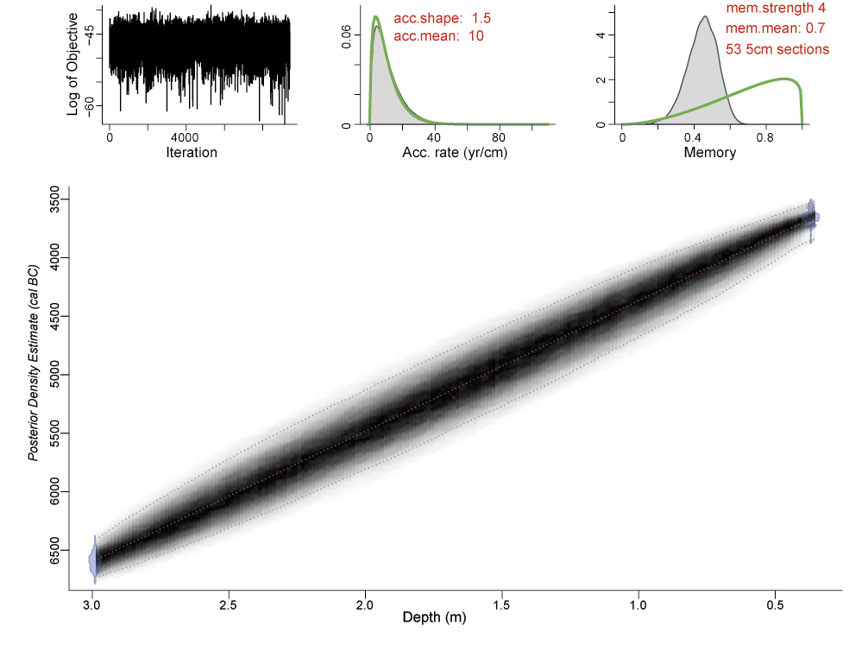
Fig. S3r Age-depth model for the Shapwick Heath, upper profile sequence based on Bacon (Blauuw and Christen 2011). The format is identical to Fig. S3b

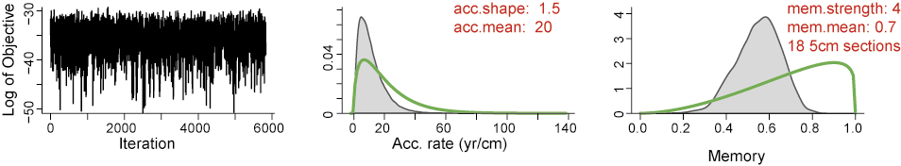

Fig. S3s Shapwick Pit 2 sequence based on Bacon (Blauuw and Christen 2011). The three panels depict the MCMC iterations, the prior (green curve) and posterior (grey histogram) distributions for the accumulation rate (middle panel) and the prior (green curve) and posterior (grey histogram) distributions for memory (right panel)

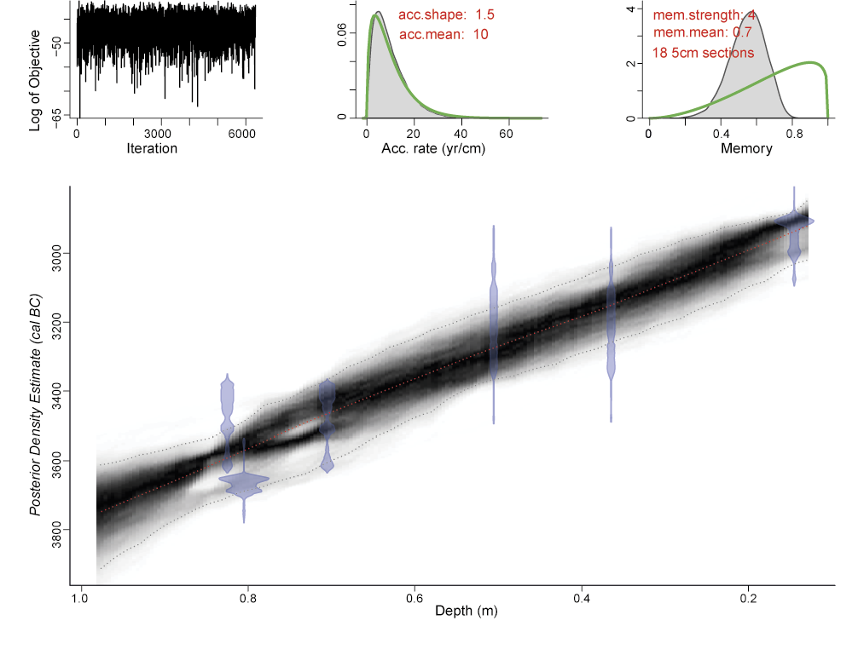

Fig. S3t Age-depth model for the Shapwick Pit 2 sequence based on Bacon (Blauuw and Christen 2011). The format is identical to Fig. S3b

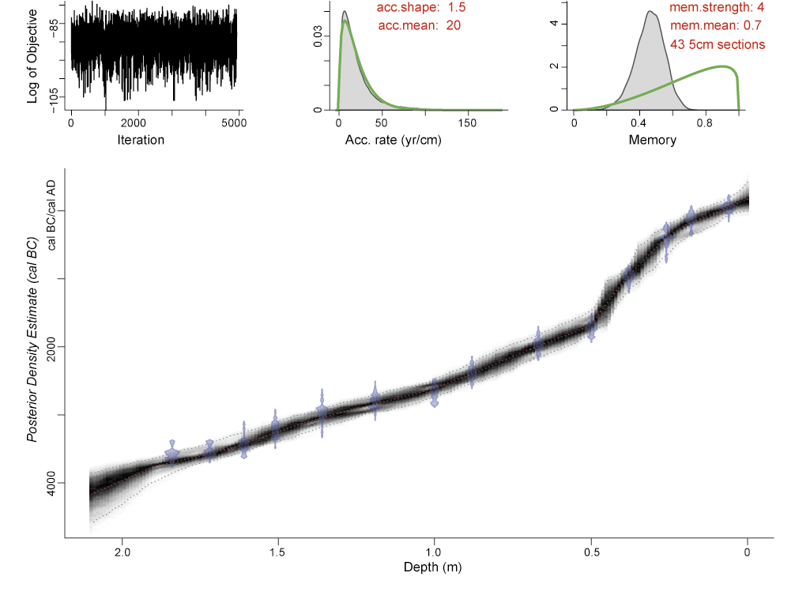

Fig. S3u Age-depth model for the Abbot’s Way sequence based on Bacon (Blauuw and Christen 2011). The format is identical to Fig. S3b

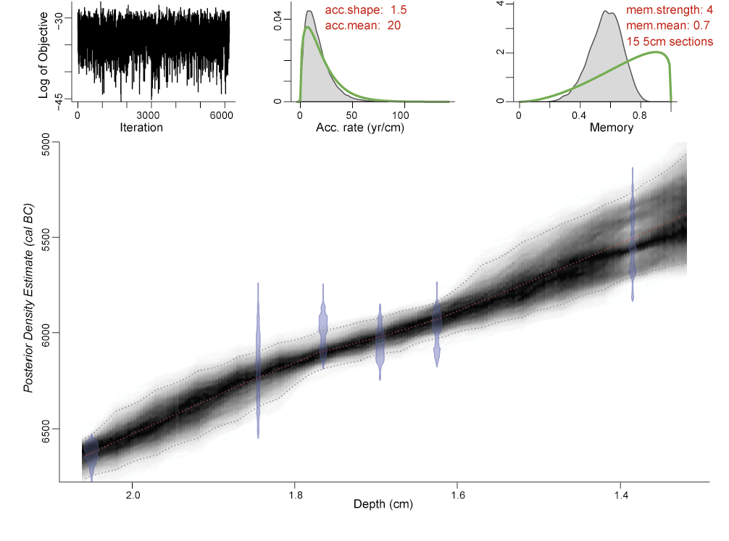

Fig. S3v Age-depth model for the Shapwick SWA93 sequence based on Bacon (Blauuw and Christen 2011). The format is identical to Fig. S3b

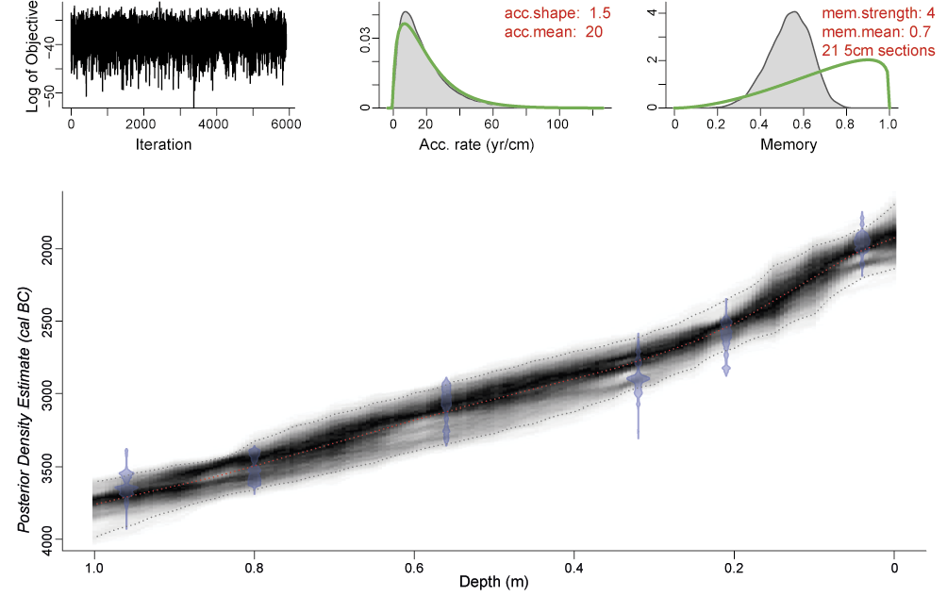

Fig. S3w Age-depth model for the Sweet Track Factory site sequence based on Bacon (Blauuw and Christen 2011). The format is identical to Fig. S3b

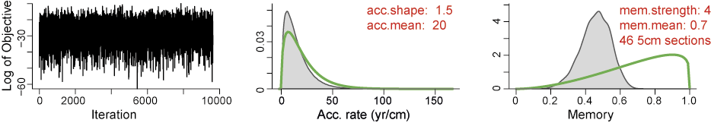

Fig. S3x Shapwick Heath axe site sequence based on Bacon (Blauuw and Christen 2011). The three panels depict the MCMC iterations, the prior (green curve) and posterior (grey histogram) distributions for the accumulation rate (middle panel) and the prior (green curve) and posterior (grey histogram) distributions for memory (right panel)

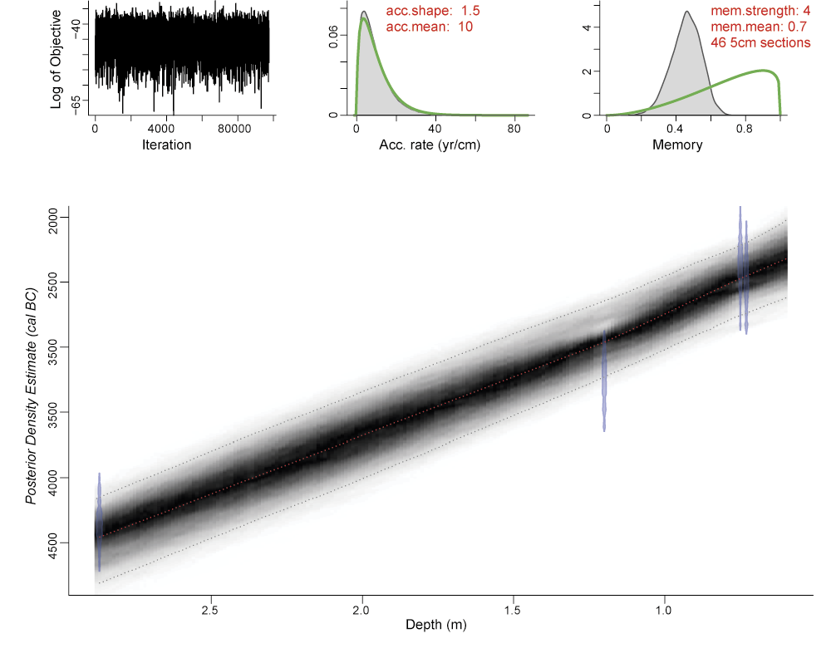

Fig. S3y Age-depth model for the Shapwick Heath axe site sequence based on Bacon (Blauuw and Christen 2011). The format is identical to Fig. S3b

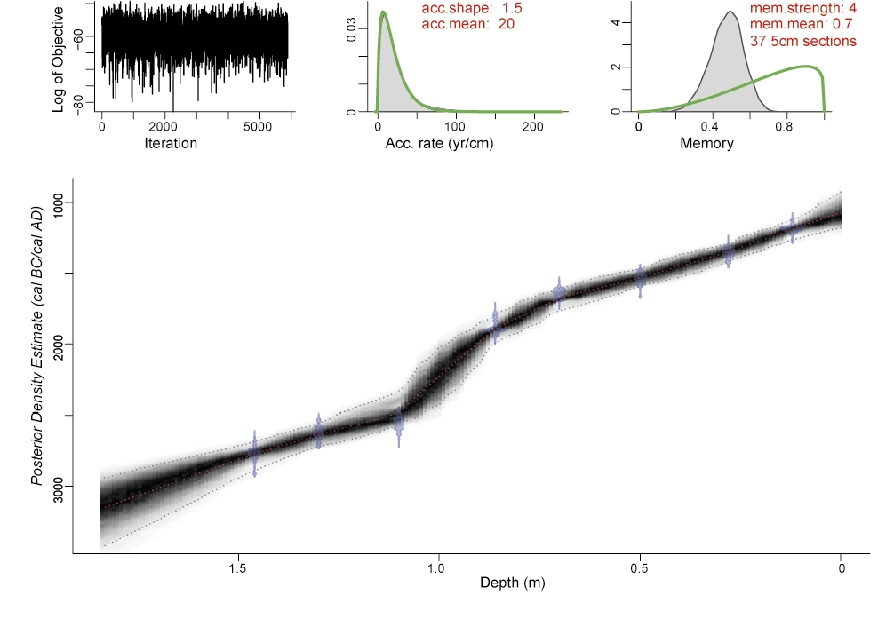

Fig. S3z Age-depth model for Meare Heath based on Bacon (Blauuw and Christen 2011). The format is identical to Fig. S3b

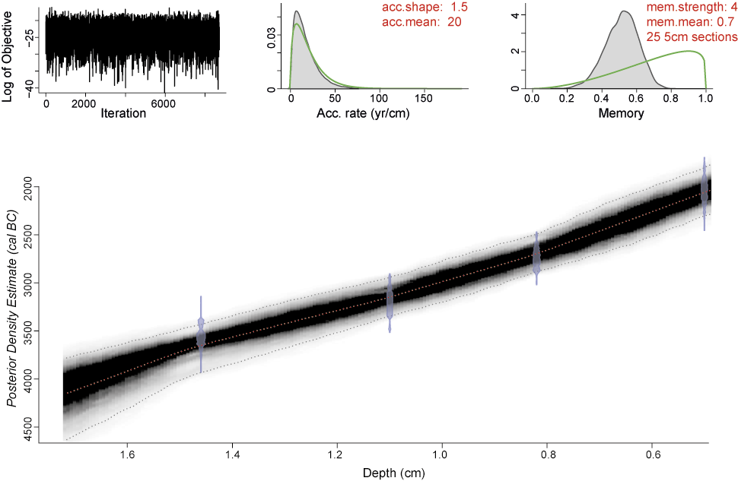

Fig. S3aa Age-depth model for the Sweet Track TW site sequence based on Bacon (Blauuw and Christen 2011). The format is identical to Fig. S3b

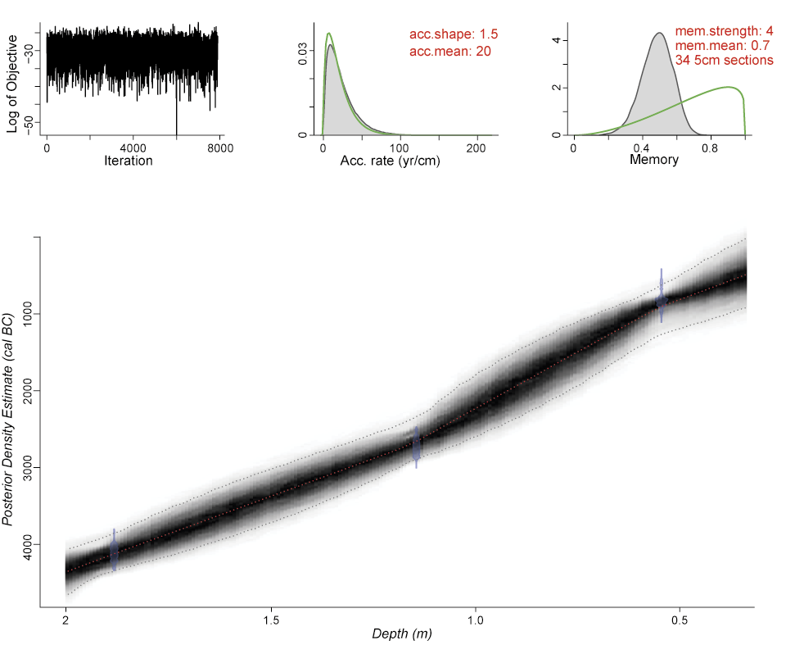

Fig. S3ab Age-depth model for Meare Village East based on Bacon (Blauuw and Christen 2011). The format is identical to Fig. S3b

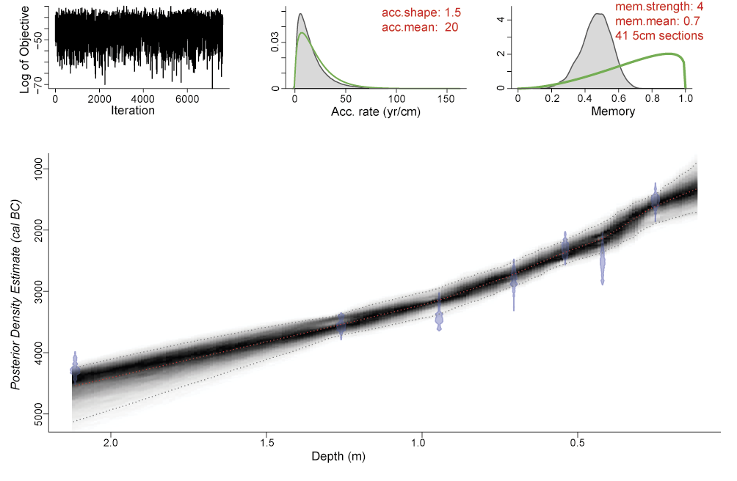

Fig. S3ac Age-depth model for the Eclipse Track sequence based on Bacon (Blauuw and Christen 2011). The format is identical to Fig. S3b

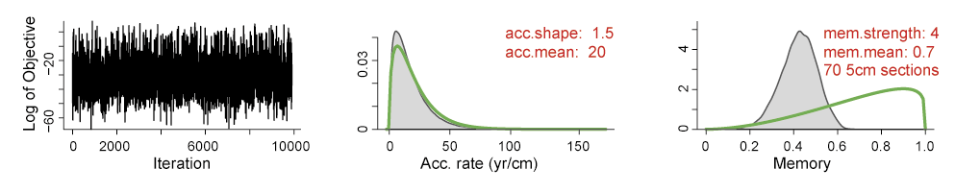

Fig. S3ad Sharpham Drove sequence based on Bacon (Blauuw and Christen 2011). The three panels depict the MCMC iterations, the prior (green curve) and posterior (grey histogram) distributions for the accumulation rate (middle panel) and the prior (green curve) and posterior (grey histogram) distributions for memory (right panel)

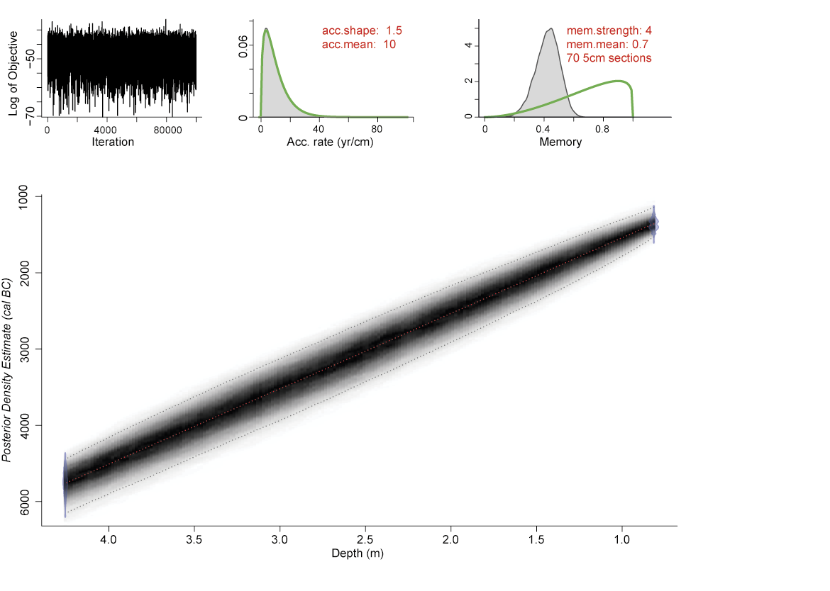

Fig. S3ae Age-depth model for the Sharpham Drove sequence based on Bacon (Blauuw and Christen 2011). The format is identical to Fig. S3b

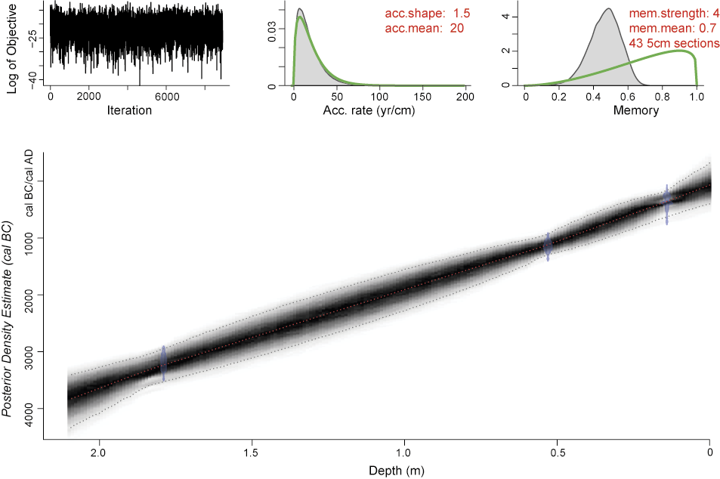

Fig. S3af Age-depth model for the Glastonbury: Benedict Street sequence based on Bacon (Blauuw and Christen 2011). The format is identical to Fig. S3b

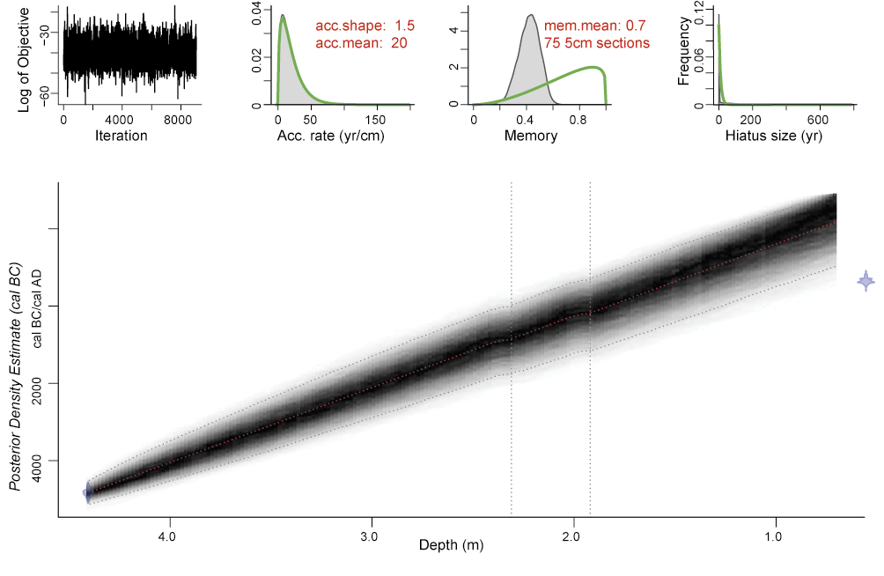

Fig. S3ag Age-depth model for the Glastonbury: Wells Road sequence based on Bacon (Blauuw and Christen 2011). The format is identical to Fig. S3b, apart from the vertical, dashed lines denoting the position of hiatus

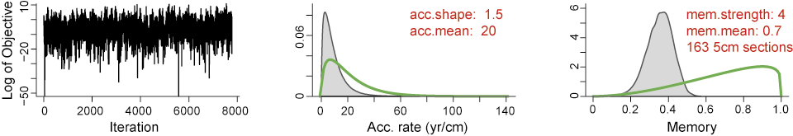

Fig. S3ah Glastonbury: GA18 sequence based on Bacon (Blauuw and Christen 2011). The three panels depict the MCMC iterations, the prior (green curve) and posterior (grey histogram) distributions for the accumulation rate (middle panel) and the prior (green curve) and posterior (grey histogram) distributions for memory (right panel)

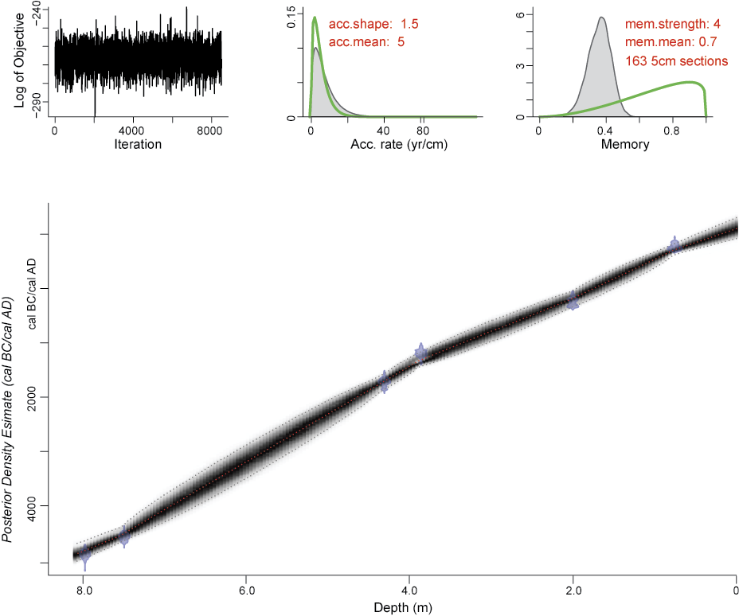

Fig. S3ai Age-depth model for the Glastonbury: GA18 sequence based on Bacon (Blauuw and Christen 2011). The format is identical to Fig. S3b

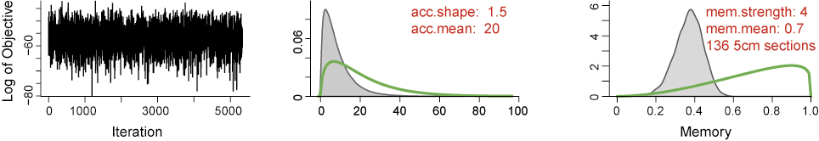

Fig. S3aj Queen’s Sedgemoor sequence based on Bacon (Blauuw and Christen 2011). The three panels depict the MCMC iterations, the prior (green curve) and posterior (grey histogram) distributions for the accumulation rate (middle panel) and the prior (green curve) and posterior (grey histogram) distributions for memory (right panel)

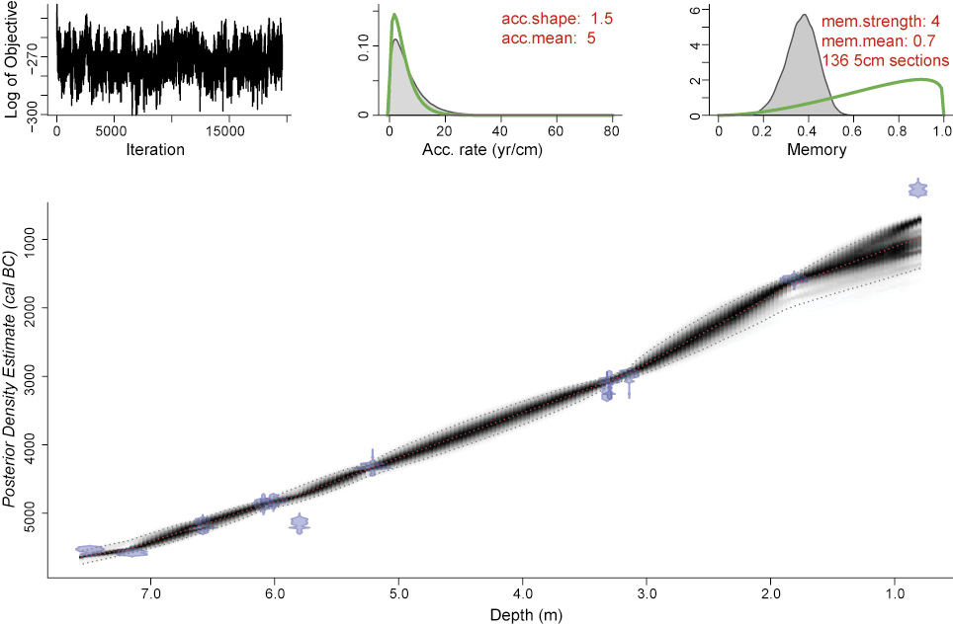

Fig. S3ak Age-depth model for the Queen’s Sedgemoor sequence based on Bacon (Blauuw and Christen 2011). The format is identical to Fig. S3b

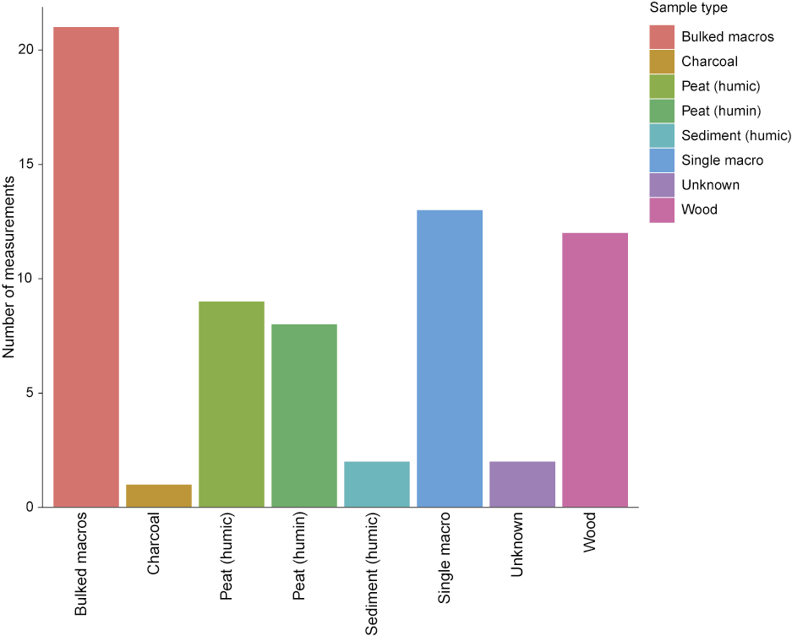

Fig. S3al Number of AMS measurements by sample type

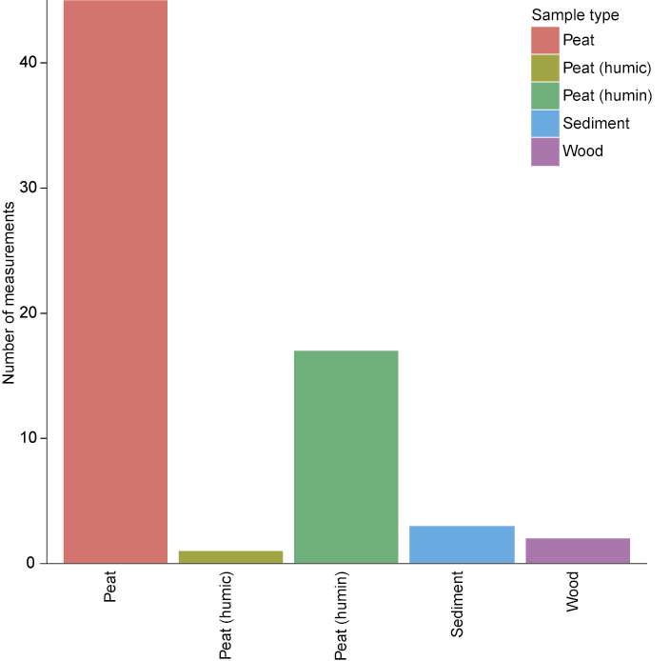

Fig. S3am Number of radiometric measurments by sample type

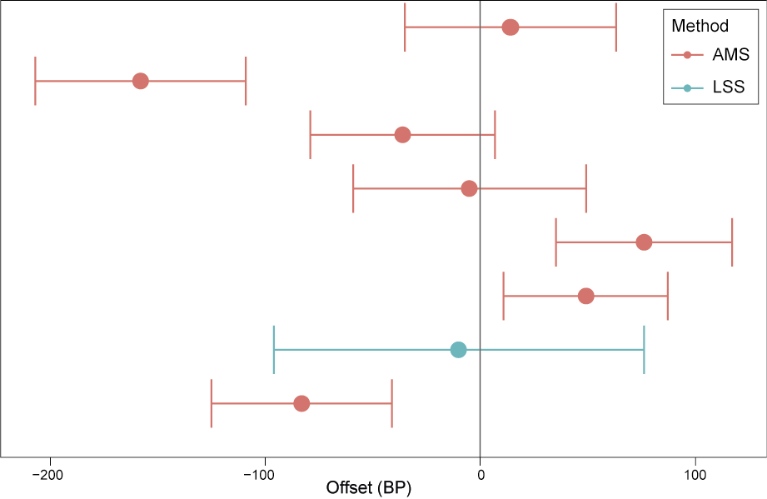

Fig. S3an Offset between pairs of measurements (humic and humin fractions) on the same peat sample

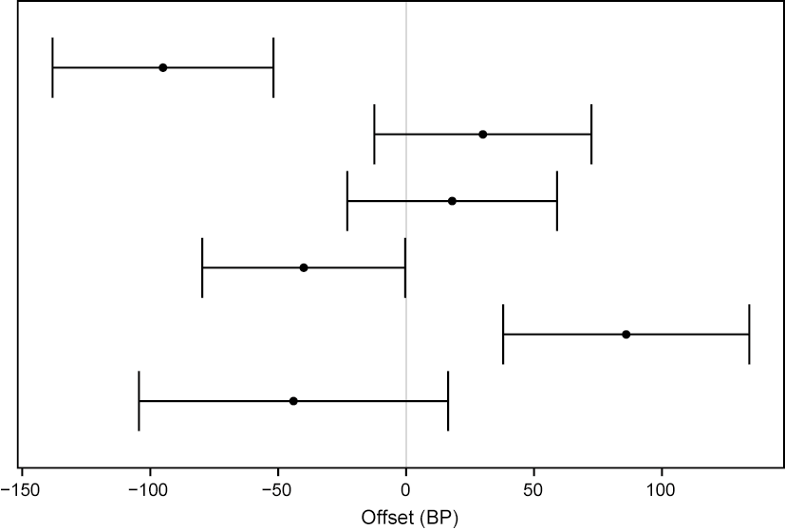

Fig. S3ao Offset between pairs of measurements (plant macrofossils and wood) from the same depth

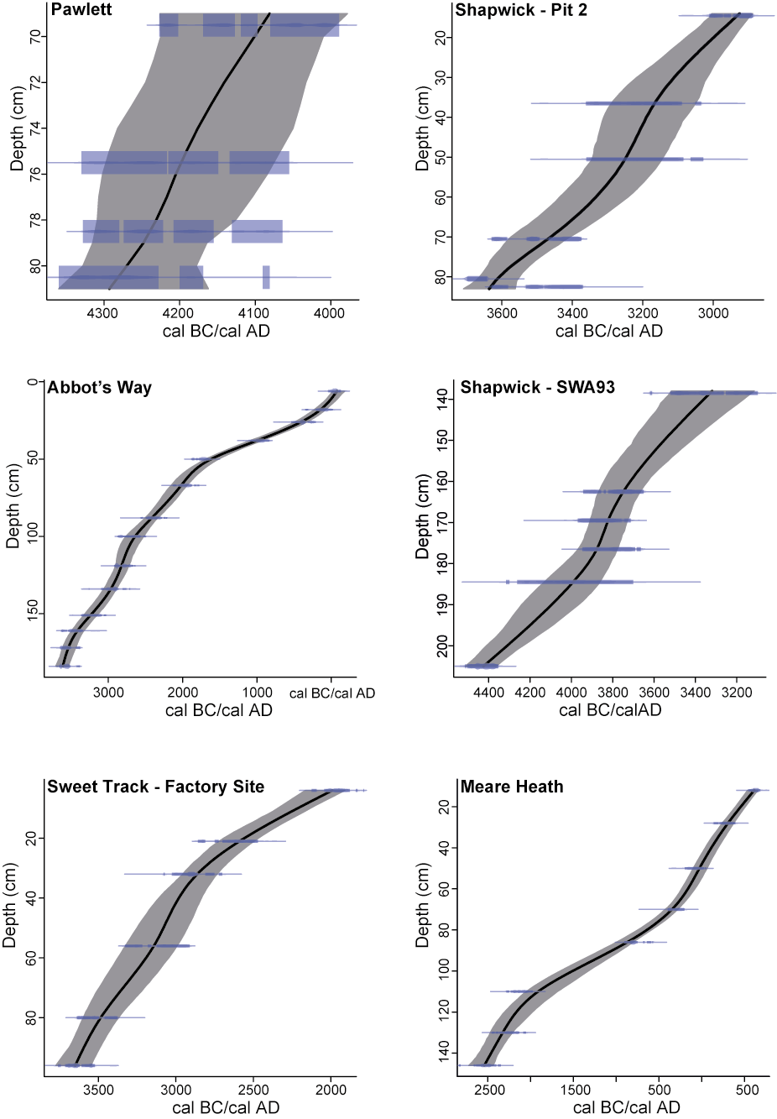

Fig. S3ap Age-depth models for Pawlett, Shapwick – Pit 2, Abbot’s Way, Shapwick – SWA93, Sweet Track – Factory Site, and Meare Heath constructed using a smooth spline regression in Clam (Blaauw 2010)

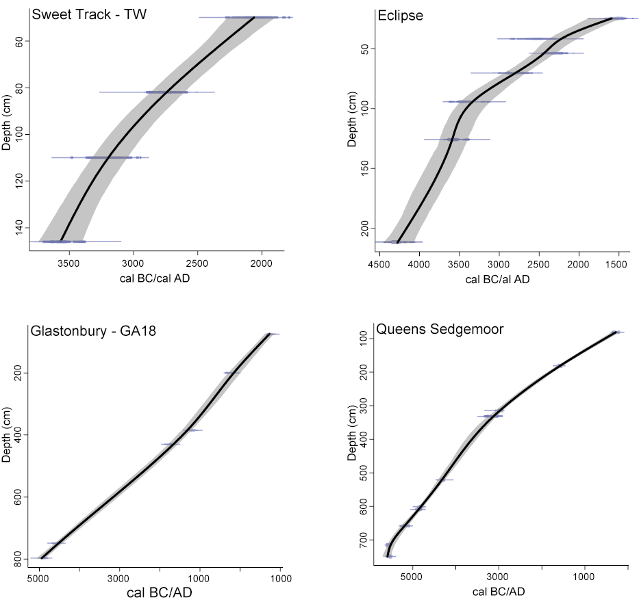

Fig. S3aq Age-depth models for Sweet Track – TW, Eclipse, Glastonbury – G18, and Queen’s Sedgemoor constructed using a smooth spline regression in Clam (Blaauw 2010)

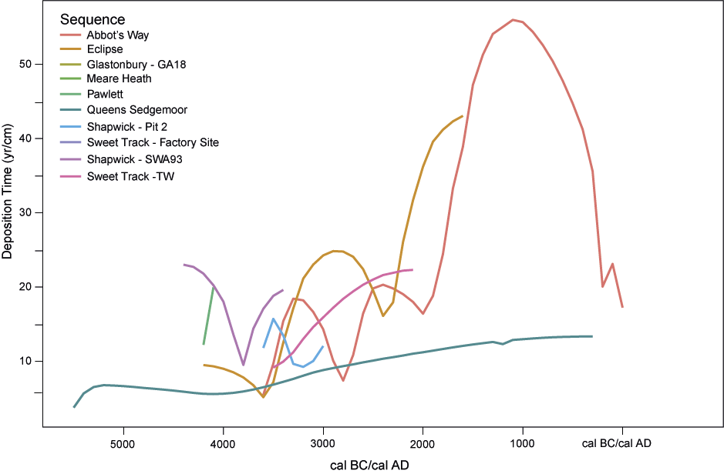

Fig. S3ar Accumulation rate profiles showing fluctuations of Deposition Time (DT) over time and its variability between sites, sampled at 100 year intervals from the age-depth models constructed in Clam (Figs S3ap–S3aq).

Deposition Time is defined as ‘the time elapsed during accumulation of a unit sediment thickness’ (Bennett 1994: 337). The inverse of Deposition Time, Sedimentation Rate (SR; = cm yr ⁻¹) is not used in this paper. In the Bacon models ‘accumulation rate’ (yr/cm) is equivalent to Deposition Time DT = yr/cm⁻¹.
Text in Courier italics denotes the actual code typed in R (statistical computing and graphics software)

