Online Resource for: Corrie Hyland^{1,2}; Michael B. Scott^{1,2}, Jennifer Routledge¹, Paul Szpak¹. Stable Carbon and Nitrogen Isotope Variability of Bone Collagen to Determine the Number of Isotopically Distinct Specimens. Journal of Archaeological Method and Theory

1. Department of Anthropology, Trent University, Peterborough, Ontario, K9L 0G2
2. School of Archaeology, University of Oxford, Oxford, UK, OX1 3TG

Corresponding authors: corrie.hyland@hertford.ox.ac.uk, paulszpak@trentu.ca

Online Resource 1
Supplementary Method: Quality Control Indicator for Lipid Contamination
An important aspect of this research was characterizing intra-individual isotopic variation in bone collagen as accurately as possible. Accordingly, we needed to ensure that the only source of variation in isotopic composition was driven by variation in the diet and physiology of the individual animal and not by experimental error. In the process of this research we observed strong correlations between the δ¹³C values and atomic C:N ratios of multiple bones within the same individual. This relationship should not exist as the amino acid composition of bone collagen does not vary among elements. The correlation between atomic C:N and δ¹³C is caused by the variable presence of contaminants with a high C:N ratio (or those that only contain carbon) and a relatively low δ¹³C value. Based on previous studies (Guiry and Szpak 2020; Guiry et al. 2016), it is safe to assume that lipids are the source of contamination. For example, most of the isotopic variation in the bones from the individual depicted in Figure S1A comes from the variable lipid content of the samples – those with C:N ratios around 3.10 have negligible amounts of lipids and those with C:N ratios around 3.40 have much higher quantities of lipids. The individual depicted in Figure S2B has a high amount of isotopic variation among the bones, but this likely represents a real dietary or physiological difference within that individual that cannot be explained by lipid contamination. It is therefore absolutely critical that great care be taken to ensure lipid contaminants are not present for future studies of this type.
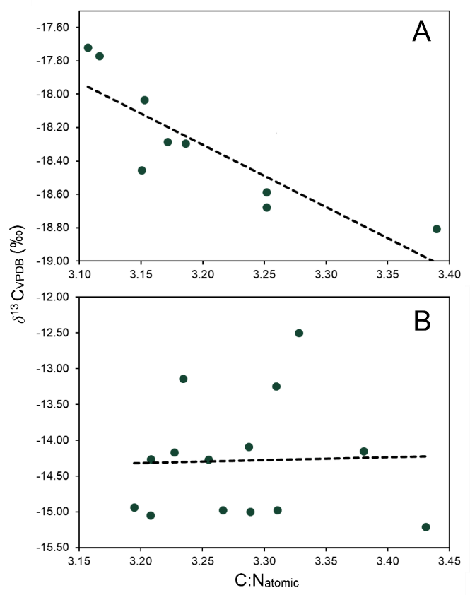
Figure S1: Relationship between C:N_{atomic} and δ¹³C values within two individual animals. Panel A is an example of a strong relationship indicating variable lipid contamination while Panel B is an example of a week relationship with no lipid contamination. This observable correlation was the method by-which samples were excluded due to lipid contamination quality control.
Online Resource 2
Supplementary Discussion: Ecological and Life-History Explanations for Variation
Additional Results
The results of the intra-individual data set were further examined to determine if trends exist based on animal species and their ecology. The diets of the individuals analysed were not directly observed, therefore, the forthcoming characterizations are based on prevalent husbandry practices and species ecology. Comparisons based on species clade revealed that birds had the lowest mean isotopic distance value (µ: 0.34 ± 0.22 ‰) when compared to mammals (µ: 0.57 ± 0.48 ‰) and fish (µ: 0.46 ± 0.49 ‰) (Figures S2). Of the terrestrial animals, mean isotopic distance values were low for the weasel (µ: 0.46 ‰) and the other domesticated species, including cow (µ: 0.55‰), pig (µ: 0.20 ‰) and turkey (µ: 0.14 ‰) (Figures S2). An exception to the low mean isotopic distance values observed in terrestrial animals can be seen with the raccoon, which had the largest value (µ: 1.10‰) observed among all the species examined in this study, primarily due to the stark variation in δ¹³C among its different elements (Figure 4). When comparing migratory and non-migratory species of the same clade, the migratory Northern Flicker had a lower mean isotopic distance measurement (µ: 0.11 ‰) when compared to the non-migratory Hairy Woodpecker (µ: 0.47 ‰) and migratory harp seals had a lower mean isotopic distance (µ: 0.40 ‰) than non-migratory Pacific Ocean Perch (µ: 0.69 ‰) (Figures S2 and Table S1).

Table S1: Summary statistics for the calculated distances between δ¹³C and δ¹⁵N values in isotopic space (‰).
Sample Group | n | Mean | σ | Min | Max
Inter-individual | 15802 | 1.45 | 1.15 | 0.00 | 11.04
Intra-individual | 484 | 0.52 | 0.45 | 0.01 | 2.80
Intra-bone | 27 | 0.63 | 0.06 | 0.03 | 1.25
Mammal | 368 | 0.57 | 0.48 | 0.01 | 2.80
Bird | 85 | 0.34 | 0.21 | 0.05 | 1.06
Fish | 31 | 0.52 | 0.46 | 0.02 | 2.53
Pacific Ocean Perch | 10 | 0.69 | 0.29 | 0.36 | 1.21
Seals | 37 | 0.40 | 0.25 | 0.06 | 1.29
Weasel | 55 | 0.46 | 0.04 | 0.01 | 1.28
Raccoon | 66 | 1.10 | 0.70 | 0.06 | 2.80
Cow | 108 | 0.55 | 0.40 | 0.04 | 1.98
Pig | 102 | 0.36 | 0.20 | 0.06 | 0.89
Turkey | 28 | 0.25 | 0.14 | 0.05 | 0.66
Northern Flicker | 21 | 0.25 | 0.11 | 0.10 | 0.48
Hairy Woodpecker | 36 | 0.47 | 0.24 | 0.06 | 1.06

Possible ecological and life-history explanations for variation
A number of other observations within our dataset lead us to believe that variation in bone turnover may be superseded by diet breadth and physiology as explanations for intra-individual variation. To assess this possibility, comparisons were made, within the study data, to further assess factors that may influence the amount of intra-individual variation. Species ecology of the sample individuals is discussed in detail in Table S2.

Table S2: A list of the species analysed of intra-bone isotopic variability, ecological history, number of individuals (n) and place of origin.
Species | Common Name | Diet | Wild or Domestic | Migratory | n | Origin of Samples
Freshwater Fish
Esox americanus | Pickerel | Carnivore | Wild | No | 1 | Lake Ontario, Ontario, Canada
Perca flavescens | Yellow perch | Carnivore | Wild | Yes limited | 3 | Lake Ontario, Ontario, Canada
Marine Fish
Sebastes alutus | Pacific Ocean Perch | Carnivore | Wild | No | 1 | Coastal British Columbia, Canada
Sebastes babcocki | Redbanded Rockfish | Carnivore | Wild | No | 2 | Coastal British Columbia, Canada
Sebastolobus alascanus | Shortspine Thornyhead |  |  |  | 1 | Coastal British Columbia, Canada
Marine Mammal
Pagophilus groenlandicus | Harp Seal | Carnivore | Wild | Yes | 12 | Newfoundland, Canada
Terrestrial Avian
Meleagris gallopavo domestica | Turkey | Monotonous-Grains and Oils fortified with vitamins and minerals | Domestic | No | 1 | Household food by-products
Colaptes auratus | Northern flicker | Insectivore | Wild | Yes | 1 | Horse ranch, Peterborough, Ontario, Canada
Leuconotopicus villosus | Hairy woodpecker | Insectivore | Wild | No | 1 | Horse ranch, Peterborough, Ontario, Canada
Terrestrial Mammal
Bos taurus | Cow | Graze, forage, grain (Herbivore) | Domestic | No | 6 | Articulated bones of dog chew
 |  |  |  |  | 1 | Dairy farm, Windsor, Ontario, Canada
Sus scrofa domesticus | Pig | Monotonous-Grains and legumes, fortited with vitamins and minerals | Domestic | No | 2 | Household food by-products
Mustela frenata | Long tailed Weasel | Carnivore | Wild | No | 1 | Horse ranch, Peterborough, Ontario, Canada
Procyon lotor | Raccoon | Opportunistic omnivore | Wild | No | 1 | Dairy farm, Windsor, Ontario, Canada

The intra-individual variation was assessed across clades: birds, fish, and mammals (Table S1, Figures S1A). This comparison demonstrated that the mammals and fish had very similar 2σ, upper values of 1.53 ‰ and 1.44 ‰ respectively for intra-individual variation. The intra-individual variation of the birds had a 2σ upper value of 0.77 ‰, indicating that, based on this limited data set; birds may have a narrower range of intra-individual variation than mammals and fish; this observation is worthy of further investigation.
Examination of the marine environment was conducted through comparison of the harp seal and Pacific Ocean perch samples (Table S1, Figures S1B). In comparison to the migratory behaviour of harp seals (discussed in main text; Bajzak et al., 2011; Falk-Petersen et al., 2004), Pacific Ocean perch may forage in areas as large as 70 km² to 400 km², but are not specifically migratory (Palof et al., 2011). Both species are marine carnivores though Pacific Ocean perch occupy a lower trophic position than harp seals (Hulson et al., 2017; Falk-Petersen et al., 2004). The 2σ upper value for intra-individual variation in the Pacific Ocean perch was determined to be 1.27 ‰ and the value for the harp seal samples was 0.90 ‰. Given the values obtained for the clades, fish and mammals (Figure S2), it is unlikely that this difference is attributable to the taxonomy. The hypothesis at the outset was that seasonal migration would produce greater intra-individual variation; however, the harp seals do not provide support for this as they had levels of intra-individual variation that were slightly lower, on average, relative to the other mammals included in this study (Table S1).
To further investigate the potential effects migration may have on variation, a comparison was made between the northern flicker and the hairy woodpecker (Table S2, Figures S1C). The northern flicker is broadly distributed across Canada, as far north as the Yukon, throughout the summer months and migrates to the southern United States for the winter months (Flockhart and Wiebe, 2007; Sibley, 2003). Northern flickers forage on the ground and are specialized consumers of ants (Gow et al. 2013). Hairy woodpeckers are broadly dispersed across Canada and are non-migratory (Sibley, 2003; Villard and Beninger, 1993; Morrison and With, 1987).
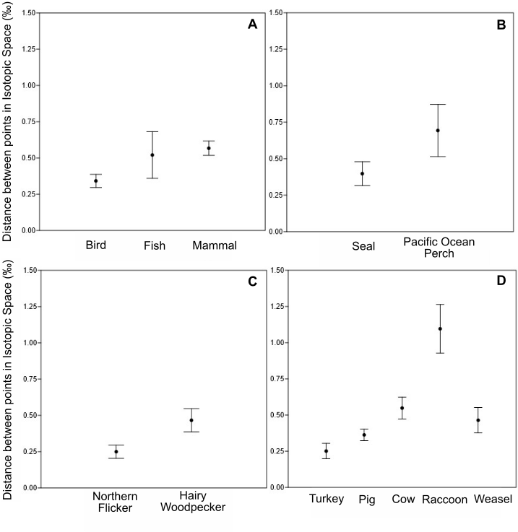
Figure S2: The mean and 95% confidence interval for the mean of different animal groupings or species based on the distance between δ¹³C and δ¹⁵N values of bone collagen from different bones within the same individual in isotopic space (‰).

Hairy woodpeckers are insectivores, foraging on a range of grubs and beetles available beneath thin bark on tree trunks and branches (Villard and Beninger, 1993; Morrison and With, 1987). The 2σ upper value of the northern flicker was 0.46 ‰ and the 2σ upper value of the hairy woodpecker was 0.95 ‰. Once again, the environmental differences associated with migration did not result in a higher degree of variation, relative to the non-migratory comparator, but our sample size was small. The confluence of diet breadth and rapid growth or high metabolic rates in birds may supersede migration in importance, with both species growing rapidly through maturation and the hairy woodpecker incorporating a wider diet breadth than the northern flicker through that period. Moreover, migratory behaviour should only increase intra-individual variation in circumstances where the endpoints of the migration are characterized by isotopically distinct foods (for δ¹³C and δ¹⁵N) and this may not be the case for the northern flicker.
Turkey and pig are fed homogenous diets consisting of pellets or crumb (Marchewka et al., 2013). Turkeys are fed grains and plant oils, sometimes with a 6% to 8% contribution of animal by-products, with nutrition balanced through the addition of vitamins and minerals (Turkey Farmers of Canada, 2019). Pigs are fed similarly with a meal comprised of grains, soybeans, and canola meal, fortified with vitamins and minerals (Manitoba Pork, 2019). The diet of beef cattle is controlled, consisting of graze and dried forage (hay) until they reach a weight of 410 kg at which time they are moved to a feedlot where they consume forage which is incrementally augmented by grain until the grain component is 90% of the diet (Canadian Cattlemen’s Association and Beef Information Centre, 2010). Dairy cows are provisioned with feed based on crops grown at the farmer’s discretion (Dairy Farmers of Canada, 2019). The most common feeds for dairy cows include grass, corn, barley, clover, alfalfa, oats, and soybeans (Dairy Farmers of Canada, 2019). Diet switching in cattle may explain why they had higher levels of intra-individual variation than either pigs or turkeys as well as the harp seals and the weasel (Table S1, Figure S2). This relatively high level of intra-individual variation for cattle is noteworthy since we used a new isotopic dataset generated from domestic cattle bones to test our NIDS metric. The relatively high levels of intra-individual variation observed for modern domestic cattle are therefore likely to increase the probability of misclassifying two bones as coming from distinct individuals when they are from the same individual.

References

Bajzak, C. E., Hammill, M. O., Stenson, G. B., & Prinsenberg, S. (2011). Drifting away: implications of changes in ice conditions for a pack-ice-breeding phocid, the harp seal (Pagophilus groenlandicus). Canadian Journal of Zoology, 89(11), 1050–1062. https://doi.org/10.1139/z11-081

Canadian Cattlement’s Association and Beef Information Centre (2010). What Do Beef Cattle Eat? http://www.ontariobeef.com/uploads/userfiles/files/what%20do%20beef%20cattle%20eat.pdf Accessed May 28, 2019.

Dairy Farmers of Canada (February 14, 2019). The Canadian Cow Diet. https://dairyfarmersofcanada.ca/en/dairy-in-canada/dairy-excellence/canadian-cow-diet Accessed June 13, 2019.

Falk‐Petersen, S., Haug, T., Nilssen, K. T., Wold, A., & Dahl, T. M. (2004). Lipids and trophic linkages in harp seal (Phoca groenlandica) from the eastern Barents Sea. Polar Research, 23(1), 43-50. https://doi.org/10.1111/j.1751-8369.2004.tb00128.x

Flockhart, D. T., & Wiebe, K. L. (2007). The role of weather and migration in assortative pairing within the northern flicker (Colaptes auratus) hybrid zone. Evolutionary Ecology Research, 9(6), 887-903.

Gow, E. A., Wiebe, K. L., & Higgins, R. J. (2013). Lack of diet segregation during breeding by male and female Northern Flickers foraging on ants. Journal of Field Ornithology, 84(3), 262–269. https://doi.org/10.1111/jofo.12025

Guiry EJ, Szpak P, Richards MP, 2016. Effects of lipid extraction and ultrafiltration on stable carbon and nitrogen isotopic compositions of fish bone collagen. Rapid Communications in Mass Spectrometry 30, 1591-1600. doi:10.1002/rcm.7590

Guiry EJ, Szpak P, 2020. Quality control for modern bone collagen stable carbon and nitrogen isotope measurements. Methods in Ecology and Evolution 11, 1049-1060. doi:10.1111/2041-210X.13433

Hulson, P. J., Hanselman, D. H., Lunsford, C. R., & Fissel, B. (2017) Assessment of the Pacific ocean perch stock in the Gulf of Alaska. In Stock Assessment and Fishery Evaluation Report for the Groundfish Resources of the Gulf of Alaska, chpt. 9. Anchorage, AK: North Pacific Fishery Management Council.

Manitoba Pork (2019). What Do Pigs Eat? https://www.manitobapork.com/on-the-farm/how-pigs-are-raised/what-do-pigs-eat Accessed May 29, 2019.

Marchewka, J., Watanabe, T. T. N., Ferrante, V., & Estevez, I. (2013). Review of the social and environmental factors affecting the behavior and welfare of turkeys (Meleagris gallopavo). Poultry Science, 92(6), 1467-1473. https://doi.org/10.3382/ps.2012-02943

Morrison, M. L., & With, K. A. (1987). Interseasonal and intersexual resource partitioning in hairy and white-headed woodpeckers. The Auk, 104(2), 225-233. https://doi.org/10.1093/auk/104.2.225

Palof, K. J., Heifetz, J., & Gharrett, A. J. (2011). Geographic structure in Alaskan Pacific ocean perch (Sebastes alutus) indicates limited lifetime dispersal. Marine Biology, 158(4), 779-792. https://doi.org/10.1007/s00227-010-1606-2

Sibley, D. A. (2003). The Sibley Field Guide to Birds of Eastern North America. Alfred A. Knopf, New York.

Turkey Farmers of Canada (2019). What Turkeys Eat. https://www.turkeyfarmersofcanada.ca/on-the-farm/what-turkeys-eat-3/ Accessed May 26, 2019.

Villard, P., & Beninger, C. W. (1993). Foraging behavior of male Black-backed and Hairy Woodpeckers in a forest burn (Conducta de Forrajeo de Individuos Machos de los Carpinteros Picoides villosus y P. arcticus en un Área Forestal Quemada). Journal of Field Ornithology, 71-76.
https://www.jstor.org/stable/4513772

