Debunking deterministic narratives of technological development through experimentation: a critical review of the prehistory of tin bronze alloying
Montes-Landa, J.; Timberlake, S.; Martinón-Torres, M.
Supplementary Information 3. Information on raw materials, their preparation, and the set up used.

1. Malachite and cassiterite
Two chunks of malachite (Fig.SI3.1) of unknown provenance were acquired at a Cambridge shop. Both chunks had several layers of different green shadows when observed in section. No inclusions of other minerals/rocks were seen when handling or crushing them. Some very minor and occasional bits of metallic Cu were observed while crushing these chunks.
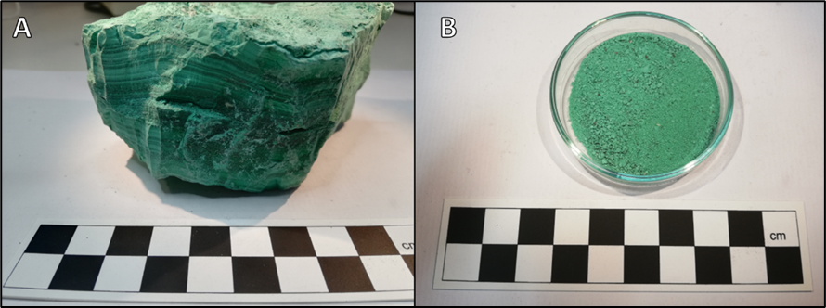
Fig.SI3.1. A) One of the malachite chunks used. B) Malachite powder for co-smelting operations
pXRF analyses on the unprepared raw materials described in this document were conducted with an Olympus Vanta M-series (40kV, 30 seconds acquisition time). The geoChem3-AuPtAsBrHgRh mode was selected for the minerals and the crucible; the AlloyPlus Extra mode was preferred for metals (see below). The data produced were rounded to two decimals. In results tables, ‘0.00’ refers to potential presence of this element in trace amounts, and ‘<LOD’ indicates that the element might be present below the limits of detection. pXRF measurements should be taken qualitatively rather than quantitatively, given the limitations of the technique on unprepared surfaces.
pXRF analyses on the malachite chunks show very similar average compositions for both. Al, Si (>2wt% for both elements), Mg and P (>1wt% for both elements) are the major elements present, and K is the most prominent minor impurity (>0.1wt%K) (Table SI3.1).
Marine alluvial cassiterite from Piriac sur Mer (Loire Atlantique, France) was obtained through a local contact. It consisted in black nodules of mineral of different sizes, ranging from a couple of centimetres to half centimetre (Fig.SI3.2). The black surfaces had a characteristic natural lustre. Some of the nodules presented very visible inclusions of other white and dark brown minerals/rocks (gangue).
Table SI3.1. pXRF analyses on malachite chunks
 | LE | Mg | Al | Si | P | S | K | Ca | V | Cr | Mn | Fe | Ni
#1 | 30.73 | 1.28 | 0.98 | 0.68 | 0.73 | <LOD | 0.02 | 0.01 | <LOD | <LOD | 0.01 | 0.02 | 0.01
#2 | 16.95 | 2.41 | 5.13 | 6.01 | 0.54 | 0.04 | 0.60 | <LOD | <LOD | <LOD | 0.01 | 0.09 | 0.00
#3 | 25.02 | 1.26 | 2.59 | 3.55 | 2.45 | <LOD | 0.41 | 0.03 | 0.06 | 0.01 | 0.01 | 0.09 | 0.01
#4 | 23.92 | 1.11 | 2.70 | 7.32 | 0.29 | 0.09 | 0.14 | 0.14 | <LOD | <LOD | 0.01 | 0.07 | 0.01
Ore 1 – Average | 24.15 | 1.51 | 2.85 | 4.39 | 1.00 | 0.03 | 0.29 | 0.04 | 0.01 | 0.00 | 0.01 | 0.07 | 0.01
#1 | 27.12 | 1.24 | 1.47 | 1.11 | 2.05 | 0.02 | 0.04 | 0.04 | 0.02 | <LOD | 0.01 | 0.02 | 0.00
#2 | 24.85 | 1.22 | 2.18 | 1.81 | 2.67 | <LOD | 0.11 | 0.03 | 0.01 | <LOD | 0.01 | 0.04 | 0.00
#3 | 33.15 | 1.64 | 1.08 | 1.54 | 0.38 | 0.03 | 0.15 | 0.16 | <LOD | 0.01 | 0.01 | 0.12 | 0.01
#4 | 20.61 | 2.34 | 5.10 | 7.24 | 0.06 | 0.04 | 0.69 | <LOD | <LOD | 0.00 | 0.02 | 0.21 | 0.01
Ore 2 – Average | 26.43 | 1.61 | 2.46 | 2.92 | 1.29 | 0.02 | 0.25 | 0.06 | 0.01 | 0.00 | 0.01 | 0.10 | 0.01
<LOD=below limits of detection.
Table SI3.1 (cont.). pXRF analyses on malachite chunks (continuation).
 | Cu | Zn | As | Rb | Y | Zr | Nb | Mo | Cd | Sn | Ba | Pt | Th
#1 | 65.23 | 0.06 | <LOD | 0.01 | <LOD | 0.01 | 0.01 | 0.02 | 0.01 | <LOD | <LOD | 0.08 | 0.11
#2 | 67.87 | 0.07 | <LOD | 0.01 | <LOD | 0.00 | 0.01 | 0.02 | 0.00 | <LOD | <LOD | 0.09 | 0.13
#3 | 64.29 | 0.09 | 0.05 | 0.01 | 0.01 | 0.01 | 0.00 | 0.01 | 0.01 | <LOD | 0.05 | <LOD | <LOD
#4 | 63.88 | 0.08 | <LOD | 0.01 | <LOD | <LOD | 0.01 | 0.02 | 0.01 | <LOD | <LOD | 0.09 | 0.13
Ore 1 – Average | 65.32 | 0.08 | 0.01 | 0.01 | 0.00 | 0.01 | 0.01 | 0.02 | 0.01 | 0.00 | 0.01 | 0.07 | 0.09
#1 | 66.50 | 0.06 | 0.01 | 0.01 | <LOD | 0.00 | 0.01 | 0.02 | <LOD | <LOD | <LOD | 0.10 | 0.13
#2 | 66.69 | 0.08 | 0.00 | 0.01 | <LOD | 0.00 | 0.01 | 0.02 | 0.01 | 0.01 | <LOD | 0.10 | 0.13
#3 | 61.54 | 0.07 | <LOD | 0.01 | 0.01 | 0.01 | 0.00 | 0.01 | <LOD | <LOD | 0.07 | <LOD | <LOD
#4 | 63.41 | 0.09 | <LOD | 0.01 | 0.00 | 0.01 | 0.00 | 0.01 | 0.01 | <LOD | 0.04 | 0.03 | 0.05
Ore 2 – Average | 64.53 | 0.08 | 0.00 | 0.01 | 0.00 | 0.01 | 0.01 | 0.02 | 0.00 | 0.00 | 0.03 | 0.06 | 0.08
<LOD=below limits of detection.
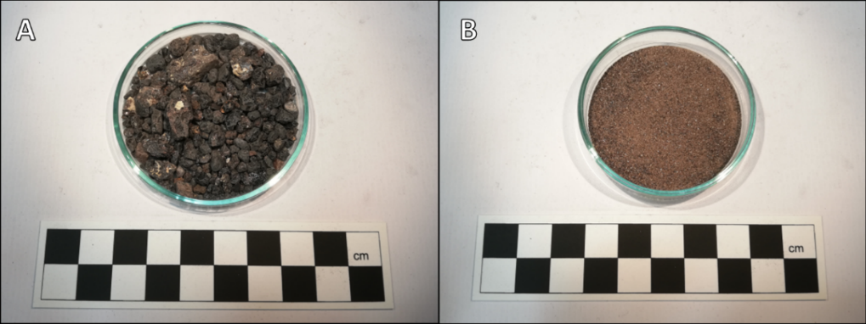
Fig.SI3.2. A) Raw cassiterite nodules with white and brown gangue. B) Gangue extracted from the cassiterite during beneficiation
pXRF analyses on raw cassiterite fragments show Ca (>12wt%Ca), K (>6wt%K), Al (>3wt%Al), Si, and Fe (>1wt% for both) as major impurities, and Mg (>0.8wt%Mg), Ti, Cu, and S (>0.1wt% for all) as minor ones (Table SI3.2).
Table SI3.2. pXRF analyses on cassiterite nodules.
 | LE | Mg | Al | Si | S | K | Ca | Ti | Cr | Fe | Ni | Cu | As
#1 | 17.47 | 0.87 | 2.99 | 1.43 | 0.11 | 6.31 | 13.12 | 0.12 | 0.05 | 2.72 | 0.01 | 0.09 | 0.01
#2 | 17.42 | 1.05 | 4.89 | 2.65 | 0.14 | 6.51 | 12.44 | 0.14 | 0.05 | 0.35 | 0.01 | 0.09 | 0.01
#3 | 16.12 | 0.76 | 2.31 | 1.18 | 0.10 | 6.41 | 13.35 | 0.12 | 0.06 | 2.17 | 0.01 | 0.14 | 0.01
Average | 17.00 | 0.89 | 3.40 | 1.76 | 0.11 | 6.41 | 12.97 | 0.12 | 0.05 | 1.75 | 0.01 | 0.11 | 0.01

Table SI3.2 (cont.). pXRF analyses on cassiterite nodules (continuation).
 | Rb | Zr | Nb | Ag | Sn | Sb | W | Au | Pb
#1 | 0.00 | 0.01 | 0.06 | 0.01 | 54.41 | 0.09 | 0.04 | 0.01 | 0.05
#2 | 0.01 | 0.01 | 0.09 | 0.01 | 53.96 | 0.10 | 0.04 | 0.00 | 0.04
#3 | 0.00 | 0.02 | 0.06 | 0.01 | 56.97 | 0.10 | 0.04 | 0.01 | 0.04
Average | 0.00 | 0.02 | 0.07 | 0.01 | 55.12 | 0.09 | 0.04 | 0.01 | 0.04
Both ores were crushed on a stone anvil located over a plastic surface, which allowed recovering a considerable number of fragments that jumped out of the working surface (Fig.SI3.3). Malachite was crushed down into powder in consistence with the microscopic nature of Cu-ore relics observed in archaeological co-smelting slag (see Supplementary Information 1). Cassiterite was crushed down into 1-2mm fragments, because archaeological slag shows that cassiterite relics are generally larger than Cu-ore ones (e.g. Montes-Landa et al., 2020). Cassiterite powder was also created in the process and used in the operations. Time spent in crushing ores was recorded (Table SI3.3). Some extra ore was crushed on-site, but the totals were not monitored to save time.
Crushed cassiterite was beneficiated because the obvious presence of sand would have produced a less accurate assessment of Sn recovery (Fig.SI3.2B). To do so, the crushed ore was introduced in a bowl and moved in a circular motion that separated the sand (brown, lighter) from the cassiterite (black, denser), which was recovered with a spoon.
The average loss of malachite and non-beneficiated cassiterite after crushing was ~5%. Special care was put into maximising recovery by hand-picking fragments/powder that jumped out of the anvil using a brush. A more ad hoc approach could imply greater mineral losses.
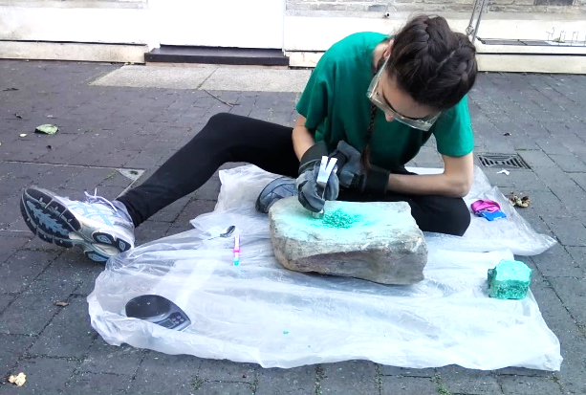
Fig.SI3.3. Set up used for malachite and cassiterite crushing
Table SI3.3. Malachite and cassiterite processing calculation
 | Malachite | Cassiterite
 | Malachite | Non-beneficiated | Beneficiated | Gangue
g crushed | 802.69 | 225.74
g obtained | 758 | 214.1 | 201.3 | 12.8
g lost | 44.69 | 11.64 | 24.44 | NA
% lost | 5.56 | 5.15 | 10.82 | NA
Time spent | ~2h for 150g | ~4h for 214g
Obtaining 150g of crushed malachite for a single operation took ~2h. ~100g of crushed non beneficiated cassiterite took the same time to process because malachite required a smaller grain size than cassiterite. The amount of beneficiated crushed cassiterite needed for a single experiment (20g) was acquired in ~15mins.
Cassiterite beneficiation was very quick (i.e. a few minutes to obtain 20g of crushed mineral). 11% of the original cassiterite – most of it gangue – was lost after beneficiation. Beneficiation involves an extra ~6% loss of material compared to the non-beneficiated cassiterite (Table SI3.3).

2. Metallic Cu and metallic Sn
Cu sheets of different thicknesses (0.5-1mm) were bought in a Cambridge shop. The provenance of the Cu is unknown. pXRF analyses show a 99.98wt%Cu with trace impurities of Fe, Cr, and Ni (Table SI3.4). Pure Cu was used to better asses the direct efficiency of the techniques. Producing our own Cu would have required more resources.
Table SI3.4. pXRF analyses of the Cu sheets
 | LE | Cr | Fe | Ni | Cu
#1 | <LOD | 0.00 | 0.01 | <LOD | 99.98
#2 | <LOD | <LOD | 0.01 | 0.01 | 99.98
#3 | <LOD | 0.01 | 0.01 | <LOD | 99.98
#4 | <LOD | <LOD | 0.03 | <LOD | 99.96
Average | 0.00 | 0.00 | 0.02 | 0.00 | 99.98
<LOD=below limits of detection
Sheet fragments were cut using metal snips to a crescent moon shape of about 6x2mm (Fig.SI3.4 and Fig.SI3.5). This shape maximises the surface in contact with Sn/cassiterite, but it is unlikely that metal was cut like this in Antiquity. However, this would be the closest resemblance to the potential use of small Cu prills/masses from an independent Cu smelting operation. Cutting time and losses were recorded (Table SI3.5).
Table SI3.5. Metal cutting losses
 | Cu | Sn
g cut | 897.7 | 111.9
g obtained | 895.35 | 81.98
g lost | 2.35 | 29.92
% lost | 0.26 | 26.74
Time spent | ~3h for 100g | ~2h for 6 pieces of ~16g
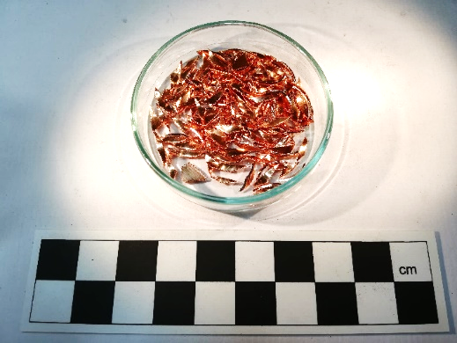
Fig.SI3.4. Cu bits used for cementation and co-melting experiments
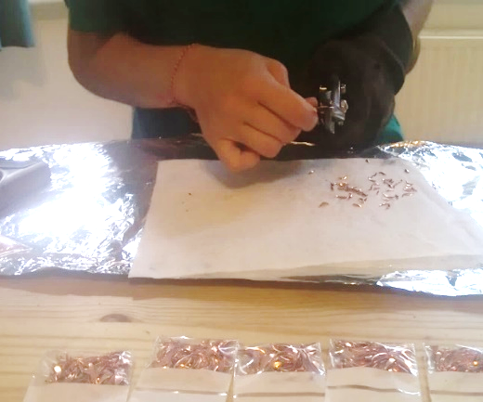
Fig.SI3.5. Set up used for cutting the Cu bits used for cementation and co-melting experiments
A small trapezoidal Sn ingot was used. pXRF analyses show a 97.06wt%Sn composition on average. Fe and Cu are major impurities (>1wt% for both elements), and Ti and Mn minor ones. Ni appears as a trace element (Table SI3.6). The ingot was cut in fragments of ~16g using a rotary diamond blade (Fig.SI3.6). Cutting time and losses were recorded (Table SI3.5).
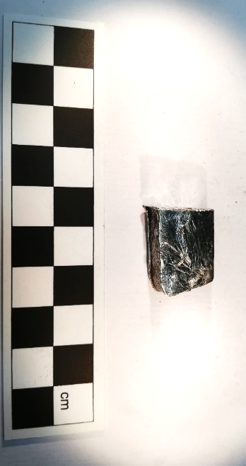
Fig.SI3.6. One of the Sn chunks used in co-melting operations
Table SI3.6. pXRF analyses of the Sn ingot
 | LE | Ti | Mn | Fe | Ni | Cu | Sn
#1 | <LOD | 0.19 | 0.07 | 1.28 | 0.03 | 2.17 | 96.26
#2 | <LOD | 0.40 | 0.13 | 1.27 | 0.01 | 1.88 | 96.30
#3 | <LOD | <LOD | <LOD | <LOD | 0.02 | 1.37 | 98.61
Average | 0.00 | 0.20 | 0.07 | 0.85 | 0.02 | 1.81 | 97.06
<LOD=below limits of detection.

3. Charcoal
Hard wood charcoal made by S. Timberlake was used. It came from a woodland at Carmarthen (South Wales). It is a steep sided wooded valley, very damp and mossy, of mostly tightly growing broadleaf trees: mostly hazel (Corylus Avellana), but also some rowan (Sorbus), ash (Fraxinus), and occasionally hawthorn (Crataegus). The trees were felled in autumn 2020, and the small, coppiced trees – with a maximum branch diameter of ~20cm – were cut into 0.3-0.4m long sections. These were stored in a woodpile in the open with a cap of tin or plastic on the top to keep them dry. They were stored for ~9-10 months. The moisture level in the wood dropped during the seasoning process to about a maximum of 15-20%.
The wood was made into charcoal in October 2020. A steel drum kiln with a conical lid and six chimneys was used to carbonise approximately 3m3 of wood over a 36h period. The carbonisation was about 80% efficient. The small amount of incomplete carbonised wood was not used for these experiments. The carbonised logs were broken up, bagged, and stored in a dry shed for about just under a year.
The raw charcoal chunks were prepared in three sizes: coarse (6-10cm), fine (2-4cm), and charcoal powder. Each was used differently: general heat, maintenance of the reducing atmosphere by covering gaps of the structure, and isolation of the crucible charge, respectively.
While charcoal making is very time-consuming, crushing it down into coarse and fine charcoal bits was quick and done at an ad hoc basis. It took 2mins and 4mins respectively to make a whole wheelbarrow of each of them. Making 80g of charcoal powder – the necessary amount for filling a crucible – took ~30mins.
Table SI3.7 records the fresh charcoal crushed during each day. This was not necessarily the way in which it was introduced in the metallurgical pit, nor the day in which it was used. A few kilograms of crushed charcoal remained untouched at the end of every working day. The charcoal invested in each operation was recorded in the individual recording sheets of each experiment (see Supplementary Information 4). The decrease in the number of buckets prepared per day shows the re-use of ashes from previous days.
Table SI3.7. Amount of fresh charcoal crushed down per day
 |  | Bucket of coarse fresh charcoal | ½ Bucket of fresh fine charcoal | Tray of fresh fine charcoal | Bag of fresh powder charcoal | Total per day
 |  | 3.6kg | 0.8kg | 0.9kg | 0.1kg | Total per day
Day 1 | Units | 5 | 1 | 2 | 3 | No. Operations: 4
Day 1 | Weight | 18.0kg | 0.8kg | 1.8kg | 0.3kg | 20.9kg
Day 2 | Units | 6 | 0 | 3 and 1/2 | 3 | No. Operations: 4
Day 2 | Weight | 21.6kg | 0kg. | 3.2kg | 0.3kg | 25.1kg
Day 3 | Units | 4 and 3/4 | 0 | 4 | 4 | No. Operations: 4
Day 3 | Weight | 17.1kg | 0kg | 3.6kg | 0.4kg | 21.1kg
Day 4 | Units | 4 and 3/4 | 2/4 | 1 and 1/2 | 0 | No. Operations: 4
Day 4 | Weight | 17.1kg | 0.4kg | 1.3kg | 0kg | 18.8kg
Day 5 | Units | 3 | 0 | 1 | 1 | No. Operations: 2
Day 5 | Weight | 10.8kg | 0kg | 0.9kg. | 0.1kg | 11.8kg
Total per unit |  | 84.6kg | 1.2kg | 10.8kg | 1.1kg | 97.7kg
pXRF analyses of the charcoal (average of different specimens) show K (>1wt%) as a major impurity. It is followed by Mg, Al, Si, P, Ca, and Mn as minor ones (Table SI3.8).
Table SI3.8. pXRF analyses on charcoal chunks
 | LE | Mg | Al | Si | P | S | K | Ca | Ti | V | Cr | Mn | Fe
#1 | 97.01 | 0.50 | <LOD | 0.62 | 0.16 | 0.01 | 0.92 | 0.53 | 0.03 | 0.00 | <LOD | 0.12 | 0.02
#2 | 97.73 | <LOD | <LOD | 0.08 | 0.23 | 0.09 | 1.00 | 0.49 | 0.01 | <LOD | <LOD | 0.24 | 0.02
#3 | 96.32 | 0.62 | <LOD | 0.16 | 0.45 | 0.01 | 1.48 | 0.66 | 0.03 | <LOD | <LOD | 0.11 | 0.07
#4 | 97.83 | <LOD | <LOD | 0.14 | 0.07 | <LOD | 1.38 | 0.34 | 0.03 | <LOD | <LOD | 0.08 | 0.03
#5 | 96.82 | 0.66 | <LOD | 0.05 | 0.48 | <LOD | 1.09 | 0.53 | <LOD | <LOD | <LOD | 0.25 | 0.02
#6 | 92.14 | 0.51 | 0.57 | 2.78 | 0.47 | 0.19 | 1.77 | 1.21 | 0.02 | <LOD | <LOD | 0.10 | 0.13
#7 | 96.51 | <LOD | <LOD | 1.24 | 0.12 | <LOD | 1.24 | 0.63 | 0.03 | <LOD | <LOD | 0.12 | 0.03
#8 | 92.72 | 1.02 | <LOD | 0.72 | 0.47 | 0.21 | 3.50 | 1.06 | 0.02 | <LOD | <LOD | 0.10 | 0.08
#9 | 95.97 | 0.61 | <LOD | 0.11 | 0.61 | 0.30 | 1.03 | 0.68 | 0.02 | <LOD | 0.01 | 0.53 | 0.05
#10 | 92.97 | 1.18 | <LOD | 1.75 | 0.58 | 0.13 | 1.46 | 1.38 | 0.04 | 0.00 | 0.01 | 0.16 | 0.18
Average | 95.60 | 0.51 | 0.06 | 0.76 | 0.36 | 0.09 | 1.49 | 0.75 | 0.02 | 0.00 | 0.00 | 0.18 | 0.06
<LOD=below limits of detection.
Table SI3.8 (cont.). pXRF analyses on charcoal chunks (continuation)
 | Cu | Sn | Sb | Ba | La | Ce | Pr | Nd | Th
#1 | 0.01 | <LOD | 0.00 | 0.00 | 0.01 | 0.01 | 0.01 | 0.03 | 0.01
#2 | 0.01 | <LOD | 0.00 | 0.00 | 0.01 | 0.01 | 0.02 | 0.02 | 0.01
#3 | 0.02 | 0.00 | 0.00 | 0.00 | 0.01 | 0.01 | 0.01 | 0.01 | 0.00
#4 | 0.01 | <LOD | 0.00 | 0.01 | 0.01 | 0.01 | 0.02 | 0.02 | 0.01
#5 | 0.01 | <LOD | 0.00 | 0.00 | 0.01 | 0.02 | 0.02 | 0.03 | 0.00
#6 | 0.01 | 0.01 | 0.01 | 0.01 | 0.01 | 0.01 | 0.02 | 0.01 | 0.00
#7 | 0.01 | 0.00 | 0.00 | 0.01 | 0.01 | 0.01 | 0.02 | 0.03 | 0.01
#8 | 0.01 | 0.00 | 0.00 | 0.01 | 0.01 | 0.01 | 0.02 | 0.03 | 0.00
#9 | 0.01 | 0.00 | 0.01 | 0.00 | 0.01 | 0.01 | 0.01 | 0.02 | 0.00
#10 | 0.04 | 0.01 | 0.01 | 0.01 | 0.01 | 0.02 | 0.02 | 0.02 | 0.01
Average | 0.01 | 0.00 | 0.00 | 0.01 | 0.01 | 0.01 | 0.02 | 0.02 | 0.01
<LOD=below limits of detection.

4. Crucibles
The composition of the crucibles used (Fig.SI3.7) was recorded by pXRF (Table SI3.9). pXRF results indicate a highly refractory material rich in Si and Al.
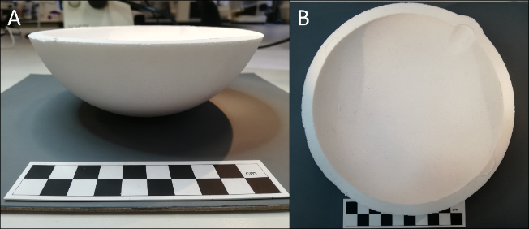
Fig.SI3.7. Open crucible. Profile (A) and top (B) views
Table SI3.9. pXRF analyses on open crucibles
 | LE | Al | Si | P | Ca | Ti | V | Cr | Mn | Fe
#1 | 66.30 | 0.18 | 33.21 | <LOD | 0.06 | 0.07 | <LOD | 0.01 | 0.01 | 0.02
#2 | 66.35 | 0.21 | 33.14 | 0.01 | 0.06 | 0.05 | <LOD | <LOD | 0.01 | 0.02
#3 | 68.51 | 1.25 | 29.85 | <LOD | 0.08 | 0.03 | <LOD | 0.05 | 0.01 | 0.03
#4 | 66.58 | 0.99 | 32.12 | <LOD | 0.08 | 0.04 | 0.01 | 0.01 | 0.01 | 0.02
Average | 66.93 | 0.66 | 32.08 | 0.00 | 0.07 | 0.05 | 0.00 | 0.02 | 0.01 | 0.02
<LOD=below limits of detection.
Table SI3.9 (cont.). pXRF analyses on open crucibles (continuation)
 | Sn | Sb | Ba | La | Ce | Pr | Nd
#1 | 0.01 | 0.01 | 0.01 | 0.02 | 0.02 | 0.02 | 0.03
#2 | 0.00 | 0.01 | 0.01 | 0.02 | 0.01 | 0.03 | 0.06
#3 | 0.00 | 0.01 | 0.01 | 0.03 | 0.03 | 0.04 | 0.06
#4 | 0.00 | 0.01 | 0.02 | 0.02 | 0.03 | 0.03 | 0.02
Average | 0.00 | 0.01 | 0.01 | 0.02 | 0.02 | 0.03 | 0.04
<LOD=below limits of detection.

5. Bellows
The valve-less single bag bellows used were manufactured from a single un-cured goatskin. The bellows were made by Brenda Craddock of the EMRG (Early Mines Research group). The bellows were triangular in shape (Fig. 3 in the main text) with an aperture at one end connected to a short wooden bellows pipe of about 30mm internal diameter inserted loosely into a clay tuyere pipe, entering (and thus blowing) a small earth furnace. The edges of the skin bag bellows were sown up using an awl and thread and then sealed with an animal-based glue. Wooden slat handles (for closing the bag opening during the downward thrust = air blast) were glued and sown on to the top edges of the bag opening. To use the bellows, the two end corners are first secured on the ground with the knees, allowing the maximum fill of air (c. 3-5 litres per blast). The use of this type of bellows can provide an air input of between 60-100 litres per minute – though the oscillatory (non-continuous) bowing cycle is most likely to translate into a micro-cycle of oxidation followed by reduction. These have proved to be very effective in the smelting of oxidised ores beneath a significant head of charcoal in pits.

