Debunking deterministic narratives of technological development through experimentation: a critical review of the prehistory of tin bronze alloying
Montes-Landa, J.; Timberlake, S.; Martinón-Torres, M.
Supplementary Information 4. Experiments recording sheets and detailed results.
Table SI4.1. People involved in the experiments.
Initials* | Operator
BPG | Bruna Pelegrín i Garcia
CT | Carmen Ting
EB | Ema Bauzyte
FJ | Friederike Jürcke
JML | Julia Montes-Landa
JV | Jasmine Vieri
MD | Mark Davis
MMT | Marcos Martinón-Torres
SA | Saltanat Amir
ST | Simon Timberlake
*These initials were used in the individual recording sheets below.
Table SI4.2. Schedule of experiments conducted.
Day 1 | Day 2 | Day 3 | Day 4 | Day 5
Cu smelting | EX-CEM-2(A) | EX-COS-3 | EX-CEM-4(B) | Sn smelting
EX-COM-1 | EX-COS-2 | EX-COM-2 | EX-CEM-4(B) | Sn smelting
Break
EX-CEM-1 | EX-CEM-2(B) | EX-COS-4
EX-COS-1 | EX-CEM-3 | EX-CEM-4(A)

1. Co-smelting experiments

1.1. Co-smelting 1
Experiment code | EX-COS-1
Technique | Co-smelting in an open crucible
Date | 20.Sep.2021 – Day 1
Operators | JML, ST, EB, BPG, MMT, MD, SA
Malachite | 150g
Cassiterite | 20g
Expected g of metal | 101.97g
Expected alloy | 84.55%Cu – 15.45%Sn
Preparation of charge in crucible | Cassiterite and malachite were mixed in advance. The bottom of the crucible was filled with a thin layer of charcoal powder. Over it, a layer of mixed malachite and cassiterite was introduced. This layer was covered by another fine layer of charcoal powder that again was covered by another layer of malachite and cassiterite. The mineral charge was separated in three layers. The last one was covered by a thick layer of charcoal powder to the top of the crucible.
Charcoal in crucible (powder) | 80g
Duration of the operation | 55mins
Minutes the crucible was in the furnace | 42mins
Other (weather, conditions, etc.) | Rainy weather
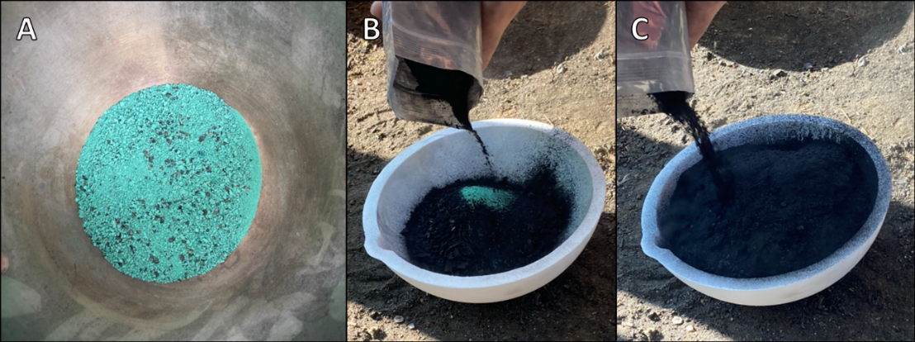
Fig.SI4.1. Charge set up for EX-COS-1. A) Malachite and cassiterite mixture. B) Covering of the first layer of charge with charcoal powder. C) Covering of the last layer of charge with charcoal powder.
TIME | EVENT | ºC | CHARCOAL |  | NOTES AND COMMENTS
TIME | EVENT | ºC | UNIT | COUNT | NOTES AND COMMENTS
15.50 | Preheating |  |  |  | The furnace was already fairly hot from previous operations.
15.57 | Temperature check | 1200 |  |  | Centre of the structure.
15.58 | Crucible in
 | Charcoal unit finished |  | Bucket | 1/2
16.07 | Temperature check | 1147
 | Charcoal unit finished |  | Bucket | 1/2 | Added more or less regularly.
16.16 | Temperature check | 1170
 | Charcoal unit finished |  | Tray | 1
16.27 | Temperature check | 1200
16.35 | Temperature check | 700 |  |  | Top of crucible crucible.
 |  | 1200 |  |  | Bottom of crucible.
16.35 | Increase the power on bellows
 | Charcoal unit finished |  | Bucket | 1/2
16.39 | Temperature check | 900 |  |  | Top of crucible.
16.40 | Stop bellowing
16.45 | Crucible taken out

Ingot
Weight | NA
Description | No ingot produced.
Other residues recovered when emptying the crucible
Weight | 93.2g
Description | Prills and masses of metal of different sizes were collected. The biggest one measures ~4x2cm. The smallest prills (<1mm diameter) were only seen using a desk mounted magnifier. Some prills are made of Cu, while others are yellow, indicating that they are made of bronze. There are also some Sn prills, but these are less abundant.
Residues attached to the crucible
Weight | 1.3g
Description | Sn prills ranging from 0.5cm down to <1mm diameter were observed. Some Cu-based prills were also visible, but in a considerable reduced proportion. Sn patches were attached to the surface of the crucible. Some of them were flattered down and scratched when trying to remove the metal from the crucible.
Metal recovered | 94.5g
Slag recovered | 0g
Charcoal outside crucible | ~6.3kg
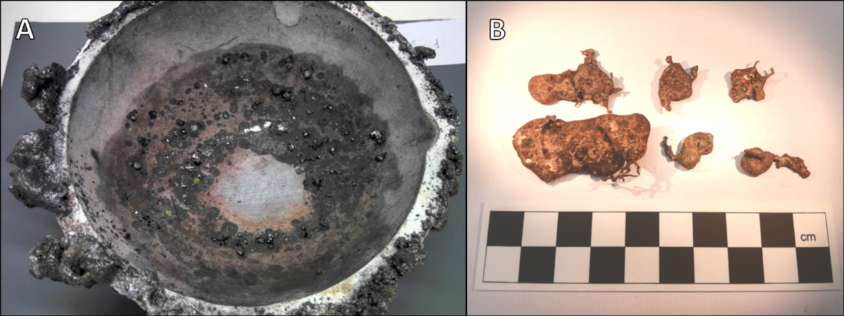
Fig.SI4.2. EX-COS-1. A) Residue attached to the crucible after the operation. B) Big chunks of metal recovered from the inside of the crucible.
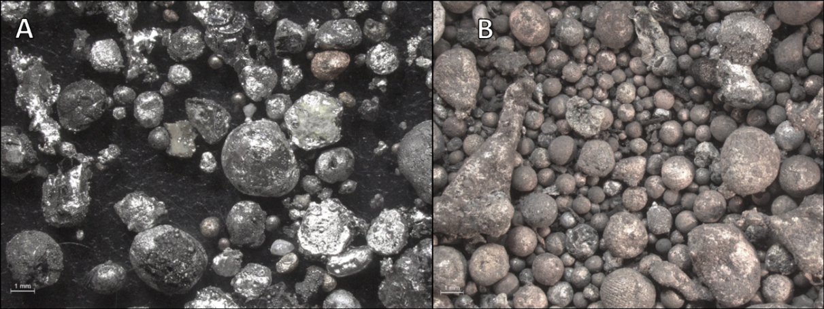
Fig.SI4.3. EX-COS-1. A) Residues attached to the crucible after their removal. B) Metallic prills recovered from the inside of the crucible (Scales=1mm).

1.2. Co-smelting 2
Experiment code | EX-COS-2
Technique | Co-smelting in an open crucible
Date | 21.Sept.2021 – Day 2
Operators | ST, SA, MD, BPG, JML
Malachite | 150g
Cassiterite | 20g
Expected g of metal | 101.97g
Expected alloy | 84.55%Cu – 15.45%Sn
Preparation of charge in crucible | As in EX-COS-1
Charcoal in crucible (powder) | 80g
Duration of the operation | 59mins
Minutes the crucible was in the furnace | 50mins
Other (weather, conditions, etc.) | NA

TIME | EVENT | ºC | CHARCOAL |  | NOTES AND COMMENTS
TIME | EVENT | ºC | UNIT | COUNT | NOTES AND COMMENTS
12.00 | Preheating |  | Bucket | 1/2 | The operation started using half old charcoal and half fresh one.
12.05 | Temperature check | 1100 |  |  | Centre of the structure.
12.09 | Crucible in
12.10 | Charcoal unit finished |  | Bucket | 3/4 | Part of the charcoal from previous experiments was reused. These ¾ are fresh.
12.14 | Temperature check | 600 |  |  | Top of crucible.
 |  | 1180 |  |  | Bottom of crucible.
12.24 | Temperature check | 650 |  |  | Top of crucible.
 |  | 856 |  |  | Bottom of crucible.
12.30 | Temperature check | 1130 |  |  | Bottom of crucible.
 |  | 900 |  |  | Top of crucible.
12.36 | Temperature check | 1070 |  |  | Top of crucible.
 |  | 1000 |  |  | Bottom of crucible.
 | Charcoal unit finished |  | Bucket | 1
12.42 | Charcoal unit finished |  | Tray | 1
12.45 | Temperature check | 1130 |  |  | Top of crucible.
 |  | 1150 |  |  | Bottom of crucible.
12.52 | Temperature check | 1030 |  |  | Top of crucible.
 |  | 1146 |  |  | Bottom of crucible.
12.53 | Increase the power on bellows
12.59 | Stop bellowing |  |  |  | The furnace seemed very hot compared to previous experiments.
xx | Charcoal unit finished |  | Bucket& tray | ½ of each | This is the charcoal used up until the end of the operation.

Ingot
Weight | 57.4g
Description | A spongy mass of metal resembling a half moon shape resulted. This might indicate that the operation was interrupted when the ingot was being formed or that a mass of metal was being oxidised due to unstable reducing conditions. The bottom of this ‘ingot’ is more compact, suggesting that all the metal had/was coalesced/-ing. The spongy mass has some yellow and pale pink areas that indicate that bronze was formed, while other areas are redder, and therefore richer in Cu.
Other residues recovered when emptying the crucible
Weight | 39.1g
Description | A few bronze (yellow) metallic chunks (~2x1cm) were recovered. The prills recovered range between 2 and <1mm diameter. The smallest ones were collected using a desk mounted magnifier. Most of the smallest prills are made of Cu (reddish) or bronze (yellowish), but there are some small Sn prills too.
Residues attached to the crucible
Weight | 1.0g
Description | Although the residues attached to the crucible resemble those of EX-COS-1, in this case there are less prills. The biggest ones are Cu-based, although there are some big Sn prills (~2mm diameter). There are also very tiny prills visible with a desk-based magnifier and these are of all types of compositions. Clusters of small Sn prills grouped around a darker substance were observed. These are cassiterite relics in the process of being smelted.
Metal recovered | 97.5g
Slag recovered | 0g
Charcoal outside crucible | ~11.2kg (+ some recycled charcoal from the pit nearby not recorded)
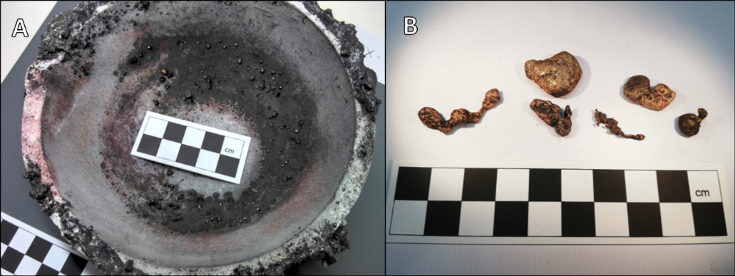
Fig.SI4.4. EX-COS-2. A) Residues attached to the crucible after the operation. B) Metallic masses recovered from the inside of the crucible.
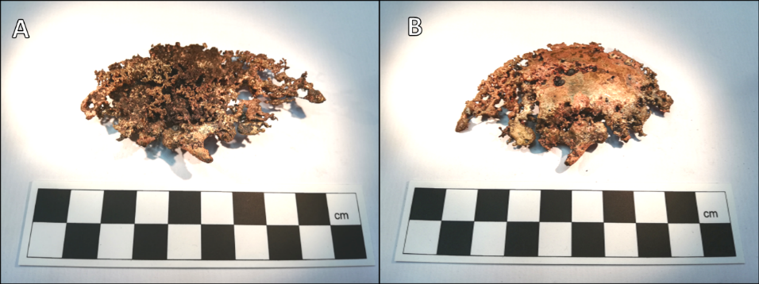
Fig.SI4.5. EX-COS-2 spongy ‘ingot’. A) Top surface. B) Bottom surface.
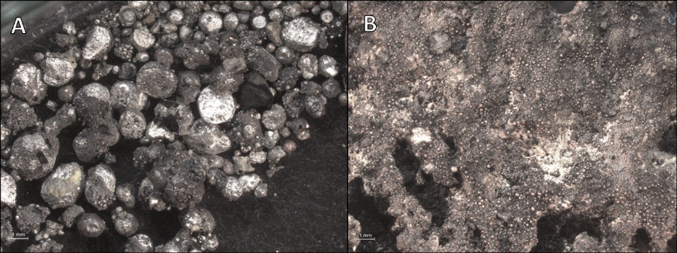
Fig.SI4.6. EX-COS-2. A) Residues recovered from the inside of the crucible. B) Surface of the spongy ‘ingot’ (Scales=1mm).

1.3. Co-smelting 3
Experiment code | EX-COS-3
Technique | Co-smelting in an open crucible
Date | 22.Sept.2021 – Day 3
Operators | MMT, ST, BPG, MD, JML
Malachite | 150g
Cassiterite | 20g
Expected g of metal | 101.97g
Expected alloy | 84.55%Cu – 15.45%Sn
Preparation of charge in crucible | Cassiterite and malachite were mixed in advance. The bottom of the crucible was filled with a thin layer of charcoal powder. The charge was then introduced all at once in a mountain shape. It was later covered with a thick layer of charcoal powder up to the top of the crucible.
Charcoal in crucible (powder) | 80g
Duration of the operation | 58mins
Minutes the crucible was in the furnace | 46mins
Other (weather, conditions, etc.) | The pit seemed dryer at the beginning of the day compared to the previous day. This is because this time the fire was not quenched before leaving the previous day. The metallurgical pit worked better this way.

TIME | EVENT | ºC | CHARCOAL |  | NOTES AND COMMENTS
TIME | EVENT | ºC | UNIT | COUNT | NOTES AND COMMENTS
10.31 | Preheating
 | Charcoal unit finished |  | Bucket | 1/2 | Preheating with fresh charcoal.
10.41 | Temperature check | 1076 |  |  | Centre of the structure.
10.43 | Crucible in
10.53 | Temperature check | 1200 |  |  | Top of crucible.
 |  | 1130 |  |  | Bottom of crucible.
10.56 | Charcoal unit finished |  | Tray | 1/2 | Some green flames were seen and immediately covered with charcoal.
11.07 | Temperature check | 1070 |  |  | Top of crucible.
 |  | 1076 |  |  | Bottom of crucible.
11.17 | Temperature check | 1120 |  |  | Top of crucible.
 |  | 1050 |  |  | Bottom of crucible.
 |  |  |  |  | A full pit of recycled charcoal was finished.
11.24 | Increase the power on bellows |  |  |  | Some green flames seen.
11.26 | Temperature check | 1115 |  |  | Top of crucible.
 |  | 1200 |  |  | Bottom of crucible.
11.29 | Stop bellowing
xx | Charcoal unit finished |  | Bucket | 1 | This is the charcoal used up until the end of the operation.
 |  |  | Tray | 1/4
xx |  |  |  |  | When removing the pipe from the tuyere, the bamboo was burnt.

Ingot
Weight | 91.6g
Description | This is the only ingot that remained attached to the inner surface of the crucible. Most parts of it are yellow or pale pink (bronze). However, there is a red area whose composition is probably richer in Cu. The bottom of the ingot shows some unreacted cassiterite fragments.
Other residues recovered when emptying the crucible
Weight | 3.0g
Description | Small bronze (yellow), Cu (red), and Sn prills were observed, including small clusters of Sn prills growing together on unreacted cassiterite fragments. The biggest metallic mass has ~6mm from side to side, while the smallest prill has a diameter of <1mm. The smallest prills were recovered using a desk mounted magnifier. A small fragment of unreacted Cu-ore was observed.
Residues attached to the crucible
Weight | 3.6g
Description | Nearby the reddish area of the ingot, Sn prills (between ~4mm and <1mm diameter) were attached to the surface of the crucible, and small clusters of Sn prills were grouped around unreacted relics of cassiterite. It seems like the process of Sn absorption by the ingot was interrupted half-way through before the mass absorbed all the Sn around it. There was also a small mass of Cu-based metal by the ingot, and some small Cu-based prills, but Sn prills were predominant. A slightly longer time might have helped to promote full absorption of Sn.
Metal recovered | 98.2g
Slag recovered | 0g
Charcoal outside crucible | ~6.5kg (+ some recycled charcoal from the pit nearby not recorded)
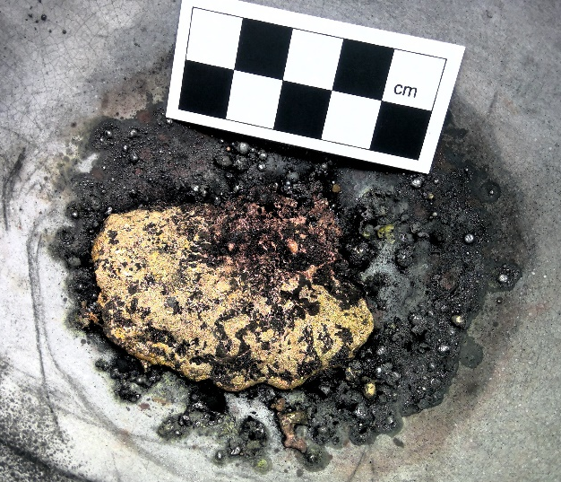
Fig.SI4.7. EX-COS-3. Bronze ingot and other residues attached to the crucible after the operation.
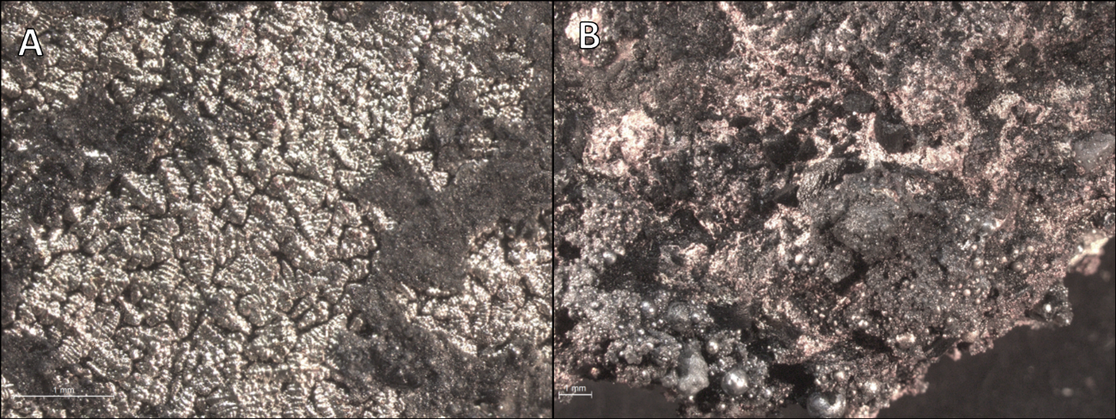
Fig.SI4.8. EX-COS-3. A) Surface of the yellow area of the ingot. B) Surface of the red area of the ingot. Note the clusters of Sn prills (Scales=1mm).
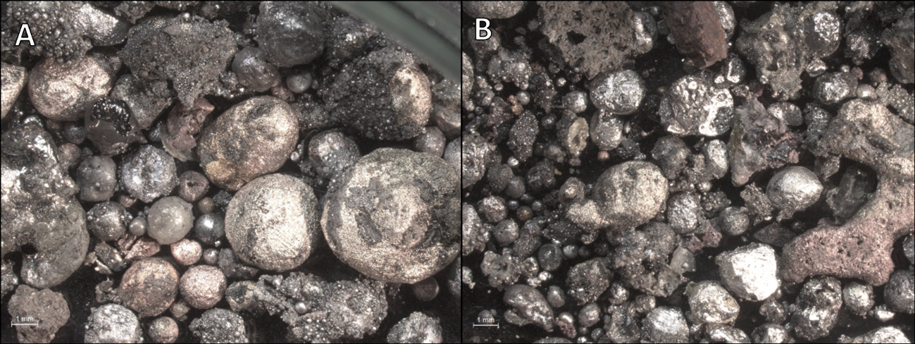
Fig.SI4.9. EX-COS-3. A) Residues attached to the crucible after their removal. B) Residues recovered from the inside of the crucible (Scales=1mm).

1.4. Co-smelting 4
Experiment code | EX-COS-4
Technique | Co-smelting in an open crucible
Date | 22.Sept.2021 – Day 3
Operators | ST, JML, BPG, MD, MMT, CT
Malachite | 150g
Cassiterite | 20g
Expected g of metal | 101.97g
Expected alloy | 84.55%Cu – 15.45%Sn
Preparation of charge in crucible | As in EX-COS-3
Charcoal in crucible (powder) | 80g
Duration of the operation | 58mins
Minutes the crucible was in the furnace | 50mins
Other (weather, conditions, etc.) | The bamboo pipe that had burnt during a previous operation was repaired using clay.

TIME | EVENT | ºC | CHARCOAL |  | NOTES AND COMMENTS
TIME | EVENT | ºC | UNIT | COUNT | NOTES AND COMMENTS
14.37 | Preheating |  |  |  | Bed of the furnace made of recycled charcoal. The rest on top was fresh charcoal.
 | Charcoal unit finished |  | Bucket | 1/2
14.41 | Temperature check | 1180 |  |  | Centre of the structure.
14.45 | Crucible in
14.51 | Temperature check | 1200 |  |  | Top of crucible.
 |  | 1090 |  |  | Bottom of crucible.
15.01 | Temperature check | 1215 |  |  | Top of crucible.
 |  | 1115 |  |  | Bottom of crucible.
15.10 | Charcoal unit finished |  | Bucket | 1
15.11 | Temperature check | 1300 |  |  | Top of crucible.
 |  | 1250 |  |  | Bottom of crucible.
15.21 | Temperature check | 1050 |  |  | Top of crucible.
15.27 | Increase the power on bellows
15.29 | Temperature probe melted down
15.33 | Temperature check | 1300 |  |  | Top of crucible.
 |  | 1270 |  |  | Bottom of crucible.
15.35 | Stop bellowing
xx | Charcoal unit finished |  | Tray | 1 | This is the charcoal used up until the end of the operation.

Ingot
Weight | 94.6g (includes some oxidised Cu that was originally metallic)
Description | A very spongy ‘ingot’ with the shape of a bit more than half of a circle resulted. This shape shows that at some point there was a metallic mass that started re-oxidising, so now a great part of it is not metallic but Cu oxide. The centre of it still shows a metallic core of yellowish colour (bronze), which had a ~1cm-wide Sn prill attached to it. In some of the surface areas of the ‘ingot’, the spongy structure has holes that originally contained some charcoal. Inside of them, it is possible to see that small Sn prills were growing together.
Other residues recovered when emptying the crucible
Weight | 2.0g
Description | A few Cu (red) and bronze (yellow) prills were recovered. These have up to 3mm diameter. Most of the residues recovered were small clusters of Sn prills growing together over another Sn prill or a cassiterite relic.
Residues attached to the crucible
Weight | 2.5g
Description | Most of the metallic residues preserved were located at the same area within the crucible. This is probably related to the direction of the air flow and/or with the way in which the crucible was emptied at the end of the operation. There are one Sn prill that has a diameter of ~0.5cm, and a few Cu-based and Sn prills with diameters of up to 3mm. There are also microscopic prills (<1mm diameter) only observable under magnifying lenses. Sn prills predominate. Clusters of small Sn prills grouped around cassiterite relics were also observed.
Metal recovered | 99.1g (includes oxides)
Slag recovered | 0g
Charcoal outside crucible | ~6.3kg (+ some recycled charcoal from the pit nearby not recorded)
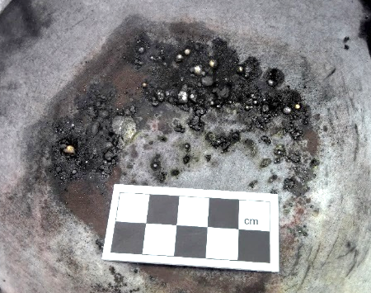
Fig.SI4.10. EX-COS-4. Residues attached to the crucible after the operation.
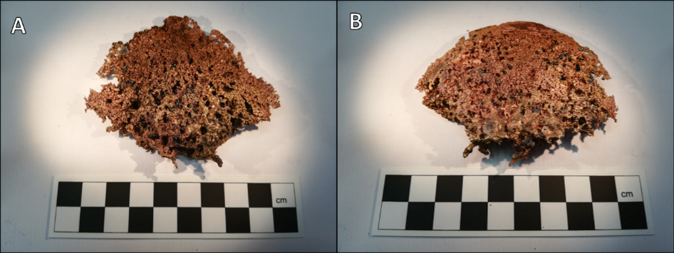
Fig.SI4.11. EX-COS-4 spongy ‘ingot’. A) Top surface. B) Bottom surface.
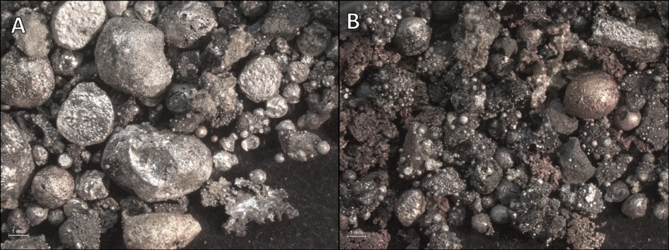
Fig.SI4.12. EX-COS-4. A) Residues attached to the crucible after their removal. B) Residues recovered from the inside of the crucible (Scales=1mm).

2. Cementation experiments

2.1. Cementation 1
Experiment code | EX-CEM-1
Technique | Cementation in an open crucible
Date | 20.Sep.2021 – Day 1
Operators | JML, ST, EB, BPG, MMT, MD, SA
Copper | 86.22g
Cassiterite | 20g
Expected g of metal | 101.97g
Expected alloy | 84.55%Cu – 15.45%Sn
Preparation of charge in crucible | Over a fine bed of charcoal powder, the Cu bits were allocated all together in the same layer. This layer was covered with a thick layer of charcoal powder to the top of the crucible. The cassiterite was to be added later during the operation once the Cu was molten.
Charcoal in crucible (powder) | 80g
Duration of the operation | 65mins
Minutes the crucible was in the furnace | 40mins
Minutes cassiterite was in the furnace | 19mins
Other (weather, conditions, etc.) | NA

TIME | EVENT | ºC | CHARCOAL |  | NOTES AND COMMENTS
TIME | EVENT | ºC | UNIT | COUNT | NOTES AND COMMENTS
14.39 | Preheating
 | Charcoal unit finished |  | Bucket | 1/3
15.01 | Temperature check | 1050
15.04 | Crucible in |  |  |  | Charcoal heaped on top.
15.07 | Temperature check | 1000 |  |  | Top of crucible.
 | Charcoal unit finished |  | Tray | 2/3
 | Charcoal unit finished |  | Bucket | 1/2
15.15 | Temperature check |  | 1000 |  | Top of crucible.
 |  |  | >1200 |  | Bottom of crucible.
15.20 |  |  |  |  | Strong blast.
15.25 | Cassiterite in |  |  |  | Hole poked into crucible with a green wood stick, but metallic Cu not visible. Cassiterite poured on charcoal bed.
15.30 | Temperature check | 1100 |  |  | Top of crucible.
 |  | 1300 |  |  | Bottom of crucible.
15.35 | Temperature check | 1000 |  |  | Top of crucible.
 |  | 1300 |  |  | Bottom of crucible.
15.40 | Temperature check | 1099 |  |  | Top of crucible.
 |  | 1300 |  |  | Bottom of crucible.
15.44 | Stop bellowing
15.47 | Crucible taken out
xx | Charcoal unit finished |  |  |  | This is the charcoal used up until the end of the operation.

Ingot
Weight | 60.5g
Description | One third of the resulting ingot is made of a compact mass of metal that in some areas is reddish (Cu), and in other areas is yellowish (bronze). The other two thirds of the ingot are fused metallic Cu bits that were not fully molten. Some of them have a yellow tint on their surface, indicating that some proper cementation occurred in the surface of these fragments.
Other residues recovered when emptying the crucible
Weight | 26.5g
Description | A big metallic fragment (~2x3cm) with yellow (bronze) and red (Cu) areas was recovered. Apart from that, small prills of Cu, bronze, and Sn were observed. The majority are Cu-based and, although there are some very tiny prills of ~1mm diameter, the presence of microscopic prills is less than for the co-smelting experiments. Most of the prills have ~3-4mm diameters. A fragment of charcoal with Sn prills growing on it was also recovered. Because of its peculiarity, the Sn prill was not removed so its weight was not accounted for. In any case, this would not radically change the results.
Residues attached to the crucible
Weight | NA
Description | No residues attached to the crucible.
Ingot + prills | 86.3g (ingot includes a big area of fused unreacted Cu bits)
Unreacted copper | 0.7g
Slag recovered | 0g
Charcoal outside crucible | ~5.4kg
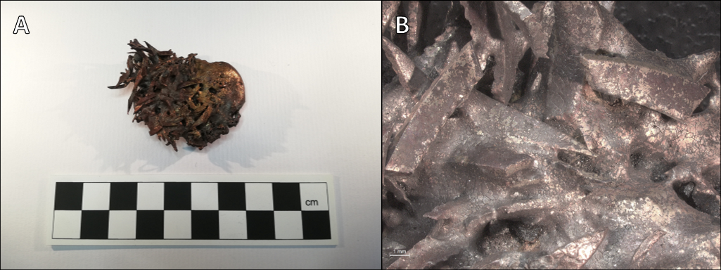
Fig.SI4.13. EX-CEM-1 ingot. A) General view. B) Surface of the ingot. Note the yellow tone of some of the partially molten Cu bits (Scale in B=1mm).
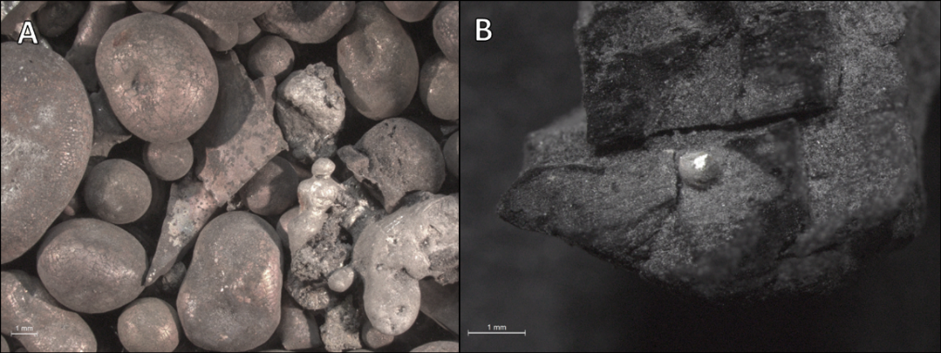
Fig.SI4.14. EX-CEM-1. A) Metallic residues recovered from the inside of the crucible. B) Charcoal fragment with a Sn prill attached to it (Scales=1mm).

2.2. Cementation 2
Experiment code | EX-CEM-2
Technique | Cementation in an open crucible and with a tile as lid
Date | 21.Sept.2021 – Day 2
Operators | ST, SA, MD, BPG, JML
Copper | 86.22g
Cassiterite | 20g
Expected g of metal | 101.97g
Expected alloy | 84.55%Cu – 15.45%Sn
Preparation of charge in crucible | The Cu bits and the cassiterite were mixed in advance. The charge was put inside of the crucible over a very thin layer of charcoal powder. It was later covered with a thick layer of charcoal powder to the top of the crucible.
Charcoal in crucible (powder) | 80g
Duration of the operation | 65mins
Minutes the crucible was in the furnace | 46mins
Minutes cassiterite was in the furnace | 46mins
Other (weather, conditions, etc.) | The pit and the charcoal were a bit wet from the previous day, as we had quenched the fire before leaving. This made the metallurgical pit difficult to preheat.

TIME | EVENT | ºC | CHARCOAL |  | NOTES AND COMMENTS
TIME | EVENT | ºC | UNIT | COUNT | NOTES AND COMMENTS
10.40 | Preheating |  |  |  | Re-use of charcoal waste from yesterday (in the nearby pit) + a bit of fresh charcoal.
 | Charcoal unit finished |  | Bucket | 1/4
10.57 | Temperature check | 1200 |  |  | Middle of structure.
10.59 | Crucible in
11.03 |  |  |  |  | A lot of smoke coming out, this is indicative of water evaporation.
11.07 | Temperature check | 500 |  |  | Top of lid.
 | Charcoal unit finished |  | Bucket | 1/2
11.17 | Temperature check | 1175 |  |  | Bottom of crucible.
11.19 |  |  |  |  | Ash charcoal from yesterday re-used to cover red flames; about 1/2 tray.
11.22 | Temperature check | 620 |  |  | Top of lid.
 |  | 900 |  |  | Bottom of crucible.
11.25 |  |  |  |  | Difficult to make the temperature rise >800ºC at bottom of crucible. Possibly because of use of wet charcoal at the bottom of the furnace.
11.31 | Temperature check | 600 |  |  | Top of lid.
 |  | 1190 |  |  | Bottom of crucible.
11.40 | Increase the power on bellows
11.43 | Temperature check | 1200 |  |  | Top of lid.
 |  | 1100 |  |  | Bottom of crucible.
11.45 | Stop bellowing
xx | Charcoal unit finished |  | Bucket & tray | ¼ of each | This is the charcoal used up until the end of the operation.
The product of this operation was remelted in EX-CEM-2(B) so further details of the end-product are summarised below. The charcoal used in EX-CEM-2 outside the crucible was ~3.8kg (+ some recycled charcoal from the pit nearby not recorded).
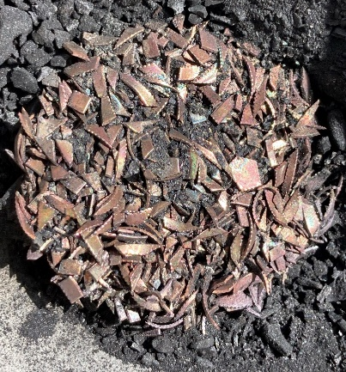
Fig.SI4.15. EX-CEM-2. Mass of semi-fused Cu bits with cassiterite fragments.

2.3. Cementation 2(B)
Experiment code | EX-CEM-2(B)
Technique | Cementation (remelting the product of EX-CEM-2) in the same open crucible
Date | 21.Sep-2021 – Day 2
Operators | ST, MMT, MD, JML, BPG, SA
Preparation of charge in crucible | The product of EX-CEM-2 was put back into the same crucible.
Charcoal in crucible (powder) | The same charcoal powder that was used in the crucible of EX-CEM-2 was re-used.
Duration of the operation | 38mins
Minutes the crucible was in the furnace | 31mins
Minutes cassiterite was in the furnace | NA
Other (weather, condiditions, etc.) | Before starting, the tuyere was cleaned and relocated a bit higher than before. Therefore, the bottom of the metallurgical pit was raised accordingly with a bed of recycled charcoal ashes. The bed of ashes was hammered to create a compressed solid layer.

TIME | EVENT | ºC | CHARCOAL |  | NOTES AND COMMENTS
TIME | EVENT | ºC | UNIT | COUNT | NOTES AND COMMENTS
14.39 | Preheating |  |  |  | Bed of charcoal with recycled charcoal, but rest of pit is full of fresh charcoal.
14.44 | Temperature check | 1200 |  |  | Centre of the structure.
14.46 | Crucible in
14.55 | Temperature check | 1006 |  |  | Top of crucible.
14.57 | Temperature check | 950 |  |  | Bottom of crucible.
14.58 | Charcoal unit finished |  | Bucket | 1
 |  |  | Tray | 1
14.07 | Temperature check | 1250 |  |  | Top of crucible.
 |  | 1125 |  |  | Bottom of crucible.
15.12 | Increase the power on bellows
15.13 | Temperature check | 1300 |  |  | Top of crucible.
 |  | 1200 |  |  | Bottom of crucible.
15.17 | Stop bellowing
xx | Charcoal unit finished |  | Bucket | 1/4 | This is the charcoal used up until the end of the operation.

Ingot
Weight | 90.6g
Description | A solid ingot, mostly yellow (bronze), resulted. In its upper surface, some green and blue shades are visible, and it is possible to see dendritic structures without magnifying lenses.
Other residues recovered when emptying the crucible
Weight | 3.7g
Description | Several metallic prills of Cu (red), bronze (yellow), and Sn were recovered. Cu-based ones are predominant. The majority have diameters of 3-4mm. There are not a lot of tiny ones compared to co-smelting experiments.
Residues attached to the crucible
Weight | 0.6g
Description | Several green patches can be seen at one side of the inner surface of the crucible. These probably represent former areas with metal attached to. At the opposite side of the inner surface, Sn residues predominate, and no Cu-based products are observed. Sn residues are mostly prills and metallic masses, but there are also dark grey residues that might be related to cassiterite. Although microscopic prills observed under magnifications can be seen, bigger prills than for co-smelting experiments predominate.
Ingot + prills | 94.9g
Unreacted copper | 0g
Slag recovered | 0g
Charcoal outside crucible | ~5.4kg (+ some recycled charcoal from the pit nearby not recorded)
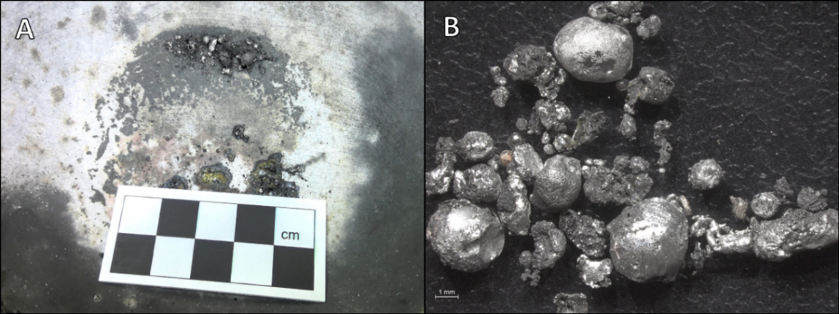
Fig.SI4.16. EX-CEM-2(B). A) Residues attached to the crucible at the end of the operation. B) Residues attached to the crucible after their removal (Scale in B=1mm).
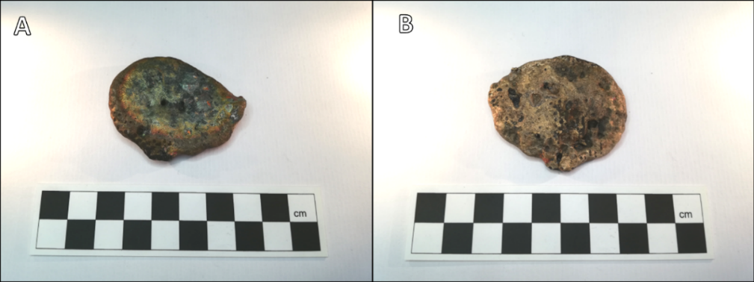
Fig.SI4.17. EX-CEM-2(B) ingot. A) Top surface. B). Bottom surface.
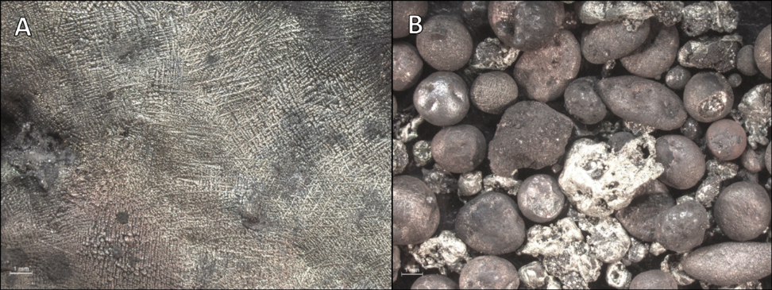
Fig.SI4.18. EX-CEM-2(B). A) Ingot Surface with dendritic structure. B) Metallic residues recovered from the inside of the crucible (Scales=1mm).

2.4. Cementation 3
Experiment code | EX-CEM-3
Technique | Cementation in an open crucible
Date | 21.Sep.2021 – Day 2
Operators | JML, BPG, SA, ST, MD
Copper | 86.22g
Cassiterite | 20g
Expected g of metal | 101.97g
Expected alloy | 84.55%Cu – 15.45%Sn
Preparation of charge in crucible | As in EX-CEM-2
Charcoal in crucible (powder) | 80g
Duration of the operation | 59mins
Minutes the crucible was in the furnace | 47mins
Minutes cassiterite was in the furnace | 47mins
Other (weather, conditions, etc.) | NA

TIME | EVENT | ºC | CHARCOAL |  | NOTES AND COMMENTS
TIME | EVENT | ºC | UNIT | COUNT | NOTES AND COMMENTS
15.38 | Preheating |  |  |  | The bed of charcoal is half recycled, half fresh charcoal.
 | Charcoal unit finished |  | Bucket | 1/2
15.44 | Temperature check | 840 |  |  | Centre of the structure.
15.49 | Temperature check | 1200 |  |  | Centre of the structure.
15.50 | Crucible in
15.58 | Temperature check | 1050 |  |  | Top of crucible.
 |  | 1030 |  |  | Bottom of crucible.
16.10 | Temperature check | 930 |  |  | Top of crucible.
 |  | 1200 |  |  | Bottom of crucible.
16.20 | Temperature check | 1200 |  |  | Top of crucible.
 |  | 1100 |  |  | Bottom of crucible.
16.30 | Temperature check | 1200 |  |  | Top of crucible.
 |  | 1100 |  |  | Bottom of crucible.
16.32 | Increase the power on bellows
16.37 | Stop bellowing
xx | Charcoal unit finished |  | Tray | 3/4 | This is the charcoal used up until the end of the operation.
 |  |  | Bucket | 2/4

Ingot
Weight | 95.7g
Description | An ingot, mostly yellow (bronze), resulted. In its surface it is possible to see dendritic structures without using magnifying lenses.
Other residues recovered when emptying the crucible
Weight | 0.6g
Description | A small amount of metallic prills were recovered; most of them were Sn ones. Some Cu (red) and bronze (yellow) prills can also be observed. They have between 1-3mm diameter approximately.
Residues attached to the crucible
Weight | 2.2g
Description | Most of the residues attached to this crucible are at the same area of its inner surface. A green patch around some of them indicates an area where Sn/cassiterite was originally present. A Sn prill of considerable size (~1cm diameter) was also recovered.  Clusters of small Sn prills were recognised. These were grouped around a darker substance of skeletal shape that can be related to cassiterite.  The big metallic prills recovered were surrounded by a dark layer that perhaps is Sn oxide. If this is so, then it shows that the maintenance of the reducing conditions within the crucible was unstable.  At the other side of the inner surface there was a small patch with Cu-based metallic residues of different sizes, but in general between 1-4mm diameter. This patch was surrounded by tiny (<1mm diameter) Sn prills that are observable under a magnifying glass.  A couple of semi-dissolved cassiterite relics were observed.
Ingot + prills | 98.5g
Unreacted copper | 0g
Slag recovered | 0g
Charcoal used | ~4.5kg (+ some recycled charcoal not recorded)
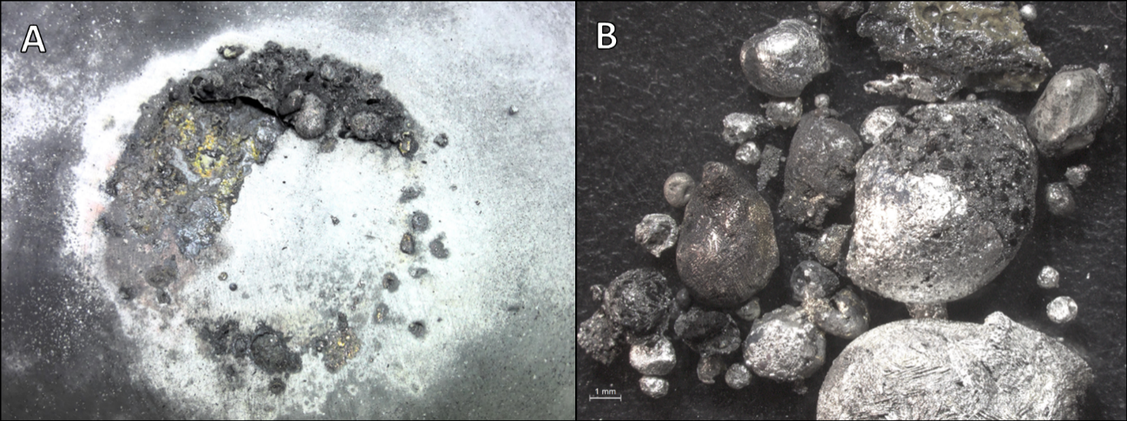
Fig.SI4.19. EX-CEM-3. A) Residues attached to the crucible at the end of the operation. B) Residues attached to the crucible after their removal (Scale in B=1mm).
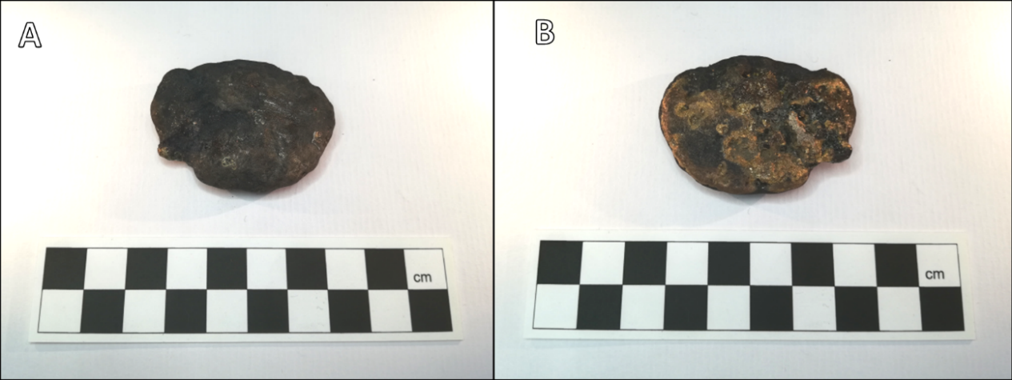
Fig.SI4.20. EX-CEM-3 ingot. A) Top surface. B) Bottom surface.
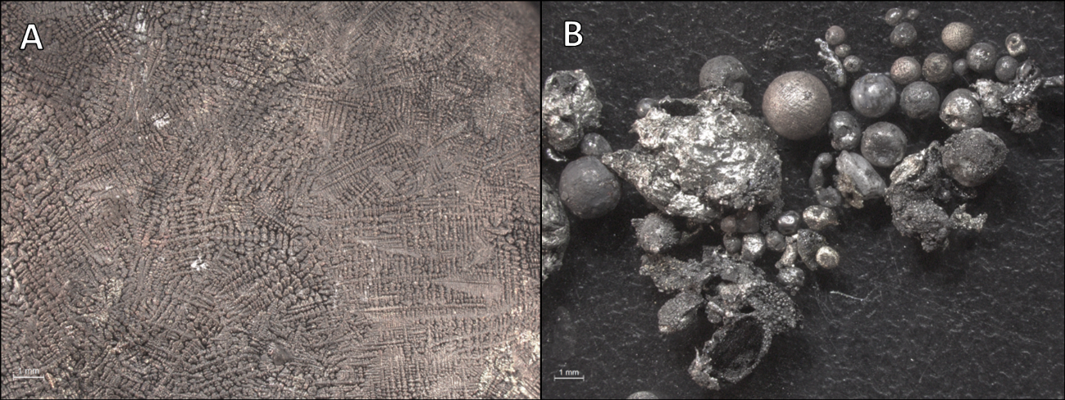
Fig.SI4.21. EX-CEM-3. A) Ingot surface with dendritic structure. B) Metallic residues recovered from the inside of the crucible (Scales=1mm).

2.5. Cementation 4
Experiment code | EX-CEM-4
Technique | Cementation in an open crucible
Date | 22.Sept.2021 – Day 3
Operators | MD, ST, CT, BPG, JML
Copper | 86.22g
Cassiterite | 20g
Expected g of metal | 101.97g
Expected alloy | 84.55%Cu – 15.45%Sn
Preparation of charge in crucible | As in EX-CEM-2
Charcoal in crucible (powder) | 80g
Duration of the operation | 57mins
Minutes the crucible was in the furnace | 48mins
Minutes cassiterite was in the furnace | 48mins
Other (weather, conditios, etc.) | NA

TIME | EVENT | ºC | CHARCOAL |  | NOTES AND COMMENTS
TIME | EVENT | ºC | UNIT | COUNT | NOTES AND COMMENTS
16.29 | Preheating |  |  |  | The bed of the furnace was made of recycled charcoal. The rest was fresh charcoal.
 | Charcoal unit finished |  | Bucket | 1/2
16.35 | Temperature check | 1300 |  |  | Centre of the structure.
16.38 | Crucible in
16.47 | Temperature check | 1300 |  |  | Top of crucible.
 |  | 1030 |  |  | Bottom of crucible.
 |  |  |  |  | The temperature is probably low because the bed of recycled charcoal has less calorific power. It is necessary to put more fresh charcoal below for next time.
17.00 | Temperature check | 1200 |  |  | Top of crucible.
 |  | 1106 |  |  | Bottom of crucible.
17.08 | Temperature check | 1300 |  |  | Top of crucible.
 |  | 1175 |  |  | Bottom of crucible.
17.18 | Temperature check | 1215 |  |  | Top of crucible.
 |  | 1230 |  |  | Bottom of crucible.
17.19 | Increase the power on bellows
17.26 | Stop bellowing
xx | Charcoal unit finished |  | Tray | 3/4 | This is the charcoal used up until the end of the operation.
 |  |  | Bucket | 1/4
 |  |  |  |  | Perhaps the level of the crucible was too low in relation to the tuyere, and this has prevented melting the Cu. It is necessary to raise the level of the bed of charcoal in the next operation.
The product of this operation was remelted in EX-CEM-4(B), so further details of the end-product are summarised below. The charcoal used in EX-CEM-4 outside the crucible was ~3.4kg (+ some recycled charcoal from the pit nearby not recorded).

2.6. Cementation 4(B)
Experiment code | EX-CEM-4(B)
Technique | Cementation (remelting the product of EX-CEM-4) in the same open crucible
Date | 23.Sept.2021 – Day 4
Operators | JML, ST, BPG, JV
Preparation of charge in crucible | The product of EX-CEM-4 was put back into the same crucible and covered with charcoal powder.
Charcoal in crucible (powder) | The same charcoal powder that was in the crucible used in EX-CEM-4 was re-used.
Duration of the operation | 63mins
Minutes the crucible was in the furnace | 48mins
Minutes cassiterite was in the furnace | Not applicable.
Other (weather, conditions, etc.) | Some bits of the tuyere that were damaged the day before were repaired with clay. The level of the crucible was raised with ashes. The top part of the bed of ashes was made of fresh charcoal to increase calorific power. The crucible was located at the top of them, so the crucible bottom was in front of the tuyere.

TIME | EVENT | ºC | CHARCOAL |  | NOTES AND COMMENTS
TIME | EVENT | ºC | UNIT | COUNT | NOTES AND COMMENTS
10.30 | Preheating
 | Charcoal unit finished |  | Bucket | 1/2
10.39 | Temperature check | 500 |  |  | Centre of structure.
10.43 | Temperature check | 1145 |  |  | Centre of structure.
10.45 | Crucible in
10.53 | Temperature check | 1260 |  |  | Top of crucible.
 |  | 1108 |  |  | Bottom of crucible.
 | Charcoal unit finished |  | Tray | 1/2
11.03 | Temperature check | 1215 |  |  | Top of crucible.
 |  | 1075 |  |  | Bottom of crucible.
11.12 | Charcoal unit finished |  | Tray | 1
 |  |  | Bucket | 1
11.13 | Temperature check | 1300 |  |  | Top of crucible.
 |  | 1200 |  |  | Bottom of crucible.
11.23 | Temperature check | 1300 |  |  | Top of crucible
 |  | 1300 |  |  | Bottom of crucible
11.26 | Increase the power on bellows
11.29 | Temperature check | 1230 |  |  | Top of crucible
 |  | 1300 |  |  | Bottom of crucible
11.33 | Stop bellowing |  |  |  | On removal of the crucible from the furnace, the content fell to the ground. We recovered the Cu-based fragments from it. It was clearly a melted mass of Cu that broke down into different metallic spillages.

Ingot
Weight | NA
Description | No ingot was formed but see the description below.
Other residues recovered when emptying the crucible
Weight | 94.6g
Description | Some of the big metallic masses of bronze (yellow) recovered were probably originally forming an ingot. Because the crucible fell when removing it from the fire, the liquid charge took the shape it had when solidifying in the air. It is possible to see the shape of the drop. Therefore, although only masses of metal and prills are reported, probably an ingot was formed. The biggest drops are ~4x2cm and ~2x1cm. The rest are big and small prills with a diameter of 1.5-1mm. These prills are mostly made of Cu (red) and bronze (yellow), although some minor metallic Sn prills were also observed. In general, the prills are bigger than for co-smelting operations.  A couple of fragments of semi-dissolved cassiterite were recovered.
Residues attached to the crucible
Weight | 0.1g
Description | In this crucible there was a patch of dark grey residue similar to the one described for EX-CEM-3. It was of skeletal shape and probably related to cassiterite. Over this type of residue there were numerous Sn prills with diameters of 3-<1mm. The latter were only observable under a magnifying glass. There were no apparent Cu-based products attached to this crucible.
Ingot + prills | 94.7g
Unreacted copper | 0g.
Slag recovered | 0g.
Charcoal used | ~6.7kg (+ some recycled charcoal not recorded)
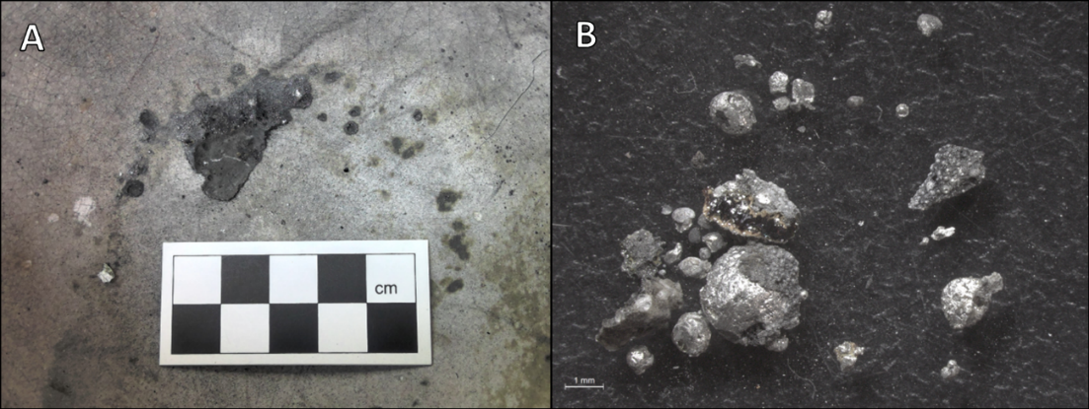
Fig.SI4.22. EX-CEM-4(B). A) Residues attached to the crucible after the operation. B) Residues attached to the crucible after their removal (Scale in B=1mm).
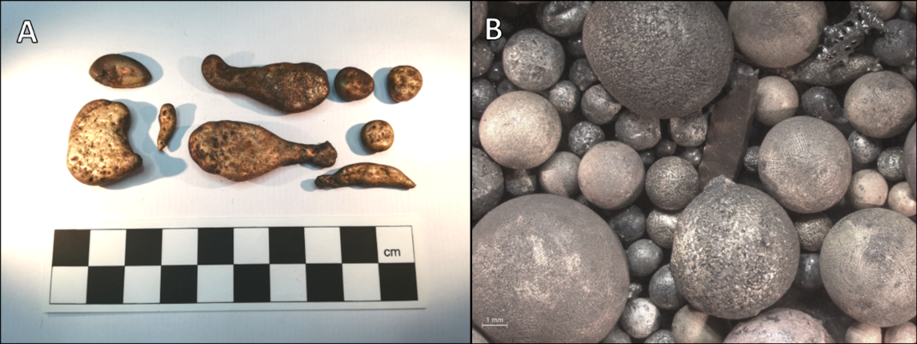
Fig.SI4.23. EX-CEM-4(B). A) Metallic masses in the shape of spillages. B) Metallic residues recovered from the ground but originally located inside of the crucible (Scale in B=1mm).

3. Co-melting experiments

3.1. Co-melting 1
Experiment code | EX-COM-1
Technique | Co-melting in an open crucible with a tile as lid
Date | 20.Sept.2021 – Day 1
Operators | JML, EB, SA, MD, BPG, MMT, ST
Copper | 86.22g
Tin | 15.75g
Expected g of metal | 101.97g
Expected alloy | 84.55%Cu – 15.45%Sn
Preparation of charge in crucible | The bottom of the crucible had a thin bed of charcoal powder. The Cu bits and the Sn chunks were layered on its top. The charge was then covered with charcoal powder to the top of the crucible.
Charcoal in crucible (powder) | 80g
Duration of the operation | 47mins
Minutes the crucible was in the furnace | 28mins
Other (weather, conditions, etc.) | NA
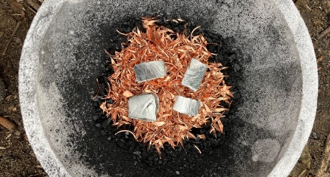
Fig.SI4.24. EX-COM-1. Set up of the charge inside of the crucible.
TIME | EVENT |  | ºC | CHARCOAL |  | NOTES AND COMMENTS
TIME |  |  | ºC | UNIT | COUNT | NOTES AND COMMENTS
12.42 | Preheating
 | Charcoal unit finished |  |  | Bucket | 1/4
12.50 | Temperature check |  | 800 |  |  | Middle of the structure.  Charcoal added regularly in small handfuls.
12.52 | Temperature check |  | 880 |  |  | Centre of the structure.
12.57 | Temperature check |  | 1040 |  |  | Centre of the structure.
13.01 | Crucible in |  |  |  |  | Tuyere at lid hight then charcoal piled on top.
13.08 | Temperature check |  | 1150 |  |  | Bottom of crucible.
 |  |  | 750 |  |  | Top of lid.
13.09 | Charcoal unit finished |  |  | Bucket | 1 | In addition to the initial ¼ previously reported.
13.10 | Charcoal unit finished |  |  | Tray | 1/3
13.13 | Temperature check |  | 930 |  |  | Top of lid.
13.18 | Temperature check |  | 1040 |  |  | Side of crucible.
13.23 | Charcoal unit finished |  |  | Bucket | 1/8
13.23 | Increase the power on bellows
13.28 | Temperature check |  | +1200 |  |  | Visibly hot throughout.
13.29 | Stop bellowing
13.35 | Crucible taken out |  |  |  |  | Lid melted but everything held together.
Ingot
Weight |  | 96.7g
Description |  | A solid yellow mass (bronze) with some unreacted Cu bits attached to its surface resulted. The surface shows dendritic structures without using magnifying lenses.
Other residues recovered when emptying the crucible
Weight |  | 4.6g
Description |  | Most of the residues recovered were unreacted Cu bits. Some of them were fused to the top of the ingot when first observed, but they detached as it was moved inside of the plastic bag. These Cu bits in some instances are partially molten, and sometimes a few of them are fused together. In some occasions they are yellow, indicating that they absorbed some Sn. Only a couple of Cu-based prills were recovered; they have a 2mm diameter.
Residues attached to the crucible
Weight |  | NA
Description |  | No residues attached to the crucible.
Ingot + prills |  | 97.0g (the ingot has a few unreacted bits of Cu fused to it)
Unreacted copper |  | 4.3g (including the bits that turned yellow)
Slag recovered |  | 0g
Charcoal outside crucible |  | ~5.2kg
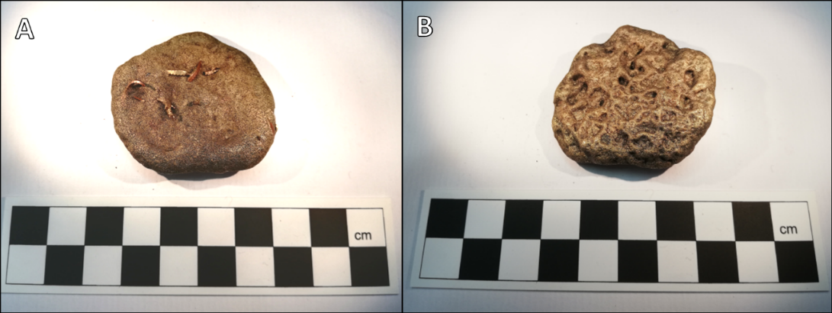
Fig.SI4.25. EX-COM-1 ingot. A) Top Surface. B) Bottom surface.
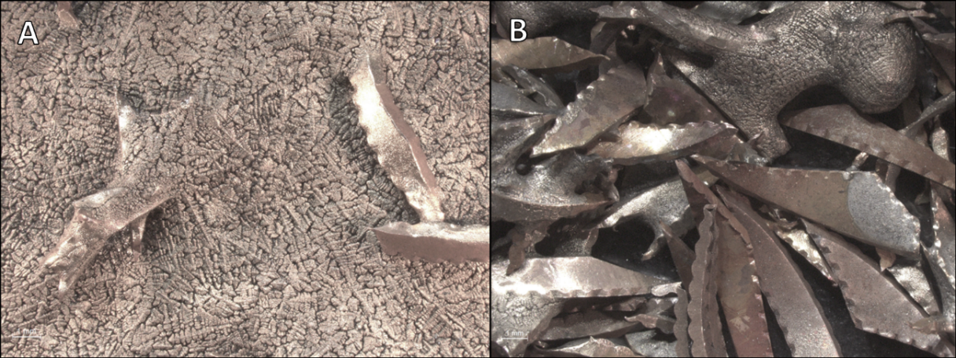
Fig.SI4.26. EX-COM-1. A) Ingot surface with dendritic structure. B) Unreacted Cu bits recovered from the inside of the crucible (Scales=1mm).

3.2. Co-melting 2
Experiment code | EX-COM-2
Technique | Co-melting in an open crucible
Date | 22.Sept.2021 – Day 3
Operators | MMT, ST, BPG, MD, JML, CT
Copper | 94.53g
Tin | 17.23g
Expected g of metal | 111.8g
Expected alloy | 84.55%Cu – 15.45%Sn
Preparation of charge in crucible | As in EX-COM-1
Charcoal in crucible (powder) | 80g
Duration of the operation | 58mins
Minutes the crucible was in the furnace | 48mins
Other (weather, conditions, etc.) | In the previous operation, the bellows pipe made of bamboo was burnt. It was amended with clay at the beginning of this experiment.

TIME | EVENT | ºC | CHARCOAL |  | NOTES AND COMMENTS
TIME | EVENT | ºC | UNIT | COUNT | NOTES AND COMMENTS
11.58 | Preheating |  |  |  | The bed of the furnace was made of recycled ashes. Over it there was fresh charcoal.
 | Charcoal unit finished |  | Bucket | 1/2
12.04 | Temperature check | 1230 |  |  | Centre of the structure.
12.08 | Crucible in
12.14 | Temperature check | 1070 |  |  | Top of crucible.
 |  | 970 |  |  | Bottom of crucible.
 |  |  |  |  | Another bucket of recycled charcoal to top the furnace when needed was used.
12.27 | Temperature check | 1150 |  |  | Top of crucible.
 |  | 1145 |  |  | Bottom of crucible.
12.40 | Charcoal unit finished |  | Tray | 1
12.48 | Increase the power on bellows
12.49 | Temperature check | 930 |  |  | Top of crucible.
 |  | 1300 |  |  | Bottom of crucible.
12.56 | Stop bellowing |  |  |  | A bit inconsistent bellowing in the last 7mins. Last 4mins were ok.
xx | Charcoal unit finished |  | Tray | 1/2 | This is the charcoal used up until the end of the operation.
 |  |  | Bucket | 2/4

Ingot
Weight | 108.7g
Description | A solid mass of yellow metal (bronze) resulted. On its surface and at one of its sides, unreacted fragments of Cu bits are fused to it. Dendritic structures can be seen on its surface without using magnifying lenses.
Other residues recovered when emptying the crucible
Weight | 2.3g
Description | Some unreacted Cu bits were recovered. Some of them are fused together but preserve their original shape. On a few occasions the Cu bits have turned yellow, indicating that they absorbed some Sn. Only four Cu-based prills were recovered, with diameters of 3-5mm.
Residues attached to the crucible
Weight | NA
Description | No residues attached to the crucible.
Ingot + prills | 109.4g (the ingot has some unreacted bits of Cu fused to it)
Unreacted copper | 1.6g
Slag recovered | 0g
Charcoal outside crucible | ~4.9kg (+ some recycled charcoal from the pit nearby not recorded)
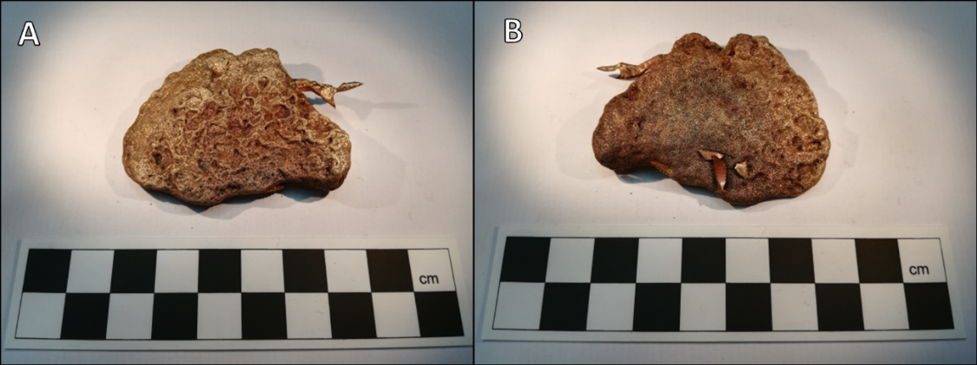
Fig.SI4.27. EX-COM-2 ingot. A) Top surface. B) Bottom surface.
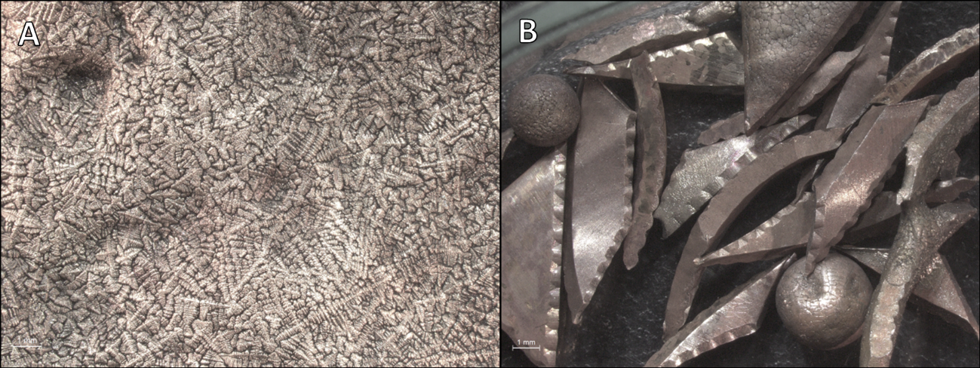
Fig.SI4.28. EX-COM-2. A) Ingot surface with dendritic structure. B) Unreacted Cu bits recovered from the inside of the crucible (Scale=1mm).

4. Cu smelting
Experiment code | COPPER SMELTING
Technique | Smelting in an open pit with no crucible
Date | 20.Sept.2021 – Day 1
Operators | JML, ST, EB, BPG, MMT, MD, SA
Malachite | 150g
Expected g of metal | 86.22g
Expected alloy | 100%Cu
Preparation of charge | Malachite was crushed down into 1.5cm chunks.
Durantion of the operation | 45mins
Minutes the charge was in the furnace | 25mins
Other (weather, conditions, etc.) | This operation aimed to test the shape of the metallurgical pit and the equipment, and to bake the earth around so the pit would hold better during later experiments. It was also used to develop an efficient way of taking notes during the experiments.

TIME | EVENT | ºC | CHARCOAL |  | NOTES AND COMMENTS
TIME | EVENT | ºC | UNIT | COUNT | NOTES AND COMMENTS
11.20 | Start of the operation
11.40 | Open of the furnace
 | Addition of malachite
11.47 | Temperature check | 970 |  |  | Centre of the structure.
11.55 | Start adding fine charcoal
 | Temperature check | 1030 |  |  | Centre of the structure.
12.01 | Stop bellowing
 | Temperature check | 900 |  |  | Centre of the structure.
12.05 | Opening of the structure |  |  |  | This implies recovery of Cu.
xx | Charcoal unit finished |  | Bucket | 3/4 | This is all the charcoal used up until the end of the operation. For the next experiments, recording should be more exhaustive regarding time of addition.
 |  |  | Bucket | ½ fine

Ingot
Weight | NA
Description | No ingot was produced.
Other residues recovered when emptying the pit
Weight | 77.1g (includes not fully metallic parts)
Description | Big chunks of metallic Cu were recovered. These are a few centimetres long and resemble the shape of native Cu. Some of these chunks show a frozen moment half-way through malachite smelting, as it is possible to still see altered bits of mineral attached to metallic areas. A fragment of charcoal with some tiny Cu prills attached to it was recovered.
Metal recovered | 77.1g (includes oxides)
Slag recovered | 0g.
Charcoal used | ~2.8kg
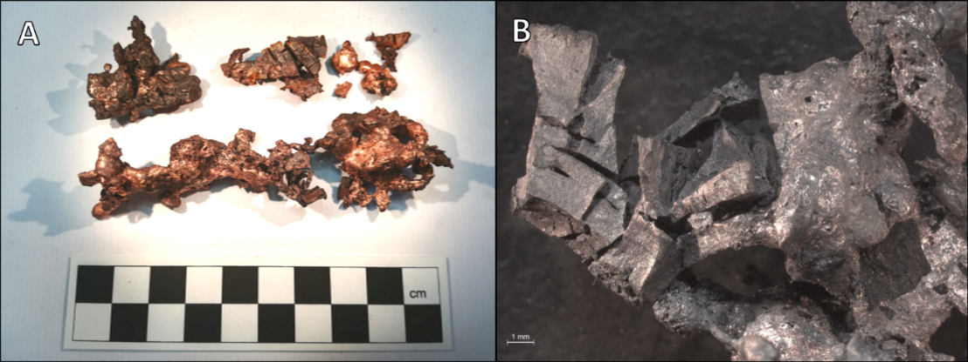
Fig.SI4.29. A) Bits of metallic Cu produced after the smelting operation. Note the altered mineral attached. B) Detail of altered mineral attached to metallic Cu (Scale=1mm).
Comment on the Cu smelting operation: This was the first operation of the week. Its aim was to test the metallurgical pit and to burnt out small roots growing at the bottom of the pit. It also made the earth more compact, and reduced humidity. For this reason, no crucible was used. We therefore were not very interested in fully recovering all the mineral put into it and that is why it only run for 25mins. A slightly longer time would have probably facilitated smelting of the malachite relics recovered. The malachite was crushed in bigger chunks than for the co-smelting operations to facilitate formation of big Cu chunks easy to recovered. No slag was produced, as this was a very pure ore.

5. Sn smelting
Experiment code | TIN SMELTING
Technique | Smelting in an open crucible
Date | 24.Sept.2021 – Day 5
Operators | ST, JML, BPG, MD, EB
Cassiterite | 129.5g
Expected g of metal | 102g
Expected alloy | 100%Sn
Preparation of charge in crucible | Cassiterite was introduced over a thick layer of charcoal powder into the crucible. The mineral was then covered by another thick layer of charcoal powder up to the top of the crucible.
Charcoal in crucible (powder) | 80g
Duration of the operation | 55mins
Minutes the crucible was in the furnace | 46mins
Other (weather, conditions, etc.) | The tuyere used in previous experiments broke down completely, so it was replaced with a new one. This introduced some minor changes to the structure of the metallurgical pit to adjust the height of the tuyere and crucible.

TIME | EVENT | ºC | CHARCOAL |  | NOTES AND COMMENTS
TIME | EVENT | ºC | UNIT | COUNT | NOTES AND COMMENTS
11.04 | Preheating |  |  |  | We used fresh charcoal to fill up the pit.
11.11 | Temperature check | 1120 |  |  | Centre of the structure.
11.13 | Crucible in
11.21 | Temperature check | 753 |  |  | Top of crucible.
 |  | 1000 |  |  | Bottom of crucible.
11.31 | Temperature check | 1200 |  |  | Top of crucible.
 |  | 1100 |  |  | Bottom of crucible.
11.37 | Charcoal unit finished |  | Tray | 1
11.45 | Temperature checks | 870 |  |  | Top of crucible.
 |  | 1100 |  |  | Bottom of crucible.
11.54 | Temperature check | 850 |  |  | Top of crucible.
11.56 | Temperature check | 1100 |  |  | Top of crucible.
 |  | 1210 |  |  | Bottom of crucible.
11.59 | Stop bellowing
xx | Charcoal unit finished |  | Bucket | 1 | This is the charcoal used up until the end of the operation.
 |  |  |  |  | Recycled charcoal from previous operations was also re-used.

Ingot
Weight | NA
Description | No ingot was produced.
Other residues recovered when emptying the crucible
Weight | 3.9g (Sn); 26.15g (loose semi-reacted cassiterite); 52.05g (chunks of cassiterite + prills)
Description | A few Sn prills were recovered (~1-5mm diameter). Sn was also produced in more elongated shapes that reminds to dry moss. These are only a few millimetres long. One of these structures was attached to a bigger prill, forming a spongy lump of a couple of centimetres.  Apart from this, numerous fragments of altered cassiterite have been recovered; most of them have greenish shades. Some of them have some metallic prills or clusters of small Sn prills attached to them  Finally, some chunks of semi-reacted cassiterite were found. These are made of attached fragments of partially reacted mineral with metallic prills emerging from some of them. These chunks were not broken down to recover the metallic Sn.
Residues attached to crucible
Weight | 9.0g
Description | The residues followed the shape of a circle, although it lacked a couple of centimetres to be a closed shape. Most of the residues are a spongy dark grey mass, like the one described above for cementation operations. It might be Sn oxide, or it might be related to the charcoal. In this mass, there were small fragments of charcoal and numerous Sn prills and metallic masses. It is possible to observe a green shade at the base of this dark grey patch. The metallic prills observed range from a few millimetres diameter to only being visible under a magnifying glass.
Metal recovered | 12.9g (+ some metal not accounted for in the chunks of cassiterite)
Cassiterite recovered | 78.2g (includes some metal attached to unreacted grains)
Slag recovered | 0g
Charcoal outside crucible | ~4.5kg (+ some recycled charcoal from the pit nearby not recorded)
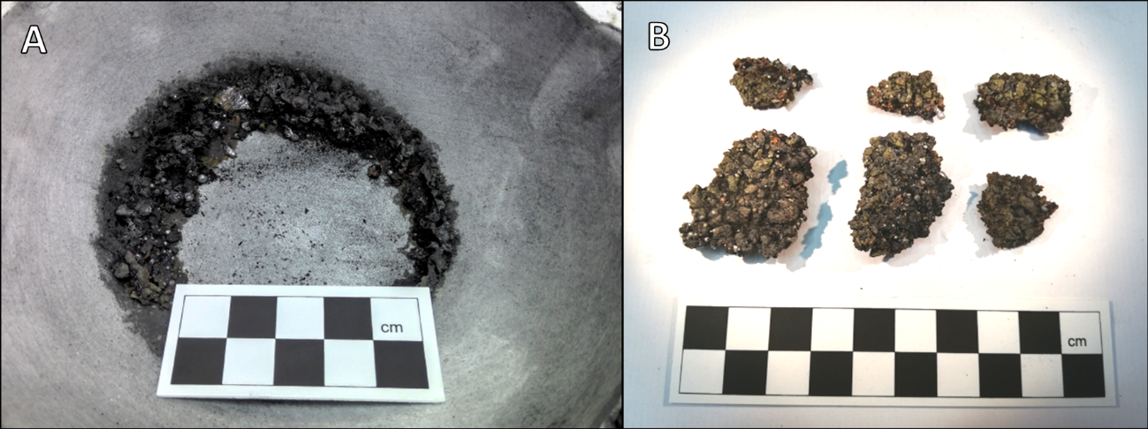
Fig.SI4.30. A) Residue attached to the crucible after the Sn smelting operation. B) Chunks of semi-reacted cassiterite with some metallic prills resulting from the failed Sn smelting operation.
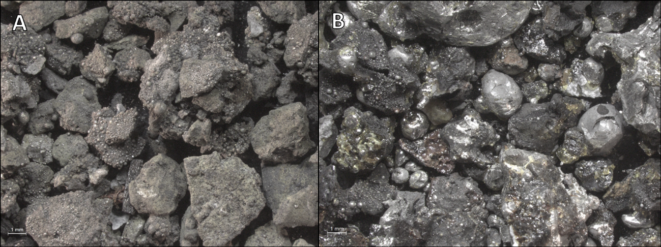
Fig.SI4.31. A) Non-metallic residue recovered from the inside of the crucible after the failed Sn smelting operation. B) Residues attached to the crucible after their removal (Scales=1mm).
Comment on the Sn smelting operation: The aim of this operation was for the team to have a preliminary understanding on how easy it was to smelt Sn compared to alloying it with Cu. We used the same setting and crucible as for other alloying experiments. However, most of the resulting products were partially reacted fragments of cassiterite. Formation of metallic Sn in some cases occurred. This combination of metallic and mineral Sn suggests that there was a problem with the maintenance of the reducing atmosphere within the crucible during this operation, as the temperature checks conducted show that we had acquired the needed temperature range. We also had this issue with some alloying operations.

