SI Material 2. Results: dental calculus microfossil analysis
The found microfossils are categorised by kingdoms of life, non-living nature and problematic debris. Identification of debris relies on publications (see e.g., Chantran and Cagnato 2021; MacKenzie et al. 2021; Henry et al. 2020; Radini et al. 2017; Cristiani et al. 2016; Hardy et al. 2016; Leonard et al. 2015; Tromp and Dudgeon 2015) and plant reference collection at the University of Tartu.
The difference between intentional and unintentional consumption is more evident with starch granules compared to other microremains. Edible plant parts can contain nutritious starch granules, suggesting that ancient humans likely consumed these parts, leading to the presence of starch granules in dental calculus. However, recent research indicates that starch granules can also enter the mouth through activities other than eating, such as grinding plant parts intended for food (Delaney et al. 2023). It is nearly impossible to determine whether a starch granule entered the mouth through eating or grinding.
Particles that are smaller than 70 μm can be inhaled (King Se et al. 2010: 297). This makes the distinction between intentional and unintentional pathways of inclusion all the more difficult. For this reason, the proposed distinction will not be made as it cannot be stated with confidence. For example, category ‘burnt debris’ may originate from airborne burnt plant parts used for making fires or, crisped-up pieces of meat intended for food. Non-living nature presents us with minerals in dental calculus which may originate from uncleaned food consumed deliberately by the person during their lifetime or, from some small specks of burial soil still stuck in the dental calculus and unnoticed by the analyst. Fungal debris’ pathway of inclusion is also difficult to determine as some particles like Alternaria fungal matter may come from plant pathogens; Glomeromycota however is a common fungus living in the soil, coming into contact with the mouth from uncleaned food or, again, from the burial context.

Table 1. All found microdebris from Pada burials’ dental calculus shown by burial number and sample.
 |  | CIII |  |  | LXI |  |  |  |  |  |  |  | XLI |  |  |  |  | VI |  | XXIX
Kingdom | Debris | 1 | 2 | 3 | 1 | 2 | 3 | 4 | 5 | 6 | 7 | 8 | 1 | 2 | 3 | 4 | 5 | 1 | 2 | 1 | 2
Animalia | cf. insect debris | 1 |  |  |  |  | 1 |  |  |  |  |  |  |  |  |  |  |  |  |  |  | 2
Animalia | insect debris |  | 1 |  |  |  |  | 1 |  |  |  |  |  |  |  |  |  |  |  |  |  | 2
Animalia | bone |  |  |  | 1 |  | 1 | 1 |  |  |  |  |  |  |  |  |  |  |  |  |  | 3
Animalia | bone/meat | 1 | 1 | 2 | 1 |  |  |  |  | 3 |  |  | 1 |  |  |  |  |  |  |  |  | 9
Animalia | flesh |  |  |  |  |  | 1 |  |  |  |  |  |  |  |  |  |  |  |  |  |  | 1
Animalia | epithelial | 4 | 4 | 17 | 14 | 3 |  | 10 | 1 |  | 1 | 3 | 2 | 1 | 2 | 2 | 1 | 2 |  |  | 8 | 75
Animalia | hyaline |  |  | 1 |  |  | 1 |  |  |  |  |  |  |  |  |  |  |  |  |  |  | 2
Animalia | cf. hyaline |  |  |  |  |  |  |  | 1 |  |  |  |  |  |  |  |  |  |  |  |  | 1
Animalia | hair |  |  |  |  | 1 |  |  |  |  |  |  |  |  |  |  |  |  |  |  |  | 1
Bacteria | cf. bacteria |  |  |  |  |  |  |  | 1 |  |  |  |  | 1 |  |  |  |  |  |  |  | 2
Fungi | fungi | 1 |  |  |  |  | 33 | 9 | 13 | 1 | 2 | 2 | 2 |  |  | 1 |  | 1 |  |  |  | 65
Fungi | cf. fungi |  | 1 | 1 |  |  |  |  | 1 |  |  |  |  |  | 1 |  |  | 1 |  |  |  | 5
Fungi | cf. Glomeromycota |  |  |  |  | 1 |  |  |  | 1 |  |  |  |  |  |  |  |  |  |  |  | 2
Fungi | Glomeromycota |  |  |  |  |  | 7 |  | 2 |  |  |  |  |  |  |  |  |  |  |  |  | 9
Fungi | hypha |  |  |  | 2 | 1 | 9 |  |  |  |  |  |  | 1 |  |  |  |  |  |  |  | 13
Fungi | cf. hypha |  |  |  |  |  |  |  | 1 |  |  |  |  |  |  |  |  |  |  |  |  | 1
Fungi | spore |  | 1 |  |  |  |  | 1 |  |  |  |  |  |  | 1 |  |  |  |  | 1 | 1 | 5
Non-living nature | cf. mineral | 1 |  |  |  |  |  |  |  |  |  |  |  |  |  |  |  |  |  |  |  | 1
Non-living nature | mineral | 2 | 1 | 12 | 2 | 7 | 1 | 6 | 2 | 1 | 5 | 3 | 10 | 2 | 6 | 7 |  | 3 | 3 | 2 | 2 | 77
Non-living nature | calclulus | p | p | p | p | p | p | p |  | p |  | p | p | p | p |  |  | p |  | p | p | 0
Non-living nature | crystal |  |  | 1 | 1 |  |  | 1 | 2 |  |  |  | 3 |  |  | 1 |  |  | 1 |  |  | 10
Non-living nature | blue matter |  |  |  |  |  |  |  |  |  | 8 | 3 |  |  |  |  |  | 1 |  |  |  | 12
Plantae | starch |  |  | 2 |  |  |  |  |  |  |  | 1 | 1 |  |  |  | 1 |  |  |  |  | 5
Plantae | cf. starch |  | 2 |  |  |  |  |  | 2 |  | 1 | 2 | 5 | 1 |  | 1 |  |  | 1 |  | 2 | 17
Plantae | legume starch |  |  |  |  |  |  | 1 |  |  |  |  |  |  |  |  |  |  |  |  |  | 1
Plantae | cf. legume starch |  |  |  |  |  |  |  |  |  |  |  |  |  |  |  |  | 3 |  |  |  | 3
Plantae | cf. Avena starch |  |  | 1 |  |  |  |  |  |  |  |  |  |  |  |  |  |  |  |  |  | 1
Plantae | triticeae starch |  |  | 1 |  | 1 |  |  |  |  |  |  |  |  | 1 | 1 |  |  |  |  | 1 | 5
Plantae | cf. triticeae starch |  |  |  |  |  |  |  |  |  |  |  |  |  |  |  |  |  |  |  |  | 0
Plantae | cf. tuber starch |  |  | 1 | 1 |  |  |  |  |  |  |  |  |  |  |  |  |  |  |  |  | 2
Plantae | cf. phytolith |  |  |  |  |  |  |  |  |  |  |  |  |  |  | 1 |  |  | 1 |  |  | 2
Plantae | cf. plant fibre |  | 2 |  |  |  |  |  |  |  |  |  |  |  |  |  |  |  |  |  |  | 2
Plantae | plant cell |  |  |  |  |  |  | 1 |  |  |  |  | 1 |  |  |  |  |  |  |  |  | 2
Plantae | cf. plant cell |  |  | 2 |  |  |  |  |  |  |  |  | 1 |  |  |  |  |  |  |  |  | 3
Plantae | cf. unidentified plant debris |  |  |  |  |  |  | 2 |  |  |  |  |  |  |  |  |  |  |  |  |  | 2
Plantae | unidentified plant debris | 5 | 3 | 3 | 5 |  | 2 | 4 | 8 | 1 | 3 | 7 |  |  |  | 6 | 6 | 3 | 1 | 2 | 2 | 61
Plantae | wood debris |  |  |  |  |  |  | 2 |  |  |  |  |  |  |  | 1 |  |  |  |  |  | 3
Plantae | cf. wood debris |  |  |  |  |  |  | 1 |  |  |  |  |  |  |  |  |  |  | 1 |  |  | 2
Plantae | microcharcoal |  |  | 2 |  |  |  | 2 |  |  |  |  |  |  |  |  |  |  |  |  |  | 4
Problematic | burnt debris | 1 | 8 | 12 | 1 | 9 | 38 | 9 | 10 | 9 | 15 | 4 | 19 | 9 | 12 | 10 | 8 | 12 | 3 | 11 | 6 | 206
Problematic | cf. burnt debris |  |  |  |  |  |  |  |  |  |  |  |  |  |  |  |  |  |  | 1 |  | 1
Problematic | cf. fibre |  |  | 1 |  |  |  |  |  |  |  |  |  |  |  |  |  |  |  |  |  | 1
Problematic | fibre |  |  |  |  |  |  |  |  |  |  |  |  |  |  | 2 |  |  | 2 | 2 |  | 6
Problematic | unidentified (<20 microns) | 25 | 13 | 26 | 46 | 50 | 43 | 42 | 23 | 19 | 13 | 11 |  |  |  |  |  |  |  |  |  | 311
Problematic | unidentified, selected |  |  |  |  |  |  |  |  |  |  |  | 7 | 3 | 4 | 3 |  | 1 |  |  | 2 | 20
Problematic | glass | p |  |  |  |  |  |  |  |  |  |  |  |  |  |  |  |  |  |  |  | 0
Problematic | glue |  | p | 1 |  |  | 2 | 2 | 3 | 1 |  |  |  | 1 | 2 | p |  |  |  | 2 |  | 14
Problematic | cf. glue |  |  |  |  |  |  |  | 1 |  |  |  |  |  |  |  |  |  |  |  |  | 1
Problematic | circular pit |  | 1 |  |  |  |  |  |  |  |  |  |  |  |  |  |  |  |  |  |  | 1
 | Total | 165 |  |  | 572 |  |  |  |  |  |  |  | 152 |  |  |  |  | 40 |  | 45 |  | 974

Kingdom Plantae
Plant debris was found to be numerous, with starch being the most prominent of identified debris. Starch was found from all individuals and all samples. Their shape, extinction cross under cross-polarised light, their surface features, measurements, hilums and other characteristics were all considered when identifying and describing the debris. The starch was compared to modern material to allow for more accurate identifications.

Table 2. Kingdom Plantae representation in the Pada dental calculus.
 |  | CIII |  |  | LXI |  |  |  |  |  |  |  | XLI |  |  |  |  | VI |  | XXIX
Kingdom | Debris | 1 | 2 | 3 | 1 | 2 | 3 | 4 | 5 | 6 | 7 | 8 | 1 | 2 | 3 | 4 | 5 | 1 | 2 | 1 | 2
Plantae | starch |  |  | 2 |  |  |  |  |  |  |  | 1 | 1 |  |  |  | 1
Plantae | cf. starch |  | 2 |  |  |  |  |  | 2 |  | 1 | 2 | 5 | 1 |  | 1 |  |  | 1 |  | 2
Plantae | legume starch |  |  |  |  |  |  | 1
Plantae | cf. legume starch |  |  |  |  |  |  |  |  |  |  |  |  |  |  |  |  | 3
Plantae | cf. Avena starch |  |  | 1
Plantae | triticeae starch |  |  | 1 |  | 1 |  |  |  |  |  |  |  |  | 1 | 1 |  |  |  |  | 1
Plantae | cf. triticeae starch
Plantae | cf. tuber starch |  |  | 1 | 1
Plantae | cf. phytolith |  |  |  |  |  |  |  |  |  |  |  |  |  |  | 1 |  |  | 1
Plantae | cf. plant fibre |  | 2
Plantae | plant cell |  |  |  |  |  |  | 1 |  |  |  |  | 1
Plantae | cf. plant cell |  |  | 2 |  |  |  |  |  |  |  |  | 1
Plantae | cf. unidentified plant debris |  |  |  |  |  |  | 2
Plantae | unidentified plant debris | 5 | 3 | 3 | 5 |  | 2 | 4 | 8 | 1 | 3 | 7 |  |  |  | 6 | 6 | 3 | 1 | 2 | 2
Plantae | wood debris |  |  |  |  |  |  | 2 |  |  |  |  |  |  |  | 1
Plantae | cf. wood debris |  |  |  |  |  |  | 1 |  |  |  |  |  |  |  |  |  |  | 1
Plantae | microcharcoal |  |  | 2 |  |  |  | 2
 | Total | 24 |  |  | 47 |  |  |  |  |  |  |  | 27 |  |  |  |  | 10 |  | 7
 | Total | 115

Distribution of smaller and larger round and lenticular granules with a central hilum is characteristic of the Triticeae tribe (Winton and Moeller 1906: 64, 69; Cristiani et al. 2016). The Pada individuals likely consumed Hordeum, Triticum and Secale plants from the Triticeae tribe. Fabaceae i.e the legume family was represented too with four (4) identifications of which three (3) were cf. Fabaceae starch is often kidney- or oval-shaped with the ‘arms’ of the extinction cross radiating from the centre in an asymmetrical manner. Crops eaten from this family include Pisum sativum and Vicia faba; Fabaceae plants can also be weeds of crops, meaning the starch may be consumed unintentionally. (see for example Punia et al. 2019; Winton and Moeller 1906) Genus Avena starch was identified to a cf. level (see for example Mariotti Lippi et al. (2015)). For the category ‘Other’, possibilities of identification range within gathered foods. See below for examples.

Table 3. Morphologies of starch granules from Pada burials. Adopted from Mackenzie et al. (2021) and Radini (2016).
No | Description of morphology | Identification and references | Example
1 | A- and B-type grains are present. The grains are oval to round in shape and simple in structure. The central hilum is clear, and the extinction cross appears X-shaped under cross-polarized light. Lamellae may be visible, and surface cracks and fissures can also be observed. | Triticeae (D'Agostino et al, 2023; MacKenzie et al, 2021; Gismondi et al, 2018; Cristiani et al. 2016; BeMiller and Whistler, 2009; Henry et al, 2009; Winton and Moeller, 1906) | 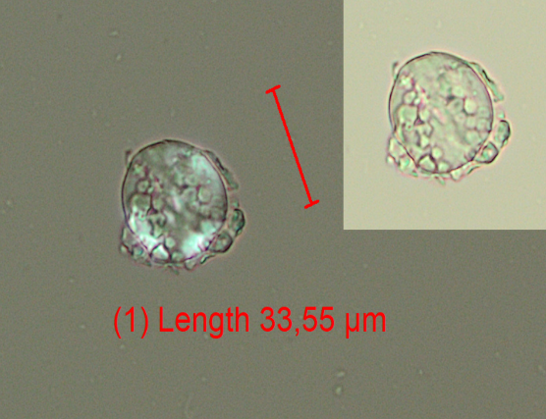  Pada burial XLI
2 | Grains are elliptical and simple, with shapes ranging from round to kidney or oval. The hilum is centrally sunken. Cracks and fissures are frequently observed, and lamellae may be present. The extinction cross can exhibit multiple 'arms' | Fabaceae (Punia et al., 2019; Gismondi et al, 2018; Cristiani et al, 2016; Henry et al, 2009; Ratnayake et al, 2001; Winton and Moeller, 1906) | 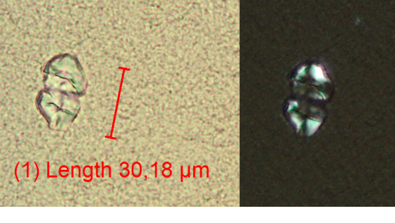  Pada burial VI
3 | Compound grains with a polyhedral shape, clustered together. Lamellae can not be seen. They feature an extinction cross and a central hilum. | Compound starch - possibly Avena (Gismondi et al. 2018; Saccomanno et al, 2017; Matsushima, 2015; Mariotti Lippi et al, 2015) | 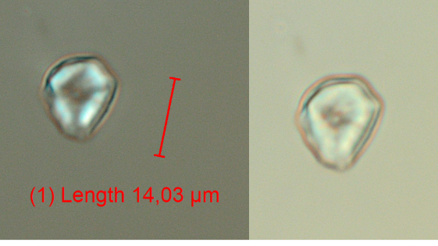  Pada burial CIII
4 | Other | These are likely starches from wild gathered plants. This category includes cf. tuber starches. Possibilities for parallels with plants include but are not limited to Quercus, Nuphar lutea, Butomus umbellatus, Trapa natans, Corylus avellana. (Chantran and Cagnato, 2021 SI materials; reference collection at the University of Tartu) | 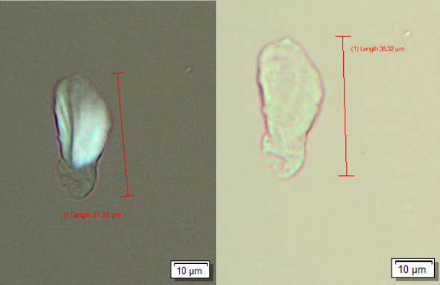  Pada burial CIII
5 | Unidentified | Not enough data to classify into a taxon. | 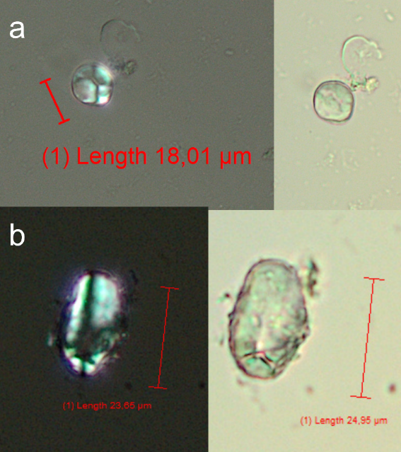  Pada burial LXI

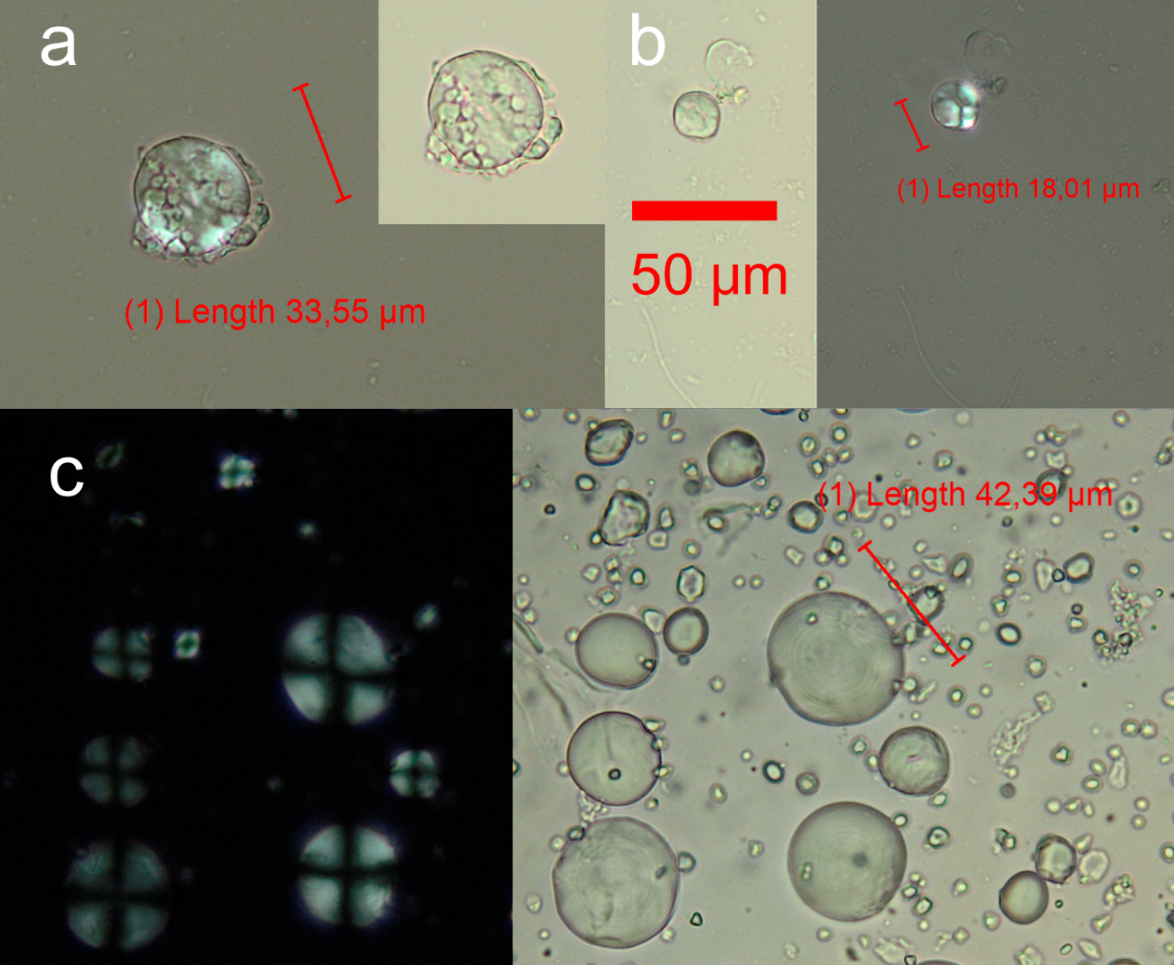
Figure 1. Tritriceae starch from burial no. XLI (a, b) and reference collection Secale cereale starch (c). Note the difference in image (a) between A- and B-type starch granules; smaller B-type granules are adhering to the larger A-type granule.
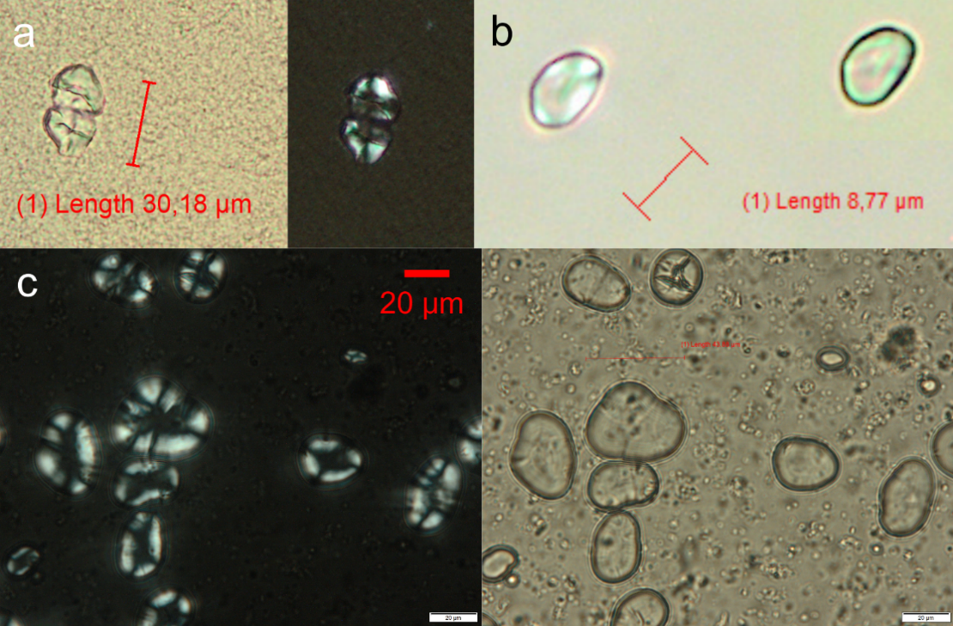
Figure 2. Fabaceae starch from burial no. VI (a) and LXI (b); reference collection Pisum sativum (c). Notice the 'arms' which sprout from the centre to outward in uneven sizes.
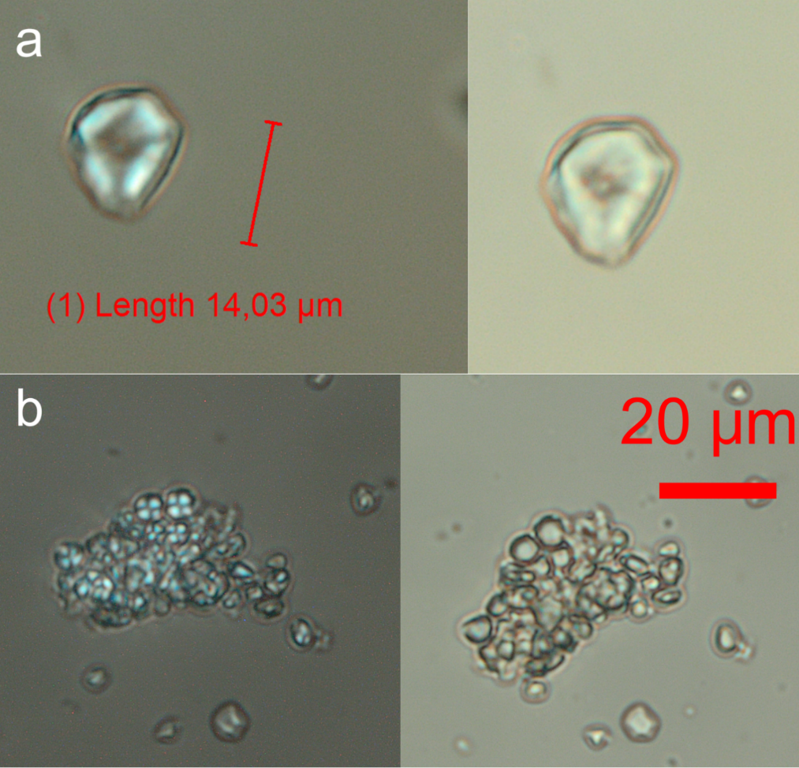
Figure 3. Cf. Avena starch from burial no. CIII (a); reference collection Avena sativa (b).
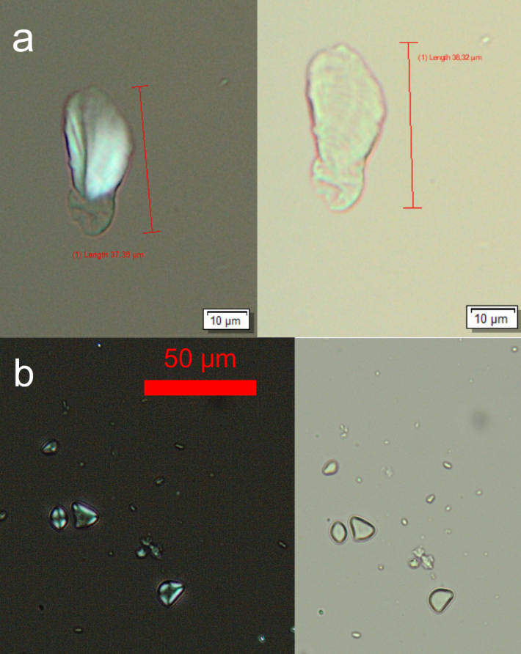
Figure 4. (a) cf. starch from an unknown gathered plant; (b) Butomus undellatus edible rhizome starch.
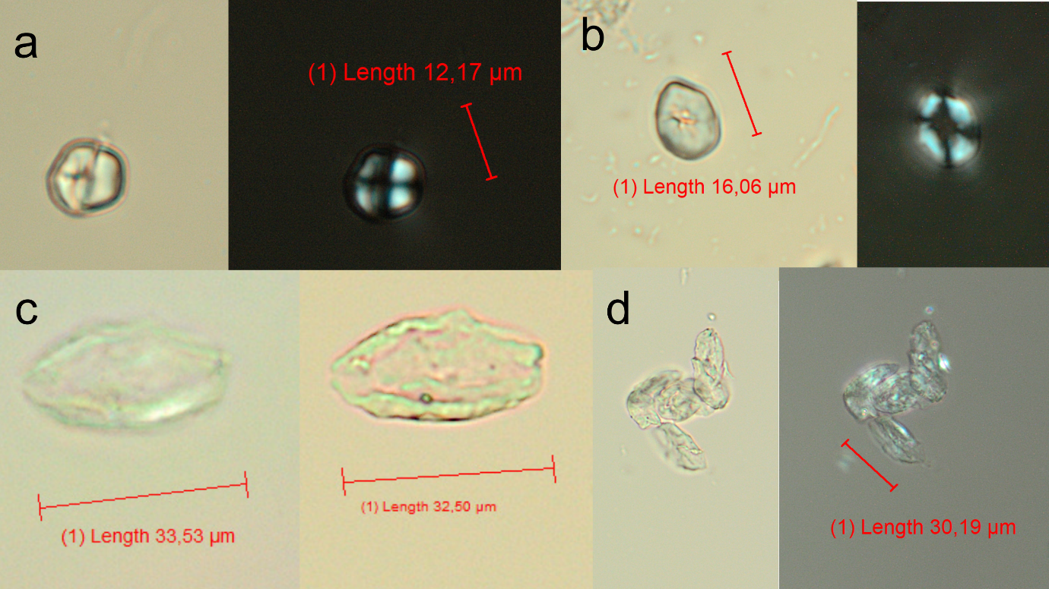
Figure 5. Unidentified starch from Pada dental calculus: burial no. XLI (a), XXIX (b), burial no. CIII (c) – cf. starch, this could be highly swollen starch, burial no. XLI (d) cf. starches.

Phytolith are not numerous and were not identified to any specific botanical taxon, only two (2) were identified with cf.
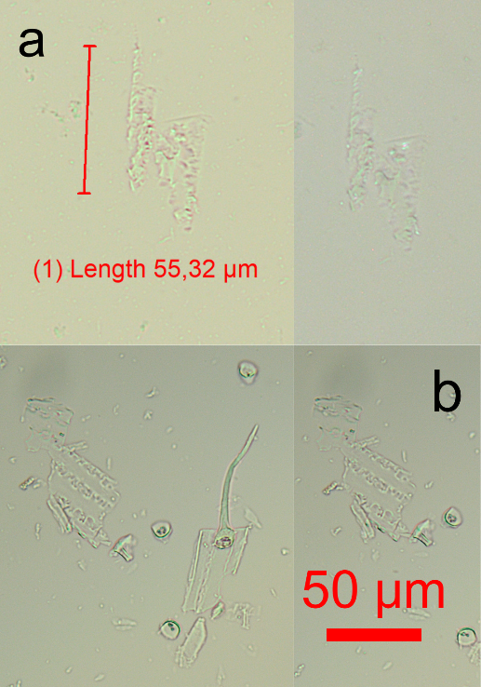
Figure 6. Cf. phytolith: (a) cf. dendritic Triticeae phytolith from burial no. XLI – note the lack of polarisation, (b) dry ashed Secale cereale.

Wood debris was not identified to any botanical level.
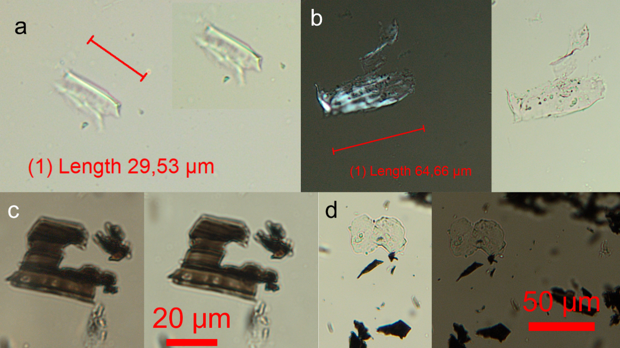
Figure 7. Wood debris from Pada dental calculus: (a) burial no. XLI wood debris, (b) burial no. LXI cf. wood, (c-d) Picea abies wood burnt.

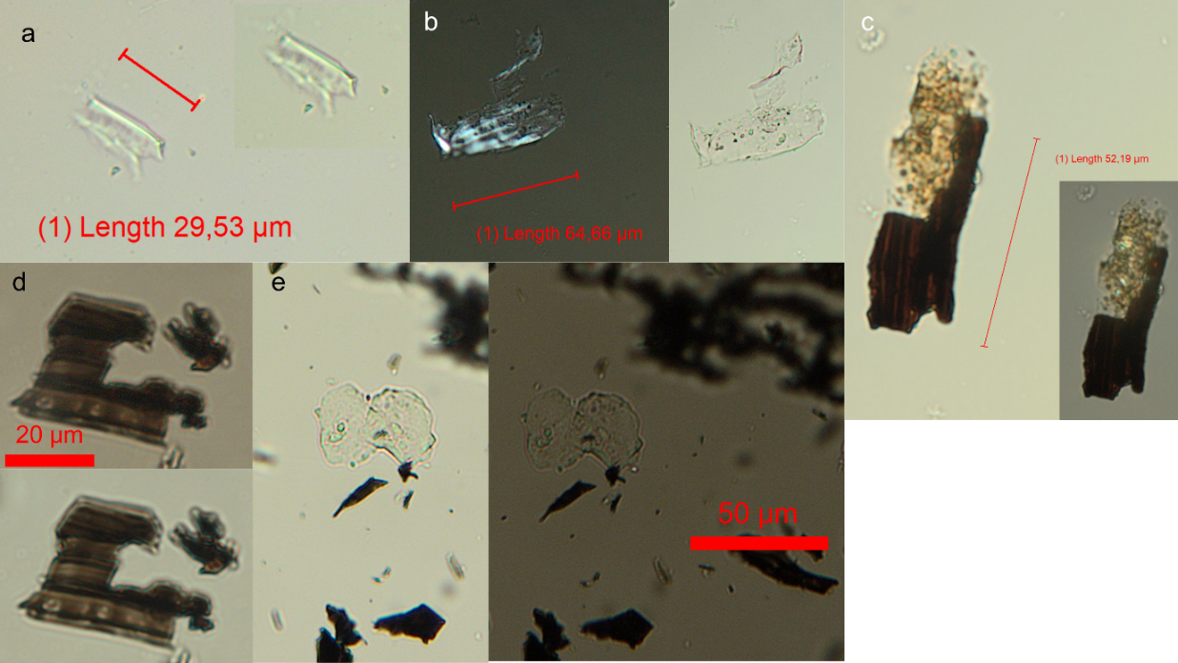
Figure 8. Wood debris and microcharcoal from Pada dental calculus and reference images: (a) burial no. XLI wood debris, (b) burial no. LXI cf. wood, (c) burial no. CIII microcharcoal, (d-e) Picea abies wood, burnt.
Fibres are commonly found in archaeological dental calculus, these may indicate to processing of raw materials, crafts (Buckley et al. 2014: 8), oral hygiene or from the remains of food and food-making (Hardy et al. 2016: 133). Bergfjord and Holst (2010) expand on identifying fibres.
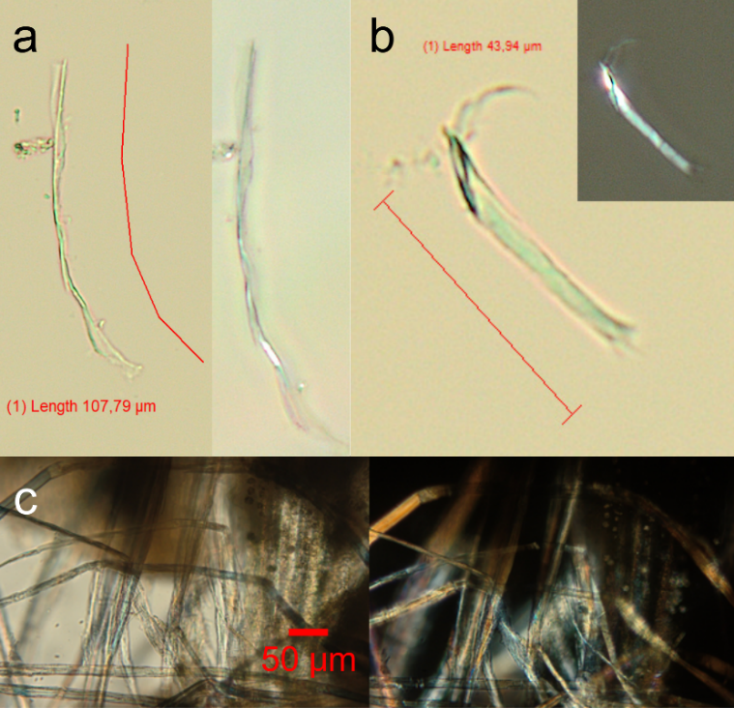
Figure 9. Fibres from Pada dental calculus and reference images: (a-b) burial no. CIII cf. plant fibres, (c) interconnected fibres from a withered Urtica plant.

Kingdom Animalia
Table 3. Kingdom Animalia representation in the Pada dental calculus.
 |  | CIII |  |  | LXI |  |  |  |  |  |  |  | XLI |  |  |  |  | VI |  | XXIX
Kingdom | Debris | 1 | 2 | 3 | 1 | 2 | 3 | 4 | 5 | 6 | 7 | 8 | 1 | 2 | 3 | 4 | 5 | 1 | 2 | 1 | 2
Animalia | cf. insect debris | 1 |  |  |  |  | 1 |  |  |  |  |  |  |  |  |  |  |  |  |  |  | 2
Animalia | insect debris |  | 1 |  |  |  |  | 1 |  |  |  |  |  |  |  |  |  |  |  |  |  | 2
Animalia | bone |  |  |  | 1 |  | 1 | 1 |  |  |  |  |  |  |  |  |  |  |  |  |  | 3
Animalia | bone/meat | 1 | 1 | 2 | 1 |  |  |  |  | 3 |  |  | 1 |  |  |  |  |  |  |  |  | 9
Animalia | flesh |  |  |  |  |  | 1 |  |  |  |  |  |  |  |  |  |  |  |  |  |  | 1
Animalia | epithelial | 4 | 4 | 17 | 14 | 3 |  | 10 | 1 |  | 1 | 3 | 2 | 1 | 2 | 2 | 1 | 2 |  |  | 8 | 75
Animalia | hyaline |  |  | 1 |  |  | 1 |  |  |  |  |  |  |  |  |  |  |  |  |  |  | 2
Animalia | cf. hyaline |  |  |  |  |  |  |  | 1 |  |  |  |  |  |  |  |  |  |  |  |  | 1
Animalia | hair |  |  |  |  | 1 |  |  |  |  |  |  |  |  |  |  |  |  |  |  |  | 1
 | Total | 32 |  |  | 45 |  |  |  |  |  |  |  | 9 |  |  |  |  | 2 |  | 8 |  | 96
 | Total | 96

Bone/meat fragments are likely indicative of food residues. As deteriorated bone and meat are not easy to differentiate between, the category covers both.
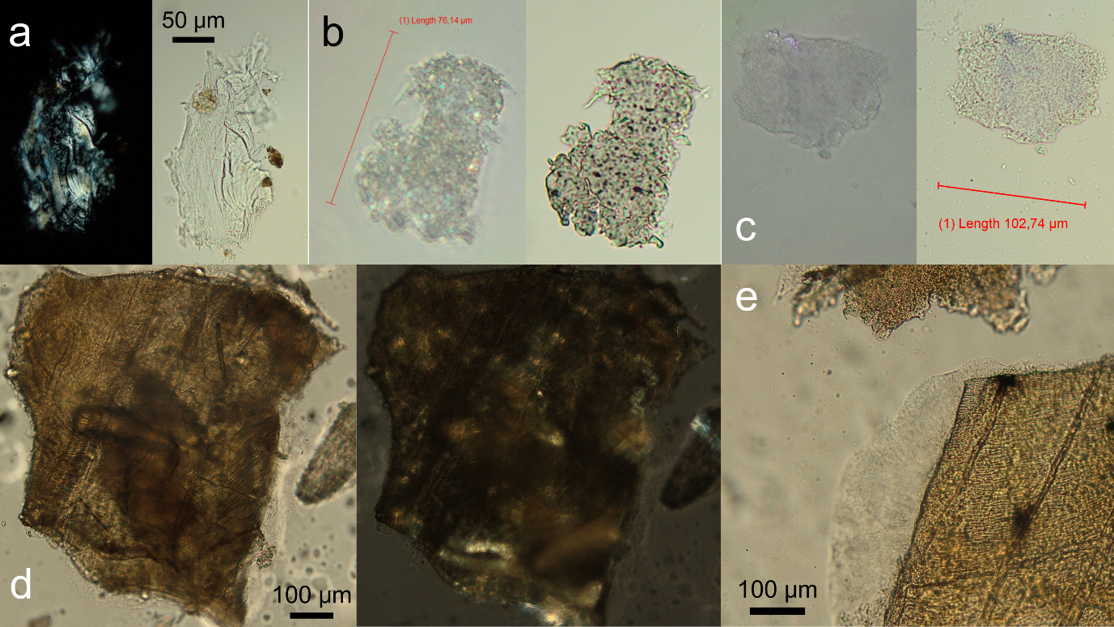
Figure 10. Bone/meat debris from Pada dental calculus and reference images: (a) burial no. CIII, (b-c) burial no. LXI, (d-e) Tinca tinca in oven at 150 °C for 1 hour.
The presence of insect debris is not uncommon as insects have always surrounded people. Insect remains in dental calculus can be found in Henry (2020: 290), Mackenzie et al. (2021: 6) and in Hardy et al. (2016) SI. Henry (2020: 290) believes that large insect body parts like legs, wings, thoraxes, heads and mandibles allow for identification of taxa; this however, was not possible in the Pada case. The insect remains were lacking identifiable features which leaves the category less specific.
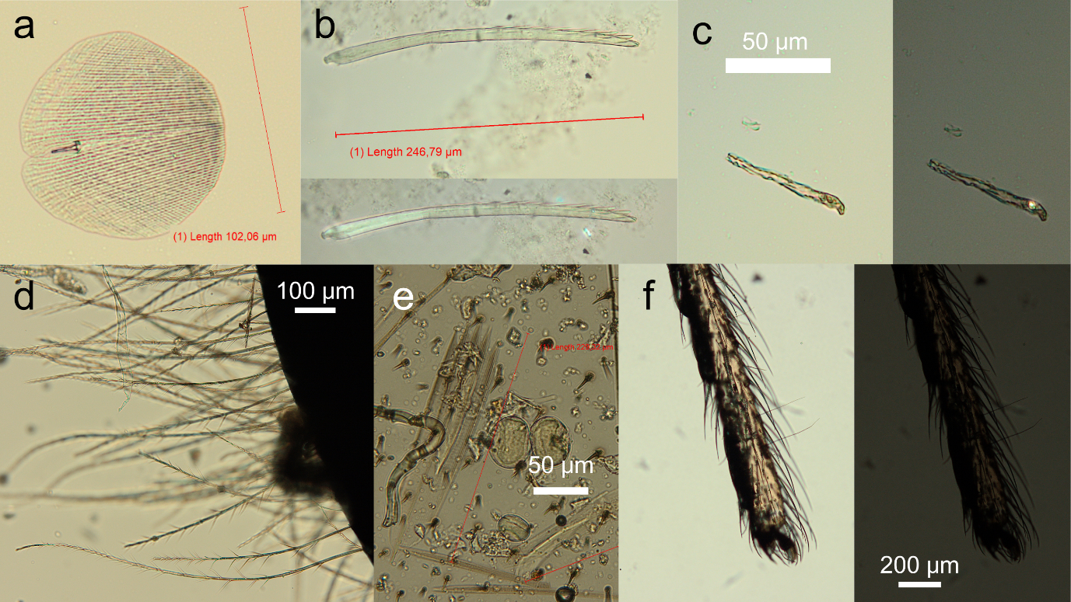
Figure 11. Insect debris from Pada dental calculus and reference images: (a) insect debris from burial no. CIII, (b) insect debris from burial no. LXI, (c) cf. insect debris from burial no. LXI, (d-e) reference images from Apidae, (f) reference images from Araneae.
Epithelial cells are most numerous in this kingdom. As mentioned in the results section, these are common cells found in human mouths. They may even be associated with the development of dental calculus (Tinanoff and Gross, 1976). The inner lining of the mouth sheds epithelial cells and these can often end up in dental calculus. Examples of the cells can be seen in Blondiaux and Charlier (2008: 8).
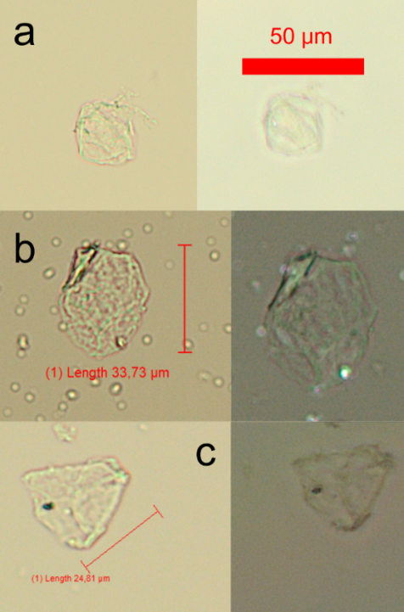
Figure 12. Epithelial cells from Pada burial no. CIII (a-c).

Kingdom Fungi
Fungal matter is notoriously difficult to identify to a taxon from dental calculus (Mackenzie et al. 2021: 7). Fungal debris can indicate to environmental factors and, as mentioned above, can be suggestive of plant pathogens such as Alternaria-type fungal matter can be; this type was not discovered in this case. It is difficult to say whether Pada people consumed mushrooms for food; intentionally consumed fungi have been identified in dietary studies (Power et al. 2015). The certainly identifiable fungal matter are Glomeromycota-type (Thangavelu and Raji 2016: Fig 2; Błaszkowski et al. 2023). Spores, hyphas and fungal fruiting bodies are all part of a larger network of fungal systems.
Table 4. Kingdom Fungi representation in the Pada dental calculus.
 |  | CIII |  |  | LXI |  |  |  |  |  |  |  | XLI |  |  |  |  | VI |  | XXIX
Kingdom | Debris | 1 | 2 | 3 | 1 | 2 | 3 | 4 | 5 | 6 | 7 | 8 | 1 | 2 | 3 | 4 | 5 | 1 | 2 | 1 | 2
Fungi | fungi | 1 |  |  |  |  | 33 | 9 | 13 | 1 | 2 | 2 | 2 |  |  | 1 |  | 1 |  |  |  | 65
Fungi | cf. fungi |  | 1 | 1 |  |  |  |  | 1 |  |  |  |  |  | 1 |  |  | 1 |  |  |  | 5
Fungi | cf. Glomeromycota |  |  |  |  | 1 |  |  |  | 1 |  |  |  |  |  |  |  |  |  |  |  | 2
Fungi | Glomeromycota |  |  |  |  |  | 7 |  | 2 |  |  |  |  |  |  |  |  |  |  |  |  | 9
Fungi | hypha |  |  |  | 2 | 1 | 9 |  |  |  |  |  |  | 1 |  |  |  |  |  |  |  | 13
Fungi | cf. hypha |  |  |  |  |  |  |  | 1 |  |  |  |  |  |  |  |  |  |  |  |  | 1
Fungi | spore |  | 1 |  |  |  |  | 1 |  |  |  |  |  |  | 1 |  |  |  |  | 1 | 1 | 5
 | Total | 4 |  |  | 86 |  |  |  |  |  |  |  | 6 |  |  |  |  | 2 |  | 2 |  | 100
 | Total | 100
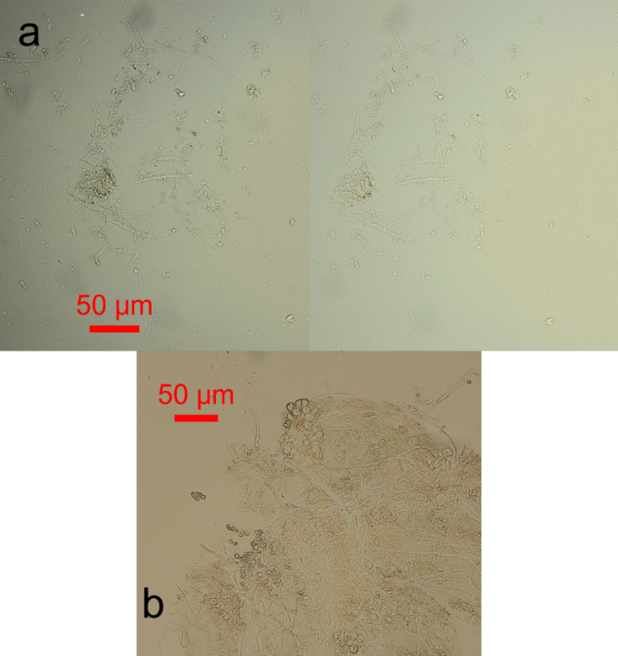
Figure 13. Hyphae from burial no. LXI (a) and reference image of mold found on apple (Malus) (b).

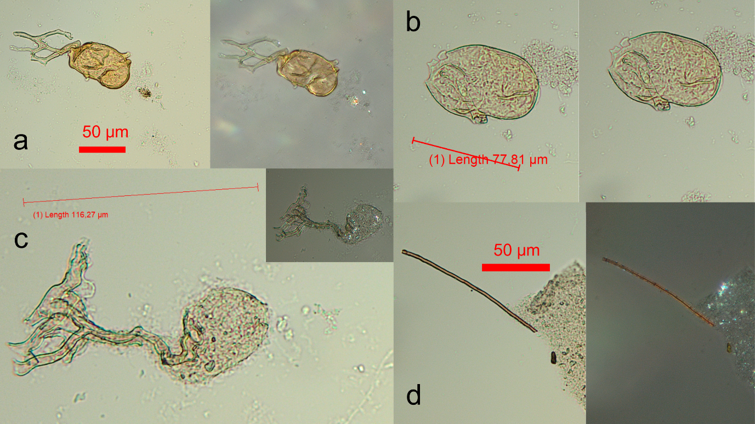
Figure 14. Fungal matter from Pada burial no. LXI dental calculus (a-d). (d) is likely a hypha. See comparisons of Glomeromycota in Niezgoda et al. (2024).

Non-living nature
Dental calculus itself was present in the samples (marked with a ‘p’ in the table as it did not make sense to count). This shows that the HCl used should have been left to work on the calculus for longer as small specs were not dissolved; however, this is often to be expected. Minerals were quite numerous and can end up in dental calculus from the surrounding environment, soil or dust (Radini et al. 2017). ‘Blue matter’ is a category that can be interpreted as representing phosphate, often found in living organisms. Category ‘crystal’ represents small cubic shapes, whose formation process may be associated with cooking processes.

Table 5. Non-living nature category: representation in the Pada dental calculus
 |  | CIII |  |  | LXI |  |  |  |  |  |  |  | XLI |  |  |  |  | VI |  | XXIX
Kingdom | Debris | 1 | 2 | 3 | 1 | 2 | 3 | 4 | 5 | 6 | 7 | 8 | 1 | 2 | 3 | 4 | 5 | 1 | 2 | 1 | 2
Non-living nature | cf. mineral | 1 |  |  |  |  |  |  |  |  |  |  |  |  |  |  |  |  |  |  |  | 1
Non-living nature | mineral | 2 | 1 | 12 | 2 | 7 | 1 | 6 | 2 | 1 | 5 | 3 | 10 | 2 | 6 | 7 |  | 3 | 3 | 2 | 2 | 77
Non-living nature | calclulus | p | p | p | p | p | p | p |  | p |  | p | p | p | p |  |  | p |  | p | p | 0
Non-living nature | crystal |  |  | 1 | 1 |  |  | 1 | 2 |  |  |  | 3 |  |  | 1 |  |  | 1 |  |  | 10
Non-living nature | blue matter |  |  |  |  |  |  |  |  |  | 8 | 3 |  |  |  |  |  | 1 |  |  |  | 12
 | Total | 17 |  |  | 42 |  |  |  |  |  |  |  | 29 |  |  |  |  | 8 |  | 4 |  | 100
 | Total | 100

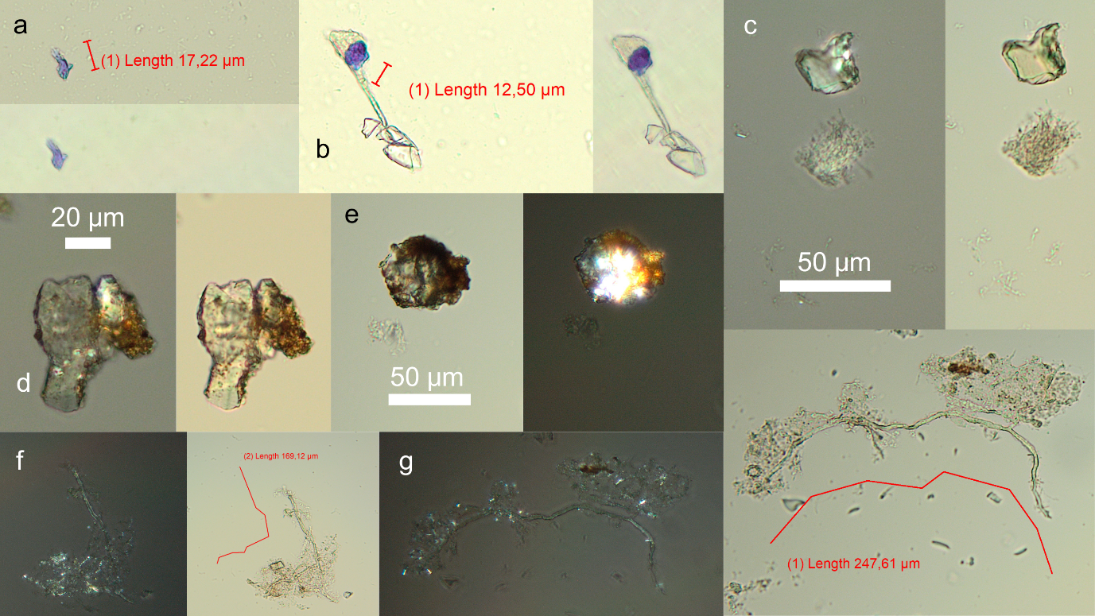
Figure 15. Non-living nature debris from Pada individuals’ dental calculus: (a-b) blue matter from burial no. LXI, (b) attached to glass effects; (c-e) minerals, (c) burial no. LXI, (d-e) burial no. CIII. (f-g) example of undissolved dental calculus from burial no. LXI.

Problematic debris
Adhering to the teeth was polyvinyl butyral (PVB glue) which had to be removed, the method for which is described in SI material 1. The glue left distinctive microscopic debris that could be noticed. At first, the category of ‘Problematic debris’ contained unidentified debris, containing all found debris above 20 µm. These microdebris were recorded for three individuals (burials no. CIII, LXI, XLI). This practise was deemed unnecessary for the other two samples (VI, XXIX) as it made slide scanning more time-consuming and ultimately contributed little to analysis. From sample XLI onwards, the category ‘unidentified’ includes only noteworthy unidentified debris that should be mentioned.
Table 6. Problematic debris from the Pada dental calculus.
 | CIII |  |  | LXI |  |  |  |  |  |  |  | XLI |  |  |  |  | VI |  | XXIX
Debris | 1 | 2 | 3 | 1 | 2 | 3 | 4 | 5 | 6 | 7 | 8 | 1 | 2 | 3 | 4 | 5 | 1 | 2 | 1 | 2
burnt debris | 1 | 8 | 12 | 1 | 9 | 38 | 9 | 10 | 9 | 15 | 4 | 19 | 9 | 12 | 10 | 8 | 12 | 3 | 11 | 6 | 206
cf. burnt debris |  |  |  |  |  |  |  |  |  |  |  |  |  |  |  |  |  |  | 1 |  | 1
cf. fibre |  |  | 1 |  |  |  |  |  |  |  |  |  |  |  |  |  |  |  |  |  | 1
fibre |  |  |  |  |  |  |  |  |  |  |  |  |  |  | 2 |  |  | 2 | 2 |  | 6
unidentified (<20 microns) | 25 | 13 | 26 | 46 | 50 | 43 | 42 | 23 | 19 | 13 | 11 |  |  |  |  |  |  |  |  |  | 311
unidentified, selected |  |  |  |  |  |  |  |  |  |  |  | 7 | 3 | 4 | 3 |  | 1 |  |  | 2 | 20
glass | p |  |  |  |  |  |  |  |  |  |  |  |  |  |  |  |  |  |  |  | 0
glue |  | p | 1 |  |  | 2 | 2 | 3 | 1 |  |  |  | 1 | 2 | p |  |  |  | 2 |  | 14
cf. glue |  |  |  |  |  |  |  | 1 |  |  |  |  |  |  |  |  |  |  |  |  | 1
circular pit |  | 1 |  |  |  |  |  |  |  |  |  |  |  |  |  |  |  |  |  |  | 1
Total | 88 |  |  | 351 |  |  |  |  |  |  |  | 80 |  |  |  |  | 18 |  | 24
Total | 561

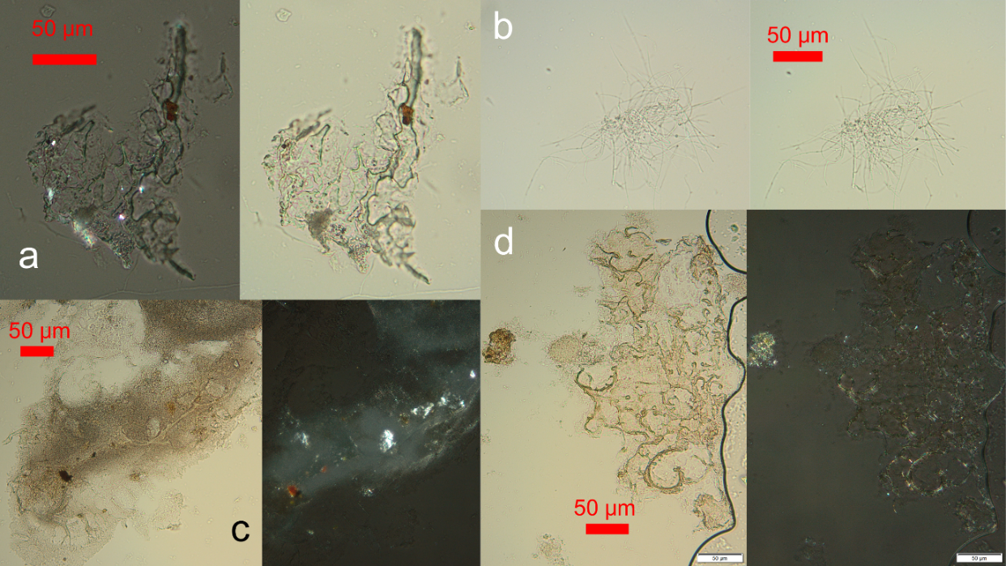
Figure 16. PVB glue in dental calculus samples: (a-b) burial no. XLI, (c-d) burial no. XXIX.

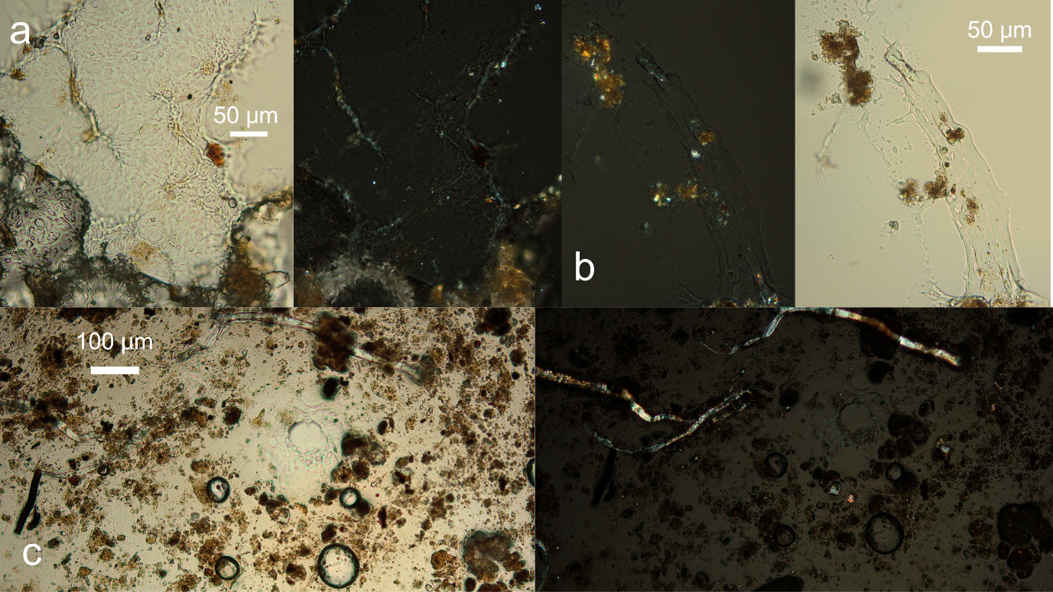
Figure 17. PVB glue reference images: (a-b) glue and dental calculus before adding ethanol. (c) dental calculus and glue after applying a drop of ethanol – glue is dissolving.

References
BeMiller, J. and Whistler, R. (2009). Starch: Chemistry and Technology. 3rd Edition. Academic Press.
Bergfjord, C. and Holst, B. (2010). A procedure for identifying textile bast fibres using microscopy: Flax, nettle/ramie, hemp and jute. Ultramicroscopy, 110(9), 1192–1197. https://doi.org/10.1016/j.ultramic.2010.04.014
Błaszkowski, J., Czerniawska, B., Wubet, T., Schäfer, T., Buscot, F. and Renker, C. (2023). Glomus irregulare, a new arbuscular mycorrhizal fungus in the Glomeromycota. MYCOTAXON, 106, 247–267.
Blondiaux, J. and Charlier, P. (2008). Palaeocytology in skeletal remains: microscopic examination of putrefaction fluid deposits and dental calculus of skeletal remains from French archaeological sites. International Journal of Osteoarchaeology, 18(1), 1–10. https://doi.org/10.1002/oa.931
Buckley, S., Usai, D., Jakob, T., Radini, A. and Hardy, K. (2014). Dental Calculus Reveals Unique Insights into Food Items, Cooking and Plant Processing in Prehistoric Central Sudan. PLOS ONE, 9(7), e100808. https://doi.org/10.1371/journal.pone.0100808
Chantran, A. and Cagnato, C. (2021). Boiled, fried, or roasted? Determining culinary practices in Medieval France through multidisciplinary experimental approaches. Journal of Archaeological Science: Reports, 35, 102715. https://doi.org/10.1016/j.jasrep.2020.102715
Cristiani, E., Radini, A., Edinborough, M. and Borić, D. (2016). Dental calculus reveals Mesolithic foragers in the Balkans consumed domesticated plant foods. Proceedings of the National Academy of Sciences, 113(37), 10298–10303. https://doi.org/10.1073/pnas.1603477113
D’Agostino, A., Baldoni, M., Di Marco, G., Scorrano, G., Icaro, I., Brilli, M., et al. (2023). Dental calculus and isotopes reveal information about ancient diet of Boccone del Povero community (1st-2nd century CE, Latium, central Italy). Journal of Archaeological Science: Reports, 48, 103845. https://doi.org/10.1016/j.jasrep.2023.103845
Delaney, S., Alexander, M. and Radini, A. (2023). More than what we eat: Investigating an alternative pathway for intact starch granules in dental calculus using Experimental Archaeology. Quaternary International, 653–654, 19–32. https://doi.org/10.1016/j.quaint.2022.03.004
Gismondi, A., D’Agostino, A., Canuti, L., Di Marco, G., Martínez-Labarga, C., Angle, M., et al. (2018). Dental calculus reveals diet habits and medicinal plant use in the Early Medieval Italian population of Colonna. Journal of Archaeological Science: Reports, 20, 556–564. https://doi.org/10.1016/j.jasrep.2018.05.023
Hardy, K., Radini, A., Buckley, S., Blasco, R., Copeland, L., Burjachs, F., et al. (2016). Diet and environment 1.2 million years ago revealed through analysis of dental calculus from Europe’s oldest hominin at Sima del Elefante, Spain. The Science of Nature, 104(1), 2. https://doi.org/10.1007/s00114-016-1420-x
Henry, A. G. (2020). Starch Granules as Markers of Diet and Behavior. In Handbook for the Analysis of Micro-Particles in Archaeological Samples (Henry, A. G., ed). Springer International Publishing, Cham, 97–116. https://doi.org/10.1007/978-3-030-42622-4_5
Henry, A. G., Hudson, H. F. and Piperno, D. R. (2009). Changes in starch grain morphologies from cooking. Journal of Archaeological Science, 36(3), 915–922. https://doi.org/10.1016/j.jas.2008.11.008
King Se, C. M., Inthavong, K. and Tu, J. (2010). Inhalability of micron particles through the nose and mouth. Inhalation Toxicology, 22(4), 287–300. https://doi.org/10.3109/08958370903295204
Leonard, C., Vashro, L., O’Connell, J. F. and Henry, A. G. (2015). Plant microremains in dental calculus as a record of plant consumption: A test with Twe forager-horticulturalists. Journal of Archaeological Science: Reports, 2, 449–457. https://doi.org/10.1016/j.jasrep.2015.03.009
MacKenzie, L., Speller, C. F., Holst, M., Keefe, K. and Radini, A. (2021). Dental calculus in the industrial age: Human dental calculus in the Post-Medieval period, a case study from industrial Manchester. Quaternary International. https://doi.org/10.1016/j.quaint.2021.09.020
Mariotti Lippi, M., Foggi, B., Aranguren, B., Ronchitelli, A. and Revedin, A. (2015). Multistep food plant processing at Grotta Paglicci (Southern Italy) around 32,600 cal B.P. Proceedings of the National Academy of Sciences of the United States of America, 112. https://doi.org/10.1073/pnas.1505213112
Matsushima, R. (2015). Morphological Variations of Starch Grains. In Starch: Metabolism and Structure (Nakamura, Y., ed). Springer Japan, Tokyo, 425–441. https://doi.org/10.1007/978-4-431-55495-0_13
Niezgoda, P., Błaszkowski, J., Błaszkowski, T., Stanisławczyk, A., Zubek, S., Milczarski, P., et al. (2024). Three new species of arbuscular mycorrhizal fungi (Glomeromycota) and Acaulospora gedanensis revised. Frontiers in Microbiology, 15. https://doi.org/10.3389/fmicb.2024.1320014
Power, R. C., Salazar-García, D. C., Straus, L. G., González Morales, M. R. and Henry, A. G. (2015). Microremains from El Mirón Cave human dental calculus suggest a mixed plant–animal subsistence economy during the Magdalenian in Northern Iberia. Journal of Archaeological Science, 60, 39–46. https://doi.org/10.1016/j.jas.2015.04.003
Punia, S., Dhull, S. B., Sandhu, K. S. and Kaur, M. (2019). Faba bean (Vicia faba) starch: Structure, properties, and in vitro digestibility—A review. Legume Science, 1(1), e18. https://doi.org/10.1002/leg3.18
Radini, A., Nikita, E., Buckley, S., Copeland, L. and Hardy, K. (2017). Beyond food: The multiple pathways for inclusion of materials into ancient dental calculus. American Journal of Physical Anthropology, 162(S63), 71–83. https://doi.org/10.1002/ajpa.23147
Ratnayake, W., Hoover, R. and Warkentin, T. (2002). Pea Starch: Composition, Structure and Properties — A Review. Starch - Stärke, 54, 217–234. https://doi.org/10.1002/1521-379X(200206)54:63.0.CO;2-R
Saccomanno, B., Chambers, A. H., Hayes, A., Mackay, I., McWilliam, S. C. and Trafford, K. (2017). Starch granule morphology in oat endosperm. Journal of Cereal Science, 73, 46–54. https://doi.org/10.1016/j.jcs.2016.10.011
Thangavelu, M. and Raji, M. (2016). Arbuscular mycorrhizal and dark septate endophyte fungal associations in Asparagus. Turkish Journal of Botany, 40. https://doi.org/10.3906/bot-1602-11
Tinanoff, N. and Gross, A. (1976). Epithelial Cells Associated with the Development of Dental Plaque. Journal of Dental Research, 55(4), 580–583. https://doi.org/10.1177/00220345760550040501
Tromp, M. and Dudgeon, J. V. (2015). Differentiating dietary and non-dietary microfossils extracted from human dental calculus: the importance of sweet potato to ancient diet on Rapa Nui. Journal of Archaeological Science, 54, 54–63. https://doi.org/10.1016/j.jas.2014.11.024
Winton, A. L. and Moeller, J. (1906). The microscopy of vegetable foods, with special reference to the detection of adulteration and the diagnosis of mixtures by Andrew L. Winton, with the collaboration of Josef Moeller. New York Wiley. http://archive.org/details/microscopyofvege00wintuoft (accessed 2021-08-03)

