Supplementary information

Faunal evidence and the duration of occupation: a statistical approach to Neanderthal archaeological sites
Valentina Lubrano¹, Vincenzo Spagnolo^{2, 3}, Anna Rufà^{1, 4}, Ruth Blasco^{5, 6}, Florent Rivals^{5, 6, 7}, Jordi Rosell^{5, 6}
¹ Interdisciplinary Center for Archaeology and the Evolution of Human Behaviour (ICArEHB), FCHS – Universidade do Algarve, Campus de Gambelas, 8005‑139 Faro, Portugal
² Dipartimento di Scienze Fisiche, della Terra e dell’Ambiente, Università degli Studi di Siena, strada Laterina 8, 53100, Siena, Italy.
³ Centro Studi sul Quaternario, Via Nuova dell’Ammazzatoio, 7, 52037 Sansepolcro, Italy.
⁴ Univ. Bordeaux, CNRS, MCC, PACEA, UMR 5199, 33600 Pessac, France
⁵ Institut Català de Paleoecologia Humana i Evolució Social (IPHES-CERCA), Edifici W3, Campus Sescelades URV, 43007 Tarragona, Spain
⁶ Departament d’Història i Història de l’Art, Universitat Rovira i Virgili (URV), Avinguda de Catalunya 35, 43002 Tarragona, Spain
⁷ ICREA, Pg. Lluís Companys 23, 08010 Barcelona, Spain

Keywords: Neanderthal occupation duration, Faunal feature validation, Zooarchaeology, Taphonomy, Statistical analysis

Valentina Lubrano
vlubrano@ualg.pt
ORCID: 000000034332952X

Figures
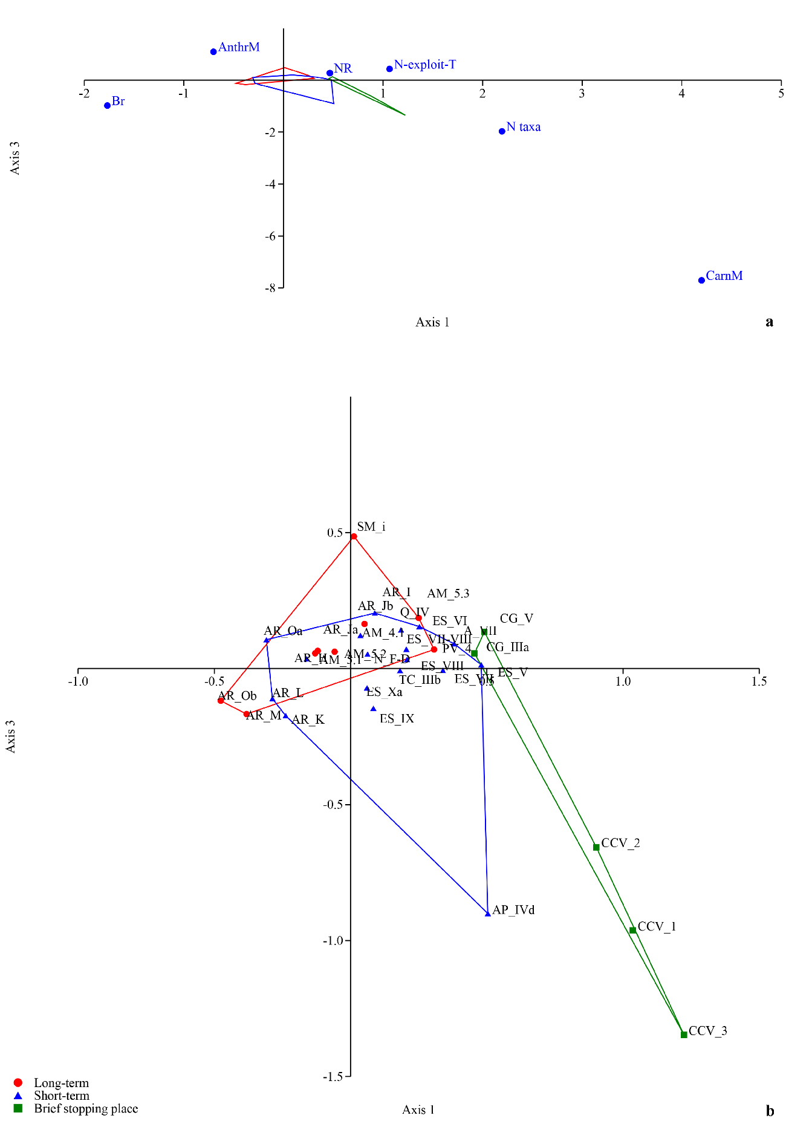
Fig. 1 SI Correspondence Analysis (Axis 1 on Axis 3). Scatter plots of the columns (a) and of rows (b). Generated using PAST
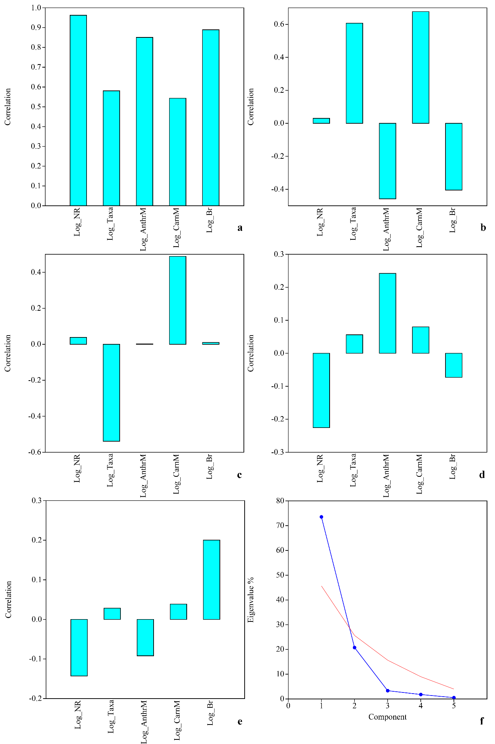
Fig. 2 SI Principal Component Analysis. Loadings plots for PC1 (a), PC2 (b), PC3 (c), PC4 (d), PC5 (3), and scree plot with broken stick (f). Generated using PAST

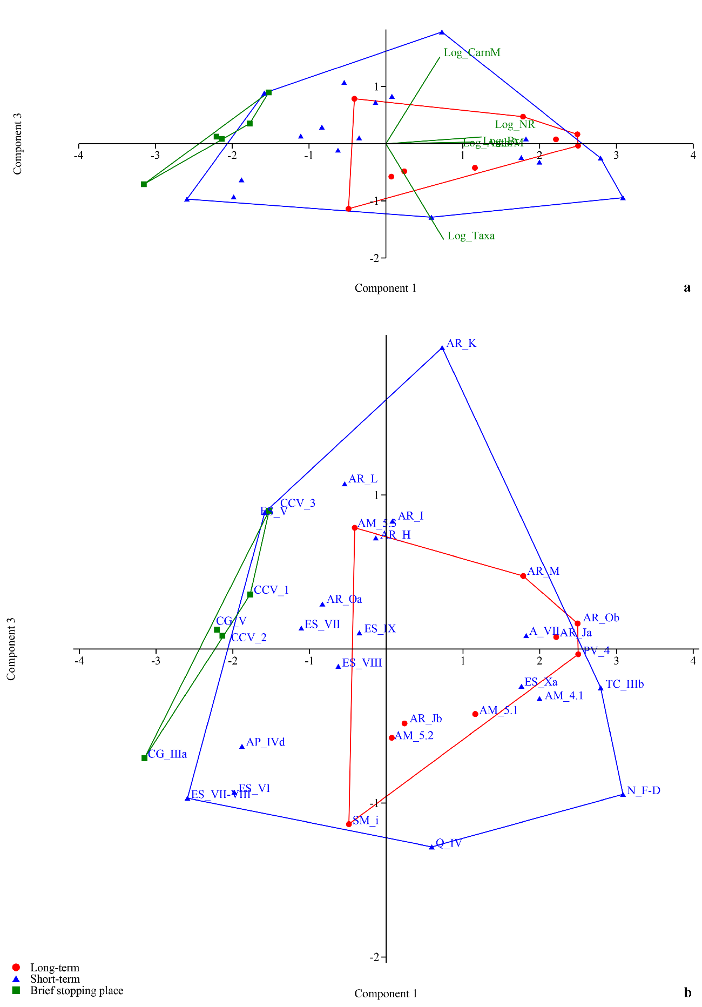
Fig. 3 SI Principal Component Analysis (Component 1 on Component 3). Scatter plots with loadings (a) and rows (b). Generated using PAST

Tables
Table 1 SI Results of the Grubbs’ test to evaluate the presence of outliers among the Log10 transformed data.
Grubbs test | Log_NR | Log_Taxa | Log_expl-T | Log_AnthrM | Log_CarnM | Log_Br
G: | 1.79 | 2.344 | 2.508 | 2.013 | 1.753 | 1.89
p(no outlier): | 1 | 0.467 | 0.27 | 1 | 1 | 1
Significant outliers | No | No | No | No | No | No

Table 2 SI Results of the multiple outlier test. The 20% most extreme values are shown. R > Rcrit (p < 0.05) marked in pink
Log_NR – Outlier Tests (Multiple Outliers Tab)
Row | Value | R | Rcrit | Outlier
ES_VII-VIII | 2.093 | 1.79 | 2.938 | No
CG_IIIa | 2.093 | 1.924 | 2.924 | No
TC_IIIb | 4.149 | 1.679 | 2.908 | No
N_D-F | 4.123 | 1.75 | 2.893 | No
AM_4.1 | 4.046 | 1.738 | 2.876 | No
AR_Ob | 3.935 | 1.652 | 2.859 | No
Log_Taxa – Outlier Tests (Multiple Outliers Tab)
Row | Value | R | Rcrit | Outlier
N_D-F | 1.279 | 2.344 | 2.938 | No
TC-IIIb | 1.204 | 2.142 | 2.924 | No
PV_4 | 1.176 | 2.174 | 2.908 | No
ES_Xa | 0.114 | 1.951 | 2.893 | No
AR_L | 0.602 | 1.983 | 2.876 | No
AR_K | 0.602 | 2.19 | 2.859 | No
Log_expl-T – Outlier Tests (Multiple Outliers Tab)
Row | Value | R | Rcrit | Outlier
CCV_1 | 0.000 | 2.508 | 2.938 | Yes
CCV_2 | 0.000 | 2.865 | 2.924 | Yes
CG_IIIa | 0.000 | 3.437 | 2.908 | Yes
CCV_3 | 0.301 | 2.448 | 2.893 | No
CG_V | 0.301 | 2.823 | 2.876 | No
AR_H | 0.477 | 1.804 | 2.859 | No
Log_AnthrM – Outlier Tests (Multiple Outliers Tab)
Row | Value | R | Rcrit | Outlier
CCV_1 | 0.000 | 2.013 | 2.938 | No
CCV_2 | 0.000 | 2.198 | 2.924 | No
CG_IIIa | 0.000 | 2.446 | 2.908 | No
CCV_3 | 0.301 | 2.404 | 2.893 | No
CG_V | 0.699 | 2.175 | 2.876 | No
ES_VII-VIII | 0.903 | 2.122 | 2.859 | No
Log_CarnM – Outlier Tests (Multiple Outliers Tab)
Row | Value | R | Rcrit | Outlier
PV_4 | 2.514 | 1.753 | 2.938 | No
TC_IIIb | 2.365 | 1.673 | 2.924 | No
CCV_3 | 2.320 | 1.724 | 2.908 | No
A_VII | 2.152 | 1.604 | 2.893 | No
SM_i | 0.000 | 1.579 | 2.876 | No
ES_VII-VIII | 0.000 | 1.69 | 2.859 | No
Log_Br – Outlier Tests (Multiple Outliers Tab)
Row | Value | R | Rcrit | Outlier
CCV_2 | 0.477 | 1.89 | 2.938 | No
CCV_3 | 0.477 | 2.045 | 2.924 | No
CCV_1 | 0.699 | 1.985 | 2.908 | No
CG_IIIa | 0.903 | 1.922 | 2.893 | No
CG_V | 0.903 | 2.104 | 2.876 | No
ES_VII-VIII | 1.322 | 1.755 | 2.859 | No

Table 3 SI Results of the Box’s M test to evaluate equality of covariance matrices among the Log10 transformed data taking into account two configurations. The Config. 1 indicates the test results on the whole dataset. The Config. 2 returns the values obtained removing the exploited taxa.
 | Config.1 | Config.2
Box’s M: | 359.09 | -7.6851
F: | 4.2062 | -0.15045
df1; df2: | 42; 494.58 | 30; 519.59
p (equal var-covar): | 3.5514E-15 | 0
Monte Carlo test | failed | 0.6745

Table 4 SI Multivariate Normality test (within groups) on Log10 transformed data (full dataset).
Mardia tests parameters | Value | Statistic | df | p (normal)
Skewness: | 6.758 | 36.04 | 56 | 0.982
Skewness, small sample corrected: |  | 40.47 | 56 | 0.941
Kurtosis: | 41.26 | -1.946 |  | 0.052
Doornik and Hansen omnibus parameters | Value
Ep: | 7.783
p (normal): | 0.802

Table 5 SI Multivariate Normality test (within groups) on Log10 transformed data (without the Number of taxa with evidence of human exploitation).
Mardia tests parameters | Value | Statistic | df | p (normal)
Skewness: | 6.909 | 31.51 | 35 | 0.637
Skewness, small sample corrected: |  | 35.54 | 35 | 0.443
Kurtosis: | 32.45 | -0.862 |  | 0.389
Doornik and Hansen omnibus parameters | Value
Ep: | 7.847
p (normal): | 0.644

Table 6 SI Results of the Bartletts’s sphericity test and Kaiser-Meyer-Olkin on the PCA
Bartletts’s sphericity test | Value
Determinant: | 0.017355
chi2: | 115.53
Df: | 10
p (spherical): | 4.06E-20
Kaiser-Meyer-Olkin measure | Value
KMO: | 0.68466 (“mediocre”)

Table 7 SI Confusion matrix of the LDA
 | Long-term | Short-term | Brief stopping place | Total
Long-term | 6 | 3 | 0 | 9
Short-term | 6 | 11 | 1 | 18
Brief stopping place | 0 | 0 | 5 | 5
Total | 12 | 14 | 6 | 32

