SUPPLEMENTARY INFORMATION
Ligand-based pharmacophore modeling for the discovery of Na_{V}1.7 inhibitors
Martina Piga ª, Peter Lukacs ^{b}, Krisztina Pesti ^{b,c}, György Várady ^{d}, Zoltan Varga ^{e}, Nace Zidar ª, Tihomir Tomašič ^{a,}*
ª Faculty of Pharmacy, University of Ljubljana, Aškerčeva cesta 7, Ljubljana 1000, Slovenia
^{b} Agricultural Institute, Centre for Agricultural Research, Martonvásár, Hungary
^{c} HUN-REN Institute of Experimental Medicine, Budapest, Hungary
^{d} Institute of Molecular Life Sciences, HUN-REN Research Centre for Natural Sciences, Budapest, Hungary
^{e} Department of Biophysics and Cell Biology, Faculty of Medicine, University of Debrecen, Egyetem ter1, 4032 Debrecen, Hungary

*Corresponding author: E-mail address: tihomir.tomasic@ffa.uni-lj.si

Contents:
Figure S1. Voltage protocol designed for testing activation and inactivation parameters of compound effects in 5 s resolution...………………………………………….………………………...…………S4
Figure S2. Ligand-based pharmacophore models for Na_{V}1.7 inhibitors with IC₅₀≤10 nM… A) LBPM_Nav1.7_Cluster5, B) LBPM_Nav1.7_Cluster8, C) LBPM_Nav1.7_Cluster10, D) LBPM_Nav1.7_Cluster11, and E) LBPM_Nav1.7_Cluster12. Each model is aligned with the inhibitor with the highest pharmacophore fit score. The pharmacophore features are as follows: hydrophobic (H, yellow spheres), aromatic (AR, blue disc), hydrogen bond donor (HBD, green arrow), and hydrogen bond acceptor (HBA, red sphere)…………………………………………………………...…………S4
Figure S3. ROC plot (curve shown in blue) generated from virtual screening of actives and generated decoys with A) LBPM_Nav1.7_Cluster4; B) LBPM_Nav1.7_Cluster5; C) LBPM_Nav1.7_Cluster8; D) LBPM_Nav1.7_Cluster9; E) LBPM_Nav1.7_Cluster10; F) LBPM_Nav1.7_Cluster11; G) LBPM_Nav1.7_Cluster12; H) LBPM_Nav1.7_Cluster13; TP = true positives; FP = false positives; AUC = area under the curve; EF = enrichment factor…………………..…………………………………………………………………...………….S6
Figure S4. Ligand-based pharmacophore models for Na_{V}1.7 inhibitors with IC₅₀≤10 nM. A) LBPM_Nav1.7_Cluster12_3; B) LBPM_Nav1.7_Cluster12_4; C) LBPM_Nav1.7_Cluster12_5; D) LBPM_Nav1.7_Cluster12_6; E) LBPM_Nav1.7_Cluster12_7; F) LBPM_Nav17_Cluster12_8. Each model is aligned with the inhibitor with the highest pharmacophore fit score. The pharmacophore features are as follows: hydrophobic (H, yellow spheres), aromatic (AR, blue disc), hydrogen bond donor (HBD, green arrow), and hydrogen bond acceptor (HBA, red sphere)..………………………...S7
Figure S5. ROC plot (curve shown in blue) generated from virtual screening of actives and generated decoys with A) LBPM_Nav1.7_Cluster12_3; B) LBPM_Nav1.7_Cluster12_4; C) LBPM_Nav1.7_Cluster12_5; D) LBPM_Nav1.7_Cluster12_6; E) LBPM_Nav1.7_Cluster12_7; F) LBPM_Nav1.7_Cluster12_8; TP = true positives; FP = false positives; AUC = area under the curve; EF = enrichment factor..………………………………………………………………..…………...……..S9
Table S1. Validation metrics for all Na_{V}1.7 pharmacophore models………………………S10
Figure S6. Ligand-based pharmacophore models for Na_{V}1.5 inhibitors with IC₅₀≤10 nM. A) LBPM_Nav1.5_Cluster13; B) LBPM_Nav1.5_Cluster15; C) LBPM_Nav1.5_Cluster16; D) LBPM_Nav1.5_Cluster17; E) LBPM_Nav1.5_Cluster18; F) LBPM_Nav1.5_Cluster19, G) LBPM_Nav1.5_Cluster20; H) LBPM_Nav1.5_Cluster21; I) LBPM_Nav1.5_Cluster22_5; J) LBPM_Nav1.5_Cluster22_6; K) LBPM_Nav1.5_Cluster22_7; L) LBPM_Nav1.5_Cluster22_8. Each model is aligned with the inhibitor with the highest pharmacophore fit score. The pharmacophore features are as follows: hydrophobic (H, yellow spheres), aromatic (AR, blue disc), hydrogen bond donor (HBD, green arrow), and hydrogen bond acceptor (HBA, red sphere)..…………………..…...S11
Figure S7. ROC plot (curve shown in blue) generated from virtual screening of actives and generated decoys with A) LBPM_Nav1.5_Cluster13; B) LBPM_Nav1.5_Cluster15; C) LBPM_Nav1.5_Cluster16; D) LBPM_Nav1.5_Cluster17; E) LBPM_Nav1.5_Cluster18; F) LBPM_Nav1.5_Cluster19, G) LBPM_Nav1.5_Cluster20; H) LBPM_Nav1.5_Cluster21; I) LBPM_Nav1.5_Cluster22_5; J) LBPM_Nav1.5_Cluster22_6; K) LBPM_Nav1.5_Cluster22_7; L) LBPM_Nav1.5_Cluster22_8; TP = true positives; FP = false positives; AUC = area under the curve; EF = enrichment factor..………………………………………………...…….………………...…...…...S13
Figure S8. Overlay of A) inhibitor 14f and LBPM_Nav1.7_Cluster12_3; B) inhibitor 14g and LBPM_Nav1.7_Cluster12_3; C) inhibitor 29 and LBPM_Nav1.7_Cluster10. The pharmacophore features are as follows: hydrophobic (H, yellow spheres), aromatic (AR, blue disc), hydrogen bond donor (HBD, green arrow), hydrogen bond acceptor (HBA, red sphere), and (HAL, dotted pink arrow)....……………………………………………………………………………….……………..S16
Figure S9. Overlay of A) compound 1 and LBPM_Nav1.7_Cluster4; B) compound 2 and LBPM_Nav1.7_Cluster9; C) compound 3 and LBPM_Nav1.7_Cluster12_8; D) compound 4 and LBPM_Nav1.7_Cluster13; E-J) compounds 5-10 and LBPM_Nav1.7_Cluster8. The pharmacophore features are as follows: hydrophobic (H, yellow spheres), aromatic (AR, blue disc), hydrogen bond donor (HBD, green arrow), hydrogen bond acceptor (HBA, red sphere), and (HAL, dotted pink arrow)...………………………………………………………………………….…………………...S17
Figure S10. Overlay of A) compound 11 and LBPM_Nav1.7_Cluster12_6; B) compound 12 and LBPM_Nav1.7_Cluster8. The pharmacophore features are as follows: hydrophobic (H, yellow spheres), aromatic (AR, blue disc), hydrogen bond donor (HBD, green arrow), hydrogen bond acceptor (HBA, red sphere), and (HAL, dotted pink arrow)....………………………………………………………………………………...…………....S18
Table S1. Known Na_{V}1.7 inhibitors identified with virtual screening performed using the Na_{V}1.7 ligand-based pharmacophore models (LBPMs) against a library of commercially available compounds: their alignment with the Na_{V}1.7 LBPM and docking binding mode in the Na_{V}1.7 DIV binding site...……………………………………………………………………………………………..…...S19
Figure S11. Dot plot of inhibition levels on NaV1.7 for compounds 1–10. Event 21 (A) represents inhibition in the resting state, whereas event 47 (B) shows the inactivated state inhibition...........…...S23
Figure S12. Data illustrating the non-selective (equipotent) effects of compounds 1 (A) and 9 (B) on both Na_{V}1.7 and Na_{V}1.5. Black (resting channel inhibition; n = 5) and grey (inactivated channel inhibition; n = 6) traces represent the compound effects on the Na_{V}1.7 amplitudes over time. Red (resting channel inhibition; n = 7) and orange (inactivated channel inhibition; n = 7) traces represent the compound effects on the Na_{V}1.5 amplitudes. Error bars represent ± SEM.......................…………....S25

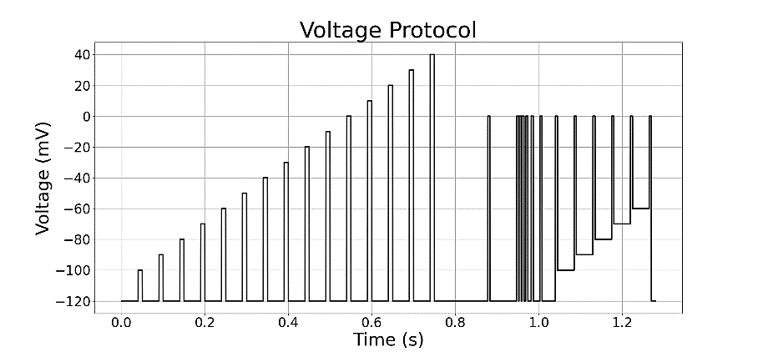
Figure S1. Voltage protocol designed for testing activation and inactivation parameters of compound effects in 5 s resolution.

A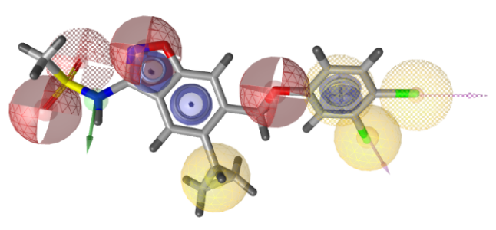 B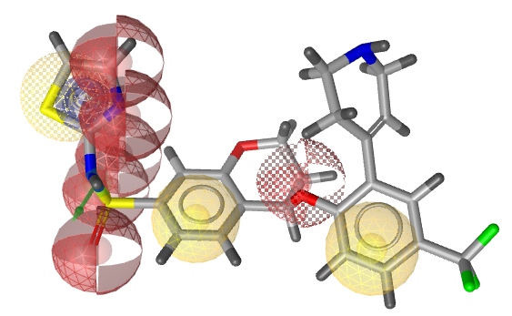
C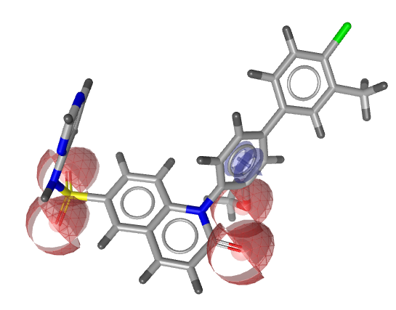 D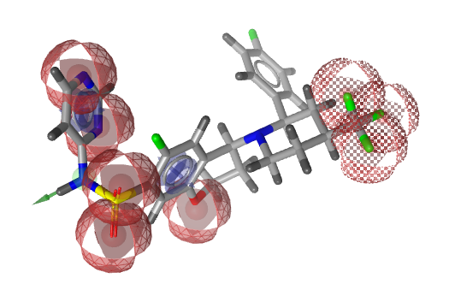
E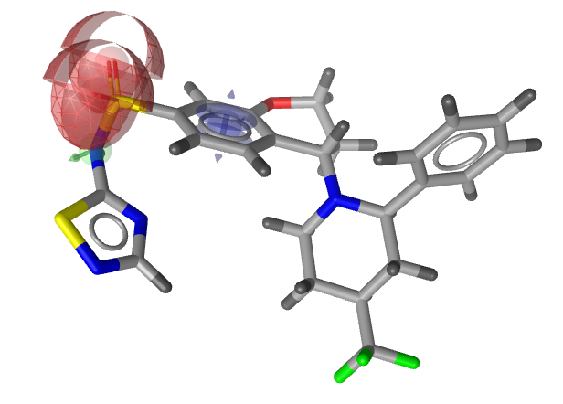
Figure S2. Ligand-based pharmacophore models for Na_{V}1.7 inhibitors with IC₅₀≤10 nM. A) LBPM_Nav1.7_Cluster5, B) LBPM_Nav1.7_Cluster8, C) LBPM_Nav1.7_Cluster10, D) LBPM_Nav1.7_Cluster11, and E) LBPM_Nav1.7_Cluster12. Each model is aligned with the inhibitor with the highest pharmacophore fit score. The pharmacophore features are as follows: hydrophobic (H, yellow spheres), aromatic (AR, blue disc), hydrogen bond donor (HBD, green arrow), and hydrogen bond acceptor (HBA, red sphere).

A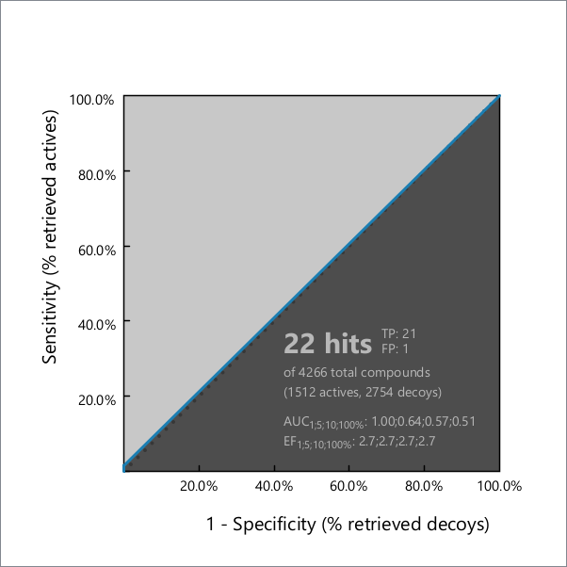 B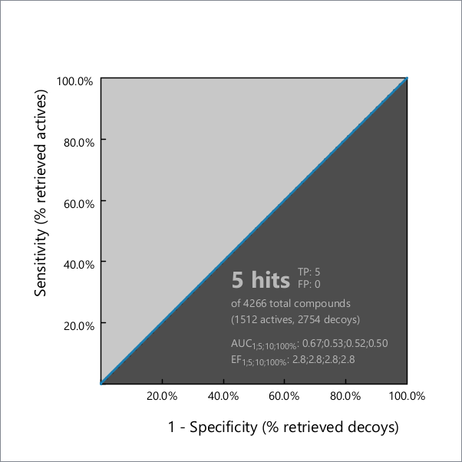
C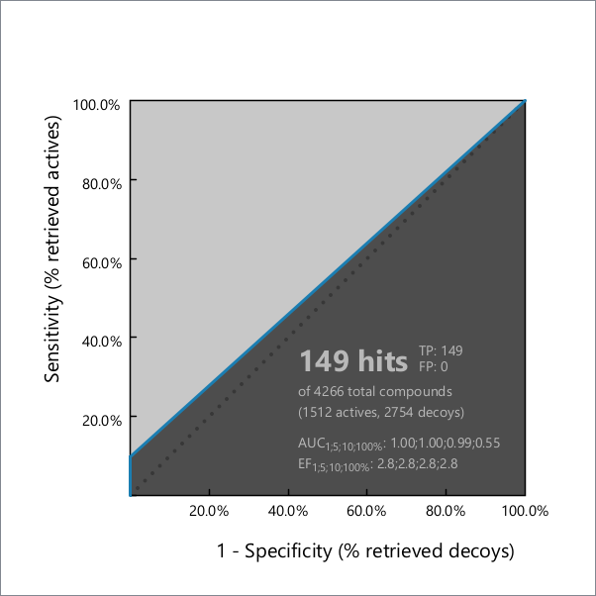 D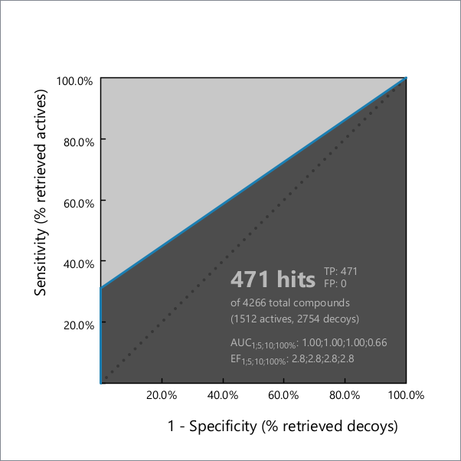
E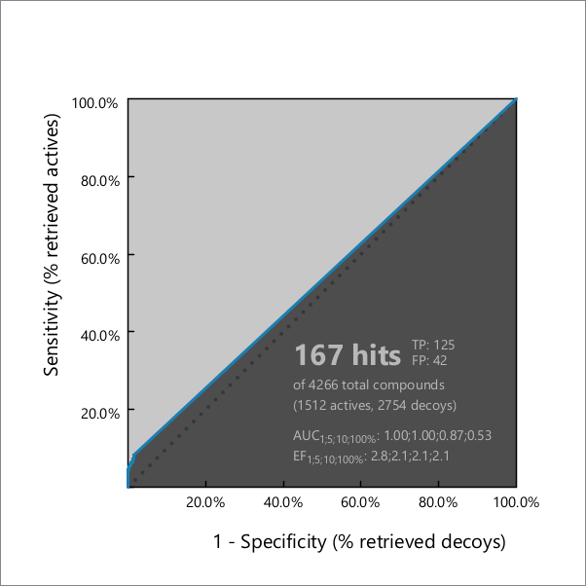 F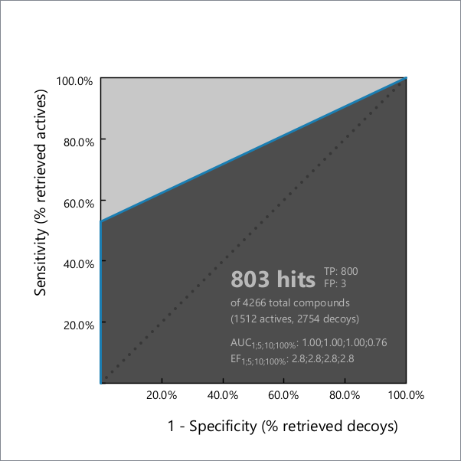 G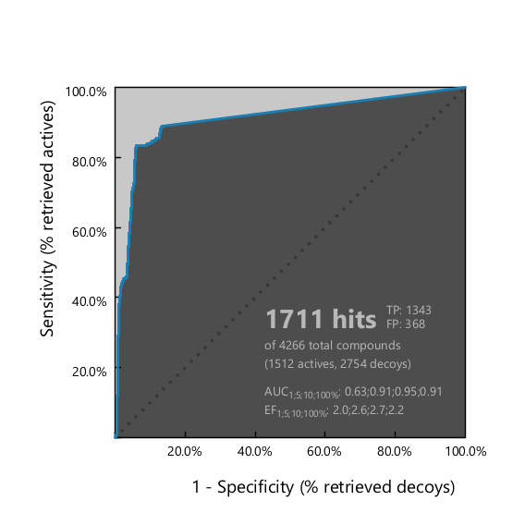 H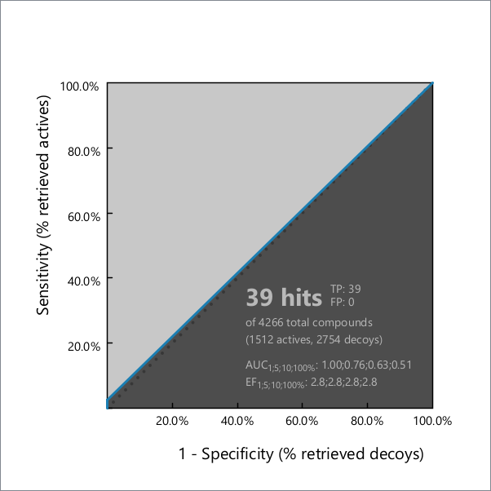
Figure S3. ROC plot (curve shown in blue) generated from virtual screening of actives and generated decoys with A) LBPM_Nav1.7_Cluster4; B) LBPM_Nav1.7_Cluster5; C) LBPM_Nav1.7_Cluster8; D) LBPM_Nav1.7_Cluster9; E) LBPM_Nav1.7_Cluster10; F) LBPM_Nav1.7_Cluster11; G) LBPM_Nav1.7_Cluster12; H) LBPM_Nav1.7_Cluster13; TP = true positives; FP = false positives; AUC = area under the curve; EF = enrichment factor.

A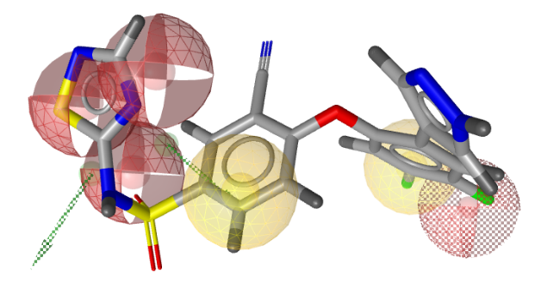 B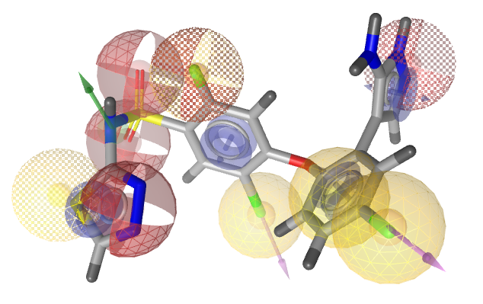
C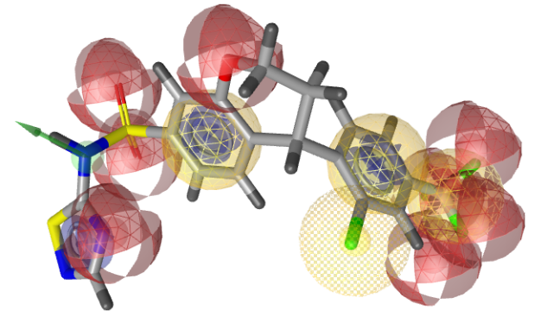 D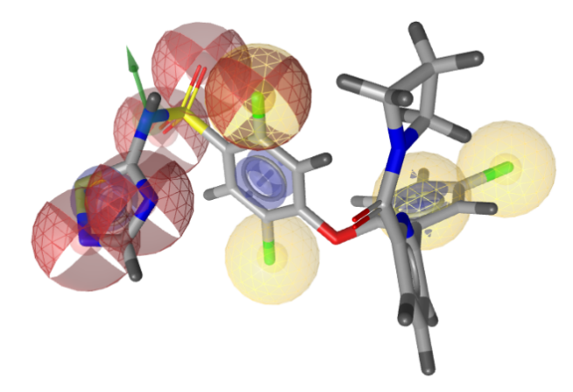
E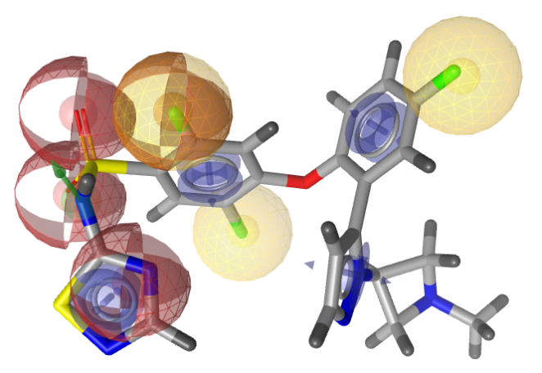F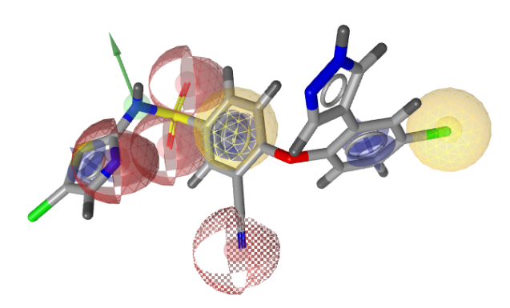
Figure S4. Ligand-based pharmacophore models for Na_{V}1.7 inhibitors with IC₅₀≤10 nM. A) LBPM_Nav1.7_Cluster12_3; B) LBPM_Nav1.7_Cluster12_4; C) LBPM_Nav1.7_Cluster12_5; D) LBPM_Nav1.7_Cluster12_6; E) LBPM_Nav1.7_Cluster12_7; F) LBPM_Nav17_Cluster12_8. Each model is aligned with the inhibitor with the highest pharmacophore fit score. The pharmacophore features are as follows: hydrophobic (H, yellow spheres), aromatic (AR, blue disc), hydrogen bond donor (HBD, green arrow), and hydrogen bond acceptor (HBA, red sphere).

A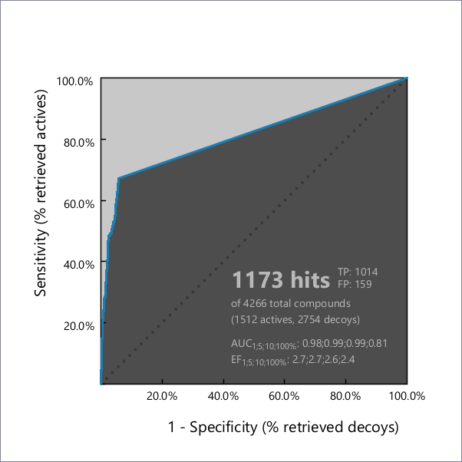 B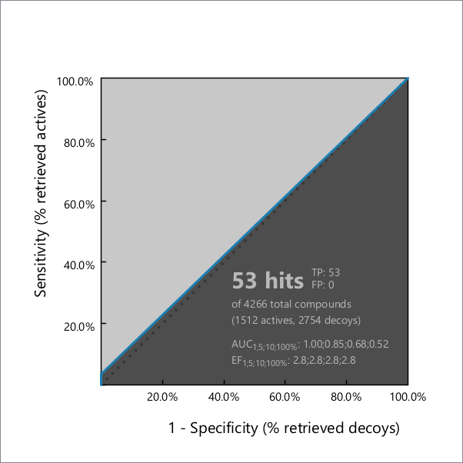
C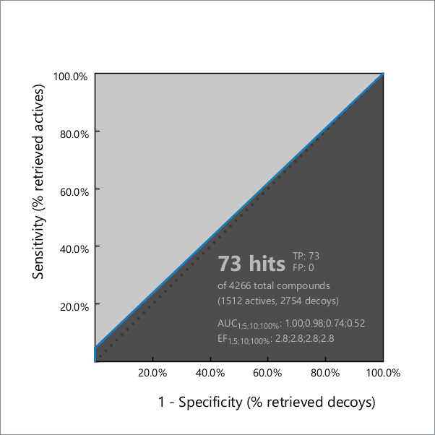 D
E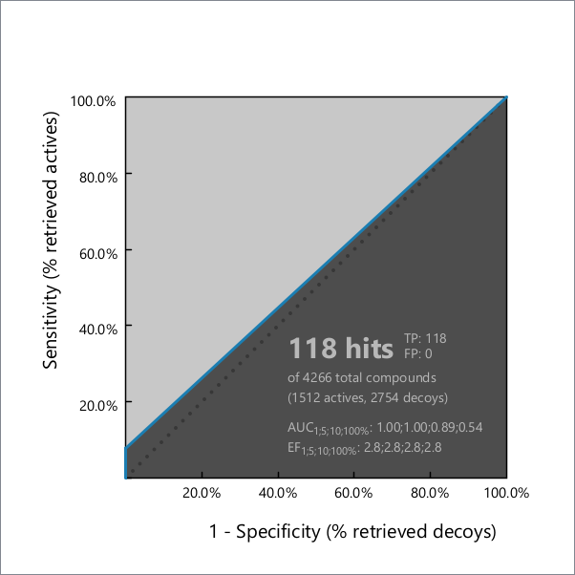 F
Figure S5. ROC plot (curve shown in blue) generated from virtual screening of actives and generated decoys with A) LBPM_Nav1.7_Cluster12_3; B) LBPM_Nav1.7_Cluster12_4; C) LBPM_Nav1.7_Cluster12_5; D) LBPM_Nav1.7_Cluster12_6; E) LBPM_Nav1.7_Cluster12_7; F) LBPM_Nav1.7_Cluster12_8; TP = true positives; FP = false positives; AUC = area under the curve; EF = enrichment factor.

Table S1. Validation metrics for all Na_{V}1.7 pharmacophore models.
 | EF  1% | EF  5% | AUC  1% | AUC  5% | sensitivity | specificity | Matthews correlation coefficient
LBPM_Nav1.7_Cluster4 | 2.7 | 2.7 | 1.00 | 0.64 | 1.4% | 100% | 0.090
LBPM_Nav1.7_Cluster5 | 2.8 | 2.8 | 0.67 | 0.53 | 0.3% | 100% | 0.046
LBPM_Nav1.7_Cluster8 | 2.8 | 2.8 | 1.00 | 1.00 | 9.9% | 100% | 0.257
LBPM_Nav1.7_Cluster9 | 2.8 | 2.8 | 1.00 | 1.00 | 31.1% | 100% | 0.475
LBPM_Nav1.7_Cluster10 | 2.8 | 2.1 | 1.00 | 1.00 | 8.3% | 98.5% | 0.166
LBPM_Nav1.7_Cluster11 | 2.8 | 2.8 | 1.00 | 1.00 | 52.9% | 99.9% | 0.646
LBPM_Nav1.7_Cluster12 | 2.0 | 2.6 | 0.63 | 0.91 | 88.8% | 86.6% | 0.736
LBPM_Nav1.7_Cluster12_3 | 2.7 | 2.7 | 0.98 | 0.99 | 67.1% | 94.2% | 0.657
LBPM_Nav1.7_Cluster12_4 | 2.8 | 2.8 | 1.00 | 0.85 | 3.5% | 100% | 0.151
LBPM_Nav1.7_Cluster12_5 | 2.8 | 2.8 | 1.00 | 0.98 | 4.8% | 100% | 0.178
LBPM_Nav1.7_Cluster12_6 | 2.8 | 2.8 | 1.00 | 1.00 | 9.9% | 100% | 0.257
LBPM_Nav1.7_Cluster12_7 | 2.8 | 2.8 | 1.00 | 1.00 | 7.8% | 100% | 0.228
LBPM_Nav1.7_Cluster12_8 | 2.8 | 2.8 | 1.00 | 1.00 | 31.2% | 100% | 0.475
LBPM_Nav1.7_Cluster13 | 2.8 | 2.8 | 1.00 | 0.76 | 2.6% | 100% | 0.130

A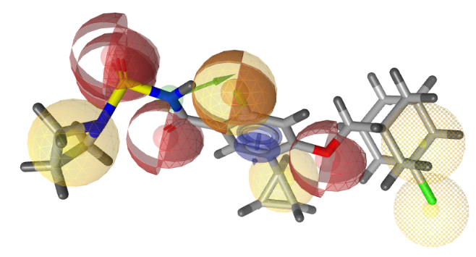B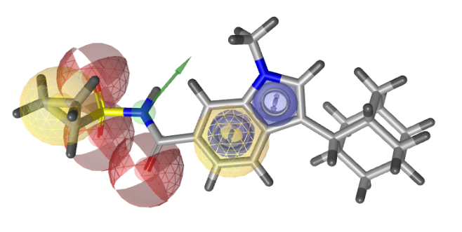C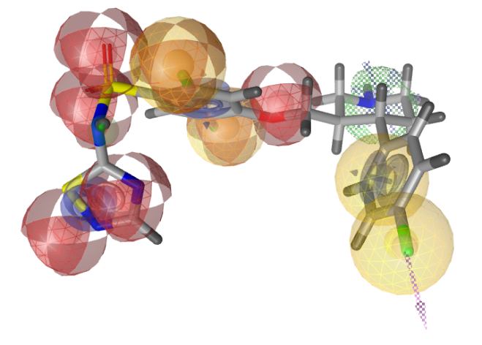D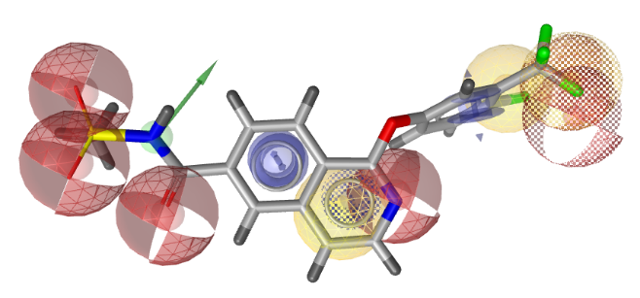E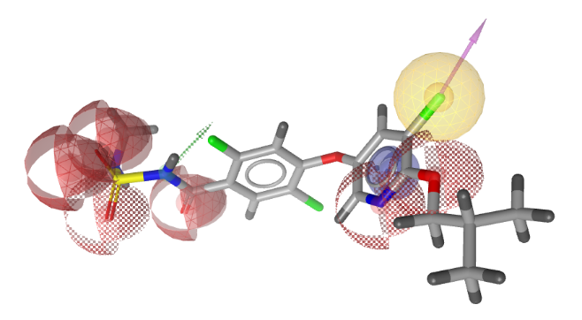F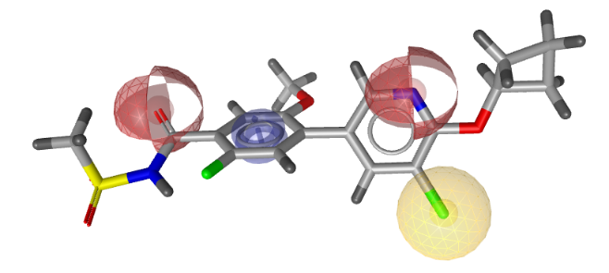G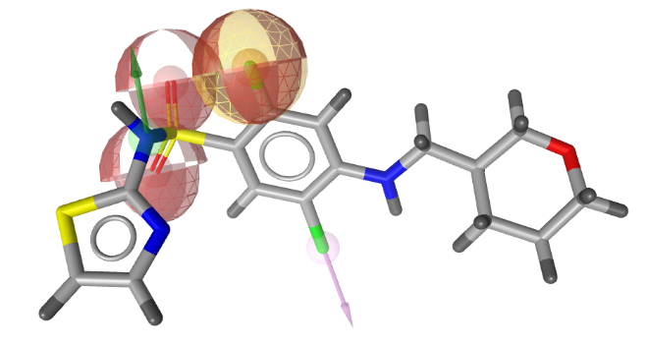H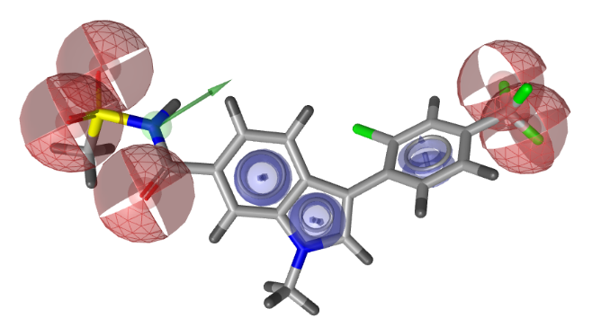I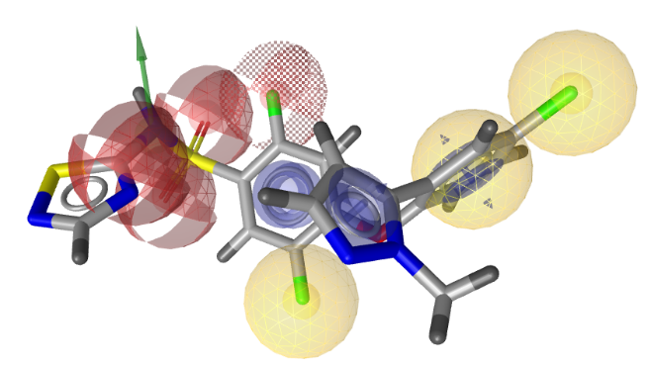J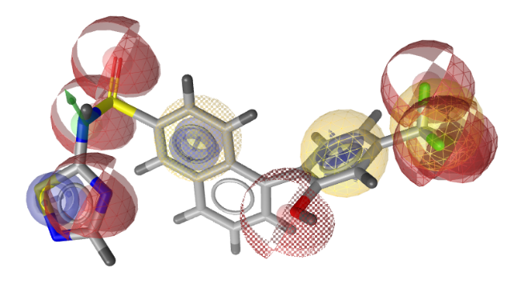
K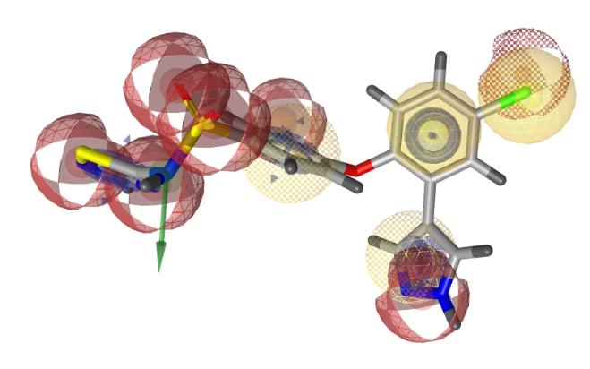L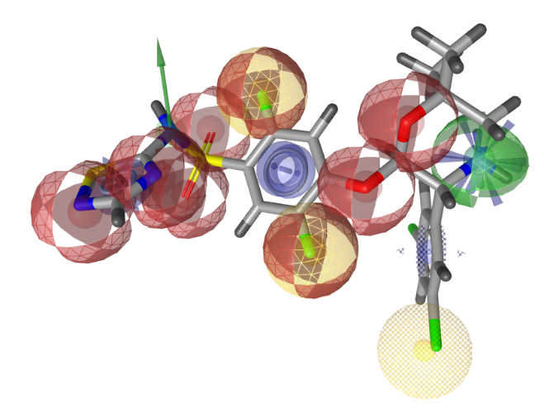
Figure S6. Ligand-based pharmacophore models for Na_{V}1.5 inhibitors with IC₅₀≤10 nM. A) LBPM_Nav1.5_Cluster13; B) LBPM_Nav1.5_Cluster15; C) LBPM_Nav1.5_Cluster16; D) LBPM_Nav1.5_Cluster17; E) LBPM_Nav1.5_Cluster18; F) LBPM_Nav1.5_Cluster19, G) LBPM_Nav1.5_Cluster20; H) LBPM_Nav1.5_Cluster21; I) LBPM_Nav1.5_Cluster22_5; J) LBPM_Nav1.5_Cluster22_6; K) LBPM_Nav1.5_Cluster22_7; L) LBPM_Nav1.5_Cluster22_8. Each model is aligned with the inhibitor with the highest pharmacophore fit score. The pharmacophore features are as follows: hydrophobic (H, yellow spheres), aromatic (AR, blue disc), hydrogen bond donor (HBD, green arrow), and hydrogen bond acceptor (HBA, red sphere).
A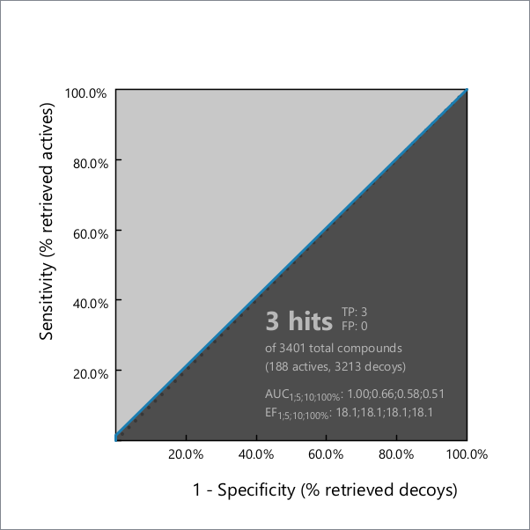 B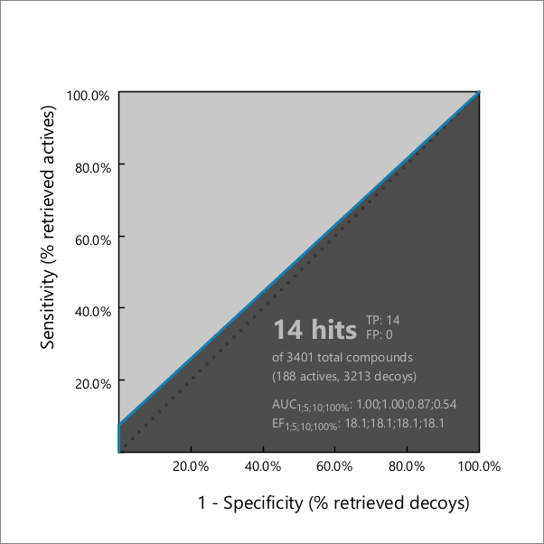C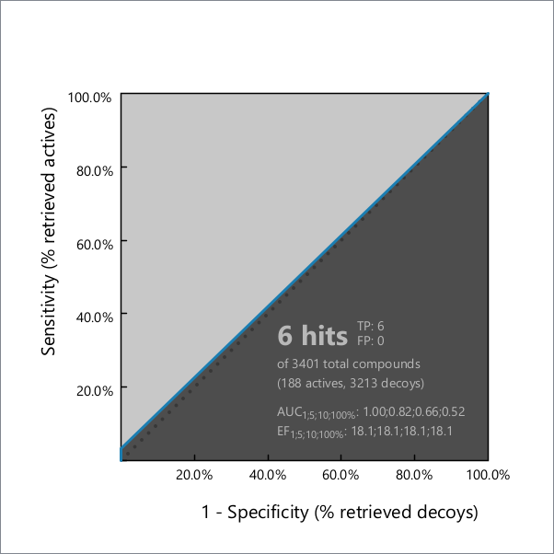 DE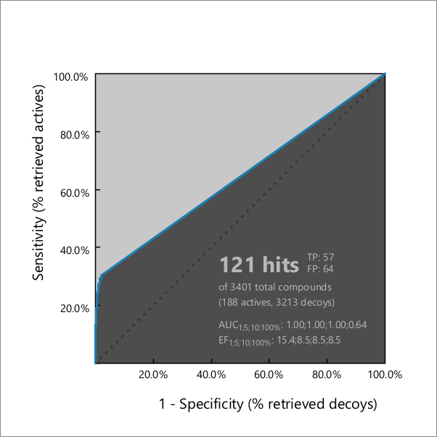 F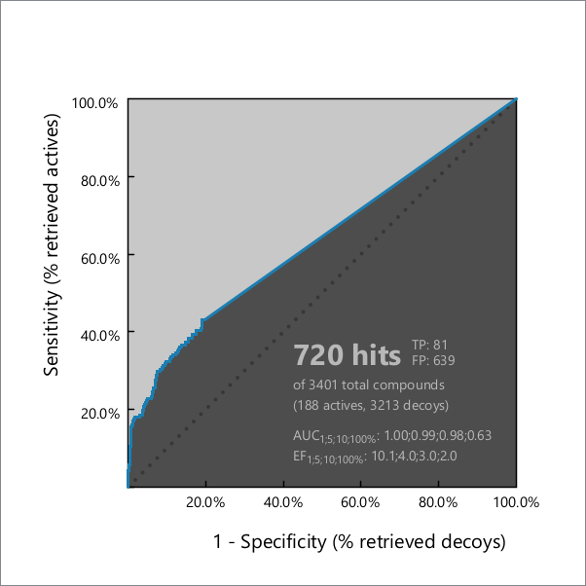G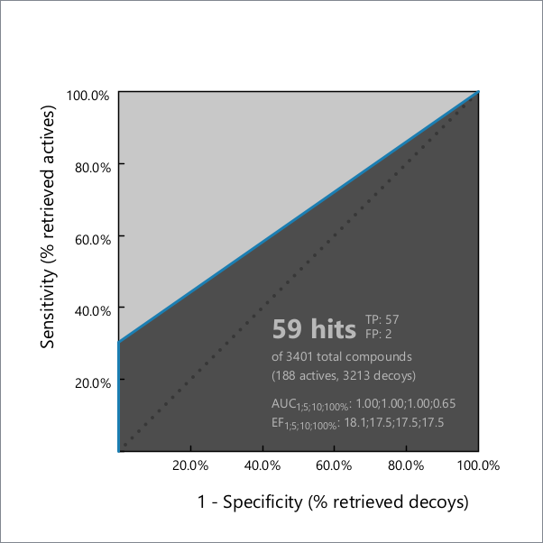 H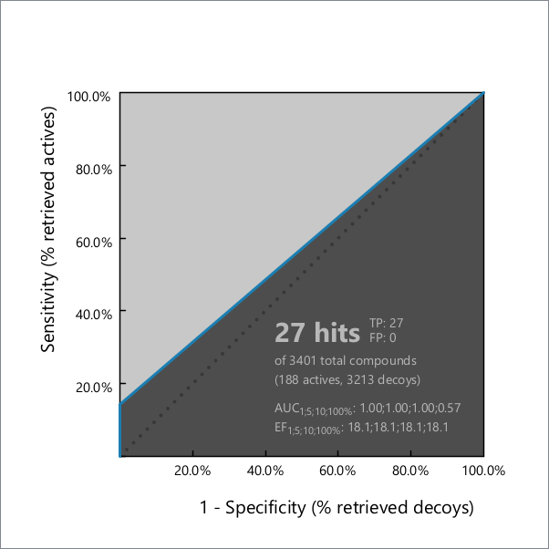I 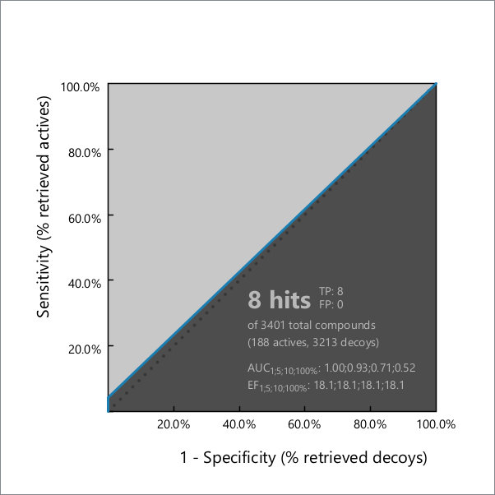 J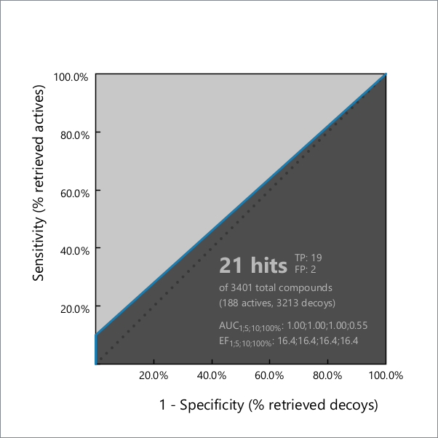K L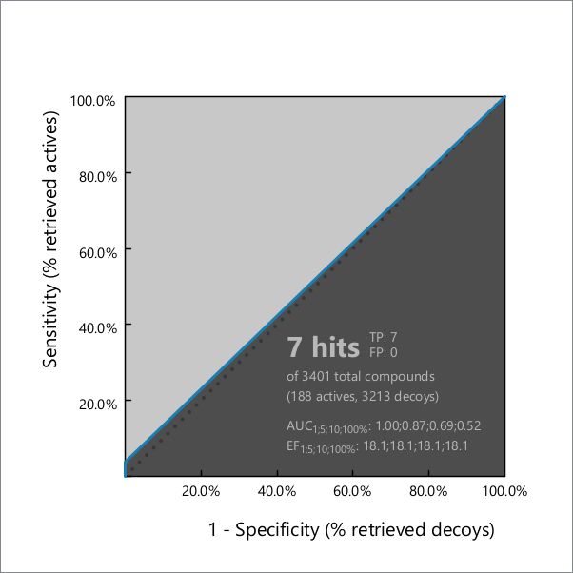
Figure S7. ROC plot (curve shown in blue) generated from virtual screening of actives and generated decoys with A) LBPM_Nav1.5_Cluster13; B) LBPM_Nav1.5_Cluster15; C) LBPM_Nav1.5_Cluster16; D) LBPM_Nav1.5_Cluster17; E) LBPM_Nav1.5_Cluster18; F) LBPM_Nav1.5_Cluster19, G) LBPM_Nav1.5_Cluster20; H) LBPM_Nav1.5_Cluster21; I) LBPM_Nav1.5_Cluster22_5; J) LBPM_Nav1.5_Cluster22_6; K) LBPM_Nav1.5_Cluster22_7; L) LBPM_Nav1.5_Cluster22_8; TP = true positives; FP = false positives; AUC = area under the curve; EF = enrichment factor

A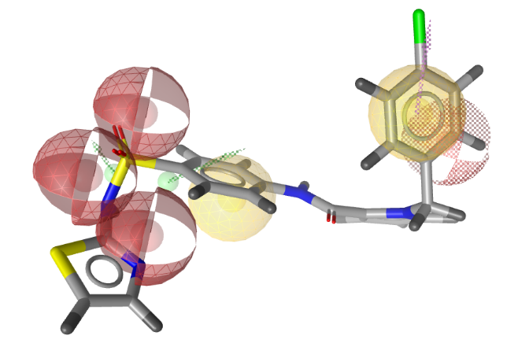 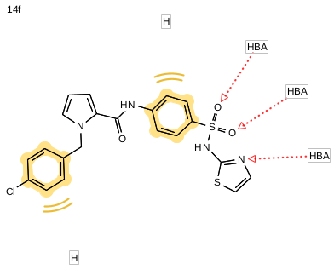
B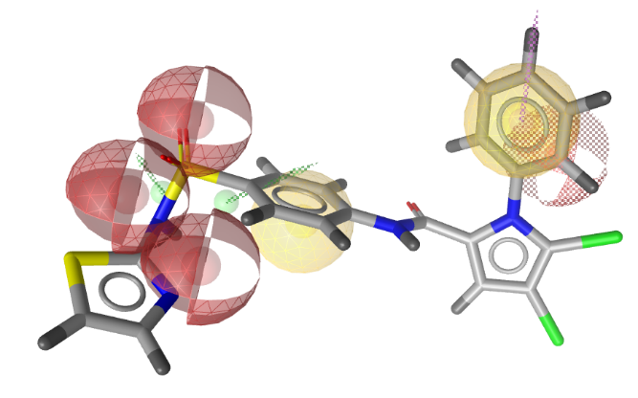 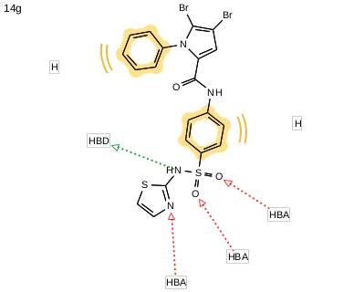C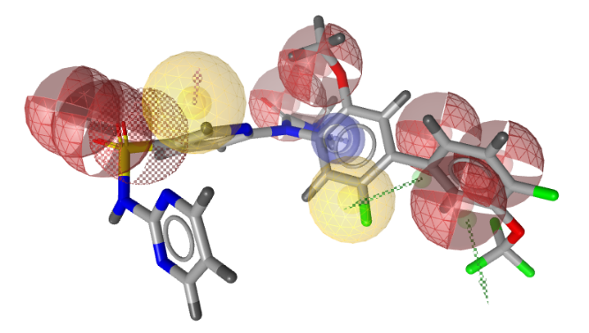 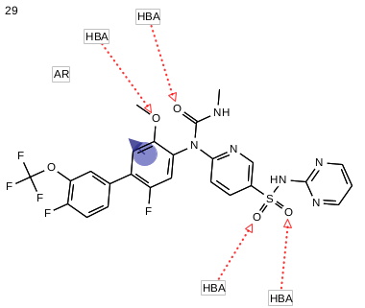
Figure S8. Overlay of A) inhibitor 14f and LBPM_Nav1.7_Cluster12_3; B) inhibitor 14g and LBPM_Nav1.7_Cluster12_3; C) inhibitor 29 and LBPM_Nav1.7_Cluster10. The pharmacophore features are as follows: hydrophobic (H, yellow spheres), aromatic (AR, blue disc), hydrogen bond donor (HBD, green arrow), hydrogen bond acceptor (HBA, red sphere), and (HAL, dotted pink arrow).
A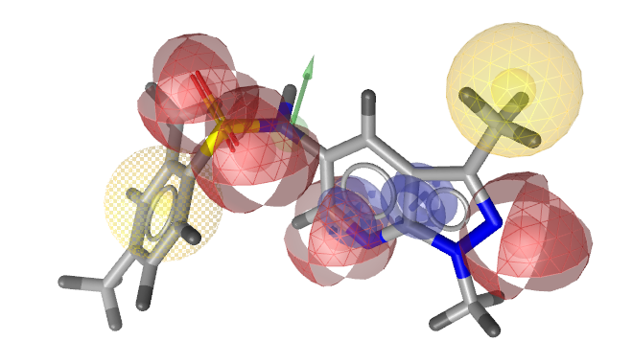B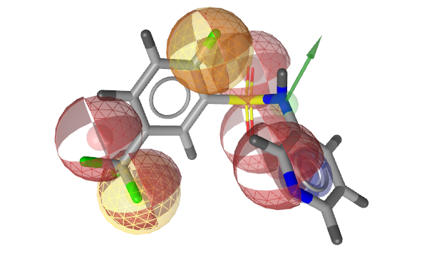
C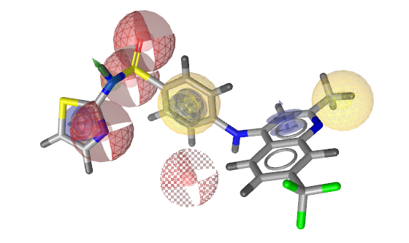D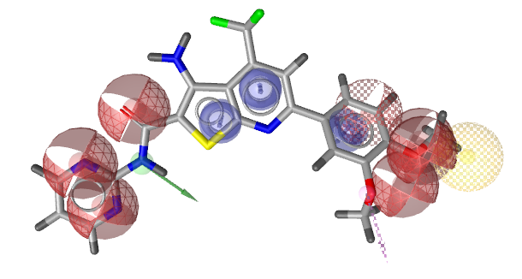
E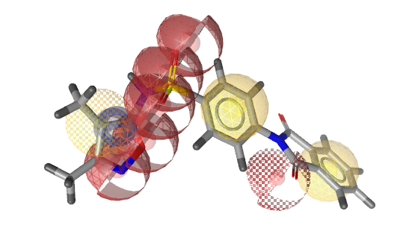F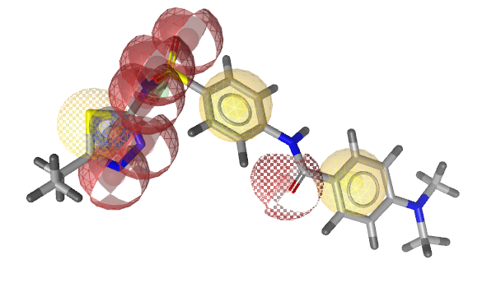
G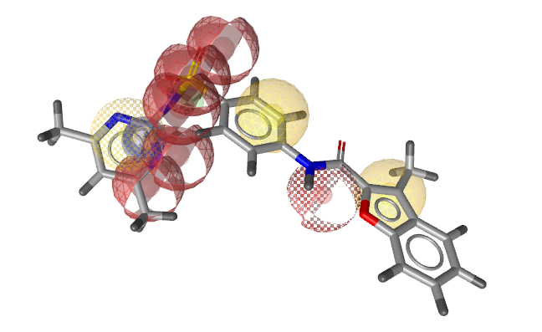H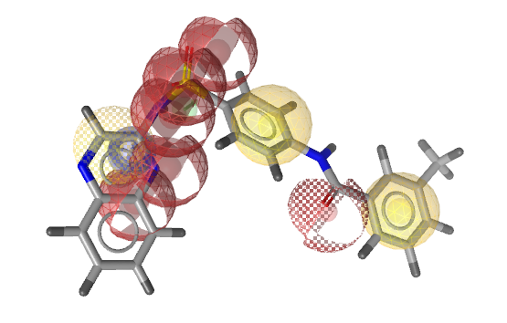
I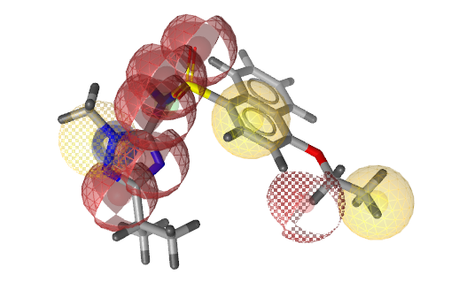J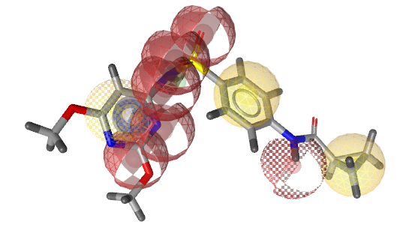
Figure S9. Overlay of A) compound 1 and LBPM_Nav1.7_Cluster4; B) compound 2 and LBPM_Nav1.7_Cluster9; C) compound 3 and LBPM_Nav1.7_Cluster12_8; D) compound 4 and LBPM_Nav1.7_Cluster13; E-J) compounds 5-10 and LBPM_Nav1.7_Cluster8. The pharmacophore features are as follows: hydrophobic (H, yellow spheres), aromatic (AR, blue disc), hydrogen bond donor (HBD, green arrow), hydrogen bond acceptor (HBA, red sphere), and (HAL, dotted pink arrow).

A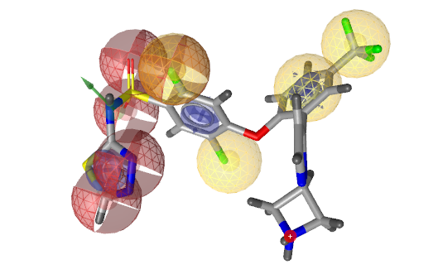B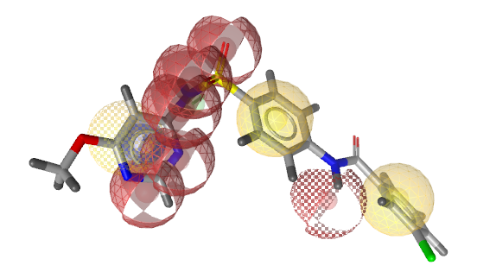
Figure S10. Overlay of A) compound 11 and LBPM_Nav1.7_Cluster12_6; B) compound 12 and LBPM_Nav1.7_Cluster8. The pharmacophore features are as follows: hydrophobic (H, yellow spheres), aromatic (AR, blue disc), hydrogen bond donor (HBD, green arrow), hydrogen bond acceptor (HBA, red sphere), and (HAL, dotted pink arrow).

Table S1. Known Na_{V}1.7 inhibitors identified with virtual screening performed using the Na_{V}1.7 ligand-based pharmacophore models (LBPMs) against a library of commercially available compounds: their alignment with the Na_{V}1.7 LBPM and docking binding mode in the Na_{V}1.7 DIV binding site.
Alignment of the VS hit with LBPM | Docking binding mode of the VS hit
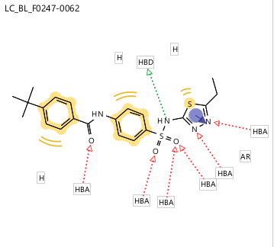  LBPM_Nav1.7_Cluster8 | 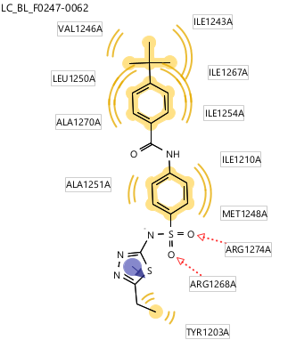
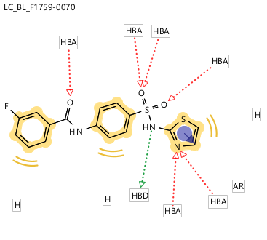  LBPM_Nav1.7_Cluster8 | 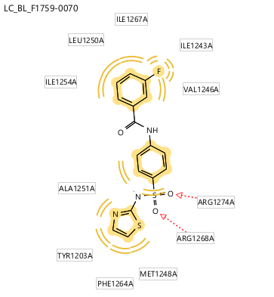
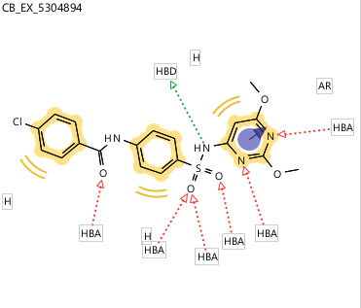  LBPM_Nav1.7_Cluster8 | 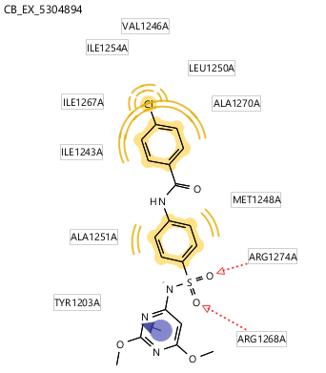
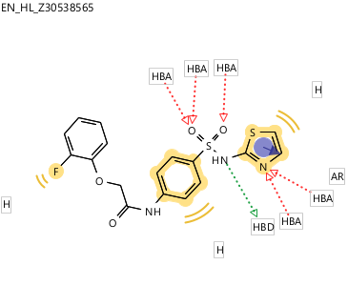  LBPM_Nav1.7_Cluster8 | 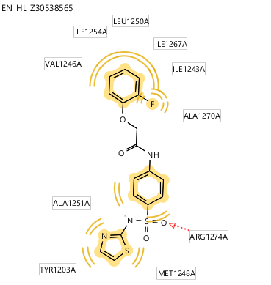
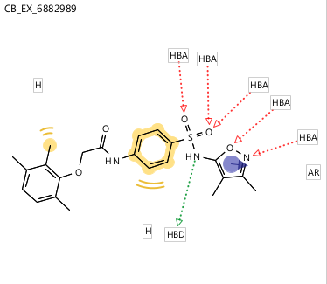  LBPM_Nav1.7_Cluster8 | 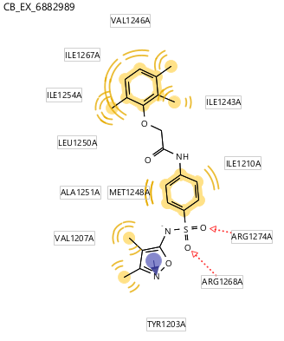
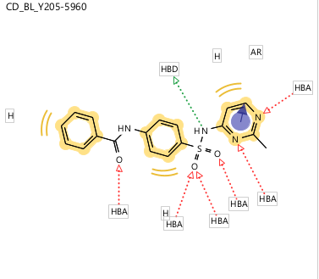  LBPM_Nav1.7_Cluster8 | 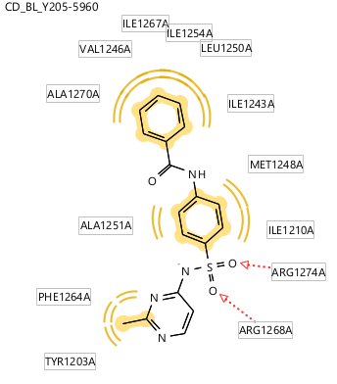
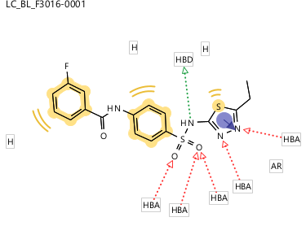  LBPM_Nav1.7_Cluster8 | 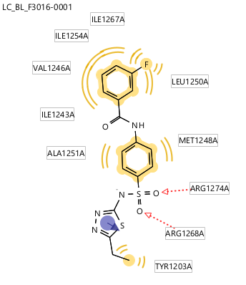
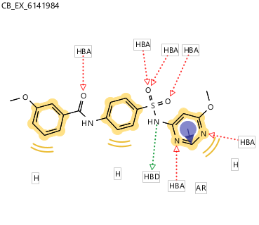  LBPM_Nav1.7_Cluster8 | 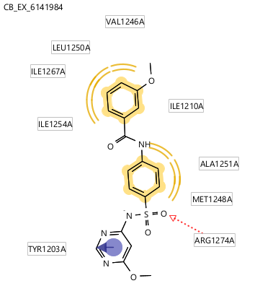
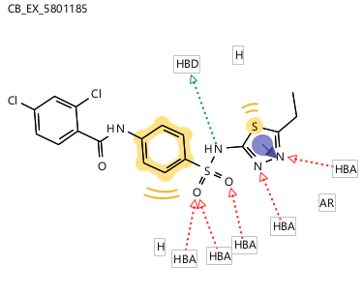  LBPM_Nav1.7_Cluster8 | 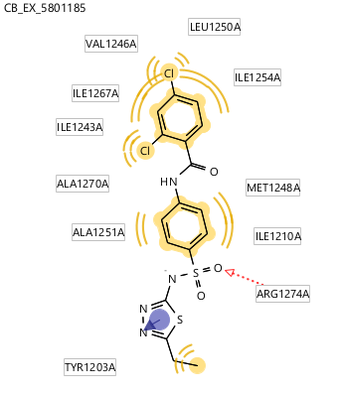
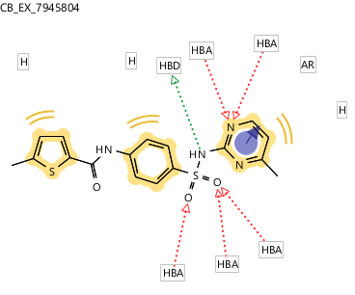  LBPM_Nav1.7_Cluster8 | 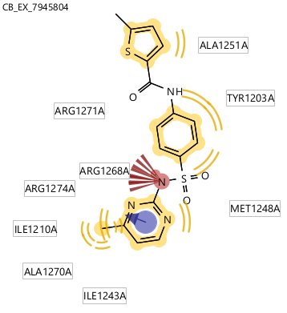
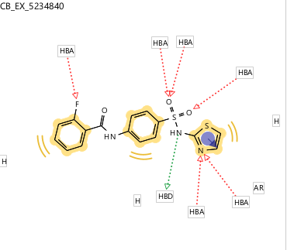  LBPM_Nav1.7_Cluster8 | 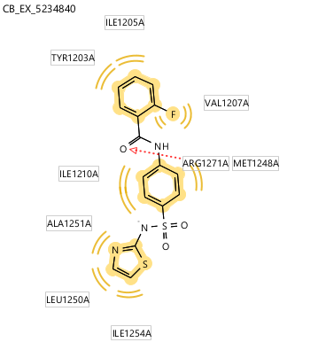
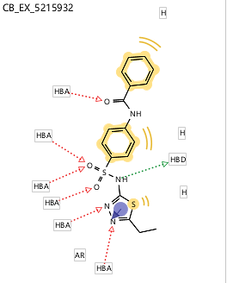LBPM_Nav17_Cluster8 | 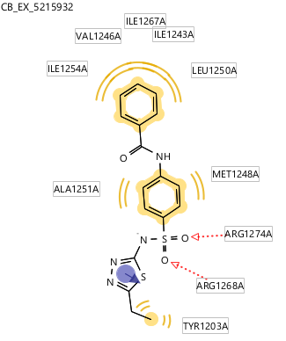

A
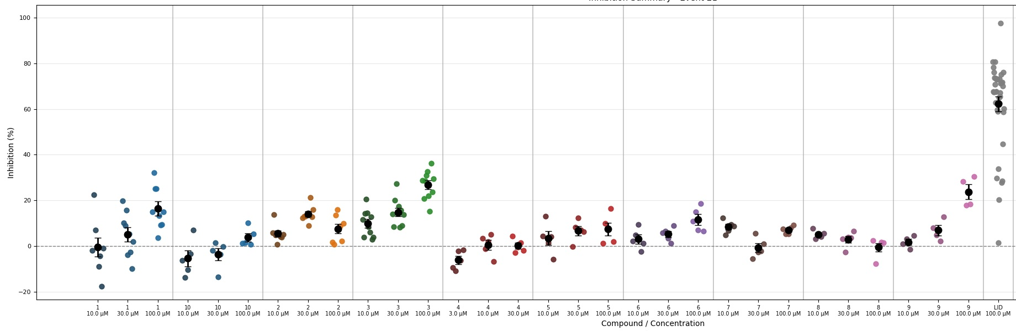

B
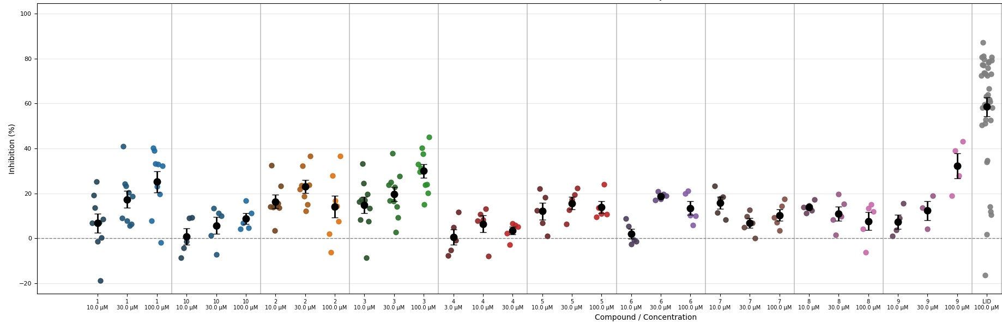
Figure S11. Dot plot of inhibition levels on Na_{V}1.7 for compounds 1–10. Event 21 (A) represents inhibition in the resting state, whereas event 47 (B) shows the inactivated state inhibition.

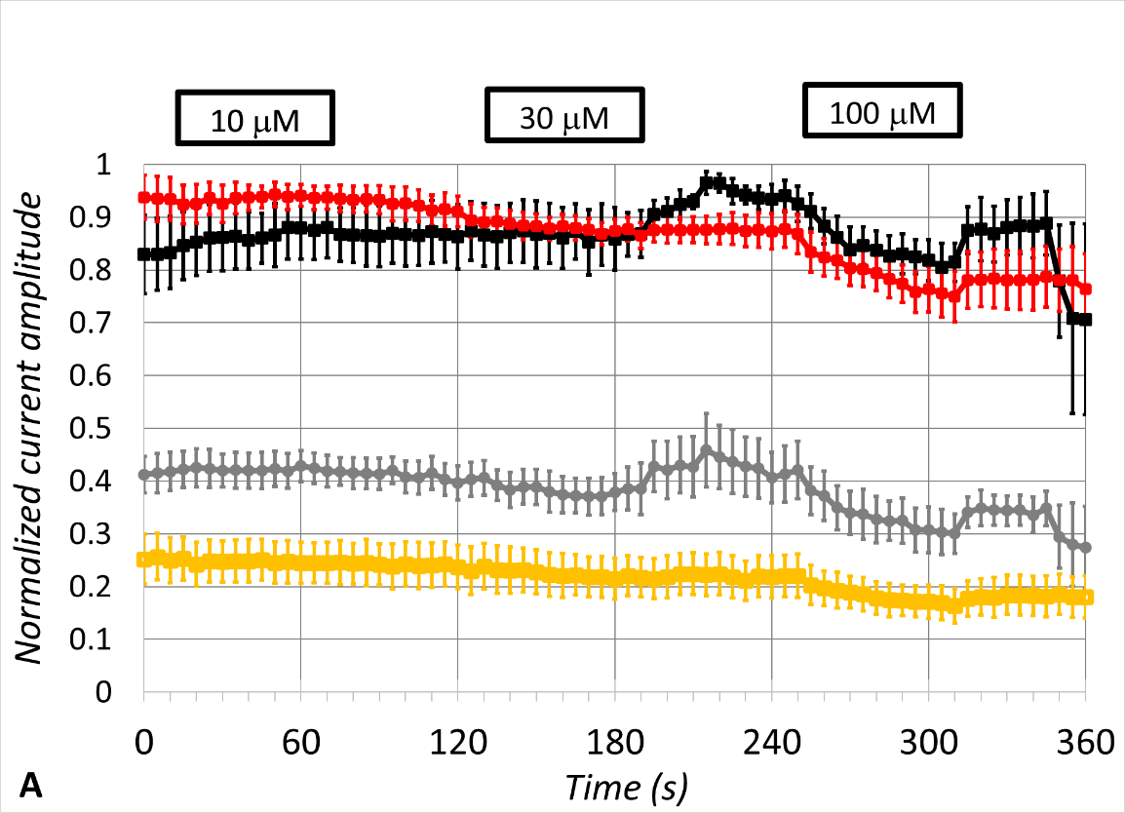
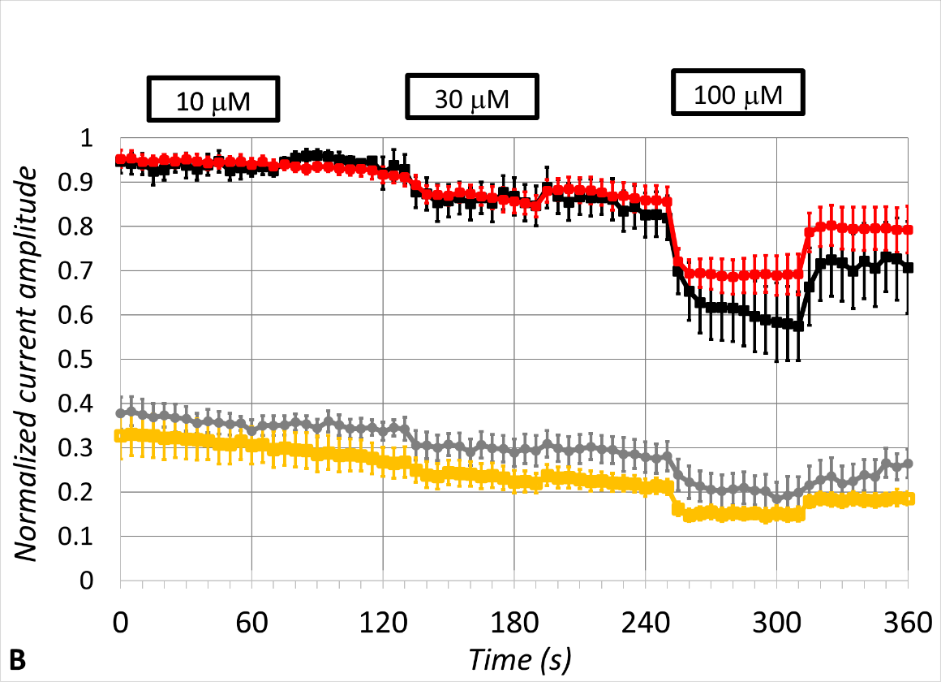
Figure S12. Data illustrating the non-selective (equipotent) effects of compounds 1 (A) and 9 (B) on both Na_{V}1.7 and Na_{V}1.5. Black (resting channel inhibition; n = 5) and grey (inactivated channel inhibition; n = 6) traces represent the compound effects on the Na_{V}1.7 amplitudes over time. Red (resting channel inhibition; n = 7) and orange (inactivated channel inhibition; n = 7) traces represent the compound effects on the Na_{V}1.5 amplitudes. Error bars represent ± SEM.

