Supplemental Materials

Figure S1. Parent-reported child and parent uses of social technology sites as an indicator of digital literacy 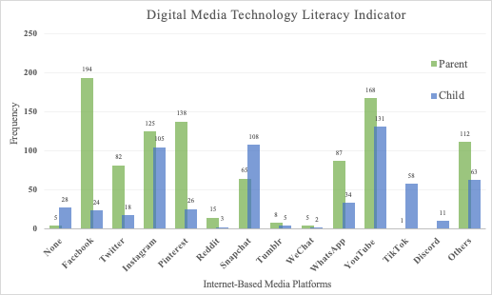
Note: Only 5 parents reported not using any of the internet-based media sites and 28 reported that their child does not use social media. TikTok and Discord use were only asked about for child’s internet-based media use. Other platforms included are LinkedIn, House Party, ooVoo, Steam, VSCO, and Kik.

Figure S2. Parent report of early adolescence social media use

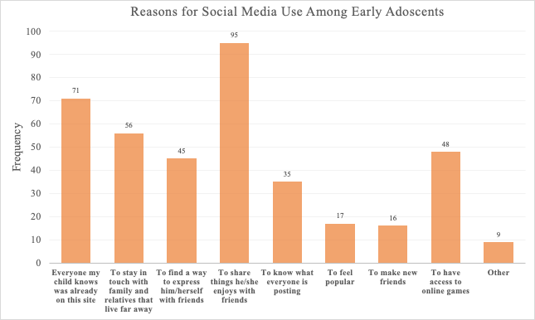

Note: “Other” includes communicating with friends without smartphones, making searches, accessing sports and health interests, watching videos, and promoting charity involvement.

Figure S3. Parental monitoring characteristics
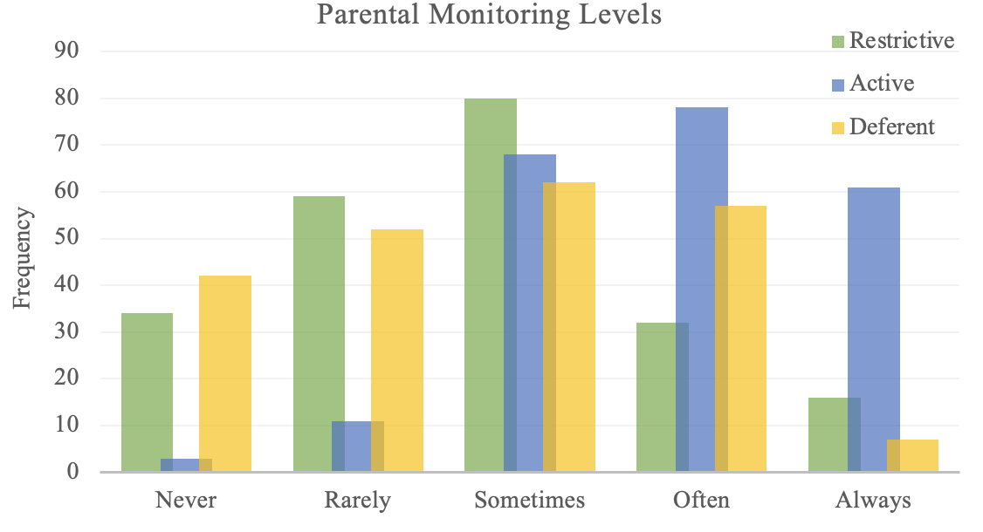
(a) (b)
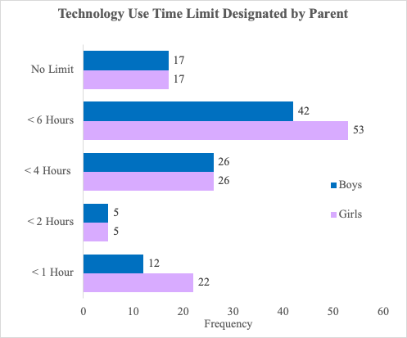

Note: Figure S3a frequencies collapsed by gender are as follows: < 1 hour = 15%; < 2 hours 4.4%; <4 hours = 22.9%; < 6 hour = 41.9%; and no limit = 15% of this sample.

Figure S4. Parental monitoring behaviors for young adolescents

