Careworkers’ Affect Regulation in Youth Residential Care: A Preliminary Study of the Psychometric Properties of the Affect Regulation Checklist

Supplemental Material

In order to identify possible confounding variables in the results obtained in the confirmatory factor analysis (CFA), post-hoc sensitivity analyses were performed. These analyses intend to rule out possible confounding variables. Thus, the variables gender, age, education, and length of working of careworkers were controlled.
The figure below shows the values of the CFA model with the introduction of the mentioned sociodemographic variables. These variables are not graphically represented in the figure, but the values presented refer to those obtained with the introduction of these variables. It is possible to observe that the values change slightly, but not significantly, and that the general results are maintained.
With the introduction of these variables in the model, we obtained the following fit: χ2/df = 1.35; CFI = .96, TLI = .95, SRMR = .05, RMSEA = .04, 90% CI [.02, .06].

ARC1
e1
.31
Dysregulation
e2
.52
.65
.67
-.14
-.04
.17
-.26
.23
ARC4
ARC7
ARC10
ARC3
Suppression
ARC6
e3
e4
e5
e6
ARC9
e7
.62
.70
.55
.72
-.17
.63
.61
e8
-.10
ARC2
Adaptive Reflection

ARC5
ARC12
ARC8

e9
Exhaustion
Avoidance
Anxiety
e11
e10
.48
.08
-.20
.20
.24
.17
-.09
.22
.71
.80
.60

Table 2
Standardized regression coefficients between the subscales of the Portuguese Affect Regulation Checklist (ARC), ECR-RS and OLBI
 | 1 | 2 | 3 | 4 | 5 | 6
ARC
1 - Dysregulation | -
2 - Suppression | .470** | -
3 - Adaptive Reflection | -.021 | -.210** | -
ECR-RS
4 - Avoidance | .215** | .338** | -.220** | -
5 - Anxiety | .313** | .307** | -.145* | .218** | -
OLBI
6 - Exhaustion | .417** | .108 | -.062 | -.087 | .230** | -
MEAN | 2.056 | 2.443 | 3.750 | 1.990 | 2.125 | 3.643
SD | .665 | .819 | .775 | .866 | 1.148 | .968
Note. * p < .05. ** p < .01
ECR-RS - Experiences in Close Relationships – Relationship Structures Questionnaire
OLBI - Oldenburg Burnout Inventory
SD - Standard deviation

Table 3
Item fit statistics for all items of the ARC
Item | S_X2 | df.S_X2 | p.S_X2
1 | 46.02 | 32 | .052
2 | 39.34 | 42 | .588
3 | 32.48 | 29 | .299
4 | 41.75 | 28 | .053
5 | 46.38 | 41 | .260
6 | 39.02 | 32 | .183
7 | 15.07 | 20 | .772
8 | 36.04 | 41 | .690
9 | 51.68 | 37 | .055
10 | 29.45 | 23 | .166
11 | 51.65 | 33 | .000
12 | 89.19 | 39 | .084

Figure 2
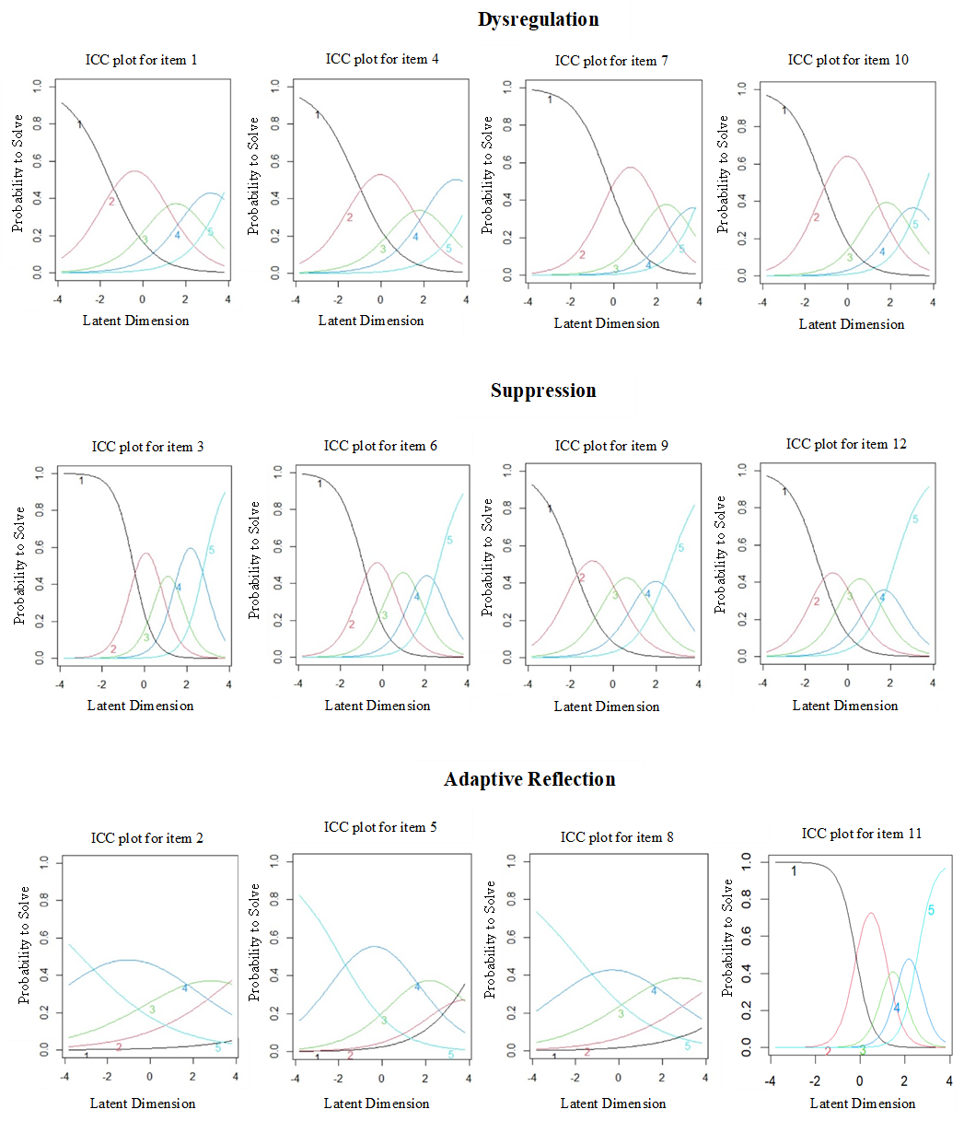
Item characteristic curves for all items of the ARC

5 – A lot like me
4 - Like me
2 - A little like me
1 - Not like me
3 - Moderately like me
Categories

Figure 3
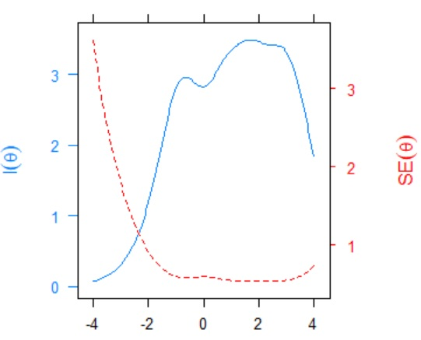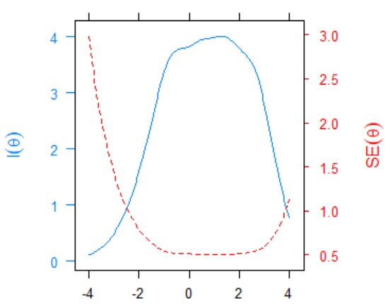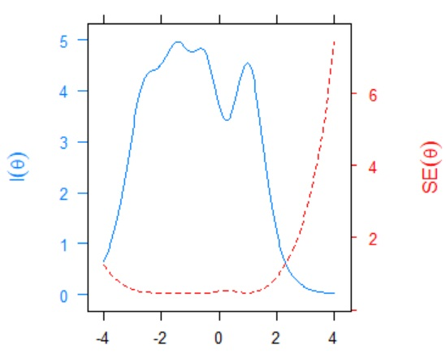Scale information and conditional standard errors
Latent Dimension
Dysregulation
Latent Dimension
Suppression
Latent Dimension
Adaptive Reflection
Information

Standard Errors

