Appendix 2
CFIES’s CFA results
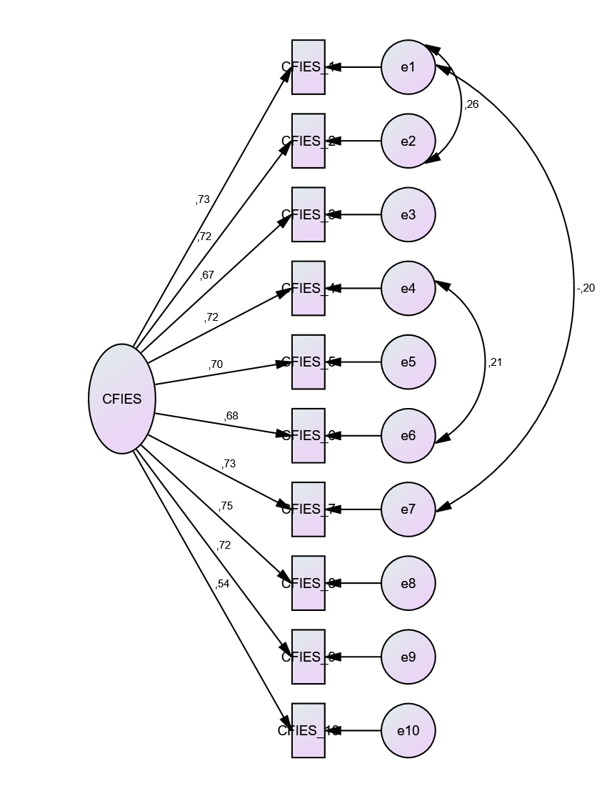

CMIN | DF | P | CMIN/DF | GFI | AGFI | PGFI | RFI  rho1 | IFI  Delta2 | TLI  rho2 | CFI | RMSEA
136.521 | 32 | .000 | 4.266 | .960 | .932 | .559 | .941 | .968 | .954 | .967 | .069

