Extended Data Figure 9_1
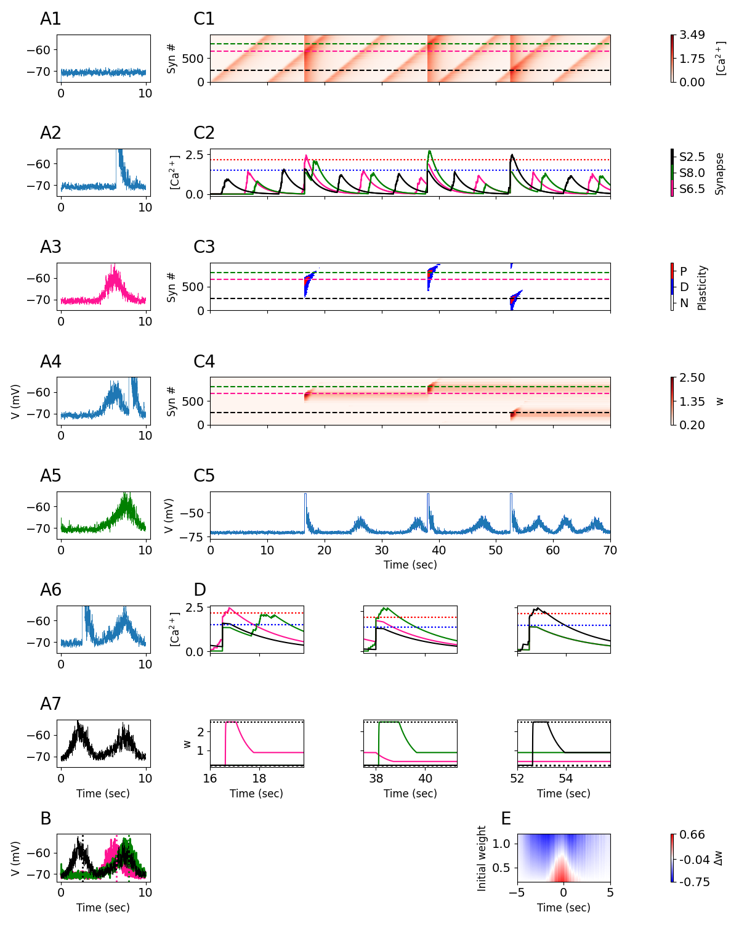
Extended Data Figure 9_1: Behavioral Time Scale Plasticity “Mirror Image” Experiment
(A1-A7) Voltage traces for 7 laps, each lap lasts for 10 seconds. A plateau potential is induced in the 2nd , 4th, and 6th laps. Green, pink, and black traces indicate place fields observed on the 3rd, 5th, and 7th laps, respectively. (B) Overlay of voltage traces for place fields from the 3rd (pink), 5th (green), and 7th (black) laps. Vertical dashed lines indicate plateau induction location during the preceding lap. (C1) Total $\left[{Ca}^{2+}\right]$ per synapse (rows, 40 synapses) over the course of all 7 laps. (C2) $\left[{Ca}^{2+}\right]$ over time for three synapses whose receptive fields are centered at the location of the first (pink – S6.5) second (green – S8) or third (black -- S2.5) plateau induction. Boxes show calcium traces around the time of plateau induction (see (D)). (C3) Plasticity bar codes for each synapse (rows) over all laps. (C4) Weights over time for each synapse over all laps. (C5) Voltage over time, as in A, for all 7 laps. (D) Zoom-in on the calcium traces (Top) and weights (Bottom) from the three synapses shown in (C) at the time of each plateau induction. In the second lap (left), the pink synapse’s (S6.5) $\left[{Ca}^{2+}\right]$ rises beyond $θ_{P}$, inducing potentiation toward the maximum strength (dotted horizontal line at top), and the green synapse’s (S8) $\left[{Ca}^{2+}\right]$ rises above $θ_{D}$, although the green synapse is already at the minimum strength (dotted horizontal line on bottom) so it can’t depress any further. In the fourth lap (middle), the green synapse’s $\left[{Ca}^{2+}\right]$ rises beyond $θ_{P}$, inducing potentiation, and the pink and black synapses’ $\left[{Ca}^{2+}\right]$ rises above $θ_{D}$, depressing it. In the sixth lap (right), the black synapse’s $\left[{Ca}^{2+}\right]$ rises beyond $θ_{P}$, inducing potentiation. (E) Change in weights as a function of initial weight and receptive field distance from plateau onset.

