Supplementary Material for
The Impact of Daycare Closures Owing to COVID-19 on Parental Stress:
The Case of Japan

Appendix A: Methods and results for reducing pretreatment bias

As mentioned in Section “Identification strategy," to estimate the treatment effects of daycare closures on parental stress, we needed to eliminate the bias stemming from the common shock of the coronavirus disease 2019 (COVID-19) crisis and the pretreatment bias stemming from the non-random treatment assignment of daycare closures. In this appendix, we present an analysis dealing with the pretreatment bias.

A1 Linear regression estimator
The basic estimation model for the empirical analysis is eq. (A.1)
$$\begin{aligned}Y_{i} =α +τ D_{i} +θ^{'}X_{i} +ε_{i}.\#\left(A.1\right)\end{aligned}$$
Here, we clarify how the status of daycare facilities during the COVID-19 crisis affected parents’ mental health. $Y$ is the Kessler Psychological Distress Scale (K6) scores for parents with children, $D$ the treatment variable, $X$ the control variable, and $ε$ the error term. Specifically, we compared the difference in K6 scores between the treatment and control groups, as shown in Eq. (A.2). We call this difference the linear regression estimator of the treatment effect (LR).
$$\begin{aligned}τ^{LR} = E\left[Y | D = 1\right]- E\left[Y | D = 0\right].\#\left(A.2\right)\end{aligned}$$
However, possibly, $τ^{LR}$ may have had some biases owing to the common shock caused by the COVID-19 crisis and pretreatment bias reflecting households’ selection of daycare facilities before the treatment assignment of daycare closures, as discussed in “Identification strategy."

A2 Inverted propensity weighting estimator
If the treatment assignment were not random and depended on individual/household characteristics and other factors, the estimates of the treatment effect would be biased. This is recognized as a pretreatment bias. In other words, if parents tended to enroll their children in daycare facilities that were likely to be closed, pretreatment bias would occur. In this context, the treatment group was considered to be the parents of children whose daycare facilities were closed after the initial declaration of a state of emergency. In Japan, nurseries (daycare facilities excluding kindergartens) prioritize households in which both parents are employed full time. Therefore, these households are more likely to choose nurseries. In contrast, if one or both parents are not regularly employed (non-regular employment, self-employed, or not employed), it becomes difficult for them to choose and enroll their children in nurseries that cater to their needs. However, these households could cope with sudden closures of daycare facilities if both parents had more flexible hours and routines than those with full-time employment. Therefore, even in the absence of daycare facilities during the first state of emergency, there might have been a downward bias in the estimates because the stress load presented was not high.
Parents could have enrolled their children in daycare facilities that were more likely to be closed. This tendency was an unobservable confounding factor ($U$); the usual LR cannot identify $τ$ and the estimate would be biased because of the pretreatment bias (Figure A1 (a)). Therefore, in addition to the usual LR, we used propensity scores (PS) to address the pretreatment bias and discuss the direction thereof. Using PS, an inverted PS weighting estimator (IPW) was used. In view of the criticism of PS matching by Smith and Todd (2005), King and Nielsen (2019), and others, we selected the IPW estimator rather than the PS matching estimator. IPW is a method of weighting an outcome variable by using the inverse of the PS estimate. PS were estimated using a logistic regression of covariates on the treatment variable. All covariates were measured before treatment.
$$\begin{aligned}π\left(X_{i};γ\right)=Pr\left(D_{it}=1 | X_{it-1};γ\right).\#\left(A.3\right)\end{aligned}$$
The PS values in Eq. (A.3) were used to weight the outcome variables. As IPW was used to adjust the balance between the treatment and control groups, the average treatment effects on the treated (ATT) are denoted as:
$$\begin{aligned}τ_{i}^{ipw}=\frac{1}{n}\sum_{i=1}^{n}{D_{i}Y_{i}}-\frac{1}{n}\sum_{i=1}^{n}{\left(1-D_{i}\right)Y_{i}\frac{\hat{π}\left(X_{i}\right)}{1-\hat{π}\left(X_{i}\right)}}.\#\left(A.4\right)\end{aligned}$$
The treatment group was weighted as $1$, and the control group as $π(X_{i})/\left(1-\hat{π}\left(X_{i}\right)\right)$. Thus, the control group had a larger weight if the PS was higher, and a smaller weight if the PS was lower. Controls with higher PS and a greater weighting become more important for treatment comparisons. The effect of covariate $X$ was controlled for by mediating the $PS π(X)$. This means that if controlling for $X$ makes the experiment unconfounded (Figure A1 (a)), then controlling for $π(X)$ also makes it unconfounded (Rosenbaum & Rubin, 1983). Figure A1 (b) shows an intuitive illustration of how $D$ reflects the causal effect on $Y$.

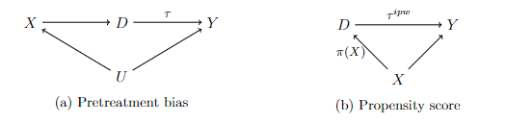
Figure A1 Directed acyclic graph of pretreatment bias

A3 Infection status in the region
We used PS and DID to estimate the effect of the closure of daycare facilities on parents’ K6 scores during the COVID-19 crisis and used pretreatment covariates to estimate the probability of treatment assignment in PS. As PS was used to address any pretreatment bias, the inclusion of covariates during the COVID-19 crisis would be inconsistent in estimating the probability of treatment assignment. However, as the closure of daycare facilities was voluntary, it was likely highly dependent on awareness of and attitude toward the COVID-19 crisis and the infection status in each region. In other words, daycare facilities in areas with a high awareness of the COVID-19 crisis, where a higher stay-home rate was observed, must actively have been closed. In addition, although the shock of the COVID-19 crisis can be considered a common shock, its impact likely differed by region. The impact on the K6 scores of residents in areas where infection rates were high may have differed from those in areas considered relatively free of COVID-19. In such cases, even if PS and DID were used, it would not be possible to accurately estimate $τ$.
Therefore, we addressed the above problem by including regional dummies and the average stay-home rate of the prefectures. Figure A2 shows the average stay-home rates in January, February, and April for each prefecture. Figure A2 shows that the top 10 prefectures in terms of stay-home rates were located in the major metropolitan areas (MMAs)—including Tokyo, Kanagawa, Chiba, Saitama, Osaka, Hyogo, and Fukuoka Prefecture. Figure A3 also shows the stay-home rates at the end of January, February, and April in ordinance-designated cities (ODCs). ODCs have larger populations than other cities, towns, and villages and are given the same level of authority as prefectures by the government as ordinary cities, towns, and villages. This chart shows that Saitama, Kyoto, Osaka, Kanagawa, Chiba, Fukuoka, and other ODCs had a higher stay-home rate. These prefectures and cities have a high population concentration and economic activity. They also have a large number of children on waiting lists to enroll in daycare facilities, which means that parents may not be able to easily enroll their children in the facility of their choice. Therefore, we considered it possible to control for the infection status of the COVID-19 crisis to some extent by including a dummy variable for the MMAs and a cross-term of dummies for ODCs and core cities in the estimation of the PS.

Notes: This figure shows the average stay-home rates in January, February, and April for each prefecture. See the “Covariates” section of the text for the stay-home rate.
Figure A2 Stay-home rate by prefecture

Notes: This figure shows the stay-home rates at the end of January, February, and April in ordinance-designated cities. See the “Covariates” section of the text for the stay-home rate.
Figure A3 Stay-home rate by ordinance-designated cities

A4 Results of the PS estimation in the baseline model
The estimation results of the PS function are presented in Table A1. The PS function is a logistic equation model described in Eq. (A.3) to explain the indicators of daycare closure. From this, we see that the more often one or both parents were employed full-time, the less likely daycare facilities were closed. It also shows that the greater the number of household members, the greater the likelihood of daycare facilities being closed. These effects may be attributed to self-selection; therefore, we calculated the PS and used them to reduce this potential bias.

Table A1. Propensity score estimation on base treatment variable
Variable | Coef | Std. Error
Constant | -2.223 | (1.740)
Female (=1) | 1.062 | (1.436)
30–34 years (=1) | 0.856 | (1.279)
35–39 years (=1) | 1.882 | (1.271)
≥40 years (=1) | 1.332 | (1.290)
30–34 years×Female (=1) | -0.770 | (1.524)
35–39 years×Female (=1) | -2.043 | (1.514)
≥40 years×Female (=1) | -0.993 | (1.540)
College graduates (=1) | 0.467 | (0.326)
Dual earner: non-regular employment (=1) | -0.957 | (0.786)
Dual earner: regular and non-regular employment (=1) | -0.641 | (0.376) | †
Dual earner: regular employment (=1) | -0.986 | (0.381) | *
First-born children: 7–12 years (=1) | -0.284 | (0.386)
First-born children: 13–15 years (=1) | -1.259 | (0.873)
First-born children: ≥16 years (=1) | -1.189 | (0.990)
Number of household members: 4–6 (=1) | 1.247 | (0.373) | **
Number of household members: ≥7 (=1) | 2.338 | (0.899) | *
Number of parents living with respondents | -1.075 | (0.781)
Number of parents living with spouse | -0.031 | (0.524)
Long-term care (=1) | 1.079 | (0.895)
Log (Household income in Jan. 2020) | -0.063 | (0.303)
Major metropolitan areas (MMAs) (=1) | -1.176 | (1.097)
Ordinance-designated cities (ODCs) (=1) | 0.125 | (1.314)
Core cities (=1) | -0.067 | (0.798)
MMAs (=1)×ODCs (=1) | 1.608 | (1.552)
MMAs (=1)×core cities (=1) | 0.398 | (1.368)
Number of observations | 258
Akaike information criterion | 340.7
Bayesian information criterion | 433.0
Log likelihood | -144.3
Notes: (=1) indicates the dummy variable.
Significance level: † $p<0.1$, * $p<0.05$, ** $p<0.01$.

To check for similarities between the groups, we compared the distribution of PS between the treatment and control groups. Figure A4 shows the distribution of PS before and after adjusting for ATT weight. ATT weighting was calculated using the PS values as follows:
$$w_{i}^{ATT}=D_{i}+\left(1-D_{i}\right)\frac{\hat{π}\left(X_{i};\hat{γ}\right)}{1-\hat{π}\left(X_{i};\hat{γ}\right)}.$$
In the treatment group, the ATT weighting is defined as $w^{ATT}=1$. In contrast, the weighting for the control group is expressed as $w^{ATT}=\hat{π}\left(X;\hat{γ}\right)/(1-\hat{π}\left(X;\hat{γ}\right))$. A greater weighting was given to households in the control group that had a higher PS—that is, they were considered more likely to be in the treatment group. Households in the control group with lower PS had a lower probability of being in the treatment group and were therefore considered less important as comparators for the treatment group and were allocated a lower weighting.
Figure A4 shows that the range in the distribution of PS before adjustment by ATT weight only concerned the overlap for the treatment and controls. Therefore, the common support assumption was satisfied for the data. However, the distribution of PS was different for the treatment and controls (the distribution of PS for controls was skewed to the right). After adjusting for ATT weight, the distribution of controls was similar to the treatment PS distribution.

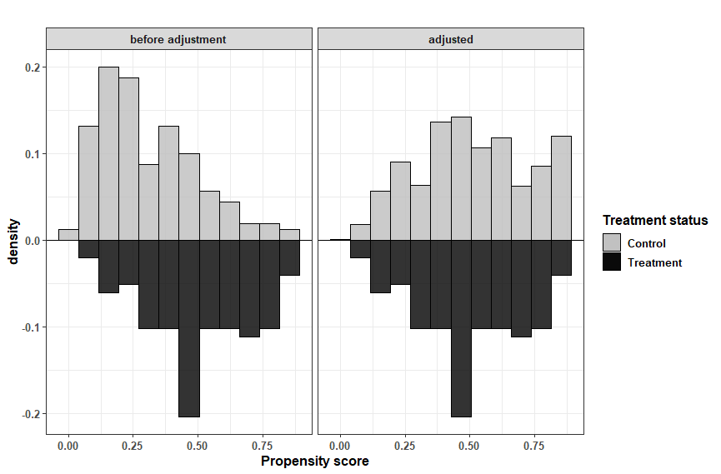
Figure A4 Distribution of propensity scores: Adjustment by average treatment effects on the treated weight

Finally, we examine a summary of the covariate balance before and after adjustment for each variable. Figure A5 illustrates the mean difference (absolute value) between the treatment and control values for each variable, both before and after adjustment. A mean difference of 0 indicates no difference between the treatment and control groups. The dotted line shows the mean difference of 0.1. From this, we see that all mean differences are less than 0.1 after adjustment for ATT weight. Therefore, we consider the covariances to be balanced after the adjustment.

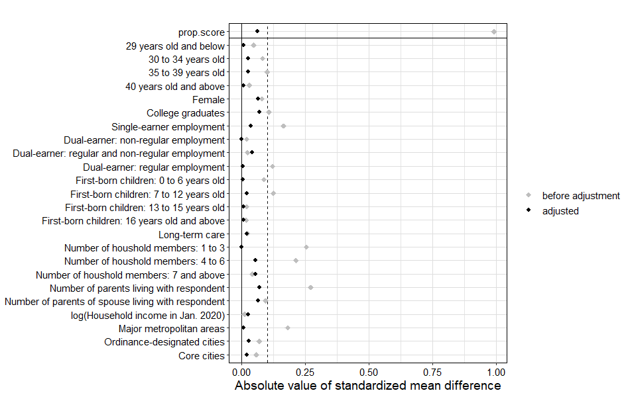
Figure A5 Balance of covariates

A5 Doubly robust DID
Based on the above discussion, we corrected the pretreatment bias using the PS and DID techniques. Combining the PS and DID methods requires that 1) the PS function of treatment variable $D$ and pretreatment covariable $X$ for calculating the PS is correctly specified and 2) that the outcome regression is correctly specified. If either is improperly specified, a consistent estimator cannot be obtained. Therefore, implementing PS combined with the DID method does not always produce robust results. To overcome such problems, Sant’Anna and Zhao (2020) proposed doubly robust DID (DR-DID) estimators, in which a consistent estimator is obtained if one of the above conditions holds. DR-DID is an estimation equation using IPW combined with an outcome regression function, which can be written as follows. First, $π\left(X;γ\right)$ is a PS function with covariance $X$ and parameters $γ$. In this study, we defined $Δ Y = Y_{1} - Y_{0}$ as the difference in outcome from January ($t=0$) to April ($t=1$), and $μ_{d,Δ}\left(X;β_{d,1},β_{d,0}\right)≡μ_{d,1}\left(x;β_{d,1}\right) -μ_{d,0}\left(x;β_{d,0}\right)$, where $μ_{d,t}\left(x;β_{d,t}\right)$ are the models for the outcome regression, $t=0,1$. Second, based on this, we calculated the estimand, evaluated via the parameter estimates, as follows:
$\begin{aligned}{\hat{τ}}^{dr did} = E_{n} \left[ \left({\hat{w}}_{1}\left(D\right)-{\hat{w}}_{0}\left(D,X; \hat{γ}\right) \right)\left(Δ Y -μ_{0,Δ}\left(X;{\hat{β}}_{0,0},{\hat{β}}_{0,1}\right)\right)\right],\#\left(A.5\right)\end{aligned}$where
$$\begin{aligned}{\hat{w}}_{1}\left(D\right)=\frac{D}{E_{n}\left[D\right]} and {\hat{w}}_{0}\left(D,X;\hat{γ}\right)= {\frac{\hat{π}\left(X;\hat{γ}\right)\left(1-D\right)}{1-\hat{π}\left(X;\hat{γ}\right)}}/{E_{n}\left[\frac{\hat{π}\left(X;\hat{γ}\right)\left(1-D\right)}{1-\hat{π}\left(X;\hat{γ}\right)}\right]}.\#\left(A.6\right)\end{aligned}$$
The moment equation in Eqs. (A5) and (A6) illustrates a two-step strategy for estimating ATT. The first step is to estimate the PS function $π(X;γ)$ and outcome regression $μ_{d,t}\left(⋅\right), d,t=0,1$. In the second step, the estimation of PS $\hat{π}\left(x;\hat{γ}\right)$ and the fitted values of the outcome regression $μ_{0,Δ}\left(x;{\hat{β}}_{0}, β_{1}\right) =μ_{0,1}\left(x;{\hat{β}}_{1}\right) -μ_{0,0}\left(x;{\hat{β}}_{0}\right)$ were plugged into the sample analog of $τ^{drdid}$.
For ${\hat{τ}}^{drdid}$ to converge to $τ$, the following three conditions must be fulfilled: 1) data should be independent and identically distributed, 2) conditional outcomes for treatment and control should be parallel in the absence of treatment, and 3) the PS support for treatment should be a subset of the PS support for control. When these three assumptions hold, if either (but not necessarily both) $π\left(X\right)$or $μ_{Δ}\left(X\right)$is correctly specified, then $τ^{drdid}$ is a consistent estimator of $τ$. (For specific proofs, see Sant’Anna & Zhao, 2020).
In the DR-DID methodology, the covariates for PS estimation and outcome regression must be aligned (see Sant’Anna & Zhao, 2020). Considering that the treatment group was formed because of the COVID-19 pandemic, the PS was calculated using covariates before the pandemic. Therefore, all covariates used in the analysis were obtained from the JHPS (as of January 2020) before the wide-scale onset of the pandemic. These descriptive statistics are summarized in “A. Key variables” and “B. Pretreatment covariates” in Table 2 of the main paper. We included monthly income in February as a pretreatment covariate.

A6 Results
We estimated a linear regression, IPW, DID, and DR-DID to determine whether closure of daycare facilities during the first state of emergency increased parents’ stress. Table A2 presents the estimation results. Column 1 summarizes the results of LR based on Eq. (A2). The results of the regression in Column 1 show that the treatment variable was positively statistically significant at the 10% level. Based on this estimate, parents who experienced the effect of daycare closure would experience an increase in their K6 score of about 1.08 points. Column 2 shows the results of the IPW based on Eq. (A4). According to the estimate, the treatment variable is positive and statistically significant at the 5% level. The closing of daycare facilities increased the K6 scores of parents by 1.303 points. This estimate is larger than that of LR, indicating a downward bias in the LR. Column 3 shows the results of the DID estimation based on Eq. (1) in the main study; however, this estimation excludes time-varying and COVID-19-related covariates. The estimate of DID is positive but not statistically significant, and is indicated by 1.003 points. Column 4 presents the DR-DID estimation based on Eq. (A5). The estimate is positive and statistically significant at the 5% level, indicating that parents’ stress increased by 1.076 points because of the closure of the daycare facility. This DR-DID was used in combination with DID to remove common shocks during the COVID-19 crisis, in addition to the IPW to remove the pretreatment bias mentioned earlier. From this, we see that the DR-DID estimate is smaller than the IPW estimate determined for the period during the first state of emergency and that there is an upward bias in the IPW, because the estimate reflects the impact of the common shock caused by the COVID-19 pandemic. Nevertheless, the estimate is still larger than the LR, meaning that the closure of daycare facilities increased parents’ stress, even after considering common shocks and pretreatment bias.

Table A2. Estimation results of the treatment effects
 | 1. LR | 2. IPW |  | 3. DID | 4. DR-DID
Treatment variable  Daycare facility closure defined by Table 1 | 1.079†  (0.582) | 1.303*  (0.601) |  | 1.003  (0.613) | 1.076*  （0.543）
Control variable | Yes | Yes |  | Yes | Yes
Number of observations | 258 | 258 |  | 516 | 516
Number of households | 258 | 258 |  | 258 | 258
Standard error type | HC1 | HC1 |  | HC1 | Inf. Func.
Estimands | ATE | ATT |  | ATT | ATT
Notes: Estimation results of the estimands on the Kessler Psychological Distress Scale (K6) score by linear regression (LR), inverse probability weighting (IPW), standard difference-in-differences, and doubly robust difference-in-differences (DR-DID) methods are tabulated. Heteroskedasticity-consistent standard errors are reported in LR, IPW, and DID, and the standard error obtained from the influence function is reported in DR-DID in parentheses, respectively. In the IPW, only the treatment dummy is included in the regression of the K6 score, because adjustment to the control variables was made in the calculation of the propensity score.
Significance level: † $p<0.1$, * $p<0.05$.

Next, we focused our estimation on the alternative definitions of the treatment variables in Table 4 in the main paper. The estimation results for the treatment variables created based on Table 4 are listed in Table A3. Panel A shows the estimated results for the alternative definitions of T1, and Panel B the estimated results for the alternative definitions of T2. We consider the results of the estimation of T1 for Panel A. LR and IPW in columns 1 and 2 are positive but not statistically significant. However, the DID and DR-DID of Columns 3 and 4 are positive and significant, respectively. In contrast, the estimation results in Panel B show that the treatment effects are positive and statistically significant for all estimation methods. Thus, it is clear that in all cases, even when pretreatment bias and common shocks are removed, closure of daycare facilities increased parents’ K6 scores.

Table A3. Robustness check: Estimation results of treatment effects with alternative treatment definition
 | 1. LR | 2. IPW |  | 3. DID | 4. DR-DID
Panel A: Alternative treatment T1
Treatment variable (=1) | 1.134  (0.701) | 1.043  (0.751) |  | 1.566*  (0.733) | 1.184†  (0.698)
Control variable | Yes | Yes |  | Yes | Yes
Number of observations | 202 | 202 |  | 404 | 404
Number of households | 202 | 202 |  | 202 | 202
Panel B: Alternative treatment T2
Treatment variable (=1) | 2.547*  (0.974) | 2.626**  (0.832) |  | 3.165**  (0.979) | 3.673*  (1.844)
Control variable | Yes | Yes |  | Yes | Yes
Number of observations | 132 | 132 |  | 264 | 264
Number of households | 132 | 132 |  | 132 | 132
Standard error type | HC1 | HC1 |  | HC1 | Inf. Func.
Estimands | ATE | ATT |  | ATT | ATT
Notes: Estimation results of the estimands on the Kessler Psychological Distress Scale (K6) score by linear regression (LR), inverse probability weighting (IPW), standard difference-in-differences, and doubly robust difference-in-differences (DR-DID) methods are tabulated. Heteroskedasticity-consistent standard errors are reported in LR, IPW, and DID, and the standard error obtained from the influence function is reported in DR-DID in parentheses, respectively. In the IPW, only the treatment dummy is included in the regression of the K6 score, because adjustment to the control variables was made in the calculation of the propensity score.
Significance level: † $p<0.1$, * $p<0.05$, ** $p<0.01$.

Appendix B: Robustness checks of clinical cutoff models

B1 Robustness checks of clinical cutoff and percentile cutoff models

The clinical cutoff models discussed in Section “Clinical cutoff models” are based on the baseline model. In this appendix, the clinical cutoff models using the treatment variable defined in Table 4 are estimated for the robustness checks in Table 9. The estimation results are shown in Table B1. Columns 1 and 2 show that the treatment variable is defined by the alternative definition of T1 in Table 4 in the main paper. The results were positive—although not significant—for medium- and severe-level psychological distress. Columns 3 and 4 provide alternative definitions of T2 in Table 4 in the main paper. Column 3, like the definition of T1, is positive, but not significant. However, Column 4, concerning severe psychological distress, shows that the estimate is positive and statistically significant at the 1% level. The results did not confirm strong robustness with respect to the clinical cutoff. However, all estimates were positive.

Table B1. Robustness checks: Estimation results of clinical cutoff models for alternative treatment definition
 | Treatment T1: |  | Treatment T2:
 | 1. Moderate level  (K6$≥$5) | 2. Severe level  (K6$≥$10) | 3. Moderate level  (K6$≥$5) | 4. Severe level  (K6$≥$10)
Treatment variable (=1) | 0.117  (0.100) | 0.096  (0.069) | 0.198  (0.133) | 0.251**  (0.083)
Control variables:
Pretreatment covariates | Yes | Yes | Yes | Yes
Time-varying covariates | Yes | Yes | Yes | Yes
COVID-19-related covariates | Yes | Yes | Yes | Yes
Number of observations | 404 | 404 | 264 | 264
Number of households | 202 | 202 | 132 | 132
Standard error type | HC1 | HC1 | HC1 | HC1
Estimands | ATT | ATT | ATT | ATT
Notes: The treatment variable indicates the daycare facility closure defined by Table 4. In parentheses are the robust standard errors.
Significance level: ** $p<0.01$.

To avoid the bias due to the arbitrary definition of the outcome variable, other outcome variables were created according to the actual distribution of the K6 score. Therefore, we created dummy variables for the quartiles and 90th percentile in the actual distribution of the K6 score. Figure B1 shows the cumulative distribution of the K6 score for all households with preschool children between January and April 2020. In April 2020, the K6 score at the 25th percentile was 2, 4 at the 50th percentile, 8 at the 75th percentile, and 12 at the 90 percentile. Outcome variables take a value of 1 if the K6 score is greater than or equal to the value in the respective percentile. For example, for the 25th percentile, the outcome variable was set to 1 if it was more than 2 and 0 if it was less than 2 on the K6 score.

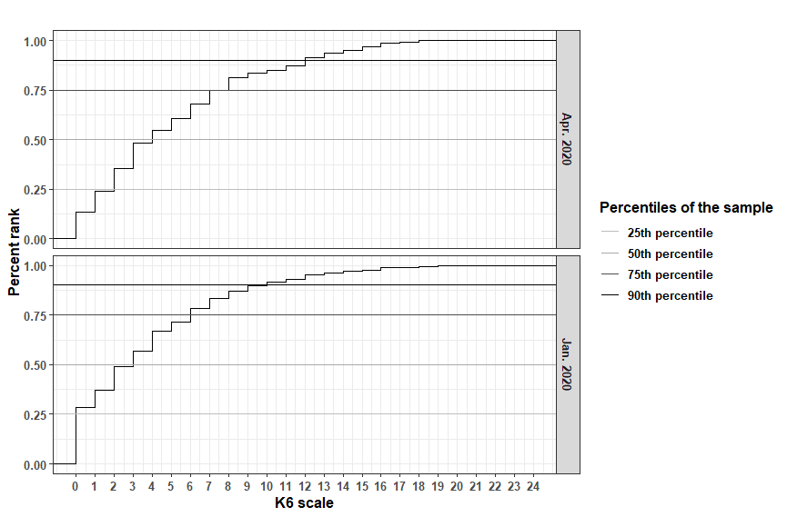
Figure B1 Cumulative distribution of the Kessler Psychological Distress Scale score for all households with preschool children

The estimation results are shown in Table B2. Column 1 shows the base estimation of the treatment definition in Table 1 in the main paper. The 50th and 75th percentiles are positive and significant. However, the 25th and 90th percentiles are not statistically significant. Columns 2 and 3 show the alternative treatment variables defined in Table 4. The results of the estimation at T1 in Column 2 show that as in Column 1, the 50th and 75th percentiles are positive and significant. In Column 3, the 25th percentiles of the T2 results are positive and significant, in addition to the 50th and 75th percentiles. This confirms the robustness of the clinical cutoff and alternative treatment definitions.

Table B2. Robustness checks: Estimation results of percentile cutoff models
Outcome | Treatment variable  Daycare facility closure defined by
Outcome | 1. Base  (Obs. 518) | Alternative treatment
Outcome | 1. Base  (Obs. 518) | 2. Treatment: T1  (Obs. 404) | 3. Treatment: T2  (Obs. 264)
25th percentile (K6$≥$2) | 0.056  (0.086) | 0.084  (0.102) | 0.269 †  (0.149)
50th percentile (K6$≥$4) | 0.181*  (0.085) | 0.201†  (0.104) | 0.277*  (0.142)
75th percentile (K6$≥$8) | 0.159*  (0.069) | 0.206*  (0.087) | 0.350**  (0.120)
90th percentile (K6$≥$12) | 0.030  (0.051) | 0.038  (0.062) | 0.110  (0.082)
Notes: In parentheses are the robust standard errors. As there was no difference in magnitude between the marginal effects and regression coefficients, the estimates listed are regression coefficients.
Significance level: † $p<0.1$, * $p<0.05$, ** $p<0.01$.

References for Supplementary Material

Abadie, A. (2005). Semiparametric difference-in-differences estimators. Review of Economic Studies, 72(1), 1–19. https://doi.org/10.1111/0034-6527.00321
Deville, J. C. (1999). Variance estimation for complex statistics and estimators: Linearization and residual techniques. Survey Methodology, 25(2), 193–204.
Hampel, F. R. (1974). The influence curve and its role in robust estimation. Journal of the American Statistical Association, 69(346), 383–393. https://doi.org/10.1080/01621459.1974.10482962
Heckman, J. J., Ichimura, H., & Todd, P. E. (1997). Matching as an econometric evaluation estimator: Evidence from evaluating a job training programme. The Review of Economic Studies, 64(4), 605–654. https://doi.org/10.2307/2971733
Jann, B. (2019) Influence functions for linear regression (with an application to regression adjustment). University of Bern Social Sciences Working Papers 32, Retrieved July 28, 2023, from https://ideas.repec.org/p/bss/wpaper/32.html
Jann, B. (2020) Influence functions continued. A framework for estimating standard errors in reweighing, matching, and regression adjustment. University of Bern Social Sciences Working Papers 35, Retrieved July 28, 2023, from https://ideas.repec.org/p/bss/wpaper/35.html
King, G., & Nielsen, R. (2019). Why propensity scores should not be used for matching. Political Analysis, 27(4), 435–454. https://doi.org/10.1017/pan.2019.11
Mizuno, T., Ohnishi, T., & Watanabe, T. (2021). Visualizing social and behavior change due to the outbreak of COVID-19 using mobile phone location data. New Generation Computing, 39(3–4), 453–468. https://doi.org/10.1007/s00354-021-00139-x
Sant’Anna, P. H. C., & Zhao, J. (2020). Doubly robust difference-in-differences estimators. Journal of Econometrics, 219(1), 101–122. https://doi.org/10.1016/j.jeconom.2020.06.003
Smith, J. A., & Todd, P. E. (2005). Does matching overcome LaLonde’s critique of nonexperimental estimators? Journal of Econometrics, 125(1–2), 305–353. https://doi.org/10.1016/j.jeconom.2004.04.011
Wooldridge, J. M. (2007). Inverse probability weighted estimation for general missing data problems. Journal of Econometrics, 141(2), 1281–1301. https://doi.org/10.1016/j.jeconom.2007.02.002

Smith and Todd (2005) and King and Nielsen (2019) pointed out that in PS matching, the PS is highly sensitive to the balance of covariates in matching and the choice of data, and that bias remains or can remain in the estimates. Smith and Todd (2005) showed that combining PS matching with difference-in-differences (DID) can eliminate bias compared to the cross-section. However, PS matching is based on a fairly strong assumption that the model for the PS is correctly specified (Wooldridge, 2007).
This stay-home rate is produced by Mizuno Laboratory (National Institute of Informatics). This rate is quantified by using the real-time population distribution estimated from the information of 78 million base stations of NTT DOCOMO, INC. cell phones. The stay-home rate for prefectures was published from January 1, 2020 to March 31, 2021, and was available for download for each date, as of May 2021. As for municipalities, data were published from January 6, 2020 to March 24, 2021, but were not downloadable, as of May 2021. For more information, see Mizuno Laboratory (http://research.nii.ac.jp/~mizuno/). See Mizuno et al. (2021) for more information.
However, considering that most schools and companies remained closed until January 5, this is the average from January 6–31.
A core city is a city that is not larger in terms of population or economic scale than an ODC, but is larger in these respects than other non-ODC municipalities.
Of course, this does not mean that the effects during the COVID-19 crisis were completely under control. Therefore, the standard DID in the main paper included COVID-19-related covariates.
Assumptions (2) and (3) are standard and important in the conditional DID method (Abadie, 2005; Heckman et al., 1997). Assumption (3), in particular, is to identify the average impact on treatments under selection by covariates (Heckman et al., 1997).
In DR-DID, the standard error is estimated using an influence function based on Sant’Anna & Zhao (2020). Essentially, an influence function quantifies how a statistic changes when the data increase or decrease slightly (Hampel, 1974). The standard error obtained from the influence function is known to asymptomatically become a consistent estimator with the standard error of the statistic (Deville, 1999; Jann, 2019). It is also a powerful and flexible approach to calculating and applying multiple estimates to various treatment effect estimators (Jann, 2019, 2020).

