Supplemental Material
Supplemental Figure 1. ROC curves to compare the optimized SVM model (black line), with classification based on a single feature: High frequency band (HF) (blue line) or amplitude (Amp) (pink line). SVM – support vector machine.

Supplemental Figure 2. Exemplary bipolar voltage electrograms where both, the machine learning (ML) algorithm and the EP specialists, performed a wrong classification:
ML and EP specialists identified “nearfield” for a farfield signal:
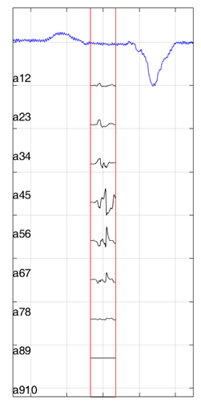 | 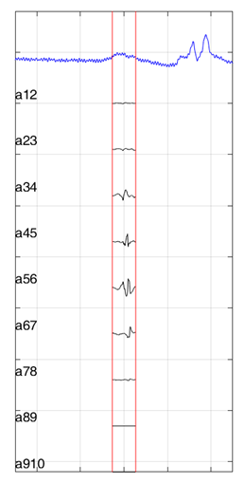 | 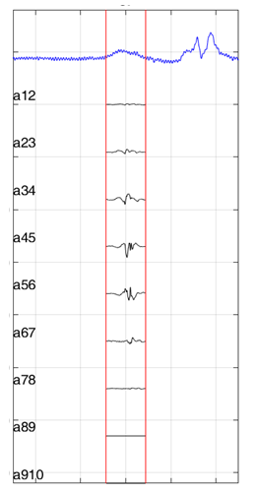

Supplemental Figure 3. Exemplary bipolar voltage electrograms where both, the machine learning (ML) algorithm and the EP specialists, performed a wrong classification:
ML and physicians identified “farfield” of a nearfield signal:
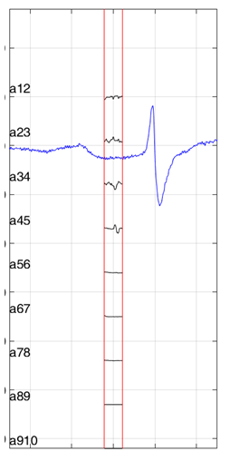 | 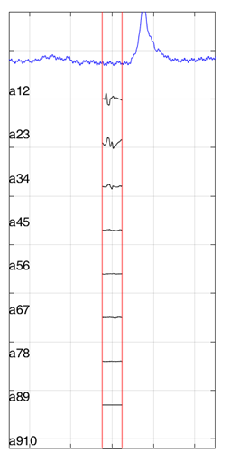

 | Prediction method | Sensitivity | Specificity | Balanced Accuracy
Single feature | P_{HF} | 78.7% | 80.1% | 79.4%
Single feature | slew-rate | 84.0% | 64.7% | 74.4%
Single feature | V_{max} | 63.0% | 85.0% | 74.0%
Single feature | P_{LF} | 53.7% | 87.1% | 70.4%
Single feature | P_{HF-rel} | 71.6% | 67.9% | 69.8%
Single feature | P_{HF_Neighbor} | 54.2% | 82.2% | 68.2%

Supplemental table 1: Single feature sensitivity, specificity, and balanced accuracy.
P_{HF} - high-frequency power, P_{LF} - low-frequency power, P_{HF-rel} - relative high power band, P_{HF_Neighbor} - P_{HF} ratio of neighbouring electrodes

