Supplementary
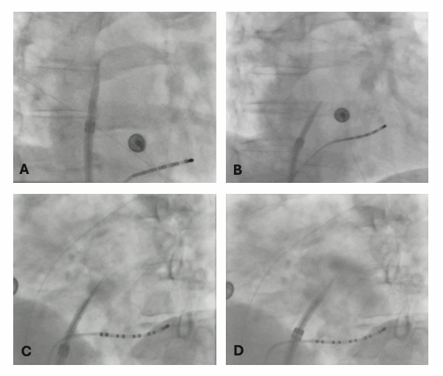
Supplementary Figure S1. Fluoroscopy-guided transseptal puncture using a large-bore Faradrive sheath.
Representative fluoroscopic views demonstrating septal positioning and left atrial access. (A) RAO 30° projection with sheath positioned in the superior vena cava prior to descent. (B) RAO 30° projection showing positioning at the fossa ovalis. (C) Needle advancement and septal crossing under fluoroscopic guidance. (D) Selective contrast injection confirming left atrial access. All procedures were performed without intracardiac or transesophageal echocardiography. Furthermore, see online Video V1.
Supplementary Video 1
Fluoroscopy-guided transseptal puncture demonstrating septal positioning, puncture, and confirmation of left atrial access with a large-bore Faradrive sheath.

