Supplemental Material
Supplementary Table 1. ICD-10-CM codes used for diagnosis of comorbidities

Diagnosis | ICD-10-CM Code
Diastolic (congestive) heart failure | I50.3
Systolic (congestive) heart failure | I50.2
Combines diastolic and systolic heart failure | I50.4
Atrial Fibrillation | I48.0
Atrial Fibrillation | I48.1
Atrial Fibrillation | I48.2
Atrial Fibrillation | I48.91
Hypertensive diseases | I10-I1A
Diabetes mellitus | E08-E13
Other chronic obstructive pulmonary disease | J44
Cerebral infarction | I63
Transient Ischemic Attack | G45
Cardiomyopathy | I42
Dilated cardiomyopathy | I42.0
Ischemic cardiomyopathy | I25.5
Ischemic heart disease | I20-I25
Typical atrial flutter | I48.3
Atypical atrial flutter | I48.4
Presence of cardiac pacemaker | Z95.0
Presence of automatic (implantable) cardiac defibrillator | Z95.810

Supplementary Table 2. Variables included in propensity score

Demographics | Age at Index
 | Sex
Diagnosis | Hypertensive diseases
 | Diabetes mellitus
 | Other chronic obstructive pulmonary disease
 | Type of atrial Fibrillation
 | Diastolic (congestive) heart failure
 | Cerebral infarction
 | Cardiomyopathy
 | Dilated cardiomyopathy
 | Ischemic cardiomyopathy
 | Ischemic heart disease
 | Typical atrial flutter
 | Atypical atrial flutter
 | Presence of cardiac pacemaker
 | Presence of automatic (implantable) cardiac defibrillator
Medications | Cardiovascular medications
 | Beta blocker
 | Diuretics
 | ACE-inhibitor
 | Angiotensin II inhibitor
 | Spironolactone
 | Sacubitril
 | Sodium-glucose co-transporter 2 (SGLT2) inhibitors
 | Antiarrhthythmics
 | Class I and III
 | Class III
 | Amiodarone
 | Sotalol
 | Flecainide
 | Digitalis glycosides
 | Anticoagulants
 | Warfarin
Laboratory parameters | Body-mass index
 | Body surface area
 | Heart rate — bpm
 | Creatinine [Mass/volume] in Serum, Plasma or Blood
 | Glomerular filtration rate/1.73 sq M.predicted [Volume Rate/Area] in Serum, Plasma or Blood by Creatinine-based formula (MDRD)
 | Natriuretic peptide.B prohormone N-Terminal [Mass/volume] in Serum, Plasma or Blood
 | Left Ventricular Ejection Fraction (LVEF) (%)

Supplementary Table 3. Baseline characteristics before propensity score matching- extended*
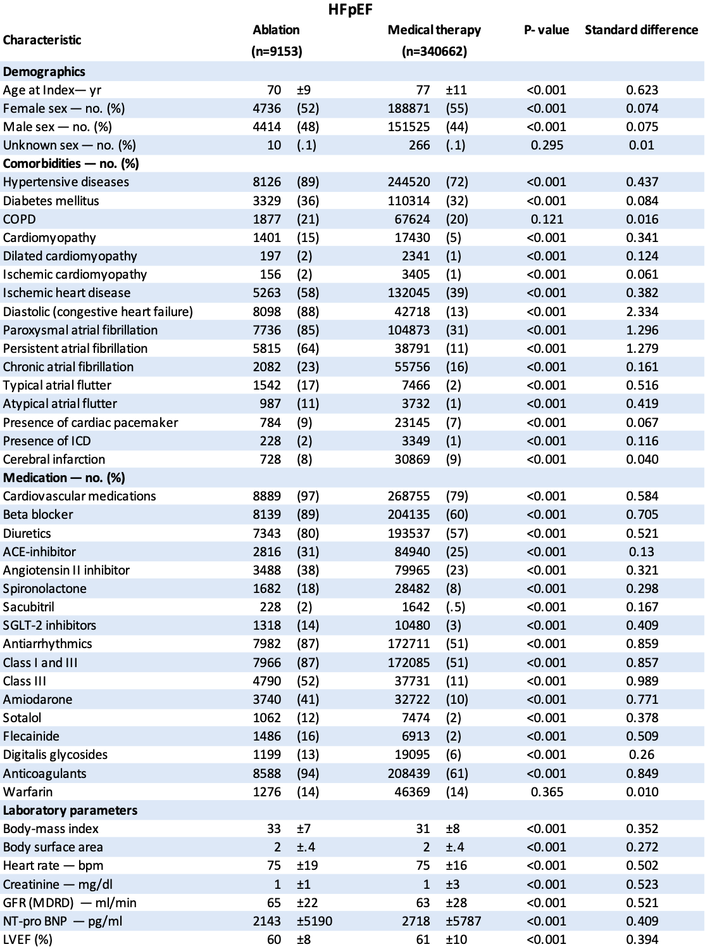
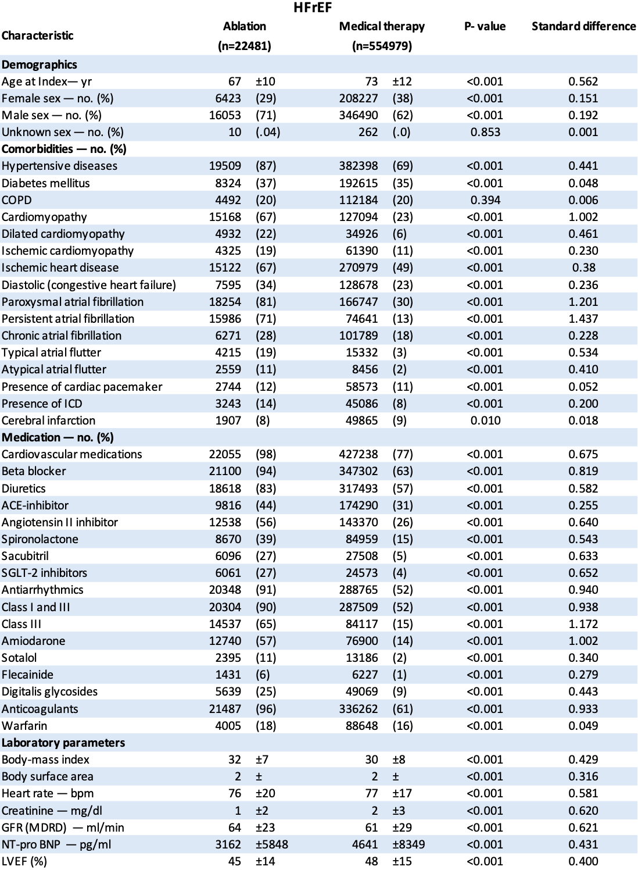
*Plus–minus values are means ±SD. Body mass index is calculated as kilograms per square meter, Body surface area is calculated per square meter, Glomerular filtration rate is calculated as volume rate per 1.73 square meter. COPD denotes Chronic obstructive pulmonary disease, ICD implantable cardioverter defibrillator, ACE angiotensin-converting enzyme, SGLT-2 sodium-glucose transport protein 2, GFR glomerular filtration rate, LVEF left ventricular ejection fraction and SD standard deviation.
Supplementary Table 4. Baseline characteristics after propensity score matching – extended*
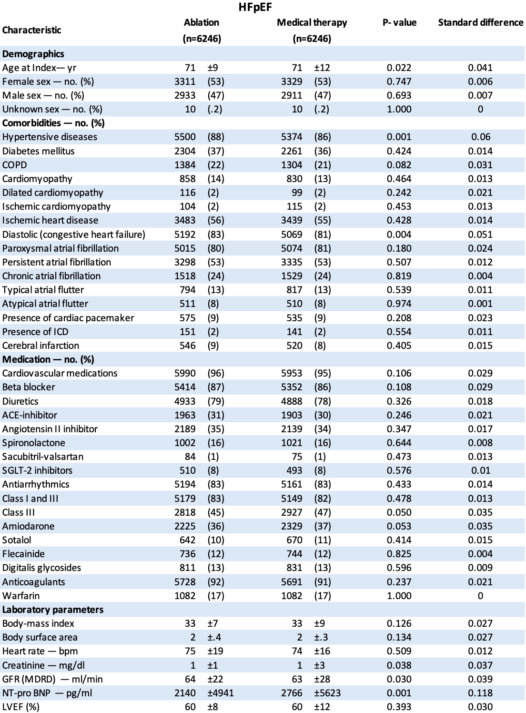
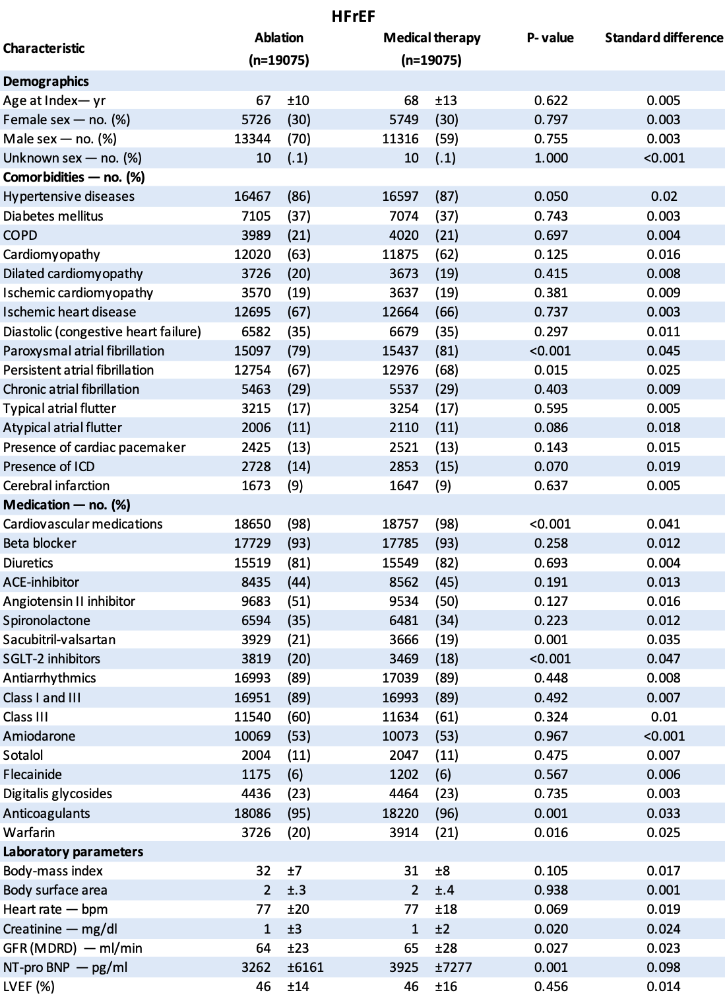*Plus–minus values are means ±SD. Body mass index is calculated as kilograms per square meter, Body surface area is calculated per square meter, Glomerular filtration rate is calculated as volume rate per 1.73 square meter. COPD denotes Chronic obstructive pulmonary disease, ICD implantable cardioverter defibrillator, ACE angiotensin-converting enzyme, SGLT-2 sodium-glucose transport protein 2, GFR glomerular filtration rate, LVEF left ventricular ejection fraction and SD standard deviation.

