Supplementary material
Table A: Raw data of Lepidoptera visits to flowers.
Species | P. rapae | P. brassicae | P. napi | M. jurtina | P. tithonus | I. io | V. atalanta | V. cardui | A. urticae | P. c-album | T. sylvestris | L. phlaeas | C. argoilus | P. icarus | A. gamma | Total
E. cannibinum | 6 | 0 | 13 | 39 | 49 | 6 | 1 | 0 | 0 | 17 | 0 | 0 | 2 | 0 | 0 | 133
L. salicaria | 6 | 4 | 4 | 0 | 0 | 0 | 0 | 0 | 0 | 0 | 0 | 0 | 0 | 0 | 1 | 15
D. fullonum | 1 | 1 | 1 | 1 | 1 | 0 | 0 | 9 | 0 | 2 | 0 | 0 | 0 | 1 | 0 | 17
B. davidii | 23 | 71 | 0 | 6 | 0 | 312 | 9 | 123 | 19 | 26 | 0 | 0 | 1 | 0 | 2 | 592
V. bonariensis | 43 | 18 | 1 | 3 | 0 | 2 | 0 | 13 | 2 | 1 | 0 | 0 | 0 | 0 | 0 | 83
E. bicolor | 185 | 10 | 9 | 26 | 4 | 4 | 0 | 1 | 16 | 55 | 0 | 0 | 0 | 0 | 0 | 310
O. vulgare | 141 | 2 | 27 | 213 | 908 | 4 | 0 | 5 | 19 | 6 | 0 | 5 | 1 | 2 | 1 | 1334
R. fructicosus | 5 | 0 | 0 | 2 | 24 | 0 | 0 | 0 | 2 | 0 | 0 | 0 | 0 | 0 | 0 | 33
L. angustifolia | 35 | 3 | 1 | 2 | 3 | 0 | 0 | 0 | 0 | 0 | 0 | 0 | 0 | 0 | 0 | 44
N. x faassenii | 82 | 5 | 5 | 0 | 0 | 0 | 0 | 1 | 0 | 0 | 1 | 0 | 0 | 0 | 3 | 97
L.corniculatus | 0 | 0 | 0 | 1 | 0 | 0 | 0 | 0 | 0 | 0 | 0 | 0 | 0 | 0 | 0 | 1
Total | 527 | 114 | 61 | 293 | 989 | 328 | 10 | 152 | 58 | 107 | 1 | 5 | 4 | 3 | 7 | 2659

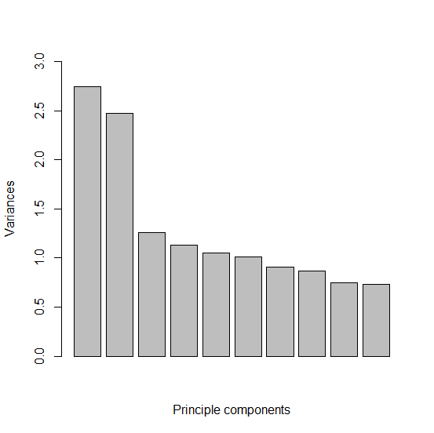
Figure A: Scree plot showing the relative importance of the first two principle components which explained 18.3% and 16.5% of the variation respectively.

