The impact of reduced tillage and distance to field margin on predator functional diversity
Journal of Insect Conservation
SK Jacobsen, L Sigsgaard, AB Johansen, K Thorup-Kristensen, P Moestrup
Department of Plant and Environmental Sciences, University of Copenhagen, Thorvaldsensvej 40, 1871 Frederiksberg, Denmark

Online Resource 1: Crop at each sampling site, 2017-19, with number of applications of plant protection products applied against pests, in parentheses, and name of applied chemical plant protection product. All products are based on pyrethroids, except for Pirimor G. CA=Conservation agriculture, RT=Reduced tillage, CT=Conventional tillage. Five sites were relocated in 2019, due to crop rotations.
2018 Site # | Cropping practice | Semi-natural structure | Crop 2017 (No. of applications) | Chemical plant protection product 2017 | Crop 2018 (No. of applications) | Chemical plant protection product 2018 | Crop 2019 (No. of applications) | Chemical plant protection product 2019
1 | CA | Set aside area | Rape seed (0) |  | Winter wheat (0) |  | Spring barley (0)
2 | CA | Set aside area | Rape seed (0) |  | Spring wheat (0) |  | Winter wheat (0)
3 | CA | Hedgerow | Broad bean (0) |  | Winter wheat (0) |  | Rape seed (0)
4 | CA | Hedgerow | Spring barley (0) |  | Spring wheat (0) |  | Winter wheat (0)
5 | RT | Set aside area | Winter wheat (1) | Mavrik 2F | Spring barley (2) | Karate 2.5 WG, Pirimor G | Perennial ryegrass (*)
6 | RT | Set aside area | Winter wheat (2) | Cyperb 100, Kaiso Sorbie | Winter wheat (1) | Mavrik Vita | Spring barley (*)
7 | RT | Hedgerow | Winter wheat (1) | Mavrik 2F | Spring barley (2) | Karate 2.5 WG, Pirimor G | Perennial ryegrass (*)
8 | RT | Hedgerow | Spring barley (1) | Cyperb 100 | Winter wheat (1) | Mavrik Vita | Spring barley (0)
9 | CT | Set aside area | Spring barley (2) | Karate 2.5 WG, Pirimor G | Spring wheat (1) | Karate 2.5 WG | Winter wheat (1) | Mavrik Vita
10 | CT | Set aside area | Spring barley (2) | Karate 2.5 WG, Pirimor G | Spring wheat (1) | Karate 2.5 WG | Winter wheat (1) | Mavrik Vita
11 | CT | Hedgerow | Spring barley (2) | Karate 2.5 WG, Pirimor G | Spring wheat (1) | Karate 2.5 WG | Winter wheat (1) | Mavrik Vita
12 | CT | Hedgerow | Winter wheat (2) | Karate 2.5 WG, Pirimor G | Spring wheat (1) | Karate 2.5 WG | Spring barley (1) | Mavrik Vita
2019 Site #
2 | CA | Set aside area | Winter wheat (0) |  | Rape seed (0) |  | Winter wheat (0)
3 | CA | Hedgerow | Spring barley (0) |  | Broad beans (1) | Mavrik 2F | Winter wheat (0)
5 | RT | Set aside area | Spring barley (0) |  | Winter wheat (0) |  | Winter wheat (*)
7 | RT | Hedgerow | Winter wheat (1) | Mavrik 2F | Rape seed (0) |  | Winter wheat (0)
11 | CT | Hedgerow | Winter wheat (0) |  | Spring oat (1) | Mavrik Vita | Spring barley (0)
*spraying charts not available due to shift in management

Online Resource 2: Habitat descriptions of all semi-natural structures 2018 and 2019 adjacent to field sample sites. CA=Conservation agriculture, RT=Reduced tillage, CT=Conventional tillage. Five sites were relocated in 2019, due to crop rotations.

Online Resource 3: Rarefaction curves of Carabidae species sampled from pitfall traps a) 2018 (0-12 m), and b) 2019 (0-24 m). CA=Conservation Agriculture, RT=Reduced Tillage, CT=Conventional tillage. Rarefaction curves and values are developed in the statistical software R, package vegan.
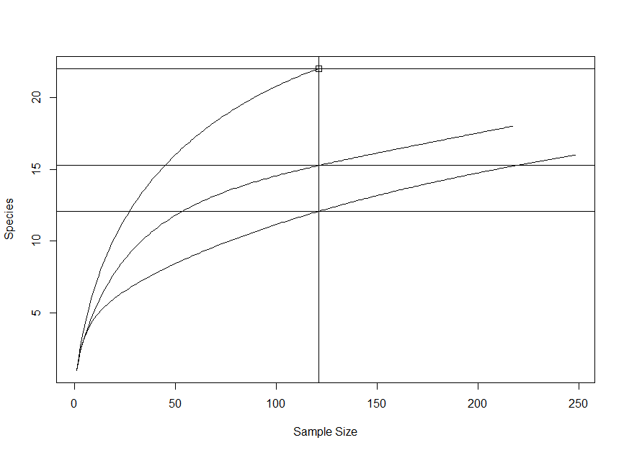
a) Rarefaction curve of Carabidae species sampled 2018. Minimum sample size = 121. Rarefaction output values of R model is CA=22.0, RT=15.26, CT=12.07.
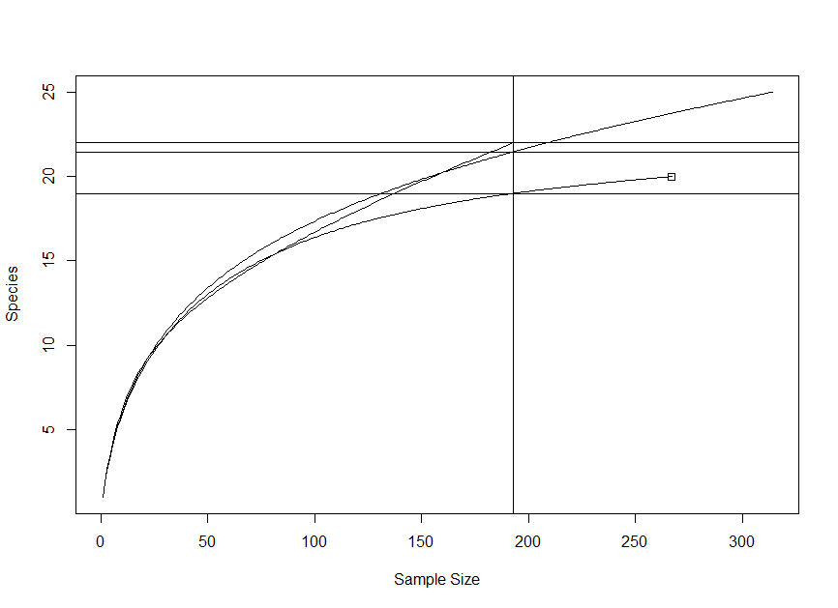
b) Rarefaction curve of Carabidae species sampled 2019. Rarefaction output values are CA=19.0, RT=21.47, CT=22.0.

Online Resource 4: Activity-density of ground beetles (Carabidae) and spiders (Araneae) in 2018 and 2019. Boxplots represent number of a) Carabidae and b) Araneae, per trap, in three different cropping practices (CA: Conservation Agriculture, RT: Reduced Tillage, CT: Conventional Tillage), at four different distances (0, 6, 12 and 24 m), ±SE

