Figure S1. a) Correlation plot for butterfly species richness modelling. Spearman correlation threshold was set at 0.6. Explanatory variables above that threshold were excluded from the maximal model.
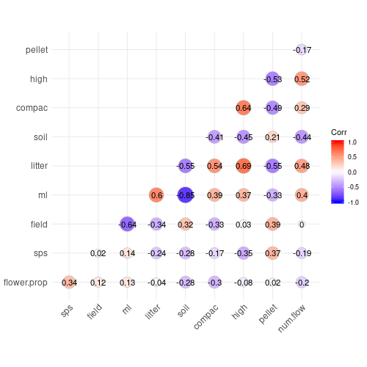

b) Correlation plot for bumblebee species richness modelling. Spearman correlation threshold was set at 0.6. Explanatory variables above that threshold were excluded from the maximal model.
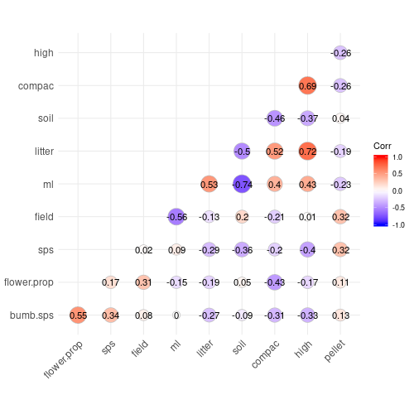

c) Correlation plot for grasshopper species richness modelling. Spearman correlation threshold was set at 0.6. Explanatory variables above that threshold were excluded from the maximal model.
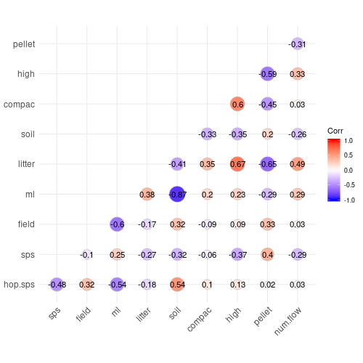

Illustration S1. Detail of the box quadrat used for grasshopper surveys. The quadrat frame was 1 m² with 0.60 m cotton-cloth high sides. We dropped it rapidly from 0.5 m height over every other grassland permanent plot. The pole of the butterfly net was used to flush the grasshoppers from the sward, going systematically from one side of the quadrat to the other. When flushed they tended to jump onto the cloth which facilitated species identification and count.

