Online Supplementary Information
Increased arthropod biomass, abundance and species richness in an agricultural landscape after 32 years
Journal of Insect Conservation
Julia Fürst (Swiss Federal Research Institute WSL, julia.fuerst@wsl.ch/fuerst-julia@bluewin.ch), Kurt Bollmann, Martin Gossner, Peter Duelli, Martin K. Obrist
Appendix S1. Pictures of the used trap types.
Appendix S2. The chosen opti3+2 weeks.
Appendix S3. Selection of families excluded from the analysis.
Appendix S4. Formula of the generalized linear mixed models.
Appendix S5. Trends of the combi-traps.
Appendix S6. Body size distribution over the years.
Appendix S7. Trends for different taxa and trophic guilds.
Appendix S8. Butterfly and water insect abundance data from the Swiss biodiversity monitoring.
Appendix S9. Data collected in other studies conducted by the Swiss Federal Research Institute WSL.
Appendix S10. Weather conditions during the study weeks.
Appendix S11. Correlation matrix of weather data.

Appendix S1. Illustration of the used trap types. Pictures 1-4 show the four trap types: pitfall funnel trap with a funnel of 15 cm diameter (1), yellow bucket trap with a diameter of 20.5 cm, placed 20 cm above the vegetation, maximum at 1 m height (2), window trap with a size of 50x83 cm, 1.2 m above ground (3) and combi-trap with a funnel of 42 cm diameter and a total catching surface matching that of the window trap (2 plexiglass plates 50 cm x 41.5 cm crossed over the yellow funnel, 1 m above ground) (4). Picture 5 shows the general arrangement of the traps in the field. Flight traps were placed in 10 m distance to the field edge and in 10 m distance to each other. Pitfall traps were placed in the middle between the flight traps.
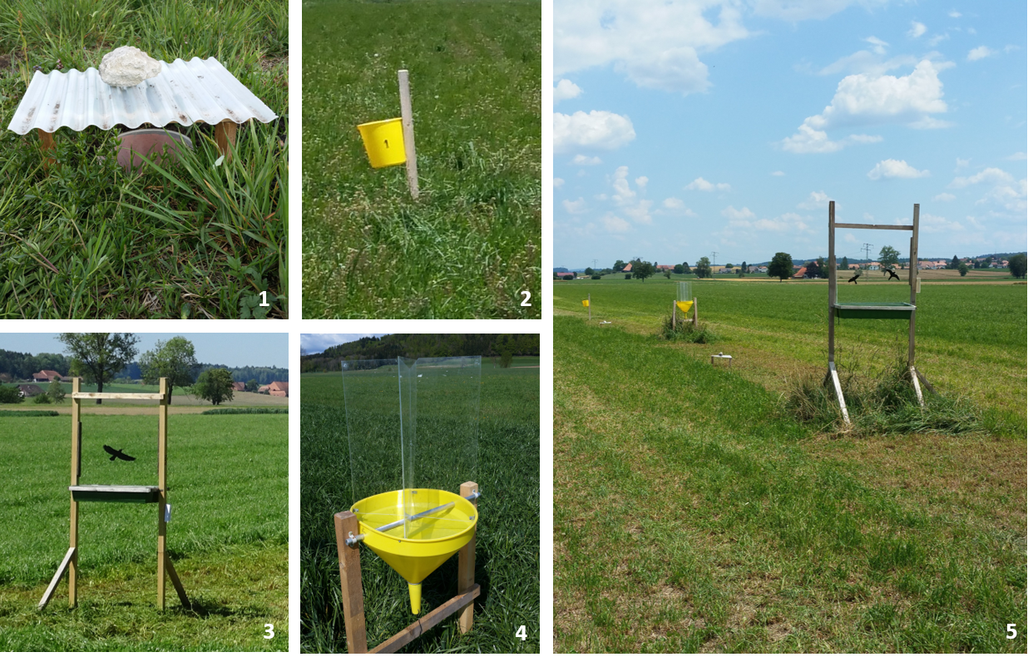
Appendix S2. Study periods and opti3+2 weeks. The study periods of 1987, 1997 and 2019 are outlined and the chosen opti3+2 weeks for the three study years marked with an x. The B indicates the break of one week between the two study periods. The opti3+2 weeks were chosen separately for flight and pitfall traps. To select the weeks richest in individuals, we used the volume of the arthropods as a proxy for the number of individuals. The opti3+2 program was already applied in 1997. In 1987 arthropods were sampled and identified during the entire season, so we had to identify the opti3+2 weeks in retrospect. We determined the weeks 19 to 29 as the study period and selected the 5 weeks richest in individuals. However, for the pitfall traps we had to shift the study period slightly forward to week 16 to 26, because in 1987 the pitfall traps were emptied only every second week after week 26. The shift did not distort the direction of the trends, as these earlier weeks contained even slightly more individuals.
 | Week | 16 | 17 | 18 | 19 | 20 | 21 | 22 | 23 | 24 | 25 | 26 | 27 | 28 | 29
1987 | Pitfall traps |  |  | x | x | x | B | x | x
1987 | Flight traps |  |  |  | x |  |  | x | x | B |  |  | x |  | x
1997 | Pitfall traps |  |  |  | x |  | x | x |  | B | x |  |  |  | x
1997 | Flight traps |  |  |  | x |  | x |  | x | B |  |  | x |  | x
2019 | Pitfall traps |  |  |  |  |  | x | x | x | B | x | x
2019 | Flight traps |  |  |  |  |  | x | x | x | B |  | x | x

Appendix S3. Comparison of the proportion of adults identified to species level versus all registered individuals in the database. “All” stands for all registered individuals and “Sp” for the number of individuals that were identified to species level. If less than 80% of the individuals were identified to species level in families with more than 10 individuals, the family was excluded from the analysis (highlighted in red the table). If the lack of identification could be attributed to certain subfamilies or genera, only those were excluded. Even though according to the above criteria the Curculionidae should have been excluded, we decided to keep them in the analysis to increase sample sizes. The proportion of identified species was only in the year 1997 to low (60%). We tested for but found no change in the observed trends without the Curculionidae (Appendix S7).
Legend for the color highlight of the family:
Family excluded from analysis
Family not excluded from analysis: contains too few individuals for determination of a clear proportion or drops anyway out of the analysis because of no determined individuals
Family not excluded from analysis: exception

 |  | 1987 |  |  | 1997 |  |  | 2019
Order | Family | All | Sp | % | All | Sp | % | All | Sp | %
Coleoptera | Carabidae | 1862 | 1862 | 100 | 2879 | 2872 | 100 | 4860 | 4855 | 100
 | Staphylinidae | 2148 | 1246 | 58 | 10024 | 7628 | 76 | 6874 | 6659 | 97
 | (null) | 0 | 0 | - | 2 | 0 | 0 | 0 | 0 | -
 | Alleculidae | 0 | 0 | - | 0 | 0 | - | 2 | 2 | 100
 | Anobiidae | 3 | 3 | 100 | 4 | 3 | 75 | 5 | 3 | 60
 | Anthicidae | 0 | 0 | - | 1 | 0 | 0 | 70 | 70 | 100
 | Anthribidae | 4 | 4 | 100 | 2 | 2 | 100 | 22 | 22 | 100
 | Aphodiidae | 53 | 53 | 100 | 133 | 115 | 86 | 142 | 142 | 100
 | Apionidae | 32 | 32 | 100 | 275 | 275 | 100 | 410 | 410 | 100
 | Aspidiphoridae | 0 | 0 | - | 2 | 2 | 100 | 5 | 5 | 100
 | Attelabidae | 0 | 0 | - | 0 | 0 | - | 1 | 1 | 100
 | Bruchidae | 6 | 6 | 100 | 7 | 1 | 14 | 48 | 48 | 100
 | Buprestidae | 18 | 18 | 100 | 66 | 66 | 100 | 124 | 124 | 100
 | Byrrhidae | 1 | 1 | 100 | 14 | 14 | 100 | 25 | 25 | 100
 | Byturidae | 2 | 2 | 100 | 2 | 2 | 100 | 2 | 2 | 100
 | Cantharidae | 226 | 226 | 100 | 302 | 297 | 98 | 1813 | 1812 | 100
 | Cerambycidae | 8 | 8 | 100 | 61 | 61 | 100 | 138 | 138 | 100
 | Cerylonidae | 0 | 0 | - | 1 | 0 | 0 | 3 | 3 | 100
 | Cholevidae | 3 | 3 | 100 | 49 | 46 | 94 | 86 | 85 | 99
 | Chrysomelidae | 53 | 52 | 98 | 300 | 175 | 58 | 671 | 671 | 100
 | Cimberidae | 0 | 0 | - | 1 | 1 | 100 | 0 | 0 | -
 | Cisidae | 2 | 0 | 0 | 10 | 0 | 0 | 13 | 0 | 0
 | Clambidae | 0 | 0 | - | 127 | 127 | 100 | 0 | 0 | -
 | Cleridae | 6 | 6 | 100 | 14 | 14 | 100 | 24 | 24 | 100
 | Coccinellidae | 24 | 16 | 67 | 325 | 313 | 96 | 359 | 359 | 100
 | Colonidae | 0 | 0 | - | 0 | 0 | - | 1 | 0 | 0
 | Colydiidae | 0 | 0 | - | 4 | 3 | 75 | 4 | 4 | 100
 | Corylophidae | 0 | 0 | - | 5 | 3 | 60 | 26 | 26 | 100
 | Cryptophagidae | 503 | 391 | 78 | 2766 | 59 | 2 | 2534 | 2534 | 100
 | Curculionidae | 65 | 63 | 97 | 1421 | 864 | 61 | 1896 | 1894 | 100
 | Dermestidae | 5 | 5 | 100 | 42 | 6 | 14 | 72 | 72 | 100
 | Drilidae | 0 | 0 | - | 3 | 3 | 100 | 1 | 1 | 100
 | Dryopidae | 5 | 0 | 0 | 26 | 26 | 100 | 62 | 62 | 100
 | Dytiscidae | 29 | 29 | 100 | 3 | 3 | 100 | 0 | 0 | -
 | Elateridae | 93 | 93 | 100 | 326 | 310 | 95 | 739 | 739 | 100
 | Elmidae | 1 | 0 | 0 | 0 | 0 | - | 2 | 0 | 0
 | Endomychidae | 0 | 0 | - | 0 | 0 | - | 4 | 4 | 100
 | Erotylidae | 2 | 2 | 100 | 4 | 4 | 100 | 19 | 19 | 100
 | Eucinetidae | 0 | 0 | - | 0 | 0 | - | 3 | 3 | 100
 | Eucnemidae | 2 | 1 | 50 | 0 | 0 | - | 1 | 1 | 100
 | Haliplidae | 2 | 2 | 100 | 2 | 0 | 0 | 2 | 0 | 0
 | Heteroceridae | 4 | 0 | 0 | 0 | 0 | - | 0 | 0 | -
 | Histeridae | 7 | 7 | 100 | 33 | 30 | 91 | 33 | 33 | 100
 | Hydraenidae | 3 | 3 | 100 | 0 | 0 | - | 0 | 0 | -
 | Hydrophilidae | 160 | 160 | 100 | 236 | 236 | 100 | 43 | 39 | 91
 | Kateretidae | 5 | 5 | 100 | 1 | 1 | 100 | 6 | 6 | 100
 | Laemophloeidae | 1 | 0 | 0 | 5 | 5 | 100 | 13 | 13 | 100
 | Lampyridae | 0 | 0 | - | 24 | 24 | 100 | 0 | 0 | -
 | Lathridiidae | 87 | 82 | 94 | 726 | 314 | 43 | 1403 | 1403 | 100
 | Leiodidae | 1 | 1 | 100 | 2 | 2 | 100 | 10 | 10 | 100
 | Limnichidae | 0 | 0 | - | 0 | 0 | - | 6 | 6 | 100
 | Lycidae | 0 | 0 | - | 1 | 1 | 100 | 0 | 0 | -
 | Lymexylonidae | 2 | 2 | 100 | 5 | 5 | 100 | 0 | 0 | -
 | Malachiidae | 2 | 2 | 100 | 13 | 13 | 100 | 30 | 30 | 100
 | Melandryidae | 0 | 0 | - | 0 | 0 | - | 2 | 2 | 100
 | Melyridae | 10 | 10 | 100 | 52 | 0 | 0 | 237 | 237 | 100
 | Monotomidae | 3 | 3 | 100 | 5 | 5 | 100 | 15 | 15 | 100
 | Mordellidae | 106 | 4 | 4 | 120 | 7 | 6 | 447 | 75 | 17
 | Mycetophagidae | 2 | 2 | 100 | 3 | 3 | 100 | 8 | 8 | 100
 | Nitidulidae | 101 | 98 | 97 | 24547 | 154 | 1 | 4404 | 2358 | 54
 | Oedemeridae | 12 | 12 | 100 | 88 | 88 | 100 | 153 | 153 | 100
 | Phalacridae | 10 | 0 | 0 | 23 | 0 | 0 | 70 | 70 | 100
 | Platypodidae | 0 | 0 | - | 0 | 0 | - | 1 | 1 | 100
 | Pselaphidae | 4 | 4 | 100 | 93 | 0 | 0 | 92 | 72 | 78
 | Ptiliidae | 15 | 0 | 0 | 239 | 41 | 17 | 44 | 44 | 100
 | Ptinidae | 0 | 0 | - | 0 | 0 | - | 1 | 1 | 100
 | Pyrochroidae | 0 | 0 | - | 3 | 3 | 100 | 10 | 10 | 100
 | Rhynchitidae | 0 | 0 | - | 1 | 1 | 100 | 4 | 4 | 100
 | Salpingidae | 1 | 1 | 100 | 7 | 7 | 100 | 8 | 8 | 100
 | Scarabaeidae | 104 | 104 | 100 | 108 | 106 | 98 | 730 | 730 | 100
 | Scirtidae | 2 | 2 | 100 | 28 | 28 | 100 | 51 | 50 | 98
 | Scolytidae | 240 | 240 | 100 | 653 | 651 | 100 | 380 | 380 | 100
 | Scraptiidae | 4 | 2 | 50 | 54 | 0 | 0 | 129 | 129 | 100
 | Scydmaenidae | 0 | 0 | - | 13 | 12 | 92 | 19 | 17 | 89
 | Silphidae | 20 | 20 | 100 | 46 | 46 | 100 | 131 | 131 | 100
 | Silvanidae | 1 | 1 | 100 | 8 | 8 | 100 | 14 | 14 | 100
 | Sphaerosomatidae | 0 | 0 | - | 0 | 0 | - | 5 | 5 | 100
 | Throscidae | 0 | 0 | - | 2 | 0 | 0 | 41 | 41 | 100
 | Trogossitidae | 0 | 0 | - | 2 | 2 | 100 | 8 | 8 | 100
Heteroptera | Acanthosomatidae | 1 | 1 | 100 | 1 | 1 | 100 | 3 | 3 | 100
 | Anthocoridae | 31 | 8 | 26 | 90 | 21 | 23 | 193 | 193 | 100
 | Aradidae | 0 | 0 | - | 0 | 0 | - | 9 | 9 | 100
 | Berytidae | 1 | 1 | 100 | 1 | 1 | 100 | 0 | 0 | -
 | Ceratocombidae | 0 | 0 | - | 0 | 0 | - | 1 | 1 | 100
 | Coreidae | 5 | 5 | 100 | 10 | 10 | 100 | 65 | 65 | 100
 | Cydnidae | 1 | 1 | 100 | 7 | 7 | 100 | 41 | 41 | 100
 | Hebridae | 0 | 0 | - | 0 | 0 | - | 3 | 3 | 100
 | Hydrometridae | 0 | 0 | - | 1 | 1 | 100 | 0 | 0 | -
 | Lygaeidae | 18 | 18 | 100 | 112 | 112 | 100 | 111 | 111 | 100
 | Microphysidae | 0 | 0 | - | 5 | 5 | 100 | 17 | 17 | 100
 | Miridae | 114 | 92 | 81 | 442 | 437 | 99 | 1081 | 1081 | 100
 | Nabidae | 4 | 1 | 25 | 27 | 27 | 100 | 9 | 9 | 100
 | Pentatomidae | 29 | 29 | 100 | 42 | 42 | 100 | 114 | 114 | 100
 | Piesmatidae | 0 | 0 | - | 4 | 4 | 100 | 54 | 54 | 100
 | Plataspidae | 0 | 0 | - | 0 | 0 | - | 1 | 1 | 100
 | Pyrrhocoridae | 0 | 0 | - | 0 | 0 | - | 2 | 2 | 100
 | Reduviidae | 7 | 7 | 100 | 37 | 37 | 100 | 14 | 14 | 100
 | Rhopalidae | 4 | 4 | 100 | 3 | 3 | 100 | 40 | 40 | 100
 | Saldidae | 7 | 7 | 100 | 2 | 2 | 100 | 1 | 1 | 100
 | Scutelleridae | 3 | 3 | 100 | 13 | 13 | 100 | 14 | 14 | 100
 | Tingidae | 0 | 0 | - | 3 | 3 | 100 | 10 | 10 | 100
Araneae | Anyphaenidae | 0 | 0 | - | 2 | 2 | 100 | 0 | 0 | -
 | Araneidae | 6 | 6 | 100 | 1 | 1 | 100 | 5 | 5 | 100
 | Clubionidae | 2 | 2 | 100 | 4 | 4 | 100 | 3 | 3 | 100
 | Dictynidae | 4 | 4 | 100 | 4 | 4 | 100 | 1 | 1 | 100
 | Gnaphosidae | 80 | 80 | 100 | 59 | 59 | 100 | 143 | 142 | 99
 | Hahniidae | 18 | 18 | 100 | 14 | 14 | 100 | 1 | 1 | 100
 | Linyphiidae | 858 | 858 | 100 | 1372 | 1372 | 100 | 559 | 559 | 100
 | Liocranidae | 5 | 5 | 100 | 3 | 3 | 100 | 9 | 9 | 100
 | Lycosidae | 1368 | 1368 | 100 | 1798 | 1798 | 100 | 3130 | 3129 | 100
 | Mimetidae | 0 | 0 | - | 0 | 0 | - | 1 | 1 | 100
 | Philodromidae | 1 | 1 | 100 | 1 | 1 | 100 | 1 | 1 | 100
 | Pisauridae | 0 | 0 | - | 1 | 1 | 100 | 1 | 1 | 100
 | Salticidae | 1 | 1 | 100 | 19 | 19 | 100 | 13 | 13 | 100
 | Tetragnathidae | 229 | 229 | 100 | 386 | 386 | 100 | 391 | 391 | 100
 | Theridiidae | 7 | 7 | 100 | 21 | 21 | 100 | 18 | 18 | 100
 | Thomisidae | 5 | 5 | 100 | 46 | 46 | 100 | 77 | 77 | 100
 | Zodariidae | 0 | 0 | - | 0 | 0 | - | 28 | 28 | 100
Diptera | Syrphidae | 131 | 122 | 93 | 249 | 244 | 98 | 102 | 75 | 74
Hymenoptera | Formicidae | 1518 | 1518 | 100 | 2894 | 2893 | 100 | 2895 | 2894 | 100
 | Apidae | 583 | 582 | 100 | 1125 | 1125 | 100 | 1677 | 1677 | 100
 | Bethylidae | 0 | 0 | - | 2 | 0 | 0 | 146 | 0 | 0
 | Chrysididae | 26 | 22 | 85 | 91 | 91 | 100 | 34 | 34 | 100
 | Mutillidae | 0 | 0 | - | 1 | 1 | 100 | 0 | 0 | -
 | Pompilidae | 0 | 0 | - | 21 | 21 | 100 | 174 | 174 | 100
 | Sapygidae | 3 | 3 | 100 | 1 | 1 | 100 | 5 | 5 | 100
 | Sphecidae | 66 | 66 | 100 | 67 | 67 | 100 | 171 | 171 | 100
 | Tiphiidae | 6 | 6 | 100 | 21 | 21 | 100 | 43 | 43 | 100
 | Vespidae | 23 | 23 | 100 | 24 | 24 | 100 | 91 | 91 | 100
Mecoptera | Panorpidae | 1 | 1 | 100 | 5 | 5 | 100 | 34 | 34 | 100
Megaloptera | Sialidae | 6 | 6 | 100 | 0 | 0 | - | 19 | 19 | 100
Neuroptera | Chrysopidae | 28 | 28 | 100 | 76 | 76 | 100 | 62 | 62 | 100
 | Coniopterygidae | 0 | 0 | - | 4 | 3 | 75 | 0 | 0 | -
 | Hemerobiidae | 2 | 2 | 100 | 0 | 0 | - | 2 | 2 | 100
Raphidioptera | Raphidiidae | 0 | 0 | - | 1 | 1 | 100 | 6 | 6 | 100

Appendix S4. Explicit formula of the generalized linear mixed models per input variable (species richness, abundance, biomass) and trap types (pitfall traps, combi-traps, yellow + window traps).
Formula 1, biomass in yellow + window traps: glmmTMB(Biomass ~ Year + Habitat + mean temperature + mean precipitation + mean windspeed + (1|Week) + (1|Site), family = gaussian (link = “log”))
Formula 2, biomass in pitfall traps: glmmTMB(Biomass ~ Year + Habitat + mean temperature + mean windspeed + (1|Week) + (1|Site), family = gaussian (link = “log”))
Formula 3, biomass in combi-traps: glmmTMB(Biomass ~ Year + Habitat + mean temperature + mean windspeed + (1|Week) + (1|Site), family = gaussian (link = “log”))
Formula 4, abundance in yellow + window traps: glmmTMB(Abundance ~ Year + Habitat + mean temperature + mean windspeed + (1|Week) + (1|Site) + (1|X), family = poisson (link = “log”))
Formula 5, abundance in pitfall traps: glmmTMB(Abundance ~ Year + Habitat + mean temperature + mean windspeed + (1|Week) + (1|Site) + (1|X), family = poisson (link = “log”))
Formula 6, abundance in combi-traps: glmmTMB(Abundance ~ Year + Habitat + mean temperature + mean windspeed + (1|Week) + (1|Site) + (1|X), family = poisson (link = “log”))
Formula 7, species richness in yellow + windowtraps: glmmTMB(Number of species ~ Year + Habitat + mean temperature + mean precipitation + mean windspeed + log(Abundance) + (1|Week) + (1|Site), family = poisson (link = “log”))
Formula 8, species richness in pitfall traps: glmmTMB(Number of species ~ Year + Habitat + mean temperature + mean windspeed + log(Abundance) + (1|Week) + (1|Site) + (1|X), family = poisson (link = “log”))
Formula 9, species richness in combi-traps: glmmTMB(Number of species ~ Year + Habitat + mean temperature + mean precipitation + mean windspeed + log(Abundance) + (1|Week) + (1|Site), family = poisson (link = “log”))

Appendix S5. Figure 2 extended to also include the 2 year trends (1997 & 2019) for the combi-traps.
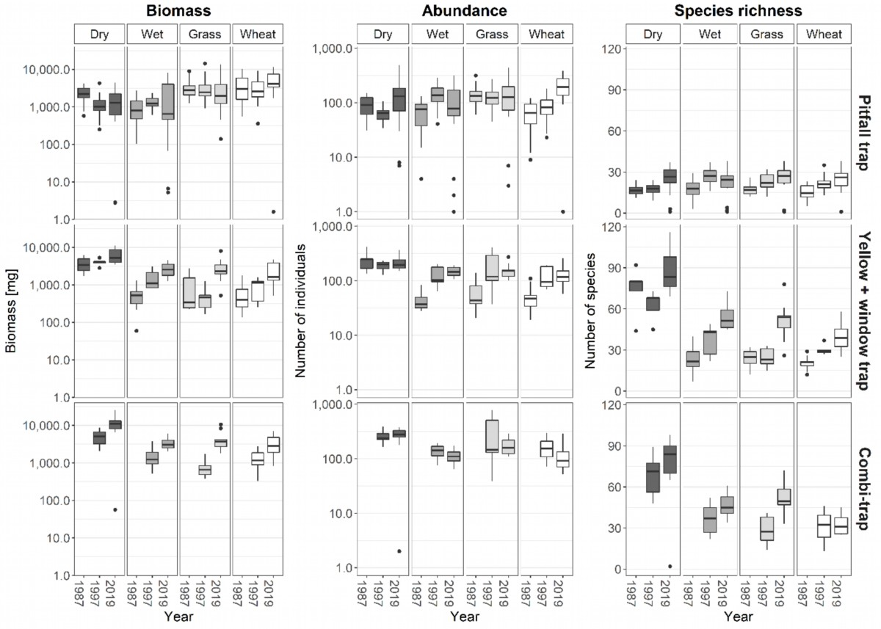
Appendix S6. Body size distribution (community weighted means) of the caught arthropods to test if filtering for smaller or larger arthropods happened over the years.
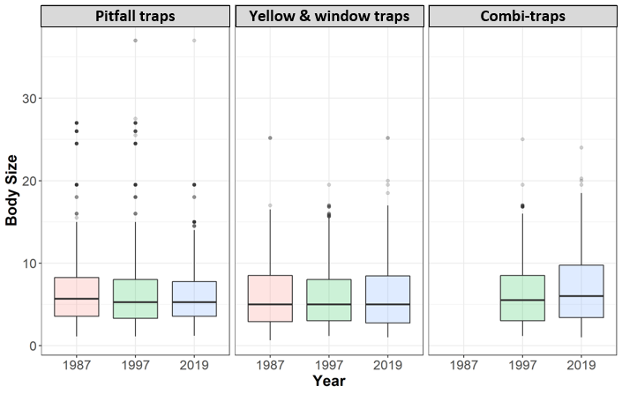

Appendix S7. Trends for the different taxa and trophic guilds. The summarized trends in Fig. 3 were derived from these boxplots. Taxon trends were not assessed for the Syrphidae, Neuroptera, Raphidioptera and Mecoptera as their abundance was too low. Trophic groups were carnivores, omnivores, herbivores as well as the pooled guild of detritivores, fungivores and trophobiotic species, as these trophic guilds contained only few individuals.
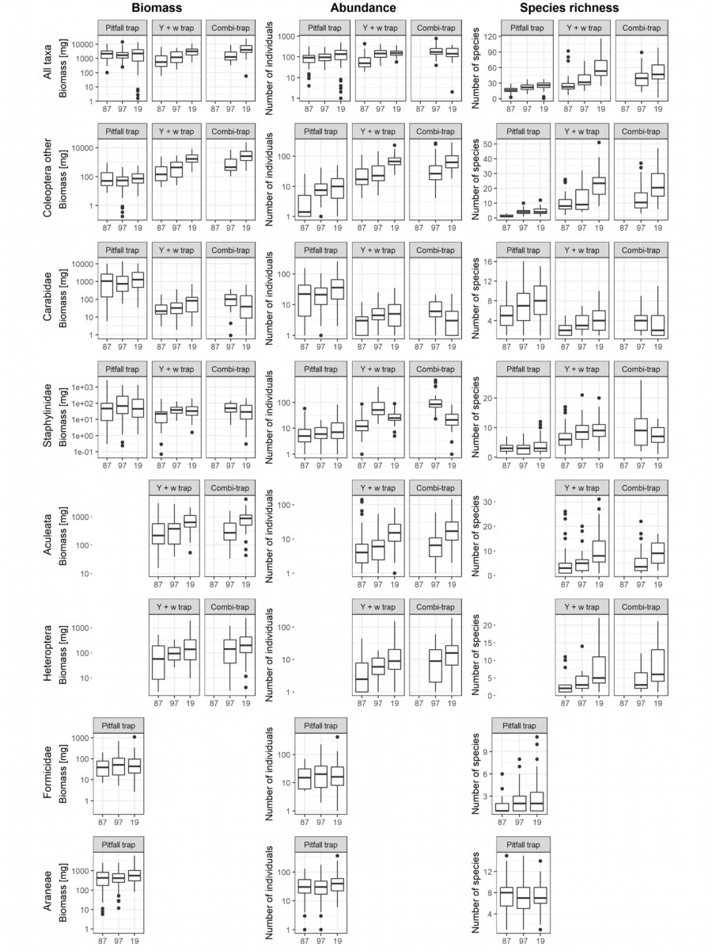
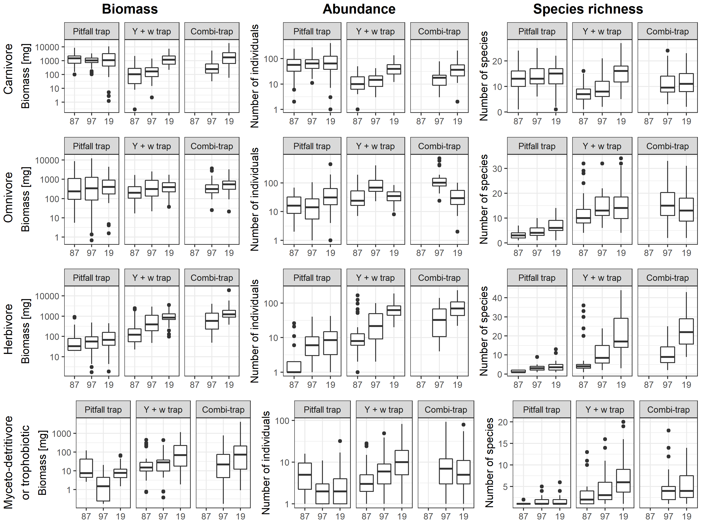

Appendix S8. Butterfly and Water insect (Ephemeroptera, Plecoptera, Trichoptera) abundance data collected in the Swiss biodiversity monitoring program (Weber et al. 2004) from 2003 (butterflies) and 2010 (water insects) to 2019 in the Swiss Central Plateau (to which the Limpach valley belongs). 2019 seems to have been an average year within the generally increasing trends for both taxa.
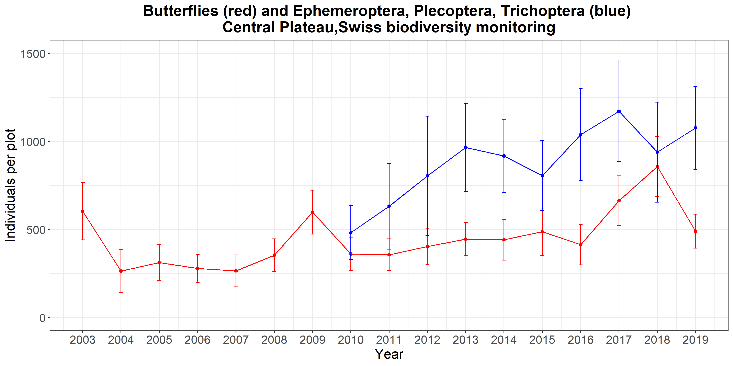

Appendix S9. Mean species richness per a) window trap and b) pitfall trap as well as mean abundance per c) window trap and d) pitfall trap found in studies conducted in meadows between 1980 and 2000 by the Swiss Federal Research Institute WSL*. Analyzed taxa were in each year the Araneae, Coleoptera, Diptera, Heteroptera, Hymenoptera, Mecoptera, Megaloptera, Neuroptera, Raphidioptera. Compared to the other years, 1987 (marked with a square) and 1997 (marked with a triangle) analyzed in our study seem to be representative years for estimating insect abundances and species richness, they are especially no downward outliers. In 1987, mean species richness and abundance per window trap were above average whereas in the pitfall traps mean species richness and abundance were at the upper edge of average. In 1997, species richness and abundance in the window traps was more or less average respectively rather at the lower edge whereas species richness and abundance in the pitfall traps was rather at the upper edge of average.
a) b)
c) d)
* Project names: Brentjong (1986), EASY (2003), EASY (2004), ENHANCE (2010), Eyholzer-Carabiden (1991), Kerzers (1986), Limpach (1987), LimpRep (1997), Limp2019 (2019), Myotis-Food (1992), Myotis-Food (1993), RandenGloor (1996), Sisseln (1985), Sisseln (1986), Sisseln (1990), Waldrand (1994), Waldrand (1995)

Appendix S10. Comparison of weather conditions of the three study years. Mean temperature [°C], mean precipitation [mm] and mean wind speed [m/s] for each opti3+2 study weeks are shown. As different opti3+2 weeks were chosen for flight and pitfall traps, weather conditions differ for the trap types. We accounted for weather conditions in all statistical models.

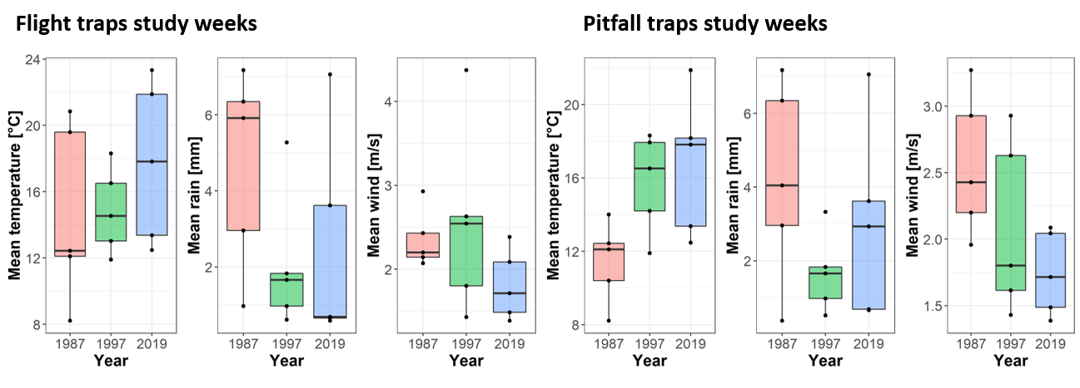
Year | Week | Mean Temperature [°C] | Mean wind speed [m/s] | Mean precipitation [mm]
1987 | 16 | 6.5 | 2.9 | 1.5
 | 17 | 11.1 | 2.2 | 1.7
 | 18 | 14.0 | 2.0 | 0.4
 | 19 | 8.2 | 2.9 | 7.2
 | 20 | 10.4 | 3.3 | 4.0
 | 21 | 8.5 | 2.6 | 6.2
 | 22 | 12.1 | 2.4 | 3.0
 | 23 | 12.4 | 2.2 | 6.3
 | 24 | 13.8 | 2.1 | 7.3
 | 25 | 13.4 | 3.7 | 11.4
 | 26 | 13.8 | 2.4 | 5.5
 | 27 | 19.6 | 2.1 | 5.9
 | 28 | 20.4 | 2.5 | 1.5
 | 29 | 20.8 | 2.1 | 1.0
1997 | 16 | 8.1 | 2.7 | 0.0
 | 17 | 4.4 | 4.6 | 0.6
 | 18 | 9.4 | 2.9 | 9.0
 | 19 | 11.9 | 2.6 | 1.8
 | 20 | 10.1 | 1.9 | 3.5
 | 21 | 16.5 | 1.4 | 1.7
 | 22 | 14.2 | 2.9 | 0.5
 | 23 | 13.0 | 4.4 | 0.6
 | 24 | 19.0 | 1.8 | 5.4
 | 25 | 17.9 | 1.6 | 3.3
 | 26 | 13.3 | 2.9 | 10.3
 | 27 | 14.5 | 2.5 | 5.3
 | 28 | 14.4 | 1.9 | 6.6
 | 29 | 18.3 | 1.8 | 1.0
2019 | 16 | 7.3 | 2.4 | 0.3
 | 17 | 12.4 | 1.6 | 0.8
 | 18 | 8.2 | 2.7 | 2.1
 | 19 | 6.6 | 2.5 | 5.4
 | 20 | 9.3 | 4.5 | 0.9
 | 21 | 12.5 | 2.1 | 7.1
 | 22 | 13.4 | 1.5 | 3.6
 | 23 | 17.8 | 1.7 | 0.7
 | 24 | 14.0 | 1.7 | 6.4
 | 25 | 18.2 | 2.0 | 2.9
 | 26 | 21.9 | 1.4 | 0.7
 | 27 | 23.3 | 2.4 | 0.6
 | 28 | 18.8 | 2.3 | 1.5
 | 29 | 18.3 | 2.1 | 2.8

Appendix S11. Correlation matrix of sampling year and weather data.

Sampling year (JAHR), mean temperature [°C] of the 365 days previous to sampling (MeanYearlTemp), mean temperature of the year before (MeanPrevTemp), mean temperature of the 5 years previous to sampling (Mean5YTemp), number of days with average temperature below 0°C (FrostDays) in the 365 days previous to sampling, mean number of days with average temperature below 0°C (FrostDays5YearAvg) in the 5 years previous to sampling, summary precipitation [mm] of the 365 days previous to sampling (PrecSumYear) and the preceding year (PrecSumPreYear) were tested. Due to the high correlations, we refrained from evaluating models with weather data substituted for year.
JAHR | 1987 | 1997 | 2019
MeanYearlTemp | 8.278 | 8.642 | 10.391
MeanPrevTemp | 7.961 | 8.581 | 9.503
Mean5YearTemp | 8.315 | 9.184 | 9.724
FrostDays | 65 | 37 | 29
FrostDays5YearAvg | 58.2 | 40.2 | 33.2
PrecSumYear | 1152.600 | 999.000 | 698.700
PrecSumPreYear | 957.500 | 1014.300 | 909.800

Weber, D., Hintermann, U., & Zangger, A. (2004). Scale and trends in species richness: considerations for monitoring biological diversity for political purposes. Global Ecology and Biogeography, 13(2), 97-104.

