Conservation genetics of the steno-endemic Chorthippus lacustris (Orthoptera: Acrididae)

Elisavet-Aspasia Toli¹, Panoraia Zacharopoulou², Anastasios Bounas¹, Vassiliki Kati², Konstantinos Sotiropoulos^{1*}

¹Molecular Ecology & Conservation Genetics Lab, Department of Biological Applications & Technology, University of Ioannina, 45110, Ioannina, Greece
²Biodiversity Conservation Lab, Department of Biological Applications & Technology, University of Ioannina, 45110, Ioannina, Greece

*Corresponding author: Konstantinos Sotiropoulos, email: ksotirop@uoi.gr
Supplementary Information

Table S1. Sequences of the primers used for the amplification of mitochondrial genes and the production of AFLP fragments.
Mitochondrial primers | 5’- 3’
LCO1490 | 5’-GGTCAACAAATCATAAAGATATTGG-3’
HCO2198 | 5’-TAAACTTCAGGGTGACCAAAAAATCA-3’
CB-L | 5’-TATGTTTTACCATGAGGACAAATATC-3’
TS-I-N | 5’-TATTTCTTTCTTATGTTTTCAAAAC-3’
Preselective primers | 5’- 3’
Presel Eco | GACTGCGTACCAATTCTC
T01P2 | GATGAGTCCTGACCGAAC
T02P2 | GATGAGTCCTGACCGACA
Selective primers | 5’- 3’
EcoR1P4 | GACTGCGTACCAATTCTCTA
T105P2 | GATGAGTCCTGACCGAACAA
T106P2 | GATGAGTCCTGACCGAACAC
T204P2 | GATGAGTCCTGACCGACAAT
T205P2 | GATGAGTCCTGACCGACAAA

Table S2. Neutrality tests and mismatch distribution analysis (10000 bootstraps), for C. lacustris, for each sequenced gene. Ν = number of sequences.

 | COI (Ν=60) | CytB (Ν=31)
Tau (τ) | 3.00000 | 3.00000
Theta0 (θ_{ο}) | 0.00000 | 0.00000
Theta1 (θ₁) | 0.56641 | 0.12246
Goodness of fit test (SSD) | 0.00251 | 0.02654
Model (SSD) p-value | 0.63690 | 0.08050
Tajima's D test | -1.78625 | -2.15313
Tajima's D p-value | 0.01180 | 0.00460
Fu’s FS test | -6.47752 | 3.37471
FS p-value | 0.00000 | 0.93200

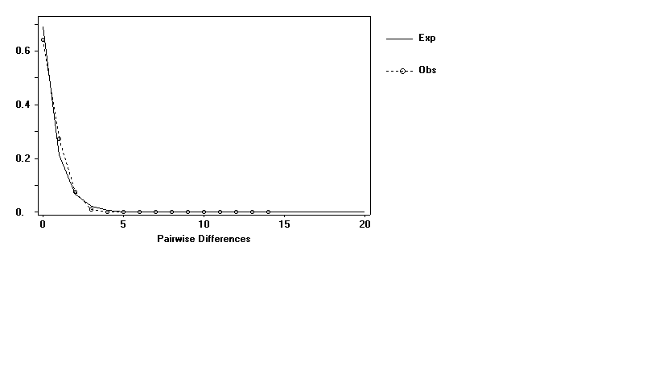
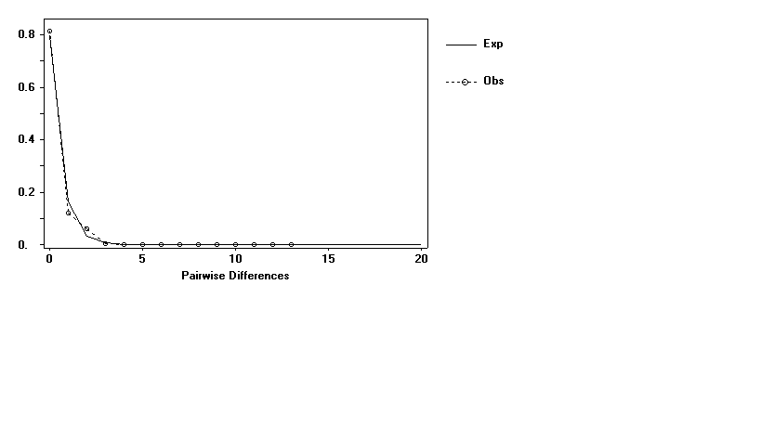
COI
CytΒ

Figure S1. Mismatch distributions for each gene. Exp: expected values and Obs: observed values.

Table S3. Pairwise genetic distances (% p-distance) (below diagonal) and standard error estimates (above diagonal) for the COI gene.
 | Vreli | Paramythia | Amfithea | Ampelia | Anatoli | Kallithea | Kastritsa | Lapsista
Vreli |  | 0.04 | 0.03 | 0.04 | 0.03 | 0.09 | 0.02 | 0.04
Paramythia | 0.05 |  | 0.04 | 0.05 | 0.04 | 0.09 | 0.03 | 0.05
Amfithea | 0.07 | 0.08 |  | 0.05 | 0.03 | 0.09 | 0.03 | 0.05
Ampelia | 0.04 | 0.07 | 0.08 |  | 0.05 | 0.09 | 0.04 | 0.05
Anatoli | 0.05 | 0.05 | 0.07 | 0.06 |  | 0.09 | 0.02 | 0.04
Kallithea | 0.13 | 0.15 | 0.16 | 0.12 | 0.13 |  | 0.09 | 0.10
Kastritsa | 0.02 | 0.03 | 0.05 | 0.04 | 0.02 | 0.12 |  | 0.04
Lapsista | 0.06 | 0.07 | 0.09 | 0.08 | 0.06 | 0.14 | 0.04

Table S4. Pairwise genetic distances (% p-distance) (below diagonal) and standard error estimates (above diagonal), for the CytB gene.
 | Vreli | Amfithea | Ampelia | Anatoli | Kallithea | Kastritsa | Lapsista
Vreli |  | 0.04 | 0.04 | 0.00 | 0.00 | 0.02 | 0.00
Amfithea | 0.06 |  |  | 0.04 | 0.04 | 0.05 | 0.04
Ampelia | 0.04 | 0.10 |  | 0.04 | 0.04 | 0.04 | 0.04
Anatoli | 0.00 | 0.06 | 0.04 |  | 0.00 | 0.02 | 0.00
Kallithea | 0.00 | 0.06 | 0.04 | 0.00 |  | 0.02 | 0.00
Kastritsa | 0.02 | 0.08 | 0.06 | 0.02 | 0.02 |  | 0.02
Lapsista | 0.00 | 0.06 | 0.04 | 0.00 | 0.00 | 0.02

Table S5. Pairwise genetic differentiation (Fst) of the populations of C. lacustris as estimated through 1,000 bootstrap replicates in AFLP-SURV.
 | Vreli | Paramythia | Amfithea | Ampelia | Anatoli
Vreli | -
Paramythia | 0.009 | -
Amfithea | 0.016 | 0.008 | -
Ampelia | 0.007 | 0.000 | 0.011 | -
Anatoli | 0.025 | 0.012 | 0.009 | 0.008 | -

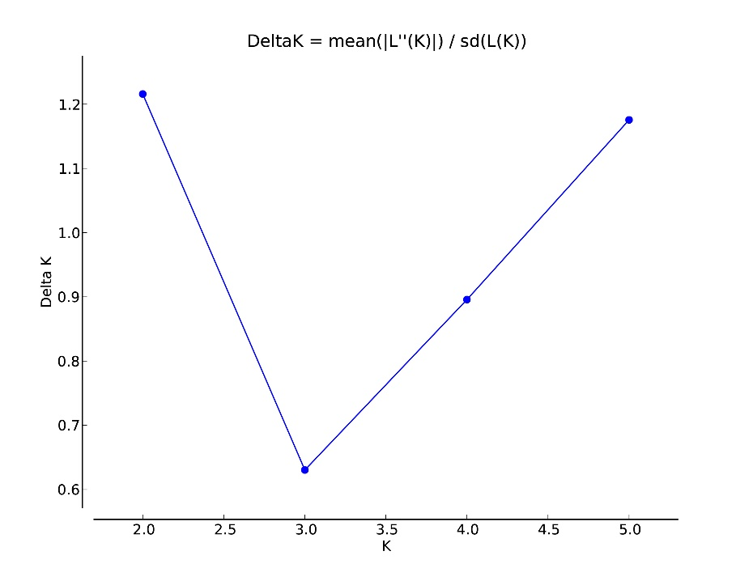

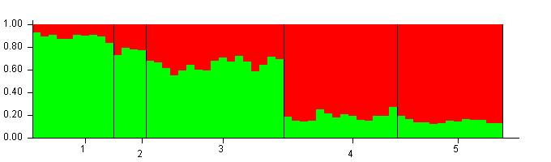
Figure S2. Delta K value estimated using Evano indicating k=2. Estimation of population structure for each of the five populations; 1. Ampelia, 2. Vreli, 3. Paramythia, 4. Amfithea and 5. Anatoli.

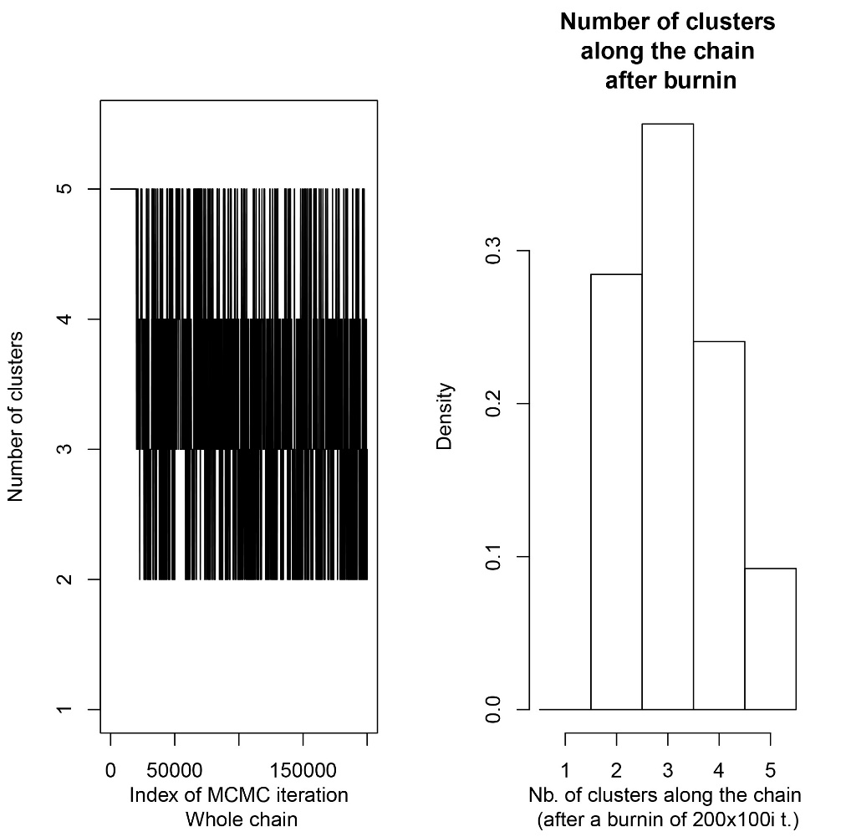

Figure S3. Number of clusters estimated in Geneland, indicating the highest probability of K=3.

