Supplementary material
Table S1. Weather data for the study area during summer (19-25 Jan) and autumn (27 April-5 May) 2017. Minimum, mean ± S.E, and maximum values are shown.
 | Wind speed (m/s at 10 m) | Air temperature (˚C) | Solar radiation (W/m²) | Relative humidity (%) | Rainfall (mm)
Summer
Min | 1.07 | 19.3 | 0 | 40.2 | 0
Mean | 4.79 ± 0.13*** | 26.10 ± 0.25*** | 232.13 ± 23.94*** | 72.48 ± 0.97* | 0.20 ± 0.15
Max | 8.41 | 33 | 960 | 93.9 | 25
Autumn
Min | 0.16 | 18.3 | 0 | 46.3 | 0
Mean | 3.49 ± 0.10*** | 22.46 ± 0.19*** | 142.31 ± 14.32*** | 75.26 ± 0.84* | 0.09 ± 0.04
Max | 6.74 | 29.7 | 701.9 | 93.3 | 7.4

Means with asterisks are significantly different between summer and autumn at ***P<0.0001 and *P<0.01.

Table S2. Butterfly species included in the study with their habitat affiliations and abundance per season.
Family | Scientific name | Common name | Habitat affiliation | Abundance in summer | Abundance in autumn
Hesperiidae
 | Borbo borbonica borbonica | Olive-haired swift | Habitat generalist | 0 | 13
 | Gegenes niso niso | Common hottentot skipper | Grassland specialist | 6 | 3
 | Kedestes callicles | Pale ranger | Habitat generalist | 5 | 0
 | Pelopidas thrax inconspicua | White banded swift | Habitat generalist | 3 | 2
 | Spialia dromus | Forest sandman | Forest specialist | 2 | 1
Lycaenidae
 | Actizera lucida | Rayed blue | Habitat generalist | 5 | 24
 | Anthene amarah amarah | Black striped hairtail | Grassland specialist | 1 | 4
 | Azanus jesous jesous | Topaz spotted blue | Habitat generalist | 1 | 0
 | Azanus moriqua | Thorn tree blue | Habitat generalist | 28 | 0
 | Baliochila aslanga | Common buff | Forest specialist | 1 | 0
 | Chilades trochylus | Grass jewel blue | Grassland specialist | 4 | 2
 | Cigaritis ella | Ella's bar | Habitat generalist | 0 | 1
 | Cupidopsis jobates jobates | Tailed meadow blue | Grassland specialist | 4 | 0
 | Eicochrysops hippocrates | White-tipped blue | Habitat generalist | 1 | 6
 | Euchrysops barkeri | Barkers smoky blue | Habitat generalist | 13 | 21
 | Euchrysops osiris | Osiris smoky blue | Habitat generalist | 12 | 7
 | Hypolycaena philippus philippus | Purple-brown hairstreak | Habitat generalist | 6 | 15
 | Lachnocnema bibulus | Common wooly legs | Forest specialist | 0 | 3
 | Lachnocnema durbani | Durban's wooly legs | Grassland specialist | 11 | 4
 | Lachnocnema laches | Southern pied woolly legs | Forest specialist | 6 | 4
 | Lampides boeticus | Long-tailed blue | Habitat generalist | 1 | 0
 | Leptotes pirithous pirithous | Common blue | Habitat generalist | 0 | 36
 | Zizeeria knysna | Sooty blue | Habitat generalist | 1 | 2
 | Zizina antanossa | Clover blue | Grassland specialist | 2 | 0
Nymphalidae
 | Acraea caldarena caldarena | Black tipped acraea | Grassland specialist | 3 | 0
 | Acraea natalica | Natal acraea | Habitat generalist | 1 | 6
 | Acraea oncaea | Window acraea | Habitat generalist | 16 | 11
 | Amauris albimaculata albimaculata | Layman | Forest specialist | 65 | 455
 | Amauris ochlea ochlea | Novice | Forest specialist | 125 | 59
 | Bicyclus safitza safitza | Common bush brown | Forest specialist | 1 | 1
 | Byblia anvatara acheloia | Common joker | Grassland specialist | 0 | 34
 | Byblia ilithyia | Spotted joker | Grassland specialist | 66 | 19
 | Charaxes varanes varanes | Pearl emperor | Forest specialist | 1 | 23
 | Danaus chrysippus aegyptius | African monarch | Habitat generalist | 75 | 100
 | Henotesia perspicua perspicua | Eyed bush brown | Habitat generalist | 0 | 23
 | Hyalites cabira | Yellow banded acraea | Forest specialist | 1 | 0
 | Hyalites encedon encedon | White-barred acraea | Forest specialist | 3 | 1
 | Hyalites eponina | Small orange acraea | Forest specialist | 16 | 125
 | Hyalites esebria esebria | Dusky acraea | Forest specialist | 7 | 0
 | Hypolimnas misippus | Common diadem | Habitat generalist | 0 | 1
 | Junonia hierta cebrene | Yellow pansy | Grassland specialist | 2 | 4
 | Junonia natalica natalica | Brown pansy | Habitat generalist | 0 | 1
 | Junonia oenone oenone | Blue pansy | Grassland specialist | 12 | 28
 | Junonia terea elgiva | Soldier pansy | Forest specialist | 8 | 10
 | Melanitis leda helena | Evening brown | Forest specialist | 0 | 6
 | Phalanta eurytis eurytis | Forest leopard | Forest specialist | 6 | 13
 | Sevenia natalensis | Natal tree nymph | Forest specialist | 6 | 0
 | Vanessa cardui | Painted lady | Habitat generalist | 0 | 1
 | Ypthima asterope | African ringlet | Grassland specialist | 1 | 75
Papilionidae
 | Graphium antheus | Large striped swordtail | Forest specialist | 8 | 0
 | Graphium morania | White lady | Forest specialist | 1 | 0
 | Papilio dardanus cenea | Mocker swallowtail | Forest specialist | 15 | 13
 | Papilio demodicus demodicus | Citrus swallowtail | Habitat generalist | 80 | 144
 | Papilio nireus lyaeus | Green banded swallowtail | Forest specialist | 15 | 7
Pieridae
 | Belenois aurota aurota | Brown-veined white | Habitat generalist | 0 | 10
 | Belenois creona severina | African common white | Habitat generalist | 26 | 34
 | Catopsilia florella | African migrant | Habitat generalist | 95 | 33
 | Colotis euippe omphale | Smoky orange tip | Habitat generalist | 0 | 1
 | Colotis antevippe gavisa | Red tip | Habitat generalist | 0 | 1
 | Colotis danae annae | Scarlet tip | Habitat generalist | 0 | 1
 | Eronia cleodora cleodora | Vine leaf vagrant | Habitat generalist | 0 | 125
 | Eurema brigitta brigitta | Broad bordered grass yellow | Grassland specialist | 67 | 135
 | Eurema hecabe solifera | Common grass yellow | Grassland specialist | 11 | 66
 | Mylothris agathina agathina | Common dotted border | Habitat generalist | 0 | 11
 | Nepheronia buquetii | Green eyed monster | Habitat generalist | 0 | 1

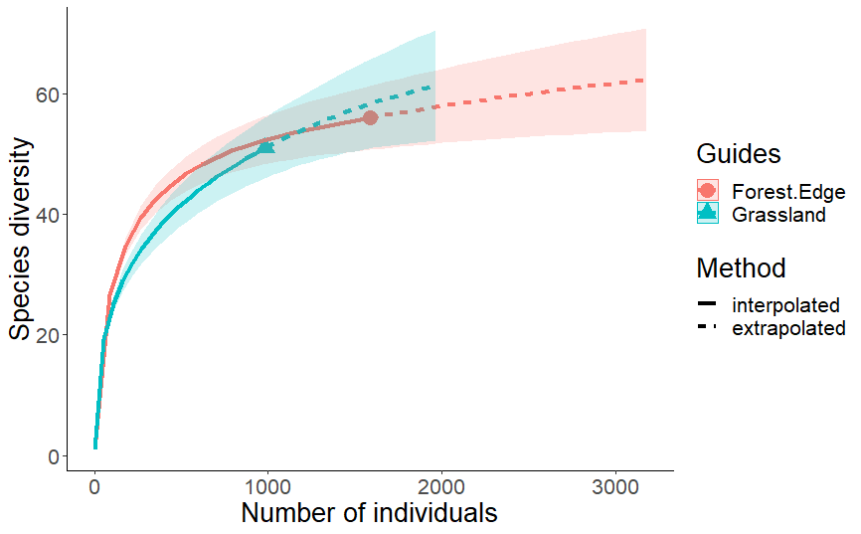

Figure S1. Individual-based species rarefaction and extrapolation curves with 95% confidence intervals for butterfly species richness at forest edges and in grassland.

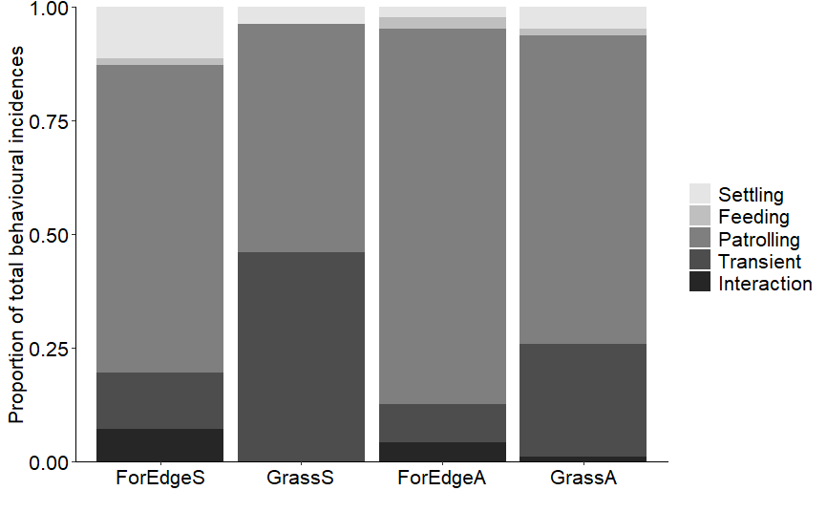
A
B
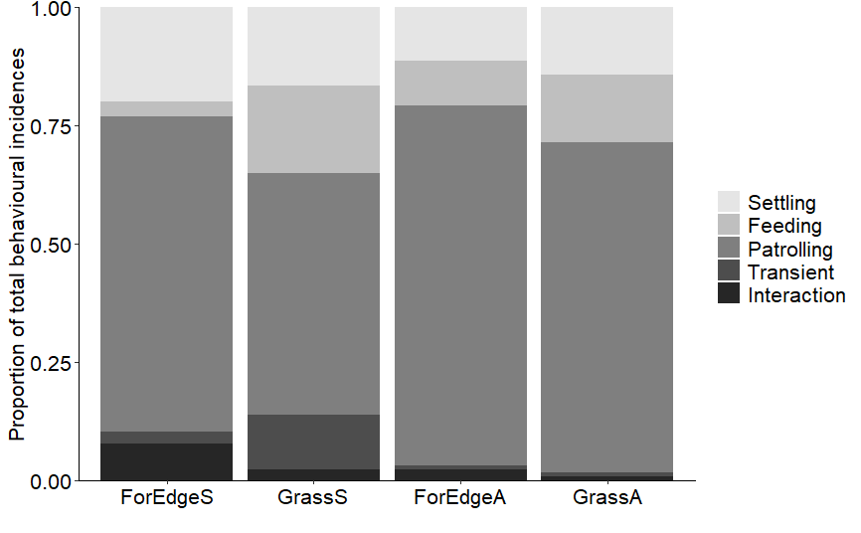
C
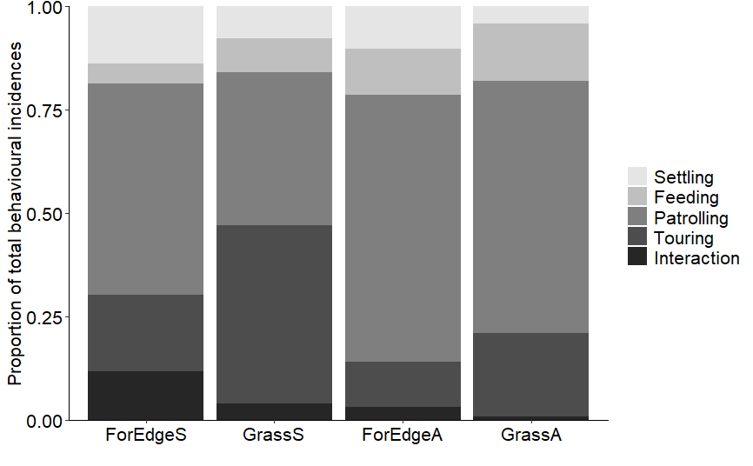
Figure S2. Different behaviours of A) forest specialists, B) grassland specialists and C) habitat generalist butterflies, expressed as proportion of total behavioural incidences, at forest edges and in adjacent grassland in summer and autumn. (ForEdgeS=forest edge summer, GrassS=grassland summer, ForEdgeA=forest edge autumn, GrassA=grassland autumn).

Table S3. Abundances of the dominant butterflies at forest edges and in grassland in summer and autumn
 | Summer |  |  | Autumn
Species | Forest edge | Grassland |  | Forest edge | Grassland
Forest specialists
Amauris albimaculata albimaculata | 64 | 1 |  | 296 | 159
Amauris ochlea ochlea | 106 | 19 |  | 40 | 19
Hyalites eponina | 12 | 4 |  | 59 | 66
Papilio dardanus cenea | 14 | 1 |  | 11 | 2
Grassland specialists
Byblia ilithyia | 52 | 14 |  | 12 | 7
Eurema brigitta brigitta | 24 | 43 |  | 56 | 79
Eurema hecabe solifera | 11 | 0 |  | 44 | 22
Junonia oenone oenone | 5 | 7 |  | 19 | 9
Habitat generalists
Acraea oncaea | 6 | 10 |  | 4 | 7
Belenois creona severina | 8 | 18 |  | 21 | 13
Catopsilia florella | 30 | 65 |  | 20 | 13
Danaus chrysippus aegyptius | 44 | 31 |  | 39 | 61
Euchrysops barkeri | 7 | 6 |  | 8 | 13
Papilio demodicus demodicus | 64 | 16 |  | 85 | 59

Table S4. Flowering plant species that butterflies visited during the study, indicating the plant growth form and number of butterfly visitations recorded over both seasons at the forest edge and in the adjacent grassland.
 |  | Number of visitations
Scientific name | Growth form | Forest edge |  | Grassland
Abutilon sonneratianum | Herb | 1 |  | 1
Acacia nilotica | Tree | 6 |  | 16
Ageratum houstonianum | Herb | 1 |  | 2
Becium obovatum | Herb | 3 |  | 0
Bidens pilosa | Herb | 0 |  | 8
Catharanthus roseus | Herb | 10 |  | 3
Conostomium natalense | Herb | 5 |  | 1
Crotalaria laburnifolia | Herb | 0 |  | 1
Cryptocarya myrtifolia | Tree | 1 |  | 0
Cyathula cylindrica | Herb | 3 |  | 0
Cynoglossum geometricum | Herb | 0 |  | 2
Desmodium dregeanum | Herb | 0 |  | 1
Ecbolium glabratum | Herb | 11 |  | 0
Eriosema psoraleoides | Shrub | 0 |  | 3
Gomphocarpus physocarpus | Herb | 3 |  | 4
Helichrysum decorum | Herb | 3 |  | 15
Hibiscus cannabinus | Herb | 0 |  | 1
Hypoxis aryenka | Herb | 0 |  | 2
Hypoestes forskaolii | Herb | 0 |  | 1
Hypotis pectinata | Herb | 2 |  | 0
Indigofera sp. 1 | Herb | 1 |  | 3
Jatropha sp. 1 | Herb | 3 |  | 7
Justificia protracta | Herb | 0 |  | 1
Kiggelaria africana | Tree | 1 |  | 0
Leucas lavandalifolia | Herb | 1 |  | 2
Leucas sp. 1 | Herb | 5 |  | 5
Lobelia anceps | Herb | 1 |  | 0
Mentha sp. 1 | Herb | 0 |  | 4
Mimusops caffra | Tree | 1 |  | 0
Monopsis stellaroides | Herb | 1 |  | 0
Oxyanthus speciosus | Tree | 1 |  | 0
Pentanisia angustifolia | Herb | 0 |  | 2
Phoenix reclinata | Tree | 4 |  | 6
Phylica sp.1 | Herb | 7 |  | 9
Polygala sp. 1 | Herb | 2 |  | 0
Pseudarthria hookeri | Herb | 0 |  | 1
Psoralea sp. 1 | Herb | 0 |  | 3
Pupalia lappacea | Herb | 1 |  | 0
Rhynchosia nitens | Herb | 0 |  | 1
Scutia myrtina | Tree | 0 |  | 1
Senecio discodregeanus | Herb | 0 |  | 1
Selago sp. 1 | Herb | 0 |  | 2
Solanum seaforthianum | Climber | 1 |  | 0
Tagetes minuta | Herb | 0 |  | 1
Tephrosia grandiflora | Herb | 7 |  | 0
Vernonia centaureoides | Herb | 0 |  | 1
Vernonia tigna | Shrub | 1 |  | 2
Zornia capensis | Herb | 0 |  | 1

