Table S1: The number of peer-reviewed journals and report series searched in each of 17 languages, the results of which were held within the Conservation Evidence database (www.conservationevidence.com) at the time of data extraction for this study. Searches of non-English language journals were conducted by the TranslatE project, https://translatesciences.com/ (Amano et al. 2021).
Language | Number of peer-reviewed journals or report series searched | Number of papers included in the Lepidoptera synopsis
Arabic | 11 | 0
Chinese (simplified) | 61 | 0
Chinese (traditional) | 14 | 1
English | 319 | 375
French | 13 | 1
German | 39 | 5
Hungarian | 4 | 0
Italian | 7 | 0
Japanese | 18 | 1
Korean | 5 | 0
Persian | 9 | 0
Polish | 10 | 1
Portuguese | 29 | 0
Russian | 12 | 0
Spanish | 59 | 0
Turkish | 22 | 0
Ukrainian | 3 | 0
TOTAL | 635 | 384

Table S2: Model selection for Poisson regressions of the number of studies included in the Conservation Evidence Butterfly and Moth Synopsis (Bladon et al. 2023). “group” refers to the taxonomic group that the study focuses on, i.e. butterflies or moths, and “year” refers to the year of study publication. “:” indicates an interaction. Models are ordered by AIC_{C}. The optimal model is italicised.
Independent variables included in the model | df | log likelihood | AIC_{C} | delta | weight
group + year + group:year | 4 | -269.14 | 546.69 | 0.00 | 0.86
group + year | 3 | -272.06 | 550.36 | 3.67 | 0.14
year | 2 | -350.94 | 706.00 | 159.32 | 0.00
group | 2 | -726.25 | 1456.62 | 909.94 | 0.00
(null) | 1 | -805.14 | 1612.31 | 1065.63 | 0.00

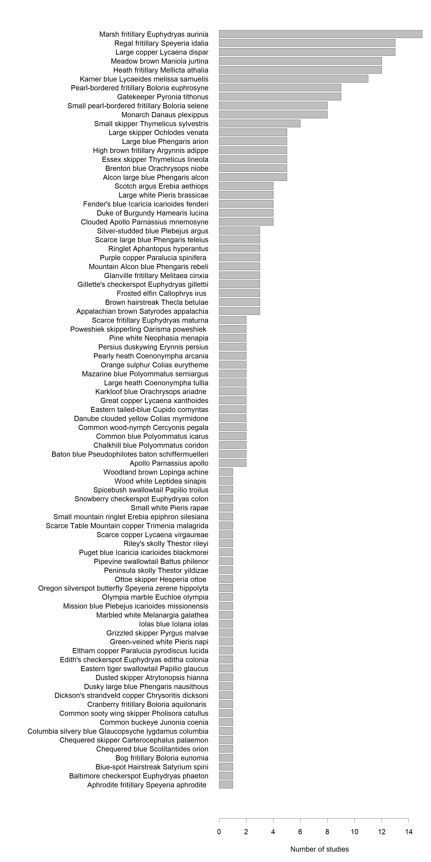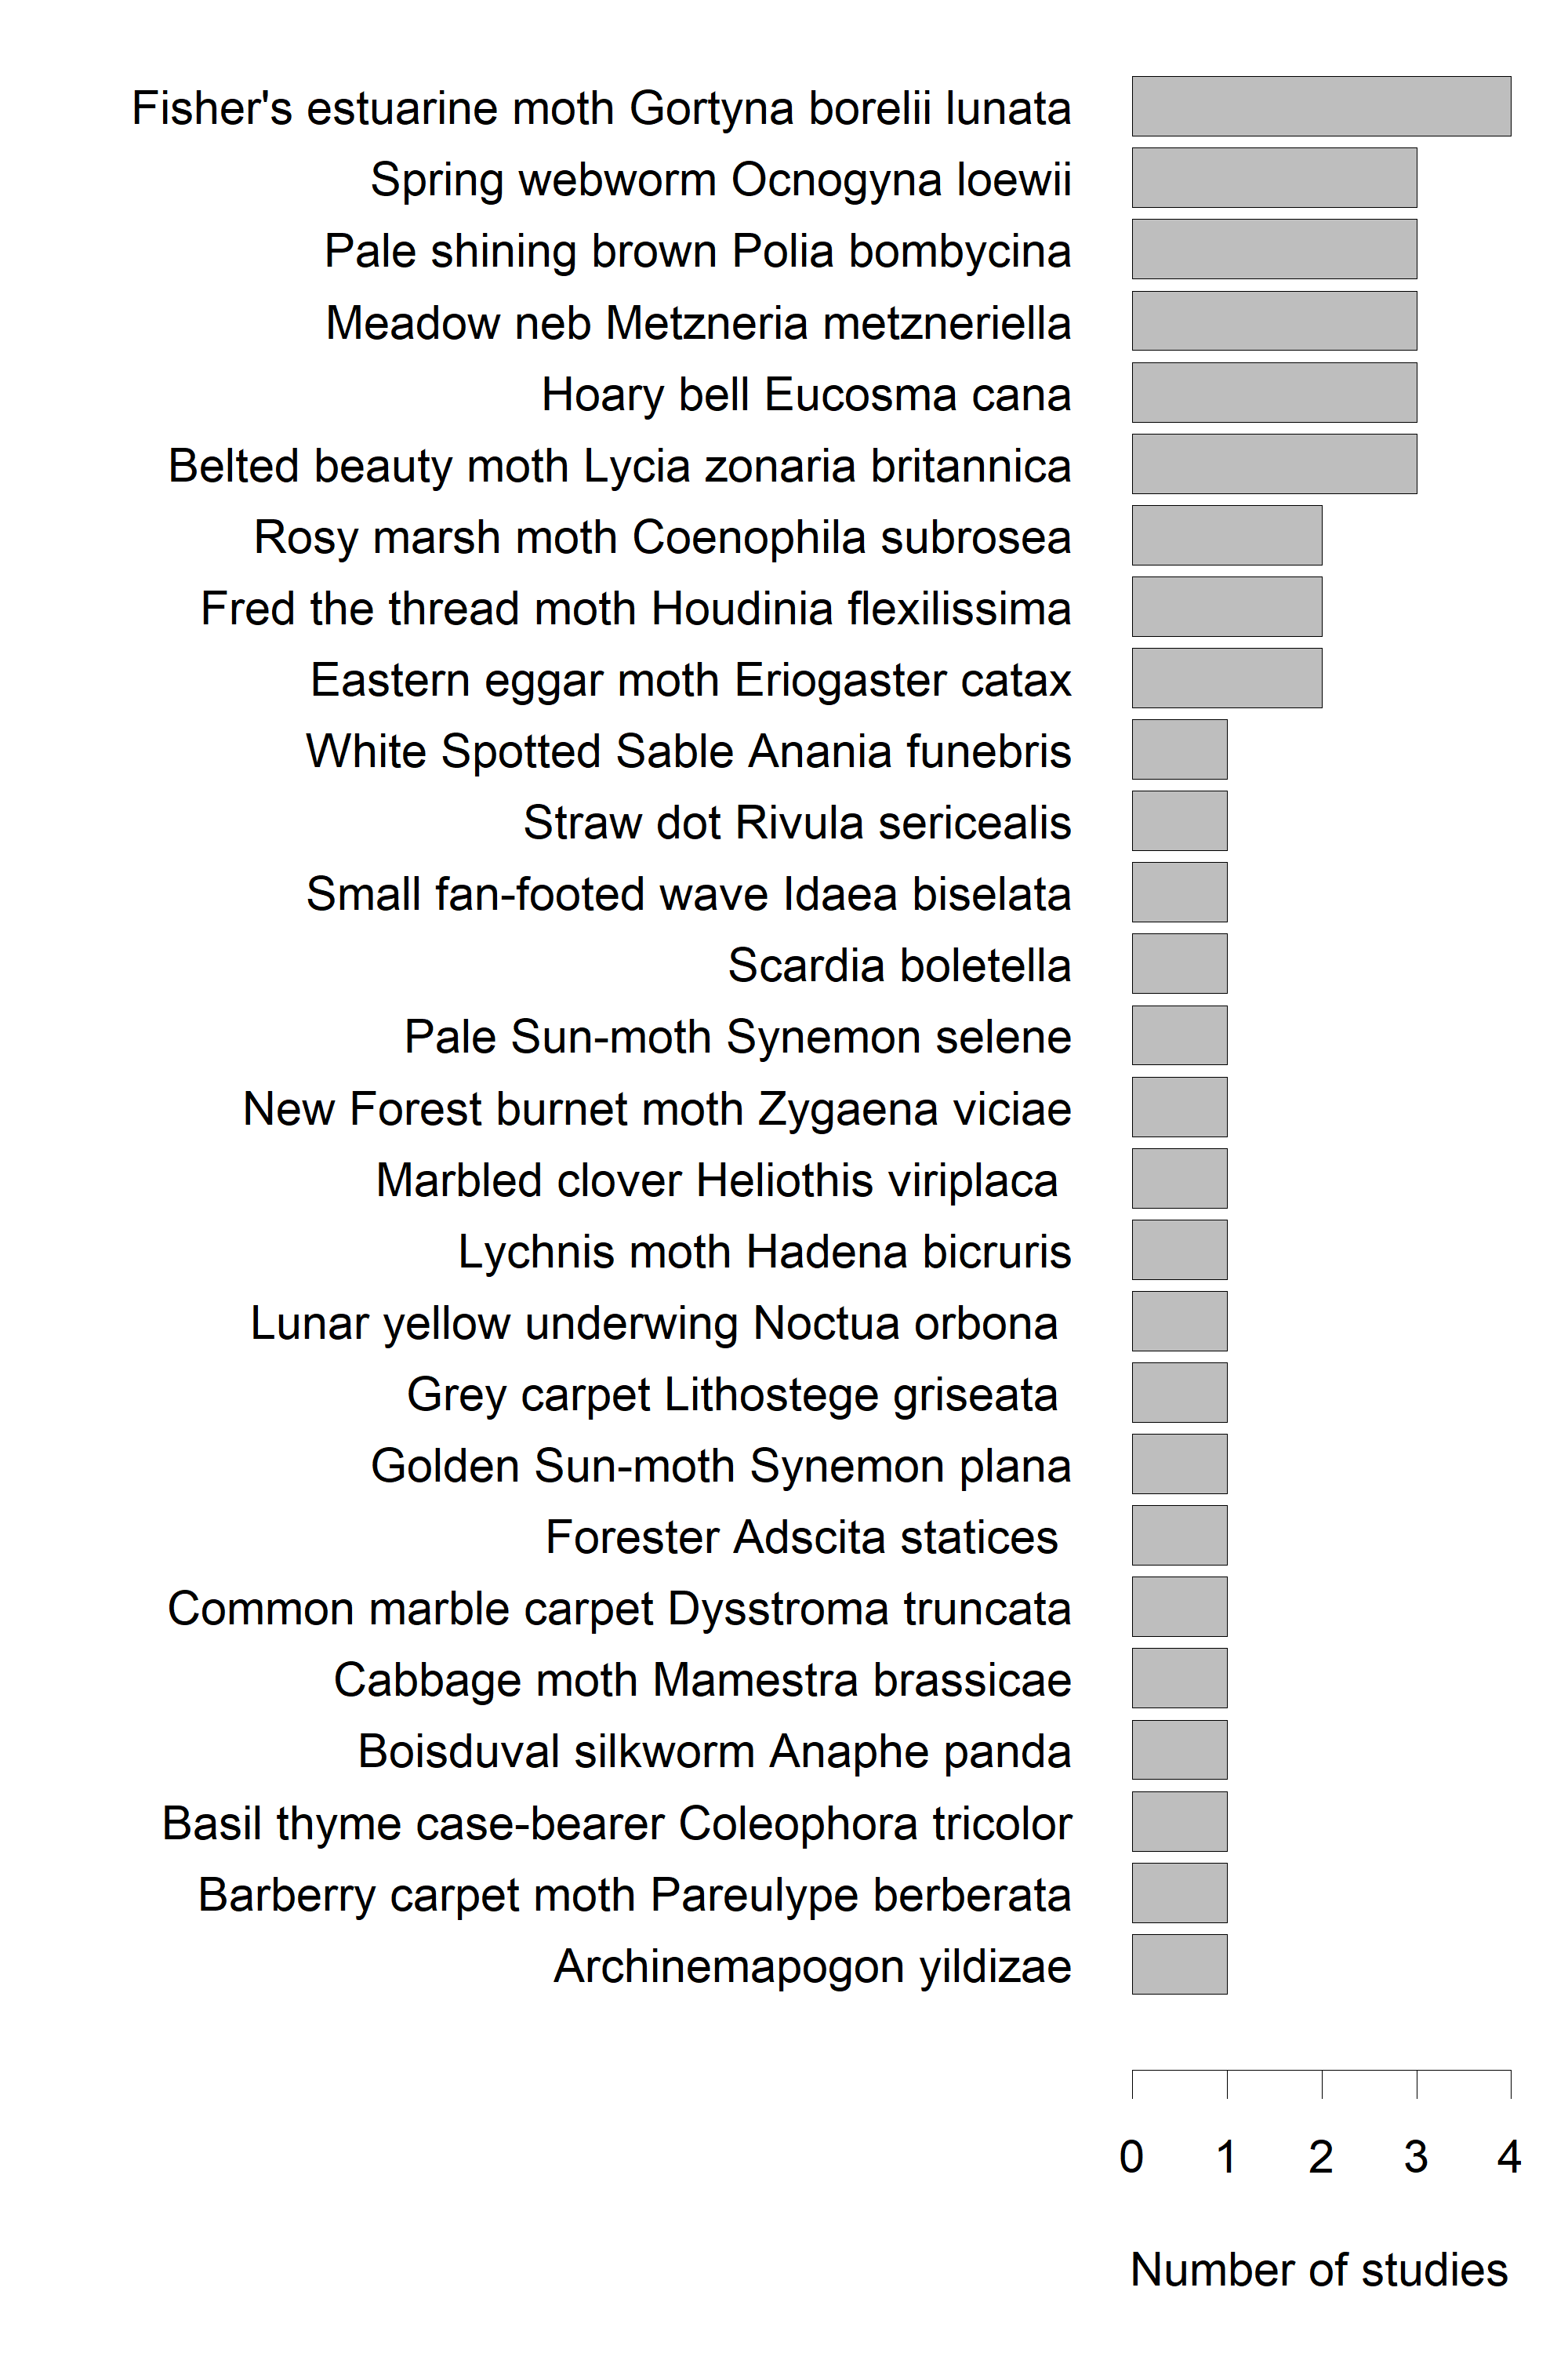
a)
b)
Figure S1: The number of studies within the Conservation Evidence Butterfly and Moth Synopsis (Bladon et al. 2023) where the outcome of a conservation action was reported for individual species of a) butterfly and b) moth.

