Supplementary Table 1 Early and late breeding date mean, standard deviation of the mean, minimum, maximum, number of hexbins (n_{bin}), and number of breeding records (n) for each province and state overlapping the core breeding range. Breeding dates should be used in conjunction with considerations discussed in the manuscript, among others, to develop suitable mowing dates. Hexbins that overlapped multiple jurisdictions were included in all overlapping jurisdictions.
 |  |  |  | Early breeding date |  |  |  | Late breeding date
Province/state |  | n_{bin} | n | Mean | SD | Min | Max | Mean | SD | Min | Max
 | Canada
Manitoba |  | 8 | 1132 | 153.3 | 7.6 | 141 | 165 | 227.4 | 12.5 | 209 | 239
New Brunswick |  | 8 | 1008 | 184.5 | 14.6 | 165 | 206 | 243.5 | 7.8 | 228 | 252
Nova Scotia |  | 11 | 1247 | 179.6 | 12.8 | 153 | 194 | 255.2 | 11.3 | 244 | 276
Ontario |  | 37 | 18374 | 164.6 | 13.1 | 134 | 187 | 246.2 | 17.8 | 210 | 280
Prince Edward Island |  | 2 | 54 | 177.0 | 17.0 | 165 | 189 | 250.5 | 3.5 | 248 | 253
Québec |  | 26 | 10834 | 184.1 | 10.9 | 153 | 203 | 242.2 | 11.2 | 220 | 259
 | Mexico
Coahuila de Zaragoza |  | 1 | 168 | 17.0 |  | 17 | 17 | 349.0 |  | 349 | 349
Nuevo León |  | 2 | 206 | 14.5 | 3.5 | 12 | 17 | 342.5 | 9.2 | 336 | 349
Tamaulipas |  | 3 | 523 | 4.7 | 6.4 | 1 | 12 | 354.7 | 16.2 | 336 | 365
 | United States
Alabama |  | 15 | 1503 | 81.6 | 27.9 | 2 | 111 | 297.2 | 22.1 | 267 | 350
Arkansas |  | 20 | 2240 | 95.5 | 17.6 | 74 | 145 | 281.9 | 17.4 | 250 | 315
Connecticut |  | 4 | 4976 | 169.5 | 7.9 | 161 | 180 | 278.8 | 8.2 | 274 | 291
Delaware |  | 3 | 3274 | 149.0 | 11.8 | 136 | 159 | 298.3 | 4.9 | 295 | 304
District of Columbia |  | 2 | 4420 | 161.0 | 2.8 | 159 | 163 | 298.5 | 4.9 | 295 | 302
Florida |  | 25 | 6201 | 5.0 | 4.2 | 1 | 12 | 360.4 | 4.5 | 354 | 365
Georgia |  | 14 | 2857 | 76.4 | 34.4 | 6 | 102 | 295.0 | 26.2 | 278 | 364
Illinois |  | 23 | 9231 | 123.7 | 15.6 | 95 | 150 | 271.8 | 16.5 | 247 | 313
Indiana |  | 16 | 7329 | 139.1 | 14.4 | 106 | 162 | 275.9 | 13.7 | 257 | 297
Iowa |  | 16 | 2220 | 133.5 | 13.6 | 113 | 162 | 259.6 | 11.1 | 234 | 276
Kansas |  | 13 | 2310 | 118.6 | 19.8 | 92 | 158 | 276.1 | 14.6 | 257 | 303
Kentucky |  | 15 | 3249 | 125.9 | 28.7 | 92 | 164 | 284.7 | 17.3 | 250 | 317
Louisiana |  | 15 | 1853 | 61.2 | 30.4 | 2 | 80 | 309.5 | 28.4 | 280 | 365
Maine |  | 13 | 2304 | 189.7 | 9.5 | 176 | 204 | 250.7 | 16.0 | 222 | 269
Maryland |  | 10 | 8742 | 157.8 | 22.9 | 116 | 192 | 290.3 | 11.2 | 269 | 304
Massachusetts |  | 8 | 4630 | 168.4 | 8.8 | 159 | 180 | 273.1 | 3.1 | 269 | 277
Michigan |  | 25 | 6621 | 145.0 | 7.5 | 130 | 157 | 251.3 | 13.5 | 225 | 271
Minnesota |  | 27 | 5820 | 140.2 | 12.3 | 123 | 170 | 244.4 | 14.2 | 216 | 266
Mississippi |  | 13 | 1687 | 75.4 | 30.2 | 2 | 111 | 300.8 | 27.4 | 270 | 350
Missouri |  | 25 | 5388 | 116.8 | 21.5 | 94 | 184 | 280.2 | 15.2 | 250 | 313
Nebraska |  | 9 | 1019 | 132.7 | 20.7 | 108 | 162 | 260.7 | 12.2 | 234 | 272
New Hampshire |  | 7 | 4144 | 187.3 | 8.7 | 177 | 203 | 259.6 | 9.6 | 242 | 269
New Jersey |  | 6 | 6940 | 156.2 | 12.6 | 136 | 170 | 290.0 | 8.9 | 280 | 304
New York |  | 23 | 14860 | 173.2 | 9.0 | 151 | 188 | 267.5 | 10.5 | 250 | 291
North Carolina |  | 22 | 4871 | 97.5 | 27.4 | 1 | 134 | 292.9 | 18.6 | 264 | 326
North Dakota |  | 7 | 449 | 142.7 | 7.7 | 130 | 150 | 244.7 | 14.6 | 224 | 266
Ohio |  | 18 | 6059 | 154.2 | 16.5 | 116 | 185 | 277.2 | 8.8 | 260 | 295
Oklahoma |  | 15 | 4902 | 96.4 | 15.5 | 75 | 145 | 295.5 | 18.4 | 274 | 328
Pennsylvania |  | 20 | 10527 | 170.7 | 11.6 | 151 | 192 | 278.1 | 9.6 | 264 | 296
Rhode Island |  | 3 | 1810 | 169.0 | 9.8 | 161 | 180 | 275.0 | 1.7 | 274 | 277
South Carolina |  | 11 | 2314 | 87.7 | 11.2 | 65 | 101 | 288.8 | 16.0 | 274 | 325
South Dakota |  | 8 | 366 | 146.1 | 13.2 | 125 | 162 | 249.4 | 11.2 | 234 | 266
Tennessee |  | 17 | 2958 | 100.4 | 12.6 | 87 | 134 | 280.8 | 15.0 | 250 | 317
Texas |  | 36 | 12181 | 60.8 | 33.6 | 1 | 97 | 326.8 | 28.8 | 294 | 366
Vermont |  | 6 | 6850 | 182.7 | 4.3 | 178 | 190 | 260.0 | 6.0 | 251 | 269
Virginia |  | 20 | 7204 | 134.1 | 30.2 | 91 | 192 | 294.6 | 18.3 | 264 | 326
West Virginia |  | 15 | 5469 | 169.9 | 24.4 | 100 | 207 | 283.2 | 13.3 | 264 | 316
Wisconsin |  | 25 | 6565 | 138.6 | 13.7 | 123 | 170 | 248.0 | 13.4 | 223 | 276

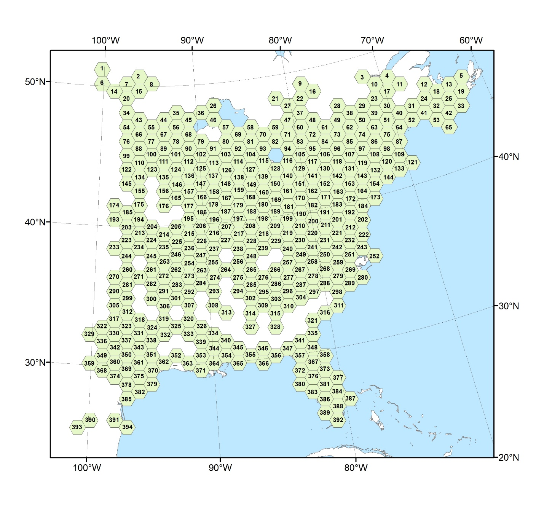
Supplementary Fig. 1 Hexbin identification numbers that correspond to the identification numbers of the supplementary breeding plots.

